PWCP-III - Eliminations Cat.A

N°
A01 | Rule cat.A | Hors réglament du concours / число шашек 8х6 не соответствует требованиям категории [ ML ]
A02 | RI 1.7.  Does not win | Probleme faux / нерешаемость - 20.15(20!)... [Г.Шестириков]
A09 | RI 2.1.1.  Identical | Forte ressemblance / ИП  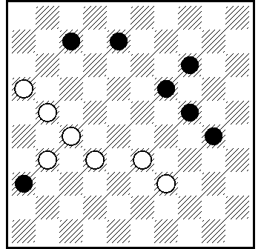  A. van den Elzen , (HD, 7-1964)  11.22.34.3… + [ А.Тavernier ]
A13 |  | Forte ressemblance / ИП  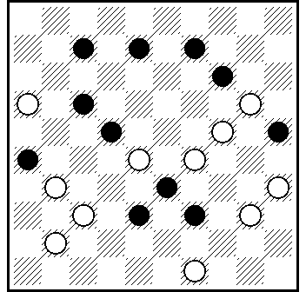  G.Geerlings(Book of G.Geerlings) 30.28.11.4.30.38 + [ АТ ]
A20 | RI 2.1.1.  Identical | Similitude / exact ressemblance J.A. Pennings, Limburgs Dagblad 1972. [ Аrjen Timmer ]
A25 |  | Forte ressemblance / ИП  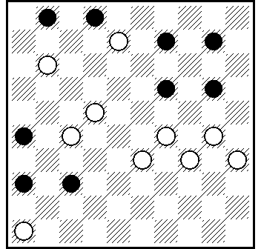  V.Malashenko (Lietuva 2008)21.43.304.4(7.42)19(48)31.37.37 + [ А.Тavernier ]  1. autre solution / ппр V.Mashenko ( Lietuva 2008 )  25.3(361)350(14A)20(47)15(372)28(36)294(261)41.36(18)223.22(12)7(17.12)6(48)1+. A (47)28.30.21.23+. [ ML ]  2. Ressemblance:  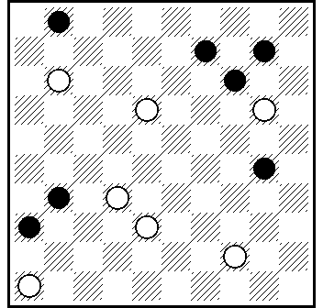  V.Malashenko (В.Малашенко), Conc. „BVLD - СЛШИ 1994/1995”. 27.15(34.7.40)10.31.37.37+.  pas de solutions / нерешаемость V.Malashenko (BVLD ) : 27? 15(35)4(7)2(41)5(47)= [ ML ]
A26 | RI 1.17.2.d.  SS | Seconde solution / ппр - 42.249.9.3 + [ ML ]
A28 | RI 1.17.2.d.  SS | Seconde solution / ппр - 10.18.5.28.41/46+ [ ML ]
A32 | RI 1.17.2.d.  SS | Dual / чпр - 37.1.42.43(45)30(12)38 + [ Antanas Gimbutas ]
A33 | RI 2.1.1.  Identical | Quasi similitude / ИП  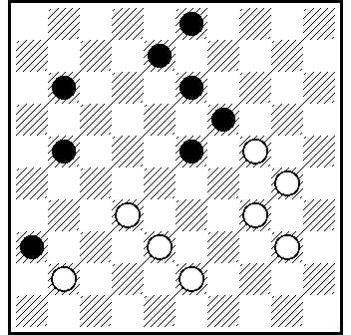  H.J. van Rees, Het Damspel 1948 [ Arjen Timmer ]
A38 | RI 1.7.  Does not win | Probleme faux / нерешаемость - 30.8.10(14)9.5(31!) = [ ML ]
A41 | RI 1.17.2.d.  SS | Seconde solution / ппр - 9.2.50.3+ of 2.9.50.3 +. [ ML ]
A42 | RI 1.17.2.d.  SS | Dual / чпр - 18.7.39.11(17)1(38)33 + [ Antanas Gimbutas ]
A49 | RI 1.17.2.d.  SS | Dual / чпр - 13.22.3.36 +. [ Antanas Gimbutas ]
A53 | RI 1.17.2.d. | Vioation regle / ИП  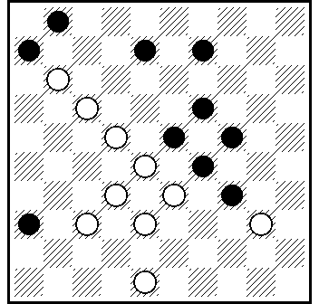  B.Ivanov(KVD 2008)31.7.27.30.4.2 + [ Аlain Тavernier ]  [ * А53 - violation des régles / не соответствует RI,п.1.17.2d ] [ Valdas Bieliauskas ]
A55 | RI 1.17.2.d.  Second solution | Duals dans le final /  [ * A55 - ressemblance / ИП  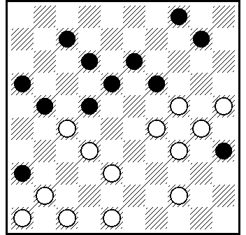  EJ. Van Rijn(HD, 1-1927) 240.38(31)42.37.8.14.1… + ] [ А.Тavernier ]  [ * А55 - duals dans le final / чпр в эндшпиле ...35(23)24(16)38(28 )  27/49(33)43 ... ] [ Ch.Romon ]
A56 | RI 1.17.2.d.  Second solution | Dual / чпр - 13.15.3.4.3-8! +. [Г.Шестириков]
A58 | RI 1.17.2.d.  Second solution | Dual /  [ * А58 - dual / чпр 4. 4x36x38x48+ / 4. 4x36x24x49+. ** dual / чпр - 22.4.9.17(21)48/49+.] [ A.Gimbutas ]
A62 | RI 1.17.2.d.  Second solution | Seconde solution / ппр - 427!+. [ Г.Шестириков ]
A66 | Rule cat.A | Hors réglament du concours / число шашек 9х8 ] [ ML ]
A67 | Rule cat.A | Hors réglament du concours / число шашек 9х8 ] [ ML ]
A68 | Rule cat.A | Hors réglament du concours / число шашек 8х9 ] [ ML ]

30-10-2010

