P W C P - 3

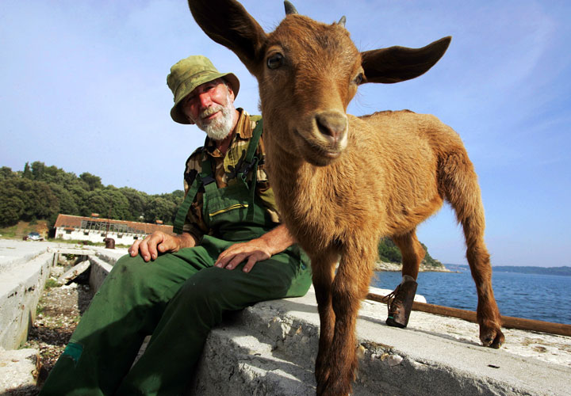

2009 / 2010

participants / участники :

В.Малашенко ( Беларусь ) 24-08-09
А.Timmer ( Niderland ) 10-11-09
С.Устьянов ( Украина ) 12-11-09
А.Moiseyev ( USA ) 17-11-09
P.Kuijper ( Niderland ) 01-12-09
N.Doubovy ( France ) 11-12-09
В.Шульга ( Беларусь ) 14-12-09
М.Левандовский ( Украина ) 15-12-09
B.Матус ( Россия ) 29-12-2009
С.Перепелкин ( Россия ) 29-12-2009
B.Fermin ( Niderland ) 31-12-2009
A.Tavernier ( France ) 31-12-2009
A.Уваров ( Украина ) 04-01-2010
V.Bieliauskas ( Lietuva ) 05-01-2010
A.Geurts ( Нидерланды ) 08-01-2010
В.Ворушило ( Беларусь )11-01-2010
И.Навроцкий (Беларусь) 11-01-2010
Б.Иванов ( Беларусь ) 11-01-2010
В.И.Никитчук ( Украина ) 11-01-2010
Г.Шестириков ( Россия ) 11-01-2010
H.J.Simons ( Nederland ) 12-01-2010
А.Ныров ( Россия ) 12-01-2010
W.Ch.Riemens ( Nederland ) 12-01-2010
A.Kačiuška (Lietuva ) 12-01-2010
В.Тринос ( Украина ) 13-01-2010
M.Tsvetov ( Israel ) 13-01-2010
В. Гребенко ( Беларусь ) 13-01-2010
А.Г.Ныч ( Украина ) 15-01-2010
Г.В.Андреев ( Латвия ) 15-01-2010
А.И.Маслов ( Украина ) 19-01-2010
Л.С.Витошкин ( Беларусь ) 19-01-2010
Е.Копылов (Россия ) 25-01-2010
А.И.Сапегин ( Беларусь ) 25-01-2010
A.Rom ( USA ) 29-01-2010
В.В.Факанов ( Украина ) 12-02-2010
Е.К.Факанова ( Украина ) 12-02-2010

Спасибо за участие в конкурсе. Je vous remarcie pour la participation dans le concours.

Замечания принимаются до 30 – 04 – 2010. Les remarques sont acceptées jusqu'à 30 – 04 – 2010.

categorie A / категория А

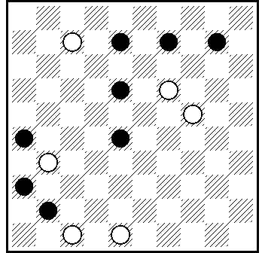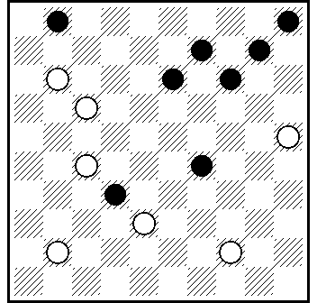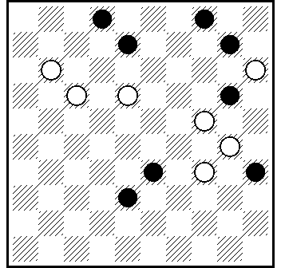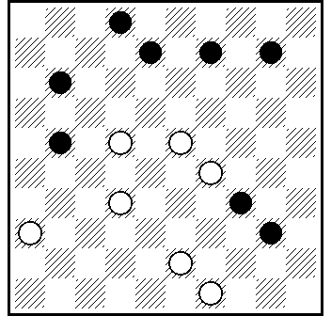
01A 02A 03A 04A

01A] 14(29A)2(27B)4(46)31.41.37+. A(30)1(37)33(46)33-42+. B(37)15(46)15-42+.
L :6.8.9.10.16.26.34.36 = 7.17.19.21.22.24.27.31.37.38.43.47.48 ...11(6x28)22(16x18)39(41) ...

02A] 20.15(34.7.40)10.1.1-23(5x14)5+.

03A] 13.7.2.9.4(19)10(24)15(29)20(34)38(39)49+.

04A] 44.5.7.31+.

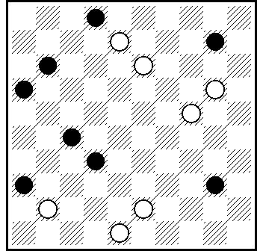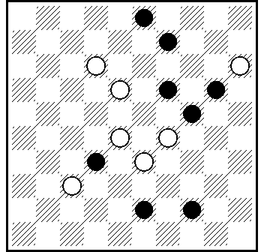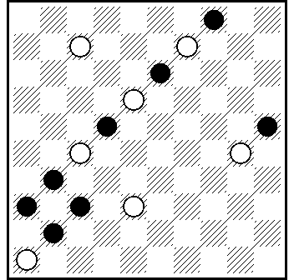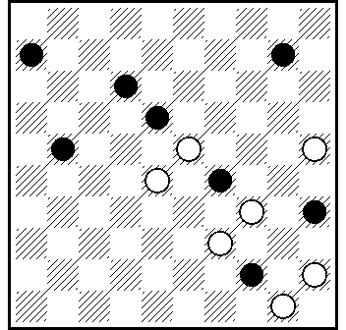
05A 06A 07A [ * ] 08a

05A] 3.15.25(44)4(8)2(21)31(38)32.25-39.38.37.46+.

06A] 8.29.4.46+.

06A] 32(28 А)26(31)37(22)31(13/34 ВС)2(34/13)43.21(33)16
(39 VP₁)11+; VP₁ (28)43+. А (34)2.2x30x26(22x13 a)37(33)18
(39)18-12(44)7(50)2(9 D)19(13)2(28)16.37.32.46+. В (13/27)
2(27/13)16.7(39)11+. C (27/34)2(34/27)16.2(32 E)11(27)16(31)
38(37)47. D (28)16.37.32(10)5.46+; E (33)16(39 E₁)11+; E₁ (28)43+. a (4x13)9.10.15(36-41)37(36)9-4+.

07A] 20.15.4.16(11.29)40.39 +.

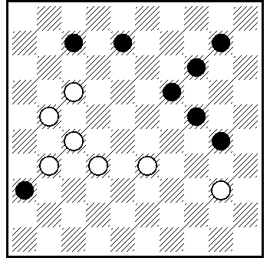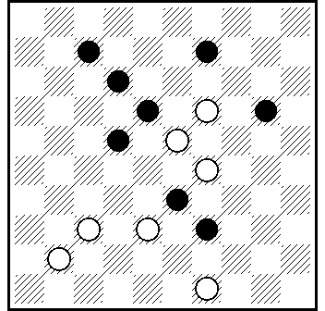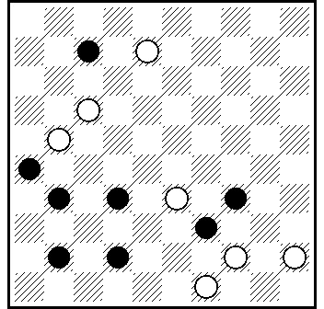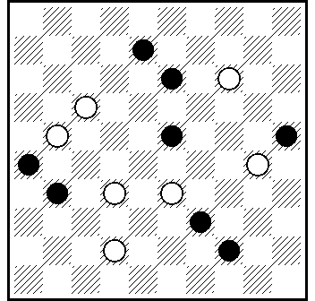
09A 10A 11A 12A

09A] 11.22.34.3 - C.Gerritsen , 1937 (35A)29(24.40)22
(45)50+. A(15)34(30.23)34(28 )29(32)42(20.37)47+.

10A] 14.3(36 A)44.1.35(2)30.40.40+. A(44.11.36.47)23(41)28(46)7(24)1(29.45)44+.
L : 7.9.12.18.20.22.27.28.32.39 = 19.23.29.36.37.41.49 ...(31)38(33)...

11A] 3(50)8 Z(11)40(45 A)44(50B)2.6+. A(17)1.44.6+. B(17)1.6.50+. Z40?(11 Y)= ; Y(6?)29.1(28)44.6(45)1+.

12A] 27.10.4(28 a)49.16(40)22.38 +. a (34)49.16 +.

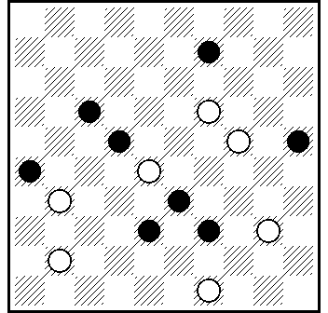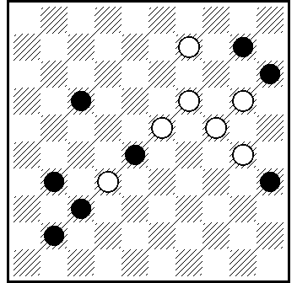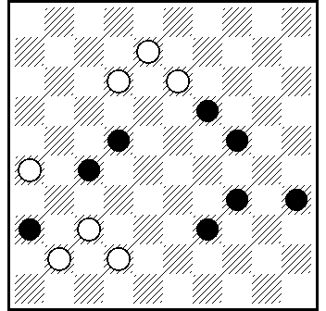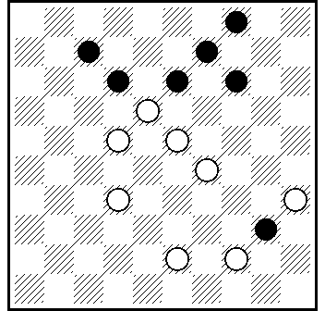
13A 14A [ * ] 15A 16A

13A] 13.4.30.38+.

14A] 19-14(10x19)13.3(15x24 AB)26.15 Z₁.36(33)27(33 C)49+. A (35x24)26.35.46+. B (28)46 Z₂ (15x24D)23+. C(32)31(38)
48+. D(35x24)35+. Z₁= 46? (33)=. Z₂= 23? (15x24)46 (40)=.

15A] 21.43.3(8A)30.2.11.50+. A(17)26.27.22.50+.

16A] 17.10.13.1(32)24(37A)29(20)15(41)23(47)30(36)
41.24.24+. A(38)34(20)15(42)350+.

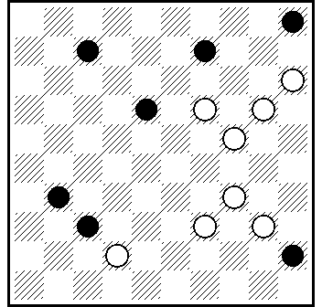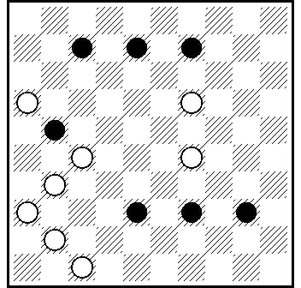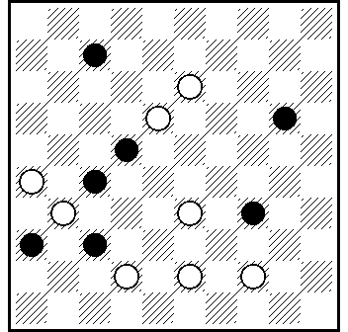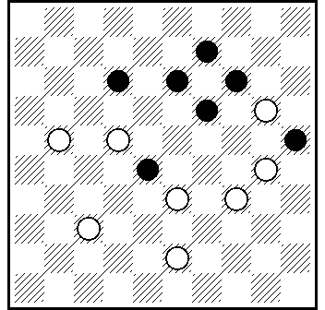
17A 18A 19A 20A

17A] 204.1.10.48(41)37(32)26(38 )48+.

18A] 42(47)11.2.37.47.4+.

19A] 8(50)2(13)18.27.37+.

20A] 24.217.10.4+.

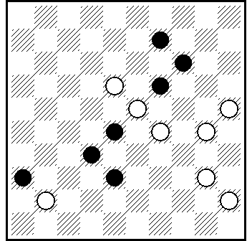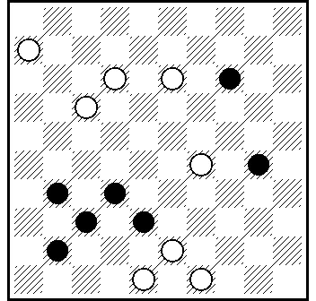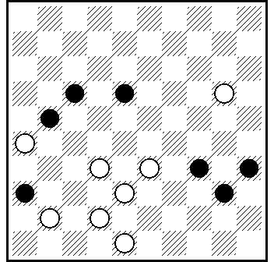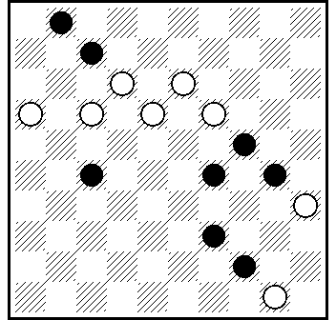
21A 22A 23A 24A

21A] 20.3.47(38 )33.34.34+.

22A] 42.44.24.3.27.26+.

23A] 27.30.21.45(20)40(24)34+.

24A] 9.33(18A)7(12A₁)3.23.39+. A (28)39.7.33.3(23)18+.
A₁ (28)39.33.3(23)18+.

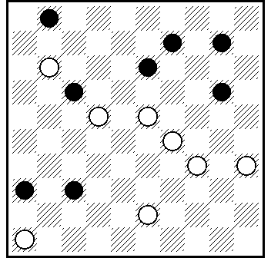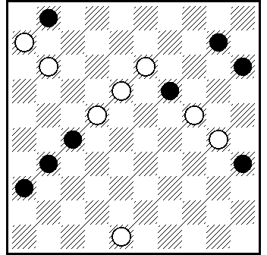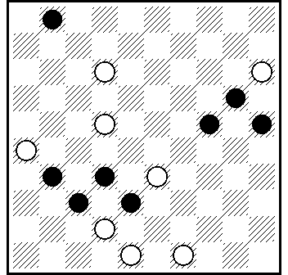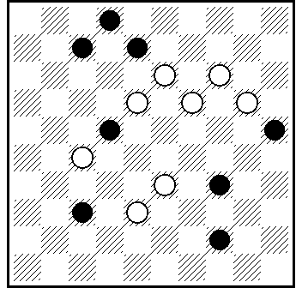
25A 26A 27A 28A

25A] 340.304.4(7.42)19(48)31.37.37+.

26A] 7.1.4.20.26(41)37.42+.

27A] 18(47)393.7.42.30.44+.
L : 1.14.20.24.25.31.37.38 = 12.15.22.23.26.28.33.42.48.49 ...19(32) ...

28A] 32,12,12.49+.

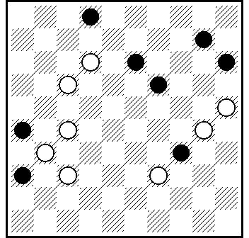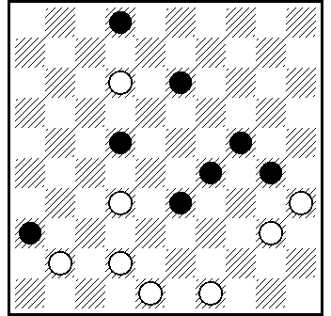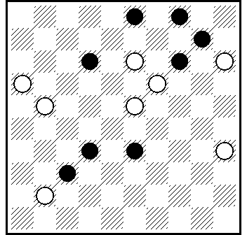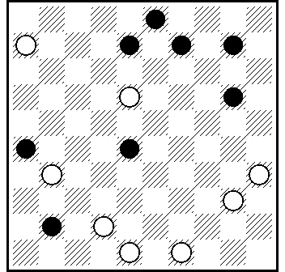
29A 30A 31A 32A

29A] 24.250.7.9.4.49(271 A)35.47+. A(34)16(40)11+.

30A] 27.9(304)44 Z.40.4(339 A)8.50(40)44(34)45(29)50 Z₁(33)45(349)43.43+. A (8)3(339)12(383)15(49)23.44.44(22)
42(27/28)37/38+. Z 4?.8.50(34)483(42)439.47(29)30/42(33)=.
Z₁ 44-40? (43.33)+.

31A] 9.4.17.9(3x14 A)15.24.24+. A(5)30.10(20)46(25)24+.

32A] 37.493.42.34.2(37a)19(32b)1(8c)2(42d)16(37)43(41)182
(48efg)39.46+. a(38)1(33)182(9)11+. b(33)41(39)28(43)1+. c(38)41(43)28(8 )39.13+. d(38)16(382)182(41)43(417)48(36)
31+ ; (41)24(37)47(46)41+. e(427)38.46+. f(46)32.47+. g(417)48.

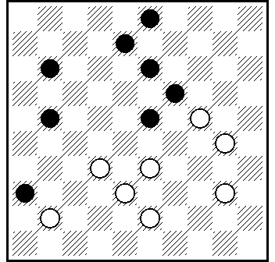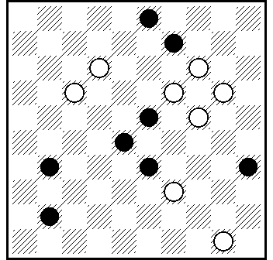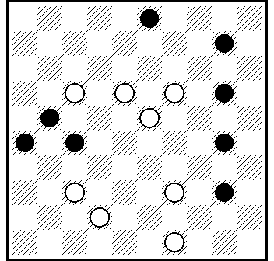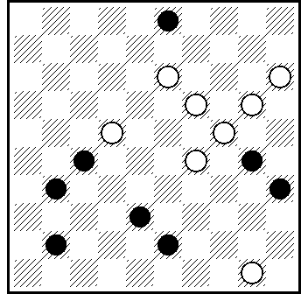
33A 34A 35A 36A

33A] 39.29.9.2(46)5+.

34A] 8.3.46.5 Z (49A)44.20.45+. A((40)39(45)20.28.6+.
Z 39?(33)28(40)= .

35A] 183.9.31.44.4.31(29A) 9(34)3(40)17.50+. A (28)9(32B) 3(18)9(23)20...+. B (33)3(18)9(23)14(28C) 32(39)49+.
C (29)20(34)38(40)33.50+.

36A] 9.14.4.40.48+.

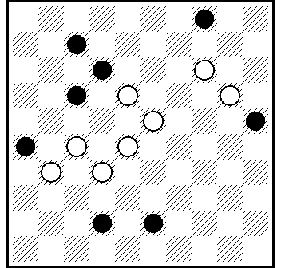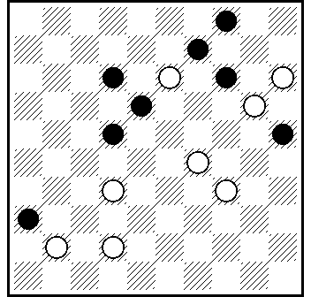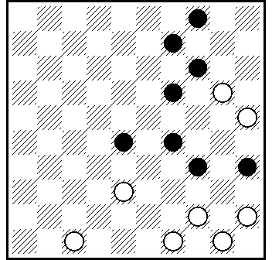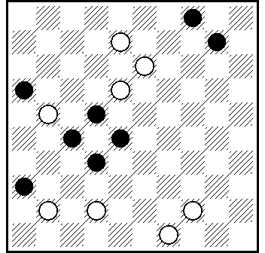
37A 38A 39A 40A

37A] 9.22.2.38+.

38A] 30 Z.8.10(32)5(38A)23.14.42+ A(10)22(38)32+. Z 42-37? (19.14)=.

39A] 32.42.43.13.9.20(22)15(28)10(33A)4(19)10(349 a)32
(40.38)44.28(45)50+. A(39)4(19)10(33 B)32(40.38)44.28(45)
50+. B (23)5/14(33)32(40.38)44.28 (45)50 +.
a (24)15(29)20(349)15+.

40A] 2.44.9(22x13 A)36(27B)22.15(37)47+.
A(4x13)44.15(31)10.26+. B(13)15.42(31.38)48+.

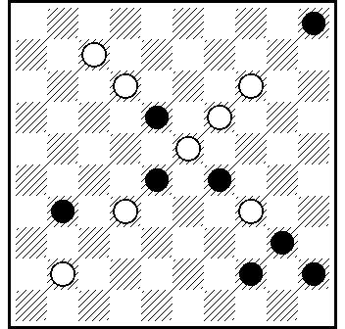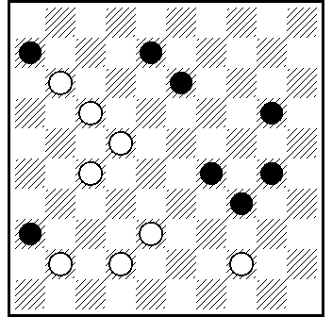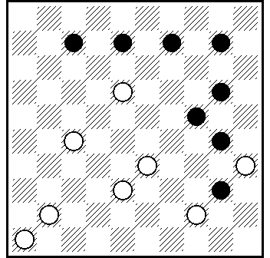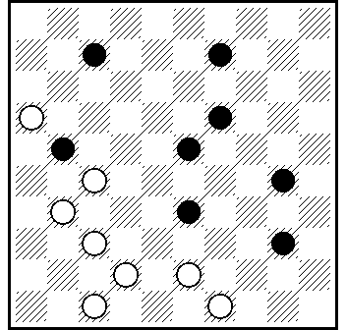
41A 42A 43A 44A

41A] 10.14.143.1.36.20.50+.

42A] 18.39.12.3.33(37)47+.

43A] 29.11.37.48+.

44A] 44(38)41.11.2.3+.

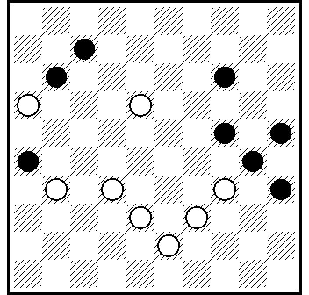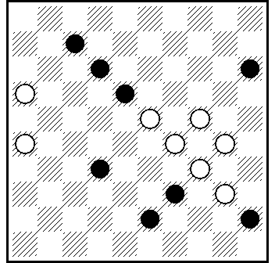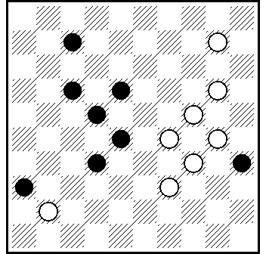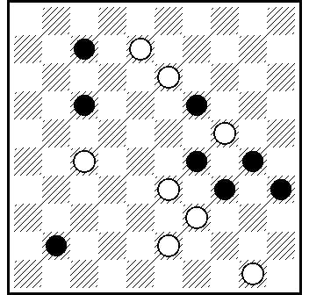
45A 46A 47A 48A

45A] 12.1(20)7(33)29.39.29. 2 (40)45(35)30(34)15+.
L : 7.11.13.14.21.24.25.30.35 = 16.23.27.31.32.34.38.39.43 ...18.18(26)...

46A] 20.21.17.40.1.25+.

47A] 23.15.4.43.34.30.2.11(45)50+.

48A] 22.2.44.3.49.30.46+.

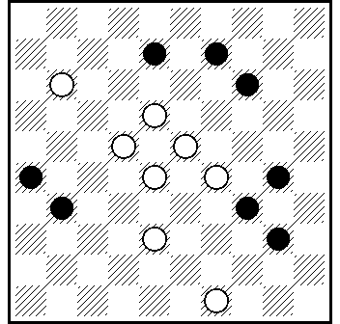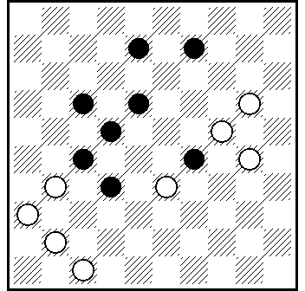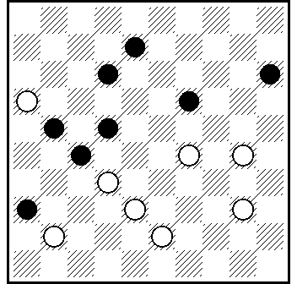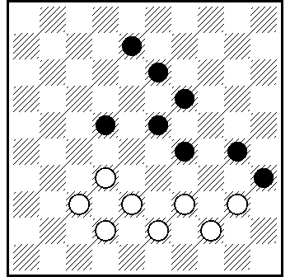
49A 50A 51A 52A

49A] 13.24.44.7.37(42 A)2.36+. A(28 )2.36+.

50A] 25.42.15.23 Z(21)37.47.18.10(19)5(24)32(26)38(30)43
(35 A)34(31)23(40)45 (37)23(361)36(42)37.27 +. A(31)25(37)
14(361)36(42)37.27 +. Z 21? (16)10(38)4(42)27.4x27.37.18
(21) =.

51A] 33.7.20(47)1(15х24)45.3+.

52A] 328.37.9 (13/294)18/29 (294/13)29/18 (23)12.7(340)
1.33.25+.

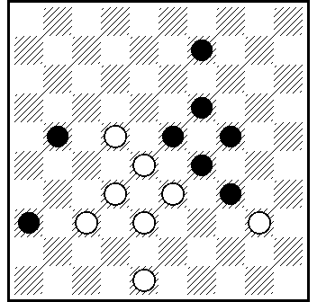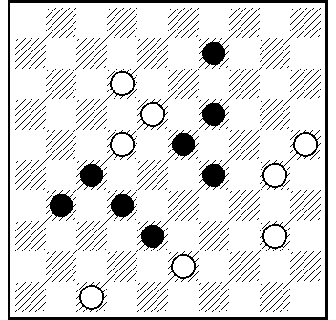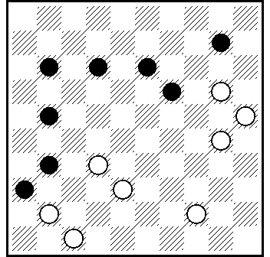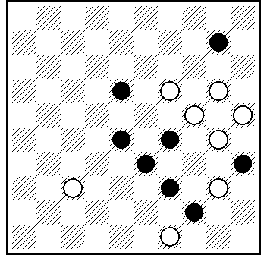
53A 54A 55A 56A

53A] 31.27.30.4.40/35+.

54A] 20.8.3.4 via 29.38.38+.

55A] 42.37.8.14.5(24)19(18 )35(23)44(16)40(28 )49(33)43
(21.39)49+.

56A] 13.15.3.4.43.26.30.15(29)20(34)38(40)33(45)50+.

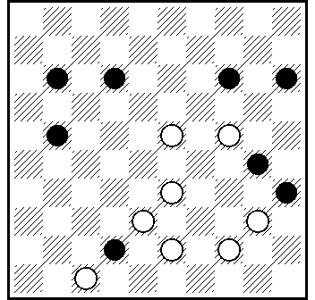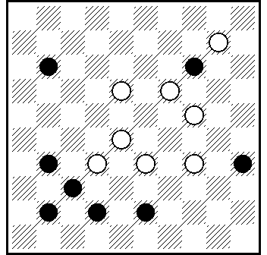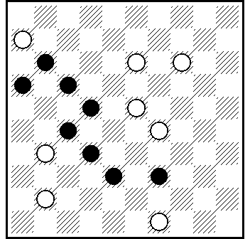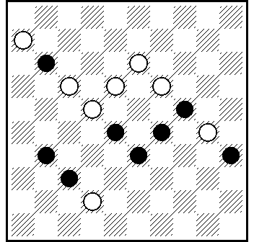
57A 58A 59A 60A

57A] 239.439.29.18(20)12(204a)8 Z(29)3(33)25(38)48(23)404
(28)44-39(43)33.25(40)39(45)50+. a(23)8(28)3(32)25(37)20
(41)39.36+. Z 34?(23)8(28)3(33)21(29.39.40)=.

58A] 22.17.4.49+.

59A] 44.42.21.37+.

60A] 172.2.39(48A)304(8 )26(40)17(45)50+. A(24)30.25(30 B)
36+. B(34)26(33)21(39)49+.

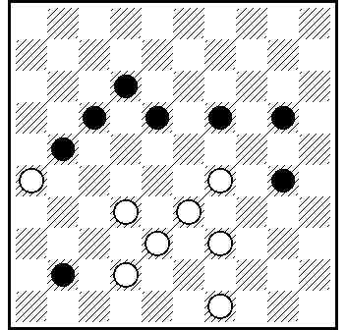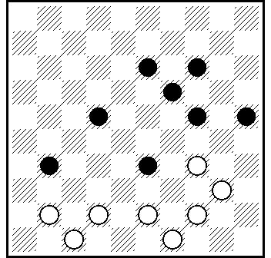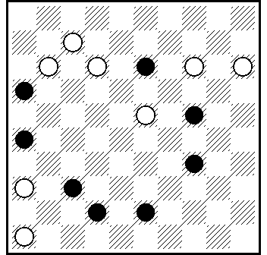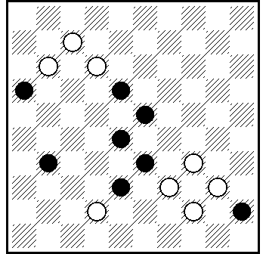
61A 62A 63A 64A

61A] 24.11(46)8.34(39 A)33.38.38+. A(43)38.33.38+.

62A] 30 Z.449.40.39.38.37.29+. Z 29?(37)27(50)=.

63A] 41.8(5)37(46)10.31.1.46+.

64A] 37.29(453)40.32.1.50+.

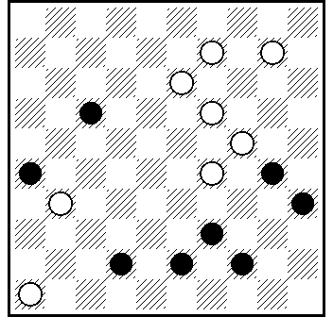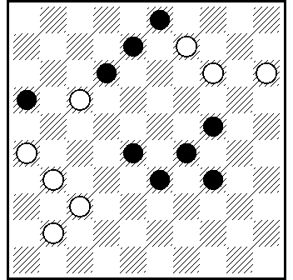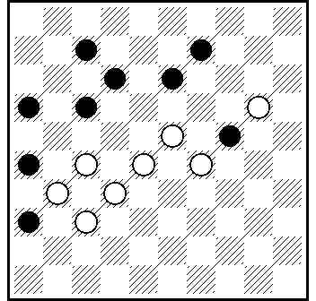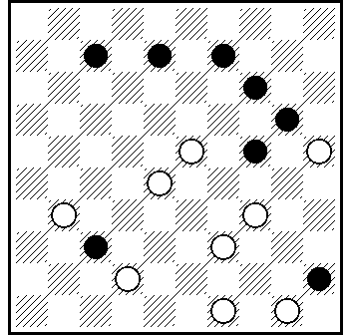
65A 66A 67A 68A

65A] 5.41.3.5x40.30.34(38)48+.

66A] 32.21.15-10.5.26.47+.

67A] 21(16-38A)14.3.18.16(31B)26(42)27.48+. A(36-38)
14.3.18.16(31B)26(42)27.48+. B(42.31)42+.

68A] 19.1(48)504.349.37(42A)1-40.39.47+. A(48)43.6.50+.

categorie B / категория B

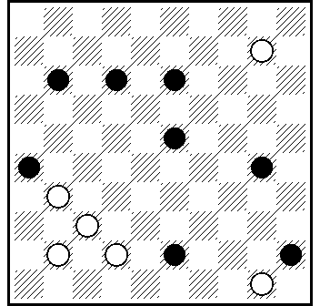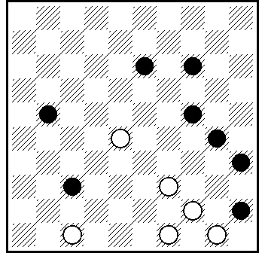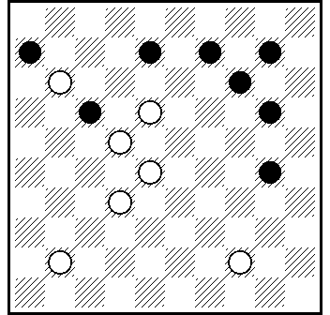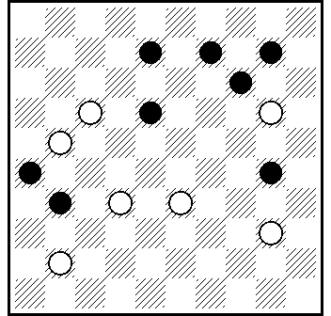
01B 02B 03B 04B

01B] 38.6.5(34)1(39)44.6+.

02B] 42.22.17.40.7(34)1(39)44.6+.

03B] 23.40.35.2(46)12.5+.

04B] 27.15.2(35)16.49(50)21.5+.

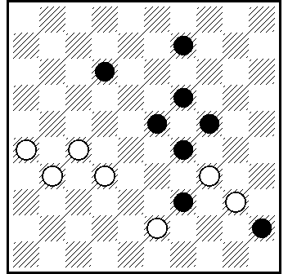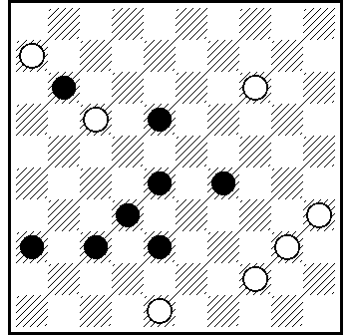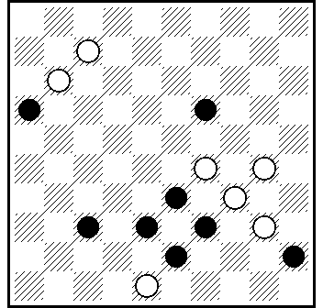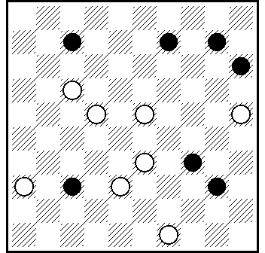
05B 06B 07B 08B

5B] 28.3(48)8.2.48+.

06B] 39.33.34.31.1(28)29(37)47(272a)10(38)22(41)36(47)
4(33)42.15+. a(33)15(41)42(46) 150(32)38.5.49+.

07B] 2.31(7)18.50(34 AB)1(39)44.6+. A (35.40) 6.39.393/34+. B (12)1/7(34.34)44+.

08B] 44.11.2(47A)20.15+. A (42)31.20.15+.

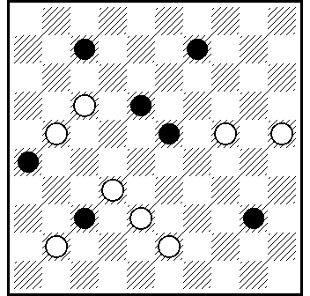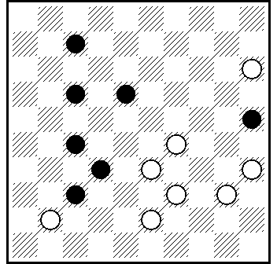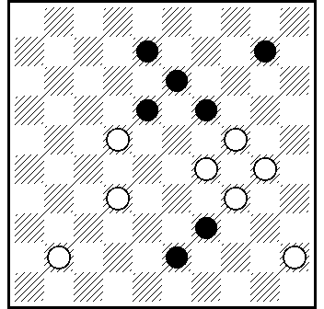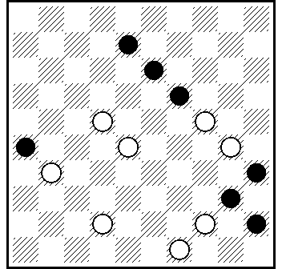
09B 10B 11B 12B

09B] 12.39(46A)34 Z.1 - L.Tevan , «L´Express du Midi» , 1938 - 6(182b)32(46)5+. a(28 )34.5+. b(46)32+. Z 33? 11(45)=.

10B] 30.38.1(28 AB)41.150+. A(22)40.29.10(29C)4(28 )10
(283)15+. B(29)40.29.10+. C(27)4(32)15+.

11B] 23.19.2.40.5+.

12A] 43.18.2.6+.

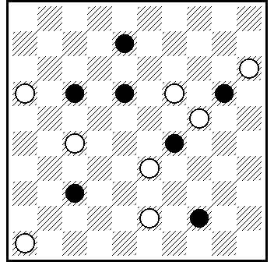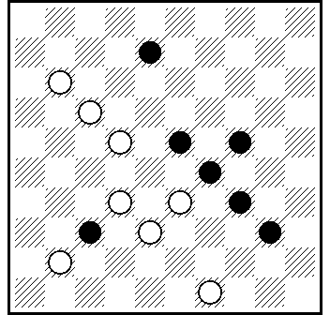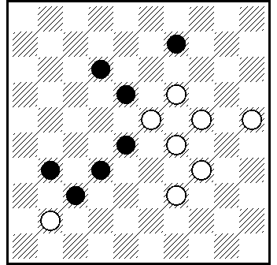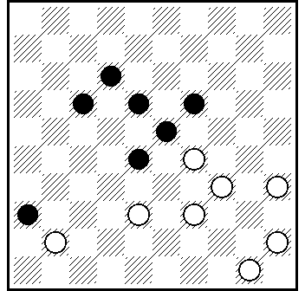
13B 14B 15B 16B

13B] 11.2(16)10.41.5.49+.

14B]27.44.12.2.5+.

15B] 14(10a)23(40b)34.3.5+. a(30)3.35+. b(20)3.5+.
L : 1.9.12.18.31.32.37 = 16.19.23.24.25.28.29.34.39.46 11(6)41(17)22(28) ...

16B] 39-33.11(47)7(1 A)6(23)40.1+. A (6)1(28 )44.6+.

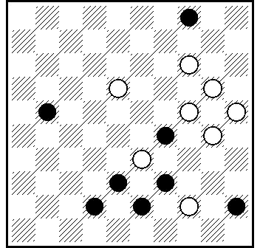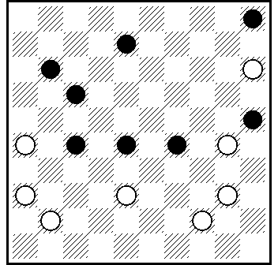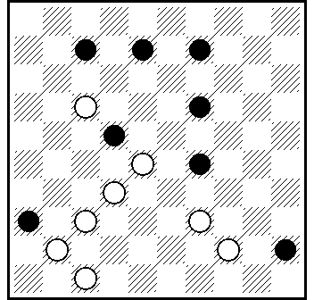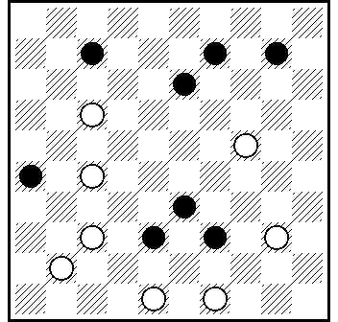
17B 18B [ * ] 19B 20B

17B] 9.14.24.3.6+.

18B] 10.31.21.3.6+.

19B] 27.38.34(6)1.6+.

20B] 483.21.43.11.2.5+.

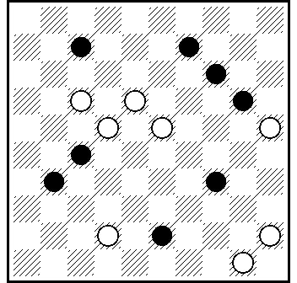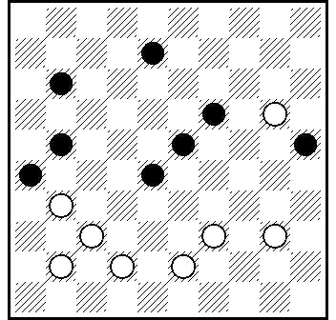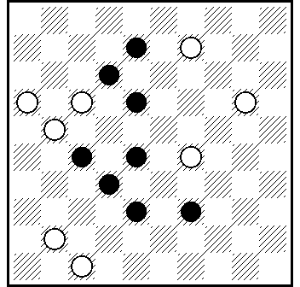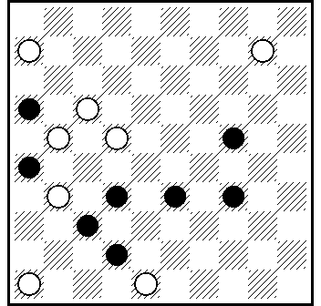
21B 22B 23B 24B

21B] 38.19.3.1(39)44.6+.

22B] 32(28x46)35.34.2.5+.

23B] 14(46)42.16-11(7)9-3(47x9)16.5+.

24B] 12.41.19.1.46+.

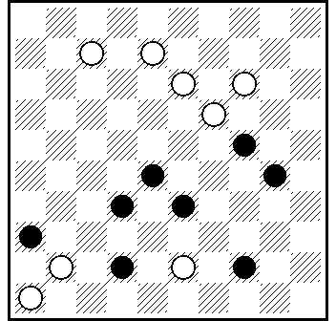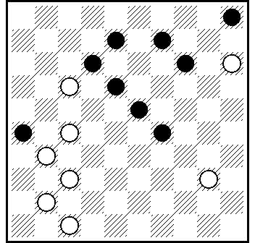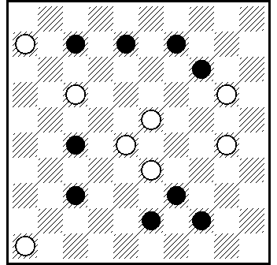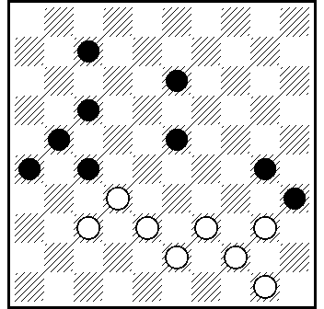
25B 26B 27B 28B

25B] 7-2.38.41(25A)3.48+. A(20)3.47+.

26B] 34.10.14(28 )4.9(4)36(5-10)31.4+.

27B] 19(34a)12(18b)41.14(5A)1.46+. A(10)1.5(33)32(39)49+. a(32)1.50+. b(17)41.14.1+.

28A] 31.32.394.2.16+.

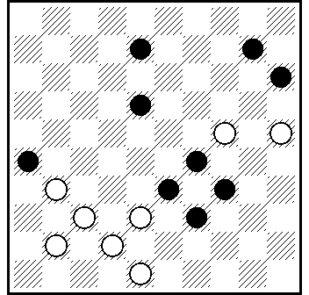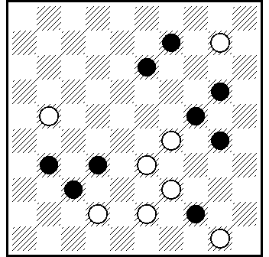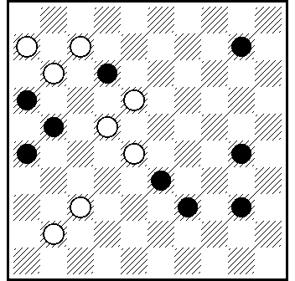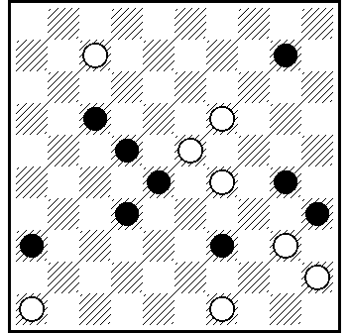
29B 30B 31B 32B

29B] 372(46A)43.250.2.5+. A(28)43.250.2.5+.

30B] 4.34.3.37.48+.

31B] 31(46)6-1.2.44.6.5+.

32B] 44.2.41.193(28x8 A)15.6+. A(47x8)5.6+.
L: 8.10.12.17.26.28.30.32.35.36.37 = 9.19.21.23.29.43.44.45.
46.48.49 ...(13)7(22)440(17)42(39) ....

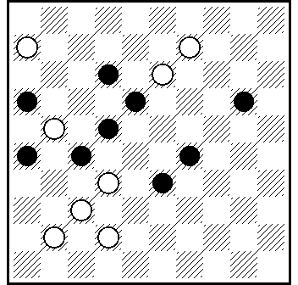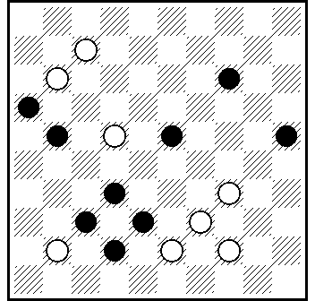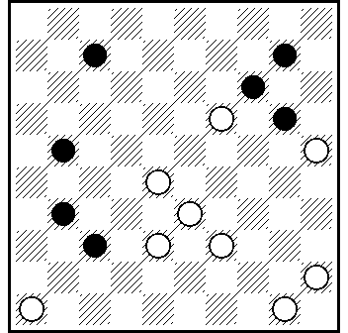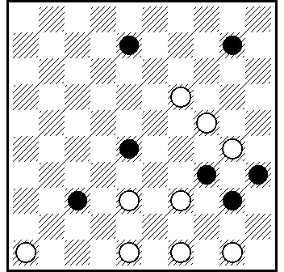
33B 34B 35B 36B

33B] 38.1(17)21(27)3.4(36)15.36+.
L : 1.12.16.18.20.22.36.38.44 = D2. 6.7.9.11.13.26.27.29.31.32.
34.35.37.40.43.46.47.49 ...461(17)261(12)117(26)350.21(1)7(12)42(36x27)44...

34B] 30.1.45(46A)17(12B)1.5+. A(7)1.17.5+. B(7)1.5+.

35B] 41.5.28(23A)1(39)44.6+. A(19/14/10)40+.

36B] 41.494(46A)42.44.38.14.2.5+.
A(49)44(46B)42.38.14.2.5+. B(40)43.38.14.2.5+.

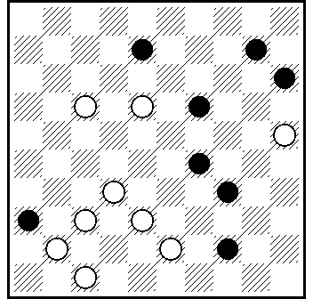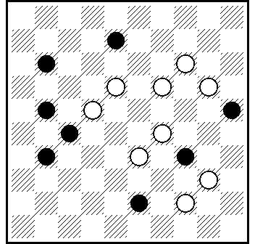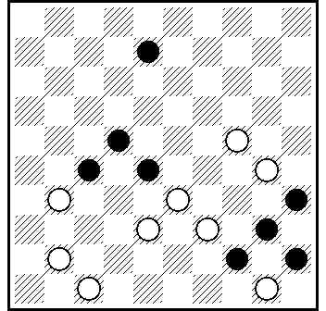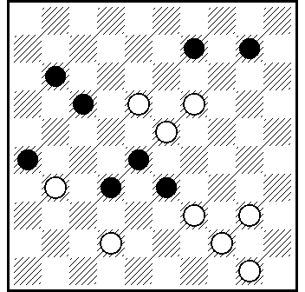
37B 38B 39B 40B

37B] 42.33.2(46)39(43 A)20.5+. A(33)20.5+.

38B] 23.19-13.13.3.6+.

39A] 29.38.44.23.2.6+.

40B] 14.3.4.10(1)6(23)40.1+.

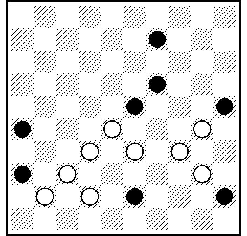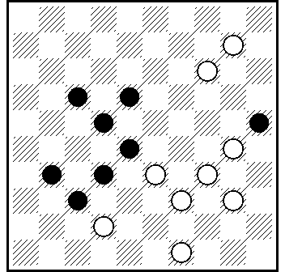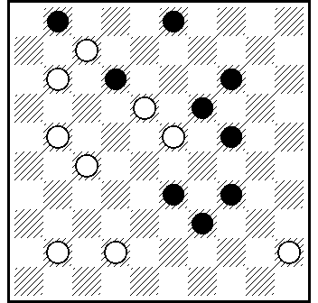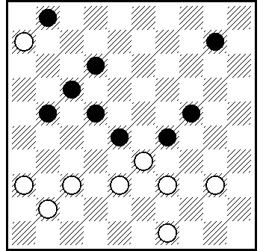41B 42B 43B 44B

41B] 27.31.3(37a)34(50)34-1.6+. a(25x34)29.39(50)6...+.

42B] 5.34-29.37.44.6+.

43B] 6.17.40.9.1(37)48.38.5+.
L : 1.3.12.14.19.24.27.28.31.32.33.34 = 7.11.18.23.36.41.42.
43.50 ...45(328)431(339)27(283)...

44B] 404.29.7.34.1(34)16(40)7(45)44(50)11.5+.

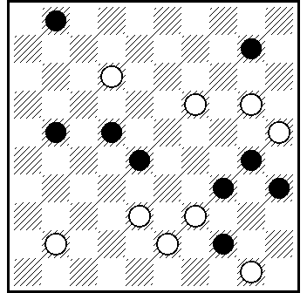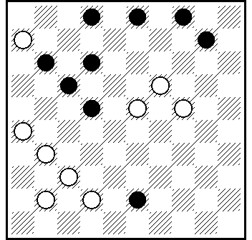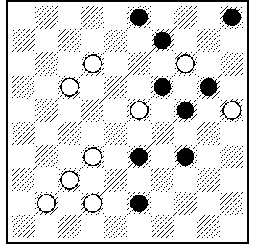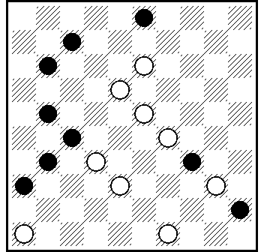
45B 46B 47B 48B

45B] 32.204.5.26(7)1(339)40(48 VP₁)34(44 A)39+. VP₁ (44)25x34(48)39+. A (25/30)48.39+.

46B] 21.8(13A)8.38.8.239.3(4-9)19(46)5+. A(12)38.8.13.3.12+.

47B] 38.8.10.3.5+.

48B] 9.41.12(15/20A)1.29.44.19.6.50+. A(24)9.3.6(34)50(40)43.6.439+.

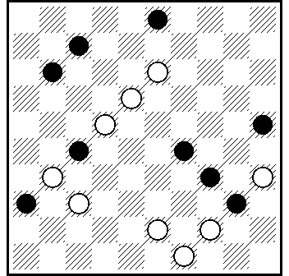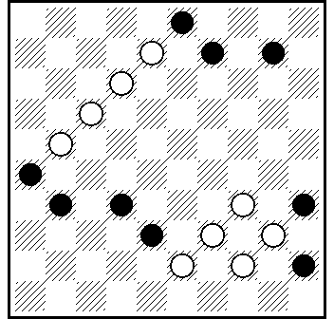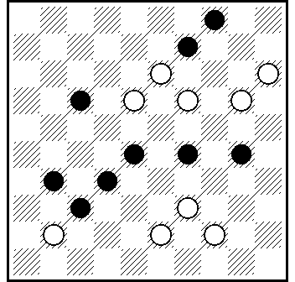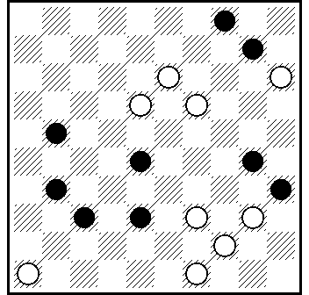
49B 50B 51B 52B

49B] 9.439.38.12(46)1.45.30.5+.

50B] 2.12-8.8.30(43)3 (24)38 Z₁ Z₂ (35 A)49+. A(32)35+.
Z₁= 15? (40 Y₁)=. Z₂ = 48? (40 Y₂)=. Y₁= (35?)15-24(19)24
(37)47+. Y₂= (35?)48-30(13)5+.
L: 3.10.24.26.31.32.35.38.45 = 8.12.13.17.21.23.34.39.40.44.49 ...(29)43(9)…

51B] 33.10.4.26.5+.

52B] 41.33.44.9.4.5 +.

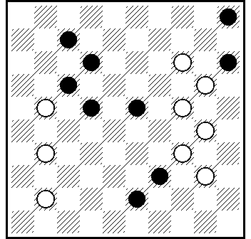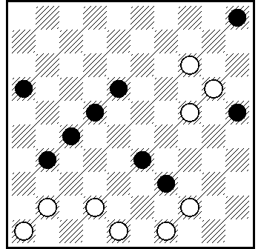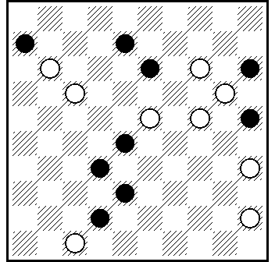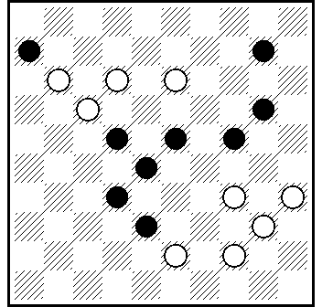
53B 54B 55B 56B

53B] 10.19.8.2.5+.

54B] 19 Z.44.43.21.13.3.21(28)17(32)21(327)26(10)41.5+. Z 483.21.249(23)39(28)15(37)150(42)(272)36 Z₁(47)9(38)34(43)
38(49)= ; Z₁ 149(328)3(10.283.47.22)40(30)14(35)=.

55B] 12(10)3(14)25.48(37)20.30.40.41.5+.

56B] 449.33.19.2.4.49+.

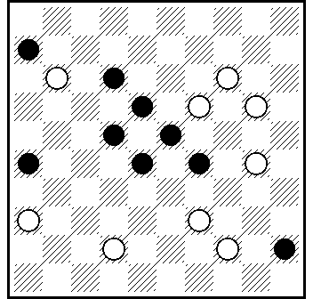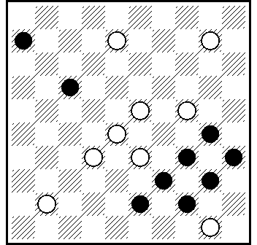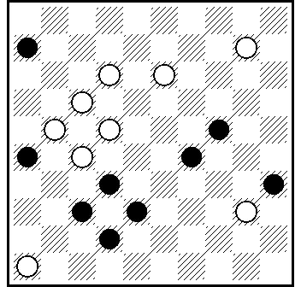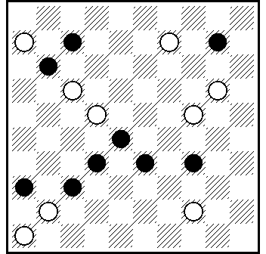
57B 58B 59B 60B

57B] 31.33.8.2.13.3.6+.

58B] 22.11(17 АВ)2(5 С)8.30.46+. A (5)3(17 D)49.30.46+. В (28)30.2.14(21)5.16+.C (28)30.14(21)5.16+. D (28)30(17 E)
49.46+. E (24)8.46+.

59B] 11.5.34.48.41.5+.

60B] 14.4.41.4x31x35.1 zz₁(40)49(32)21/27(49)16 +.
z 2(40)49(27)35(22) =. z₁ 13(40)49(32.49)=.

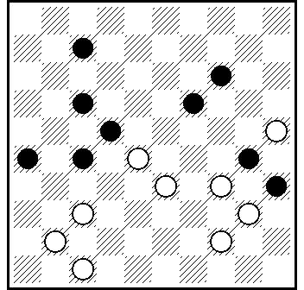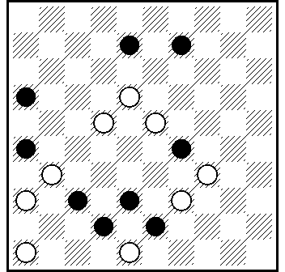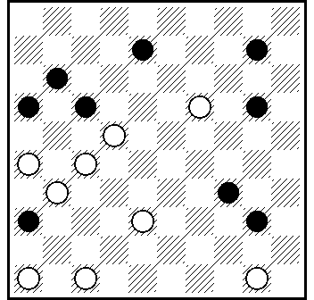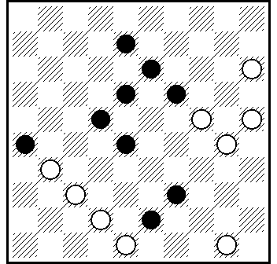
61B 62B 63B 64B

57B] 20.9.31.3.11.41.5+.

58B] 12.3.41.37(5 AB)25.46+. A(10)25.5(42)37.27+. B(32)27.31+.

59B] 271(16x18)461.44.21(46)3.41.5+.

60B] 32(28x37)44.39(20)3.10.4.48+.

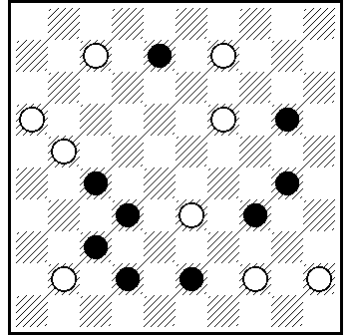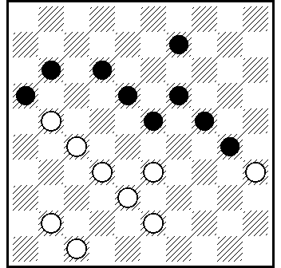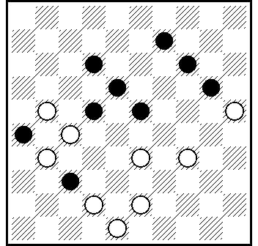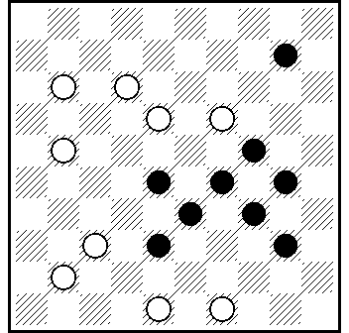
65B 66B 67B 68B

61B] 11.4.450.1.23(50)41(5)4-10+.

62B] 22(18x27)29.4.38.18.5+.

63B] 17.28.438.10.3(25)4.48+.

64B] 44.24.43.127.32.2.5+.

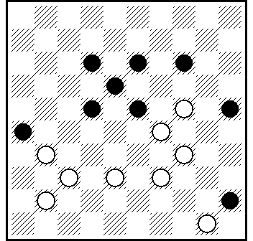
69B

65B] 30 (252 A)10.5.249.1(39)44.6+ . A(232)10.5 ...+.

categorie C / категория C

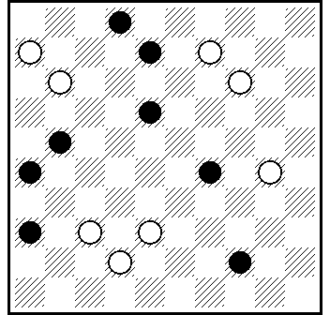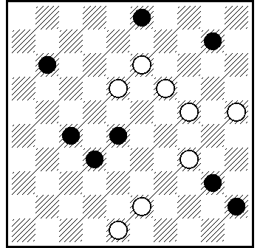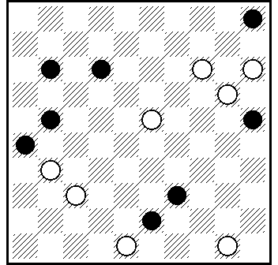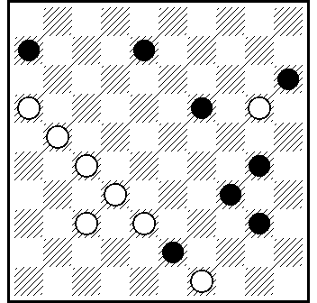
01C 02C 03C 04C

01C] 31.7(25A)33(11 B)26.3.27.37+. A(11)26.33.3.27.37+. B(38)6-1.24(48)30.3.14+.

02C] 9.38.5.40.30+.

03C] 44.39.4.10(20)372.15.4+.

04C] 11.31.44.2.26+.

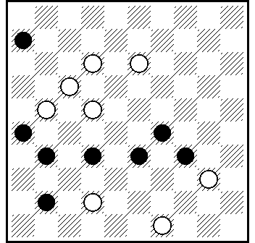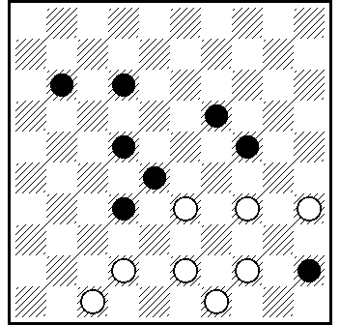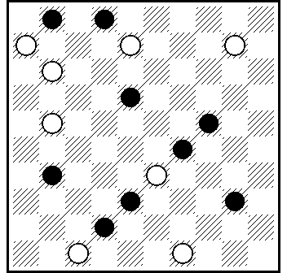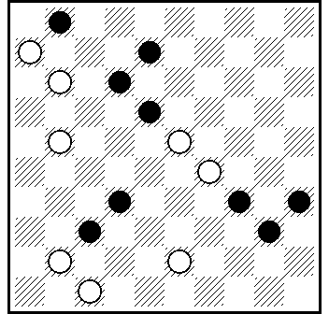
05C 06C 07C 08C

05C] 138.38(43A)38.11.2.50+. A(42)11.2.6(50)494+.

06C] 339.29.40.39.16(33a)38.38(23)11(28)7(29)2(29-33b)29
(32)16(37)38(41)24(47)29(36)18.24+. a(29)11(293)38.38(24)7(29)2(293.32)16(37)+. b(283)24+.

07C] 4.7.17.43.38(27 A)1.49+. A(32)1.49(42)38.27(39)49+.

08C] 7.41.17.3(23)48.1(38A)47(45)438(40)39(50)44.45+. A (45)40(34B)38.25.39.50+. B (44)38.50+.

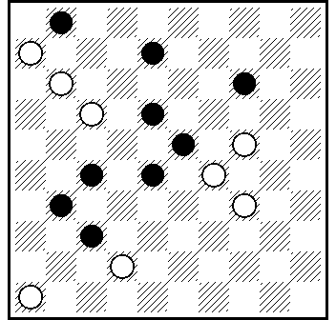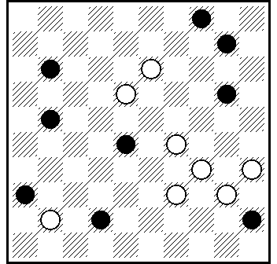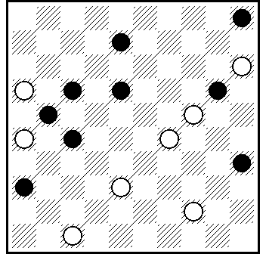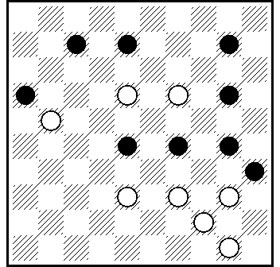
09C 10C 11C 12C

09C] 7.1.12(19)25.37.37+.

10C] 9.33.4.47+.

11C] 41.23.3.11.17.10.7+.

12C] 40-34.34.5.30.44+.

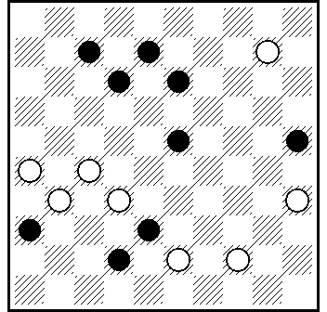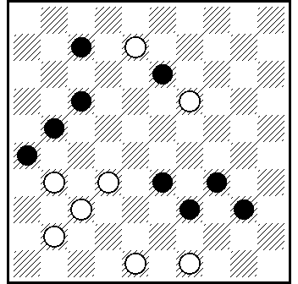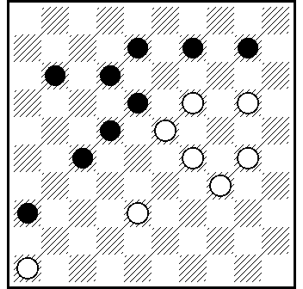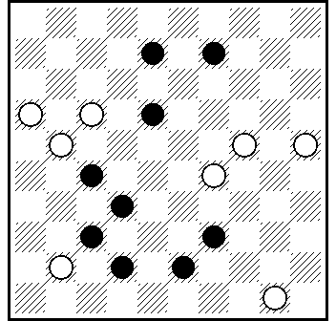
13C 14C 15C 16C

13C] 30.28.17(21 AB)4(34)2.22.50+. A(34)4(27)30.35+. B(27)4(21)48.35+.

14C] 3.43.44.36.2.17.21.27+.

15C] 204.41.304.4.9.35(28)2(32)24(37)47+.

16C] 161.23.1.44.6.5+.

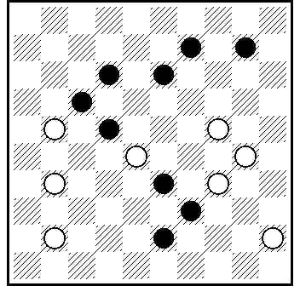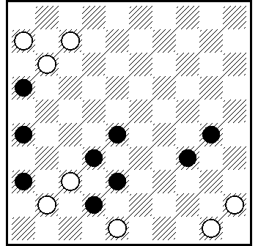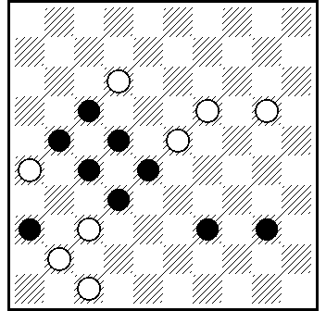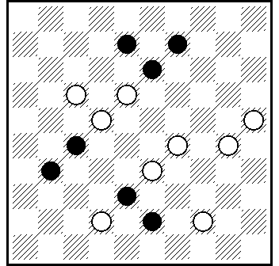
17C 18C 19C 20C

17C] 19.8.40.3.5+.

18C] 31.37.40.2.47(34A)1(39B)44.6.50+. A(35)1.6.39.39-33+. B(40)6.39.39-33+.

19C] 15.17.42.14.4.16+.

20C] 182.39.24.1(28 )34(18 )7(32)16(327)27.31(17)27+.

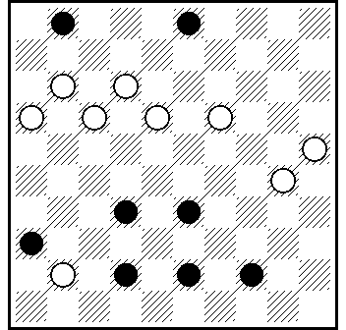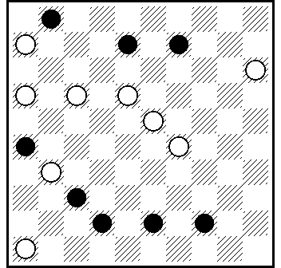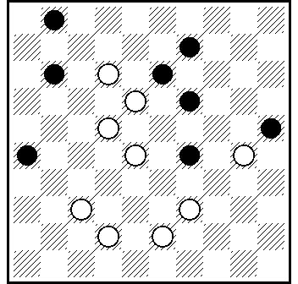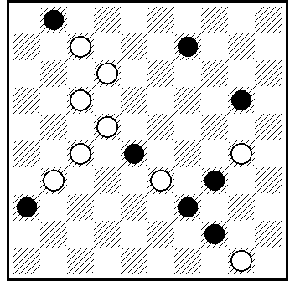
21C 22C 23C 24C

21C] 8.20.7.47+.

22C] 41.10.23.7.1.47+.

23C] 31.7.34.3.16+.

24C] 8.3.4.14.30.30+.
L :1.9.28.29.34.36.39.44 = 7.12.17.22.24.27.31.33.35.50 ...30(20) ...

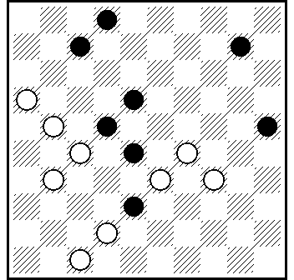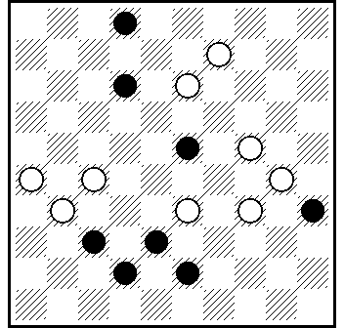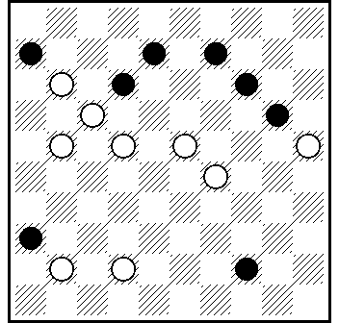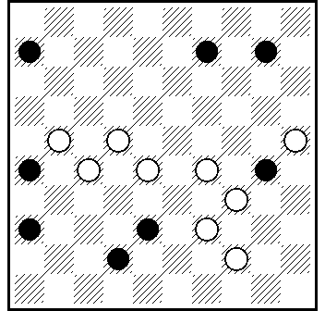
25C 26C 27C 28C

25C] 30(23)41.29.17.21.1(14A)40(19)7.44(16)49(24B)38(30)
43(35)49+. A(39)7.6+. B(23)38(28)27(33)43+.

26C] 261(17 A)3(20 B)25.8(13)22.29(33)38+. A (20)3 - VP - +. B (40)138.22.4+.
L : 1.2.12.25.35.38.42.43 = 9.11.13.19.22.24.26.27.29.30.31.32.
33.34 ...(6)20(37)294(23) ...

27C] 16.19.3.27.22.27+.

28C] 33.24.5.11.37.47+.

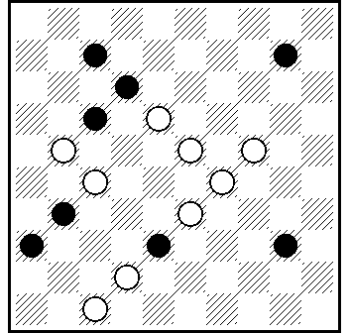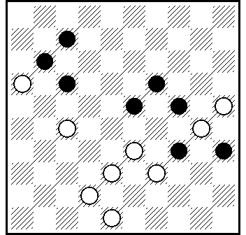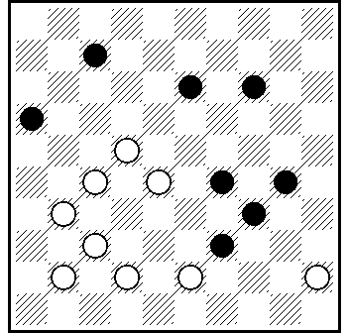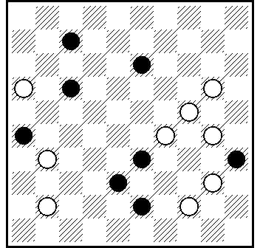
29C 30C 31C 32C

29C] 41.18.1.29.35(39)49+.

30C] 21.1(38)20.7(47)2(24)42.24.14+.

31C] 428.21.40.23.1.50+.

32C] 39.23.11.2.25(38 )48+.

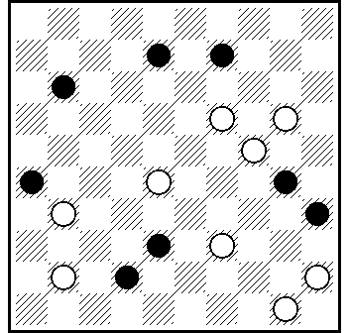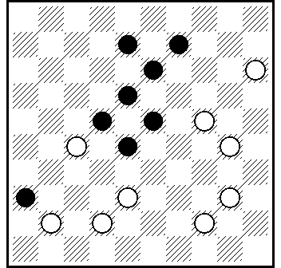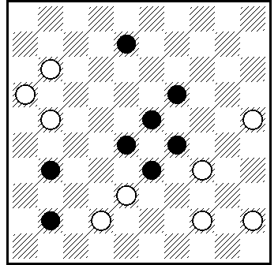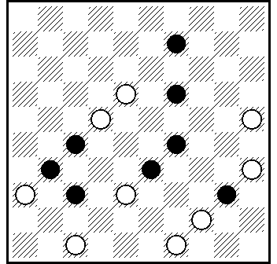
33C 34C 35C 36C

33C] 13.4.31.48.16(42)38.40.28+.

34C] 19.39.29.10.5.13+.
L: 1.8.9.13.18.22.23.36 = 15.16.21.24.27.30.31.37.38.40.42.
44.47 ...11(6)41. 372(28)...

35C] 32.7.11.2.34.34.34+.

36C] 43(42A)38.32.30(38B)13.24.43(37)38+. A(49)32.30(38)
13.24.43(37)38.38+. B(32)13.24.21.38(21)32(26)27+.

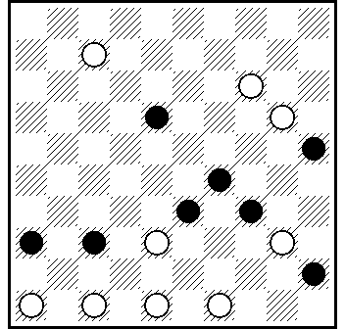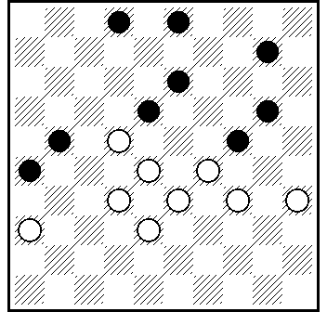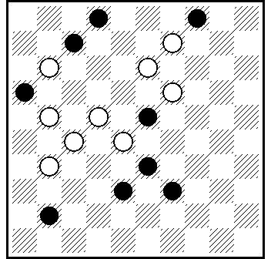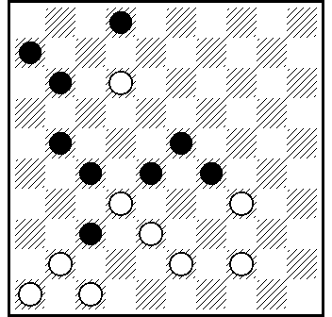
37C 38C 39C 40C

37C] 482.461.38.2.13.3.6.43.44(40)35(33A)30(38)48+. A (34)
44+.

38C] 340.8(13)22.23.4(27)31.30(9)24(13)20(19)15(23)10(29)
4(34)10(39)32(44)27(50)33.27 +.

39C] 8.227.8.9.2.46+.

40C] 8.42.3.16.37.37(31.11.11)21 +.

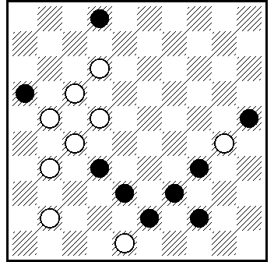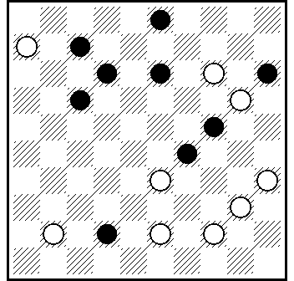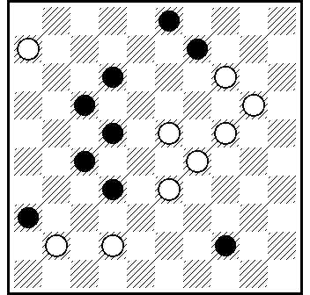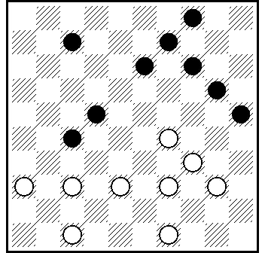
41C 42C 43C 44C

41C] 8.42.29(23)11.7.2(22 A)2x30x16(29)7(33)16(39)11(43)
48+. A(31)2x3026(29)3+.

42C] 30.8.37.9.1.9.35.44(19)39(23)33+.
L: 3.7.12.13.15.17.23.24.42 = 6.14.25.33.35.40.41.43.44 ...20(239) ...

43C] 38(47)18.1.8(12)33.15.24 +.

44C] 372(11)21(16)35 Z.32.42.43.340.8(13)10.30(28)38(25)24
(20)15(30)10(34)5(39)32(44)27(50)33.27+. Z 23? (27)1 (30)25
(32) =.

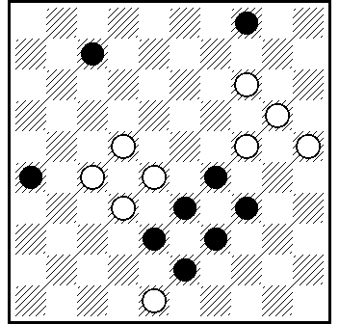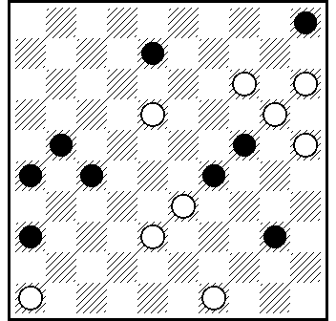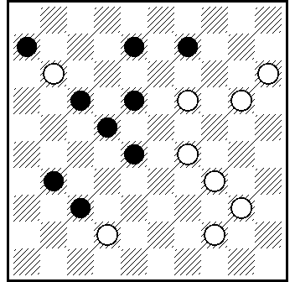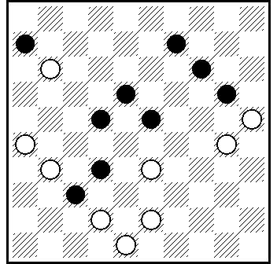
45C 46C 47C 48C

45C] 42.21.2.44.28.20(29)39.9.35(39)49+.

46C] 41.44.12.3.4.31.24.14+.

47C] 10.5.14.1.44-40(29)40(28)49(33)43(21A)16(39)49+. A(22)16(39B)11(43/44)48/50+. B(28 )43+.

48C] 21(26)28.438.10.3.4.48+.

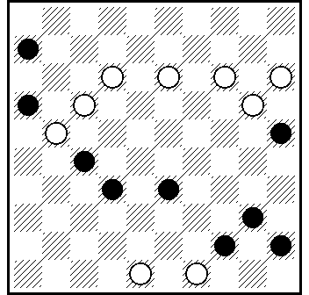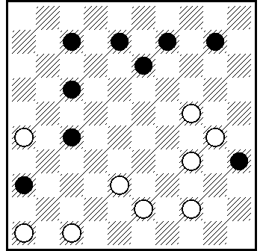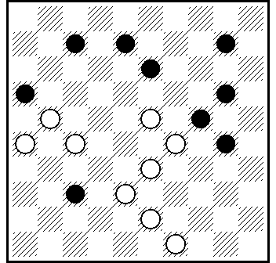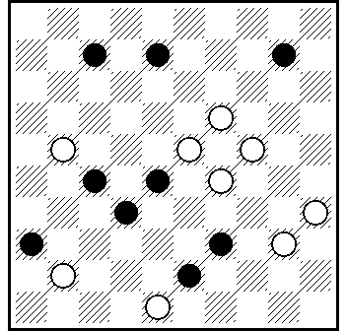
49C 50C 51C 52C

49C] 11.4.36.38.50.40.44+.

50C] 471.19.21.3.41.5+.

51C] 32.22.3.5(25)43.37.37+.

52C] 20(47)15.4(19)1.404.2(49)43.11.42+.
L : 8.10.16.27.28.32.36.39.43 = 17.19.21.23.24.29.35.40.41.48 ...11(7)...

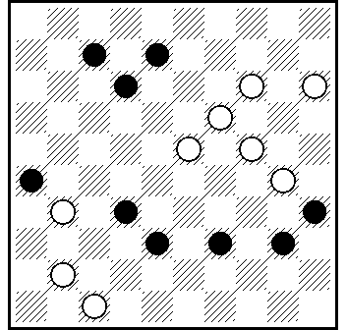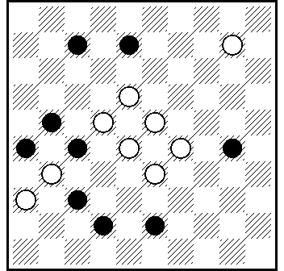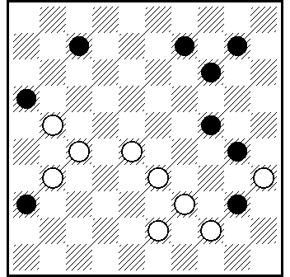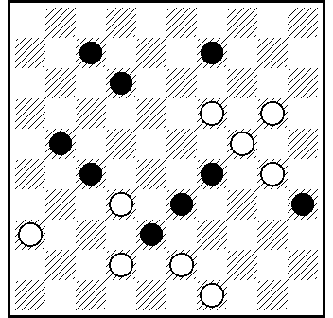
53C 54C 55C 56C

53C] 18.193.4.42.15.5+.

54C] 13.27.24.1.48(47A)31.27.27+. A(31)27(47)21.36+.

55C] 272.34(168 A)1.22.13(19)354(30)35+. A(368)1 ...+.

56C] 44.204.3.44.15+.
L : 1.9.12.16.18.29.33.35.38 = 7.11.19.20.21.24.27.30.32.41.43.
47.49 ...217(12х21)272(18х27)416.472(16х7)...

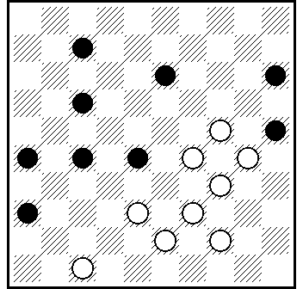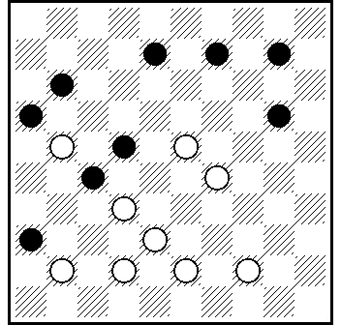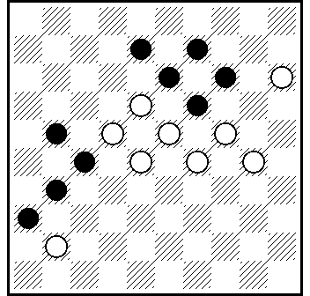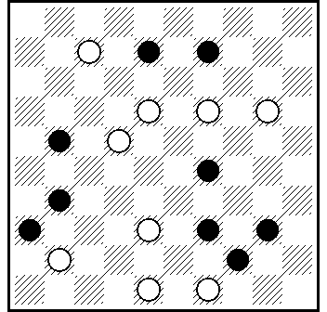
57C 58C 59C 60C

57C] 41.23.1.18.48(20)42(25)48+.

58C] 33.24.2.35(28)2+.

59C] 12.20.1.23.24.24+.
L: 1.9.13.14.19.21.27.31.36 = 11.12.15.18.22.23.24.28.30.34.46 ...29(6)41( 8 )...

60C] 12.194.3.45.40(24)2(35)16(44A)49(50B)44.39+. A(49)34.483.25+. B(35)450.35/40+.

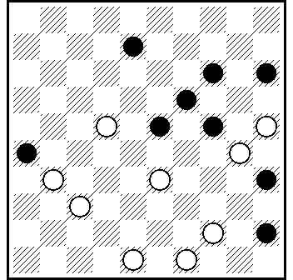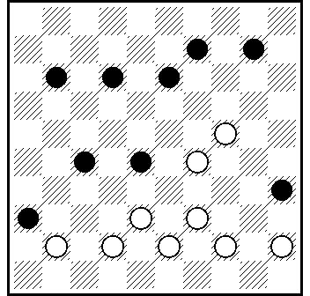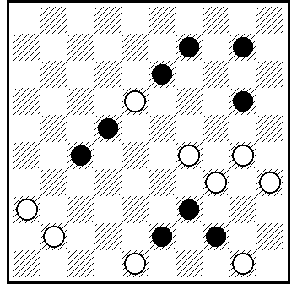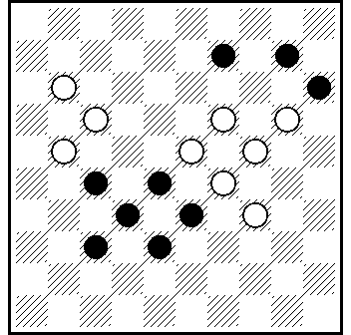
61C 62C 63C 64C

61C] 18.29.483.40.39.9(23)27(29a)22(17b)11(33c)7(12.39)
4(43)12 Z (49)7(44)2(28)24(46)250(5)31.35.46+. a(17)22.3+. b(33)31.3+ ; (34)3(13)17(39)11(20.19.43)16(49)17(44)12(39)
12-8-3(22)12-7-1+. c(34)3+ ; (13.34)7(40)2(45)11+. Z 13?
(31.43-49-32)=.

62C] 440.40.32.3.6+.

63C] 31.27.8.13(43-49A)39.9.39+. A(44-49)39.8.39+.

64C] 13.4.13.31.12.42+.

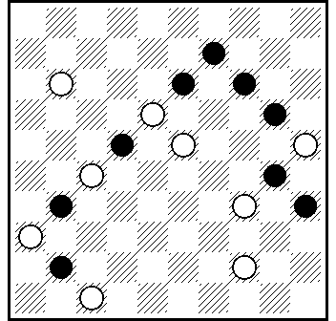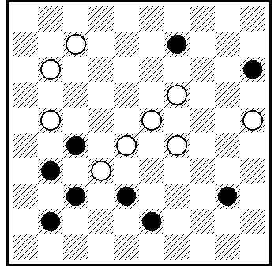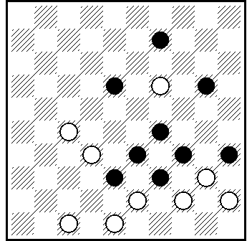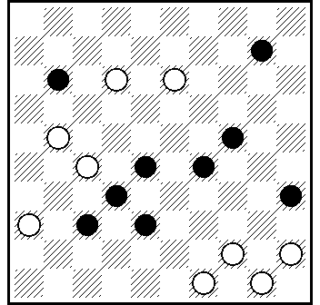
65C 66C 67C 68C

65C] 40.19.3.2.27(46 A)41.50+; А (50)36.11.27+.

66C] 20.18.1.49.3+.
L : 4.15.27.31.37.38.40.41.43 =10.14.16.17.19.21.23.25.28.29.
32 ...171(20)7(15)11(9)...

67C] 13.4.14.23.22.43.38+.
L : 2.7.16.20.29.33.34.38.39 = 8.11.13.17.18.19.23.27.
32.35.40.43.45.47.48.49 ...18-12(7x9)44.30(35)19(7)12(18) ...

68C] 31.43.5.30.44+.

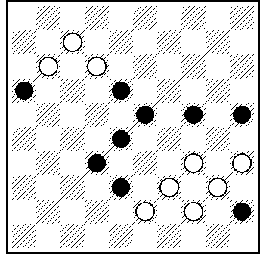
69C

65C] 8.350.29.3.8.30.2.35+.

categorie D / категория D

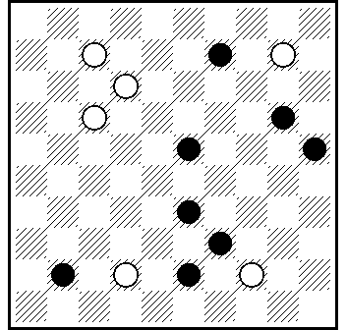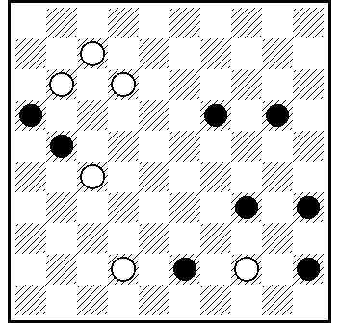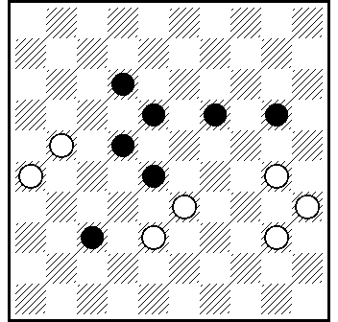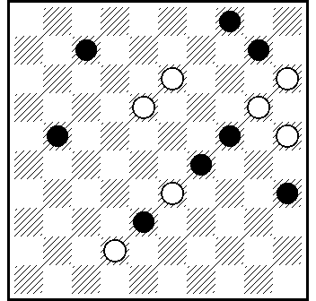
01D 02D 03D 04D

01D] 4.49.7(16A)428.46+. A(11)37.7/2+.

02D] 1.48.40(44A)38.50+. A(34)25(40)39(45)50+.
L : 16.19.20.21.23.34.35.45 = 7.11.12.27.32.38.42.44 ...28(23x43) ...

03D] 25.23.32.17(21A)17.34.22(16)17+. A(11)34.22(16B)17.
17+. B(12-17)18(22.17)27-21(22)17.21+.

04D] 9.4(47 A)30.24.14+. A(15)2.24.14(40)11(45)50+.
L : 1.4.10.21.22.24.29.31.32.35.38 = D2.11.13.15.20.25.33.
41.42.47 ...(7)417(41)18.11(7) ...

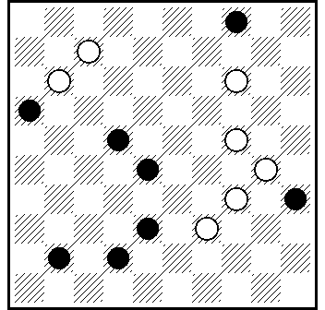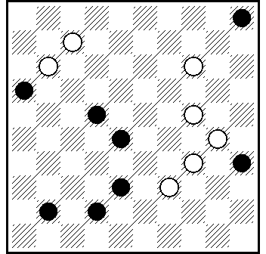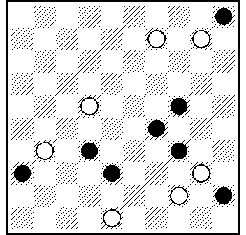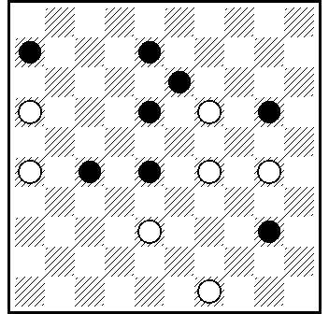
05D 06D 07D [ * ] 08D

05D] 9.33(40 A)1.4(45 BC)19.50+. A (20)29.1.25(32)20(37)
47+. B (32/33)19.35+.C (44)19.50+.

06D] 10.33(40 A)19.1.45(32 B)29(37)47+. A(20)29.1.15(32)
42(19)15(37 C)10+.B (33)34(38)48+. C (23)20(28)42+.

07D] 3.43(14A)39(34B)27.35(33C)30(38)48+. A(49)25.19/2.
35.44(40)35(33C₁)30(38)48+. B(49)25.35+. C (34)44(40)35+. C₁(34)44(40)35+.
L: 5.19.24.29.34.36.38.45 = 9.15.17.18.22.27.31.40.44.48 ...
(19-23)15-10(23x32)…

08] 294.44.21.3 - H.Borgman , «Dam Eldorado» , 1974 - (21A)26(34BCa)11.45+.A(32/27)11.24/15(40)33(45)50+. B(40)11.45+. C(33)17(38 )161(42D)8/3.48(40)39(45)50+. D(43)8/3.49+. a(11)7(33) 1(38 )48+/2(40b)11(38)48(45)50+. b(39)48(44)48-30+.

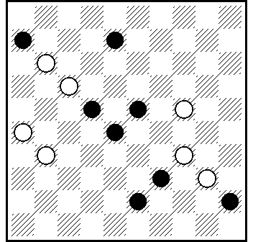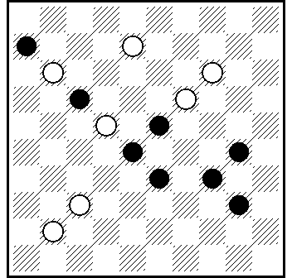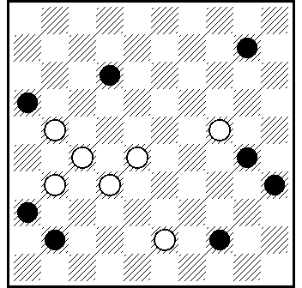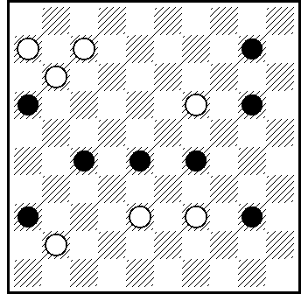
09D 10D 11D 12D

09D] 12.3(17A)49.497(33)28.27.17+. A(34)321.48(33)27.37(38)30/25(28)48(42)39.36+.

10D] 32.39(28A)10.2.14(21)5.16+. A(5)3(43A₁)19 idee V.Matus (28)46+. A₁(28 )9/20.3.46+.

11D] 39.7(36x38A)2(27B)8.15(40)28(45)50+. A(16x38)2(27 C)
8.15(40)28(45)50+.B(19)36.15(40)28(45)50+. C(19)47.15(40)28(45)50+.

12D] 6-1.393.1-6.14(9 A)2.15(47 B)6-33(29 C)33.50+. A(19)
7-1.21(50 D)21-17.35(33 E)30(38)48+. B(50)15-33.35+. C(24)45+. D(47/42)38.35 и так далее как в варианте А E(34)44+.

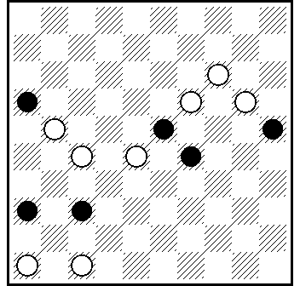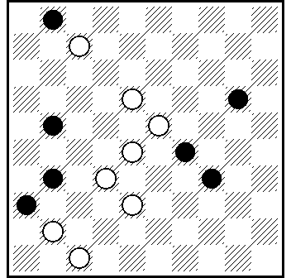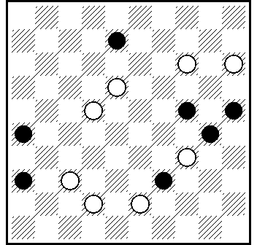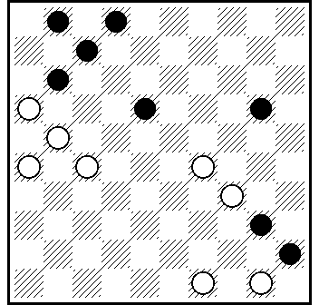
13D 14D 15D 16D

13D] 272.461(46A)42.37.13.3.47+. A(32)42.13.3.31/26.48+.

14D] 27.38(12a)7(47VP1)1(18A)15(33)16(40B)11.50+. A(33)6.16+. B (39)49+.VP₁ (18)1.15.16...+.
a (47)2.12.40/45+. "L" : 22-17(12:21)...

15D] 13.4.31.36(37 Aa)31.13+. A(39)37.48+. a(31)13.48+.

16D] 24(20x29)12.7(12A)494.16.8.11(23)7(29)2(18)7(34)
40.44+. A(11)494.16.6 (23)11(29)7.1 (34)40.44+.

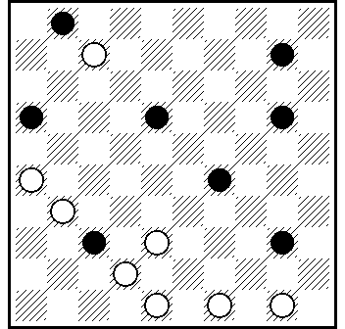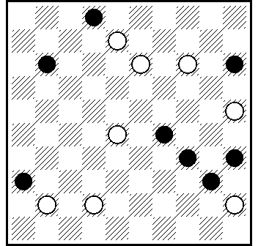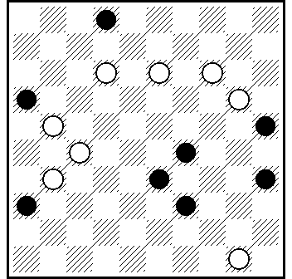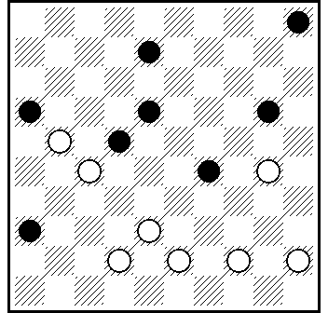
17D 18D 19D 20D

17D] 483.27.494.44.4(127 A)11.17+. A(49)27.8+.

18D] 20.23.3(13A)21.16.11(49B)44.34+. A(24)25.30.34+. B(50)6(40.45)1+.

19D] 7.22(16-9A)3(27B)45.34(38B)48+. A(36-9)3(27B)
45.34(38B)48+. B(40)29.34+.

20D] 25.14.32.3(41)37(32A)21(37)26(36)42(41)47(46)15.4+. A(42)10.36+.

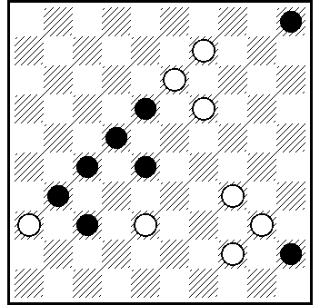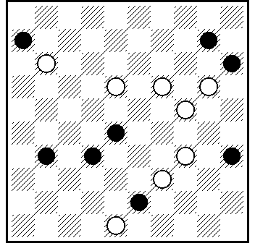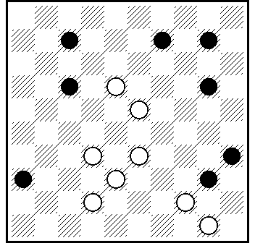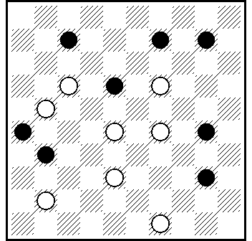
21D 22D 23D 24D

21D] 32.27.42.14(30A)3.39.10.26+. A(25)39.3.26+.

22D] 33.39.12.19-14(10x19A)2.34.36.22.50+. A(30x19)5.3(40)
34.8(33 B)30(38)48+. A1 (33)30(38)48+. B(30)35(34 A1)44(40)
35+.

23D] 13.4.31.1(16)38(43A)40.48+. A(49)44.45+.

24D] 293.44.12.1(46)3.5+. A(17)25.5+.

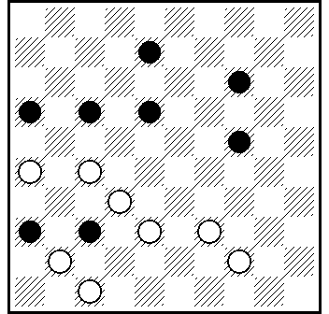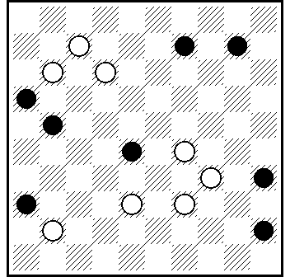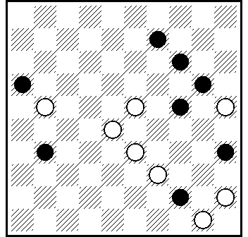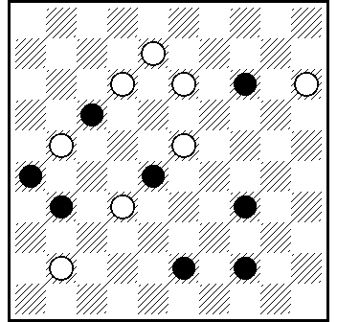
25D 26D 27D 28D

25D] 34(28A)42.32.3.11.17+. A(46)261.3.26+.
L₁: 8.14.16.17.18.22.31.3642.D48 = 26.27.29.32.33.37.38.41.
44.47 ...(43)39(37)338(24)...
L₂ : 5.14.16.17.18.22.31.36 = D4.15.26.27.29.33.37.39.41.42.
44.47 ...150(19)13(8)38(14)372(37)338(24) ...

26D] 8.8-2(44 ABab)2-30.29.2.50+. A(50)2-30.29.2.6+. B(15)29(44)30.2.50+. a(20)29/1+ ; b(24)30.2+.

27D] 19.3.21.29(443A)36(29/30)40.39 +. A (243) 26(49)44.34 +.

28D] 19.10.3.10(14A)48.49+. A(17)14(37B)46+. B(36)46+.

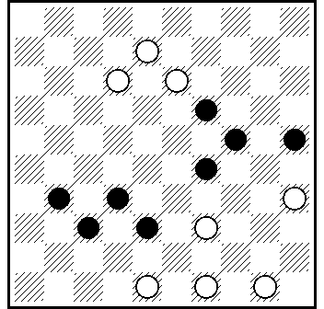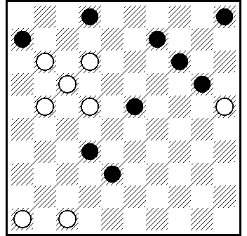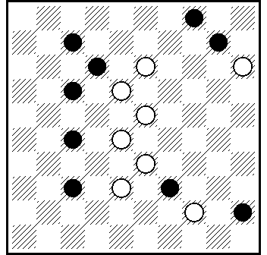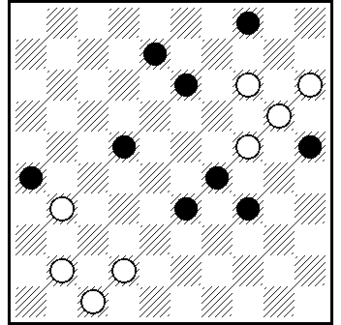
29D 30D 31D 32D

29D] 493.42.3.45(30A)44.20.24+. A(34)20.44.44(19)39
(23/24)33/34+.

30D] 8.18(12A)10.3.42(37B)31.471(42)37.41+. A(22)10.3.42
(37B)31.471(42)37.41+. B(31)26(38)48+.

31D] 19.9.4(50A) 28(44B)6.50+. A(28)33/39(50)6.50+. B(39)44(50)6.50+.

32D] 150(48 )42.5.3(14)9(13A)33+. A(20)25(9)3+.

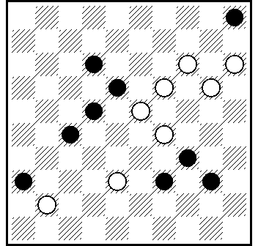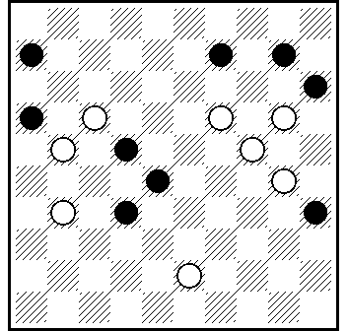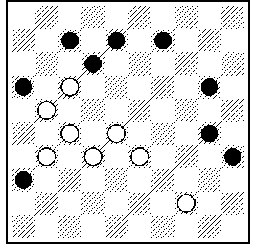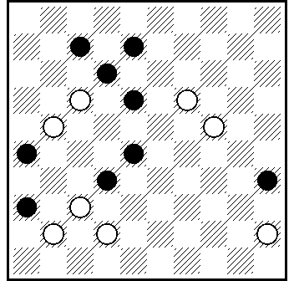
33D 34D 35D 36D

33D] 13(47)19.30(25 A)150.3(25x14 B)45(28)19(32)29(37)14
(41)47(46)15.4.15+;А (9)3.45(27)34(31 C)48(36)37+; В (5x14)
45(28)9(33)3(38)29(43)29-20.48+;C (32)48(38 D)10(43)3+; D (19)42(23)20/26(28)42+.

34D] 11.38.194.4(35x24A)32.38(30)43(35)49(21)16(40)
11(45)50+. A(15x24)15.49 (33)43(21)16(39)49+.

35D] 272(169 A)40.23(44 B)3.2+. A (369)40 etc. B(21)1.16+.

36D] 40.13.8(17)2(41A)13.49 +. A (44)49.46(33)32(39)49 +.

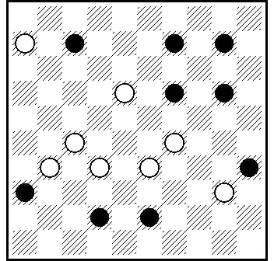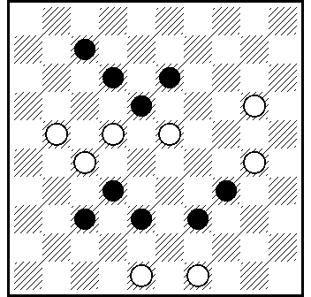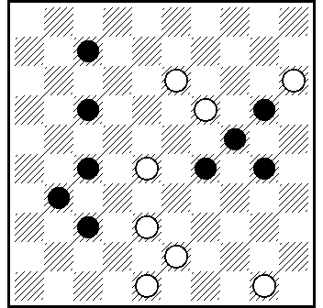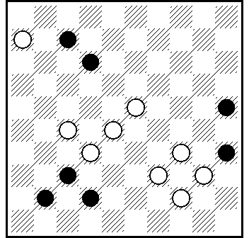
37D 38D 39D 40D

37D] 22.12.1.294(38х29А)15(30В)49+. А(20х29)15.50+ В(29)50+.

38D] 217.10(29)4.493.43(18A)23(27)1(32)29(37)47+. A(13/9)1+.
L : 4.9.12.13.14.16.19.32.37.38.39 = D6.20.21.22.23.24.25.27.
28.30.48.49 ...(138)24x13.11(18)9(13)20(7)23(34)...

39D] 42.44.32(4A)1.36+. A(9)1.3(37)26(41)37.10(37B)4
(19)10(41C)46+. B(38)4(19)10(24)15(42D)47+. C(42)48+. D(43)49+.

40D] 30(45A)40.18.1.50+. A(43)39.18.1.48+.

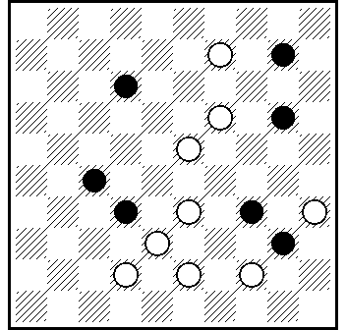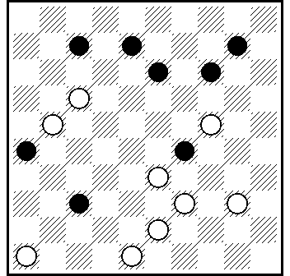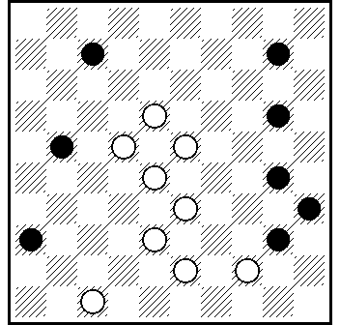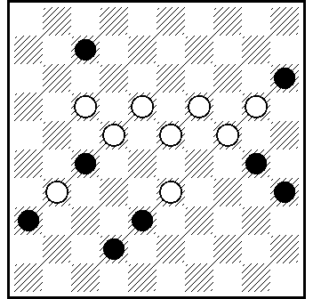
41D 42D 43D 44D

41D] 14.4(43A)17.44.44+. A(49)26.48+.

42D] 12.3.25.42.41(46A)34.5+. A (34)2.5+.

43D] 12(29A)4.41.228.16.25.39.50+. A (27)22.4.41.15.16.25.
39.50+.

44D] 183.194.12 (7x18 A)4.16.47+. A(27x18)1(24)13.48+.

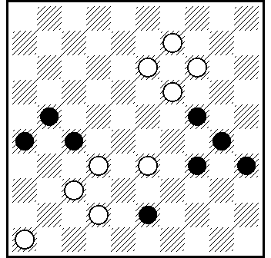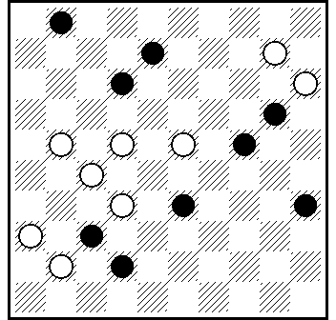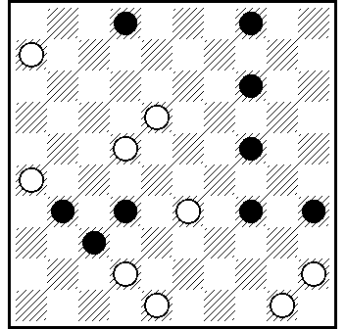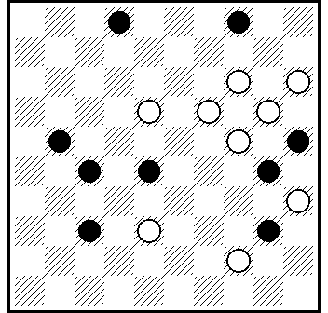
45D 46D 47 48D

45D] 29.40.41.3(20 A)48.31.49+. A(25)194.40(27)49(34)16(39B)49+. B(40)11(45)50+.

46D] 217.18.37.29.2(39abc)5(6)28(43)28-11.12.48(40)39(45)
50+. a(40)5(45)7.50+. b(38)5(6)28(42)11.12.47(40)33(45)50+. c(6)5(11.40)11(38)33 Z.28(45)50(34) 12(40)7(44)6(50)7-1(45)50+. Z 37?(43)39.28(45)50(40)12(44)28(50)6(45)1+.

47D] 29.18.43.10.1(43a)40.48(7.24)43+. a(44)39(7)20.34(40)30.34+.

48D] 183.32.139.8.4(14 A)36.44.44+. A(13)17.44.44+.

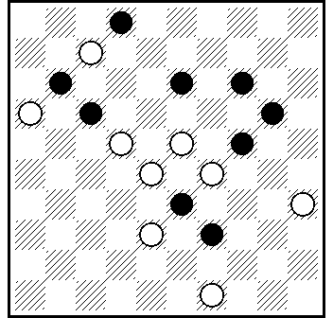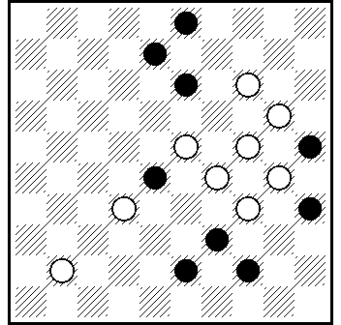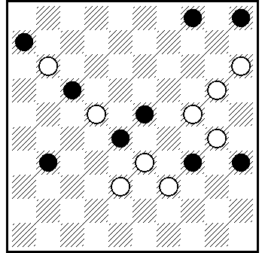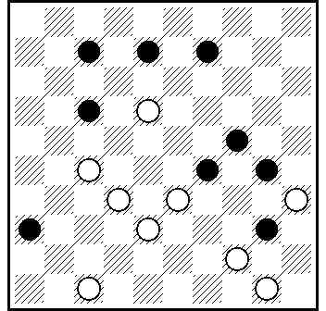
49D 50D 51D 52D

49D] 19.49-38(42)1(28)7(11)30(35A)24.16+. A(33)24.16+.
L: 2.11.13.14.20.24.26.31.33.39 = 7.16.22.23.27.28.29.35.
36.38.42.49 ...(37)31(37)31(26)21(17)...

50D] 10.18.9.23.2.10(14 A)43(19)39+. A(30)23+.

51D] 14.9(13 a)20(24 b)9.3.10(14 A)36.27(33)43(22 B)16
(39 VP₁)11+; VP₁ (28)43+;A (17)3x21x25.36(32 C)31(38)48+; B (21)16(39)49+; C (33)27(39)49+; a (39)3.26.49+;
b (39)14.150.4.15/20+.

52D] 338.41.272.4(49x A)25.39.39(29)34.44+. A(33x)25.43.44.44(29)39+.

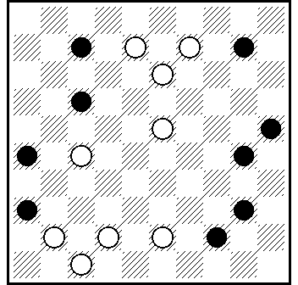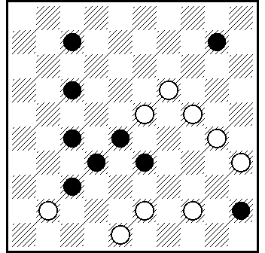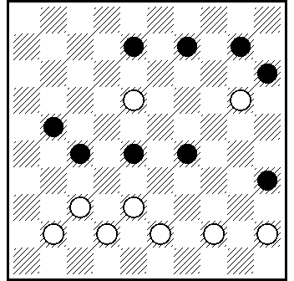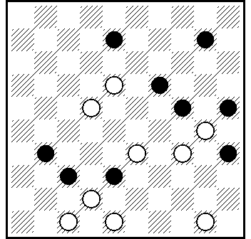
53D 54D 55D 56D

53D] 39.38.38.2(31A)5(48 )37.4.13+. A(36)5(26-31 A₁)37.
4.48+. A₁(47)41.4.13+.

54D] 40.39(44 A)43.38.1.19(28 B)30.5+. A(46)42/43...+.
B (46)30.5+.

55D] 13.31.32.3(24A)26.4+. A(37)42.4+.

56D] 339.12.43.5(34A)37.40.39+. A(24)37.20.44(19)39
(23)33+.

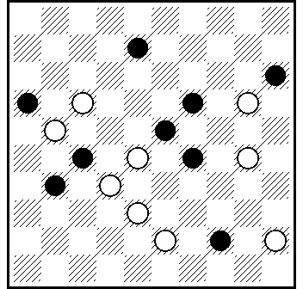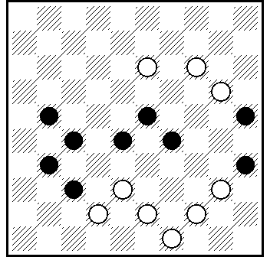
57D 58D

57D] 39.33.2.40(27A)49.36+. A(44)35.29(37)47+.

58D] 33.22.3(44A)5.45+. A(14)12.45+.

Legality / Легальность

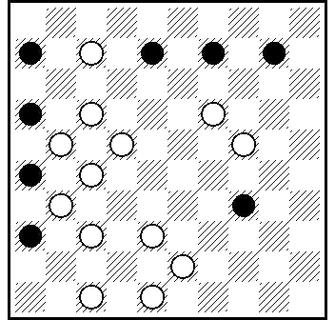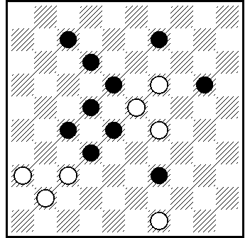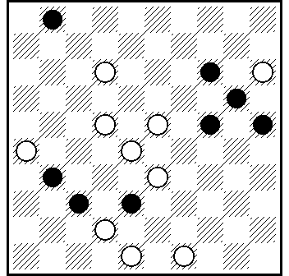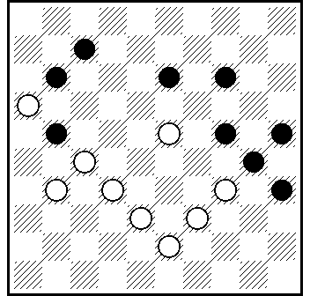
add 01A add 10A add 27A add 45A

add 01A] 11(6x28)22(16x18)39(41) ... dij. 01A !
add 10A] (31)38(33) ...dij. 10A !
add 27] 19(32) ... dij. 27A !
add 45A] 18.18(26) ... dij. 45A!

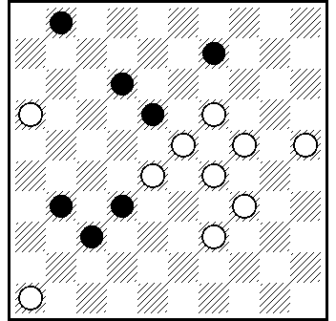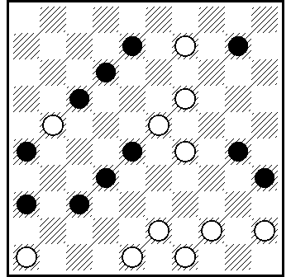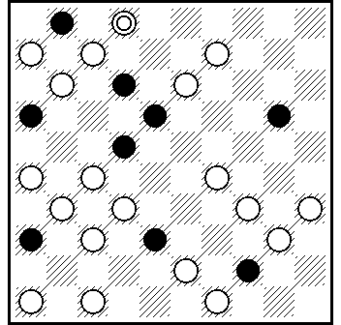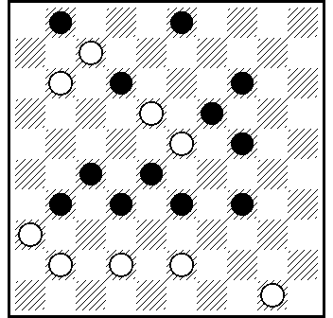
add 15B add 32B add 33B add 43B

add 15B] 11(6)41(17)22(28) ...dij. 15B!
add 32B] (13)7(22)440(17)42(39) ...dij. 32B!
add 33B] 461(17)261(12)117(26)350.21(1)7(12)42(36x27)
44...dij. 33B!
add 43B] 45(328)431(339)27(283) dij. 43B !

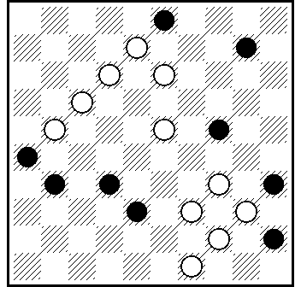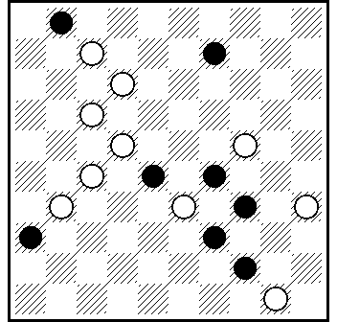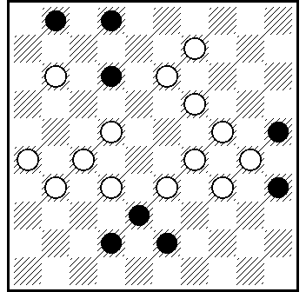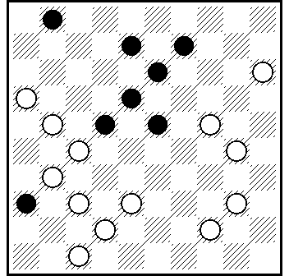
add 50B add 24C add 26C add 34C

add 50B] (29)43(9)...dij. 50B!
add 24C] 30(20) ...dij. 24C!
add 26C] (6)20(37)294(23) ...dij. 26C!
ads 34C] 11(6)41.372(28)... dij. 34C!

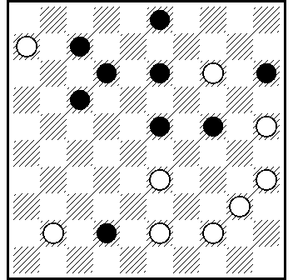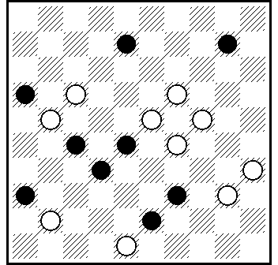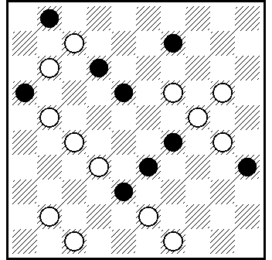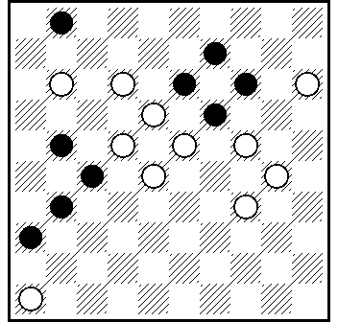
add 42C add 52C add 56C add 59C

add 42C] 20(239) ... dij. 42C!
add 52C] 11(7)... dij. 52C!
add 56C] 217(12x21)272(18x27)416.472(16x7)...dij. 56C!
add 59C] 29(6)41( 8 ) ...dij. 59C!

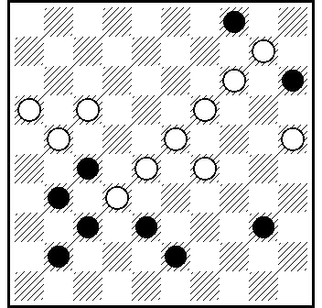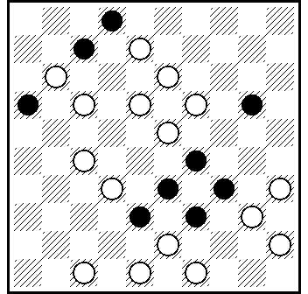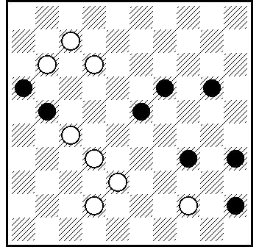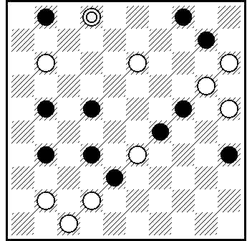
add 66C add 67C add 02D add 04D

add 66C] 171(20)7(15)11(9) ...dij. 66C!
add 67C] 182(7x9)44.30(35)19(7)12(18) ...dij. 67C!
add 02D] 28(23x43) ...dij. 02D!
add 04D] (7)417(41)18.11(7) ...dij. 04D!

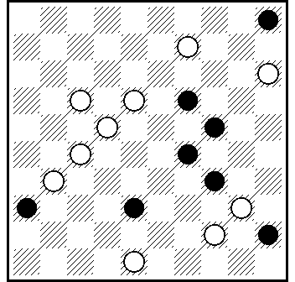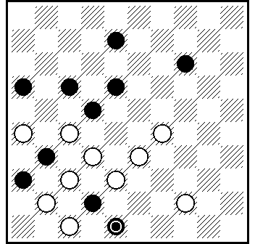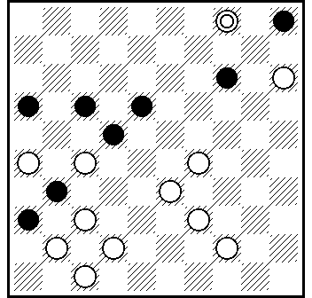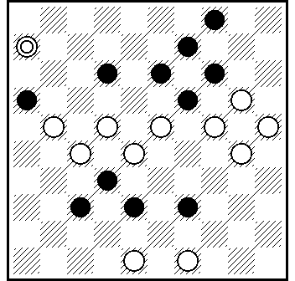
add 07D add 25D add 25D add 38D

add 07D] (19-23)15-10(23x32) ...dij. 07D!
add 25D] (43)39(37)338(24) ...dij. 25D!
add 25D] 150(19)13(8)38(14)372(37)338(24) ...dij. 25D!
add 38D] (138)24x13.11(18)9(13)20(7)23(34) ...dij. 38D!

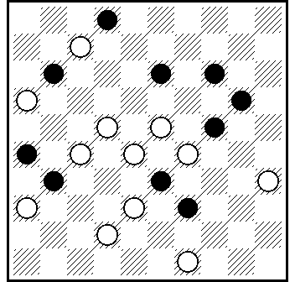
add 49D

add 49D] (37)31(37)31(26)21(17) ...dij. 49D!

comments only for jury members / коментарии только для членов жюри : [ * ]

add А07 After black capture the play splits into 3 independent compositional variations with different finals.
Тема: после боя чёрных игра разделяется на 3 независимых композиционных варианта с разными финалами.

add А14 Piece 17 is necessary for the removal of a partial cook.

Шашка 17 нужна для устранения частного побочного решения.

add В18 If you put away draught number 28 , side solution 32! or 24!+ is possible.
If you put away draught number 11 , side solution 24!+ is possible.

Если снять из ударной цепочки шашку 28 , то возможно побочное решение 32!+ или 24!+.
Если снять из ударной цепочки шашку 11 , то возможно побочное решение 24!+.

add D07 Piece 32 is necessary for the removal of a partial cook.

Шашка 32 нужна для устранения частного побочного решения .

Регламент

3-го личного чемпионата мира по проблемам
(PWCP-III), раздел – малые проблемы. [/size]

1. 3-й личный чемпионат мира по проблемам, раздел малые пробемы (PWCP-III), является официальным чемпионатом мира под эгидой ФМЖД, которая несёт за его проведение полную ответственность. Совет директоров ФМЖД (CD) возлагает на комиссию по композиции (CPI FMJD) осуществление контроля и проведение чемпионата PWCP-III.

2. Время проведения PWCP-III: с 15го сентября 2009 года по 15 сентября 2010 года.

3. PWCP-III проводится в соответствии с Правилами RI для проблем (часть 1) и для соревнований (часть 2), а также в соответствии с Инструкцией судьям, разработанную и утверждённую CPI во время проведения 2-го чемпионата мира по проблемам PWCP-II.

4. В соревновании могут принимать участие только малые проблемы (без дамок в начальной позиции), соотвествующие уровню мастер (RM) или супер-мастер (RS). Малые проблемы, соответствующие базовому уровню (RB), к соревнованию не допускаются.

5. Соавторство и совместное участие запрещено. Не допускаются также к участию в соревновании проблемы или их незначительные вариации как ранее опубликованные, так и учавствующие в соревнованиях, стартовавших до начала данного чемпионата.

Запрещено участие в соревновании произведений, опубликованных ранее в электронных средствах массовой инфомации, включая Интернетные форумы и сайты. .

6. PWCP-III проводится по 4-м категориям. Задание во всех категориях: «белые начинают и выигрывают».
Во всех категориях PWCP-III решение позиций может начинаться как комбинацией (жертвой шашек), так и тихим ходом белых.

Категория А. Соотношение сил: 6x8, 7x8, 8x7, 8x8. Тема свободная.

Категория B. Соотношение сил: 6х8, 7x8 (8x7), до 9x9, включая 7x9.

Tема: Решение должно заканчиваться одной или несколькими оппозициями белых и чёрных дамок на любых диагоналях доски.

Пример: D46/D5; D5/D46; D50/D6, 45; D50, 45/D6; D25/D48, D3 и так далее.Последний ход белых перед получением финальной оппозиции может быть ударным или тихим.

Категория C. Соотношение сил: 7х9 or 8x9, 9x8 or 9х9. Tема свободная.

Категория [b]D[/b]. Соотношение сил: 6x8, 7x8 (8x7) до 9x9, включая 7x9.

Tема: решение должно содержать не менее двух тематических вариантов.

Финалы вариантов могут отличаться или совпадать, но игра в обоих вариантах
должна быть разная. Разделение на тематические варианты может происходить в
любой момент решения в виде выбора боя чёрными.
Пример1. M. Фёдоров, МК “Lithuania-2006”: 1-21-29-31-32-35-38-42/ 6-11-18-40-41-
43-44-45 Решение: 7,1,37,34(29x40 A),16,49+. A(49x40),30,34,16+.

Пример2: Scheijen /v. Prooijen: 7-8-9-19-24-27-36-45/ 25-28-33-34-38-41-42-44-50

Решение: 40, 32 (27x29) 1 (6) 20 (34 A) 40 (28) 44, 6. A (15) 34 (20 B) 25, 39, 39 (24)34+. B (1) 35, 44+. Вариант «А» возникает при выборе боя, вариант «В» - нет.

CPI FMJD подчёркивает, что материальное большинство в две белые шашки соответствует уровню мастера (RM) и Правилам RI, пункт 1.17.2 b.

7. В каждой категории участник может представить не более 2-х композиций, указав категорию соревнования и полное решение до момента, когда выигрыш белых не вызывает сомнений. Решение должно быть дано в краткой форме с указанием только композиционных вариантов и композиционных ложных следов, а также, если необходимо, доказательства легальности начальной позиции. Координатор посылает решения в средства массовой информации для публикации, включая Интернетные сайты.

В то же самое время участник может указать отдельно в дополнении к решению не композиционные варианты, доказательства единственности решения, разъяснения насчёт роли и назначения отдельных шашек, итд. итп. Эти дополнения координатор посылает судьям, но они не входят в текст публикаций.

8. Подведение итогов PWCP-III.

Процесс подведения окончательных итогов включает в себя два этапа.

1) Члены жюри оценивают малые проблемы по 100-очковой шкале и определяют места каждого произведения в каждой категории.

2) После этого произведениям присваиваются очки в соответствии с занятыми ими местами:

1-е место – 100 очков, 2-е место – 97 очков, 3-е место – 94 очка, 4-е место 92 очка, 5-е место – 90 очков, 6-е место – 88 очков, 7-е место – 87 очков и далее уменьшая на 1 очко за каждое последующее место.

Исключение композиций из соревнования (0 очков) разрешается только в случаях, базирующихся на объективных критериях, описанных в Правилах RI и разьяснениях в инструкции судьям 2-го чемпионата мира по проблемам (PWCP-II).

9. Индивидуальные результаты PWCP-III будут определены в соответствии с суммой пяти лучших произведений, занявших наиболее высокие места в своих категориях. Это означает, что будут учтены все произведения каждого участника во всех категoриях.

10. В случае равенства очков по пяти лушим произведениям, описанными в предыдущем разделе, дополнительными критериями являются:

а) Сумма зачётных очков в 6-и лучших произведениях.
b) Сумма зачётных очков в 7-и лучших произведениях.
с) Сумма зачётных очков в 8-и произведениях.

11. Победителю чемпионата в разделе малые проблемы присваивается звание чемпиона мира. Он будет награждён золотой медалью и дипломом CPI FMJD. Второй и третий призёры чемпионата в общем зачёте будут награждены серебряной и бронзовой медалями и дипломами.
В дополнение, призовой фонд включает в себя:

- I место 300 долларов США.
- II место 200 долларов США.
- III место 100 долларов США.

12. Членами жюри чемпионата мира являются:

S. Žilevičius (Литва), И. Ивацко (Украина), Н. Грушевский (Беларусь), A. Нагуманов (Россия), C.Romon (Франция ).

Миленко Лепшич (Хорватия) назначен координатором чемпионата.

13. Участники чемпионата должны послать малые проблемы на адрес координатора чемпионата (см. ниже) стандартной почтой и могут продублировать отправку имэйлом.

Окончательный срок отсылки: 15 Января, 2010 Дата отправления определяется почтовым штампом. Участники могут также указать адрес электронной почты, если он у них есть. Информация о получении проблем будет опубликована на сайте Миленко Лепшича: www.minietiud.forum2x2.ru

Miljenko Lepšić , V. Becića 7, 51000 Rijeka, Croatia
E-mail: miljenko.lepsic1@ri.t-com.hr

Регламент Чемпионата Мира по малым проблемам, а также предварительные и окончательные итоги чемпионата будут опубликованы на Интернетных сайтах:

FMJD site: http://www.fmjd.org.
TAVLEI (http:// www.gambler.ru/plus/tavlei)
Eric van Dusseldorp site: www.ericsdamsite.com,

Miljenko Lepsic site: www.minietiud.forum2x2.ru

Инструкция для членов Судейской Коллегии чемпионата мира по малым проблемам 2009-2010, PWCP III

1. PWCP-III является официальным чемпионатом мира, проходящим под эгидой FMJD. Исполнительный комитет FMJD назначил комиссию по композиции (CPI) ответственной за организацию и контроль по проведению PWCP-III - чемпионата мира по малым проблемам.

В данном документе CPI даёт членам Судейской Коллегии PWCP-III более подробные инструкции, включая последние изменения в RI (международные правила для проблем). Подобная инструкция для PWCP-II помогла в своё время предотвратить конфликты и способствовала более объективному судейству.

В случае, если один или несколько членов Судейской Коллегии не следуют данной инструкции, Координатор разъяснит это членам Судейской Коллегии. В случае, если судьям не ясны отдельные положения данной инструкции, Координатор адресует вопрос CPI c разъяснением конкретной ситуации. Если соглашение не достигнуто, CPI принимает окончательное решение и инструктирует судью, к которому относится это решение.

Все выше перечисленные организационные меры и регулирование принимаются для защиты интересов участников. Организация и правила должны быть максимально просты и понятны всем участникам. В случае, если Правила не являются достаточно чёткими и понятными участникам, любые сомнения должны трактоваться в пользу участников.

От чёткой организации в выигрыше окажутся и члены Судейской Коллегии, которые будут точно знать, что они должны ожидать от Координатора и CPI. Независимость судьи при оценивании

произведений, участвующих в соревновании, полностью гарантируется Правилами и данной Инструкцией. Это относится также к роли и обязанностям Координатора, которые будут разъяснены ниже.

2. Первый этап – достижение соглашения относительно исключения позиций.

После публикации произведений, Координатор получит большое число замечаний от участников, судей и всех желающих. Члены Судейской Коллегии должны решить, какие замечания являются наиболее важными, и, в частности, могут повлиять на принятие решения об исключении произведения из соревнования.

Обязанностью Координатора на данном этапе является накопление информации о всех замечаниях, включая имена авторов. При публикации замечания имя автора, от которого оно поступило, должно указываться, за исключением случаев, когда замечание поступило из многих источников.

Политика CPI заключается в том, что произведения, участвующие в соревновании, могут быть исключены (оценка – 0 очков) только по объективным критериям, указанным в RI - побочное решение, нерешаемость, предварительная публикация, и тд.

Судьи, в принципе, свободны в своём решении и могут выставить произведению любую оценку, но не могут исключить произведение без объективных на то причин. В случае, если произведение не исключено судьёй, минимальной оценкой является 10 очков.

Как результат данной политики, CPI требует, чтобы между всеми членами Судейской Коллегии было достигнуто соглашение относительно всех произведений – кандидатов на исключение. В случае, если причина исключения является объективной и описана в RI, не должно быть больших затруднений c исключением позиций на раннем этапе соревнования. Дополнительной причиной данного подхода к проблеме является стимуляция членов Судейской Коллегии последовательно применять RI в каждом конкретном случае.

Третьей и, пожалуй, наиболее важной причиной является тот факт, что CPI намерено защищать интересы участников и

избегать нежелательных ситуаций при исключении произведений, имевших место во многих предыдущих соревнованиях. В дополнение к вышесказанному, CPI намерено также полностью исключить ситуации с безобразными отличиями в оценках, когда один судья без всяких разъяснений выставляет 0 очков позиции, которая позднее становилась победителем из-за высоких оценок остальных членов Судейской Коллегии. Это случалось также раньше, когда произведения были исключены даже в случае, если они являлись корректными и более оригинальными, чем иные произведения, которые были оценены.

После достижения членами Судейской Коллегии полного и окончательного соглашения насчёт позиций, подлежащих исключению, CPI по умолчанию предполагает, что судьи корректно и правильно применяли правила при вынесении окончательного решения, и все данные позиции будут исключены из соревнования до предварительного объявления результатов.

В случае, если судьями не будет достигнуто полное соглашение насчёт исключения одной или нескольких позиций, участвующих в соревновании, они в первую очередь получат возможность через Координатора ознакомиться с мнением остальных членов Судейской Коллегии с разъяснением конкретных пунктов RI, которые были применены для вынесения того или иного решения.

Ситуация, когда судьями не достигуто по данному вопросу полное и окончательное соглашение и не выработано общее мнение, является нежелательной. Тем не менее, если это случилось, Координатор передаёт всю информацию в CPI для вынесения окончательного решения и дальнейших инструкций судьям.

CPI в первую очередь проверит, что утверждение позиции (не исключение) не противоречит правилам RI. В случае, если правила RI не нарушены, будут применены общие базовые принципы CPI FMJD, указанные выше: любые сомнения трактуются в пользу участника. Иными словами, позиция не может быть исключена, если не доказано, что правила RI нарушены.

Большинство случаев исключения, указанных в RI, описаны очень чётко. Тем не менее этого описания было недостаточно для случаев с предшественниками.

Правила RI были дополнены параграфом 2.1.1 с следующим текстом:

2.1.1. Предшественники (с участвующей композицией).

Необходимо различать совпадения, достаточные для исключения позиций (0 очков)
очков) и совпадения, которые влияют на судейскую оценку, но не на её исключение.

Наличие предшественника может считаться достаточным для исключения в случае
полного совпадения позиции или почти идентичного решения. Решение считается
почти идентичным, когда позиции при первом тихом ходе чёрных полностью
совпадают и записи подавляющего большинства белых и чёрных ходов решения до
этого момента также совпадают. Во всех остальных случаях судья не может
выставить позиции нулевую оценку.

Наличие предшественника считается достаточным, чтобы негативно повлиять на
оценку, если комбинация и/или эндшпиль имеют много общего с позицией,
учавствующей в соревновании. Судья принимает решение – оказывает ли
предшественнник негативное влияние на оцениваемую позицию, не имеет никакого
влияния, или даже оказывает положительное влияние, если оцениваемая позиция
намного лучше всех указанных предшественников.

В случае необходимости, CPI разъяснит судьям трактовку и применение данных правил и другие аспекты Инструкции.

PWCP-III проводится в четырёх категориях. Новым для PWCP-III является разрешение на участие в соревновании позиций с материальным большинством белых в две единицы, что соответствует уровню RM (Мастер) и RS (Супер). Некоторые проблемисты считают, что такое разрешение расширяет композиционные возможности. Члены Судейской Коллегии
вправе давать таким позициям более высокую или более низкую оценку. Судья также вправе дать позиции низкую оценку, если очевидно, что участник мог оформить идею при равенстве сил, или большинстве белых на одну единицу.

Судейская Коллегия PWCP-III состоит из 5-и человек. Самая высокая и самая низкая оценки не учитываются при подсчёте, и проблема получает оценку как усреднённое число 3-х остальных оценок (RI, параграф 2.3).

Два других параграфа RI также претерпели некоторые изменения / расширились с коротким разъяснением.

Приводим здесь эти изменения.

1.13.1.
f) реализация правила большинства. К примеру: Д46, 36, 42 /38, 47, 49. Белые играют 41. (46x43) является ходом с использованием правила большинства из за наличия чёрной шашки на 36.

g) Устранение побочного решения.

В правилах дописано: «за исключением случаев, когда наличие такой шашки устраняет побочное решение».

1.6.1.

Финал должен быть чистый. Это означает:

a) На доске присутствует только одна белая единица (шашка или дамка) и отсутствуют шашки или дамки чёрных в финальной позиции.

b) Присутствует минимальное число белых единиц, необходимых для запирания чёрных шашек.

Пример 1: 18, 36, 38 / Д1, 41. Белые играют 1 x 47, финал корректный..

Пример 2: Д49, 40 /Д16, 44, 45. Чёрные играют (32) с корректной финальной позицией после 16 x 49.

Смотри также параграф 2.1.1. RI.

3. Внутренние и внешние контакты.

Члены Судейской Коллегии вправе консультироваться с экспертами насчёт оригинальности позиций, участвующих в соревновании, но остальные члены Судейской Коллегии и Координатор должны быть оповещены о результатах таких контактов и заключении эксперта. Члены Судейской Коллегии не должны ни с кем обсуждать вопросы исключения позиций, за исключением других членов Судейской Коллегии данного соревнования и Координатора. Судьи не должны обсуждать оценки ни с кем и ни при каких обстоятельствах.

Для CPI наиболее важным является правило, что не должно быть никаких обсуждений вне официального круга ответственных за проведение судейства лиц, включающего в себя членов Судейской Коллегии и Координатора. Для CPI является абсолютно неприемлемой ситуация, когда судьи и/или члены CPI помещают свои комментарии во время PWCP в Интернете или имэйле с отсылкой копии не членам Судейской Коллегии и не Координатору.

Эти простые правила способствуют организации более эффективного и аккуратного процесса принятия решения и защищают имидж CPI FMJD.

Regulations

Of the third personal world championship of problems (PWCP-III), Small problems section.

1. The third Personal World Championship of Problems, Small problems section (PWCP-III), is an official world championship of the World Draughts Federation (Fédération Mondiale du Jeu de Dames - FMJD). The FMJD bears the ultimate responsibility for this world championship. The FMJD Board of Directors (CD) charged the composition commission (Commission du Problemisme International – CPI FMJD) with organizing and control of the PWCP-III.

2. The championship period – from 15th of September 2009 till 15th of September 2010.
The PWCP-III is carried out according to the CPI FMJD International Rules (RI) for problems (Part I) and for competitions (Part II) and also according to the Instructions for the judges developed and approved by the CPI during the holding of PWCP-II.

3. Allowed to the championship are small problems (without Kings in initial position) which correspond to levels either “Règles de Maîtres” (RM), or "Règles Supérieures“(RS). The small problems which correspond to the “Règles de Base” (RB) level only are not allowed.

Team or cooperative participation is forbidden. Published problems (or minor alterations) which took part in any competition as well as problems which have been published in electronic mass media, including forums of various sites, are not allowed.

4. The PWCP-III is carried out in four categories. In all categories White plays and wins.
The PWCP-III categories have the following conditions:
In all the categories White can start with sacrifices (combination) or with moves that do not force Black to capture (forcing).

Category A. The number of pieces is: 6x8, 7x8, 8x7, 8x8. The theme is free.

Category B. The number of pieces is 6х8, 7x8 (8x7), till 9x9 including 7x9. The theme: The solution has to result in opposition of Kings in any diagonal(s) of the draughts board. Example: D46/D5; D5/D46; D50/D6, 45; D50, 45/D6; D25/D48, D3 and so on.
This position can be reached after a capture by the White King or otherwise.

Category C. The number of pieces is 7х9 or 8x9, 9x8 or 9х9. The theme is free.

Category D. The number of pieces is 6x8, 7x8 (8x7) till 9x9 including 7x9. The theme; the combination should contain at least two thematic variants. The finals of these variants can be different or the same, but the combinational play must be different. The split in thematic variants can be reached at any moment of the solution, but must be a choice of captures.

Example: M. Fedorov, International contest “Lithuania-2006”: 1-21-29-31-32-35-38-42/ 6-11-18-40-41-43-44-45 Solution: 7,1,37,34(29x40 A),16,49+ A(49x40),30,34,16+
Example: Scheijen /v. Prooijen: 7-8-9-19-24-27-36-45/ 25-28-33-34-38-41-42-44-50
Solution: 40, 32 (27x29) 1 (6) 20 (34 A) 40 (28) 44, 6. A (15) 34 (20 B) 25, 39, 39 (24) 34
B (1) 35, 44. The moment of the A variant is a choice of captures, the B variant is not.

The CPI FMJD takes notice that the majority with two pieces of Whites is allowed according to “Règles de Maîtres” (RM) of International Rules (RI) point 1.17.2 b.

5. In each category a participant can offer not more than two compositions, indicating the competition category and the full solution till the moment when Whites win without any doubt. Solution should be given in a short form with indicating only compositional variants and compositional false directions and, if necessary, proof of initial position’s legality. The coordinator gives these solutions in publication on websites or another mass media. At the same time participant can give non-combinational variants, proofs of the only solution, indicate why that or another piece is not a figurant and so on in separate addition to solution. Such additions are sent to the judges by the coordinator but not published with positions.

6. Results of PWCP-III. There should be two steps:
1) The members of jury value the compositions by 100 points scale and determine the places for each composition in every Category.
2) then the compositions receive points according to their places – the first place – 100 points, the second place – 97 points, the third place – 94 points, the forth place – 92 points, the fifth place – 90, the sixth place – 88, the seventh place – 87 points and so on minus one point. Elimination of participating compositions (0 points) is only allowed when based upon objective criteria as described in the RI and explained in the Instruction for the judges PWCP-III.

7. The individual scores of the PWCP-III will be determined according to the sum of his five best performances, irrespective of the category. This means that the points of all the compositions of each participant in all four categories of the championship will be taken into account.

8. Ranking of the competitors when the points as described in point 7 are equal:
а) Score sum of the 6 best performances;
b) Score sum of the 7 best performances;
с) Score sum of the 8 performances.

9. The winner of the championship in Small problems section will be given the World champion title; he will be awarded with a golden medal and a CPI FMJD diploma. The number two and three of the total scores are awarded with silver and bronze medals accordingly and diplomas.
In addition, the prize money is established as follows:
- For the I-st place – 300 US dollars;
- For the II-nd place – 200 US dollars;
- For the III-d place – 100 US dollars.

10. The jury composed of S. Zilevicius (Lithuania), I. Ivatsko (Ukraine), N. Grushevsky (Belarus), A. Nagumanov (Russia) and C. Romon (France) is formed for the direct carrying out of the PWCP-III.

Miljenko Lepsic (Croatia) is appointed the championship coordinator.

11. The championship participants are asked to send their small problems by ordinary post mail or by email but in that case problems should be sent also by ordinary post mail, till January 15, 2010 at the address of the championship coordinator. The date of sending is fixed by post stamp. The participants can indicate their emails if the have them. The information about receiving problems will be published on the site of Miljenko Lepsic: www.minietiud.forum2x2.ru
Miljenko Lepsic
V. Becica 7,
51000 Rijeka, Croatia
E-mail: miljenko.lepsic1@ri.t-com.hr

The World Championship Regulations will be published at the websites
FMJD site: http://www.fmjd.org.
TAVLEI (http:// www.gambler.ru/plus/tavlei)
Eric van Dusseldorp site: www.ericsdamsite.com,
Miljenko Lepsic site: www.minietiud.forum2x2.ru,

Preliminary and final results of PWCP-III, Small problems section, will be published at the same websites.

Instruction for the jury members of the PWCP III

1. The PWCP-III, an official FMJD World Championship

The Executive Board of the FMJD has delegated the organization and control of the PWCP-III to the CPI.

The CPI gives more detailed (expert) Instructions to the jury, including the RI (the International Rules for problems), as it was done for the PWCP-II. This Instruction for the PWCP-II helped to avoid any conflicts and evaluating results objectively.

When one or more jury members do not follow the instructions, the contact will explain this to the jury member involved. When the Instruction is not clear to the jury member the contact will ask the CPI to explain the application of the rule for this particular case. In the case that no common opinion can be reached, the CPI takes the decision and instructs the jury member involved.

All this is organized in order to protect the rights of the participants. The organization and the rules must be as clear as possible and in the case that they are not fully clear the participant should have the benefit of the doubt.

The jury also benefits from a clear organisation. They know what they can expect from the contact and the CPI. The independence of the jury concerning the level of the scores for the participating competitions is within these rules fully guaranteed.

The role of the contact is also further clarified in this way.

2. The first step, reaching unanimity about eliminations.

After publication of the participating compositions the contact will get a large number of remarks from participants, jury members and others. The jury members have to decide what the value of these remarks is and in particular if these remarks have to lead to elimination of the participating composition concerned.
The contact will keep record of the remarks received and the names of those who made the remarks. When remarks are published the name of the person who made the remark is published as well, unless the same remark is made by many persons.

The policy of the CPI is that participating compositions can only be eliminated (0 points) based upon objective criteria. These objective criteria are mentioned in the RI (second solution, not winning, already published, etc.). The jury members are in principle free to give any score they prefer, but not free to eliminate participating compositions for not objective reasons. When a composition is accepted, the minimum to be given is 10 points.

As a result of this policy the CPI insists that the jury members reach unanimity about eliminations. When the reasons given are objective and referring to the RI it should not be difficult to complete the list of eliminations in an early stage of the competition.
Another reason for this approach is that it stimulates the jury members to apply the RI in a consistent way.

The third and even more important reason is that the CPI wants to protect the interest of the participants and wants to avoid the unsatisfactory situations concerning eliminations at many former contests. Also to avoid ridiculous differences e.g. where one jury member gave 0 points, without explanation, for the composition that later was declared to be the winner as a result of the high scores of the other jury members. It also happened that compositions are eliminated though they are correct and more original than compositions that are accepted.

When the jury members reach full unanimity about the eliminations, the CPI will assume that the jury members have applied the rules correctly and those participating compositions will be eliminated for the provisional result.

When the jury members do not reach unanimity about elimination of one or more of the participating compositions they first get the opportunity from the contact to convince the other jury members based upon specific articles of the RI. It should be unlikely that he jury members do not reach a common opinion, but if it happens the contact will ask the CPI for a decision and the CPI will instruct the jury members.
The CPI will first check if the acceptance is not against the RI, the Instruction, and the Regulations. Is this not the case then the principle of the CPI FMJD mentioned above applies. The participant has the benefit of the doubt. In other words the participant cannot be

convicted with elimination of his composition, when it is not proven that his composition is against the rules.

Most of the cases of elimination mentioned in the RI are fully clear. This was insufficiently the case with what is called resemblance.

The RI are extended with paragraph 2.1.1 with the following text:

2.1.1. Resemblances (with a participating composition).
A distinction is made between resemblances relevant for elimination (0 points) and resemblances only relevant for the score by the judges.
A resemblance is relevant for elimination when the initial position is fully identical or when the solution is nearly identical. The solution is considered nearly identical when the position at the first moment that Black is not forced to capture is fully identical and the notation of the majority of the Black and White moves before that moment is identical as well. In all other cases a jury member is not allowed to give 0 points.
A resemblance is relevant for scoring when the combination and /or the end game have important aspects in common with the participating composition. The jury member decides whether the resemblance has a negative influence on the score, or no influence, or even a positive influence when the participating composition is much better than all the resemblances found.

The CPI will give explanation to the jury members of these rules or other aspects of this instruction when required.

The PWCP-III is carried out in four categories. The new for the PWCP-III is that problems with predominance of Whites in two units which correspond to levels either “Règles de Maîtres” (RM), or "Règles Supérieures“(RS) are allowed. Some problemists think that it gives more compositional opportunities. The jury members are free to give more or less points for it. The member of jury can give fewer points if it will be obvious that participant could design problem with equal forces or Whites predominance in one unit.

The jury of the PWCP-III consists of five persons. The smallest and biggest scores are deleted and the problem receives score from the average of the sum of third scores (RI, article 2.3.)
Two other RI paragraphs were somewhat changed /extended with a short explanation.
These extensions are given below:

1.13.1.
f) creation of a majority capture. For example K46, 36, 42 /38, 47, 49. White plays 41. (46x43) is a majority capture, caused by the Black piece on 36.
g) elimination of a second solution.

Write up in the clause 1.13. of the Rules for problems as follows: “ except for the cases when such checker is required to eliminate a collateral solution”

1.6.1.
This Final position must be pure. It means:
a) The presence of only one White piece (Man or King) when there is no Black piece left in the Final position;
b) The presence of only the minimally required number of White pieces for blocking the Black piece(s).
Example 1: 18, 36, 38 / K1, 41. White plays 1 x 47, final position correct.
Example 2: K48, 40 /K16, 44, 45. Black plays (32) with correct final position after 16 x 49.

See also the article 2.1.1. RI.

3. Internal communication

The jury members are free to consult experts about the originality of the participating compositions, but with a copy to the contact and the other jury members.
The jury members should not discuss eliminations outside the jury and the contact. They should not discuss scores at all.
For the CPI the most important rule is that there should be no discussions at all outside the jury and the contact. For the CPI it is unacceptable when jury members and/ or CPI members comment during the PWCP on public Internet or with emails with distribution lists outside the jury and the contact.

These simple rules support clearer and more efficient decision processes and protect the image of the CPI FMJD.

