II Personal World Championship of Problemism
II ЛИЧНЫЙ ЧЕМПИОНАТ МИРА ПО ШАШЕЧНОЙ КОМПОЗИЦИИ

Category A

A-1 A-2 A-3 A-4 A-5 A-6
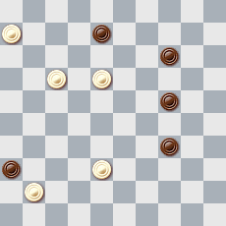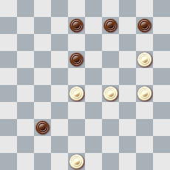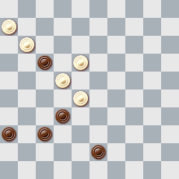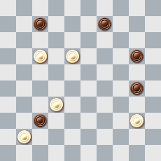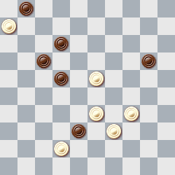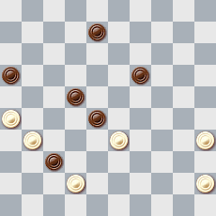

A-7 A-8 A-9 A-10 A-11 A-12
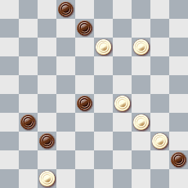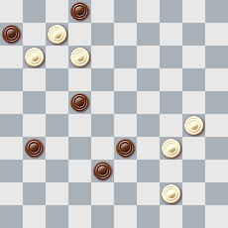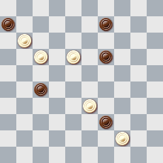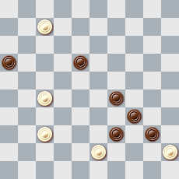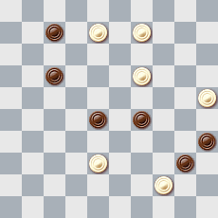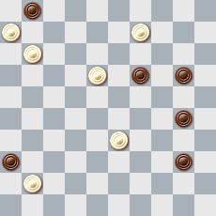

A-13 A-14 A-15 A-16 A-17 A-18
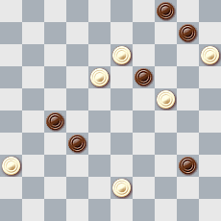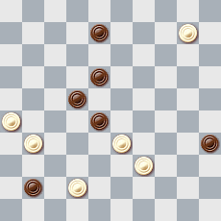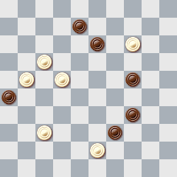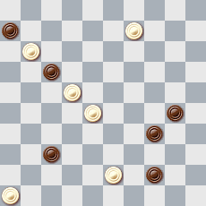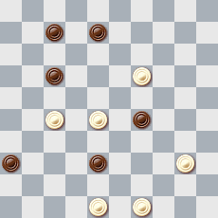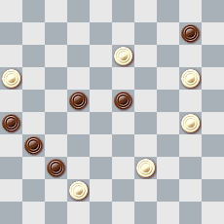

A-19 A-20 A-21 A-22 A-23 A-24
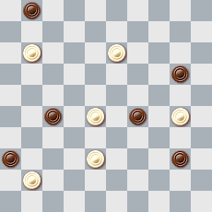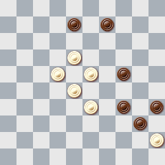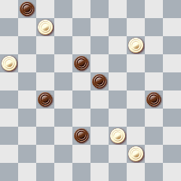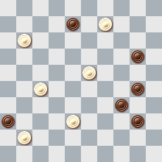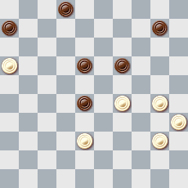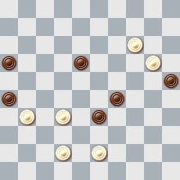

A-25 A-26 A-27 A-28 A-29 A-30
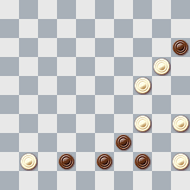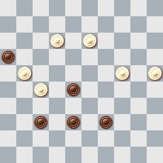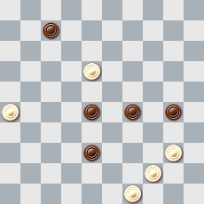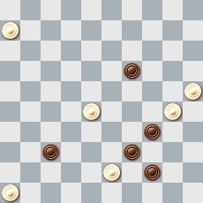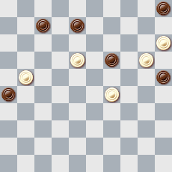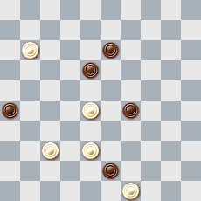

A-31 A-32 A-33 A-34 A-35 A-36
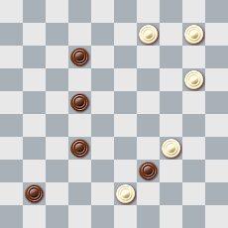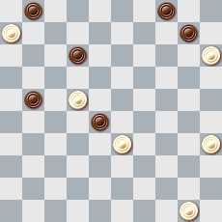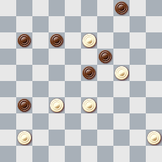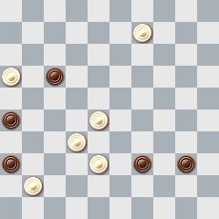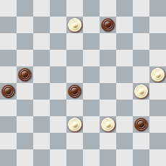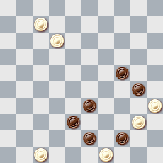

A-37 A-38 A-39 A-40 A-41 A-42
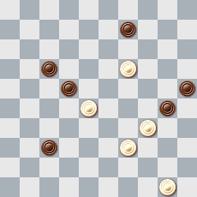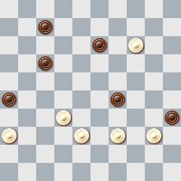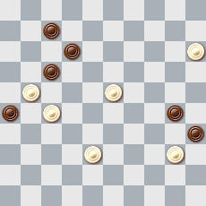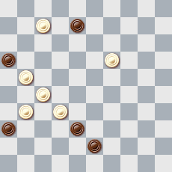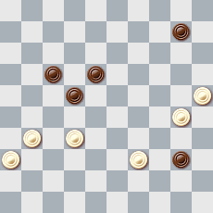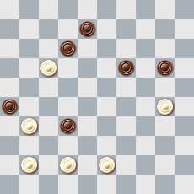

A-43 A-44 A-45 A-46 A-47 A-48
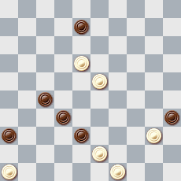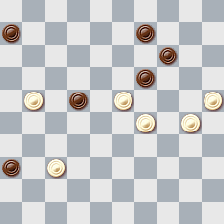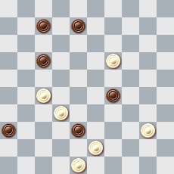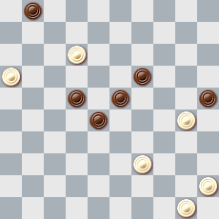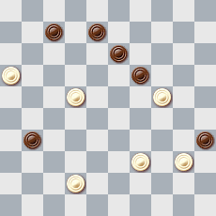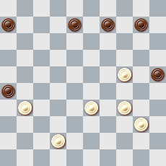

A-49 A-50 A-51 A-52 A-53 A-54
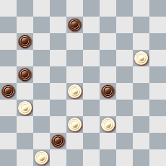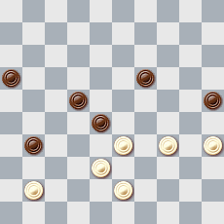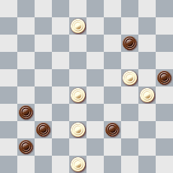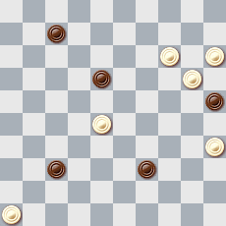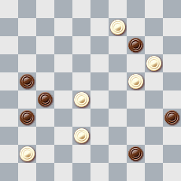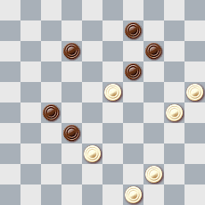

A-55 A-56 A-57 A-58 A-59 A-60
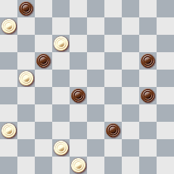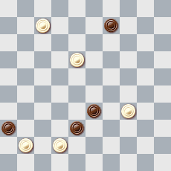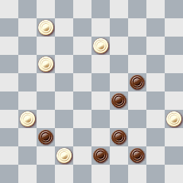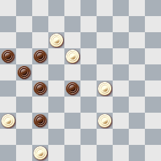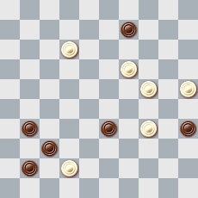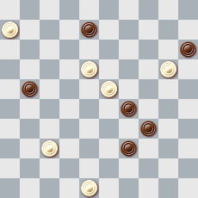

A-61 A-62 A-63 A-64 A-65 A-66
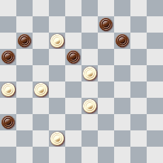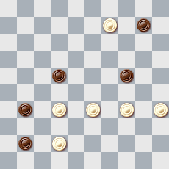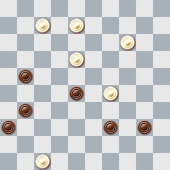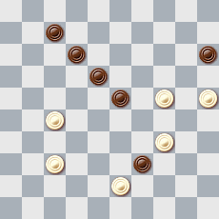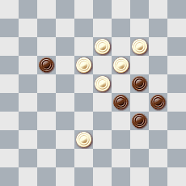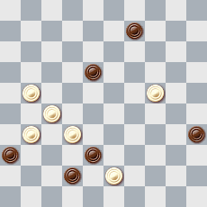

A-67 A-68 A-69 A-70 A-71 A-72
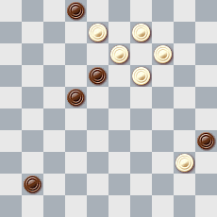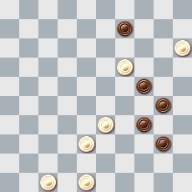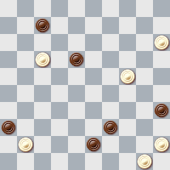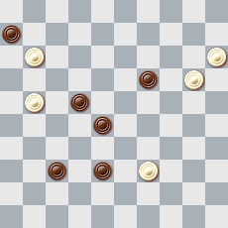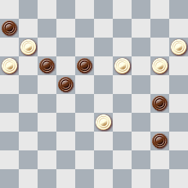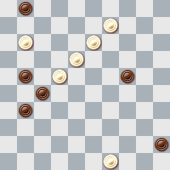

A-73 A-74 A-75 A-76 A-77 A-78
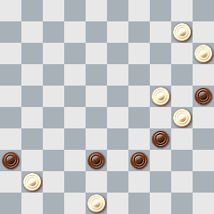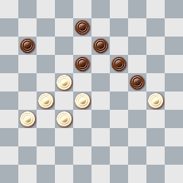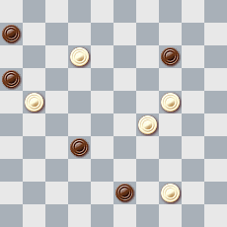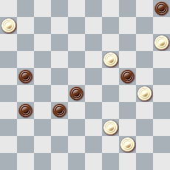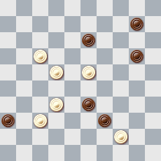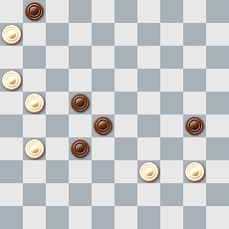

A-79 A-80 A-81 A-82 A-83 A-84
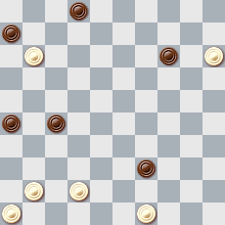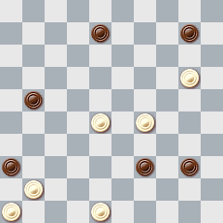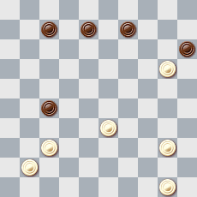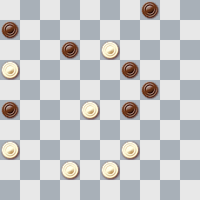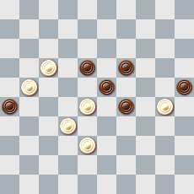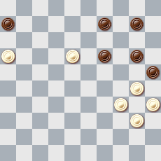

A-85 A-86 A-87 A-88 A-89 A-90
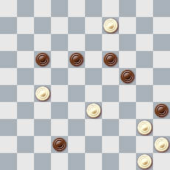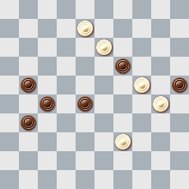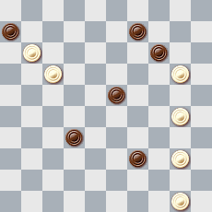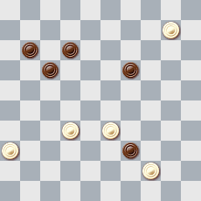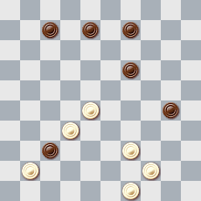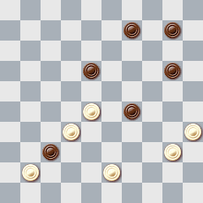

A-91 A-92 A-93 A-94 A-95
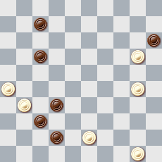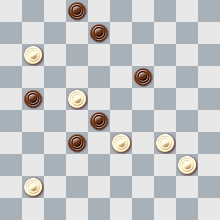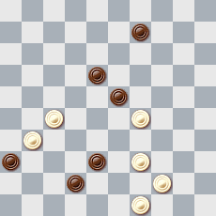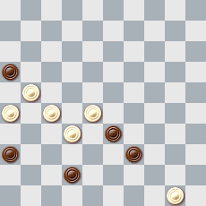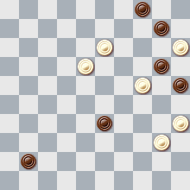

Решения категории A

- I. 17-12(47A), 3(1B), 45+ A(17), 1, 12, 21+ B(7), 1(39), 34, 1+ I. 33, 17-12(17), 1(12)=
- 42, 293, 3(46A), 5 + A (41), 46+
- 1, 31, 13+
- 28, 172, 1, 3+
- 18, 7, 34, 1 и 3 варианта:
1) (27), 34(31), 48(36) [(21или (or)22), 37, 25+] 43(21) A[(41), 37, 25+] 16(41), 37,
15+ A(24), 37(22), 16(28), 31, 30… +
2) (27), 34Z (24), 37(21), 43(29), 49(34), 372, 16(40), 11(45), 50+ Z 40? (31)=
3) (24), 40 [34? (21!)+] (27), 44 [37? 32! 30!=] (21), 49(30), 37Y (34/35), 372,
16(40), 11(45), 50+ Y 43?(35), 49(26!), 16(40), 11(45), 50(31)=
- 21(36a), 31, 40, 34, 2(28), 11(32), 16(31), 38(37), 47+ a(17), 40, 34, 2+
Легальность (Legality): 2, 8, 12, 16, 19, 25, 25, 28, 37/D48; 22, 26, 31, 33, 34, 35, 39,
42, 45 30, 7(11), 17(22)
- 149, 42, 3(25A), 23, 14, 36+ A(30), 24, 13, 45+
- 8(17), 29, 40Z(13A), 2, 36(28), 27(33), 43(21B), 16(39), 49+ A(11/44), 3, 50(27,32), 33(37), 47+ B922), 16(39), 11+ Z 3?, 33(40,49)=
- 182(50), 8(22), 28, 23, 3(272), 38(14), 47(32), 42(19), 15(23), 20+
- 2, 30, 11, 1+
- 9-3, 2(32), 24(5/10), 14, 34+
- 7, 4, 1(29A), 4-18, 28(45), 50+ A(24), 14, 45+
- 9, 4, 38, 31, 19+
- 37, 27(21A), 17, 2(40), 16(45), 32, 41+ A(31), 2(317), 5(40), 24(45), 10(50), 10-15, 31(38), 48+
- 18, 9(48), 3(17A), 26, 16+ A(31), 6, 36+
- 39(43a), 41, 3(5A), 19(28B), 46+ A(10), 5, 32+ B(17), 22, 18(17), 13(22), 9(28), 4(33), 27(39), 49+ a(33), 39(28), 3(17), 48+
- 493, 282, 2, 26(41), 37, 42+
- 9, 14, 5, 17, 36+
- 22, 7, 25, 3, 35(33A), Z 30(38), 48+ A(34), Z1 44+ Z 49?(39=) Z1 49?(39=)
- 29, 30, 34(29AB), 12, 3+ A(14), 17(29), 13(9), 11(12), 6+ B(8-13), 19(29), 23(19), 12+
- 9z, 33, 3(294, 40), 13(49), 27, 27+ z) 10, 33, 5(304), 3/8(33)=
- 4, 13, 25(40), 39(44/45), 50+ Легальность (Legality): 20, 21, 30, 34, 36, 40/9, 12, 16, 22, 23, 27, 31, 32, 38, 47 11(26), 41(8)…
- 23, 24(20), 33, 34, 4(23), 22(29), 17(34), 16-11(8,17), 21(40), 17(45), 50+
- 10, 5, 48(23 AB), 43(21 CE), 28 (22 D), 16(29), 7(33), 16(39), 11(43), 48+ A(21), 28, 26(21-27), 37(31,28), 3+ B(22), 28(38 tG), 17+ C(38), 34, 31/36+ E(29), 27+ D(32), 16(39), 49+ t(39), 34/25, 43+ G(27,32), 33(21), 26+
- 37, 50, 30, 40, 39(23), 33+
- 22, 41, 37+
- 43, 35, 22, 17, 17+
- 41(46), 1(48A), 50, 34, 34(23), 29, 44+ A(23), 49, 43(39), 24, 43+
- 10(5x14), 9, 3(8-12), 8, 2, 35+ Легальность (Legality): 3, 6, 7, 8, 25, 26/10, 14, 15, 17, 18, 20, 21, 23, 29 9(3x5), 11
- 31, 7, 2(22), 18, 43+
- 30, 3, 46+
- 44, 17, 8(27), 3Z(31AB), 26(36), 37(7, 10, 41), 23(47), 30(36), 41, 24, 24+ A(14), 20/25+ B(3Z), 9YX, 4+ Z2? (9,31/32=) Y 20?(14), 9, 10(18), 4(23=) X 30?(38)=
- 9, 338, 6(37), 1(46), 34, 25+
- 4, 11, 31, 35+
- 34Z, 24, 3(31), 32, 2(27a), 26(36), 42(41), 37, 16(31), 38(37), 47+ a(26), 16(36), 14(42), 37, 32+ Z 2? (45), 11(31), 33(37), 32, 26(50), 34(45)=; 3?(44), 16(42)=
- 42, 20, 24, 1, 49+
- 14, 3, 30, 30+
- 383, 31, 2(18), 9(31A), 3(36B),13, 47+ B(39), 13, 26+ A(39), 3(44), 12, 50+
- 18(44), 22(28), 10, 5, 33, 49+
- 22(16x), 1(38x), 2(41), 13+
- 34, 24, 5(23), 28, 28, 27, 27+
- 24, 2, 16(37A), 14, 5+ A(27), 37, 46+
- 19, 40, 183, 2, 37(41), 31, 37+
- 20, 3, 14(41), 11, 46+
- 28, 282, 2, 26, 37, 42+
- 33, 8, 40, 2(24AB), 48(27CD), 11(29E), 26 [25? (31)=] (32F), 3(7), 2(37), 20(34), 19(39/40), 41(44), 39(50), 20-14+ E (28), 26[42? (28-32!= или (or) 25? (31)=] (33), 3(7, 39), 16(31) 26+
F1 (33), 3 и т.д. как в варианте E
F2 (34), 3(7), 2(39), 16(31), 26+
C (7), 43(29), 38+
D (23-28), 43+
A (6), 43(29), 38(34), 43(40), 49(27), 35(32), 24(37), 47+
B (22/23-28), 43(33), 11(28), 6(7), 27(11,39), 49(33) 16+ или (or) (39), 1(11), 6(33), 22+
- 11, 2, 37, 18, 25(38), 48+
- 20,15, 2(35), 11+
- 14(44A), 10, 41, 5(19A), 13+ A(23), 50+ a(22), 9, 3+
- 36(48A), 18, 13(30), 8(34), 2(40), 35(45), 44(50B), 6(21), 12(27), 7(31), 7-1(36), 12(44), 50, 23(47), 50-33(36), 41, 15+ A(30), 13(227), 9(30), 4(34), 18(39), 34(32), 36x27(43), 9+ B(21), 50(27), 13(31), 9(36), 4(41), 10+
- 43, 3, 43, 47+
- 41, 150(23A), 5, 1, 34, 24+ A(19), 1, 34, 24+
- 4, 282, 50(40a), I. 20, 45(44A), 50(49A1), 17, 5+ AA1(36), 10, 15, 16+ a(36), 50-33/50-45, 29, 16(40), 11(45), 50+ I. 36?(37)[(27?), 45(44), 50(49), 17, 21, 38+] 19(27), 14(31), 27(41), 10(47), 32(30)=
- 20, 3, 38, 39, 27+
- 7(26), 37Z, 43, 1, 32(4A), 27, 27+ A(48), 37, 27+ Z 2?(35), 11(43), 15(49), 29(31, 16)=
- 1(36x47A), 29, 33, 3+ A(38x47), 29, 13, 15, 47+
- 1(48a), 21, 30, 43(30), 25, 39, 50+ a(26), 38+
- 42(48), 31, 11, 1, 16+
- 8,13, 14, 24, 34+
- Z. Z1. 1, 43, 12, 26, 2+ Z. 43?(48=). Z1. 12?, 43(48=).
- 19(23), 28, 6, 1(11), 6(21), 4(27A), 31(27), 37+ A(41), 10(47), 15(20), 16+
- 338, 27, 37, 4(30A), 18, 34, 24+ A(15,24), 340(29), 24, 30+
- 41, 1, 33(44/45), 50+
- 21, 30Z, 19, 8(12,23), 12(28), 8(32A), 3(37B), 17(20,42C), 3(48), 3-9, 9-3+ C(41), 24(46), 24-19+ B(38), 17(20,42), 3+ A(33), 3(38/39D), 17+ D(20,38), 17+ Z. 22, 44=
- I 33, 12, 2 II 47(39), 10(34A), 5(43C), 42(39DEt), 33, 49+ A(44), 5(50B), 33, 35+ B(49), 38, 35+ C(40), 33, 45+ D(48), 23-19+ E(49), 38+ t(40), 48(49), 43, 45+
  - 10? (22,9), 4A1, 22(18,27)=
  - 42? (39), 10(43), 5(34)= A1 5, 23(39), 28(19, 44)=
- 17, 22, 4, 25, 39(45), 50+
- 4, 15, 33, 50+
- 14, 29, 44+
- 12, 1, 34, 24, 40, 48(24), 43(30), 39(35), 34+
- 33, 31, 14, 4(32), 42+
- 13, 14, 44(28), 11x22, 17, 7+
- 7, 3, 40, 44+
- 42(38x47A), 4, 24, 15, 44Z (40,34), 44+ A(36x47), 44, 24(40), 35, 30, 4/5+ Z50?(40), 24(45), 19(30), 13/14(34)=
- 23, 19, 2(29), 16(33), 271, 43(22), 16(39A), 11(27), 44(32), 33(37), 47+ A(28), 43+
- 39, 19, 37(19), 8(23), 2(29), 16(31), 26(34), 16-21(40), 17(45), 261(50a), 16, 7+ a(11,50), 17+
- 33, 10, 17, 17+
- 31, 28, 4(19), 22(16), 27(24), 38(30), 43(35), 49+
- 17, 7, 1(35A), 23, 27+ A(17), 29(21AI), 42(26), 48, 26(38), 48(35AII), 404(43), 33, 25+ AI(34), 30(21), 27(37), 26(41), 47(46), 11+ AII(43), 394, 34, 25+
- 43, 21(6x), 12(31), 41(8,36), 20, 24, 24+
- 15, 4(15), 42, 41, 22(13), 35(27), 2(32), 24(37), 47+
- 31, 14, 1+
- 31, 34, 3(18), 17+
- 12, 33, 22, 2+
- 24, I. 13, 34, 4(23), 22(30), 17(34), 161(29), 7(40), 1(45), 40+ I. 34?, 13(30)=
- 22, 4, 30, 39+
- 3(43), 22, 4+ Легальность (Legality): 19, 25, 27, 28, 31, 45/8, 13, 17, 18, 24, 30, 34, 39, 40 1.39(45x21)
- 12, 8, 3+
- 338, 5, 16(50), 28, 27+
- 40, 23, 1+
- 30, 22, 42+
- 21, 1, 38, 40+
- 7, 35, 2(37), 32, 37+
- 43, 22, 4, 45+
- 44, 48, 42(41), 37, 42+
- 9, 4, 47(39), 20, 34, 24+

Category B

B-1 B-2 B-3 B-4 B-5 B-6
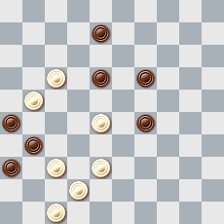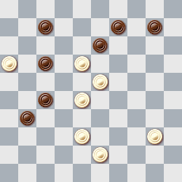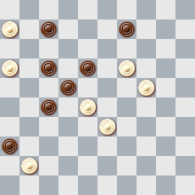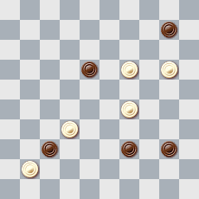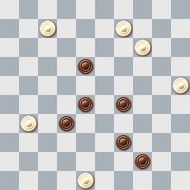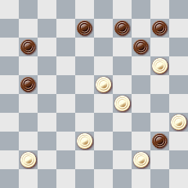

B-7 B-8 B-9 B-10 B-11 B-12
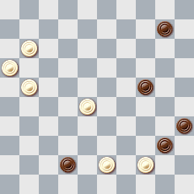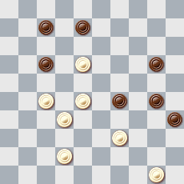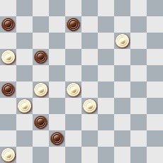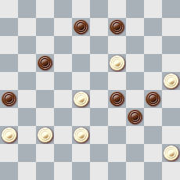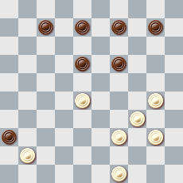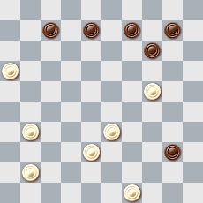

B-13 B-14 B-15 B-16 B-17 B-18
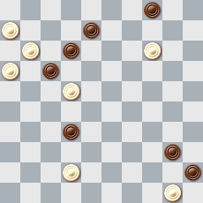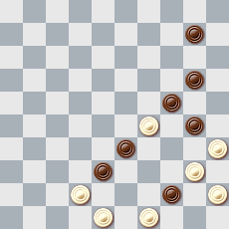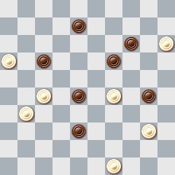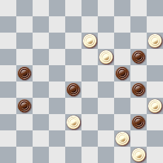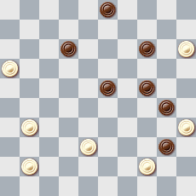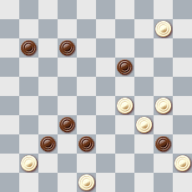

B-19 B-20 B-21 B-22 B-23 B-24
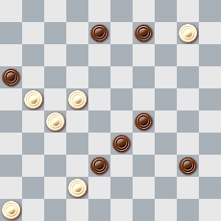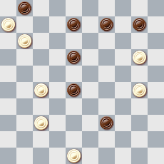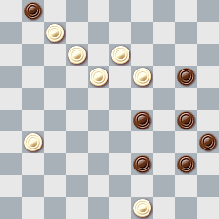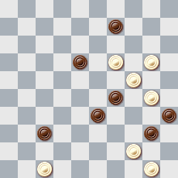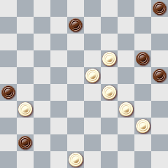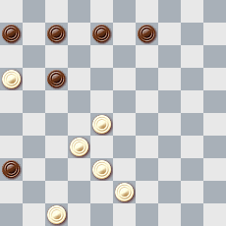

B-25 B-26 B-27 B-28 B-29 B-30
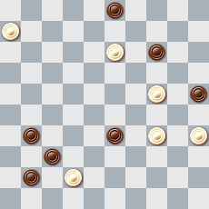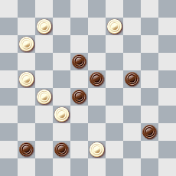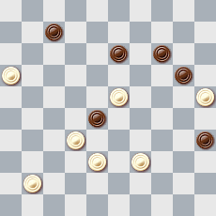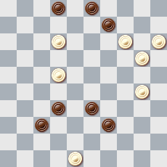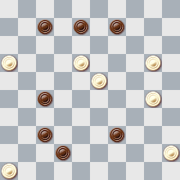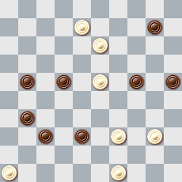

B-31 B-32 B-33 B-34 B-35 B-36
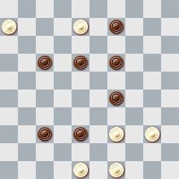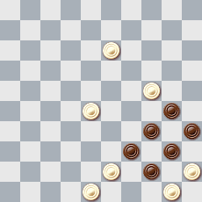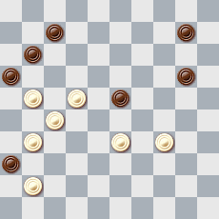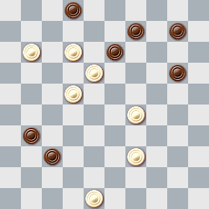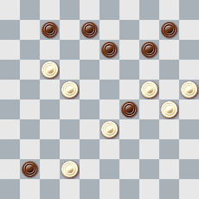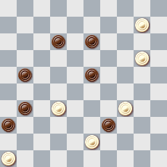

B-37 B-38 B-39 B-40 B-41 B-42
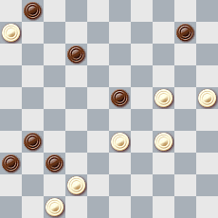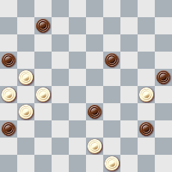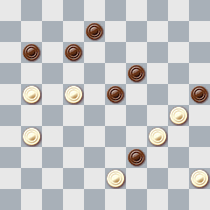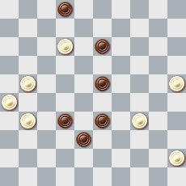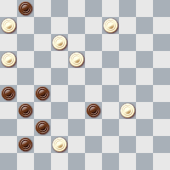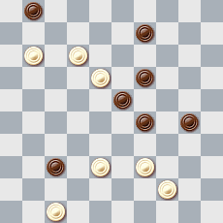

B-43 B-44 B-45 B-46 B-47 B-48
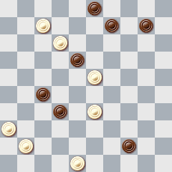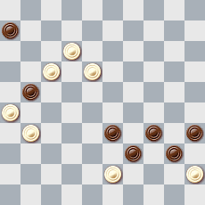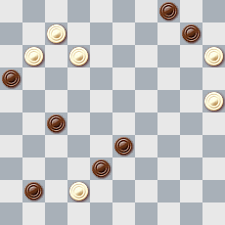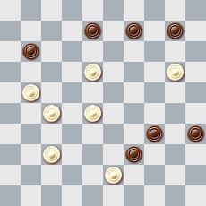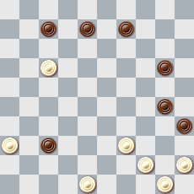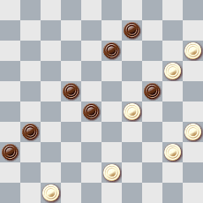

B-49 B-50 B-51 B-52 B-53 B-54
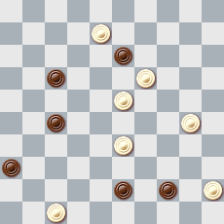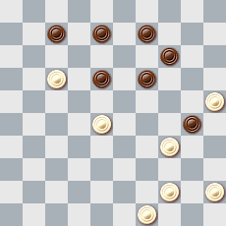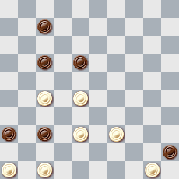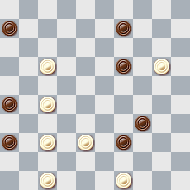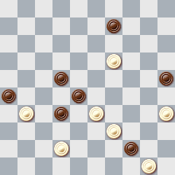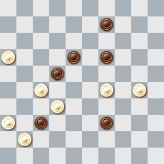

B-55 B-56 B-57 B-58 B-59 B-60
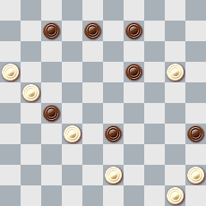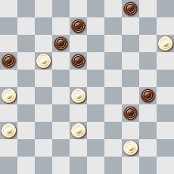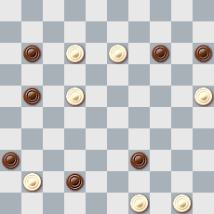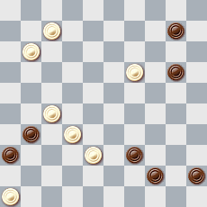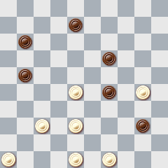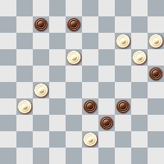

B-61 B-62 B-63 B-64 B-65 B-66
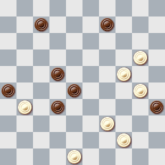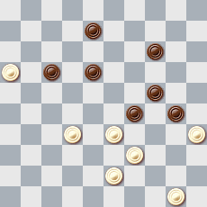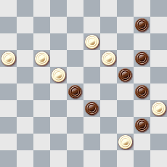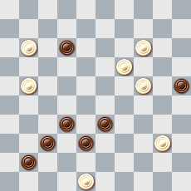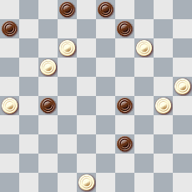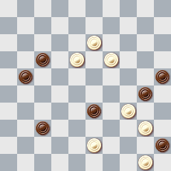

B-67 B-68 B-69 B-70 B-71 B-72
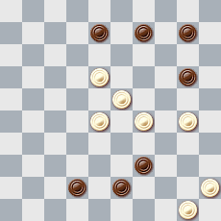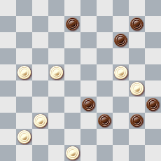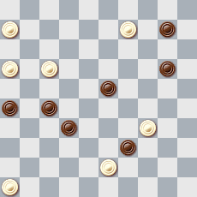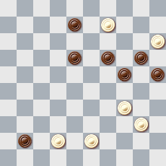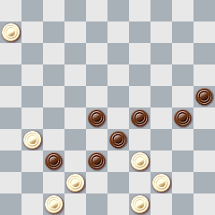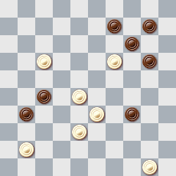

B-73 B-74 B-75 B-76 B-77 B-78
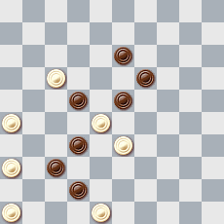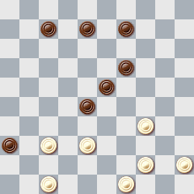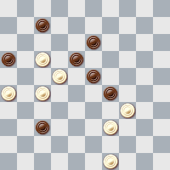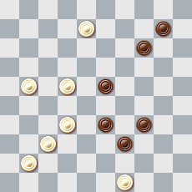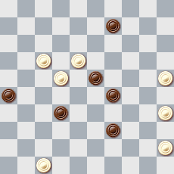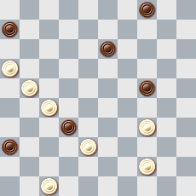

B-79 B-80 B-81 B-82 B-83 B-84
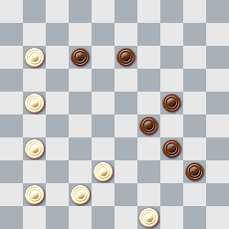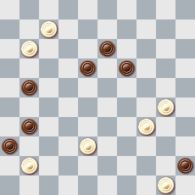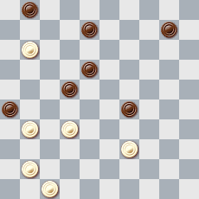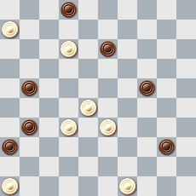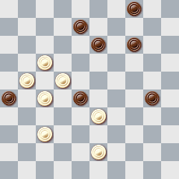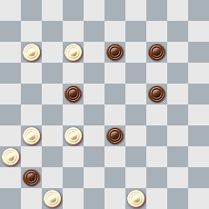

B-85 B-86 B-87
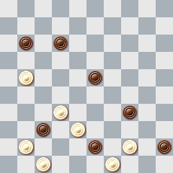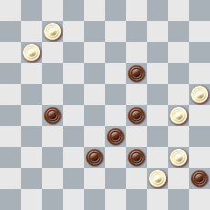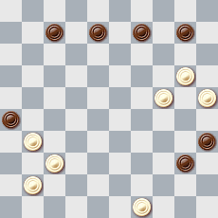

Решения категории B

- 41, 33, 2, 22, 11, 47+
- 32(49), 11, 2, 239(8A), 12+ A(13), 5+
- 11(16A), 20, 204(2B), 3, 7, 17+ A(47), 2(15), 1, 20+ B(8), 32, 28, 1+
- 28 I, 293, 204, 5, 35(34A), 44II A(33), 30IV (38), 48+ I. 24?(28III), II. 49? (39)= III. (46?), 204(23), 5, 35+ IV. 49?(39)=
- 43, 2, 8, 4, 23, 23+
- 15, 2(19), 38, 23, 24, 24+
- 38, 7, 11, 2, 4, 22(45), 50+
- 12, 21, 23(33), 3, 34(49), 45(27…), 38(49A), 44, 18(31,40), 22(45), 50+ A(43), 40, 48+
- 41, 21(5), 3, 28, 11, 47+
- 13, 40, 3(50), 21(22A), 382, 371(33), 28, 27+ A(11), 17+
- 393, 23, 5(35), 1(2), 30, 40, 40+
- 44, 11, 15, 24+
- 37(41), 1(28a), 46(44m, 50), 7(2b), 23(9c), 12(13…), 8, 7, 7+ a). (6), 46(12y), 9, 11, 17+ y). (13), 17B+ b). (5), 2(410m), 19+ c). (12), 14, 17, 7+ Легальность (Legalite): 4, 8, 10, 12, 17, 34, 40, 45/6, 11, 16, 20, 22, 23, 28, 29, 42, 50, 14, 14(32)
- 23, 42, 43, 19, 4, 44, 34+
- 43, 35, 2(26), 161, 33, 24, 24+
- 10, I. 5(4), 13(27A), 43, 44, 44+ A(22), 39, 39(29), 34, 44+ I. 4?, 14, 30(36), 24(19,41)=
- 161, 117, 9, 24, 24+
- 4, 42, 18, 49, 40, 5+
- 5, 461, 23, 4(22A), 36, 2+ A(13), 35< 2(32), 24(37), 47+
- 22(27), 7, 43, 1, 21(46), 5+
- 43, 138, 14, 3, 23, 45, 3, 17(45), 50+
- 45, 42, 194, 3, 25, 44, 34+
- 18, 42, 183, 2, 46(24), 20(14), 10(14), 34(19), 29+
- 41, 11, 4(36), 327(18), 11, 38(22), 32+
- 8(12a), 1, 20, 24, 24+ a(48), 2(19), 20, 1+
- 22, 3, 2, 19, 36+
- 11, 2, 32(46A), 5(24), 20, 34(20), 29(24<40), 20-14, 45+ A(41), 46(40B), 5(45C), 14(50), 33+ C(24), 34, 28(34), 44(30), 20(35), 14(340), 50(45), 9(40), 4+ B(24), 10(29), 15+
- 43, 17, 8, 3(9), 8, 10(37), 4(19), 10(41), 46+
- 41, 11(34), 4, 34, 34+
- 43, 19, 30, 41, 2, 5+
- 493, 1, 3, 24, 39+
- 8, 23, 2(32), 38, 11(449A), 44, 11(494), 34, 39, 39+ A(439), 16(393), 48x30, 34+
- 26, 339, 29, 1(21), 4, I. 27, 6+ I. 15?(37), 47(17)=
- 117, 42, 227, 6, 1, 36+
- 11, 2(15), 18, 47(19A), 304(30), 34+ A(140), 5(4), 10, 304+
- 340, 328, 37, 37+
- 240, 339, 7, 34(37), 15Z(42AB), 38Y(41,47), 18x(45), 1(50), 12(44), 17, 17+ A(14), 10, 1+ B(41,46), 1(17), 27(14), 6(21,23), 1(45), 11+ Z 1?(361,46) Y4?(48), 29(37)=
- 17, 38, 44, 11, 2, 22(3/49), 17/27(21), 17+
- 16, 29, 17, 294, 2, 30, 34+
- 7, 17, 27, 8(42a), 3(47), 17(38), 21(42), 26(40), 42, 34, 34+ a(43), 2(38), 24+
- 7, 1, 21, 17, 47+
- 42, 117, 40, 33, 29(18A), 3, 25+ A(23), 2, 3(23), 17(29), 39(7), 6(34), 1+
- 1, 42, 31(47x36A), 22, 15+ A(27x36), 8, 15+
- 11, 17, 182, 3, 30, 34+
- 8, 2, 24, 5(47), 2(36), 41, 24, 24+
- 15, 2, 16, 25(40), 39(45), 50+
- 42, 31, 34, 44, 1+
- 14(20), 10, 5(39), 26(48), 30, 48(27), 472(18 ABC), 404, 31, 37+ A(31), 404, 18+ B(32), 37Z, 404, 46+ Z 404? (43!)= C(24), 404, 2(41), 37, 16(31), 38(37), 47+
- 41, 3, 40(1), 34, 34+
- 23, 3(6), 20, 1(30), 40(35), 34(11), 44, 6+
- 272, 471, 41(22A), 1, 39(50), 6+ A(44), 1(22), 44, 6+
- 43, 21, 41, 14, 3, 16+
- 14, 3(30A), 39(48B), 9, 34, 24+ B(43), 9, 49+ A(34), 30, 9, 49+
- 294(31A), 4(46), 44, 27, 27+ A(46), 4, 9, 44, 27, 27+
- 161, 4, 14, 38(43A), 40, 48+ A(49), 44, 34+
- 21, 22, 2(26A), 35(10), 4(40), 31(49), 35-13, 27, 27+ A(35), 7(350), 35(39), 11+
- 138, 504, 43, 38, 3, 24, 14+
- 1, 41, 40, 49, 50+
- 44, 24(23A), 2, 15(32/14B), 10, 42(10), 37, 37+ A(41), 2(5), 15(14/32), 10, 42…+ B(36), 41, 482+
- 21, 9(29), 3, 24, 24+
- 40, 19, 42, 194, 3, 1(32A), 29(37), 47+ A(33), 34(38), 48+
- 11(49), 2(16), 34, 43, 44, 44+
- 12, 2(13a), 35x2, 38(32), 27, 27+ a(49), 2-11, 27, 27+
- 43, 10, 20, 4I, 42+ I. 48?(38)=
- 43(48), 20, 8, 3, 38(32, 11, 11), 21+
- 12, 34(30A), 44, 2, 17(30B), 6(35C), 39(40), 11/33(50), 6, 35+ A(8), 2(8), 17/12+ B(50), 6+ C(34), 40(50), 29(45), 1+
- 44, 294(13), 4, 2(44/49), 40, 19+
- 43, 20, 9, 3, 5+
- 30, 1, 4, 31, 38+
- 37, 29, 2(338A), 3, 9, 49(250), 7(34), 40, 40+ A(30), 35(338), 2, 4, 49+
- 1(48), 45(26), 42, 43(39A), 33(34,34), 29, 43(28), 38+ A(34,34), 39, 29+
- 13, 23, 4(36), 31(47), 9(6), 39, 39+
- 31, 27, 6, 41, 28, 1(138), 28(46), 5+
- 29, 450, 41, 372, 1(28), 44, 6+
- 33(38/40), 43/44, 11, 2, 22(3/49), 17/27(21), 17+
- 43, 3, 39, 5+
- 30, 24, 3(27,37), 21(42a), 25(48), 40(37), 42, 34, 34+ a(41), 34(46), 41, 34+
- 17, 41, 30, 17, 7+
- 44, 6, 17, 39+
- 24, 2, 40, 1(28), 44, 6+ Легальность (Legalite): 4, 18, 19, 31, 36, 45/7, 9, 11, 30, 34, 38, 46, 50 41(13)
- 34(46), 3(28), 41, 7, 5+
- 44, 1, 127, 41, 22+
- 12, 3, 9+
- 317, 27(46), 42, 38, 18+
- 16(46), 40, 44, 49, 44+
- 34, 24, 21, 2, 50+
- 44, 32, 15, 1(31), 4(37), 31, 18+

Category C

C-1 C-2 C-3 C-4 C-5 C-6
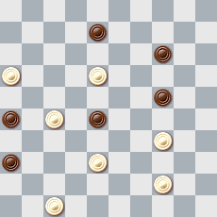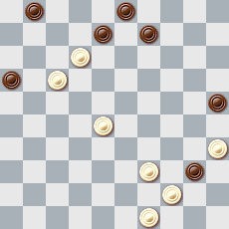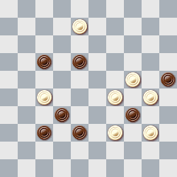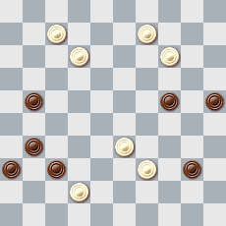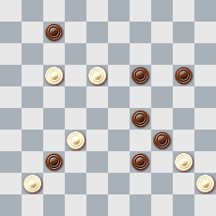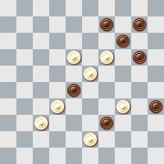

C-7 C-8 C-9 C-10 C-11 C-12
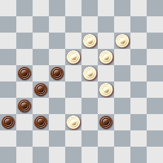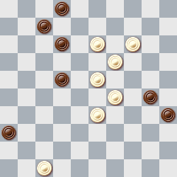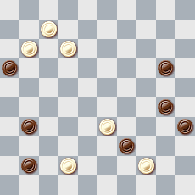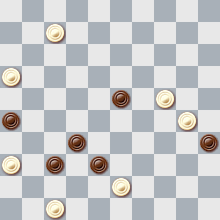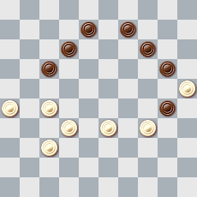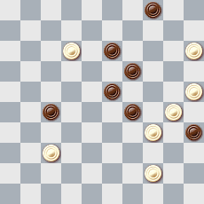

C-13 C-14 C-15 C-16 C-17 C-18
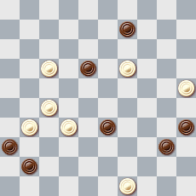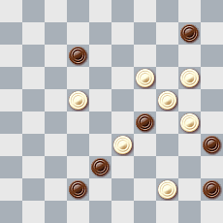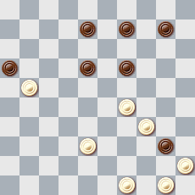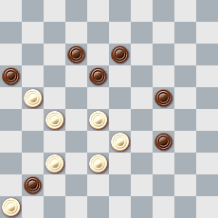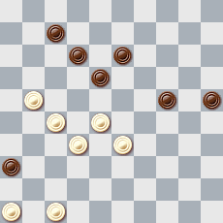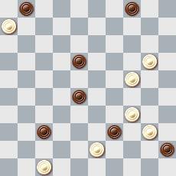

C-19 C-20 C-21 C-22 C-23 C-24
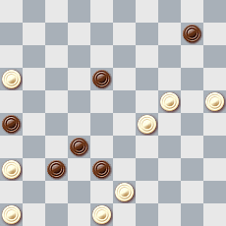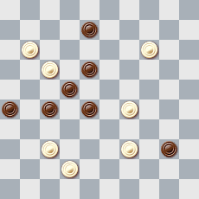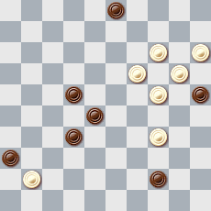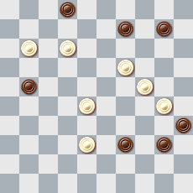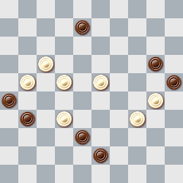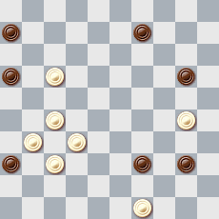

C-25 C-26 C-27 C-28 C-29 C-30
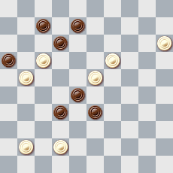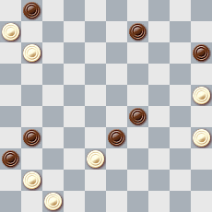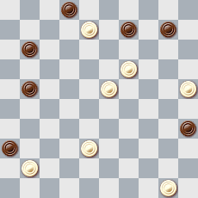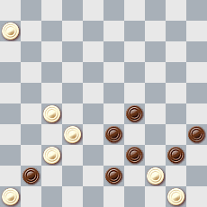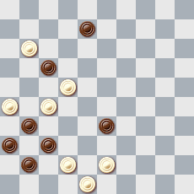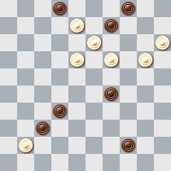

C-31 C-32 C-33 C-34 C-35 C-36
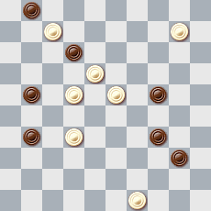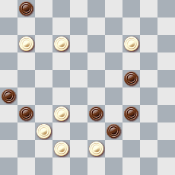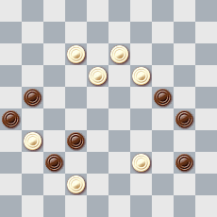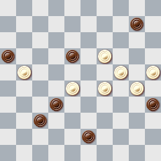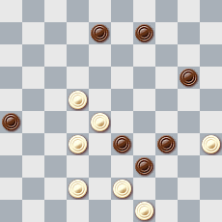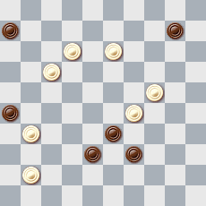

C-37 C-38 C-39 C-40 C-41 C-42
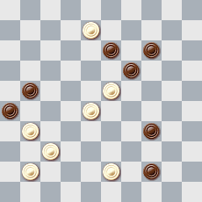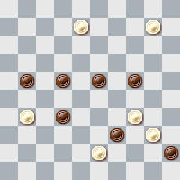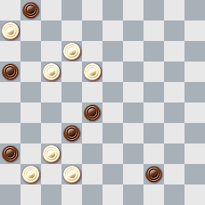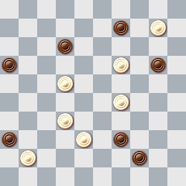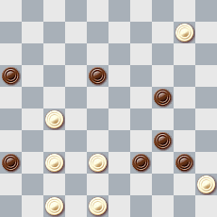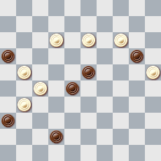

C-43 C-44 C-45 C-46 C-47 C-48
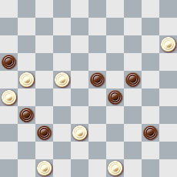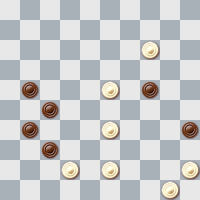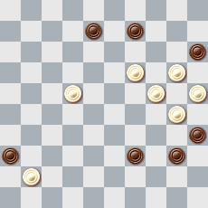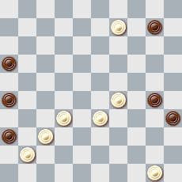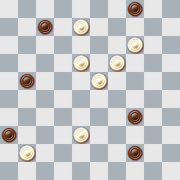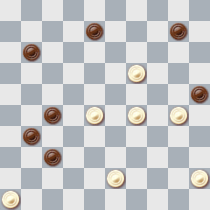

C-49 C-50 C-51 C-52 C-53 C-54
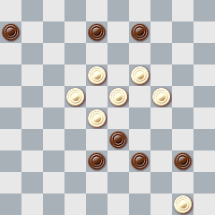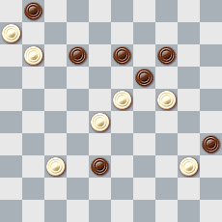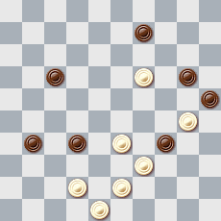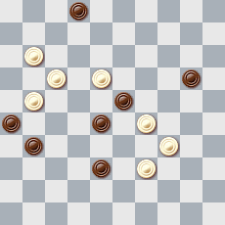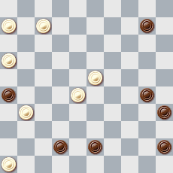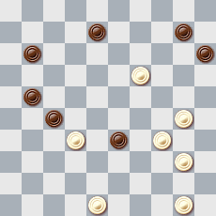

C-55 C-56 C-57 C-58 C-59 C-60
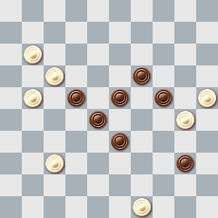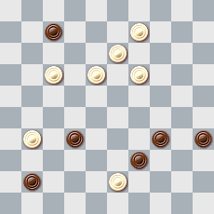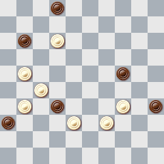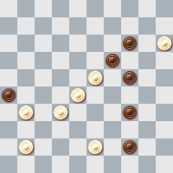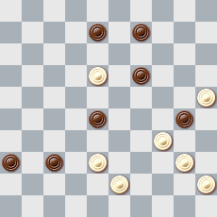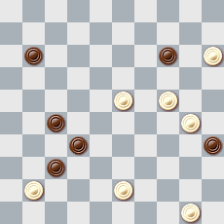

C-61 C-62 C-63 C-64 C-65 C-66
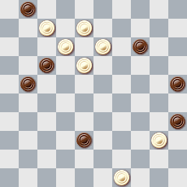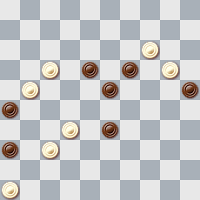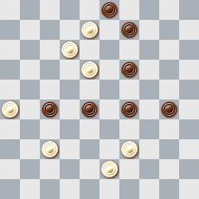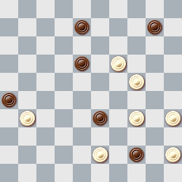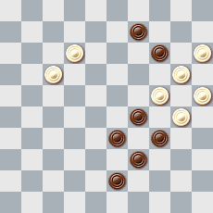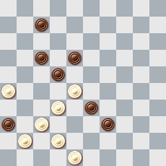

C-67 C-68 C-69 C-70 C-71 C-72
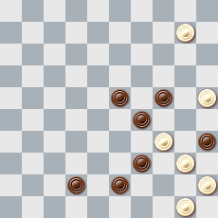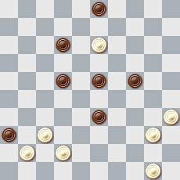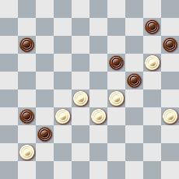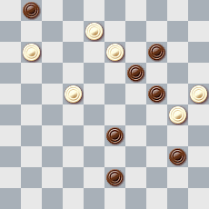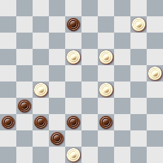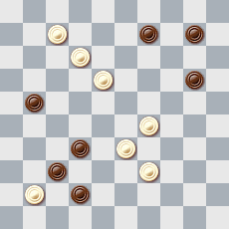

C-73 C-74 C-75 C-76 C-77 C-78
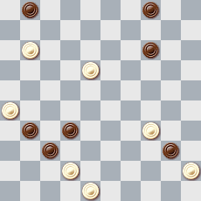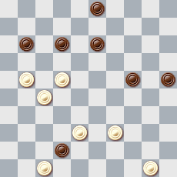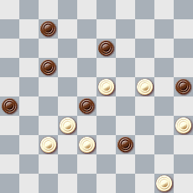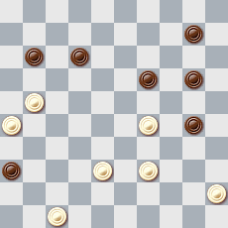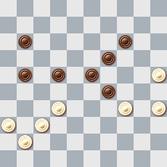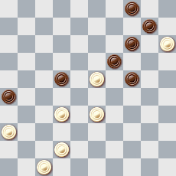

C-79 C-80 C-81 C-82 C-83 C-84
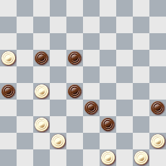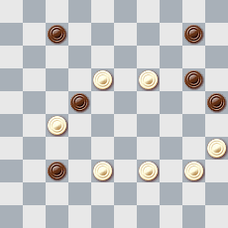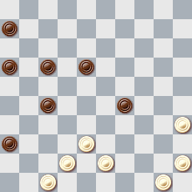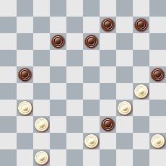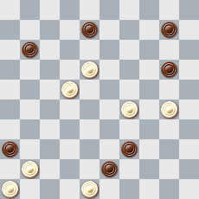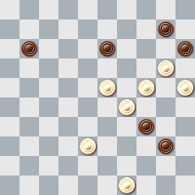

C-85 C-86 C-87 C-88 C-89 C-90
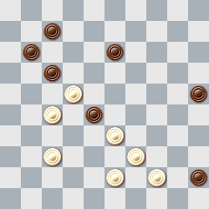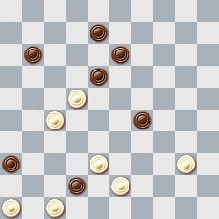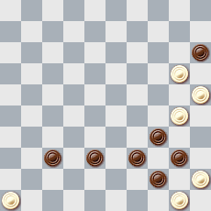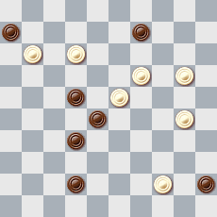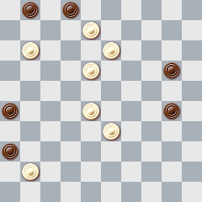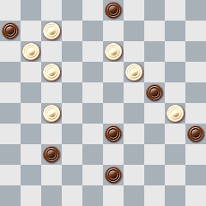

C-91 C-92 C-93 C-94 C-95 C-96
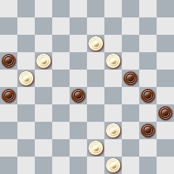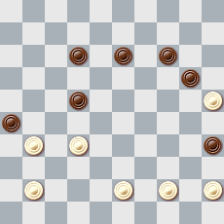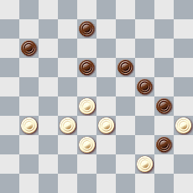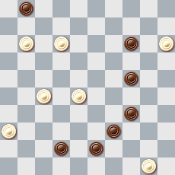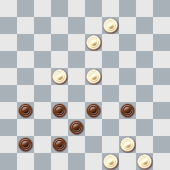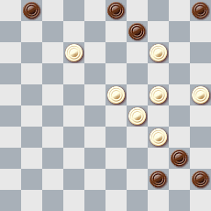

C-97
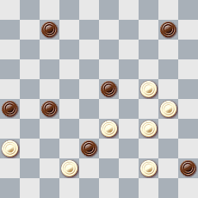

Решения категории C

- 41, 12, 3, 22(3A), 17, 27+ A(49), 27, 27+
- 30, 38, 11, 4+
- 19, 3(45), 3x20x40, 49+ Легальность (Legality): D15, 16, 17, 25, 26, 32, 34, 37, 38, 39, 43/ D45, 8, 12, 21, 23, 24, 27, 29, 30, 40, 48(15-10), 50(28), 11(18), 39(17)
- 10, 5(30A), 41, 3, 1, 20, 45+ A(34), 41, 3, 1, 20, 39, 50+
- 28, 172, 1, 25(33), 38(44), 40, 34+
- 38, 183, 25, 5(29), 28(40), 50(45), 372(34), 383(40), 328(44), 39, 44, 44+
- 33, 41, 8, 37+
- 41, 28, 8, 1(29), 25(40), 39(45), 50+
- 1, 46(50), 427, 26, 17(45), 50+
- 2, 42, 249, 37, 27, 27+
- 261, 23, 19, 3(29), 25(33), 22(38), 31, 3(382AB), 18, 47+ A(372), 17, 48+ B(41), 18, 36+
- 39, 20, 9, 34, 10(32), 28(34), 23, 4(19), 8(40A), 3(45B), 13, 50+ A(23), 3(40), 4-18, 35+ B1(44), 13, 50+ B2(32), 13, 35+ B3(23), 18, 35+ B4(24), 15(30), 25+
- 44, 22(30), 4, 29+ Blonde
- 17, 15, 4, 48, 40, 26(33), 21(39), 49+
- 23(28), 32, 504, 43, 5+
- 23, 22, 227, 48(31), 41(36), 37(42), 31, 37+
- 471, 41, 30, 29, 17(11,22), 1(228), 29, 47+
- 41, 12, 7, 1(19), 10, 34+
- 23, 5, 42, 37, 27, 27+
- 31, 7(5A), 2, 46+ A(10), 2, 2x35x5(33), 32(39), 49+
- 29, 140, 4, 23, 13+
- 117, 14, 8, 23, 3, 2(33A, B, C, C1, C2, D, E, a, b, b, b2), 5+ A932), 5+ B(22), 45(32F), 29(37, 47+) C(14), 35+ C1(27), 35+ D(44), 50+ E(45), 50+ F(33), 34(38), 48+ a(23), 5+ b(16), 15+ b1(17), 15+ b2(26), 15+
- 12, 3(17A), 45, 15+ A(34), 48, 45+
- 43, 21(36x38A), 25(26B), 3, 172, 35+ A(16x38), 25, 3, 35+ B(31), 3, 11, 45(32), 29(37), 47+
- 14, 4, I. 31, 317(328A), 32, 47+ A(338), 27, 32+ I. 27(328), 24, 47+, но на 27(37)= Легальность (Legality): 7, 8, 9, 12, 16, 27, 28, 32, 33, 34/17, 19, 20, 21, 23, 41, 42, 43, 48 (9-13), 15, 438(43), 19(272)
- 30, 38, 24(20a), 3(20b), 25(36C), 7, 1(20m), 26(41), 37, 29(37), 47+ a(33), 7, 1(12m), 1, 26(24), 12+ b(24), 7, 20, 1+ c(37d), 7, 1(17), 23(42), 29+ d(7), 2(37), 24(41), 14+
- 13, 20, 15, 4, 40, 28+
- 1, 40, 28, 48+
- 7, 2, 31, 22, 21, 38, 46+
- 10, 4(2x22A), 18, 32+ A(24x22), 18, 32+
- 44, 5, 239, 17, 31+
- 8, 27, 31(5A), 3, 7, 46+ A(10), I. 3, 7, 27(40B), 22(45), 50+ B(39), 49+ I. 2?, 15(39)= Легальность: 1, 24, 26, 31, 33, 39, 45/11, 12, 14, 32, 37, 40, 42, 48 483(34)
- I. 9(22A), 7, 1(34B), 4, 48+ A(4), 7, 1, 46, 16+ B(37), 45, 45x12x42(34), 4(28C), 10(39D), 38, 49+ D(40), 38, 35+ C(27), 31(39), 33, 42+ I. 7?, 1, 46, 45(27), 23(31)= Легальность (Legality): 15, 21, 26, 30, 32, 34, 37, 40/12, 13, 18, 19, 20, 31, 42, 43, 48 39(43), 39(24)
- 293, 5(32x14a), 41, 36, 48+ a(25x13), 5-23+
- 350, 28x39, 25, 21, 38+ Легальность (Legality): 6, 8, 9, 20, 33, 34, 39/11, 21, 22, 28, 32, 35, 43, 48, 49 1. 48-42 6x26
- 19, 11, 2, 5+
- 32, 39, 2, 5+
- 5(48), 26(30A), 2, 19, 27, 35(39), 49+ A(25), 3, 27, 48+
- 11(38), 127(23), 1(7A), 49, 46(33), 32(39), 49+ A(41), 46, 1+
- 13, 21(27A), 5, 14, 49+ A(47), 4, 9, 49+
- 41, 5(29a), 43, 19, 19x30x11, 1+ a(33), 43, 19, 19x30x6+
- 22, 5(16x27A), 16, 47+ A(36x27), 48(32), 26, 42…+
- 18, 10, 44, 5, 41, 28(19), 8(33A), 30(38), 48+ A(30), 35(34B), 44+ B(33), 30(38), 48+
- 39, 18, 29, 40, 37+
- 18, 204, 183, 2, 24, 14+
- 31, 4, 15, 44(34a), 49(39), 494(43), 40, 48(21), 42(27), 37+ a(21), 39(27), 25(32), 48+ Легальность (Legality): 8, 16, 26, 30, 35, 36/9, 14, 19, 24, 29, 32, 33, 37, 46, 50, D20. 13(8x10), 41(19), 20-24(30)
- 12, 2, 9, 50, 26(33), Z. 21(39), 49+ Z. 48?(38)=
- 293, 41, 13, 5(23), 2(37), 19(39), 34(42), 28(48), 39(26), 17, 34+
- 12, 11, 45, 32(28), 14, 21+
- 18, 7(12a), 1(44A), 1x29x25, 50+ A(30), 33, 50+ a). (30/44), 2, 46+
- 438(323a), 38, 14, 3, 39, 29, 43+ a). (343), 36, 30(24), 13(35), 4+
- 33, 7, 9, 3(36ABCa), 14+ A(35), 15(40), 33(44/45), 50+ B(25), 35+ C(34), 36+ a(37), 41/46+
- 2, 41, 24, 5, 39(50), 17, 7, 7-1(44), 40, 1, 45+
- 24, 43, 30, 14, 2(24), 20, 44+
- 12, 32, 44, 127, 1(2), 24, 34+
- 4, 182, 30, 46, 28(45), 50+
- 8(43A), 48, 17, 9, 4(29Et), 31/36(40), 22(45), 50(40), 43(44,50), 43-39+ A(13), 17, 30, 6 motive E.Lieubrau: (40B), 1(45), 6(31), 393(36C), 28(41), 22(46D), 32, 50+ B(31), 1(36), 23(40,41), 34+ C(37), 32, 50+ D(47), 17, 50+ E(30), 31/36(39), 22+ t(32), 10+
- 10, 39, 4, 5+
- 12, 41, 34, 34, 34+
- 20, 10, 38, 5, 40, 48+
- 3, 42, 26, 30, 18+
- 12, 28, 3, 47+
- 34, 21, 14, 3(28AB), 14(283), 20(34), 38(39), 49+ A(33), 14(29), 20(34), 38(39), 49+ B(34), 14(29), 20(40), 33(45), 50+
- 350, 40, 14, 2, 35(23), 24(29), 23(39), 34(41), 349+
- 10, 15, 3, 10, 49(30), 7(35), 27(40A), 1(44), 49(50B), 44(43), 6, 48+ A(44), 1(40C), 45(49), 16(35), 172(49), 127(35), 2(44), 40, 49+ C(44), 1(49), 16(350), 45 и т.д. как в варианте A B(43), 16(49), 45(35), 172 и т.д.
- 27, 261, 1, 27, 26+
- 5(30), 34(44A), 39, 254, 34, 34+ A(39), 34(40), 43(40), 38(29), 20(34), 33(45), 15(40), 29, 39, 24, 24+
- 9, 30, 8(14), 3(20), 25(28), 48(42), 39, 36+
- 30, 292, 5, 27(14), 6, 28(40), 22(44A), 29, 50+ A(45), 29, 50+
- 20, Z2, 29, 18, 7(18), 2(23), 11(29), 39(7), 6(34), 1+ Z3?(35)=
- 193(19), 24, 4, 41, 36+
- 1, 28, 13, 5+
- 7, 43, 10, 25+
- 227(31), 17, 30, 30(9), 24Z C.Blankenaar 1892: (13A), 20(19), 15(23), 10(29), 5(34B), 23(39), 28(43), 37, 49+ A(14), 41/42+ B(33), 37, 29+ Z 25?(14)=
- 30(34A), 31, 44, 2(18,39), 33, 2(32B), 7(22), 11(27), 16(31), 38(37), 47+ A(19), 27, 21, 1+ B(33), 7(22), 16(39), 11+
- 23, 41, 34, 5(33), 28, 17, 6(28), 1(32A), 29(37), 47+ A(33), 34(38), 48+
- 27, 37(40), 44, 7(28), 2(32), 24(19), 13(37), 36(42), 47, 40(37), 42, 34, 34+
- 338, 38, 9, 4(41), 31, 31, 36+
- 43, 32, 21, 11, 40, 17+
- 193, 32, 33, 34, 4(11a), 8(30b), 2(34), 16(37), 2(40d), 19(42), 24(48), 42, 45+ d(41), 19(46), 5(40), 9(45e), 9-14, 28(50), 6+ e(41), 46(44), 4(49), 32+ a(36), 10(30), 8(34), 2(12), 7(39), 1(43), 34(48), 19, 19+ b(37), 3(42c), 17, 48+ c(16), 17(42), 11, 12, 48+
- 32, 44, 21, 30(11), 24(17), 19(22), 13(28), 8(33), 2(39), 11(43), 38, 16(31), 38(37), 15(42,41), 10+
- 26, 14, 42, 24, 35(15), 40(14), 10, 34(9A), 29(14B), 24(30), 20, 24+ A(10), 350(14/15, 24+ B(13), 23+
- 304, 4(15), 42, 41, 13, 49+
- 18, 44, 19, 16+
- 40, 30, 21, 1+
- 461, 38, 38, 34, 3+
- 41, 43, 30, 34, 34+
- 40, 10, I. 4, 47+ I. 5?, 47(37)=
- 7, 3, 21, 3+
- 8, 2(13), 31, 48, 38+
- 44, 12, 2, 49(21), 16(40), 11(45), 34, 50+ Легальность (Legality): 15, 16, 26, 28, 30, 35, 40/13, 17, 19, 20, 27, 39, 43, 49 27-21(24)
- 28, 10, 14, 34+
- 22, 29, 2, 16, 47+
- 127, 7, 44, 10, 26(7), 21(12), 17, 31+
- 44, 43, 44, 4, 50+
- 10, 8, 319, 7, 3, 50+
- 40, 31, 25, 5, 35(39), 49+

Category D

D-1 D-2 D-3 D-4 D-5 D-6
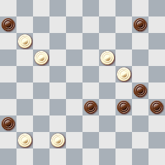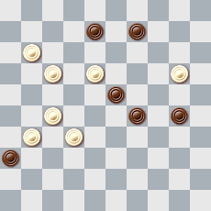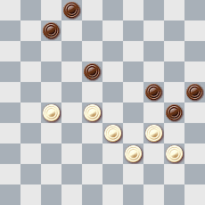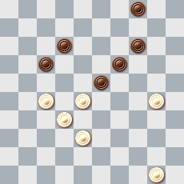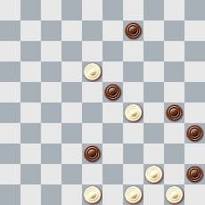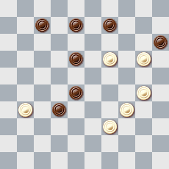

D-7 D-8 D-9 D-10 D-11 D-12
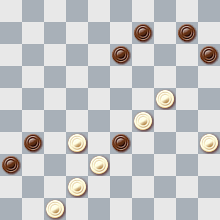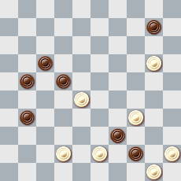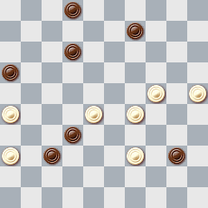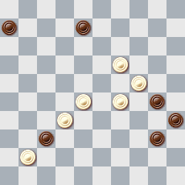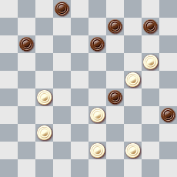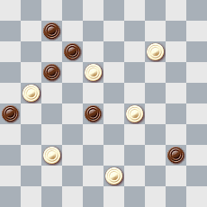

D-13 D-14 D-15 D-16 D-17 D-18
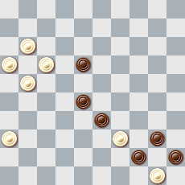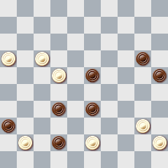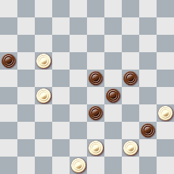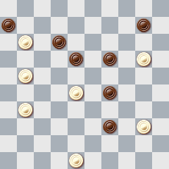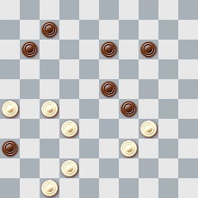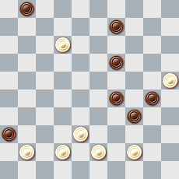

D-19 D-20 D-21 D-22 D-23 D-24
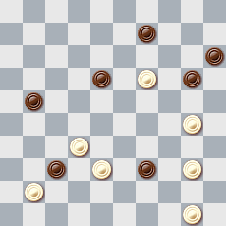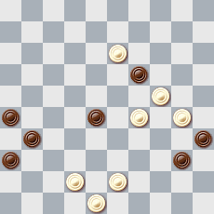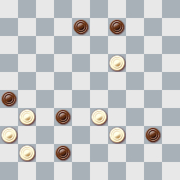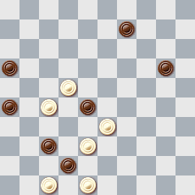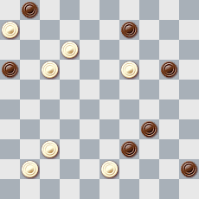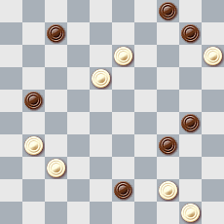

D-25 D-26 D-27 D-28 D-29 D-30
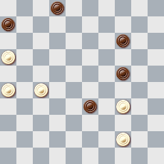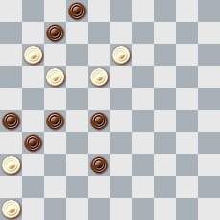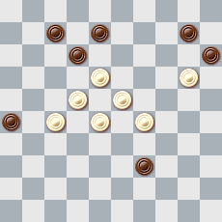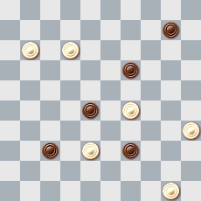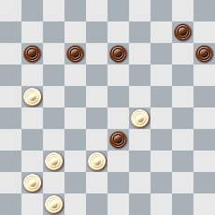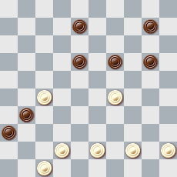

D-31 D-32 D-33 D-34 D-35 D-36
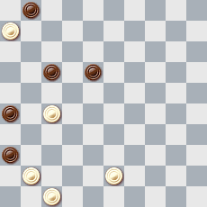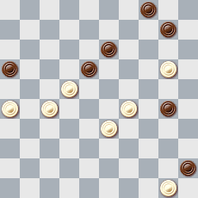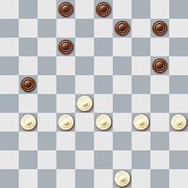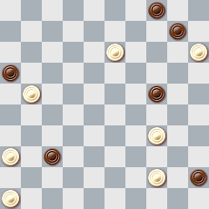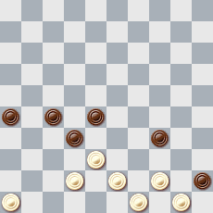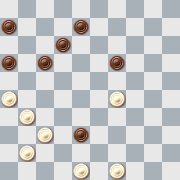

D-37 D-38 D-39 D-40 D-41 D-42
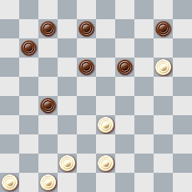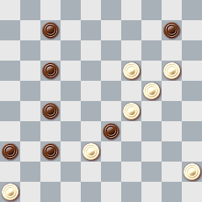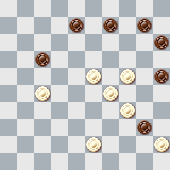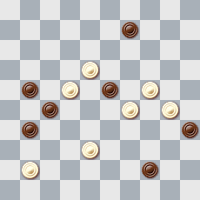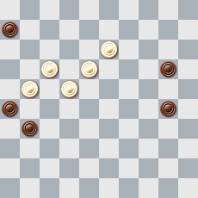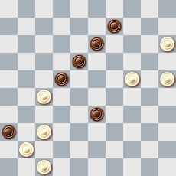
D-43 D-44 D-45 D-46 D-47 D-48
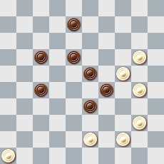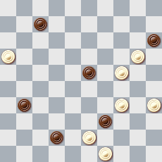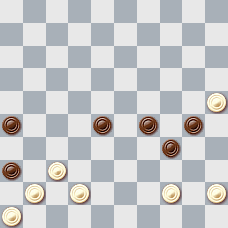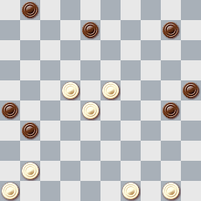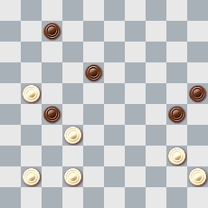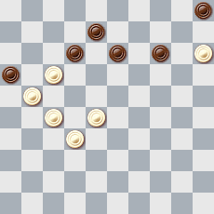

D-49 D-50 D-51 D-52 D-53 D-54
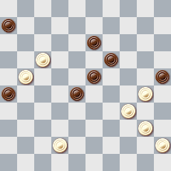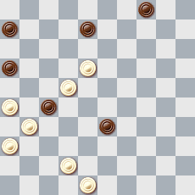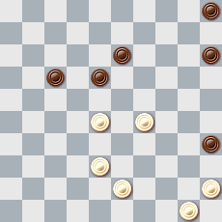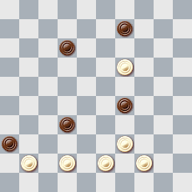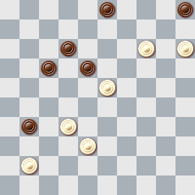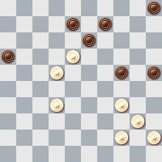

D-55 D-56 D-57 D-58 D-59 D-60
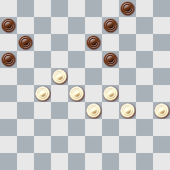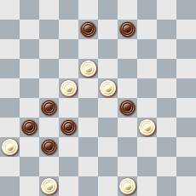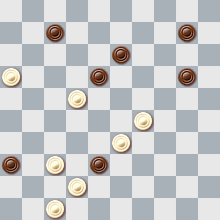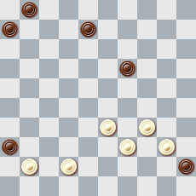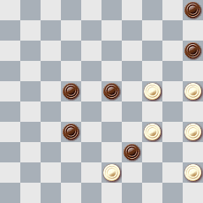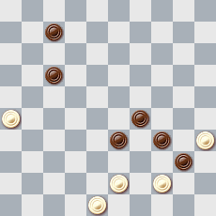

D-61 D-62 D-63 D-64 D-65 D-66
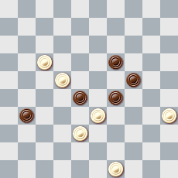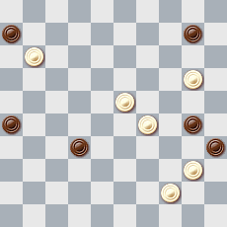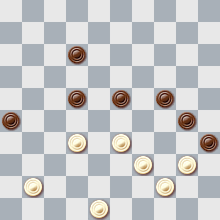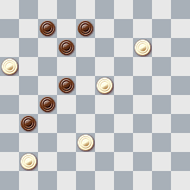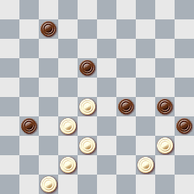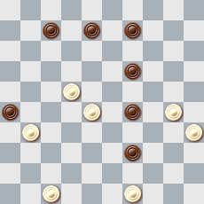

D-67 D-68 D-69 D-70 D-71 D-72
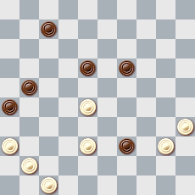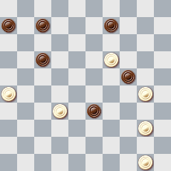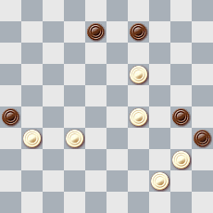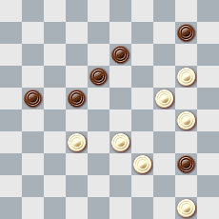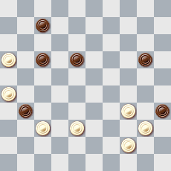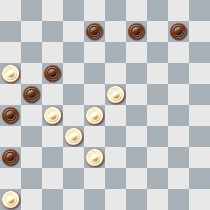

D-73 D-74 D-75 D-76 D-77
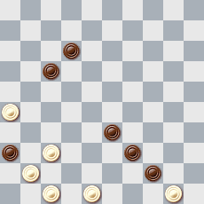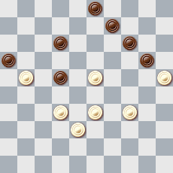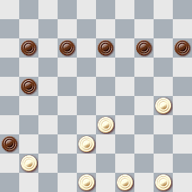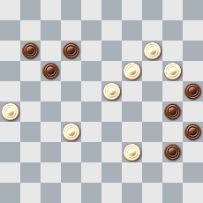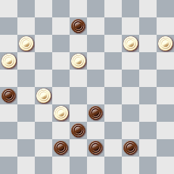

Решения категории D

- 14, 5, 5x32x25(38A), 3(40BC), 172, 35+ A(40), 3(45), 172, 50+ B(43), 172, 49+ C(42), 172, 48, 39(45), 50+
- 21, 14, 1(27AB), 25, 48+ A(33), 6(38), 43(27C), 439(32), 6-33(37), 47(35), 34+ B(304), 28(27), 283, 40/45(32), 29(37), 47+ C(35), 1(27), 18(32), 23(40), 45(37), 23(42), 38+
- 35(8), 349(22), 17Z(7-12), 29, 24, 28, 19(28A), 10(32), 5(38), 37(13), 26(18), 33, 3(33), 9(23), 14(29), 20(34), 38(40), 33(45), 50+ A(20), 28(13), [(12), 33, 14+], 22(24), 34(19), 18+ Z18?(8-12), 20, 24, 32, 19(28!, 32), 5(38), 37(11!), 31(17), 37(22!) [на (21?), 48(27), 26+] 48(28)= или (or) 26(27!)=
- 272(21), 24[18?(27!)=] 10, 17(18,22), 21(27) 16(31), 27, 11(27), 7[6?(34!), 1(32!)= (31), 1(36), 50-45(20A), 1-40(24B), 23(34C), 40(41), 23(47), 34, 34+ A(41), 23(47), 34, 25+ A(34,41), 23+ B(41), 23(47), 34, 14+ B(34, 41), 10+ C(29, 41), 34+
- 12, 483(42), 38, 40, 38 1) – (34), 33(40A), 7(44B), 39(50), 1(13), 45(19), 1(24), 45(30), 1(35), 45+ A(13), 7(19A1), 29, 2+ A1(18), 29, 1+ B(14), 1(20B1), 6+ B1(19), 1-29+
- 194, 1(22), 1-29(27), 33(37), 30, 15(42), 20+
- 19(13x), 20, 20(15), 14, 30(25), 24(20,30), 10(34), 4(39), 327, 27(41, 44), 428+
- 14, 5, 28(42A), 22, 17(48), 39+ A(41), 22, 17+
- 34, 7, 3, 31ZY(42ABC), 17, 27, 48, 42(26D), 37+ A(41), 17, 27, 46+ B(17), 42+ C(21), 6, 9+ D(27), 37+ Z 20?(17), 24X(16-21), 19(42), 37, x16(22)= Y 14?(42), 37, x27 или (or) x37= X 14?(42), 37, x27(16-21)x16(22), 11(28), 7(33), 2(38)=
- 27, 13, 2, 39(45), 50(40), 21(44A), 17(50B), 16, 7+ B(11), 6, 17, 17+ A(11, 50), 272+
- 40, 15(44A), 4(16B), 19, 49(17/8/7C), 32, 12/3+ C(32), 7, 32/31+ B(21), 19, 7, 32/31+ A(16B), 4, 19, 49 и т.д. c+
- 24, 1(31a, 42), 29(48b), 23(5A), 46+ A(10), 5(33), 32(39), 49+ a(45), 29(50), 39+ b(47), 38+
- 12, 2(49a), 19, 32, 32, 27, 27, 39, 33, 27+ a(38), 19, 35+
- 18, 47(30A), 38, 38, 34, 14+ A(38), 32(24), 28(240), 37(35), 34(40), 32, 23, 28+
- 30, 39(43), 34, 39(45), 33(21), 16(50), 11, 6, 17+
- 17, 15, 4(26), 11, 2(23A), 19(41B, a), 43, 34, 36+ A(34), 29(23), 19 и т.д. как в варианте B B(34), 29(41b), 193(44), 43(50B1,C), 39, 46+ B1(49), 23, 46+ C(47), 38, 49+ a(42, 43), 8(33), 2(38), 8+ b(44), 43(50b1), 39+ b1(49), 193+
- 28, 6, 1(41a), 25(46A), 41(34B), 39, 50+ A(45,50), 394(45), 340(29), 37(23), 371(19), 27, 30, 27+ B(30), 45+ a(45), 20(50), 20-33+
- 439, 3, 20(43), 25(49A), 43, 2+ A(48), 7, 39+
- 13(46), 4(44), 16, - Belard 1931, - (24AB), 33, 39(32), 20, 34+ A(35), 44+ B(25), 33, 39(30), 38(35), 34+
- 438, 23, 2, 49(37A,37), 32, 42(33m), 43(41B), 37, 27(39), 49+ A(41), 37(33), 38, 46(31), 41+ B(39), 34(41), 37, 29(37), 47+
- 37, 38, 13(18A), 32, 2(45), 11, 6+ A(19), 34, 4(41), 10(47B), 15+ B(46), 5+
- 21, 4, 15(41Aa), 42(46), 31, 41, 37+ A(25,37), 43(30), 39+ a(42), 38, 43(31), 42+
- 7, 14, 3(26), 48(50A), 417, 17, 17+ A(27), 417, 22(21B), 50(27), 1(32), 29(37), 47+ B(50), 17, 17+
- 39(49A), 9, 4, 35(48), 504, 49(25), 43, 26, 37+ A(48), 9, 4, 35(49), 504, 49(25), 43, 26, 37+
- 29(39), 9, 22(17), 3(28), 17, 7, 21(16), 17(21), 26, 21+
- 8, 2, 43(37), 31(42), 48, 41, 5+
- 21, 13(19a), 5, 2, 11(17), 6(44A), 28, 50+ A(43), 28, 48+ a(17), 2(22), 9+
- 23(41), 5(46A), 32, 44, 33+ A(47), 32, 44, 33+
- 16, 9(37A,14,33), 28, 42+ A(14,33), 37, 29+
- 24(30/29), 41, 5, 19(27A), 2(32), 7(22), 11(28), 33+ A(12), 14(17), 32+
- 21(172), 17Z, 17(31), 39YX(23), 12(28), 8AD(32), 3(317), 26, 37, 33(7), 28(11), 22(16), 17+ Z 16?(31), 11(28), 7, 1(32)= Y 38?(23), 12(29), 8(34), 3(40), 17(45), 50(6/7)= X11?(23), 39[38?(28), 6(32,22)] (28)=
- 24, 14(183), 5(10), 14, 17(18), 261(14), 11, 17(19), 12(22), 29, 28 Nicod 1934, 19(22), 14(27), 10(32), 5(38), 44(42/43), 40, 48/49+ A(183), 18(24), 12(29/30), 7(34), 1(39), 44, 6, 50+
- 317(26), 21, 22, 13(17), 27(7), 43(11), 38(16), 32(171), 22(26), 27(21), 16(31), 8, 17, 36+
- 40, 29, 9, 4(41), 15(47), 31, 41(20), 47+
- 41(261), 36(327), 439, 43, 22, 38(23), 33+
- 483(18), 32(193), 36, 21, 32, 2(40), 11(21), 22(45), 44(11), 6(27), 39(32), 31(50a), 26, 39(37), 28(42), 37, 37+ a(38), 33, 27(50), 272+
- 14(712), 5(127,37), 471(42), 37, 41+
- 194, 41, 1(20AB), 1-40(41C), 23(47), 34, 14+ A(41), 23(47), 34, 25+ B(34), 40(41), 23(47), 34, 34+ C(24/25), 23(34D), 40(41), 23(47), 34, 34+ D(29), 25, 34(46), 32, 34+ D1(47), 33, 34+
- 20, 21, 5(30), 40(35), 34(39A), 23, 45+ A(22), 30, 37(27), 48(30), 38, 35+
- 13, 4, 50(40), 20, 45(44), 50(49A), 17, 5+ A(36), 10, 15, 16+ Легальность (Legality): 2, 4, 6, 8, 19, 21, 27, 28, 31, 33, 35, 37, 42, 44/13, 18, 24, 29, 30, 38, 47 23(11), 41(17), 29(9), 38(7), 22(23)
- 11(6x28), 9, 12, 3(36ABCD), 14+ A(37), 32+ B(33), 36+ C(25), 35+ D(35), 25, 39(45), 50+
- 250, 29, 23, 33(24A), 29(18a), 24(22), 19(27/32), 13(18), 4(23), 15(28), 42(37), 31(33), 27(39), 49+ A(29), 14, 33(18B), 28+ B(19), 29+ a(14), 24(20), 10, 4(19), 10(24), 15(30), 33+
- 439(28), 394(23), 19, 3, 25(39), 48, 37, 37+
- 11, 2, 30 I, 47(40A), 44, 36+ A(36), 44(29B), 24(41C), 40, 39, 36+ B(28), 38+ C(40,41), 438(46), 32, 24+ I 38?, 30, 36(28), 44(33)=
- 450, 41, 43(50A), 36, 27+ A(31,50), 37 I, 37+ I 40?(28), 36(32), 39(28), 34(23), 21(12), 16(7), 31(18), 26(7), 21(12)=
- 36(37), 31(42), 228, 41, 13, 5, 48(34), 30(34), 504(6A), 39, 38(11), 32(16), 27+ A(7), 39, 38(12), 32(18B), 28+ B(17), 27+
- 428, 35(34), 30(39), 37, 33, 1(39), 34, 40(21), 31/32(26), 27(35), 34+
- 23(138), 28, 272, 23, 3(19), 26(34), 8(23), 12(29), 3(40), 10, 33(45), 50+
- 38(18A), 33, 43, 29, 11(6x17), 14(31), 10(37), 5(39), 34(42), 28(48), 39(26), 17, 34+ A(32), 27(18B), 35(31), 36(22), 28, 17(38), 12(42), 8+ B(28), 11(6x17), 12(33), 7(38), 1+
- 38, 37(13,13), 18, 21(11,21), 26(217,28), 32, 31(41A), 17, 27, 46+ A(42), 17, 27, 48+
- 283(182a), 18(10), 27 z(22, 40A, 14, 42), 38, 29, 44+ A(14,42), 38, 40, 28+ a) (21,18,27), 18(31), 12(36), 8…+ z) 9(14,42)+
- 438, 14, 3(18), 9(23), 14(40), 49(45), 40, 44(40), 35(33), 30(38), 48+
- 19(3-9a), 3(10), 4(36), 11, 21, 21+ a(172), 150(36), 37(28,29), 4(34), 371, 31(40), 22+
- 35Z(10), 440(15A), 340, 20, 30, 27(19), 13, 24(13B), 20(19), 15(23), 10(29), 4(33), 21, 31(39) van Emden 1785 27(44), 22+ B(12), 19(17), 14(171), 22(26), 10+ A(10-14), 340, 20, 40(21), 34(19), 350(14), 13(26C), 3(31D), 24(36), 47(20,41), 10(47), 18(33), 12(6), 8(1), 24(40), 2(34), 27(40), 22(49), 18(44), 15(28), 12…+ D(23), 18, 13(19,31), 27, 19+ C(23,29,34), 11(40), 22-18+ Z 27(10)=
- 293(14), 238(20Z,13), 23, 15(17A,17), 10(18), 5(172), 21, 37(31,28B), 3 Fiu Classvgue (33C), 9(23), 14(29), 20(34), 38(40), 33+ C(32), 9(23), 20+ B(23), 12(238), 21(33), 16+ A(19), 10(24), 5(29D), 23, 13(17), 8(171), 22(26), 3(31), 14(21), 18(36), 13+ D(30), 23(35), 228(17), 13+ Z(4-9), 12(20), 349(25), 293+
- 12, 3(41Aa), 21, 38(46), 41, 38(21), 32(26), 27+ A(42,43,37), 31(36), 14(36-41), 32, 46+ a(38), 26+
- 23(27AB), 11, 2(32C), 4(41), 31, 36(32), 37, 47+ A(18x29), 4+ B(38x29), 1+ C(22), 4(28), 31, 31, 38+
- 30, 33, 2+ Guerra
- 38, 29(24,24), 40(10), 34(14), 340(19A), 20, 24, 24+ A(29), 24, 30+
- 21, 1(42A), 37(38), 30, 34+ A(40), 45(39), 34+ Легальность (Legality): (10-15), 493, 15x33
- 12, 30, 2(40AB), 44, 16(32), 38, 47+ A(36), 19(40), 46(45), 44(41), 28, 33+ B(37), 19(40), 46(45), 44, 32+
- 15, 4(31), 36(38AB), 9(34C), 3, 43(50), 40, 49+ C(42), 20(48), 25(21d), 16(42), 18(24), 12(33D), 127, 1, 49+ D(2), 38(16), 33(2), 34(16E), 449(2), 6(16), 8(7), 1, 2(35-40), 35(50), 44+ E(19), 7(23), 1, 44, 45+ d(48-34), 19+ A(34), 19, 47(21), 39, 26(38), 48+ B(37), 4(41), 10(46), 5, 6, 1(45), 40+
- 328, 29, 8(31), 3(36A), 42, 25(34), 48(43B), 25(37), 20(41), 39, 36+ B(37), 26/31(43), 48, 30, 35, 44+ A(327), 32(36), 20(34), 29(41), 15(46), 39+
- 10(36), 4, 11, 13, 7(28), 11(282), 16(31), 38(37), 47+
- 23(304A), 1, 40, 39, 49(40), 38(45), 44(50), 27, 38, 32+ A(37), I 25(48), 34, 34+ I 1(48), 25(42)=
- 24(20), 30, 41, 25, 1(46A), 44, 6, 5+ A(44), 49x40, 18, 5+
- 34, 22(27), 31, 32(41), 42(47), 27, 27+
- 27, 28(12A), 271(11), 13, 16+ A(6-11), 271(14), 1, 6(16), 33+
- 13, 2(34), 39, 4+
- 15(44), 4(49), 19, 338, 16, 40, 39+
- 21, 1(39), 15(50), 38, 49, 40, 45(28), 11, 50+
- 11, 16(31), 11, 41, 282+
- 43, 28, 37(18), 32(22), 23(28), 42+
- 328, 8, 19, 3(29), 32, 16(44), 11+
- 32, 27, 20, 504+
- 34, 13, 3, 16(40), 261, 11(45A), 6(31), 27, 50+ A(31), 27, 35+
- 21, 13, 4, 22(50A), 17, 7+ A(49), 27, 27+

Всего на чемпионат поступило 355 позиций, в том числе:

Категория A – 94 миниатюры
Категория B – 87
Категория C – 97
Категория D – 77

Всего участников – 50, из 10 стран, из них
Украина – 16
Россия – 7
Литва – 6
Голландия – 6
Франция – 6
Беларусь – 4
США – 2
Израиль – 1
Латвия – 1
Швейцария – 1

