Personal world championship for end games.
Второй личной чемпионат мира по этюдам.
(PWCE-II).

Category A. There should be only White and Black pieces in the initial position. The number of pieces is free till the maximum of 7 Black and 4 White pieces.
Категория А. В начальной расстановке со стороны белых и черных должны присутствовать только простые шашки. Соотношение сил свободное до максимума 7 черных и 4 белых.
Category B. There should be both White pieces and White Kings in the initial position.
The number of units is free, till the maximum of 7 Black and 4 White pieces or Kings.
Категория В. В начальной расстановке со стороны белых должны присутствовать как
простые, так и дамки. Соотношение и качество сил свободное, до максимума 7 черных и
4 белых, как шашек, так и дамок.
Category C. There should be only Kings from White (from 1 till 4) but Black is not limited,
except the maximum of 7 Black pieces or Kings.
Категория С. В начальной расстановке у белых должны присутствовать только дамки
(от 1 до 4), а у черных – свободное количество и качество сил до 7.
Category D. Mini-end games. There should be not more than two units from White: two
pieces, one piece and a King, or two Kings. There are not more than seven units from
Black.
Категория D. Мини – этюды. Со стороны белых присутствуют две единицы свободного
качества: простые, или простая и дамка, или дамки. Для черных – не более 7 единиц любого
качества.
The jury composed of P. Malahieude (France), E. Zubov (Russia) and A. Katuha (Ukraine)
Is formed for the direct carrying out of the PWCE-II.
Для непосредственного проведения PWCE - II создается судейская коллегия в составе:
P. Malahieude (Франция), Е.Зубов (Россия), А. Катюха (Украина).

Victor Shulga (Belarus) is appointed as the championship coordinator.
Координатором чемпионата назначен Виктор Шульга (Беларусь).

Участники – participants

L. Vitoshkin, V. Vorushilo, V. Grebenko, B. Ivanov, I. Navrotski, (Belarus),
S. Yushkevich, S.Уsтianоv, M Fiodorov, I. Bulatov, V. Trofimenko (Ukraine),
A. Tavernier, N. Doubovy, F, Laurent (France), A.Kačiuška, N. Comik, J.Šiožinys (Lithuania),
I. Bastiaannet, T. Smedinga (Holland), A. Nyrov, E. Kopylov (Rusia),
J, Bus (Germany), M.Lepsic (Croatia), А. Моisеyеv (USA), М. Tsvetov (Israel), G. Andreev (Latvia).

Замечания присылать координатору до 10. 05. 2010.

PWCE – II
Categorie A
N1 N2 N3 N4
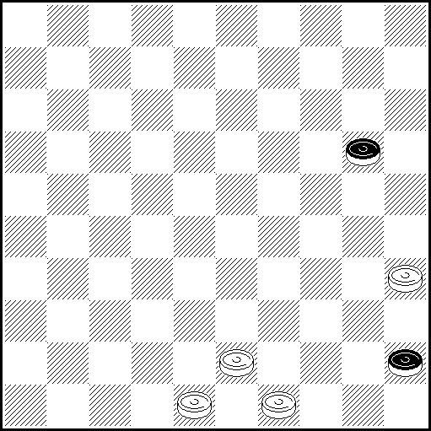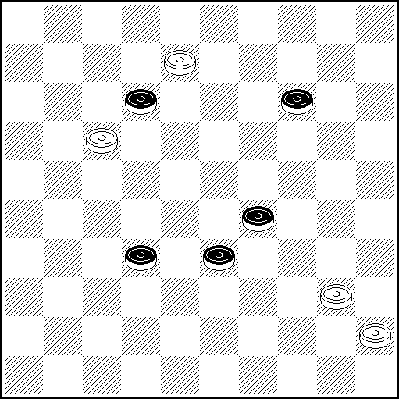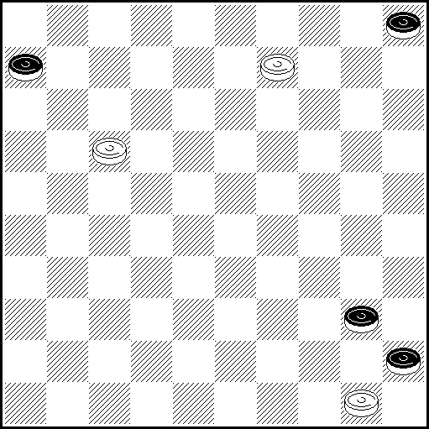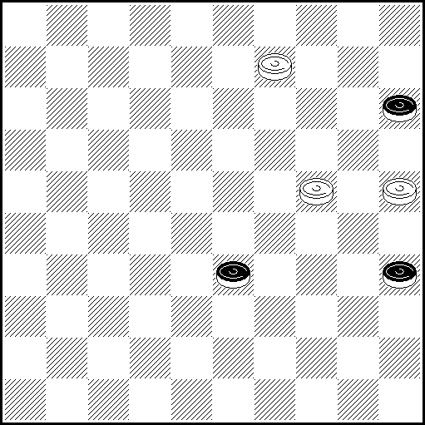
N1 VP: 44(50 A), 30, 39, 39, 34 x; A(24), 40, 39, 39(29), 34, 44 x
N2 VP: 3,20 (338 ABC) 42 (26) 47 (31 D) 36 (317 E) 47 (41 F, 38) 22 (42) 34 (48) 39
(26/42) 17/33,34x A(26) 34,27 (44) 40,18 (31,40) 22 (45) 50x B(328) 34,34
(26or27) 15 (31) 349,26x C(27) 34,34 (39,37 G) 9 (31 H, 42) 38,27 (39) 49x
D(37) 34 (31) 36 (42) 22 (48) 39 (26/42) 17/33,34x E(327) 22 (41) 34
(46or47) 28or33,34x F(38) 33 (41) 34 (46) 28,34.x G(31) 14 (38,36) 27x
H(32) 14x
N3 VP: 3(10 A),8(44),39(50),2,16 x. A(44),39(50),17-12 x
N4 VP: 250(40 AB)4(44/45 В1)19.50 x A(38)4(42)19.48(40)39.50 x B(39)4(43 C)19.49.35 x
B1 (38/39)19.35 x C(44)19.50 x
N5 N6 N7 N8
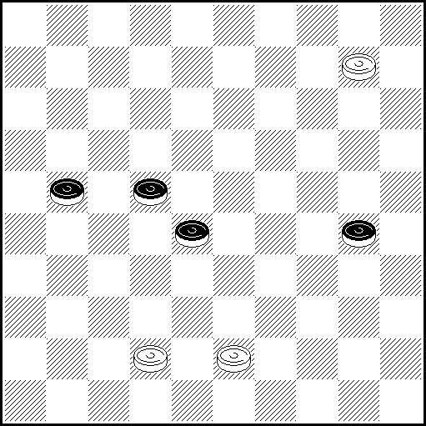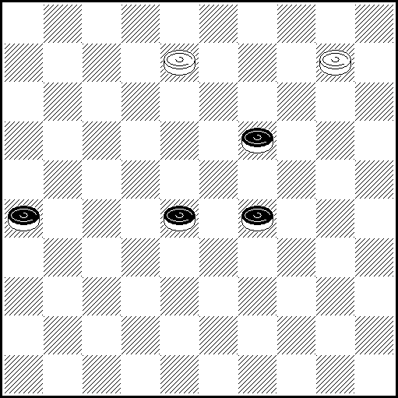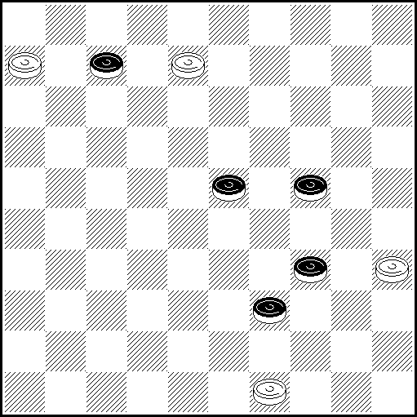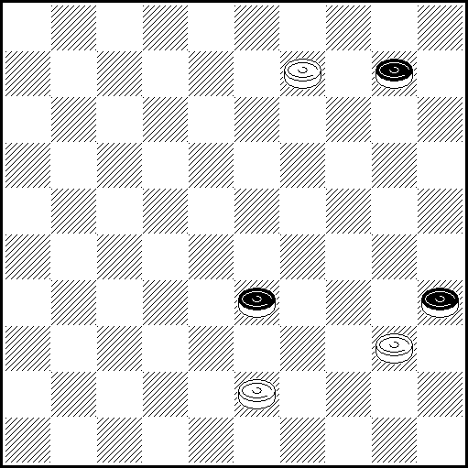
N5 VP: 4(217 A), 10(33), 15(31), 38(34 ВC), 16(40 D), 11(27), 37, 38, 35(32), 24(37), 47 х
A(26), 36(34), 18(32), 40/45(37), 31(37), 23(42), 38 x
B(36), 32(35), 23(41), 46(40), 39(45), 38(27 E), 41(31 F), 46(50, )382(41), 26 x
C(28), 39(36), 37(35), 34 x D(36), 39, 49(41), 37 x E (28), 23(50), 383(45), 1 x F(50), 47 x

N6 VP: 3 Z₁(24 AB), 4(32 CD), 14 (38 E), 37(31 FG ), 36(43), 23, 48 x
A(32), 5 Z₂ (34), 40(38 H), 49(42), 49-21, 48 x B(283), 4(38), 14 x
C(34), 15(30), 25(32), 33(37), 28(42 IJ), 39, 37 x. D(283), 14(34), 19, 30/25 x.
E(33), 37(31), 26 Z₃ (39), 48(44), 39, 15(29), 20(34), 38(39 K), 49 x F(43), 19, 48, 26 x
G(30), 23, 25 x H(37), 14/23(42), 37, 23/14 x I(40), 45(42), 37,23 x
J(35, 37), 41/46(40), 28(45), 50 x K(40), 33(45), 50 x
Z₁ = 4?(32 Y₁ ), 2 Z₄ (37, 37), 15(41) = .Z₂ = 4?(37), 31(41), 8, 36(42) =
Z₃ = 36?(39), 28(43), 39, 13(29), 18(33), 40(38), 34(42)= Z₄ = 3(37), 10(33/34), 41(39)=
Y₁ = (24?), 3 (32 Y₂), 14(38 Y₃), 37(31), 36(43), 23, 48 x Y₂ = (34), 15(30), 25(32), 33 (37), 28(42),
39, 37 х Y₃ = (33), 37(31), 26(39), 48(44), 39,15(29), 20 х

N7 VP: 2(12), 30, 1(44), 34(30A), 40, 34, 24 x A (50),44, 24 x

N8 VP: 34(39A),3(48),25,34 x A (14,39),30,34 x

PWCE – II
Categorie A
N9 N10 N11 N12
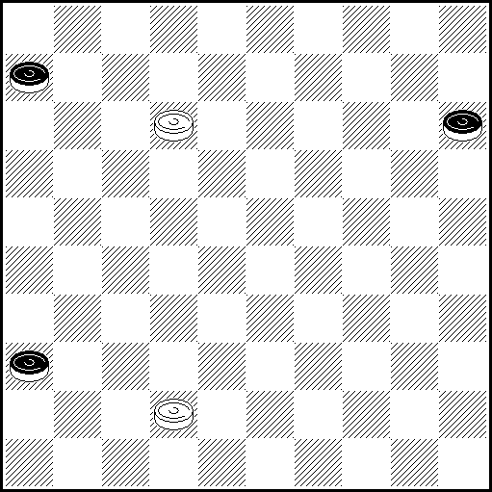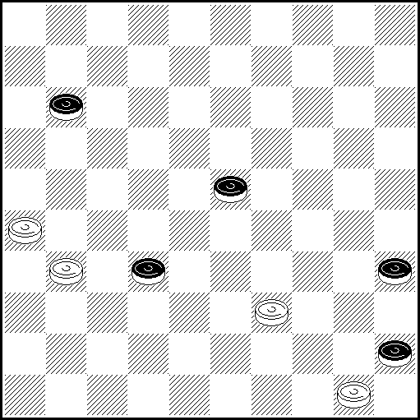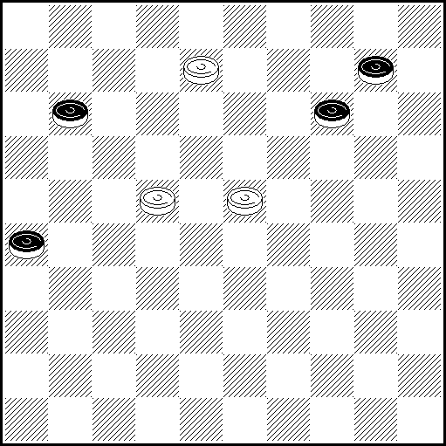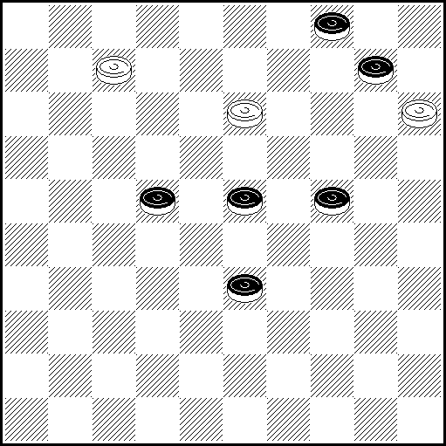
N9 VP: 37(11 A), 8(17), 3(22), 21(28), Z 26(20), 31, 25 x Z 38?(20, 32, 41)=
A (20), 8(24, )3(11 B), 21(29 C), 38(34), 31 x B(30), 17(34/, 35)44 x C(16), 38(30), 43(35), 49 x

N10 VP: 27,6(40A),Z.34,1(34B),40,44 x A(29), Z1.34,1(44),39(40C), Z2.6(50),39-33,35 x
B(23),34(32), Z3.29(37),47 x C(50),6 x
Z. 1?(29,29x). Z1.1?(40,29x.). Z2.7/29?(50=). Z3.48?(38=).

N11 VP: 3(31 A), 20(36 A1Ba), 33(17 Cb), 11(41), 7(47 D), 1, 5 x
A(15), 25(31), 48(36), 37(20), 2218z(24), 13 (30), 8 (34), 2(39 E), 16(41), 46(44), 28 x
A1 (15), 42(36), 37 see variant A.
B(14), 3(37 F), 2217, 9 x C(41), 47(46G), 36(14), 17, 20/25 x. D(15), 2(47 H), 2319 x
E(40), 16(45 c), 11(50), 6 x F(36), 2217, 18, 14 x. G(17), 36 x. H(20), 15 x
a (37), 17, 9 or 17, 15(14), 4 x(Все как у автора). b (14), 28(20), 19(25), 14(30), 10(34), 5 x.
c(44), 31 x z 19?(25), 14(30), 9/10(34), 4(16/17y) = y (40?), 31, 6(45), 50 x
N12 VP: 9, 4 (19)A, 27 (30) 2 (24) 11 (28) 6 (35) 49 (30) 27 (34) 272, 25 x
A(18) 2 (249) 11 (238) 7 (23) 27 (39) 1 (283) 278, 43 x
N13 N14 N15 N16
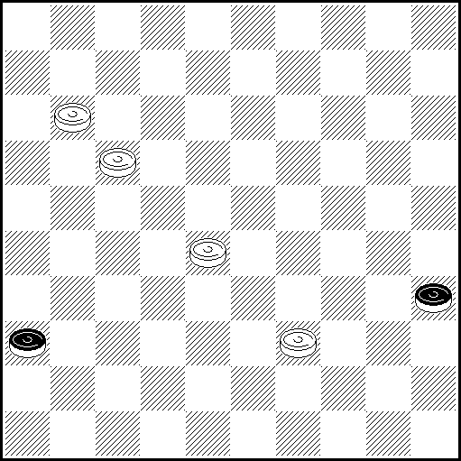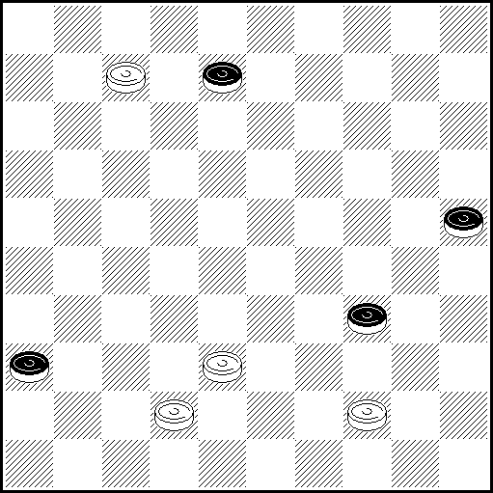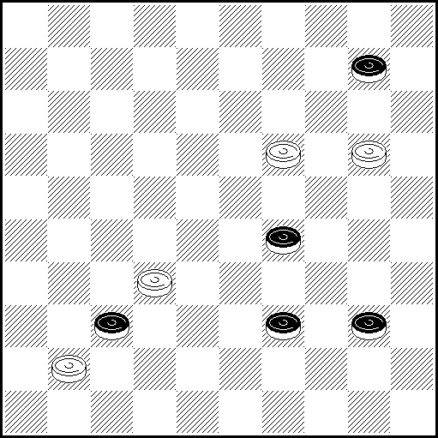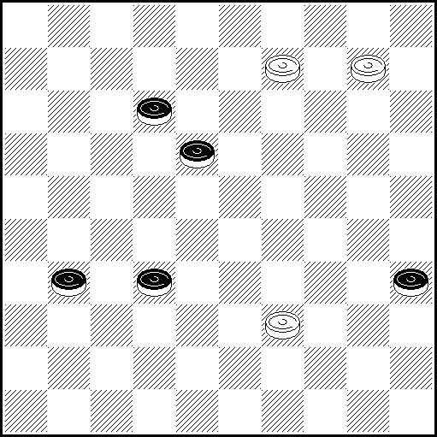
N13 VP: 6(41 A), 1(47), 45(40), 34 ZZ₁(20 BC), 28-23 Z₂(3 VP₁), 11(14), 18(9),
12(22) 45(50 ), 127, 50(1), 45 x VP₁ (14), 18(28), 45(50 VP₂), 11, 50(1), 45 x
VP₂ (44), 50(6), 7(1), 45 x А (40), 34, 23, 12, 1(12), 23, 46 x В (33), 45, 50 x
С (24), 28-23(29), 12(1), 45(6), 50 x
Z 12? (20), 3(24), 23(42), 17-12(37), 18(31)= Z₁ 1/7/18/23? (20)=
Z₂ 11? (14), 34-23(25), 23-34(14), 22(9), 34-18(25), 18-34(9), 17(3), 34-12(25),
33(20), 12-29(3), 29-12(20), 28(14), 12-23(3), 23-12(14), 22(9), 12-18(3)=

N14 VP: 2(30, a), 35(41, A), 24(46, B), 39, 37, 47 x A (40), 2, 16, 43/48(41), 37 x
B(47) 39, 15(38) 42. x a (12) 16 z etc z: 37? (30), 35(40), 31(49) =

N15 VP: 28, 20-14, 5, 35(34A), I 44 x A (33), 30, 48 x I 49?(39) =
N16 VP: 5 (40 A), Z1 8(45), 9-3(50 B), 12 x A(36), 46(22), 3(18), 20(28), 1/12(41), 40, 36 x
B(22), 26(50 C), 3-21, 27 x C(28), 26-12(50 DE), 3-8, 23 x D(33, 50), 22 x
E(32), 25(37 F), 40 x F(50), 25-3 x Z1. 3?(45), 17(22, 50)=
PWCE – II
Categorie A
N17 N18 N19 N20
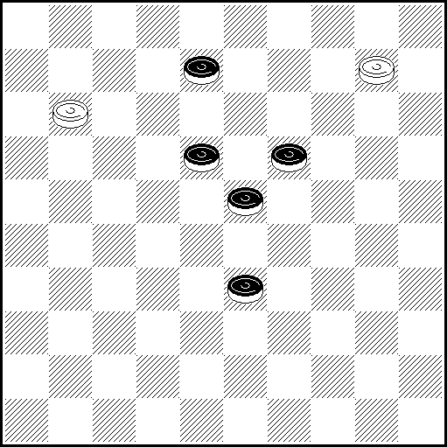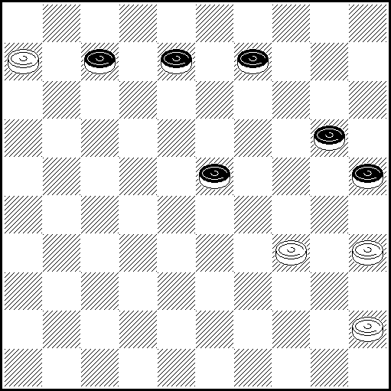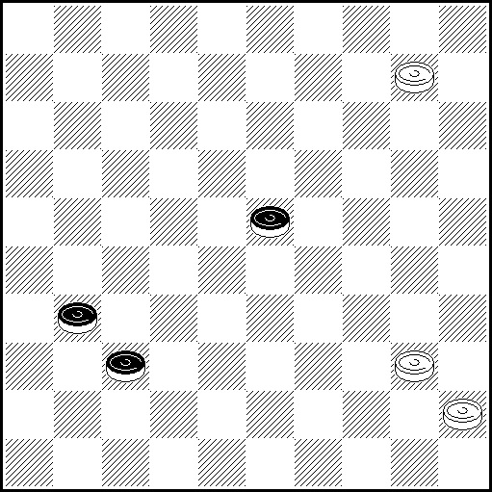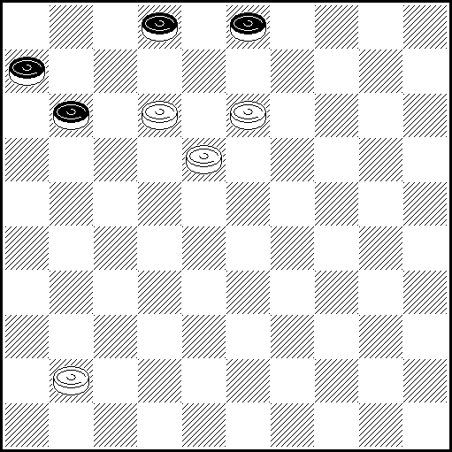
N17 VP: 7(38), 2 Z(13), 5(43 A), 14,49(23), 32(29,33), 32(39), 49 x Z 4(12), 43(1) =
A(42), 14,48(22), 43(28), 38(15), 24(32), 42(15,37), 47 x
N18 VP: 1(8-12 A), 6(14 abc), 3530z(29 d), 23, 18, 1 (29 BCe), 10(39f), 15(24D), 40(34 EF), 44, 50 x
A(29), 14(40), 34, 29(14 G), 24(30), 20, 24 x
B(28), 10(39), 32(24), 49(29 H), 4540(44 J), 38, 15/24(40), 33(45), 50 x
C(40), 15(44), 40, 29(20),15(40), 33(45),50 x D(33), 38(44), 40 x E(43), 34, 35 x F(33), 38 x.
G(13), 23 x H(30), 16/38(34 Kg), 49 x J(33), 16/32 x K(44), 40, 7 x
a(24), 33(13), 15(28) p.e. 10(33), 15(30), 24 (1218), 4 x.
b(13) p.e. 39(24), 48(2430 b1), 24 (28), 37(33), 3719(1318), 2(11), 16 x
b1(19) p.e. 3530, 40, 30, 48:2/8:50(29), 6 or 39 x c(18) p.e. 3530, followed by 33 etc. x
d(19) p.e. 44(18), 50(2024), 44, 49(12), 4540 x e(24), 3/9(39), 25 or 21(44), 40 x
f(25), 15(33), 38/47 x g(35), 16/38(44), 11(49 g1), 44, 34 x g1(50), 6(40), 34 (45), 1 x
z50?(17), 2(24), 30(29), 23(34) =

N19 VP: 5(29), 41(33 A), 36(37), 47(41 BC), 36(38), 22(42a), 34(48), 39 x A(36), 28(33, 41), 40-34 x
B(38), 33(41), 34 x C(39), 34, 40 x a(43), 39, 29 x
N20 VP: 37Z(16), 32(21), 28(26 Aa), 22(31 B), 7, 17 36 x A(27), 22(32), 7, 17, 38 x B(11), 17, 27 x
a(11),22 (16), 17(27), 11, 1(32), 18-12 x Z 7? (3-8), 16, 12(23), 7, 7(11), 16 =
N21 N22 N23 N24
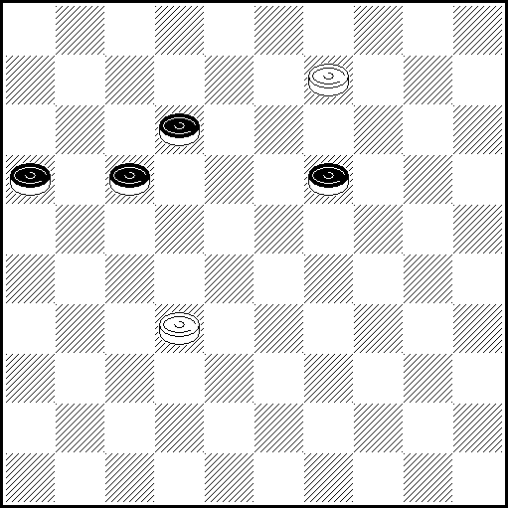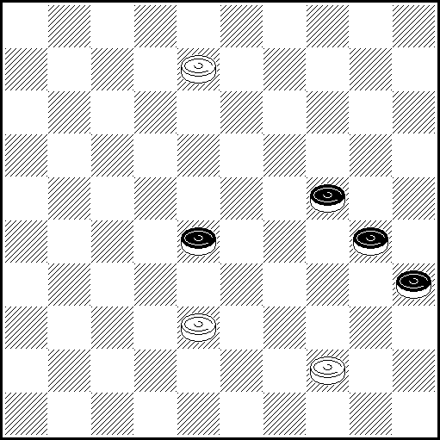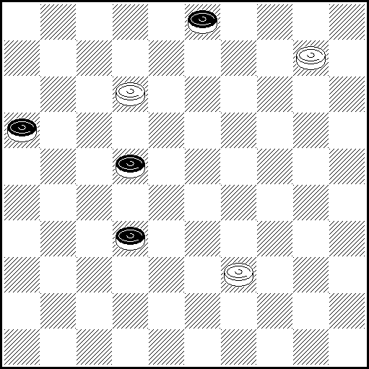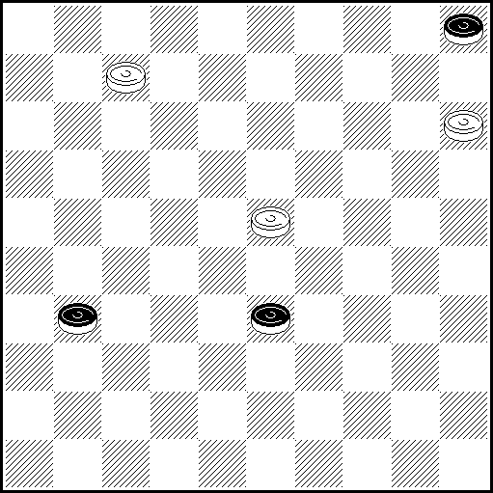
N21 VP: 27(24 ABCD), 3(18 EF), 26(29 G), 48(33), 43(23), 22(28 I), 17(32), 27(39), 49 x
A(16-21), 16(24), 3(30), 11, 17(34), 44 x B(17-21), 3, 43/49(24), 38(30), 43(35), 49 x
C(18), 3(17-22), 26 x D(23), 3(28 J), 22(17-21 K), 26 x E(16-21), 16(30), 11, 17(35), 44 x
F(30), 22, 25 x G(30), 48(35), 34 x H(29), 17(34), 30/25(38), 48 x I(21), 16(28 L), 27/49, 43 x
J(16-21), 16(28), 11 x K(18), 33(23), 26 x L(39), 7 x
N22 VP: 2(29)11Z (294 A)33(340 B)11Z1,16,25,39,50x A(293,32)33(37)47x B(39)6,383,25,39,50x
Z 40,49(283)32(39Y)28(34Y1)= Y (34)44(349)49x Y1 (33)16,11x Z1 449(34Y2)30(24)=
Y2 (45)6(40) 32(50)328x

N23 VP: 5Z(38)33,7(33)1(27)19(38)30(8,21 AB)11(31)17,26 x A(32)11,42 x B(31)11,26 x
Z 4(27)31(9,37) =
N24 VP. 1(10 AB), 4(38/39 C), 36(43/44), 22(48/49), 39/44 x A(36), 10, 19, 47 x
B(38/39), 10, 19, 26 x C(37), 22(38), 33 x

PWCE – II
Categorie A
N25 N26 N27 N28
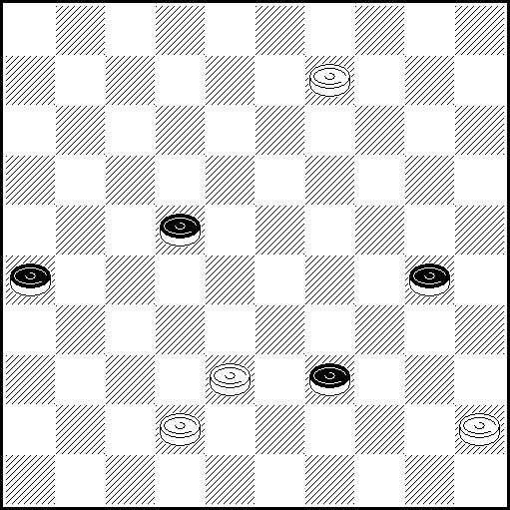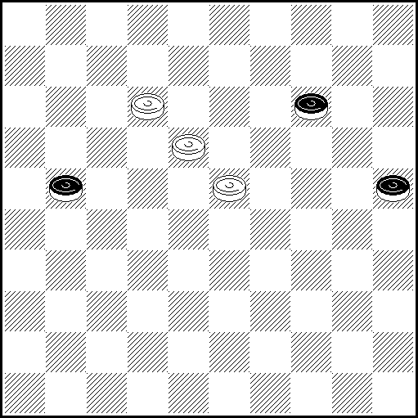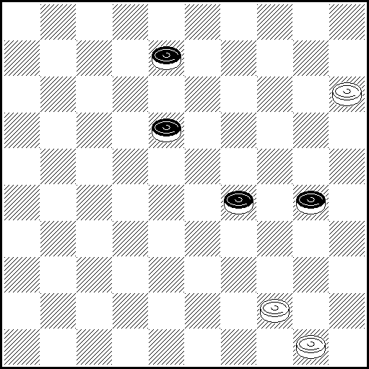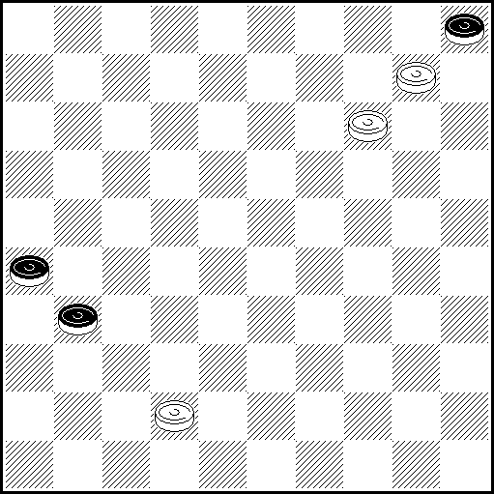

N25 VP: 3(44 AB), 40(35), 25(27), 34(261 C), 33(36), 28(31), 45(41 D), 37, 36, 22(45), 50 x
A(35), 33(28), Z1 38(27), 14, (272, 33), 21(17), 3(39 EF), 21(44), 17 x B(28), 25(34), Z2 37 x
C(271), 32(36), 28(41), 37, 18(31, 40), 22(45), 50 x D(37, 27), 22 x
E(22), 9(28), 14(32), 37(38G), 48 x F(21), 26(38), 48 x G(39), 32(44), 28 x
Z1. 9?(33), 27(39), 37(44), 22(50 Y1), 6(40, 45)= Y1. (49?), 44, 34 x Z2. 33? (32, 40, 37, 37)=

N26 VP: 7(30 AB), 1(35 C), 13(26 D), 8(31), 3(40 E), 20(36 FG), 33(41), 28(46 VP₁ H), 238, 45 x
VP₁(47), 33, 45 x A(27), 1(20), 13 Z₁ (32 I), 8(38 J), 2(43 K), 24, 48 x B(26), 1(31 K₁ ), 19, 36 x
C(26), 19, 25 x D(27), 8(19), 14(32), 3(38), 17/21(42), 3(40), 45(47 D₁), 29 x D₁ (48), 34 x
E(19, 37), 23(40), 45(41), 23(47), 29 x F(44), 33(49 M), 44(12), 36 x G(37), 33(42 N,44), 33(49), 44 x
H(44), 50(47), 33 x I(30), 9(34), 4(39), 31/36(43), 22 (48 H₁), 39, 15 x H₁ (49), 44,15 x
J(24), 2(37), 35(41 L), 44(46), 28(30), 238,,25 x K(30, 42), 24, 47 x
K₁(20), 13(31), 8(37), 2(42), 24, 47 x
L(42), 44(30), 33(48), 39,25 x M(50), 33-6(37), 1-12/18(44), 50(42), 1(48), 39 x N(45), 47(50), 6 x
Z₁ 18-12?(30 Y₁)8(34)2(31 Y₂)24, 40(37)29(41)23(47 Y₃)=
Y₁ (31?)8(37)2(24 Y₄)35(42)44(30)33(48)39, 25 x
Y₂ (32?), 16(37), 32 x Y₃ (46?), 5x Y₄ (30, 42), 24, 47 x

N27 VP: 10(22 A), 4(28), 27(35), 49 ZZ₁Z₂(293 B), 39, 39(12), 38 → (40),, 34, 20(32), 3(18), 9(23), 20(37 VP₁), 14 x VP₁ (32), 42 x
A(33), 4(23), 39 Z₃, 39(35 CC₁), 15(28), 47 Z₄(32 A₁D), 41(38), 47(43), 48(40), 33(45), 50(12), 43
(17), 6(50), 43-39 x A₁ (12), 38 →VP x B(40), 35(34), 30 Z₅.504(30 E), 21(34 F), 3(32), 26(38), 48 x
C(28), 27(13 GG₁), 9(32), 20(37), 47(35), 34,x C₁(29), 27(294), 49, 3 x D(40), 34, 2(32), 24(37), 47 x
E(33), 39, 2, 35 x F(35/33), 3(33/35), 25(38), 48 x G(12), 43 Z₆(17 G₂), 38(22), 16(35), 34(33), 11(28 H) ,29, 20/15(40), 33, 50 x G₁ (35), 49(12), 38 → VP x G₂ (35), 38 → VP x
H(27), 39/44/50(32), 33(37), 47 x
Z 40?, 39(13 Y), 9(293), 34(38), 14(32), 37(43), 14(49) = Z₁ 39? (40 Y₁), 38(283), 28(44, 49)=
Z₂ 43? (293), 16(12), 45(17 Y₂), 450(39), 11(44), 6(49) = Z₃ 27? (34 Y₃), 43(339), 33(29), 2(38), 24(43), 35(48) = Z₄ 34? (40 Y₄), 45(32), 42(12), 40(17), 34(21), 34-29(26), 23(37, 37) =
Z₅ 16? (33), 43(349), 2(38), 24(43), 29(48 Y₅) =
Z₆ 49? (33 Y₆), 28(17), 43(35), 34(21), 45(26), 18(31), 36, 23(44), 22(49) x
Y (293), 49, 2(32), 24(37), 47 x Y₁ (293), 49, 39(12), 38 → VP x
Y₂ (18), 21(22), 16(39), 33.11 x Y₃ (28), 49(35), 39, 39(12), 38 → VP x
Y₄ (32), 30, 3 x Y₅ (49), 34(32), 43, 44, 44 x Y₆ (35), 38 → VP x

N28 VP: 4(36 A), 14-9(41), 37, 3(37 B), 14(42), 37, 36(10), 41(15), 37(20), 42(25), 48 x
A(37), 31, 15(41), 47(46), 15, 4, 15 x B(31, 38), 4(42 C), 10, 47 x C(43), 10, 48 x

PWCE – II
Categorie A
N29 N30 N31 N32
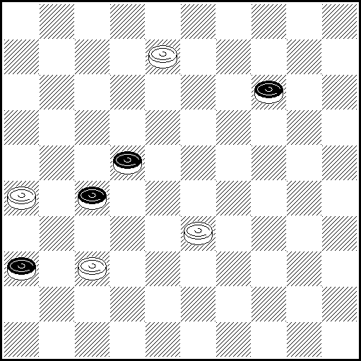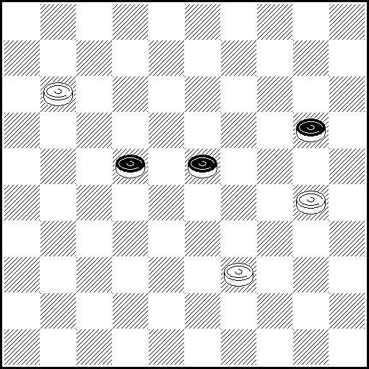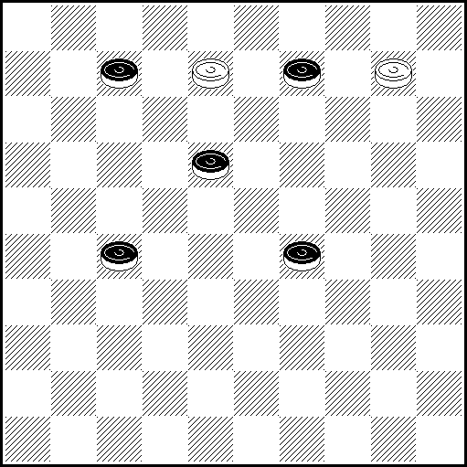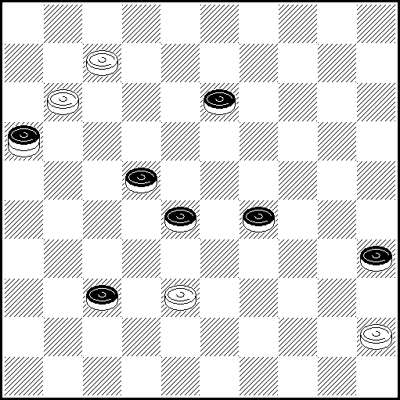
N29 VP: 3(19), 8 (23), 31(41), 8-27!(36 A), 27, 46 x A(16), 27, 46 x
N30 VP: 7 Z(238 A), 2 Z1(27 a), 304 Z2 Z3, A.Moiseev, 2008: 11(283 B), 28(34 C), 282, 7 x
A(27), 1 Z4(28), 33 Z5 Z6, 24 x B(282), 16 x C(31), 23, 7 Z7(23, D), 29(37), 47 x D(36), 23 x
a(32), 13 Z8 etc.
Z 6? (238 Y), 1(32), 24, 34/45(37 Y1) = Z1: 24?, 2(32 Y2 Y3), 11(34 Y4) =
Z2 19? (33), 28(24 Y5), 22(13 Y6) = Z3 13/11? (25, 43) =
Z4 24?, 1(28 Y7 Y8), 34/45(31), 29(36 Y9 Y10) = Z5 29? (31), 15(36), 10(29, 41) =
Z6 45? (24 Y11) 19(31), 29(36), 47(32), 14(37), 10(361, 42) = Z7 28? (22, 37) =. Z8 11? (25, 43) =
Y (27?), 1(28), 33, 24 x Y1 (28?) 29(37) 47(32) 393 x Y2 (27?), 11 etc. x like in VP.
Y3 (293?), 35, 49(33), 16 x Y4 (27?), 16 x Y5 (31?), 304, 283 x Y6 (18?), 13(9), 19 x
Y7 (32?), 33, 42 x Y8 (31?), 33, 26 x Y9 (32?), 23(317), 33 x Y10 (37?), 47(32), 393 x
Y11 (272?), 50(25), 24(38), 33 x
N31 VP: 3(13), 20(34), 38(31), 16(12), 21(36), 48(41), 37, 4(23), 15(37), 10(41), 46 x
N32 VP: 33(39 A),2, 34, 34 x A(38), 2, 1(32 B), 29(37), 47 x B(33), 34(40 C), 29, 34 x C(38), 48 x
N33 N34 N35 N36
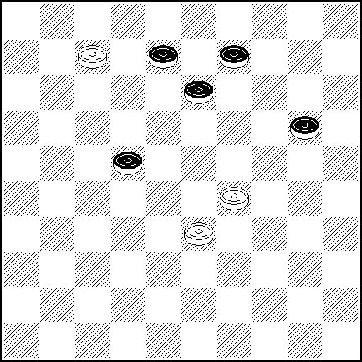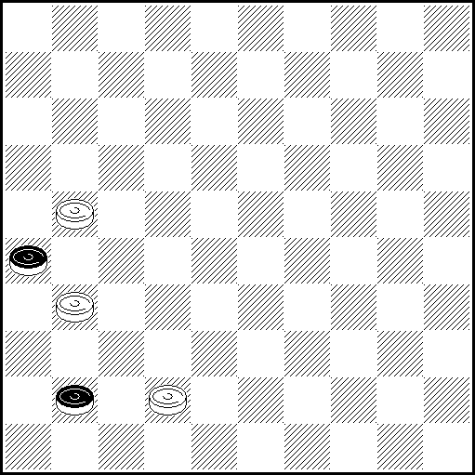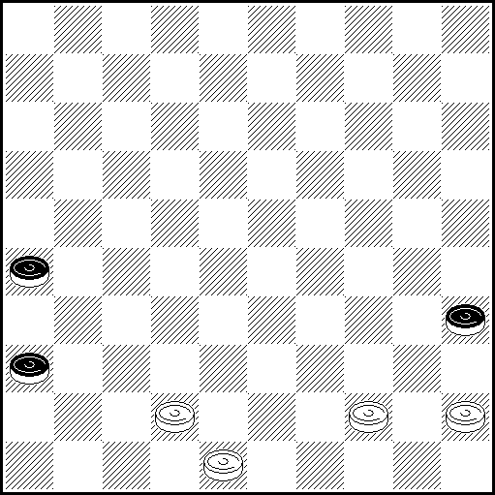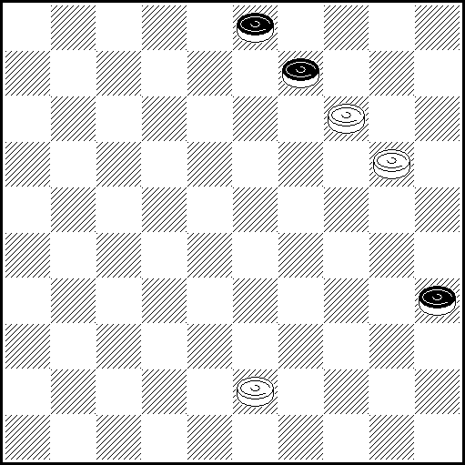
N33 VP: 2(14 ABC), 23(24 D), 29!! Z1, 11(27), 39!(32 Ea), 18, 20(37), 47 x
A(27), 23(12 F, 32), 4(14), 31(18), 20(37), 28(41), 47(46), 42 x B(25), 23!(30), 19, 4(34), 27!(40), 22(45), 29, 50 x C(24, 27,) 16(31), 32(36), 15!(19), 26(41), 37, 28, 10(28), 5 - one dual, allowed- (33), 32(39), 49 x D(27), 18 Z2, 10!(24), 4 (30), 29(35), 23(40), 23-18, 45(32), 29(37), 47 x
E(31), 18, 20(37) 47 x F (14), same as D.
a(12), 25(149, 31), 20 z3(37), 47(17), 10(19), 5 x
Z1 11?(12 Y, 30), 29(128, 35, 18, 40) = Y (27?), 29, 39(32), 18, 20(37), 47 x
Z2 29(139, 20!, 32 Y2), 239(38) = Y2 (31?), 239(37), 23(41), 47(46), 38 x z3 10? (36!) =
N34 VP: 37(17 A), 46(22), 27, 41(36), 37 x A(32), 27, 38(21B), 32(26), 27, 36 x B(22), 32 x
N35 VP: 45-40 Z (41A), 39, 38, 46 x A(31), 37, 37 x Z 39?(40 Y , 41) = Y(41?), 40, 38, 46 x
N36 VP: 39 Z (40 AB), 34, 15 33 x A(13), 34(18), 15 Z1(23 C), 30, 15-10 (23-29), 5(8 D), 14-10 Z2(12), 4(30), 15(29-34), 24, 40/45 x B(8, 40), 14(45), 9, 3 x C(8), 30, 9(30), 10(35), 3(13), 4(40), 12, 45 x D(30), 9, 25 x
Z 10?(14), 19(40) = Z1 10?(23), 5(29, 40) = Z2 9?(13, 33) =
PWCE – II
Categorie A
N37 N38 N39 N40
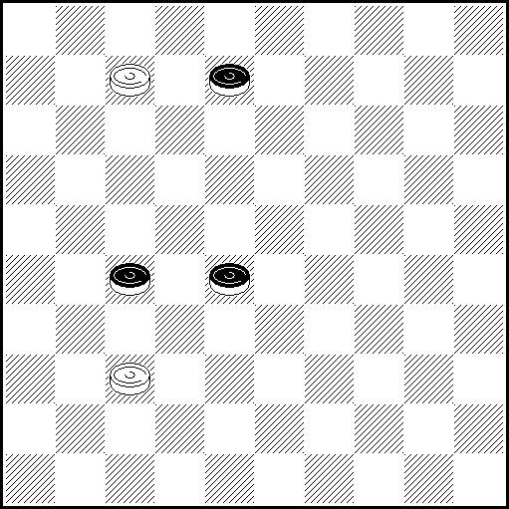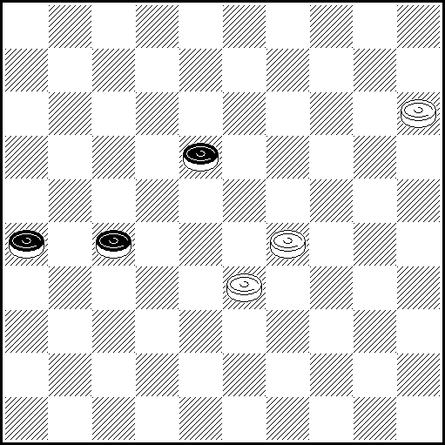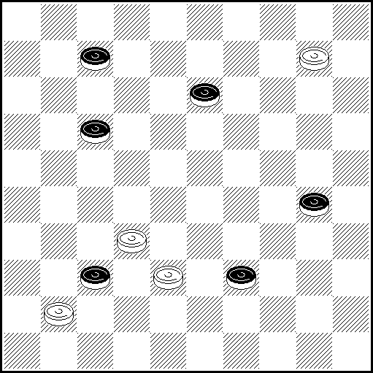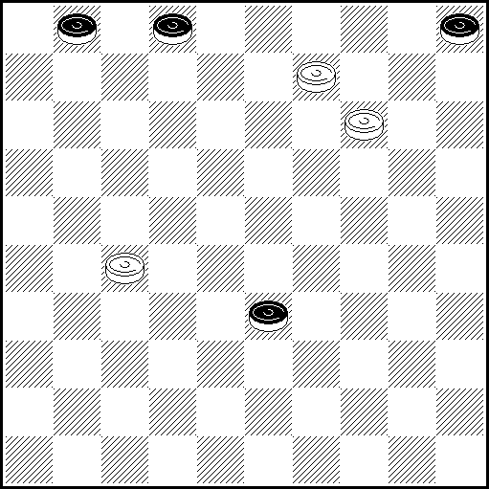
N37 VP:2(12 ABa),16 Z (31 b), 26(33), 261(18), 11(38), 7(22), 11 x A(282), 36, 47 x B(272), 19, 46 x
a(31), 36(33), 27(39), 49 x b(282), 28(31), 32 x Z 24(271 Y), 26(32), 42(17 Y1), 29(22 Y2), 42(27) =
Y (272), 19, 46 x Y1 (18), 20(23), 15(28), 42(37), 31(33), 27(39), 49 x Y2 (37), 23(42), 37, 37 x
N38 VP: 10 (26-31 A), 5(36 B), 46(22 C), 29-23(31), 19(27 D), 13(37), 16(41), 2 x
A(27-31),5(36), 46(22), 29-23/24(31), 19(37), 11(41), 7 x B(22),10(36), 46(32 E), 6(41), 23 x
C (32), 1(41), 29-23(46), 28(41), 23-18 x D(37), 11(41), 7 x E (31), 29-23(27), 19(37), 16(41), 7 x
N39 VP:Z 28, 5 (23 A),35 x A(19),2(18 B),35(23),33, 24(32), 20/15(37C), 14 x B (43), 35, 24(37), 47 x
C (28), 42 x Z 33?(37:28Y) = Y (39:28), 23, 5 x
N40 VP: 3(10), 5(39 A), 23(44 B), 23-12(1-7), 1(50), 7, 22, 26 x A(38), 27-21(43), 32(49), 21-17 x
B (43), 34(49), 34-12 x
N41 N42 N43 N44
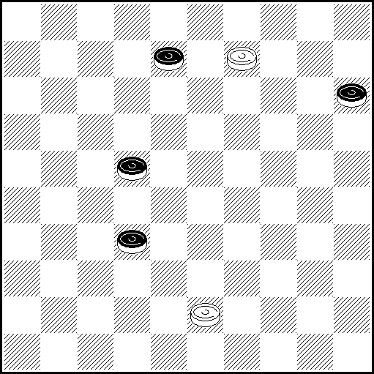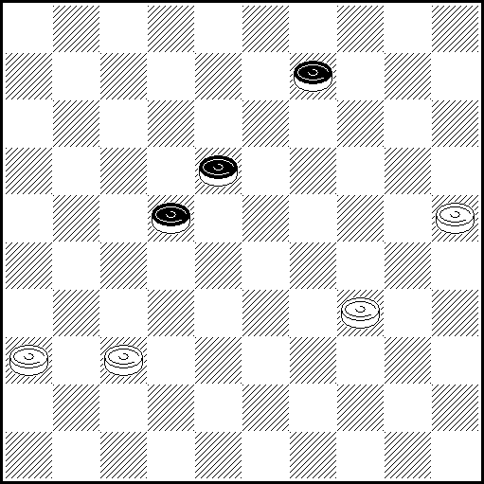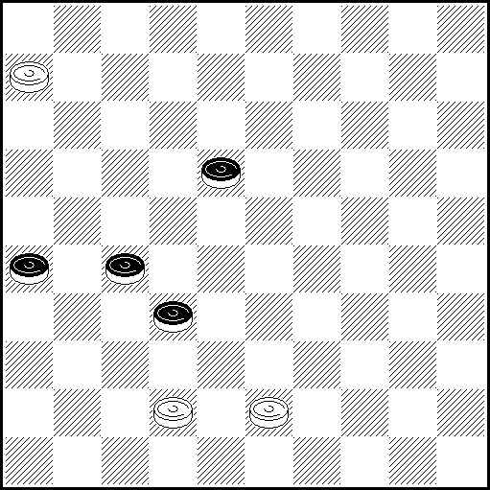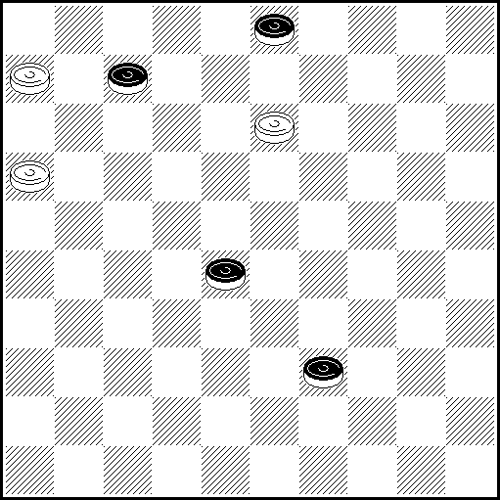
N41 VP: 3(27 A), 26(20), 42(25 B), 48(31 C), 26(30), 48(34 D), 38 x A(13), 14(28), 38, 49(18), 27(23),
38(28), 24/47(32), 42 x B(24), 20/15(37), 9/4(32 E), 1410 x C(30), 38, 25(32). 20(37), 47 x
D(35), 38 x E(31), 36(42), 38, 27(39), 49 x
N42 VP: 29(28 A), 20(23, 33), 12(39), 7(43), 361!! Z1(49), 1(38 a), 15 (14), 26(14-20), 24, 29, 37 x
A (14), 24Z2(19 b, 9), 32(13 c), 20(19), 15(24), 10(29), 4(34), 27! (39), 28!(44), 49(50), 27, 27 x
a (35), 23(35-13), 26(31), 15, 37, 37 x
b (28), 24-20(19), 15(33), 10(39), 5!(24), 5-32(44), 38(30, 50), 371! x c (14), 27, 27(19), 22 x
Z1 2(48), 32(25), 15(9-14), 27(39), 24(28) = See explanation, below.
Z2 32(19!), 24, 34(27!, 23), 17(28), 12(32!), 8(38), 3(43!) =
N43 VP: 1(22), 6(28), 50(27-31A), 45(32-37BC), 50, 36 x A(26-31), 45(32-37a), 50, 28 x
a (31-37), 22(37), 23(42), 38 x B(31-37), 31, 23 x C (31-36), 23(31), 26(41), 42-37 x

N44 VP: 8, 1(44A), 11, 49(33), 43 x; A(33), 11, 43 x.

Categorie A, Kатегория A :
Ukraine – 5, Bielorussie – 4, Lituanie – 3, Russie – 2, Netherlands – 2, France – 2, USA – 1, Israel – 1, Germany – 1, Croatia – 1 Latvia - 1. TOTAL : 44 etudes (23 participants )

PWCE – II
Categorie B
N1 N2 N3 N4
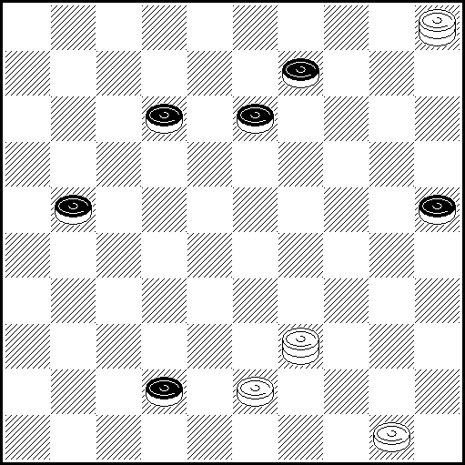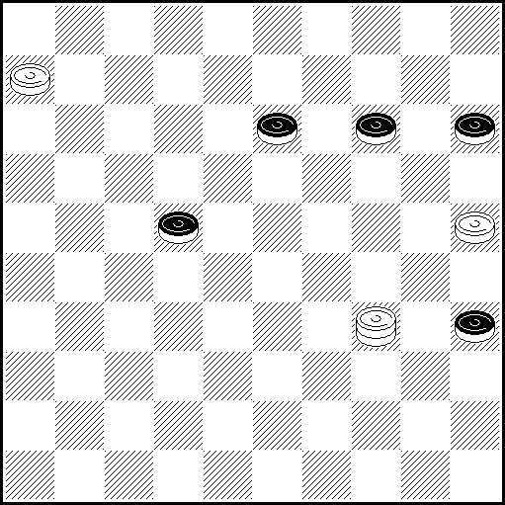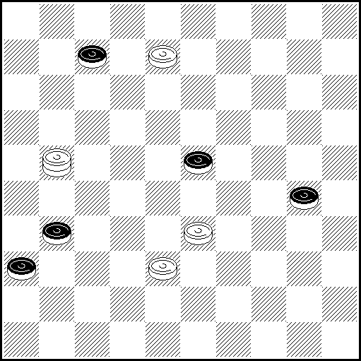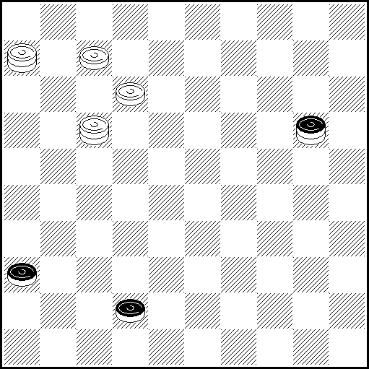
N1 VP: 33(47 A)15(36)41,438(24)16(138 BC)11(23)6(14 D)33(30 E)39(35)33 (20 FG )15(28) 20
(32 H)3(18)9(23)14(28)45 [P.Faure] (33)37(39 I) 32(44)28 [A.Everat] (49 J)44, 34 x
A(48)24, 16(138)11(23)6(14)33(28)20, 44(19)39(23)33 x B (17)32 Z₁(30)44(35)49(22) 40, 8(28) 3(13)20(32)15(18 K)4(23)15(28 L)42 x C (19)32 Z₂(24)21(18)8(23 M)35(28)49(33)504
(30 N)39, 4 x D(13)33(19)504(24)15(28)38(30 O)21(35 PQ)3(33)25(38)48 x
E(28)20, 44(19)39(24)34 x F(40)45(28, 44)40 x G(19)45(18 )50(24)40 x
H(40)14(33)3(18)9(23)14(29)20(45)15(34)38(39)49 x I(38 )48 x J(50)6(40, 45)1 x K (37)4(19)10 x
L(37)10 x M(29)13(23)4(28)10(283)15(30)20(304 M₁ )25(40 R)20(45)15(34)38(39)49 x
M₁ (35)15(40)20(45)15(34)38(49)49 x N(13)39, 8/2(30)35 x O(17)43(33)49(30 S)39, 21/26 x
O₁ (28 )49(30)39 x P(33)35(38)24(43)39 x Q(34)3(32)26(38)48 x R (339)20(33)38(40)32/16
(394 T)39(45)28/11(50)6 x S(22)43(30 O₁ )25(38)9(27 U)31(43)39 x T (404/45)49 x
U(28)14(33)20 x
Z₁ 2?(18 )8(172)19(27)13(23)31(28)4(32)15(37)47(30)=
Z₂ 21?(18 )17(183 Y₁)33(30)39(35)33(40)45(24, 44)40, 14(29)20(34)25(340)39(45)50(40)=
Y₁ (24?)8(29 Y₂ )13(23)4(28 )10(283)15(30)20(30-34 Y₃)25(40 Y₄ )20(45)15(34)38(39)49 x
Y₂ (23)35(28 )49(33)504(30 Y₅ )39, 4 x Y₃ (35)15(40)20(45)15(34)38(49)49 x
Y₄ (339)20(33)38(40)32/16(394 Y₆ )39(45)28/11(50)6 x Y₅ (13)39.8/2 x Y₆ (404/45)49 x

N2 VP: 6-1 (27 a) 34-23 Z1 (15-20 A) 5 (31, 19, 37 B) 23-18 (42) 28 (40) 33 (44 C) 50 (48 D) 39 x
A (40) 45! (32 E) 45-7! Z2 (37 F) 2 (13-19) 24 (19) 8! (20, 41 G) 29 (47) 3 x B(40) 23-18 (44) 28 (49 H) 44, 36 x C(48) 39, 45 x D(47) 33 x E(31) 45-7! (36) 2 Z3 (13-19) 24 as variant A F(14-20, 20, 37) 2 (19) 24 (41) 23 (47) 25-20 (36) 41, 15, 24 x G(42) 3 (48 J) 34 x J(47) 29 x
H(50) 28-6 (37) 1-12 (44, 42) 1 x a (28) 20 ! Z4 (25) 43 x
Z1 1-23 (139!) 37 (24) 5 (20!, 30 Y1, 40 !) 39 (32!) 9 (45!, 50) = Z2 1-7 (37 Y2, Y3) =
Z3 6 (13-19 Y4) = Z4 43 (18!) 5 (40) 41 (45 Y5) =
Y1 (32) 14-10! (37) 4 (30) 25 (40) 41 (45) 39 or 10 – one dual, allowed- (50) 10 or 39 (5) 46 x
Y2 (38) 16! (42) 29! (47) 2 (20) 10, 14 x Y3 (13-19) 2 (37) 24 (19) 8! (20, 41) 29 (47) 3 x Y4 (14-20, 19, 41) 7-1 (46) 28 (20) 23-18, 15 x Y5 (20, 45) 39 or 10 – one dual, allowed- (50) 10 or 39 (5) 46 x

N3 VP: 26(35 AB) 19 Z(12, C) 17(40) 35 Z1 Z2(45) 2(41, D) 2-11(46, E) 32, 6, 50 x
A(12) 35, 29 Z3(41) 19 x B(37) 25(41) 8-3 Z4(47) 25-14 Z5(29) 24, 14/25x
C(40) 3 Z6(44) 19-32(49) 16(32) 38/49(41) 32(47) 32-14 x D (50) 2-11(22) 28(41) 6(46) 32(41) 282 x
E(47) 28, 28(50) 6 x Z 14/5? (12 Y, 40)= Z1 1932? (44 Y1)= Z2 23? (44 Y1)= Z3 19? (8, 41)=
Z4 34? (28) 22(47, 3)= Z5 34? (36 Y3) 1(27)= Z6 2? (44) 16 Z7(50) 29(41, 33)= Z7 11? (49)=
Y (40?) 3(44) 14-32 etc.x like in C-variant Y1 (45?) 16 etc. x, like in VP Y2 (45?) 7 etc. x, like in VP Y3 (28?) 1, 3-12 x

N4 VP: 7-1(47 ABC), 33, 15, 28 x A(25), 39, 39, 47 x B(41), 33, 33, 36 x
C(3), 26(21), 12(48 D), 39, 23 x D(41), 39(41-47 EF), 48 x E(42-47), 33, 46 x F(46), 28, 47 x

PWCE – II
Categorie B
N5 N6 N7 N8
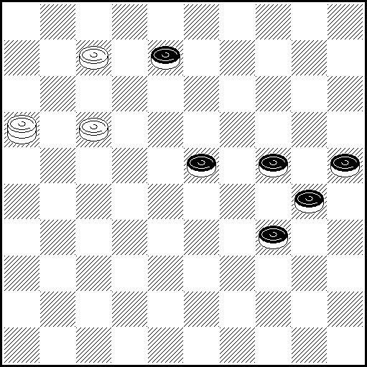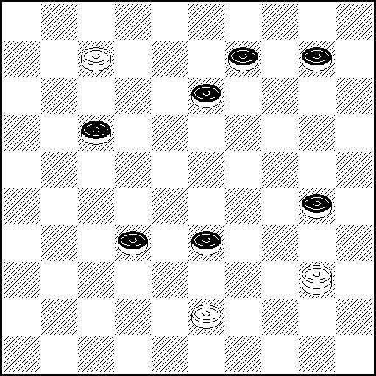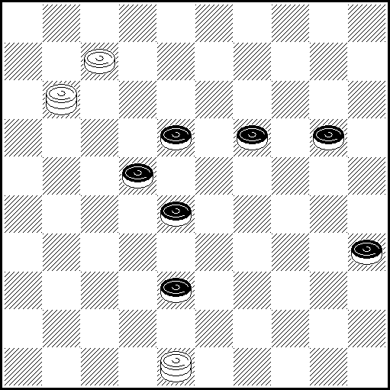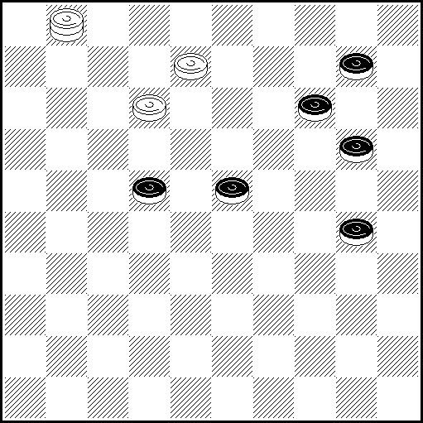
N5 VP: 1(249 A)6(33 ВС)12.35(339 DE)16-49 Z(30)24(40)35(43)38.24(37)47 x
A(239)17-12.6(21 F)49(35)1(33 G)45(39)50(40)20.35 x B(35)2(12)8(33)30(34)3(350 H)19.39.50 x
C(13)12(35)12-7(18)7-1(33)30(34)6(350)39 Z₁.35(28 I)2(33 J)7(22)16(39 C₁)11 x C₁ (28)43 x
D(349)35-49(30)11(34)32(40 D₁)32-28.35 x D₁ (38)49 x E (38)30.44 x
F(22)44(35)7(33)45(38)33 x G(250)44 Z₂(350 G₁)35(33)40/45(38 a)45/40(42/43)29.47/49 x
G₁(33)45(38)33 x H(39)19.43/48.39.50 x I(29)2(34)7 x J(32)7(22)11(27 J₁)16(31)38(37)47 x
J₁ (28)33(37)47 x a(39)45/40(34)15/20(43)38.24(37)47 x
Z 35-49? (40)35(30)19(44)23(50)= Z₁ 43? (45)25(22 Y₁.50)=
Z₂ 7? (33)45(39)50(34 Y₂)15(39)24(44.44)= Y₁ (29)20(50)33 x Y₂ (40)20(45)40.25 x

N6 VP: 2(35 A),5,39,32(39),49 x A(328),35,44,15 x

N7 VP: Z1 2 (19-23 ABC), 17, 49, (33 D), 34(28 E), 1/7(39), 6(33), 32(24), 11(29 F), 6(40 G), 328, 35
(34 H), 44 x A(32), 25(40 I), 35(45), 37, 40, 46 x B(18-23), 15 Z2 (40), 47(45), 31(33 J), 38(50),
39/44 x C(20-24), 17, 49(22), 32, 18(23), 15/20(40), 33, 50 x D(24), 42(32 K, 24), 20/15 x E(25), 48(22 LM), 38, 29/45 x F(30), 23(40), 45(38), 50(42), 34, 47 x G(34), 23(350 NO), 238, 35(39), 49 x H(33), 30(38), 48 x I(37), 4(42), 15(48 P) Z3 7/11(26), 42, 7-34 x J(50), 45(28-33), 29, 50 x K(239), 48 (32 QRS), 30, 39 x L(28), 38, 1/12 x M(29), 39, 1/12 x N(38), 50(43 T), 40, 48 x O(340), 45(38), 50(42), 40, 47 x P(40, 45), 33/39(50), 33/25-39(45), 50 (23), 7, 45 x Q(23), 30(293 U), 8(32), 27(40), 17(28), 176/272(45), 272/176, 50 x R(29-33), 38, 1/12 x S(28-33), Z4 39, 1/12 x T(350), 45(42), 29, 47 x U(40), 35(293), 8(38), 3(43 VW), 19, 48 x V(32), 19, 42 x W(33), 30(42 X), 19, 47 x X(29), 26 x
Z1. 1? (183, 40, 45), 33, 27(50)= Z2. 47?(40, 45), 33(39)= Z3. 16?(40), 16-43(39, 45)=
Z4. 30?(22), 31(39 Y1), 22(33), 6(40, 38, 42)= Y1. (34?), 38, 25, 39+

N8 VP: 3(25 AB), 20, 8(35 C), 34(27), 3(32 D), 20 (37 E), 47(14), 3429Z(19 F), 34(24), 15(41 G), 30, 36 x A(34), 9, 8, 27(40), 22(45), 50 x B(2228), 9, 8, 5(33), 32(39), 49 x C(2328), 3(35), 20(32),
[A. Fedoruk 1973] 42 (28), 1-29(14), 26Z1(38 H), 42Z2(40), 17 (32), 39Z3(19 J), 15(45 K), 50(23 L),
42(28), 6(50), 4233(28), 33(37), 47 x D(15), 25(32 D1), 23(40), 45(37), 23(42), 29 x
D1(31), 23(40), 45(37), 23 x E(14), 9(37), 31Z4, 18 x F(20), 15(40), 1533(45), 50 x
G(40), 45(41), 23 x H(20), 15(40), 17(38 M), 35(43), 38, 24(37), 47 x J(45), 50(20), 15(37), 47 x
K(37), 34 x L(37), 10 x M(37), 35(41), 23 x
Z 23?(19), 14(40) = Z1 48?(19), 26(38Y), 42(40), 17(32), 50(24), 20 (37), 47(45) =
Z2 47?(40), 17(32), 42(19), 39(45), 50(23), 20 (28), 6(37), 47(50), 4733(28), 33(41), 28 (47Y1) =
Z3 6?(19), 15(37), 10(44), 41(49) = Z4 23?(40Y2) = Y (23?), 7(38), 16(32), 31(40), 3127, 35 x
Y1 (46?), 5 x Y2 (42?), 37, 36(40), 22(45), 50 x

PWCE – II
Categorie B
N9 N10 N11 N12
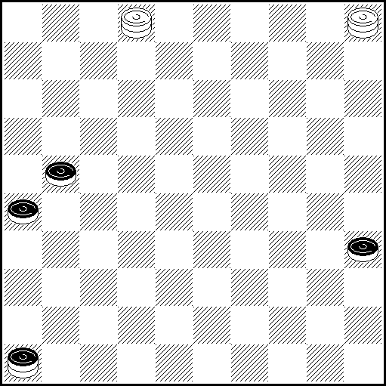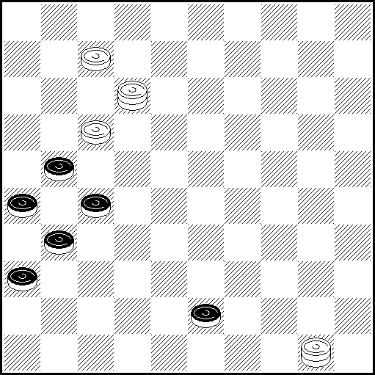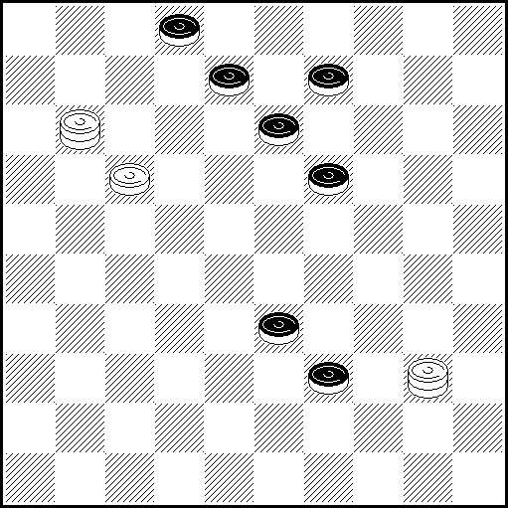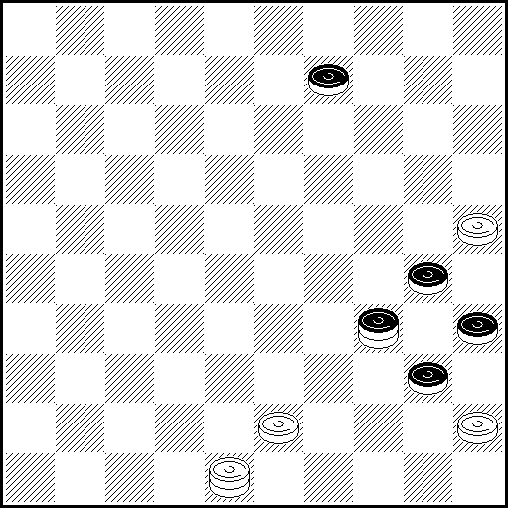
N9 VP: 16(27AB), 49(40 C), 35(31), 35-19, 26 x A(40), 35(31), 35-19, 26 x B(31, 40), 22(45) , 50 x
C(31), 49-32, 26, 17, 50 x
N10 VP: 1(49 ABCD), 44, 12(32 EF), 1, 46 x A(48), 39, 12(32 E1F1), 1, 46 x B(37), 3, 25(41), 25-14(47), 33 x C(32), 23, 37, 37(31, 41), 37, 33, 47 x D(41), 39 x E(41), 3, 46 x F(37), 3, 46 x E1(41), 3, 46 x F1(37), 3, 46 x
N11 VP: 40-12(7 A), 1(38), 17-12(38-43 BC), 50(18), 23(48/49), 39/44 x A(18)7(38 D)16 x B(39-43), 8/33 (можно 33,8 - перестановка), 33.48 x C(42), 44/50(47/48), 33/39 x D(43/44), 6.48/50 x
N12 VP: 39, 25:34Z(30A), 3Z₁, 17(49 B), 44, 34 x A(25), 34, 3, 17 x B(50), 6(40), 34(45), 1 x
Z 39(30-34), 30, 34(14) x Z1 25(40), 39(45), 50(14) =
N13 N14 N15 N16
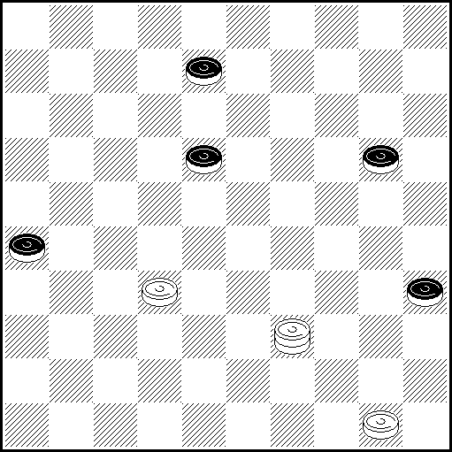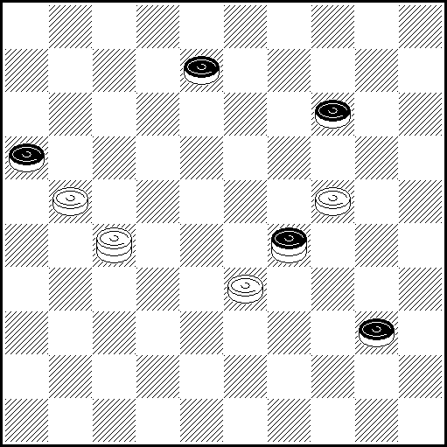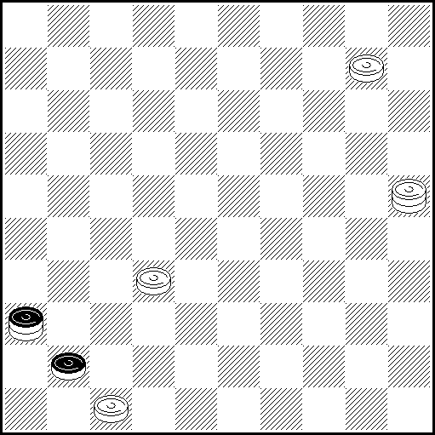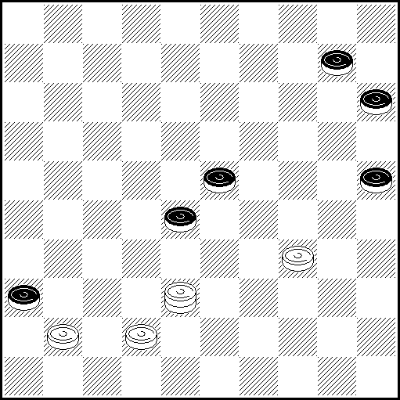
N13 VP: 27(12 A)21, 11(23 BC)6 Z₁ , Z₂(29 DEFC₁)1(17)34(21)50-45(24 GH)43(26)49(31)450,
36 x A(23)34!(28 )39(32)38(31)45(24)50(36)40,15(41)10(47)15(20)2 x
B(24)33(22)30, 44(29)39 x B₁(28)30, 44(29)39 x C(40)45(17)25(44)40 x
C₁(40)45(17)25(44)40 x D(18)33(25 I)45(30)39(29)25(33)20 Z₃ (39)9(23 J)14(29)20
[Blonde, 1798] (34 K)25(350)30, 43(30)39(35)34 x E(24)33(30 B₁ E₁ L)39(40)25(28 )14
Z₄(33)3(18 M)9(23)14(29 M₁)20(45)15(34)38(39)49x E₁ (40)20(28 )14 ... x
F(25)33(40)45(28, 44)40, 12 x F₁ (40, 44)40 x G(27)25(24 F₁)43(31)49(36 G₁)450, 19 x
G₁ (37)450, 41/46 x H(40)39(27, 32)48(38 )29/30(25)24 x I(40)15(28 )10 Z₅(33)4(23)10(29)
15(45)20(34)38(39)49 x J(22)27(44)22 [A.Everat] (49 N)44, 34 x K(33)38(44)33 [A.Everat]
(49 N)44, 34 x L(239)39(33 O)30, 44(29)39 x M(17)21(39)16/27/32/38(394 P, 45)11/22/28/33(50)6 x M₁(28)32(39)38/27/21/16... x N(50)6(40, 45)1 x O(18)30 x P(404/45)49 x
Z₁ 39?(40 Y₁ Y₂ Y₃)45(24)34(249)50.45(44)= Z₂ 11-44?(239 Y₄, Y₅)39(25 Y₆)=
Z₃ 9?(23)14(29)20(40, 39)= Z₄ 3?(44)33(49) = Z₅ 4?(44)33(49)=
Y₁ (18?)33(40)15(28)10(33)4(23)10(29)15(45)20(34)38(39)49 x Y₂ (24?)33(28, 24)
44(29)39 x Y₃ (25?)33(18)45(30)39(29,33)20(39)9 (23)14(29)20 (34 Y₇)25(350)30, 43,
39(35)34 x Y₄ (24?)33(239)39(33, 24)44 x Y₅ (18?)33(25)45(30) 39 en als Y₃ !
Y₆ (40?)45(33, 44)40 x Y₇ (33)38(44)33(49 Y₈)44, 34 x Y₈ (50)6(40, 45)1x

N14 VP: 27-38(15 A), 47(27 b), 29(38 C), 45(32), 29(37), 47 x A(27), 20, 15, 45 x b(38), 45, 23 x
C(33), 35 x
N15 VP: 14(46 А), 32-28, 37(22 В), 31, 4 x А(4), 36, 10, 27, 27 x В(4), 32/37-42, 38, 38 x
N16 VP: 41-37(32), 19(41 A), 30, 16(47), 2 x A(30), 25(41), 24(46), 35, 37(46), 20, 5 x
PWCE – II
Categorie B
N17 N18 N19 N20
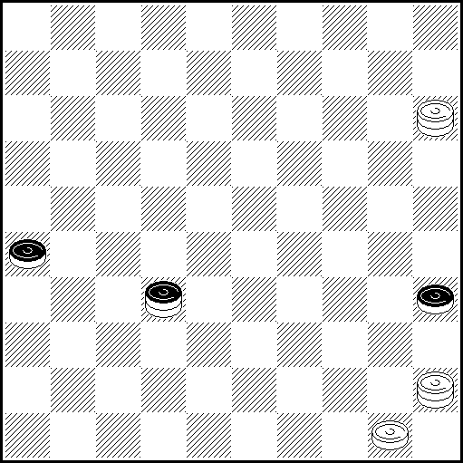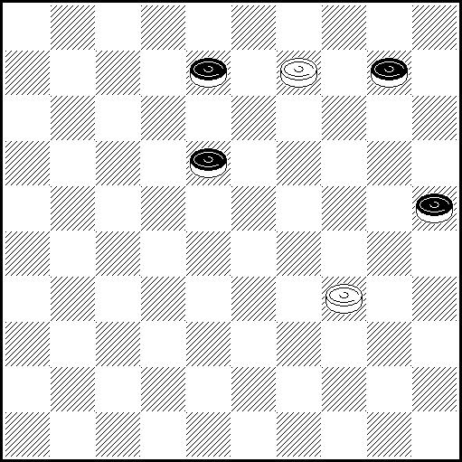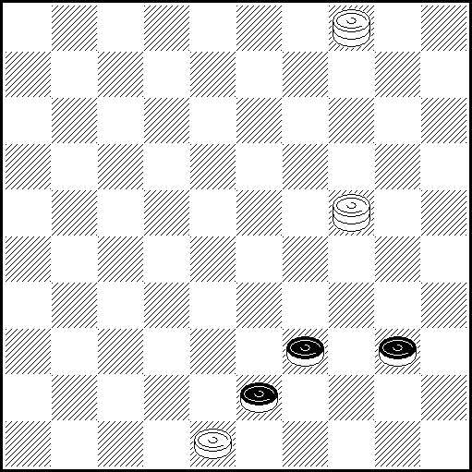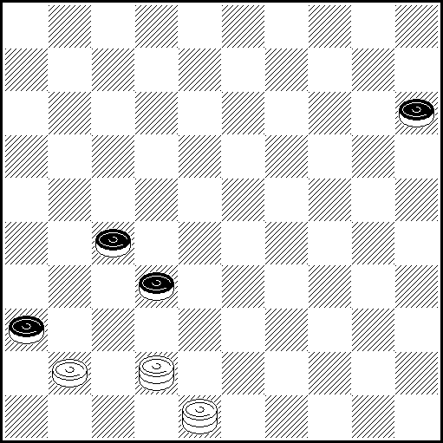
N17 VP: 38(49 A), 44, 18(31), 36, 22, 50 x A(43), 40, 48 x
N18 VP: 4(23), 15(28), 38(12 A1), 34-29(17 AB), 49(30), 24, 35(23), 40(33), 21(39), 49 x
A1(13), 34-29(30 C), 43(35), 23, 34 x A(33), 21, 35 x В(30), 24, 21(32), 24(37), 47 x
C(19), 43(24, 14), 38(19), 20(32), 15(23), 20 x
N19 VP: 4-15(49 A), 43, 35 x A(45), 29(49 B), 43, 50 x В(50), 33, 39 x
N20 VP: 47(38 AB), 24, 25, 31/36 x A(31), 26(38 C), 24, 3 25 x В(20), 15, 48-42, 42 x C(20), 15, 26-42(38), Z₁42 x Z₁47(37) =
N21 N22 N23 N24
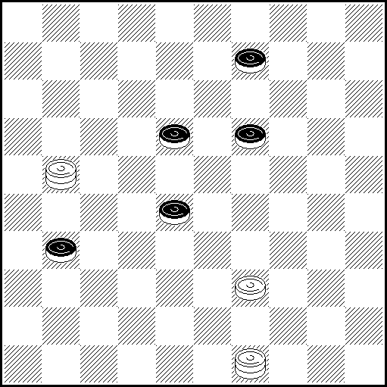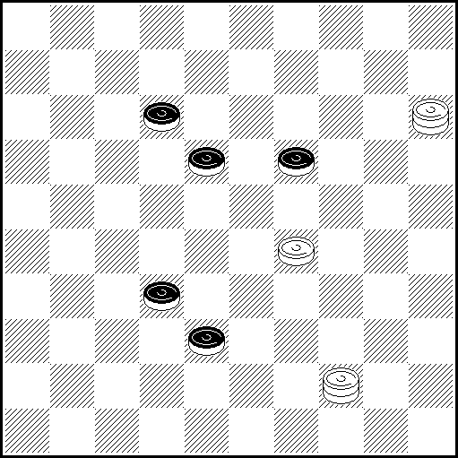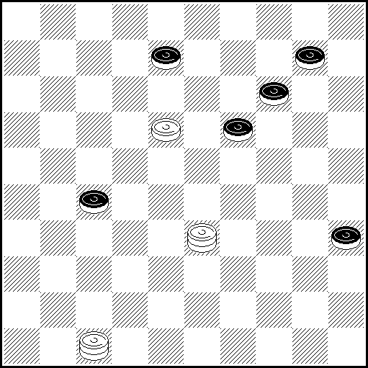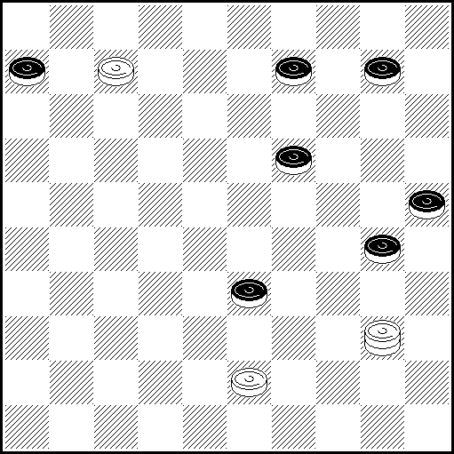
N21 VP: 3 Z(183 AB), 20 Z1(37 C), 44(41) 50(46 DE), 14, 33, 5 x A(13), 26 Z2(36), 16(41),
33 Z3(37) x B(14), 25 Z4(36), 33, 48(41), 37 x C(36), 29 x D(32), 24, 34, 46 x E(47), 38/42 x
Z 26? (36), 16(33 Y) 28(41), 23(28 Y1) = Z1 25? (36), 33, 48(24 Y2 Y3), 16 Z6 Z7(30 Y4, 41) =
Z2 16? (28 Y7, 22, 36/37) = Z3 37?, 38(22), 34(18 Y8) = Z4 20? (36) 9(193 Y9 Y10 Y11),
33(28 Y12, 41) = Z5 35? (249), 37(28 Y5, 41) = Z6 32? (41 Y6) = Z7 35? (249), 37(28 Y14, 41) =
Y (41?), 33, 37 x Y1 (29?), 37 x Y2 (41?), 37, 21/16(24), 8 x Y3 (28?), 21/16(41), 37, 38 x
Y4 (41?), 37 x Y5 (33?, 39), 49 x Y6 (30?), 35(41), 32, 24(37), 47 x Y7 (36?), 26, etc x, like in Y.
Y8 (23?), 38-29(27), 9/4(272), 14 x Y9 (32?), 24(41), 14(47), 15 x Y10 (33?), 28(193), 31(32), 16 x Y11 (183?), 31, 21/16(29), 49(293), 34(23), 43(39), 48, 25(33 Y13), 14(29), 20 x Y12 (41?), 29, 46 x
Y13 (32?), 20 x Y14 (34?), 19/5(39), 49 x
N22 VP: 29-24, 42(34 A), 35(22 BC), 20(27 DE), 25(40), Z1 44(37 F), 3(18), 35 (23 GHJ), 13(31),
36(42), 18, 48 x A(35), 29(37 K), 17, 42/48, 33(45), 50 x B(23), 48(38), 25(42), 19, 48 x C(39), 48(37), 3(43), 13, 48 x D(17), 25(27), 11(37), 19(42), 37 x E(37), 3(18 L), 13, 18/13 x F(31), 35(327 M), 3(17), 26(36), 42/48(41),37, 24(37), 47 x G(22), 2(41/42 NO), 17, 46/47 x H(42/41), 13, 47/46 x J(32), 24(41 P), 13, 46 x K(23), 1/7(37), 1-40(41/42), 50, 46/47 x L(40), 41/46(45), 40 x M(317), 19(38), 41/46(42), 37 x N(31), 26(36), 42/48(41), 37, 11(27), 16(31), 38(37), 47 x O(28), 13(31), 36(33 R), 26 x P(23), 14(28), 47 x R(42), 22, 48 x Z1. 49?(37) =

N23 VP: 39(23, 40), 38!(31 A), 42(36 A1), 37(13 B), 33!!(15 CD), 5(20), 10! Z1(24 E, 19, 41), 23!(47), 24(36), 41, 15, 24 x A(44), 25(24), 34(29), 5 x A1(44), 25(24), 34(29), 5 x B(20, 13), 33!(24 F, 19, 41) as variant VP. C(20, 25) as variant E. D(20, 24, 19, 41) as variant VP. E(25), 6- one dual, allowed- (30), 19!, 19 x F(25) as variant C. Z1 50(24, 19, 41) =
N24 VP: 2(24 AB), 38, 34, 15(30), 33(34 C), 44 x A(39), 35, 34, 15(30), 33(34), 44 x
B(35), 42/47, 39 x. C(35), 44 x
PWCE – II
Categorie B
N25 N26 N27 N28
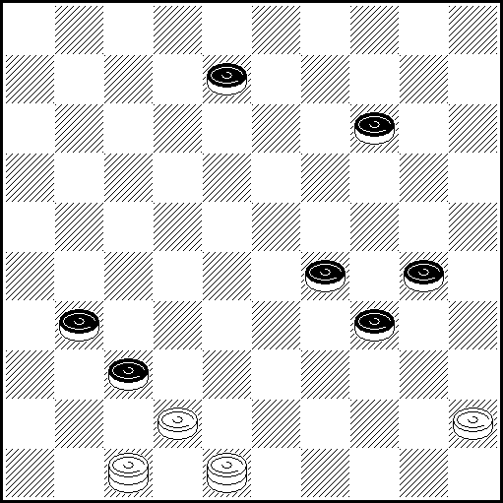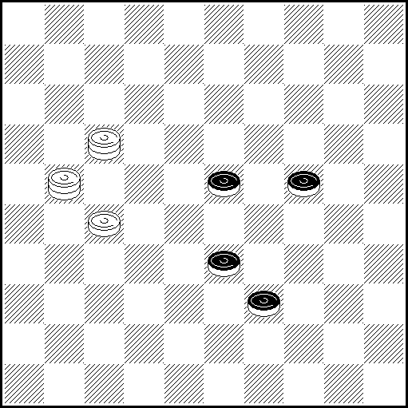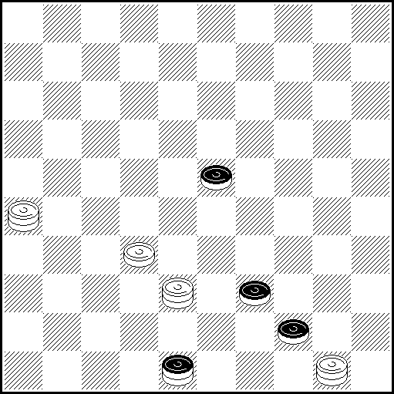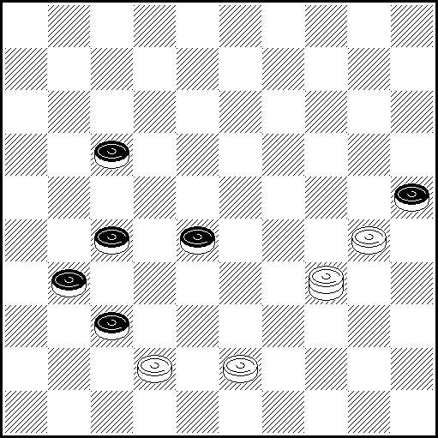
N25 VP 38(40a), 34, 36(33 AB), 39(41), 34(46C), 32, 34 x A (41), 34(47), 33 x B (34), 40(41), 34 x
C(47),33 x a (33, 19, 24, 41), 47(36b), 14(46), 5(13), 34 x b (46), 36 x

N26 VP: 26ZZ1(30 AB),12(34 C),38(44),17(50 a),2722(3439 D),6(5044 EF),33,50 x A(2429),28Z2(31 G),25(33),14(29),20(34),38(40 H),33(45),50x B(38),44/50*(43),28,48 x * if 50: (30**),2722(43),39,18, 35(39),49 x ** (2429),39(33),14(43),14-3x C(28),2617(34 Jb),45(32 K),29(43),39x D(45),6(4540 E1F1),49(39 Lc),35(43),49(48),43x E(3944),49(45),35(23),40,1x E1(3440),49(44),35(23),40,1x F(45), 1(50),6(45),1(50),3829(5044 M),34,6,25x F1(39),1(50), fast 3829(5044 M1),34,6,25x G(21),43x H(39), 49 x J(38),42/47(43),38,26x K(38),42/47(43),38x L(35),40,25/30 x M(3944),40,6 x
M1(3944),40,6 x Z 2722?(2429Y), 3(34), 16(29Y1), 12(40Y2), 43(44y), 39(49Y3) =
Z1 12?(2429), 2117(38), 44(28Y4), 34(42Y5) = Z2 42?(34), 40(43), 12(48Y6) =
Y (30?),18,35 x Y1 (40?),38,18,45 x Y2 (44?),23 x Y3 (50?),28(45),50(23),7,45 x Y4 (42?),28,48 x
Y5 (33?),28(42),37 x Y6 (49?),3 x y(45?),11(50),38(fastest win), 6,48 x
a(39),3833,50 x b(32),29(43), p.e. 39,25 x or 24,23,48 x c(45), fast 2217(39 d), 1(50), 44(43),6,48 x d(3440),35(23),40,1 x

N27 VP 49(29A), 7(48-43B), 11(27), 21, 2 x A (48-43), 12(3), 17 x
B (39-43), 28(49), 16, 38(25), 43, 28-37 x

N28 VP 12, 12:21:34(33ABC), 45, 26 x A(32), 45, 26 x B(37), 45, 41/46 x C(36),45 x
N29 N30 N31 N32
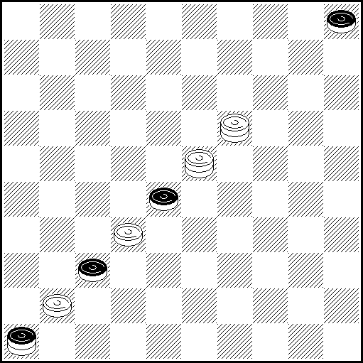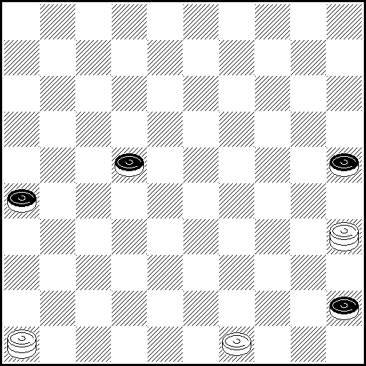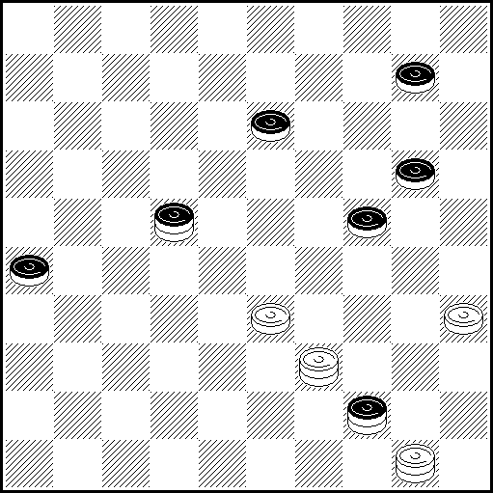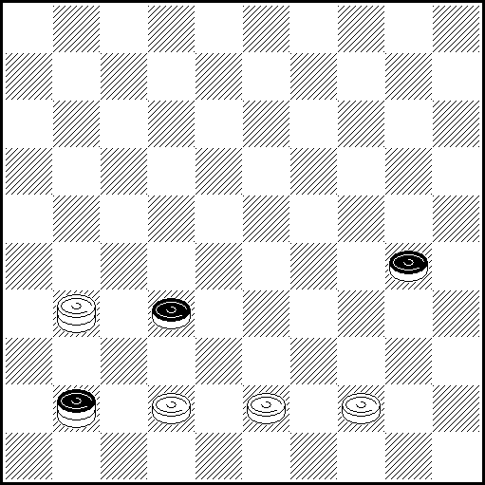
N29 VP: 10(19 A), 28(10 B), 5, 37 x A(14), 5(42 C), 23, 48 x B(42), 10, 48 x
C(33), 328, 32(28), 32/46 x.
N30 VP: 49-44(31 ABCD), 44-40, 23(37 E), 45(42 FG), 30, 48 x A(50), 13(33), 31 x
B(28), 23(50 H), 34, 13 x C(27), 44-40, 13(26-31 J), 18(39), 37, 34 x D(30), 31, 28, 6 x
E(39), 34, 36 x F(28), 30 x G(41), 30, 47 x H(30), 19(50), 5 x J(40), 31, 45 x

N31 VP: 28(443 А), 39, 15(31), 30, 26, 17, 50 х А(223), 15(6 В), 30,29, (1 СD), 50-45, 18(31), 36, 22, 50 х В(49), 44, 44(31), 40 - М. Tsvetov - (36 E), 35(30 FG), 354, 47 x C(31), 29-33, 36, 22, 50 x D(40, 31), 29/34(1), 505, 36 x E(37), 35Z(42), 30, 47, 33, 50 x F(25), 47 x G(41), 30, 36, 22, 50 x
Z 34?(30), 14(41), 140(47) =
N32 VP: 31-37(47 A), 35, 49 x A(38), 46, 28(45), 50(34), 38(39), 6(50), 31-33 x
PWCE – II
Categorie B
N33 N34 N35 N36
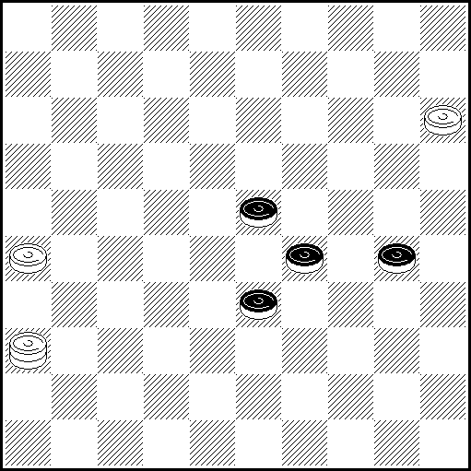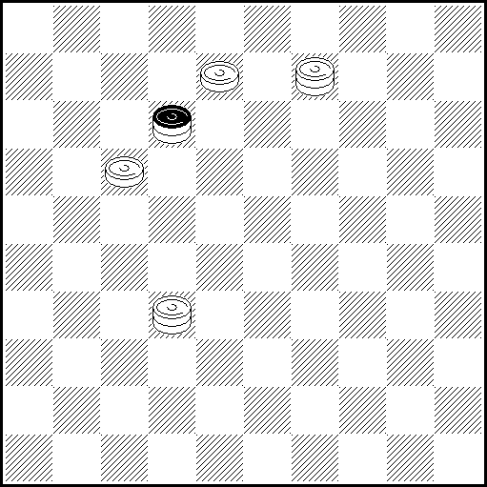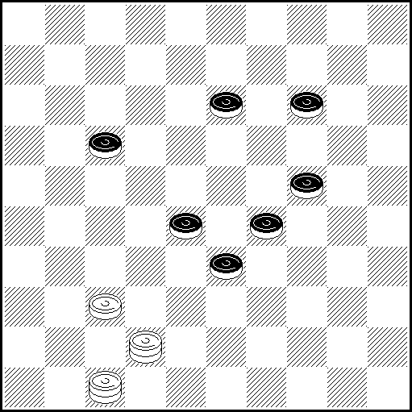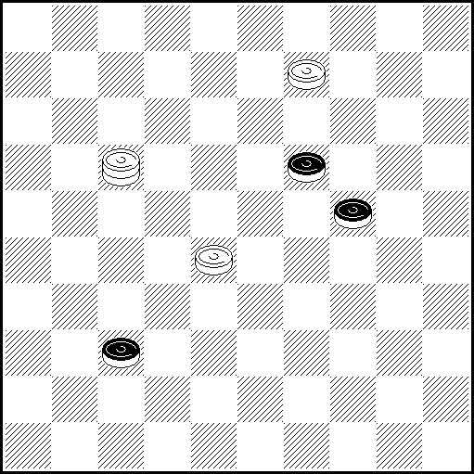
N33 VP: 10(294), 5(349), 32(35 a)22(40), 23(45 A), 29, 50(29), 21(33), 6(50), 217, 28 x A(38, 42), 37, 37 x a(44), 28, 49 x

N34 VP: 9-27 Z (26А), 3(42), 31, 32-21 x А(3), 49 x Z 32-14(3 Y) = Y.(21/26)? 25 x

N35 VP: 48(18 Aa), 32 Z.10(39 B), 36(34 CD), 15(30), 41(44 E), 29, 49 x
A(139), 36 Z₁(38), 27(22), 25(23 F), 32(37 G), 31 Z₂(28), 14(32), 37(43), 23.48 x
B(38), 33, 15 x C(30), 32(44 H), 23, 49 x D(43/44), 23, 48/49 x E(35/40), 33 x
F(293), 48-34(32), 39(23 I), 1(42 J), 33(29), 45(47), 25-34 x G(27), 25-43 Z₃ (282), 38 x
H(304), 22(33), 6/11(40 H₁), 32-28, 35 x H₁ (38), 49 x I (42), 23, 33 x
J(30), 34(42), 34-23/18/12(47),33 x a(20), 25(34), 6/11, 349, 15(32), 44/50, 28(47), 28-33 x
Z 34? , 6(32), 28(44), 23(49) = Z₁ 47-42? (30), 26(39), 2(44), 32(37) =
Z₂ 26? (28), 31(32), 31-48(33),26(30), 37(43), 32(49) =
Z₃ 9? (272), 13(30), 25(37),3(283), 18, 42(39) =

N36 VP: 4(41 AB), 36(47 C), 23, 15 x A(30), 31, 23, 25 x B(23), 30(42 D), 15(48), 3, 150 x
C(46), 3, 13, 15/20 x D(41), 28(47), 15(36), 41(‘затяжка’ с 4(47) и т.д.), 304 x
N37 N38 N39 N40
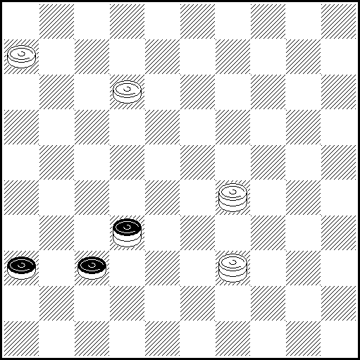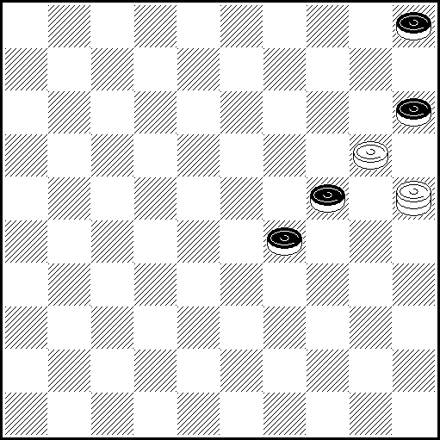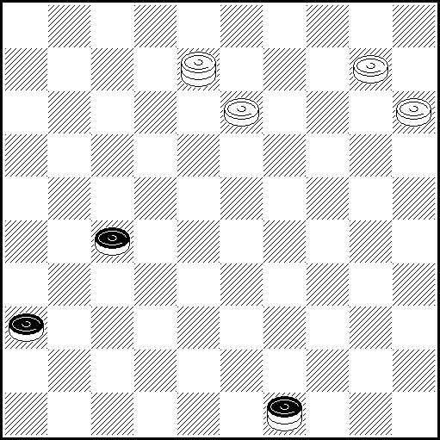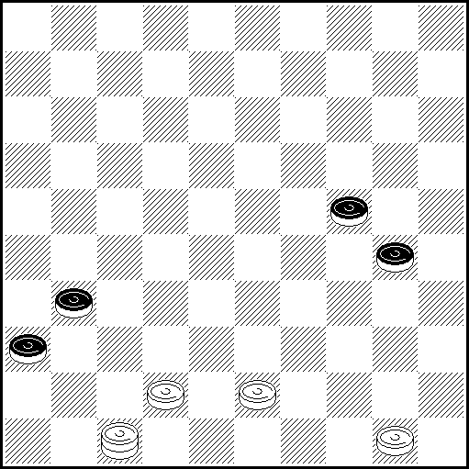
N37 VP: 1(36-41 ABCDA1), 42, 43, 46 x A(21), 38, 46 x B(10), Z 42, 43, 5 x C(37-41), 38, 46 x
D(5), 29-33(36-41 E), 42, 43, 46 x E(37-41), 28, 28, 46 x A1(49), 44, 46 x
Z 29-33? (36-41Y), 47(14 Y1Y2Y3), 36(3) = Y (4?), 22, 22, 46 x Y1 (46?), 42, 43, 5 x
Y2 (5?), 36(42), 41, 28, 47 x Y3 (15?), 36(37-42), 47(48), 43, 29 x
N38 VP: 14(33), 9(20 AB), 14(39 CDa), 4(44), 19, 50 x A(38), 20(30), 42(34), 48(40), 39 x
B(29), 43(34), 30(38), 48 x C(10), 5(39 E), 4(30), 15(44), 24, 50 x D(38), 4(42), 19, 48 x
E(38), 4(42), 19, 48 x a(30), Z 3(10), 5(34), 32(34-39), 17 x Z 4?(35) =

N39 VP: 5(27-32),37(27 A), 31(4),8-13(18 B),13(41),19(47),24,24 x B(36:27),36 x A(41),46(27),3(4), 41(31), 9, 36 x
N40 VP: 39(35 A), Z 44(29 B), 37, Z1 24(41 C), 40, 36 x A(29), 37, 35(41), 49(46 D), 32, 39 x B(30), 37, 15(41 ab), 40, 36 x C(40), 35(41), 393(46), 28, 24 x D(47), 38, 39 x a(40), 24(41), 10(47), 15 x b(34), 30, 47 x Z 45?(30), Z2 37, 15(40Y), 25(41) = Z1 20?(40Y1), 35(41) = Z2 34?, 37, 50(40Y2) =
Y (41), 40, 36 x Y1 (41), 40, 36 x Y2 (41), 40, 46 x
PWCE – II
Categorie B
N41 N42 N43 N44
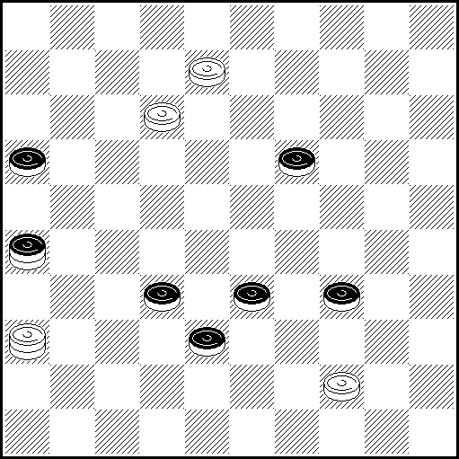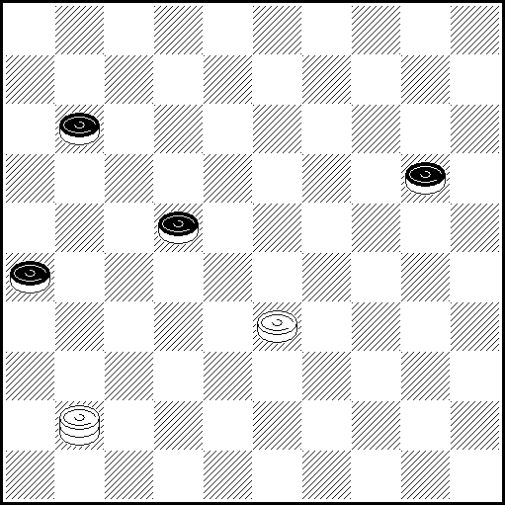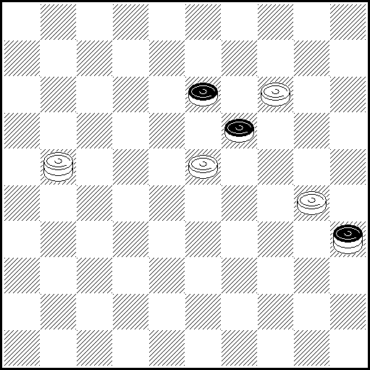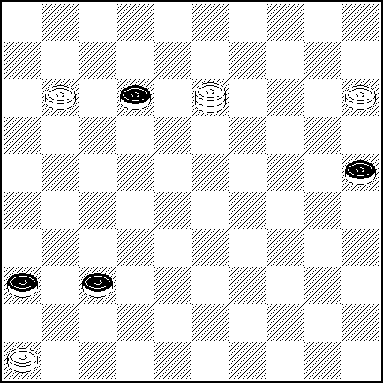
N41 VP: 39(43 A), 3, 48(43 B), 13(38), 367(42), 21, 48 x A(44), 3, 49(42 CD), 21, 47 x B(37), 26(43),21,48 x C(24),47(30),35(37),32,49(33),43(21),16(39),49 x D(21),47(24),15(37),16(41),32 x

N42 VP: 36(25 A), 13(31), 36(30), 27(35), 49(17), 29(22), 23 x A(28), 22(16 BC), 17/18(24), 12(29),
7(33), 22(38), 11(31 D), 1, 26 x B(25), 17, 13 x C(24), 17 x D(42), 1, 47 x

N43 VP: Z 16(28 Aa),2(5 B),46 x B(10),5(33),32(39),49 x A(10),2(46 C),5 x C(41),46 x a(24),2 x
Z 10?(24Y) = Y(28), 8, 46 x

N44 VP 6 Z Z1 (42A), 24(48), 41 Z2, 1, 34, 35 x A (30), 35(42), 24(48), 47(34), 10(17), 5(21), 1 x
Z 9(17), 22(48), 9-4(39), 22-18(34), 18-13(30), 13-9(48) = Z1 24(30), 35(42), 24(48), 47(37), 6(23) =
Z2 47(34), 10-si 24(23), 1(5) = - (45), 4(30), 22(35), 33(34), 22(45), 39(23), 25(45), 43(45-18) =

Categorie B, Kатегория B :
Bielorussie – 5, Ukraine – 5, Lituanie – 3, Russie – 2, France – 2, USA – 1, Israel – 1, Germany – 1, Croatia – 1, Netherlands – 1. TOTAL : 44 etudes (22 participants),

PWCE – II
Categorie C
N1 N2 N3 N4
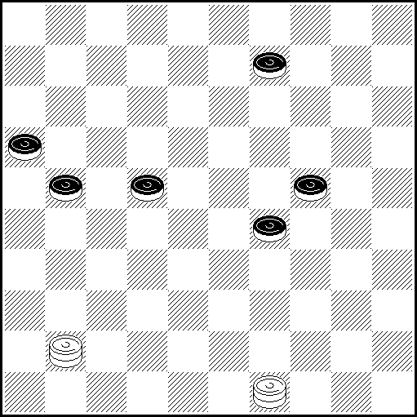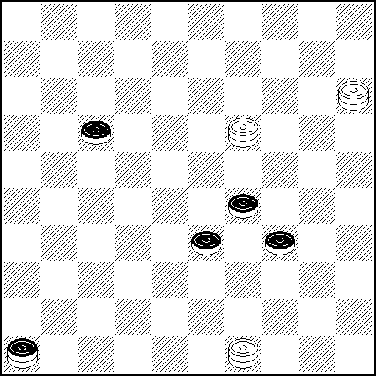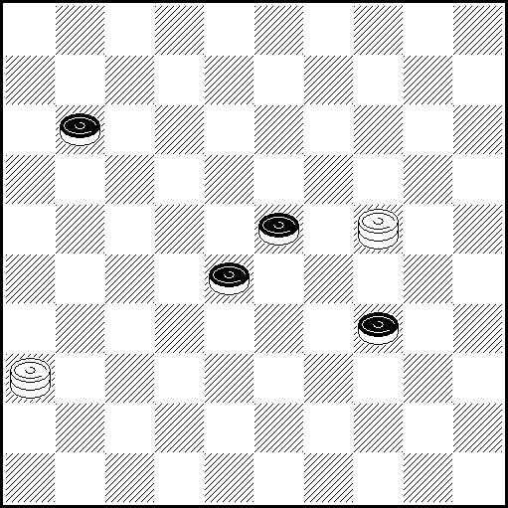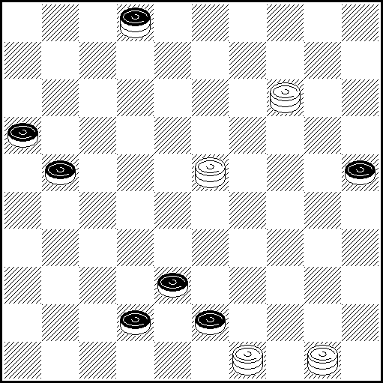
N1 VP: 35(14 ABa), 10(33), 4(217 C), 32, 43(21, 39), 49 x A(217,33), 32,43(21, 39), 49 x B(26), 4(33), 36(39), 46(43), 31,49 x C(26), 36( 39)46(43), 31, 49 x a(28), 26(33), 19(39, )28(43), 32 x
N2 VP: 5(22 A), 4932(28), 41(40 BCD), 28(39 EF), 35, 30(38), 48 x A(21), 16(40), 49(45), 40, 20(40 GHJ), 2014, 35(33 K), 30(38), 48 x B(3439), 36(28), 41(34), 40(38), 42/47(43), 38, 29(37), 47 x
C(27), 36(32), 22(3439), 18(34 L), 16/27 (40), 45(44), 40x D(38), 42/47(39), 33 x
E(45), 50Z(34), 6(50), 2033 x F(38), 42/47, 45 x G(3439), 2014, 43 x H(38), 42/47(39 M),
29(43/44 N), 2923, 49/50 x J(41), 46(40), 28, 6/17(45), 50 x K(34), 44 x L(3338), 48 x
M(40), 33(45), 50 x N(41), 46(43 O), 38 x O(44), 40 x Z 44?(27Y), 16(50) = Y (50?), 6 x

N3 VP: 8(29 ABC), 18(32 D), 9(16 EF), 24, 27 x A(17), 26(40), 22, 45 x B(40), 17, 45(32 G), 29
(37), 47 x C(33), 17, 38(39 H), 49 x D(283), 19(16 IJK), 9(349 L), 24, 43(21, 39), 49 x
E(40), 17, 35(34 M ), 44 x F(33), 17, 40/45 x G(33), 34(38), 48 x H(40), 33, 50 x
I(339), 30, 43/48(17), 39(21), 43(26), 48 x J(38), 9(40 N), 23, 35 x K(17)2(22)27(40)11(45), 50(33),
6(50), 272/18 x L(339), 35(43 OP), 24, 48 x M(33), 30(38), 48 x N(43), 24, 48 x
O(33), 27(40 O₁), 49 x O₁ (38), 49 x P(21), 20(33), 16 x
N4 VP: 14-19(35 AB), 23-40,17(42), 38, 39(21), 43(26), 48 x A(24), 39, 27, 8 x
B(30), 34, 48 - M.Tsvetov - (30 C), 25(42), 38,43(21), 16(39), 49 x C(21), 30, 16(40 D), 11, 50 x
D(39), 49 x
N5 N6 N7 N8
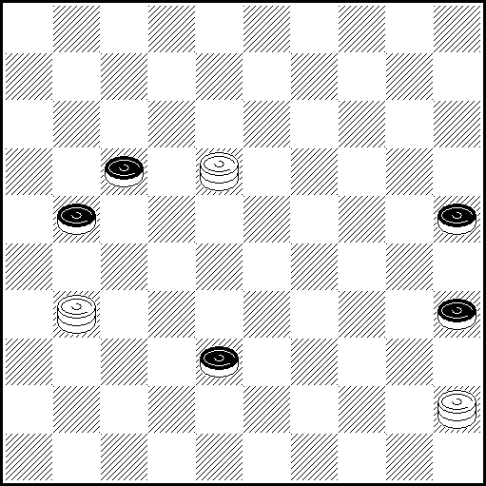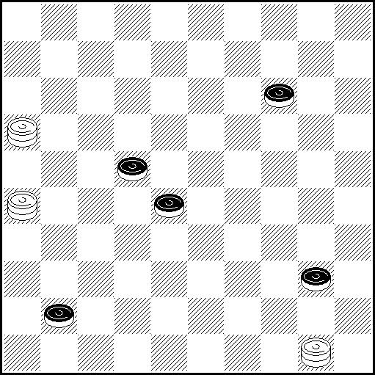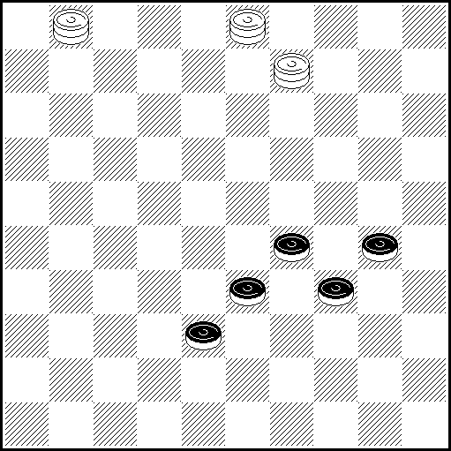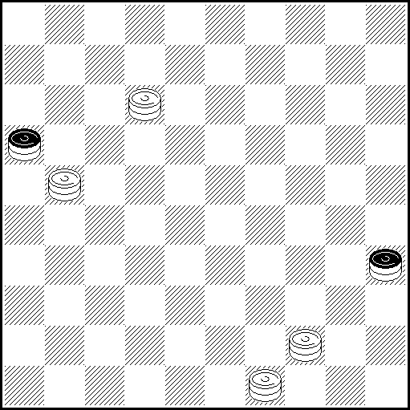
N5 VP: 18-34(22 A), 13(30 B), 25(42), 22(47 C), 30, 33, 26 x A(27), 6(42), 11(48 D VP1), 2, 40 x
B(42),340(24),30, 48 x C(26), 33(47), 254, 18 x VP1 (30,47), 30, 33 x D(47), 33 x
N6 VP: 45(46 AB), 32(19/23), 17 x A(47), 41, 31 x B(44), 23, 37 x
N7 VP: 14 ZZ₁(40 ABa), 45(42 C), 37 [Н.Шеломенцев], 20(39), 25(34 D), 36 (44), 39, 27(39), 49 x
A(35), 3-9(33-39 E), 14-23, 50(42/43 A₁F), 40,47/48 x A₁ (340), 45(42), 40, 47 x
B(339), 32, 20(33 GH), 16/21(35 I), 45(44), 11/17(50 B₁), 6 x; B₁ (49)44 x
C(43), 32(49 J), 45-12 ,25 x D(36), 48, 37, 29(37), 47 x E (340), 45(39), 34, 27(42), 38, 25(39), 43/48, 39, 50 x F(350), 45(42/43), 29, 47/48 x G (31), 50(37), 40/45(41/42), 34, 46/47 x H (43), 49(31), 45(37), 35 x I(40), 45(44), 40, 7/12(34), 45 x J (48), 26(30-34), 38/47(25), 43, 32-37 /47-42 x
a(42), 14-23, 47(39), 25(34), 29/33 x
Z 20? (33-39), 42(43), 40(49 Y), 8, 2(49) = Z₁ 23?, 49(35), 17(349), 6(40), 35(38), 50(42 Y₁) =
Y(34), 12(49), 38 x; Y₁ (43), 39, 44 x
N8 VP: 8Z(27/43 A), 16(2B), 35 x A(2), 35, 16 x B(49), 35 x Z7?(27/43Y), 16 = Y(2), 8, 40 x

PWCE – II
Categorie C
N9 N10 N11 N12
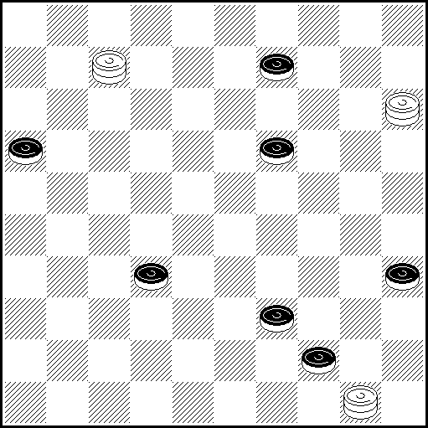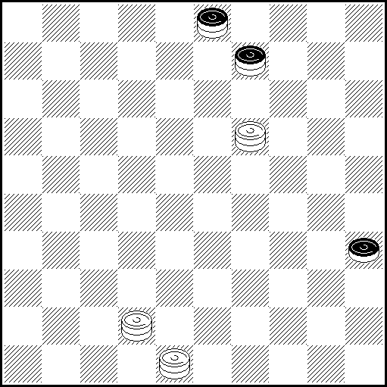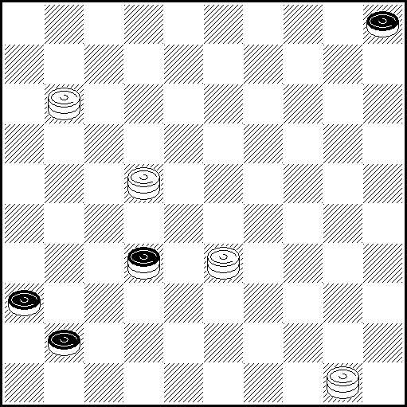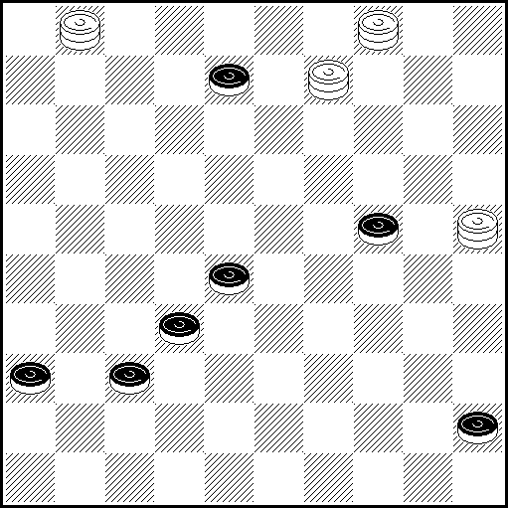
N9 VP: 4(14 AB), 13, 34, 49(21), 16(40), 11(45), 50 x A(49), Z.27, 40, 26 x
B(40), Z1.21, 31/36(44), 40 x Z 2?(350Y), 45(161) = Z1 27?(49)=
Y (161), 7-45(350), 26(40), 26-17(49), 21, 50-11 x

N10 VP: 8(21 A), 30, 26 x A(26), 37, 4, 22, 50 x

N11 VP: 16(47 AB), 38(36-41), 22-28(46), 10, 33-39, 5 x A(37), 31(27 C), 32, 46 x
B(14), 22-28(37 D), 32, 46 x C(26), 21, 46 x D(32), 38(46 E), 32, 28 x E(10), 47(46), 41, 5 x

N12 VP: 40, 25x48x3(37 AB), 31(26) 14(31, 41), 37, 10(38), 15 x A(41) 36(37 CD), 20/15(41),
47(46), 41, 22 x B(38), 31, 31/36(43), 22, 49 x C(47), 4-22, 15 x D(46), 41, 22/27 x
N13 N14 N15 N16
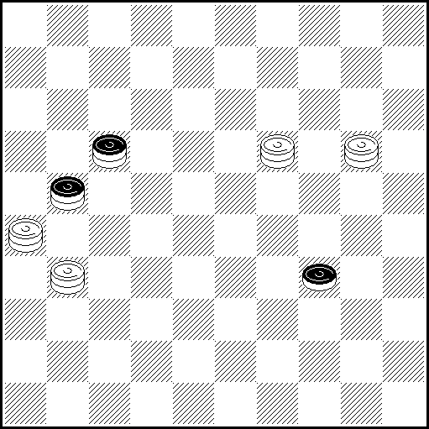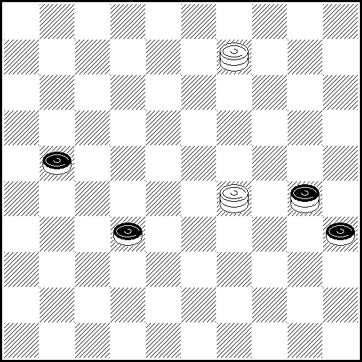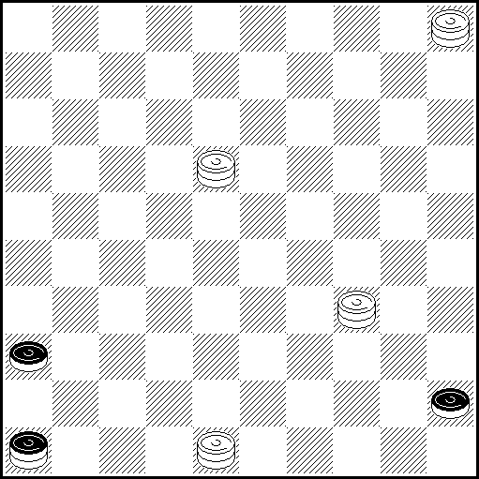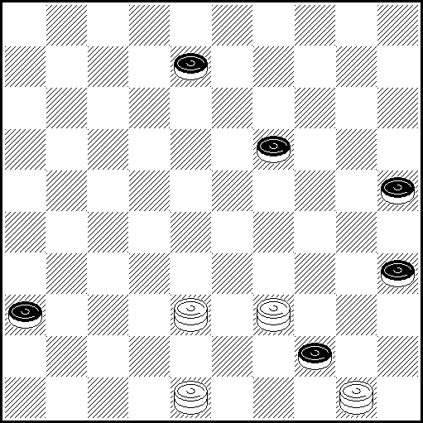
N13 VP: Z1 19-24 (40 AB), 15(40-44), 27, 50 x A(34-39), 15 (32 C Vp1), Z2 12(5 D), 48(44), 40, 10,
25, 39 (45), 50 x B(3), 40/45, 48(14), 20, 404 x C(49), 12/3(394), 21, 27, 50 x
D(14), 35(43), 21(48 E), 154 x E(49), 18, 7, 154 x Vp1 (44), 27, 50 x
Z1 15? (Y1 32) = Y1 (340?), 194…x VP Z2 3? (5 Y2 Y3), 35(43) =
Y2 (46?), 17(43), 38, 37, 47 x Y3 (44?), 21, 27, 50 x

N14 VP: 25(24 ABCD), 15Z(40), 34, 16 x A(43), 48(26), 29-42Z1Z2(40 E), 38, 45 x
B(19/2), 24, 16, 11, 50 x C(48), 294, 16, 11, 50 x D(40), 16(44), 40 x E(37), 31, 31/26, 22, 50 x
Z 20?(37Y), 15(26 Y1), 34(31 Y2) = Z1 23(40), 45(37), 31 = Z2 483(40), 27(45Y3), 22(31), 50 =
Y (40), 34, 16 x Y1 (41), 30, 36 x Y2 (40), 45(41), 23(47), 239 x Y3 (44), 40, 18 x

N15 VP: 42(36-41 A) 39(50 B), 4, 15 x A(50), 45(50-28), 32/37(7 C), 1, 37, 29(37), 47 x
B(47), 1(50 D), 6 x C(1), 42-29, 23 x D(44), 1-23, 50 x

N16 VP: 30(34), 2(41 A) 19(40 B), 46(44), 48-37(50), 33 x A(40), 34, 15, 19 x
B(47), 15(36), 41, 48-42(38), 42/47(40), 33(45), 50 x

PWCE – II
Categorie C

N17 N18 N19 N20
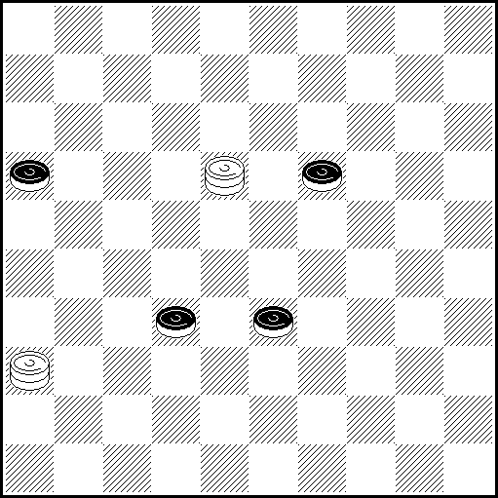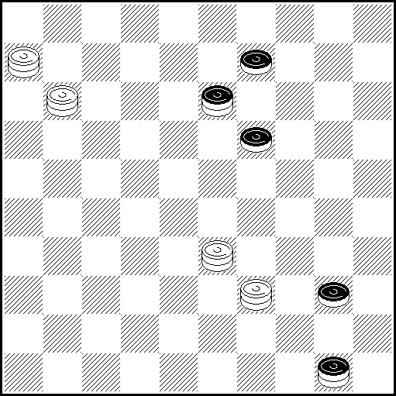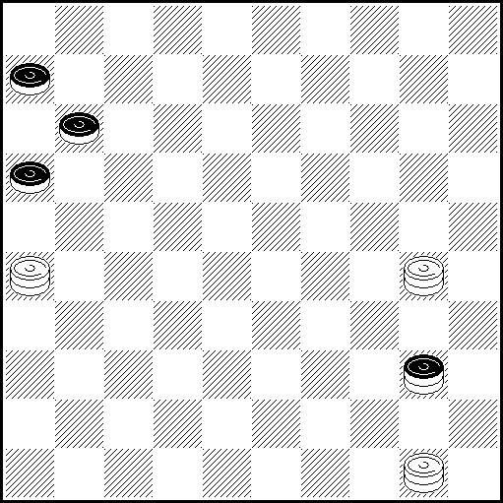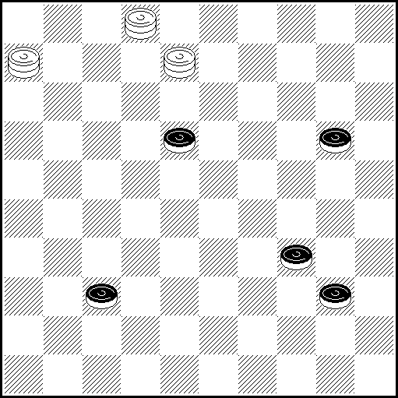
N17 VP: 18-31(32-38 AB), 27 Z (42), 21, 47 x A(39), 26(38 C), 21, 32 x B(21), 37, 26 x C(44), 27, 49(21), 16 x Z 26(21! Y1 Y2), 30(42), 47(48) = Y1 (43), 21, 49 x Y2 (39), 21, 32 x
N18 VP: 11-22(31 AB), 48(22), 4(26 C), 4-31 x A(27), 33-22, 31/36 x B(36), 47, 4 x C(36), 48-31 x

N19 VP: 13(34 A), 18(7 B), 17, 2 x A(35), 50-17 x B(1), 45 x
N20 VP: 26Z1Z2(41), 37, 16(37 A), 32, 22(45), 50 x A(25), 35(22, 34), 44 x Z1 7(44), 49(24Y Y1,41) = Z2 16(39, 41) = Y (41), 24, 33, 46 x Y1 (42), 24, 38, 39 x

N21 N22 N23 N24
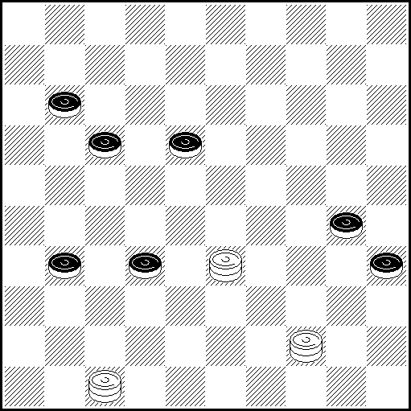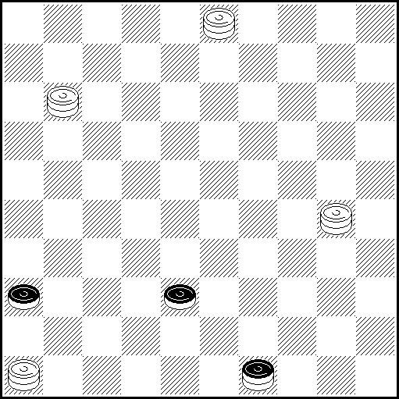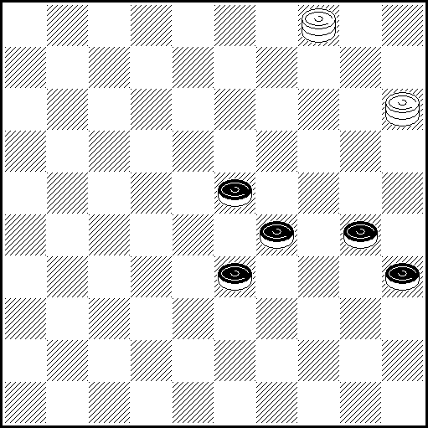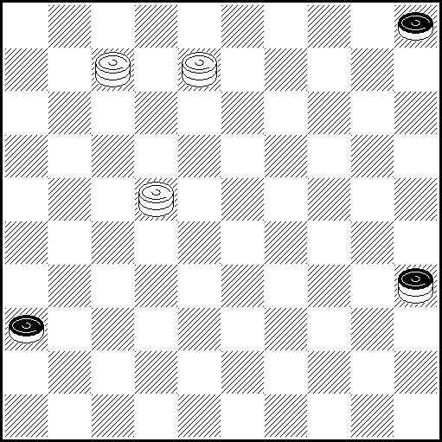
N21 VP: 29 Z(182), 1 Z₁Z₂ (27 Aa), 49(34), 45(36 B), 47-38, 2(41 C), 12, 46, 28, 50 x A(16), 45(27),
6(327), 6-50(32), 20(36 D), 25(361 E), 21, 40, 47 x B(22), 47-38, 2(28), 11(37), 50(41/42), 40, 46/47 x
C(40), 26, 37, 24(37), 47 x D(21), 42, 39 x E(371), 21, 40, 46 x
a(327), 23(36), 46(34), 44-28, 45(22), 50(17), 44(21), 26(40), 17 x
Z 49? (327), 28(21 Y), 25(40), 46(45), 37, 15(50) = Z₁ 45? (16), 1(27), 6(327), 22, 46(34), 36(35-40), 22(21/45), 46-28(45/21), 50(40 Y₁), 6(27), 50-28(31), 46(50), 46-28, 35(37), 24(41),19(47) =
Z₂ 39? (327), 25(28), 14(33 Y₂), 38(40), 46(44), 21, 37, 50(31), 6(37), 33(41), 28(47) =
Y (34), 46(340), 16(45), 23/29/34(50), 46-37, 6(40), 45 x
Y₁ (26), 22-44(31), 40(36), 23 x Y₂ (32), 34(22), 36(27), 28, 41/46 x

N22 VP: Z1 Z2 43(41 A), Z3 14(42 B), 33, 47 x A(44), 32, 17 x B(44), 32, 17(5 C B1 C1), 46 x
C(46), 5 x B1(10), 5 x Z1. 48?(41)= Z2. 16?(35)= Z3 5?(44!), 32(6) =

N23 VP: 15-10(28), 32(294 A), 31(349 BC), 38, 25, 39, 50 x A(39), 22(33), 23Z(34 D), 45(38), 50(42),
40, 47 x B(350), 28, 44 x C(340), 28, 45 x D(38), 50(40), 45(43), 39 x
Z 6(43Y), 48(40,45),= Y (34?), 23 - Н.Шеломенцев - (350 Y1), 23-28, 35(39), 49 x
Y1 (38), 50(42/43 Y2), 40, 47/48 x Y2 (350), 45(42), 29 x

N24 VP: 22-13Z(40 AB), 45(41), 2(46 C), 23 x A(44/49), 40, 2, 19 x
B(19), 35(41), 8-24(47 D), 7-29(36), 18 x C(47), 29 x D(10), 7-29(14), 47(46), 41, 10 x
Z= 8-2(44Y), 50(41) = Y (40), 45(41), 22-13(10), 29(14), 47 x

PWCE – II
Categorie C
N25 N26 N27 N28
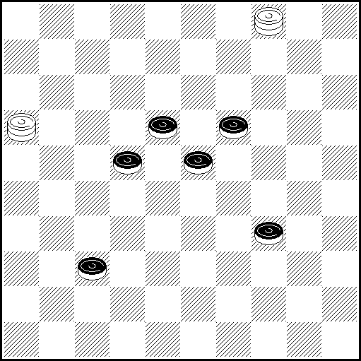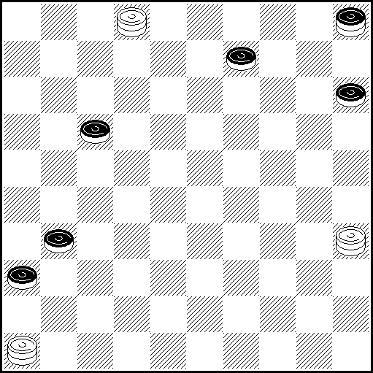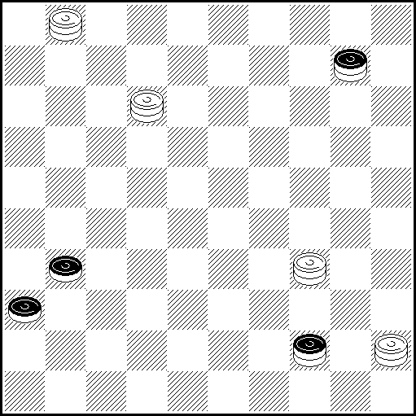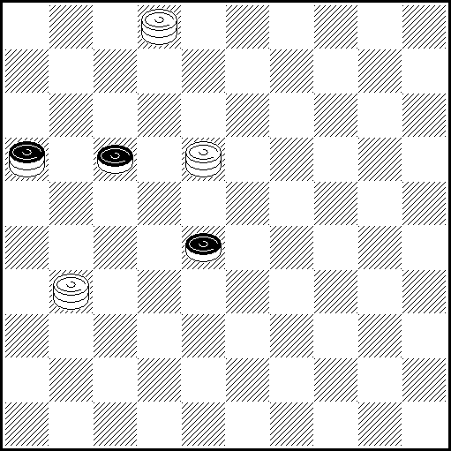
N25 VP 11(42 ABC), 13, 47 x A (39), 44Z(28), 24(41), 10(47a), 10-15 x B (41), 13, 47 x
C (238), 17, 4:31:16 x a (46), 5 x Z 41?(22), 27(44) =

N26 VP 2-19 Z (37A), 26(37B), 42 Z 1(41C), 20, 46 x, A (23/32), 42/37 Z 1(41C), 20, 46 x
B (20), 15, 19 x C (20), 15, 19 x Z 35-19?(37), 26(37Y), 42(41Y1) = Z 148?(41), 25Za(46Y2) =
Za 37,24(37), 47(20, 41) = Y (20?), 15, 19 x Y1 (20?), 15, 19 x Y2 (47), 24 x

N27VP: 50(40 AB), 45(31-37 C), 45-29(36-41), 47(46 D), 42, 39, 5 x A(49), 44, 5(37), 46 x
B(35), 40(49), 44, 5 x C(36-41), 45-23(37), 28, 47 x D(5), 36(42), 41, 28, 47 x

N28 VP: 18-7(22 A), 9(49 BC), 40, 9-13 x A(33), 35, 31-13(19), 21(39), 49 x
B(21), 3(27), 21, 11 x C(16-32), 22, 12 x

N29 N30 N31 N32
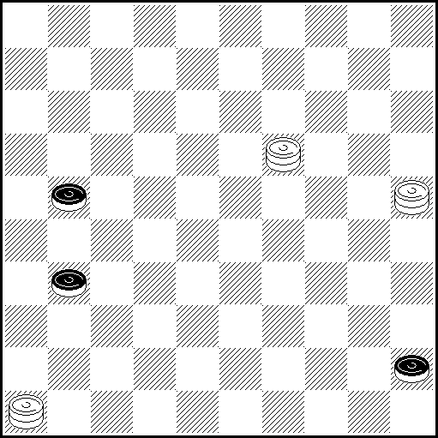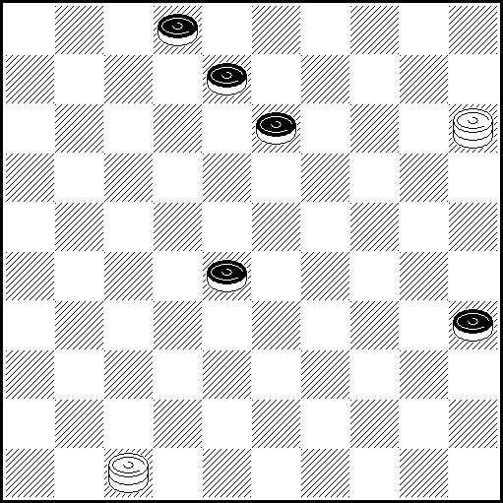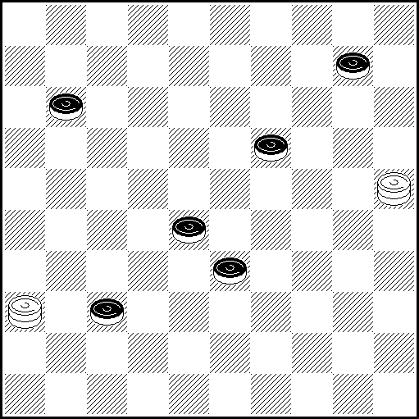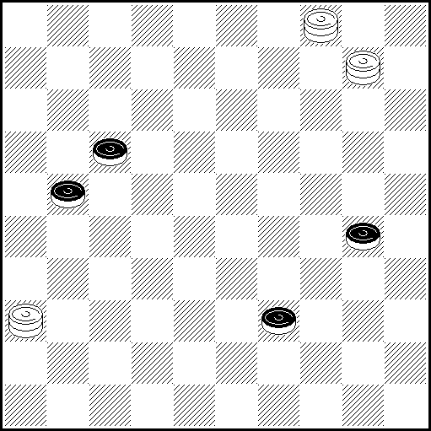
N29 VP: 39(37 А), 16(50), 16-32(46 BCD), 5 x A(50), 19-37 x B(41), 46 x C(10), 5 x D(5), 46 x

N30 VP: 4 Z (19), 41! (23 AB), 18, 1(7, 40), 17(45), 50 x
A (33), 14! (12), 22!! Z2, Z3, Z4 (38), 3(18), 4(42 CD), 8, 48(40), 39(45), 50 x
C(43) 8, 49 x D(40) 8, 35 x B(24, 24), 15! (30), 29(12), 1(7), 25 x
Z 47-29(33 Y1, 40) = Z2 3(17!, 8) = Z3 32(17!) = Z4 18, 44(7), 49(12!) =
Y1 (18, 40), 4 (45 Y2, Y3, Y4), 8, 50 x Y2 (44), 8, 50 x Y3 (32), 8, 35 x Y4 (33), 8, 35 x

N31 VP: 3(42 A), 17, Z.36:4:47 x A(39),22,16 x Z 36:13:47?(32) =

N32 VP: 4-18(34 A), 40(22), 13(43 B), 30(49 C), 2, 10-19 x A(22), 16(44), 28 Z(50), 16-27, 35 x
B(27), 31(43), 49(48), 26/10-37(34), 49, 26 x C(48), 25, [Gabriel, 1913] (42, D), 15(37), 42, 40-34, 16 x
D(31), 4(37), 31, 12 x Z 16-27? (34 Y), 28(39), 28-32(50) = Y (49?), 10-32(44), 28, 35 x

PWCE – II
Categorie C
N33 N34 N35 N36
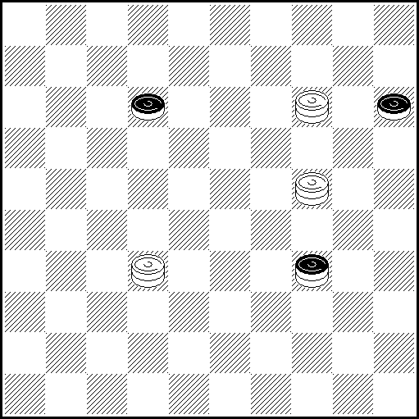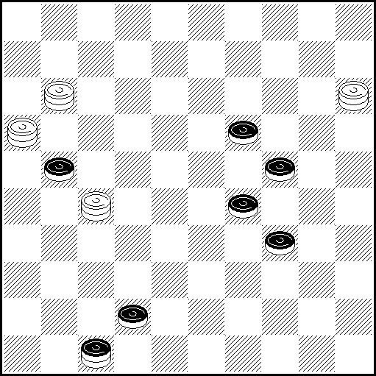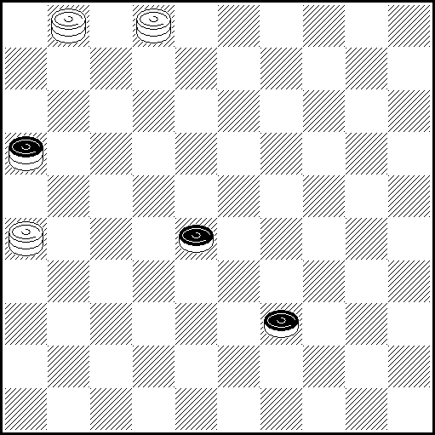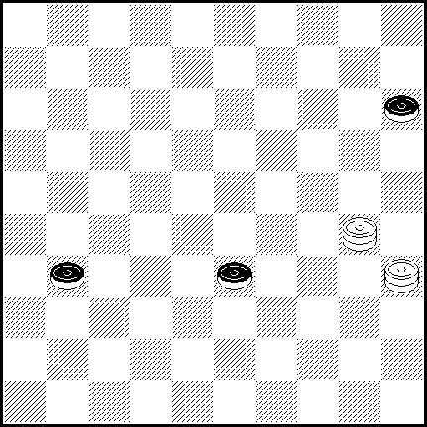
N33 VP: 14-20(25 AB), 32-14(48), 25 Z₁ (17 CDE), 9 Z₂(20 FD₁), 15(26 G), 24 (26-21 H I), 22, 33,
1 x A(45), 23, 35 x B(48), 25 [A.Горин , Шашки 1989] (17 JK), 27 (21 LM), 16(20), 15(26), 42,
16-43 x C (20), 15(26 N), 24(21 O), 8, 9, 26 x D(26), 37 x D₁ (26), 31 x
E(18), 24-30* [ * 38(31), 24(48) ... ] (20), 3(22 P), 31(26 E₁), 48 x [* затяжка/вечное решение]. E₁(25), 48 x F(21), 250(21-26 F₁), 36(25), 24-13, 9 x F₁(27), 36(25), 24-13 x G(22), 27(37), 42, 27-43 x
G₁(37), 42, 27-43 x H(22), 27(17 G₁), 8, 27-9 x I(37), 22, 33, 31/26 x J(20), 26(39), 43, 24-42 x
K(18), 32-14(20 R), 15(26), 24(23), 28/32(12 S), 8, 32-14 x L(20), 26(34), 43, 24-42 x
M(26), 31, 17/26 x N(31), 4(26 T), 48(18), 27(17), 21, 14-37 x O(31), 13, 17/26 x P(34), 31, 48 x R(22), 24-30* [ *29(31), 24(48) ...] (20), 3(27 U), 31(26 R₁), 48 x [ * - затяжка/вечное решение ]. S(31), 42, 28-39/32-43 x T(36), 13/31 x R₁ (25), 48 x U (39), 31, 48 x
Z₁ 9?(26 Y₁, Y₂), 25(20 Y₃), 14(18), 27(12/17 ) =
Z₂ 32?(22), 32-14(27 Y₄), 24-30(20 Y₅), 3(31 Y₆) = z₃ 36?(20) = Y₁ (18?), 36(25), 24-13 x
Y₂ (17?), 25(21),25-20 z₃ (21-26), 36(25), 24-13, 9 x Y₃ (18?), 31 x Y₄ (20?, 26), 24(28), 32(17 Y₇), 8, 32-14 x Y₅ (48-31?), 37(42), 24 x Y₆ (26?), 36(37), 31, 48 x Y₇ (31), 42, 32-43 x
N34 VP: 38, 11:30, 13(41 A), 30, 36 x A(40), 13-24, 45 x
N35 VP: 1-7(16-43/49 A), 21, 11, 44/50 x A(11, 44), 35(50), 44, 32 x B(33), 11, 11(38), 44/50(43), 39 x
N36 VP: 24(39 A), 35-30(36 BC), 48(41), 37, 42 x A(36, 20, 41), 23 x B(44), 39, 26 x C(20), 26 x

PWCE – II
Categorie C

N37 N38
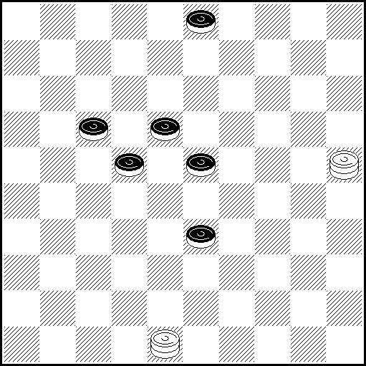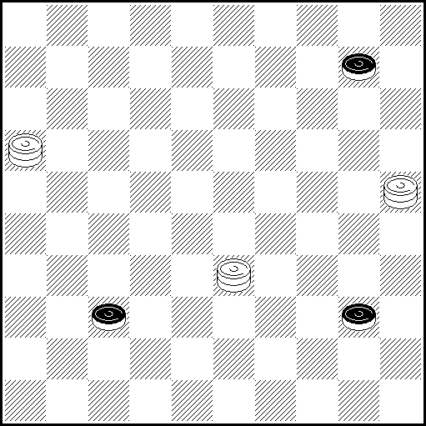
N37 VP: 20(29 A), 26(23 B), 12(8 CDab), 3(34), 38z (40 Ec), 33(2328 FG), 17(11 H), 6 (45), 50 x
A(27), 8, 26(29 J), 3(33), 9(23), 14(29), 20 (34), 38(40), 33(45), 50 x B(9 or 38), 34 x
C(9), 3(39 de), 14(2228), 17(32 K), 50(37), 21 (41 L), 32 x D(27), 24, 16/21 x
E(39), 25(44), 29, 50 x F(27), 12(45 M), 29(32 f), 50(37), 47 x G(45), 6(50), 3-17 x
H(39), 35 x J(22), 3(27), 9(32 N), 20(28 O), 42 x K(2833), 32(34), 6/11(40), 3228Z, 35 x
L(42), 38 x M(28), 31/36(44), 40 x N(28), 31/36(33), 27(39), 49 x O(37), 14(41/42), 46/48 x
Z 23?(38YY1), 35(43), 28(48Y2) = Y (4044?), 34, 50 x Y1 (45?), 2328, 50 x Y2 (49?), 2844 x
a(34), 40(39) 38(8), 4049(43), 27, 36 x or simply 25 x
b(2228) and now 7(8), 2(12), 25(32), 19/24 x or 17(9), 3(34), 14(40), 22, 35 x
c(2328), p.e. 26(40), 27, 45 x or also 25(40), 49 (45), 40, 43(33), 16(28), 43 x
d(38), 20(33 g), 34(27), 15/24(31 h), 3429, 26 x or 15(36), 3429, 47 x
e(27) p.e. 18, 43 x or also 14(31), 26(38), 34 x
f(50), 6(31), 2933(28), 33(37), 47 x or 12 (45f1), 6-1, 36 x f1 (36), 1217, 28 x
g(34), 42/47(39), p.e. 33, 38 x h(32), 3429, 42 x or 15(37), 3429 x
z 42?(2328), 25(40), 39z1(27) = or (45), 50(27) =. z1 29(44y) =
y (45?), 40, 43(33), 16(28), 43 x

N38 VP: 50(41 A), 34(29), 49(46 B), 33, 5 x B(47), 38, 5(33), 32(39), 49 x
A(14), 9(41), 44(49), 9-27, 46 x

Categorie C, Kатегория C :
Ukraine – 5, Bielorussie – 4, Russie – 2, Lituanie – 2, USA – 1, Israel – 1, Netherlands – 1, Germany – 1, Croatia – 1, France – 1. TOTAL : 38 etudes (19 participants),

PWCE – II
Categorie D
N1 N2 N3 N4
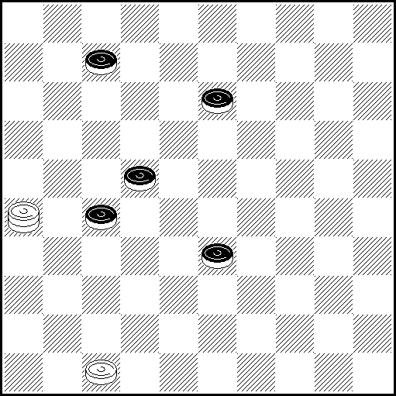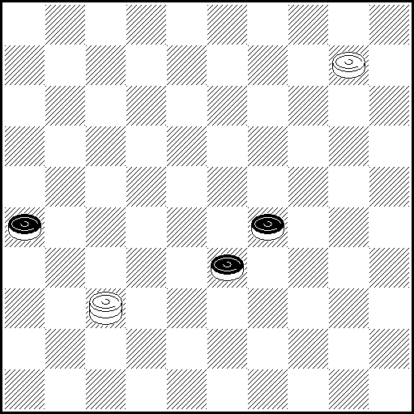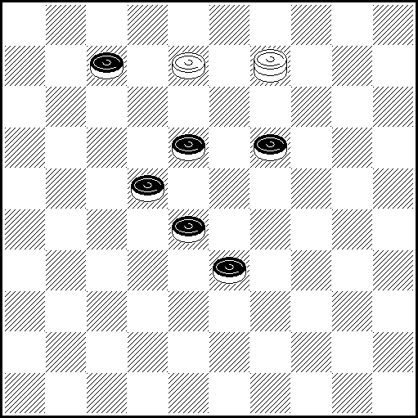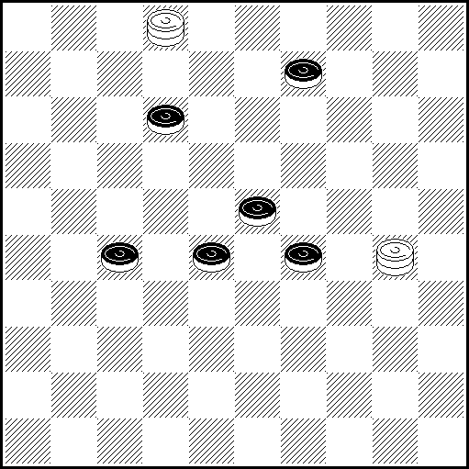
N1 VP: 26-42(39), 24(18), 2(12), 11(17), 7(21), 43(28), 42(33), 48(32), 38(43), 26 x

N2 VP: 4(34 A), 27(40 BC), 27-31(45 DB1), 46,50 x A(39), 23 x B(349), 27-31(44), 46, 50 x
C(339), Z 28(31), 44/50 x D(38/39), 46, 35 x B1(44), 46, 50 x
Z 27-31?(43 Y Y1), 46, 49(39)= Y(44?), 46, 49 x Y1(40?), 46, 35 x

N3 VP: 2 (193 A), 11(39 B), 17, 44(16), 40(28), 49(33), 43 x A(24), Z2 16(30), 25(35), 7(39), 43(40) 49(45), 40, 43(33), 16(39), 11(43/44), 48/49 x B(29), 7(23), 27(39), 1(283), Z1 278, 43 x
Z1 49? (38 Y1), 14(34), 40(43)= Y1 (44?), 35(38), 24, 42/47 x
Z2 11? (38 Y2), 7(33), 15(27), 31(39), 42(44)= Y2 (30?), 25(35), 7 …x var. A

N4 VP: 25(282 А), 26(34), 7(29 B), 17 Z(38 CC₁), 16(32 a), 28, 25(33), 14(29 D), 20(34), 38(40), 33, 50 x А(18), 3(283 E), 14(32), 37(39), 26(23 F), 3(34 G), 35(43), 19, 48 x B(38), 47(39), 48(44), 39 x
C(31), 39, 26(38), 48 x C₁(37), 39 x D(28), 32(39), 49 x E(282), 14(28), 9(22 H), 18, 31(38), 48 x
F(43/44), 12, 49/50 x G(44), 19, 50 x H(283), 44/50 Z₁(31 H₁), 16(36/317), 15(41), 28(47), 28-33x
H₁(34), 16 x а(31), 25(37), 20(34), 47 x Z 42? (31), 26(33), 40(39), 49(38), 16(44), 27(50) =
Z₁ 31? (39 Y₁), 16(34), 49(40), 35(43), 22(48) = Y₁ (34), 11(338), 16(40), 31-27, 35 x
N5 N6 N7 N8
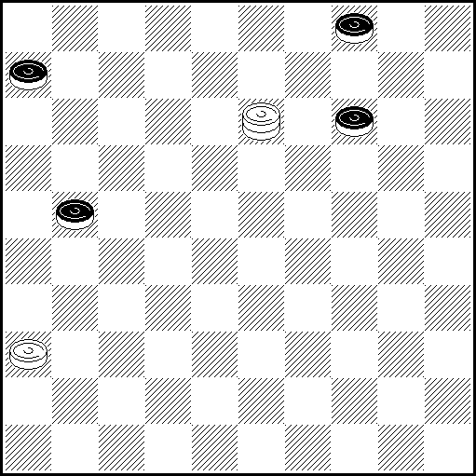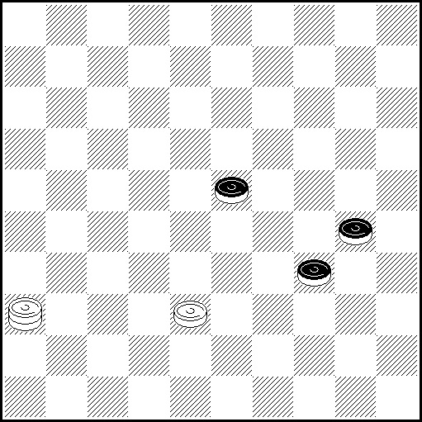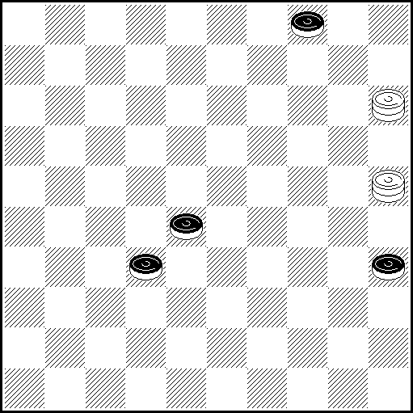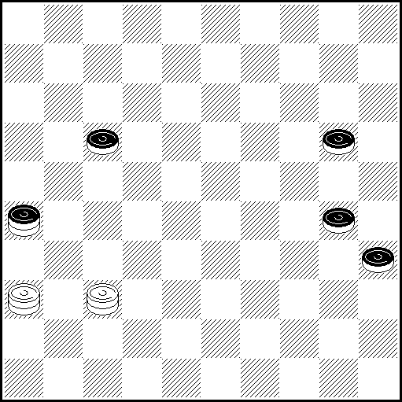
N5 VP: 24(26 A), 8! Z1(11) , 30! (20 B), 19(17), 46(10, 22), 37(27), 42 (32, 37), 10(42), 37, 27 x A(11), 2!(17), 16(26), 32(20), 46(10, 22), 37(27), 42(32, 37), 10(42), 37, 27 x B(17) , 48 Z2(20) , 31, 25(9) , 3 x Z1 42(19!), 37(24), 46(31!, 29), 28(34!), 44(9 !), 27-22(13!),17(18) =
Z2 39(19, 23), 33(10! Y), 42(28), 37(33) = Y (9), 20! (28, 33), 25(38), 48 x

N6 VP: 41(29 A), 47(39 BC), 33(28 D), 35(32 E), 24, 47 x A(39), 35 x B(40), 33, 44/49 x C(35), 33, 45 x D(38),44/50 x E(33), 30, 48 x

N7 VP: 14(9 A), 3(40 B), 17(38 CD), 35(43), 38, 24(37), 47 x A(10), 5(40), 38, 35 x
B(37), 25(41), 30, 36(32 E), 31(38), 48 x C(37), 35(41), 19 x D(45), 50(37), 47 x E(33), 27(39), 49 x

N8 VP: 361(261 ABCDEE1), 22, 16, 11, 50 x A(22), 48, 37/26, 28, 50 x B(24),48,12(29), 25, 39, 50 x C(25), 48, 12 x D(40), 48, 45 x E(171), 48, 34/48 x E1(34), 48, 39/48 x

PWCE – II
Categorie D
N9 N10 N11 N12
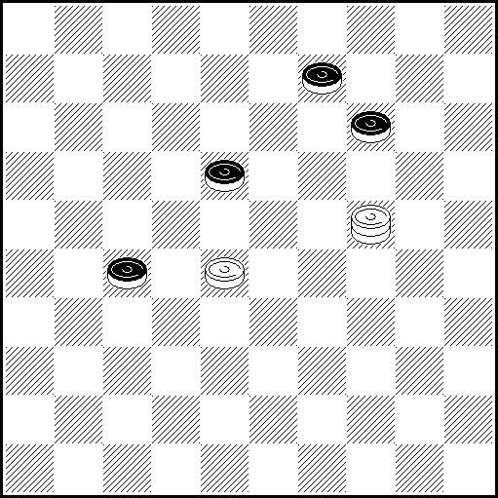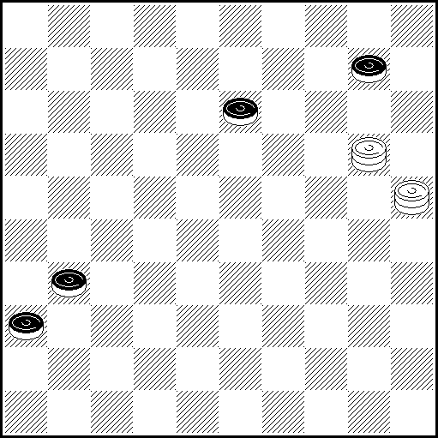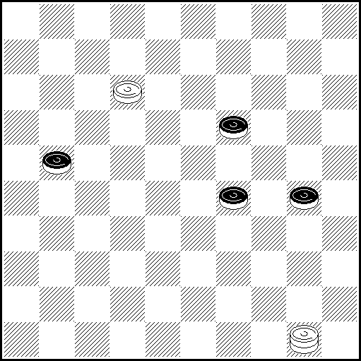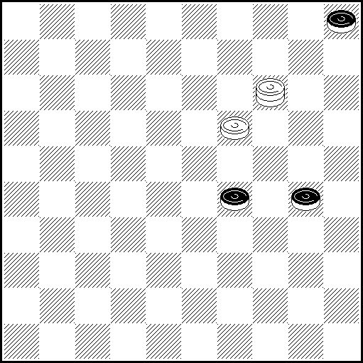
N9 VP: 22(31 ABC), 4(36), 10, 19 x A(32), 4(37), 19, 10 x B(20), 4, 31/36(33), 27(39), 49 x
C(19), 224, 31/36 x

N10 VP: 47Z (37 A), 48(37-41 BCD), 31, 15 x A(19), 14(15), 26(20), 15, 37 x B(19), 26(24 E), 4, 37 x
C(36-41), 47x15(41), 37 x D(15), 9 x E(15), 8(24), 30/35(20), 15, 19 x Z 15?(19), 4(37) =

N11 VP: 7(23 A), 1(27 B), 12(32), 22(35 CD), 3(33 EF), 50 Z₁(28 G), 22(37 H), 14(42), 37, 36(40), 22, 50 x A(27), 2(24 I), 45(33), 34, 21/16(39), 49 x B(304), 22(40), 228, 45 x
C(304), 3(40), 18, 35(34 J), 44 x D(38), 21(42 K), 38, 25(28 ), 14(34 L), 32(39), 49 x
E(28 ), 24/20/15(37), 47(40), 17(45), 50 x F(37), 18, 24/20/15(40), 33(45), 50 x
G(40), 20(45), 42(28 M), 6(50), 42-33(28), 33(37), 47 x H(38), 21(42), 38 x
I(23), 35(32), 49(37), 33.41/46 x J(33), 30(38 ), 48 x K(28), 35(42), 38, 30(38), 48 x
L(283), 20(34), 38(40), 33, 50 x M(29). 24/20/15(37), 47 x Z1 44?(37 Y₁Y₂), 14(40, 49) =
Y₁ (28?), 22(37), 14(42), 37, 36(40), 22, 50 x Y₂ (29?), 12(37), 40(41), 50, 46 x

N12 VP: 3(33 ABC), 19-14(10), 5(35), 32(39), 17 x A(29-34), 19-14(40), 10, 45 x B(10), 20(29-34),
25(15), 19-14 x C(30-34), 19-14(40 D), 10, 33, 50 x D(10, 39 ), 28(43 E), 39, 20 x E(33), 25 x
N13 N14 N15 N16
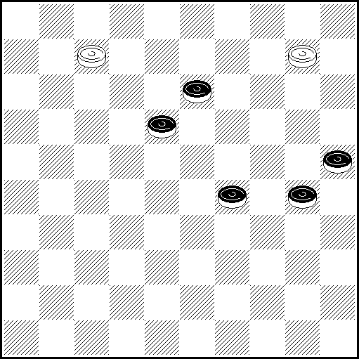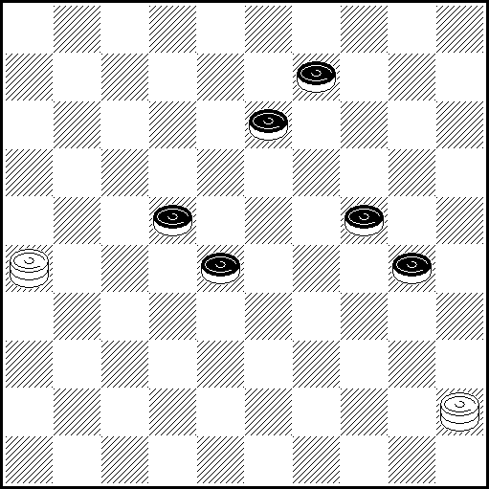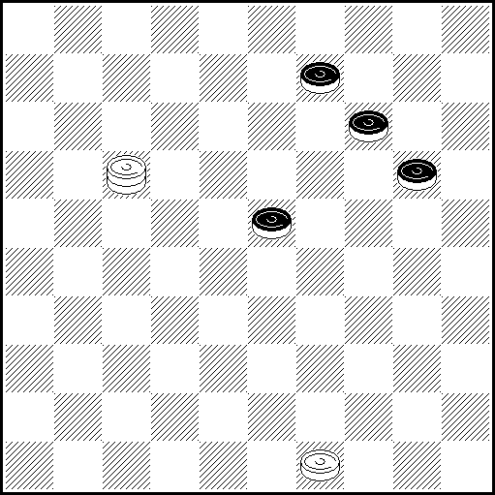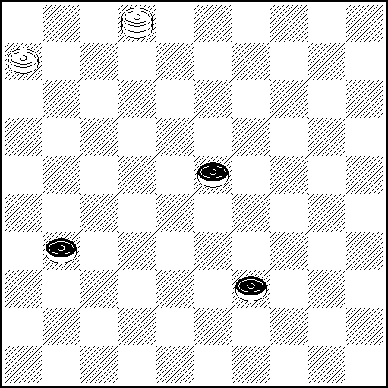
N13 VP: 2(294), 35(39), 49(22), 4(28), 4-27(30), 16(35), 11(33), 32(40), 28, 35 x
N14 VP: 18(33 AB), 27, (35 C), Z1 16(40), 17(45), 50(18), 7(22), 6(50), 12(45), 6-1, 3 x
A(19), Z2 4(34 D), 27(40), 22, 45 x B(35), 27(29), 49(32 EF), 27(40), 17(45), 6(19, 50), 4-22 x
C(34), Z3 38, 2/8 x D(33), 27(34), 8(349), 27-13(44 G), Z4 Z5 3, 50 x
E(18), 3(40, 45), 40 x F(19), 32, 4, 22(45), 50 x G(30), 38(35), 17 x
Z1 17?(30, 40) = Z2 27?(34, 39), 17(Y1 29) = Z3 17?(349), 49(29/30), 3(34), 38(40) = Z4 2?, 49(39) = Z5 17?, 50(Y2 12), 39(18), 17(30) =
Y1 (33?), 10(30), 32(35), 11/6(40), 32-28, 35 x Y2 (29), 39(13), 11(34), 2(18), 7(40), 45 x

N15 VP: 43(24), 8(19 A), 12(28), 17(32), 26(29 B), 48(38 CD), 32(33), 28, 31(28), 4(33), 10(24), 15(29), 20(34), 38(40 E), 33, 50 x A(28),30(32),38,48 x B(30), 48(35 F), 38, 4, 22, 50 x C(33), 38, 3 x
D(23), 38, 3(34), 14(40), 28, 50 x E(39), 49 x F(34), 38, 4 x
N16 VP: 1(28 A), 23, 26 x. A(36), 48(41), 37, 24(37), 47 x

PWCE – II
Categorie D
N17 N18 N19 N20
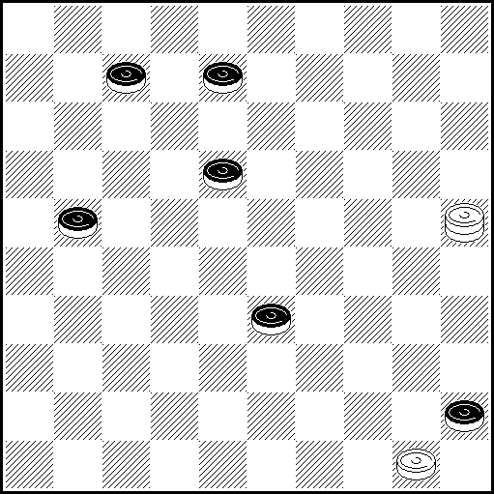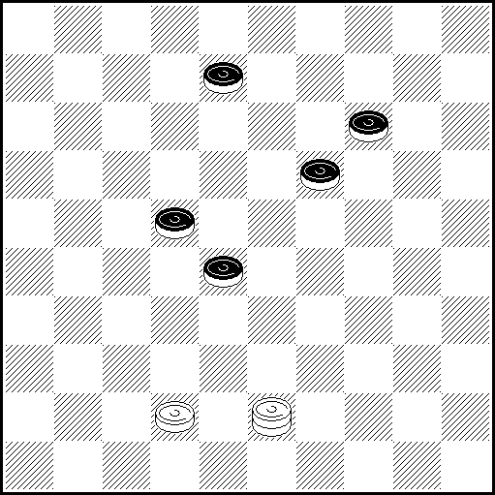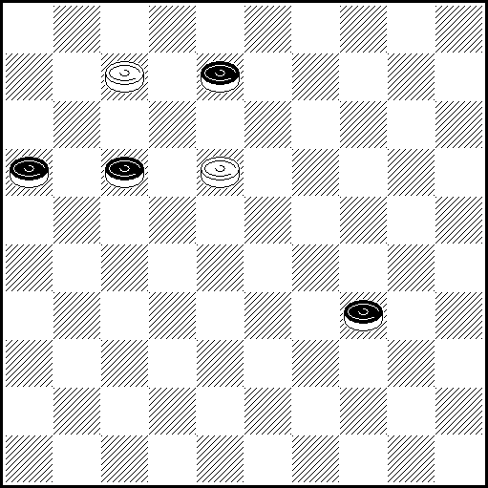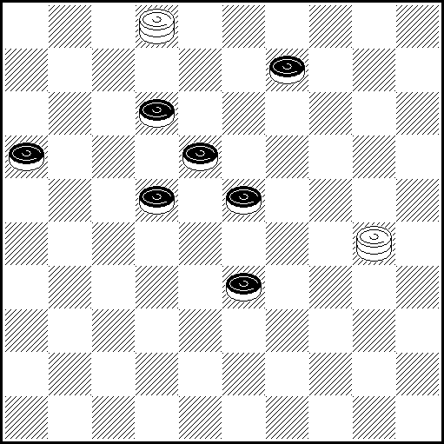
N17 VP: 44(50 Aab), 48, 12 x A(39), 22(50), 6 x a(8-12), 40, 13 x b(7-12), 40, 2(27), 19 x

N18 VP: 25(24 A), 27(30 B), 18(13), 9(34), 3(40), 17(32), 39(45), 50 x A(27), 23, 38 x
B(29), 43(293), 48(32), 38(42 C), 2 x C(43), 3 x

N19 VP: 2(12, 40 A), 35(45), 40, 1(39 B), 6(17-21, 272), 28 x A(39), 1(17-21), 11, 16 x
B(22), 40(28), 49(33), 43(21, 39), 49 x

N20 VP: 2-24(17 A), 42(171 a)25 Z(13 B), 39 Z₁(238), 29(217 C), 1(272 DE), 30(38 FG), 2(32 H), 2-7
(42/43 IJ), 11, 47/49 x A(29), 25, 44(23), 40(28), 49(33), 43(21), 16(39), 49 x
B(26), 3(238), 37(33), 48(31 K), 26(39), 9(23 L), 36(43/44), 21, 48/49 x C(26), 1(19 E₁b), 30(33),
27(31), 36(38), 22(42), 11, 47 x D(31), 18(36 M)31,31/36(19), 27(24), 38(30), 43(35), 49(21), 16, 11,
50 x E(21), 30(26), 2(261 c), 18 26 x E₁(21), 30(217), 2(261), 18, 26 x
F(27), 8(31 d), 17(327), 33(41 N), 11, 47 x G(37), 2(32), 11, 42 x H(33), 11, 43 x
I(27), 11, 42(31), 26(38), 48 x J(28), 11, 42 x K(27), 9(22), 4/13(261 e), 26(39 O), 21(31), 36 x
L(44), 17, 50, 6 x M(27), 9/4(272), 36(38), 36-27(42), 21, 48 x N(36), 11, 46 x
O(38), 48(32), 31(21), 27 Z₂(26), 16(31), 26 x a(228), 39(172), 25(13), 30 x b(32), 11, 37/46 x
c(272), 19(33 c₁), 41/46(38), 29(43), 38 x c₁(31), 5/10(36), 1-23 x d(37), 18(31), 36(33), 26 x
e(28), 36(32), 37 x Z 39? (238), 37(23), 34(29, 40) =
Z₁ 30? (26), 2(27), 37(29), 42(34), 7(271, 37, 37) = Z₂ 26? (43), 25(38), 17(42), 33(47) =

N21 N22 N23 N24
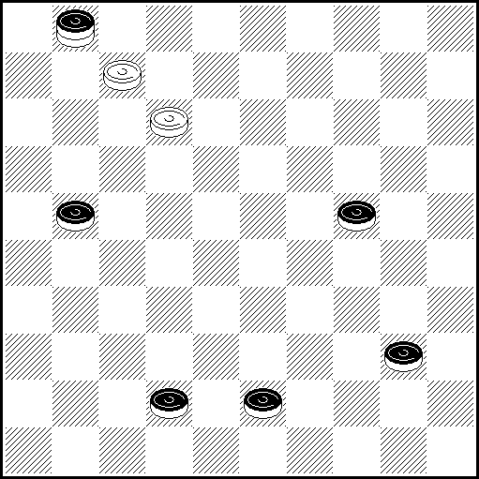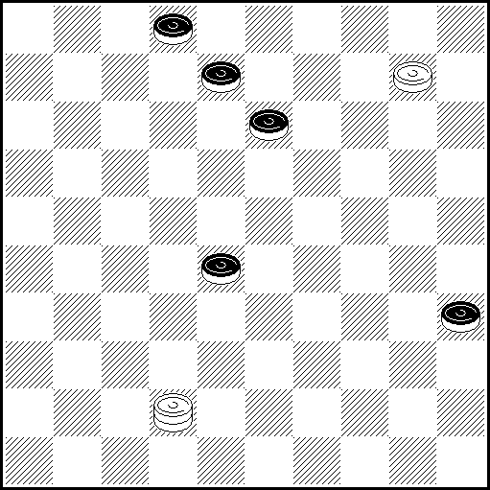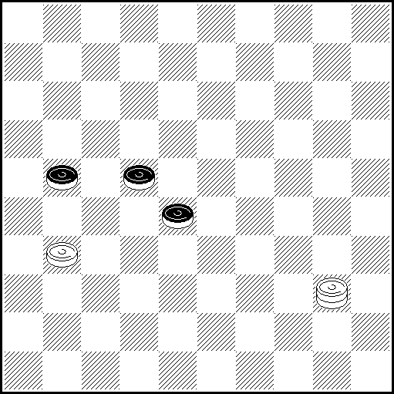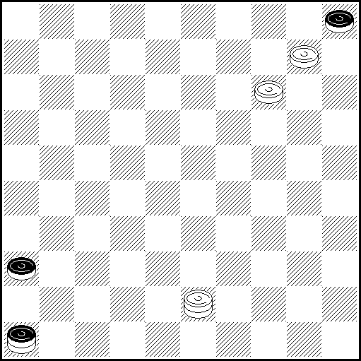
N21 VP: 2(29A), 45 x A(34), 17 x
N22 VP: 4 Z1(19), 37! (33 AB), 14! (12), 22!! Z2 Z3 Z4, (38), 3 (18), 4(42 CD), 8, 48(40),
39(45), 50 x A(23), 18, 1(7, 40), 17(45), 50 x B(24, 24), 15! (30), 29(12), 1(7), 25 x C(43), 8, 49 x D(40), 8, 35 x
Z1 37(18 Y,40),4(45) = Z2 3(17!,8)= Z3 32(17!)= Z4 18, 44(7),49(12!)= Y(33?),4 gagne comme VP.

N23 VP: 49(26 A), 35, 13(32), Z 42 x A(33, 39), 11(27), 44/50, 28 x Z 48?(38)=
N24 VP: 38(36-41 ABC), 47 x A(37), 4, 15(41 D), 32 x B(32, 41), 38(47), 15 x C(19, 14), 32(20),
19(25), 14(30), 10(34), 5(39 E), 49 x D(10, 41), 10 x E(34), 5-28(45), 50 x
PWCE – II
Categorie D
N25 N26 N27 N28
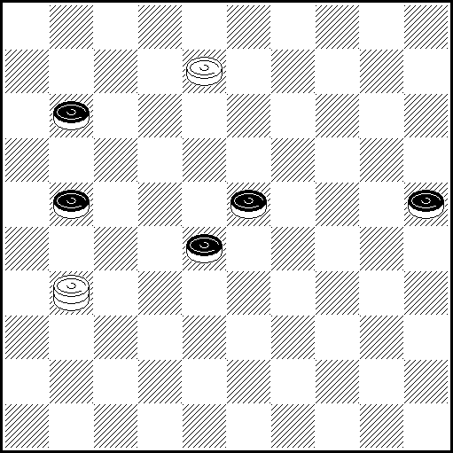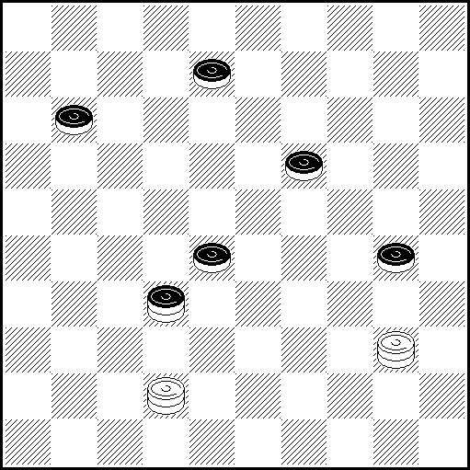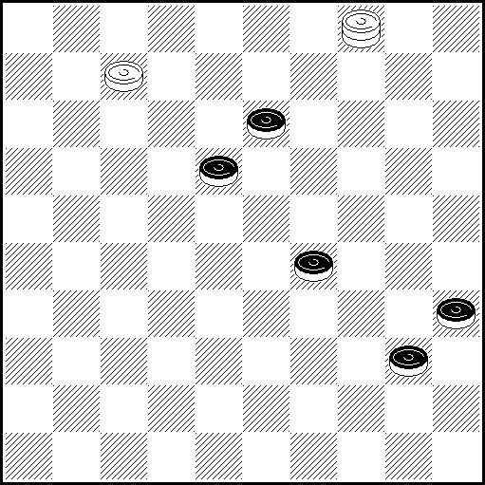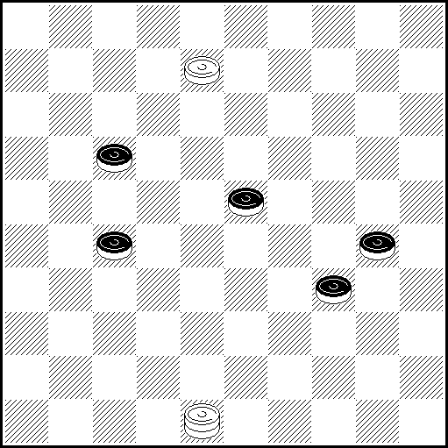
N25 VP: 26(27 Aa), 2(16 b), 13(29 B1cd), 31(34 Bef), 12 (39 g), 48(32 C), 34(37 D), 3418(42 h), 21, 48 x A (32), 29(30), 47(34), 2(17 EF), 8(21 j), 26 (40 k), 17(45), 6(50 G), 4733(28), 33(37), 47x
B (32), 27z, 34(21), 43(26), 48 x B1(2832), 31/36(29), 27, 34(21), 43(26), 48 x
C(44), 30, 49(33), 43 x D(38), 1229(30), 25 x E(16), 33(40 H), 3311, 35 x
F(37), 16(40 J), 11(45), 50 x G(37), 50 x H(38), 42/47(39), 30(44), 39 x J(39), 49 x
a(17), 2(32 a1), 16 x a1(29/33) p.e. 11 etc. or even faster 16 etc. x
b(2832), 16(29) and now 7(33), 11(3338), 39 x or 12 (33), 18(3338), 31(30), p.e. 3127, 25 x
c (2732), 24(30 c1), 35(38), p.e. 48 (21), 40 x c1(21), 29 or 33(37), 19/47 or 47 etc. x
d(33), 31(39) and now 36(43), 21, 48 x or 12 (28), 48 see variants VP, C, D x
e(2833), 12(34 e1), 40(39), 27 or 48 x e1(21), 34(38), p.e 37 x
f(2933) and now p.e. 27*(39), 32, 34(21), 43 (26), 48 x * also 17 and 36 win.
g(33), 40(38), 34 or 49 x h(30) and now 21, 25 x or 26(41), 21, 47 x
j(22) and now 13(28), 19(40), 38, 35 x or 26 (40 j1), 37, 45 x j1(39), 48(44), 38, 50 x
k(39), 33, 42 or 48(44), 33/38 x
z 12?(33), 34z1(3338y), 3148(43y1), 39 (37), 1(30y2), 25(41/42) = z1 48(30 or 37) =
y (21?), 42(3238) and now 37(26), 3748 x or 4248(27), 26(32), 31x y1 (21?), 12(43), 34/39(38), 26 x
y2 (41/42?), 11, 46/47 x

N26 VP: 49(46/32-16 ABC), 37/38, 35(32 D), 24(37), 47 x A(24), 13(32 C1), 15(37), 35(41), 19 x
B(116), 3(35), 31(32 EF), 13, 49(21), 16(40), 11, 50 x C/C1(35), 30 x D(33), 30(38), 48 x
E(40), 13, 35 x F(21), 26(40),22 х

N27 VP: 1(45 AB), 40(44 C), 50 x A(34), 29, 45 x B(23), 18, 45 x C(34), 45 x

N28 VP: 2(35 AB ), 25(21 CD), 7 Z₁(28 E), 3 Z₂(33 FG ), 26 (39 H), 17(43), 22, 48(40), 39, 50 x
A (32, 38 ), 25(42), 19, 48 x B(28,282), 25(37), 3(22 I), 2(41 B₁ JK), 17, 46 x B₁(42), 17,47 x
C(28 ), 19 Z₃ (272 LM), 20(21 N), 47(26), 15(31 O), 30, 15:38:36(33 P), 27(39), 49 x
D(31), 19.37/42/48(40), 28/33/39, 50 x E(32), 29(37 E₁), 14(40), 45(42), 37, 23 x E₁(40, 37), 23/14(42), 37, 14 x F(27-32, 38), 16(32), 31(40), 317, 35 x
G(26), 14(33 QR), 11(38 ), 16(32), 37(43), 49 x H(40, 39), 17(43), 39, 31/36 x
I(31), 26(36), 42/48(41), 37, 24(37), 47 x J(28), 13(31, 42 S), 22, 48 x
K(31), 26(36), 42/48(41), 37, 11(27 K₁), 16(31), 38(37), 47 x K₁(28), 33(37), 47 x
L(33), 20(39),33 x M(282), 37/46(40), 39(45), 6(50), 37/46-28 x N(40), 38, 35 x
O(40), 38, 35 x P(32), 31(38), 48 x Q(27-32), 11(31), 33/39(317), 33/39-28 x
R(40), 21, 45 x S(33), 26 x
Z₁ = 34?(40 Y₁ ), 36(44/45) = Z₂ = 29?(33 Y₂,Y₃,Y₄), 42(40), 34, 24(32) =
Z₃ = 34?(282), 19(38), 24(40), 42, 20(32), 3(22), 9(28 Y₅), 14(33), 37(39), 32(44) =
Y₁ = (32?), 26(40), 11(38), 48(45), 50 x Y₂ = (282?), 14(40), 45(38), 29(43), 38 x
Y₃ = (272?), 33, 16(40), 11, 50 x Y₄ = (26?), 14(40), 21, 45 x Y₅ = (27?), 31(38), 48 x

PWCE – II
Categorie D
N29 N30 N31 N32
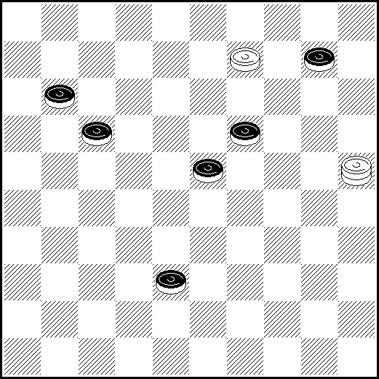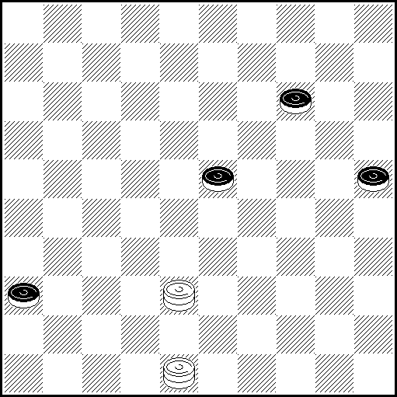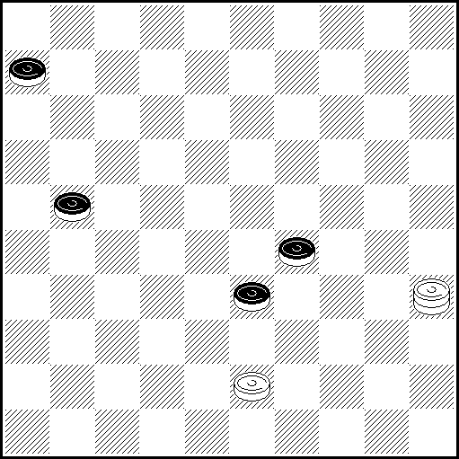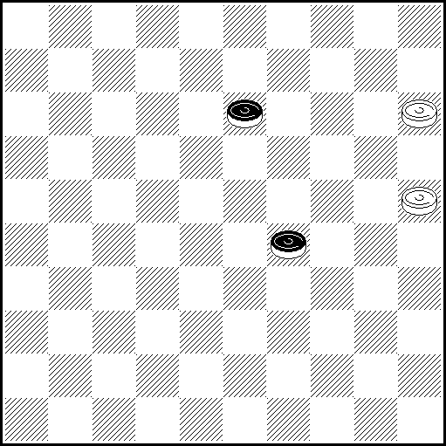
N29 VP: 4(15), 27(42), 16(47 AB), 24, 6 x A(48), 34, 6(23), 33 x B(47), 24, 48 x
N30 VP: 37(41 A), 10(47), 10-15 x A(19), 38-32(24 BC), 35 x
B(30), 16(29), 14/5(33), 37(39), 31, 25 x C(29), 14/5(33), 48(39), 34 x

N31 VP: 49(38 A), 32(26 B), 44(31 CD), 27, 17(34), 44 x A(11), 39 x B(33), 44 x
C(11), 6(31), 27 x D(34), 27 x
N32 VP: 10(34 AB), 4(19), 15Z(40/39), 24 x A(33), 4(19), 15(39), 24, 43 x
B(19), 4(33), 15(39), 24, 43 x Z 10?(24), 15(30), 10(35) =
N33 N34 N35 N36
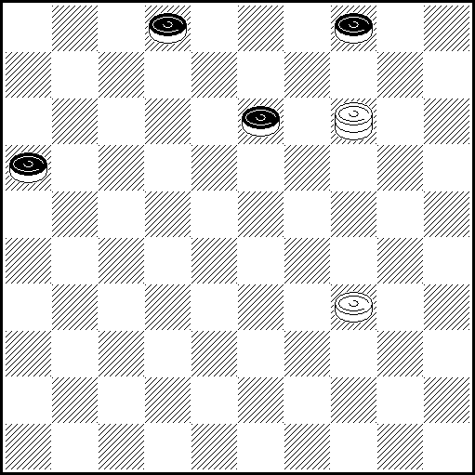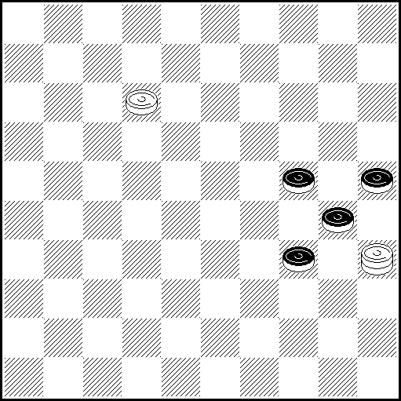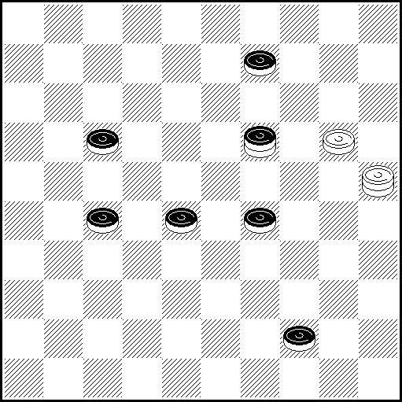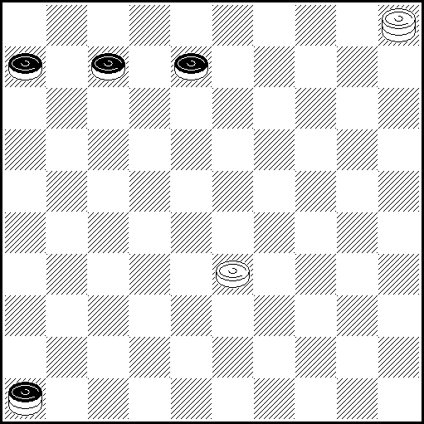
N33 VP: 29 Z(21 a), 9(26 A), 36 Z1(8), 41 Z2(31), 293(36 BC), 28 Z3(9 Db), 18(8-13), 11/6, 28 x
A(19) 25(27) 24 x B(9), 18(8-13 VP1), 36, 4 x C(12) 18 Z4 x D(13), 32/46(10), 18, 5 x
VP1(36), 28(8-13), 11/6, 28 x a(18), 19 Z7(22), 13(8), 2 etc.
b(10), 19(15), 14(13), 32 Z10(19), 23(20), 19(25), 14(30), 10(34), 5 etc.
Z 3? (18), 26(22), 31(28), 37(33), 42(21), 20(27), 14(31) = Z1 27? (8), 32(31), 293(9,) 18(8-13 Y) =
Z2 47? (31), 42(36), 37(9), 24(9-13) = Z3 32? (9), 19 (9-13), 14(18) =
Z4 19? (9), 32 Z5(18), 13 Z6(23), 3(37) = Z5 46? (18), 32(36), 37/46(23), 28(14) =
Z6 46? (23), 28(14) = Z7 37? (8), 26 Z8(13), 17(10), 28(15), 24 Z9(21), 28-19(26 Y1 Y2), 8(23)
17(31) 26(36) 37(20) = Z8 19? (21), 2(26 Y3) 2-19(31), 294(9), 13(36), 4(22) =
Z9 44? (21 Y4) 35(27) = Z10 37/46? (19), 23(20) =
Y (36?), 28 etc. x, like in VP Y1 (27?), 2(32), 7(22), 11(27), 16 x
Y2 (20?), 26, 3(33), 9(23), 14(29), 20 x Y3 (27?), 294(32), 7(22), 11(27), 16(10), 19/20(15), 14 x
Y4 (19?), 35(193), 294(28/22), 20 x

N34 VP: 7(39), 49(35 A), 2(29), 11(33), 32(30 B), 23(38 C), 50(40,42), 34,47 x
A(34), 2(240, 30), 24(40, 43), 38, 24(37), 47 x B(40), 32-28, 35 x C(34), 45(38), 50(42), 40, 47 x

N35 VP: 14(10 AB), 25:3:21:49:5(33), 32(39), 49 x A(5), 25:46 x B(20), 25:14:32:21:12:49 x

N36 VP 29(7-11 A), 29-23(19), 32(13), 16(17), 2(18), 7(18-22), 11 x
A(13), 29-23(19), 1(19), 18(11), 22(16), 27(23), 38(28), 27/49(33), 43 x

PWCE – II
Categorie D
N37
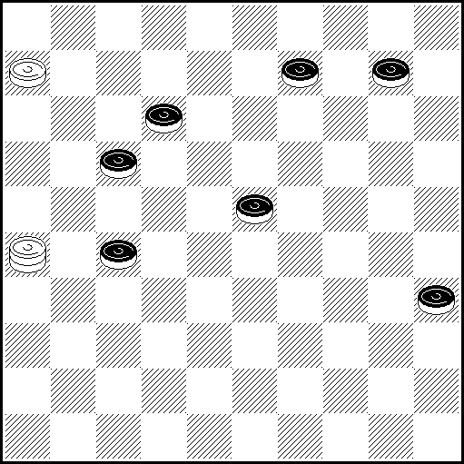
N37 1(9-14 ABCDa), 34zz1(20 EFb), 25(32),20(37 G), 47(14), 3429Z(19 H), 34(24),15(41 J), 30, 36 x
A(31), 15Z1Z2(37), 29/34(40), 45(41), 23 x
B(28), 15Z3(2832c), 12(31), 47(36), 23(40), 45(37), 23(3641), 36(42), 37 x
C(32), 15(28 K), 3/8Z4(40 d), 17(38 LM), 35(43), 38, 24(37), 47 x
D(1014), 31/36(28), 4(19 N), 30, 10(33), 15 (29), 20(34), 38(40 O), 33(45), 50 x
E(15), 25(32 E1), 23(40 e), 45(37),23(42), 29 x E1(31), 23(40), 45(36), 23 x F(40), 20, 16/21 x
G(14), 9(37), 31Z5, 18 x H(20), 15(40), 33(45), 50 x J(40), 45(41), 23 x
K(22), 4(27P), 31/36(40), 27, 45 x L(37), 35(41), 19 x M(45), 50(37), 47 x
N(32), 20(40), 22(45), 50(37), 47x O(39), 49 x P(2228), 4-13 or 4-31(38), 22 x
Z 23?(19), 14(40) = Z1 3?(14 or 18), 5(40) = Z2 5?(22), 4(40) = Z3 16?(40), 5(44), 28(50) =
Z4 12 ?(37), 47(33), 15(41), 23(40) = Z5 23?(40Y) = Y (42?), 37, 36(40), 22(45), 50 x
a(13), 15(22), 48z2(31a1), 26(40), 33(2328), 17/48 x a1(2328), p.e. 30, 21(33), 16(28), 43 x
b(22), 37 x c(22), 37z3(2732), p.e. 48(27), 30, 31 x d(37), 25/30 x p.e. 25(41), 30, 36(33), 27 x
e(20), 9(38), 32, 31/36 x or 20(43), 38 x z 45?(32), 20(14), 9(38), 20(43), 34(40/49) =
z1 31?(28), 25(40), 39(32/33) = z2 also 12(2328), 42(?-32), 7(27/28), p.e. 11 x
z3 also 29(2832), 2642 x or (2732), 48 x

Categorie D, Kатегория D :
Ukraine – 5, Bielorussie – 4, France – 2, Lituanie – 2, USA – 1, Israel – 1, Netherlands – 1, Germany – 1, Russie – 1, Croatia – 1. TOTAL : 37 etudes (19 participants ),

