10.05.2010 г.

X CHAMPIONSHIP OF UKRAINE-2009.

REMARKS FOR CATEGORIES “MINIATURES” AND “PROBLEMS”

REMARKS FOR “MINIATURES”

There are present remarks indicated by A/Gimbutas (Lithuania, the text is marked by BOLD), I.Ivatsko (the text),A.Tavernier (the text and diagrams), S.Yushkevitch (the text, diagrams and remarks to ## M107 and M021).
The abbreviations are:
ПР, SS – Second solution.
ППР – Completed second solution.
ЧПР – Partial second solution.
HD: “Het Damspel”.
DP: “De problemist”.
DE: “Dam Eldorado”.
I.e., it is indicated DE-09.1981, then it means: “Dam Eldorado”, September 1981 year.

The judge of categories “Miniatures” and “Problems” is S. Yushkevitch,
the International Grand Master of problemism

М001- М008: S. USTIANOV
M004: Similarity
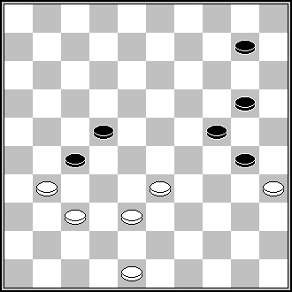 "Le sacrifice de la dame blanche sur 31 se retrouve dans le problème de J.Scheijen" (De Zuid Limburger, 1973) 29,4,31,31,37 +

М009- М016: A. MASLOV
М009: Similarity
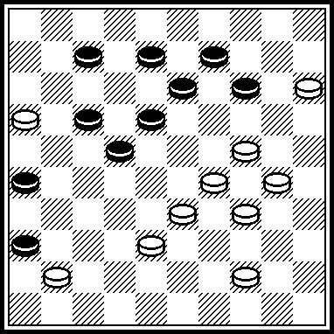 H/van Alphen, DP-12.1984. 20,294,28,10,4,19,27.
M013: ППР 127[39A]317,27[46]2,43+. A[28,46]2,6[20]1+.
M013: ПР 127+ и 2.... не (46), а 1318, 4146=.

M016: ППР 2,12,16,27+. ППР 12,2,16,27+.

М017- М024: M. LEVANDOVSKIJ
М017: Remark of the judge: there is no false solution, because after 11, 3(328) 43(39) 20, 47 a draw is reached also with (23)=.
In this connection, to the author’s comment to M017 it is useful to give also to give a characteristic given by the judge of Belarus’ championship-1998 (where M017 was scored with 82,5 points): “The sacrifice at the first move is wonderful and unexpected. Two thematic’s variants, the both similar, rise a quality. The strong iompression gives the false solution!”.
It is evidently from this characteristic that false solution was important component as a part of the score.
Bur, as it turned out, there is no false solution.

M021 The variant «A»: ЧПР 5. 2[19CD,41]249+. C[41]9,8+. D[20]18[24]31,16[31]32
[29]8[33]2[39]27,11+.
Remark of the judge: this dual in A-variant is interpretated by the author of this remark (A.Gimbutas) as Partial second solution. The same interpretation was met not once in a practice of contests, but such interpretation has no ground.
Such interpretation is based at the choice as the main variant the black move (19) after the fifth move of white 2. But such choice is not obligated. It is possible, for instance, to choice for black (41) and then there is no Partial second solution because the only 9, 8, 46 give the win. So, as it is written in author’s solution.
In this case it do exist two interpretations of this dual: either as Partial second solution or as a dual.
In such non-defined situation a choice should be done in favor of the author.
So, the conclusion is the following:
Not-exact move in A-variant does exist, but it is not Partyial second solution, it is a changing of moves, consequently it is a kind of duals.
However, M021 has no originality in its endgame-phase of Main variant after 7. This variant does repeat the endgame of K.Haletskij, published in SHASHKI, October 1968, and re-published in “Anthology” of L.Vitoshkin, [art 3, diagram 109:

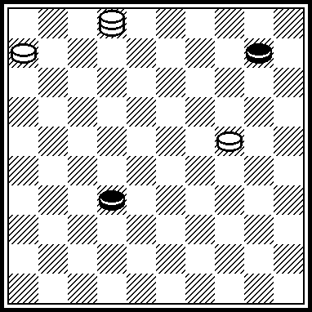

2419(37, A) 1913(41) 1(47, B) 29, 5.
A(14) 10(38) 24(43) 38, 5(38) 32, 1 etc.
B(14) 9, 8, 46.
This endgame was not indicated in remarks to “Lietuva-2003” contest in which M021 did share 2-3 places.
The endgame of K.Haletskij is incorrect because a draw does exist in author’s conception after 2419(37) 1913(15), 1(20) =, but it brings no more originality to M021.
Too, it is possible to add that the B-variant mechanism, from K.Haletskij’ endgame, was used in H/Wilsens’ problems:

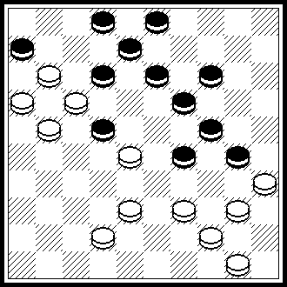
404, 44, 28, 40, 7, 2(31, 37) 1(41) 8, 46. «Molodezh Azerbaijana», 01.05.1982.

М025- М032: I. IVATSKO
М026: Similarity
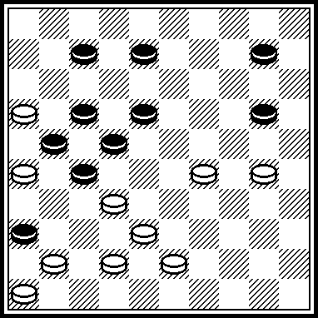 V.Matus, USSR Championship-1976. 427,304,4,38,27,19,37,37+.

M028: A Draw! 32,15,4[40!]36[294]13[35]9[45]25[340]38[44,40]30[50]
393[404]=.
Similarity
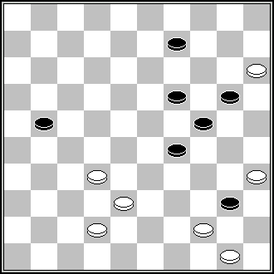 C.K Kaan (Vrienden,15-1-1943) 28,32,30,4… +

М031: Similarity
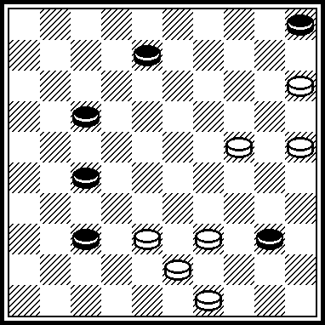 From the book of J.Tol and T.van Proijen “De onbegrensde mogelijkheden in het eindspel”, 1977 year. 44,32,3(47) 33 etc.

М033- М040: A. NYCH
М037: Similarity
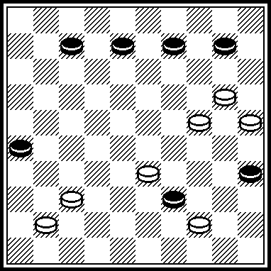 E.Tkachenko, «Leninska zmina», 16-5-1985: 28,31,15,1,
but here also 40, 19, 32, 204 gives win.

М041- М048: A> UVAROV
М042: Similarity
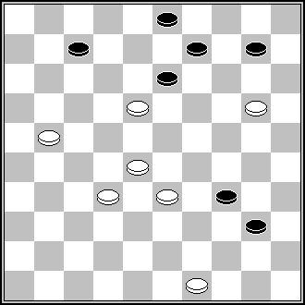 L. de Rooij (Damvreugde,6-1966) 12,29,8,17,44,15,31 +

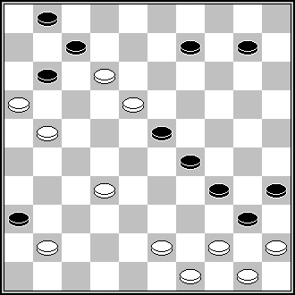 F. van Leeuwen (DP, 12-1997) 38,39, 30,34,20,7,17,44,15,31

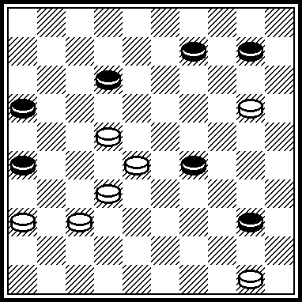 S.M. van Eijk (Das Problemblдttchen, okt. 2002): 17, 23, 44, 15, 31.

M045: ППР 2, 127, 18[28]183, 14+.
М046: Copy А.Jovaisas, « Novopolotsk », voir Patent 2003

М041: The idea of similar maneuver was arranged more effective in S. Ustianov position form “Lietuva-1997” contest.
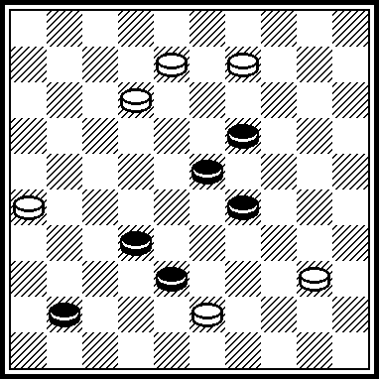 4,13.36,7(11,А)27,6 etc. А(16) 21б 29 etc.

М043: A maneuver 4, 15, 15 has no principal originality. Similarity
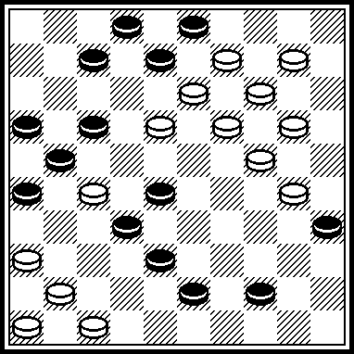 B.Fermin, DP-10.1984. 31,42,40,12,11,13,41,4,15,16 etc.

М049- М056: N. SНAPOVAL
M049: Similarity
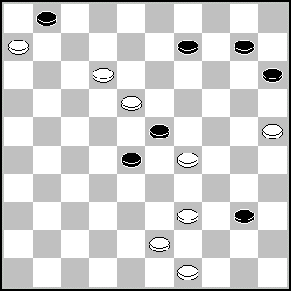 A.Kaciuska (Dambrete, 9-1986) 44,7,20,1,48 +

М052: Similarity
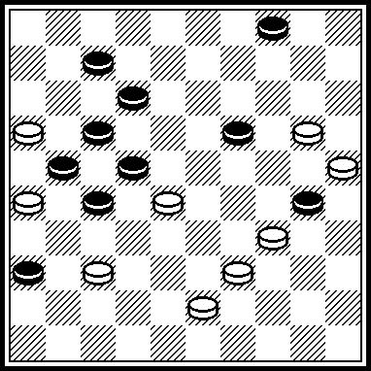 P.Kuijper, HD-02.1992. 11,31, 8,2(31, A) 13, 14, 14. A(26) 8, 14,14.

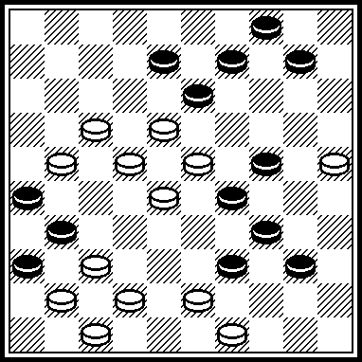 S.Yushkevitch, «SHASHECHNYJ MIR», № 1, 1997. 44,44,38,172,5,9,3,13,14,14.

M054: Similarity
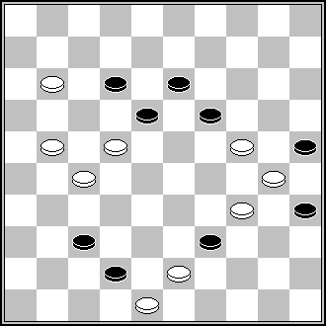 D. van den Berg DP, 4-1980) 38,43, 217,7,2,40,38,50 +

М055: ПР: 2520, 26, 48+.

M056: A mirror;s reflection:
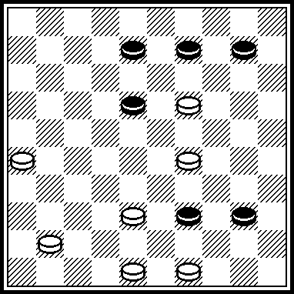 S. van Eijk, “Comp. in Zwart-Wit”-2. 4843, 44, 23, 5, 37, 37.

М057- М064: V. NESTERENKO
M058: Also 35, 11+. In author’s solution is a draw! 404, 34, 21[37]=.

М059: Similarity
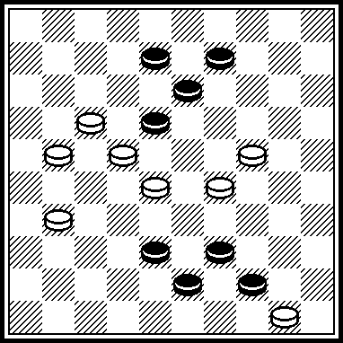 S.Kovalev, USSR Championship – 1976 г. 12, 19, 4, 33, 48.

M060: Similarity
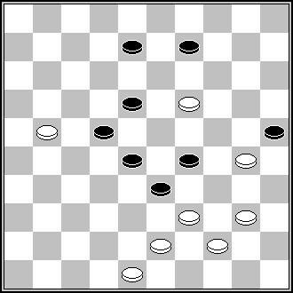 J.J van Tol (DP, 9-1947) 404,14,32,17 +

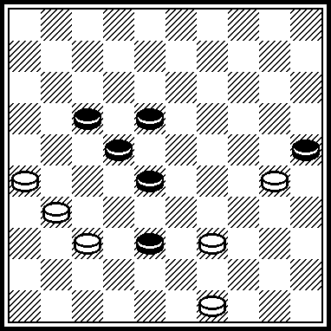 J. van den Boogaard, “Het Kompas”, 20.09.1947. 27, 21.

M062: ППР: 138,8-2[23]36[28]22[14]2[10]171[4]17[31]117 etc.,+.

М063: Similarity
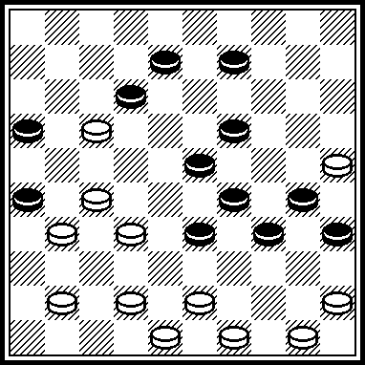 M.Douwes, DE-09.1981. 36,22,31,27,428,28,39,21,38,40,48.

М065- М072: I. KOBTSEV
M065: ПР 6. 41[304]47,40[44]33,50+. ПР 6. 32[304]39,22[349]11[34]328+.
М065: ПР: 1106, 7, 1 (283) 34, 38 (36) 30 (24) 19.

М066: Similarity
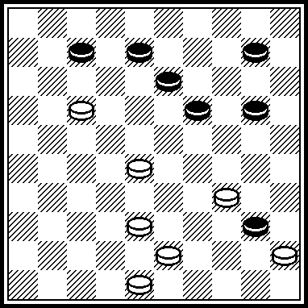 P.Lourans (G.Gortmans, «1001 miniaturen», 1939., N 642) 12(17),22(28),32(37),42,5+.

М068: Copy J.Scheijen (Verzamelde 14)

M069: Copy S.M. van Eijk,deel 6 ,p. 3510, Gouda/Rijeka,2002.

М070: A final black 23 – white king 4 has no exact solution.
Similarity
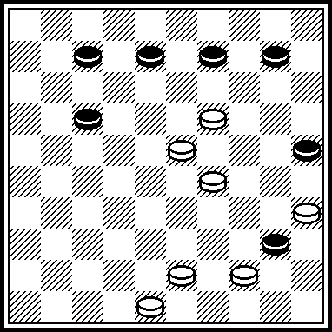 L. Dalman (Combat dans l'aréne, 1976): 30, 14, 42, 4
Final 23/D4 avec nombreux duals !

М071: Similarity
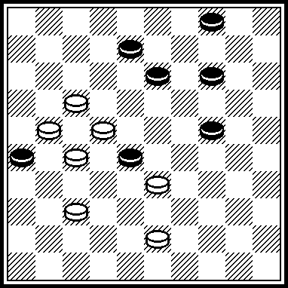 S. Zilevicius (Azerbeidjan, 1982). 12 etc.

M072: A draw: 22, 41, 43, 3 (17)=.

М073- М080: V. TRINOS
M074: ППР 28, 22, 32, 13+.
М074: 74. Avec pion blanc 47 à 46, copy W.Lente (DP, 2-1958)

M075: ПР 3. 2, 36+.

M076: ППР 42, 20[31]14[36]37[22]10[227]5[16]23[26,27]23-28+.
Similarity
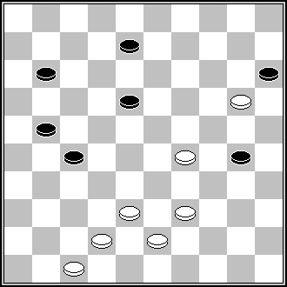 A. van den Elzen (Clubblad HDR, 5-1975) 34,42,3,47 +

M078: ПР 8. 20[22]15[14]38[19]29[27]18[32]4+. 8. 9[23]20+.
М078: Of course the motiv is not clean. After x9 (12) 3 (18) several winning moves are possible [as 9 or 20 etc.].

M079: Main variant: ЧПР 8. 29[28]38[14]24[32]42[150]15[37]47[19]250+. 13. 3[32]26+.

M080: Main variant: - ЧПР 5. 20[22]15[14]38[19]29[27]18[32]4+. 5. 9[23]20+.
М080: Motiv not clean: see 78.
Similarity
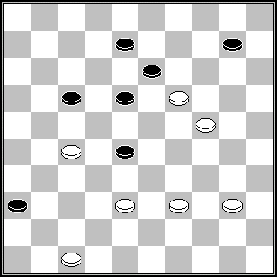 (G.Gortmans, «1001 miniaturen», 1939 г., page 156, in cifferstand) 22, 41, 14, 3+

М081- М088: V. POKHIL
М081: Similarity
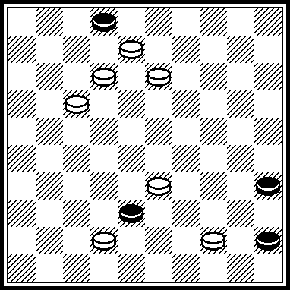 «Patent», June 2003. 29,3,40,7 etc.

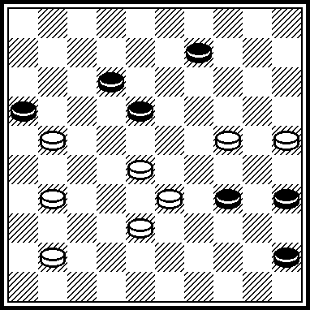 J.Bus, “Nieuwsblad van het Noorden”, 27.09.1965. 23, 29, 40 etc.

M084 ППР 28[16]38[22]2,50[12]33[24]20[28]3[17]21[33]29,8[29]2+.

М087: Similarity
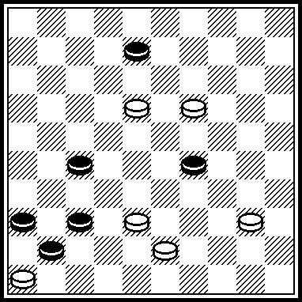 S. van Eijk, “Zesjes”-9, 1999. 32, 193, 2,31.

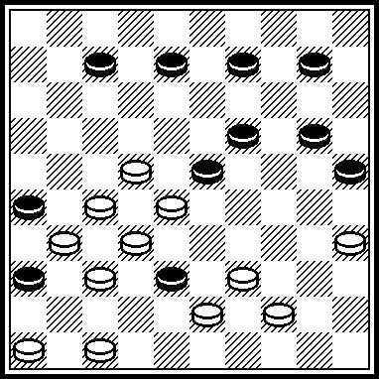 V.Matus, USSR Championship-1976. 30, 34, 17, 11, 21(1638) 472 etc.

М089- М095: V. MULIAR
M089: Similarity
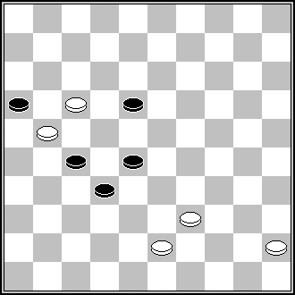 A. van den Elzen (Clubblad HDR, 4-1991) 11,38,1+.

М090: A variation of A.Maslov, Вариация: A. Mаслов (USSR Championship, 1988).
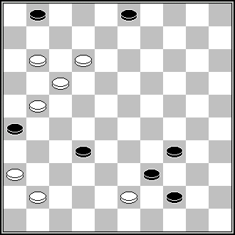 6, 7, 8 etc.

M091: Similarity
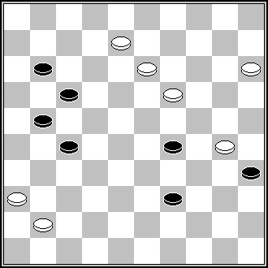 V.Matus (from the book “Mir Miniatur“ by B.Shkitkin, V.Matus, S.Yushkevitch, 1994, № 107) 31, 2, 12, 2, 24, 24 +

М093: Similarity
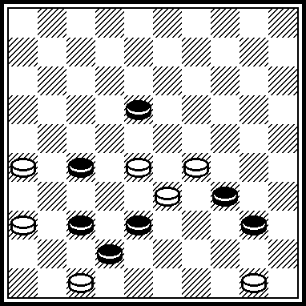 S.Ustianov, FMJD-1998. 21,31,45.

М097- М104: I. VLASOV
М097: Similarity
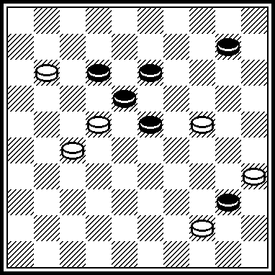 P.Kozhanovskij (from the book “Mir Miniatur“ by B.Shkitkin, V.Matus, S.Yushkevitch, 1994, № 433): 20, 14 etc.

М099: A mirror’s reflection:
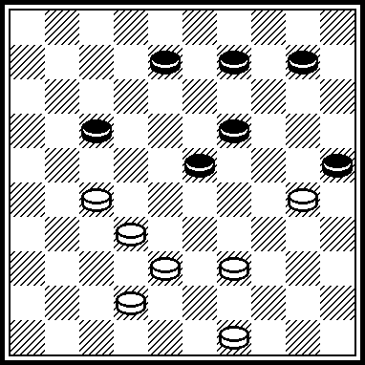 M.Levandovskij (from the book “Mir Miniatur“ by B.Shkitkin, V.Matus, S.Yushkevitch, 1994, № 449): 21, 5 (48) 28, 37+.

М100: A mirror’s reflection:
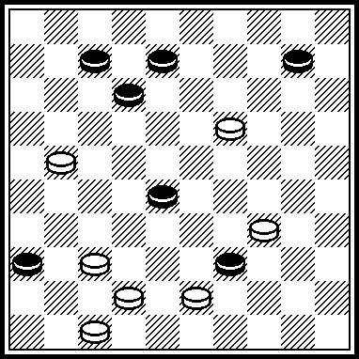 B.Slegtenhorst,“Het Damspel”, 11-1969. 29,14,41,24,42.

М101: Similarity
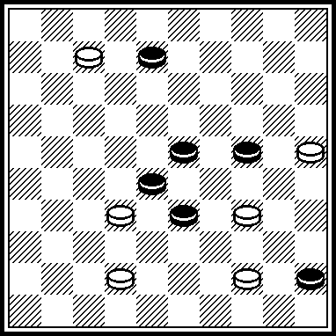 R.Ancion, from DAMMENSPEL-17 by A. van der Stoep, 2005. 40,2,44,35.

M102: ППР 43,23,29+.
With 47 on 46: S. Juskevic (Leninska Zmina, 19-5-1983). Two solutions.
This miniature was composed as an example of so called :Double-problems”. Earlier the ohte miniature of S. Yushklevitch was published for this theme:

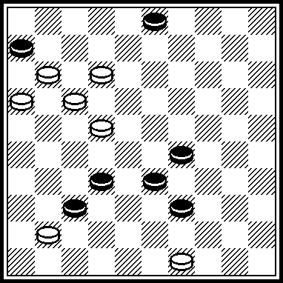 8, 38, 43, 38, 43. «Gudok», 11.12.1980.

М104: Similarity
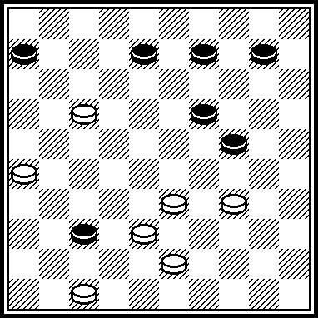 W.Schuurman, “Dam Eldorado; 03-1972. 28(42) 12, 5(30) 1, 41, 37, 37.
W.Schuurman position after the first move also was published in в “Het Damspel”, 1972.

М105- М112: N. ROMANIK
М105: Copy G.A Cremer (G.Gortmans, «1001 miniaturen», 1939 year, № 231)

М106: Copy «Novopoltsk-IX», 2008 year, G.Andreevs

М107: Similarity
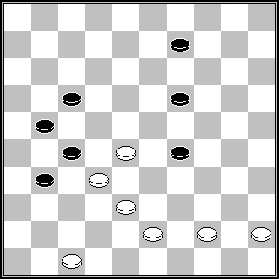 D.Vuurboom (De Enkhuizer courant, 12-1-1952) 22, 32, 3 +

М108: Similarity
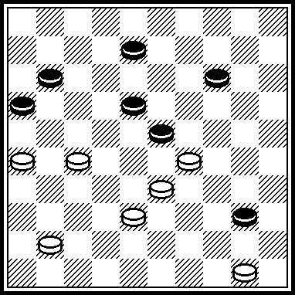. J. Roozenburg (Delftse Courant, 24-9-1960): 261, 29, 44, 22, 2, 5+.

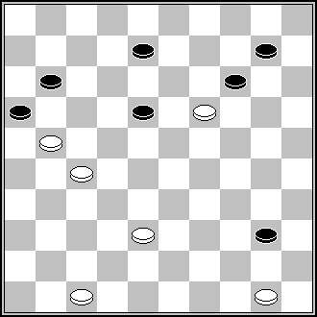 J. Deelen (DP, 6-1983) 41, 44 etc.+.

M112: Similarity
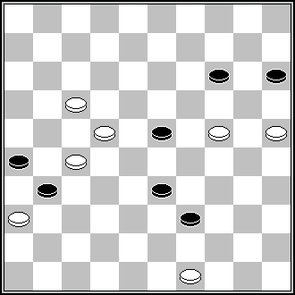 M.Lepsic (Zb min, 1998) 240,18,9… +

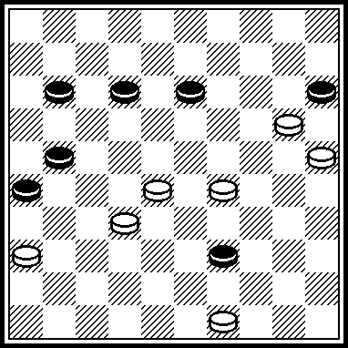 P.Shkludov, «Shashechnyj mir», № 2, 1997. 27 etc. Author of the final is N.Crassier, “Le Progrès de la Somme”, 11.12.1880.
White 25, Kings 2 and 41. Black 33 and 43. Solution : 16(48) 38, 47.

М113- М120: S. DARCHENKO
M113: ППР 27, 3, 37+. ППР 15, 4[29]6[34]23[41]39, 27, 49+.

M114: ППР 8, 31, 39+.
Similarity
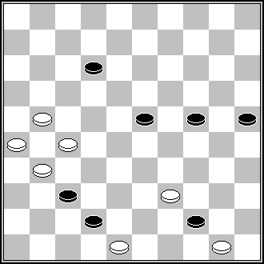 A.Liakovskij (Vilnius, 1985) 17, 21+.

М117: Similarity
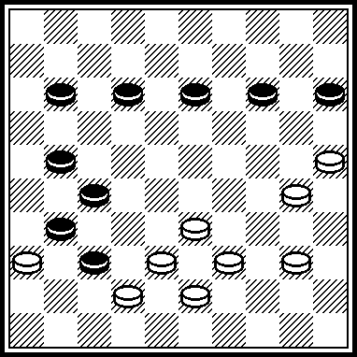 S.Klomp, HD-06.1955. 404,32,20,34,45.

M119: ППР 25+.
Similarity
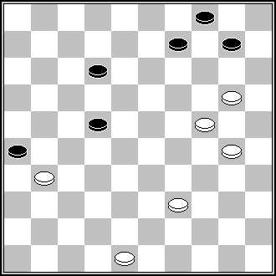 Leclercq (from «Trésor des Miniaturistes francaises») 19, 42, 194, 5, 8 +

M120: Similarity
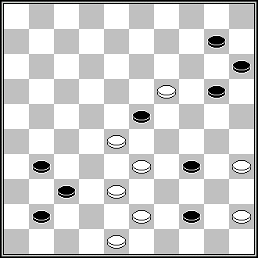 A.Hlasny (250 problems) 42, 14, 5, 47+.

Too:
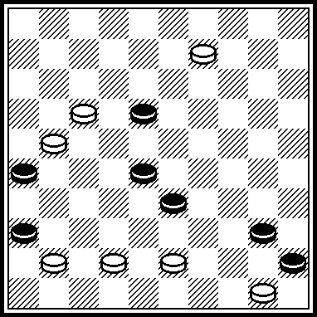 V.Babuk,USSR Championship-1979. 39,12,3,49.

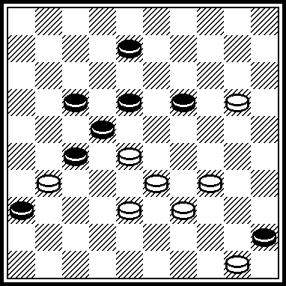 J.Scheijen “Verzmeling”-1, 1987. 32,14,3,49.

М121- М128: M. FEDOROV
М124: «A clear block-variant А» does not take to be written in details to be scored correctly, because the position with King 21-Black piece 34 is well-known in problemism. In the problem’s database this position is met 25 times. Accordingly, also and «economical variant C». That is one of 25 positions:
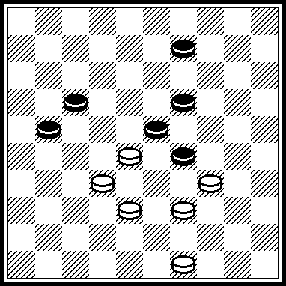 J.Scheijen, HD-11.1952. 27(2143)38,3,21.
The similar position White King 16 – Black piece 34, with the same play, is met in the database 61 times.

М126: A mirror’s similarity of main conception of S.Ustianov’ miniature, which was not indicated in remarks to “Lietuva-2003” contest.
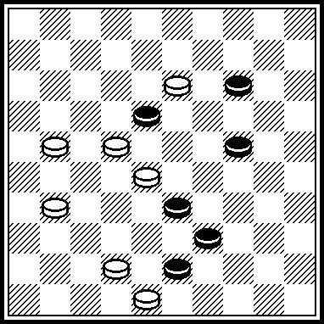 S.Ustianov, see the book “700” of M.Ben and S.Yushkevitch, page 39, 1997 year. 9,49(41) 44,37,46.

M128: A draw! 17,28[44]40[42!,39]22[43A] I 34,34[48]29[39]18[44]24[40]
13[35]19[30] II 461[39]=.
I 42[34,48]38[39]18[33]32[24]12[19]27[2]41[16]22[11]18[16]13[27]
138[32]36[23]=.
II 42[48]38[37]=.

М129- М136: A. KATUKHA
М129: Position black 3 – white 17 has no exact play.

M130: A draw! 13,2[14!!]294,24[19!]13[33]39[35:44]=.

M131: Copy: J.Leishys , R.Mackevicius «Saskiu miniatiuros», page 334, Vilnius-Rijeka, 2001.

М132
Similarity
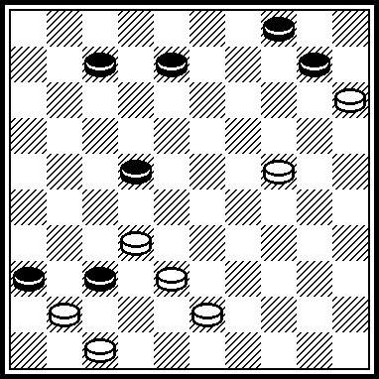 I.Kobtsev, «SHASHKI», September/October 1963: 42, 19, 27 etc.

M134: There is no originality in ehdgame’-phase.
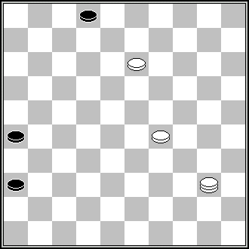 L.Schut (HD, 3-1938) 49 итд.

M135 The variant «B» ЧПР 4. 13, 2[29]7[293]11[20]42+.
Similarity
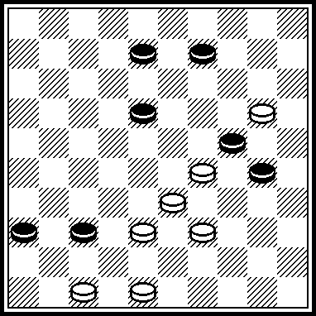
P. Skludov (Belarus, 1996), but in this case there is also a win after 14, 32, 2.

M136: Ничья! 10[15]4[117!]33[172]35[17]29[28]39[20]33, 23, 43[30,27]=.

М137- М144: I. NAUMENKO
M138: A draw! 449,42,34,3[24!!]21[17,24]=.
Similarity
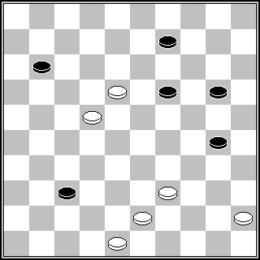 A.Noordhuis (from G.Gortmans «1001 miniaturen», 1939, № 230) 42,34,3+.

M139: A draw! 9[5]44,4[18]2[47]=. The win is after 44,4[18]24+.

М142: Similarity
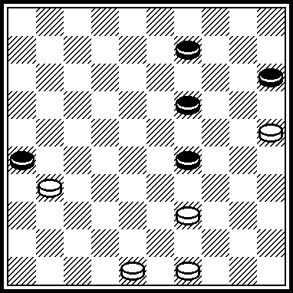 HD-10.1983. 493,42,34.
М145- М152: A. SAVCHENKO
M145: ППР 25, 49[21]18, 20[18]15+.

М146: Exact the same as: J. Leisys (championship of Simferopol, 1984 [problem nr. 36).

M148: ППР 34, 11, 2, 12+.

М151: With 39 on 38 - S.M. van Eijk, Collected work, part 11 [2005], problem nr. 5837.

М153- М160: V. FAKANOV
M154: Similarity
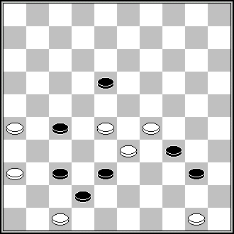 S.Ustianov, FMJD-1998. 21, 31, 45, 21, 27 +.

M157: Copy: G.Kupka, from G.Bakker «495 Miniatiuren», Deel 1, page 487”
Exact the same as: G. Kupka (Krimskaja Pravda, 04.02.1986).

M158: ППР 13, 21, 39+.
Similarity
A.Liakovsky (Vilnius 1985) 17, 21, 30, 48 +.

М160: Similarity
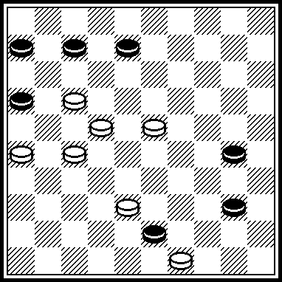 A.van Prinsenbeek, “Orgaan Prov.Groningen Dambond”, 02-1997. 11, 44.

М161- М163: V. KRUCHKOV
M161: ПР 22, 13, 2, 12+. М161: ПР 22, 2, 1813+.

М163: Similarity
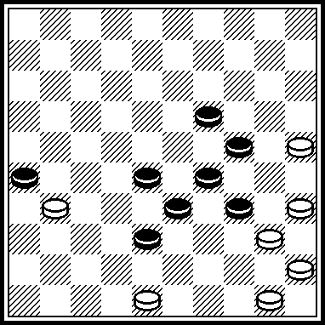 A. van Art, DE-01.1987. 30,30,24 etc.
М169- М172: L.NESTERENKO
M170: ППР 25, 12+.

M172: Similarity
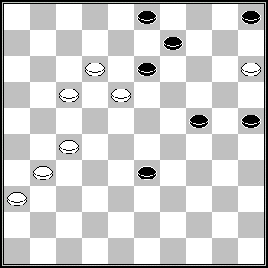 P.Jongeneelen (500 Damproblemen, 1992) 8, 27, 20, 10+.

REMARKS FOR “PROBLEMS”

P001-P008: S. USTIANOV
P001: Similarity:
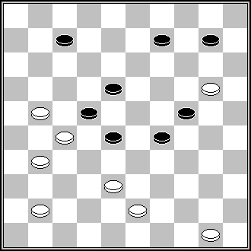 J.Scheijen (De tijd,1968) 32,15,2(36)30,38,39,39 +

P002: Similarity
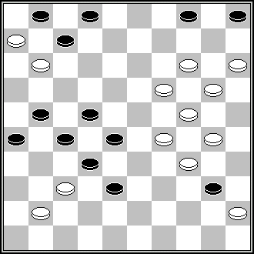 D. v.d. Berg (HD,11-1967) 25,9,8,23,17,21(27)10,7+.

Р006: Similarity
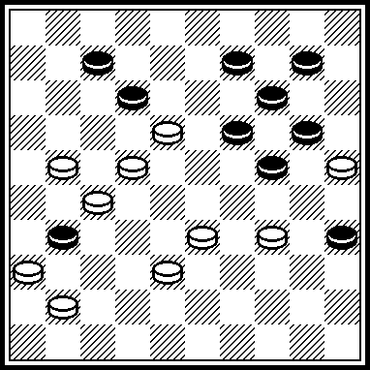 J.van den Boogaard, DP-02.1951. 30, 29217, 12, 15,10, 14, 37, 20.

P007: Similarity
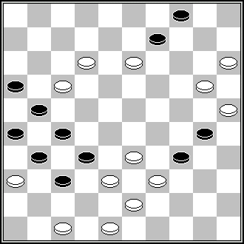 L. de Rooij (Tubantia 20-3-1971) 482,10,29,12,1,32,32

P009-P016: A. MASLOV
P009: Similarity
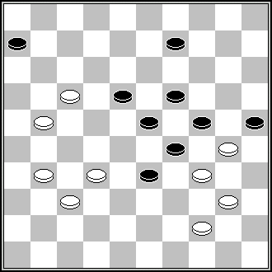 G.Artigala (DP,8-1972) 11,28,3,40,17,47 +

P013: Similarity
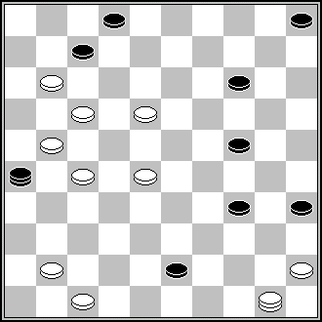 T.J Bouwes (HD, 3-1907) 44,42,11,440,37,9… +

Р015: Similarity
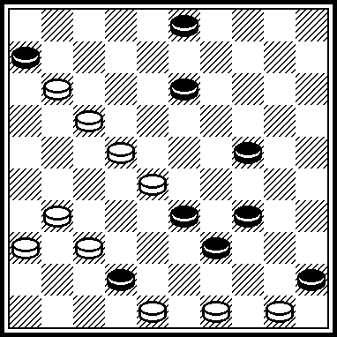 V.Levitskij, Ukraine Championship-1987. 27,504,8, 38,33,44,39.

Р016: Copy, M.J Kuipers (HD, 1950)

P017-P024: M. LEVANDOVSKIJ
P017: A-variant: ППР 3. 183,36[16]42+.

Р018:
A-variant has SS after (17, 17) 19(27) 13(31) 8(36) 3(41) 21(47)
3933 (40, B, 34) 12(36) 40(22) 39(27) 4034(49) 25+.
B [39,36] 40[13] 35[18] 17[45] 6,30,1+"

P021: ППР 22[23A]8, 28, 39,23,1+ etc. A[8]217[23,11]7,17 + etc.

Р023: ПР: 3631(43),4238,3126+

P025-P032: N. SHAPOVAL
P026 ППР: 30,16,1[34A]3,47+. A[23]47,41,11,49+

P029 ППР: 10[4:15] 11 etc.
Р029: Dual: 10 (2415) 1611(6), 2808(13) 5 etc.
Similarity
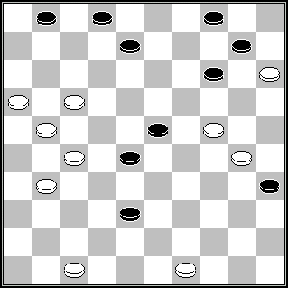 G.Geerlings (Book of Geerlings, 1988) 42,22,33,161,16,7,9,4...+

Р031: Similarity
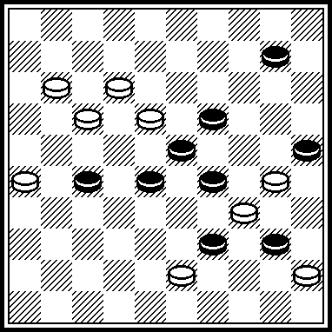 G.Shestirikov, «Molodezh Azerbaijana» 03.04.1982. 21,1,5,16,43,29,43.

Р032: Dual in endgame: 32 или 3731.

P033-P040: I. IVATSKO
Р034: Similarity
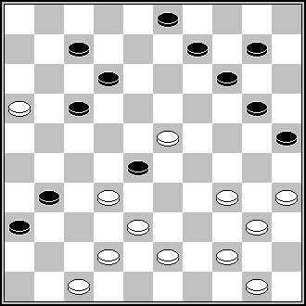 M.Nicolas (HD, 6-1962) 449,18,41,11,2,13,12 (8,14)44 +
This problem was not indicated to “Retro”-contest.

P035: Similarity
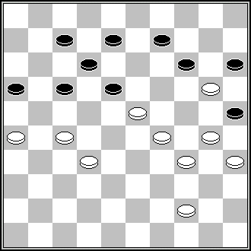 W.Lente (DP, 8/1959) 261,22,4,27,44,44 +

P041-P048: A. NYCH
P042: Similarity
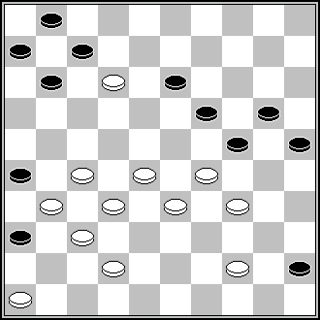 J.de Wit (DP, 6-2003) 272,41,31,40,9,14,4,2 +

P048: Similarity
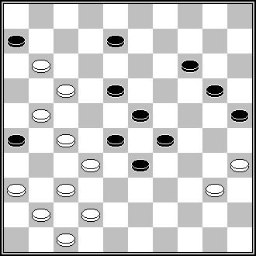 L.de Rooij (De A.D.Ger, 1971, N1) 371,34,42,10,3,31,30,46.

P049-P056: A. UVAROV
P049: ППР: 4,9,2,13,28,9,45+. ПР: 104,49,242,2213,139,23+
Р049: S.S: 4,9,24x2,13,9,3 +

P050: Similarity
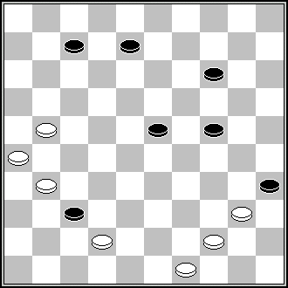 F.Denoel (1001 min) 17,21,12,3,1 +

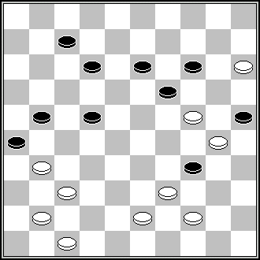 M.Douwes (DP, 4-1951) 38,8,41,2,39,13 +

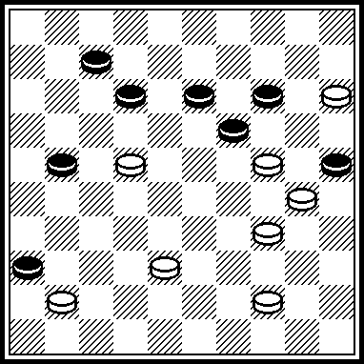 E.Grigorian, «Molodezh Azerbaijana» 24.12.1987. 17, 8, 2, 43.

Р051: Similarity
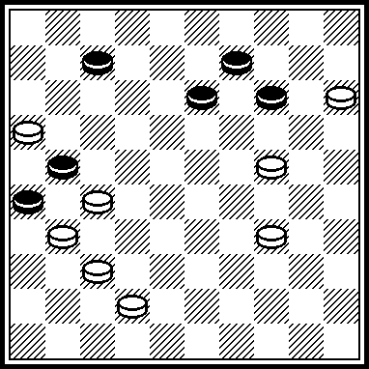 J.Viergever, DP-10.1954. 20,11,2,(1425) 46,14.

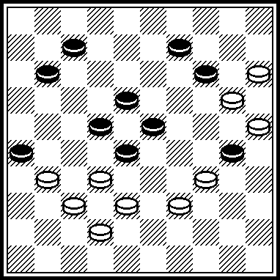 P. van Dijk, “De Leidse courant’, 02.01.1957. 29,1, 34, 6(30) 46, 14.

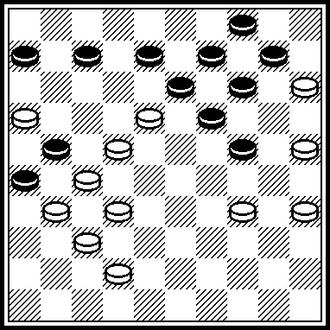 E.van Dusseldorp, “DB-De Brouwerij” (Dam Magazin), 07.1980. 20,11,1,9,18,4,20,24.

P052: ППР 39,43[17]37[31]27,4+. ПР 4339,43,37(44),4,40,27х
Р053: Dual in endgame 8.3732 и 8.3731. Similarity
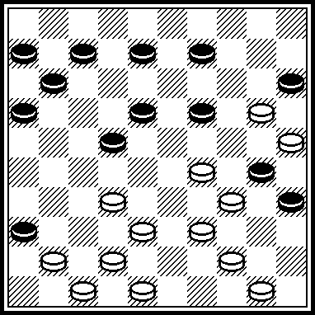
L.Schut, HD-19.08.1937. 27, 17, 4237, 4742, 43, 1(22) 40, 17. Five-times majority.

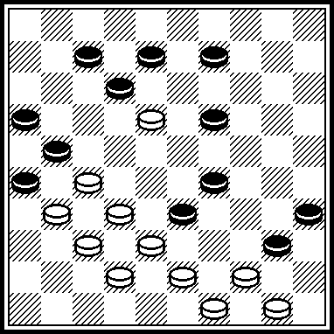 V.Muliar, DP-12.1986. 28,32

Р054: ПР: 128(3) 45, 7(34) 12(11, 3339) 7, 2(26) 39+.

P057-P064: I. KOBTSEV
P060: Similarity
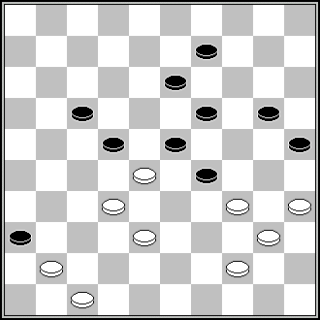 J.Kocken (DE, 1-1989) 42,350,28,3…+

Р061: Similarity
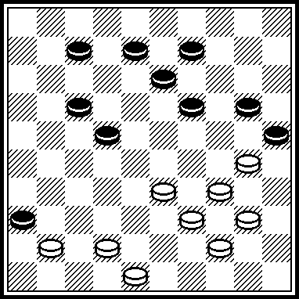 A.Polman, DP-02.1964. 28, 33,1,6,25.

P062: Similarity
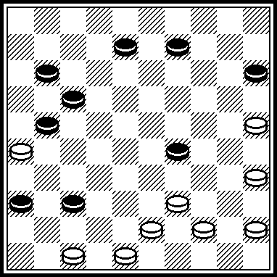 482, 41, 33, 34, 24, 12, 6. J.Apeldorn, HD-12.1960

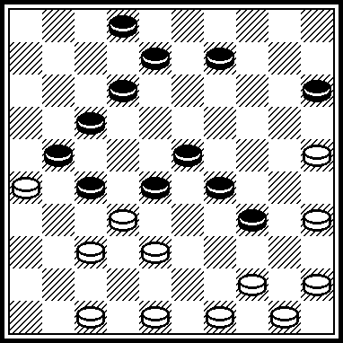 31(36) 440, 33, 7, 493, 482, 41 etc. J.Visser, DE-09.1975.

P063: Финал неоригинален:
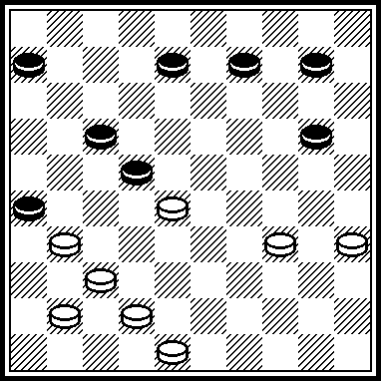 32, 340, 24, 2. M. Sabater, DP-12.1986.

Р064: Copy D. Vuurboom (DP, 3-1948)

P065-P072: S. REZNIKOV
P065 ППР 3. 19,37,8,2,35+.

Р068: Similarity
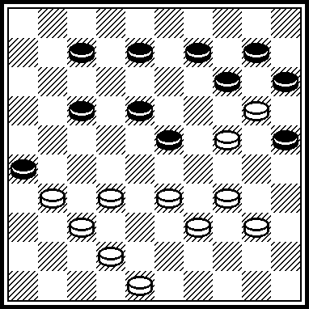 P.Deguée (Effort, 7/1965) 328,37,349,42,23,4,20,34+.

P069 ППР 44,25,3[193A]19,194[26]3-9,36 [42]23[15]149[17B]4+ etc.
A[32-23]24,36,37[35]38[28C]9[32]11[43]32,48[40]30 + etc.
B[4]23-18!+
C[40]372,9[26]4,2[37]7[17]31,42+.
Р069: ПР: 44,25,3(32-23)24,36,37(35)38(28)9(13)4(40)22,35, etc +
Similarity
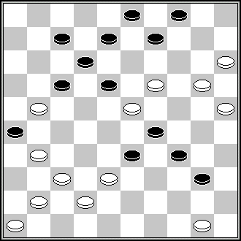 N.Irzhavskij («64», № 13, 1978 г.) 44,13,13,10,4,21,37 +

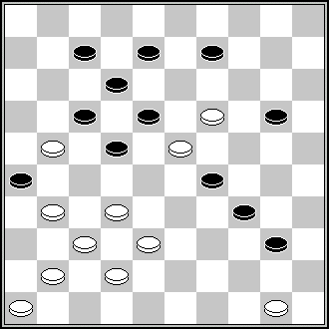 V.Matus (SHASHKI, 2-1979) 28,44,13,4,9,21,37

Р070: Similarity
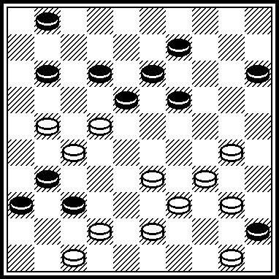 S.Yushkevitch, SHASHKI-04.1979. 25, 20, 41,36,44,3,6,17,17.

Combinational idea 272,3221,47 etc. Is very old:
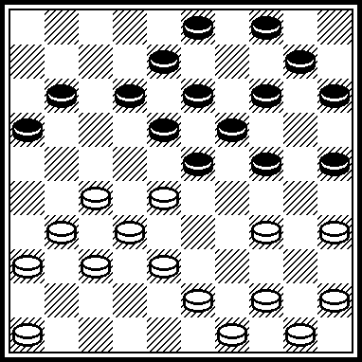 Blonde (1740 – 1819), «Geschiedenis van damproblematiek» 1945 year, by D,Kleen. 272,21,47,340,471,449 etc.

P072: Similarity
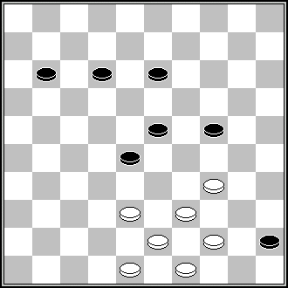 H.Wilsens (Brabants Dagblad, 15-2-1975) 32,42,29,6,1…+

P073-P080: V. MULIAR
P073: Similarity
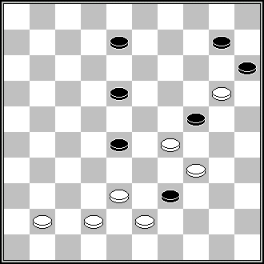 J.Scheijen (DP, 2-1951) 33,2,29,35,5 +

P074: Similarity
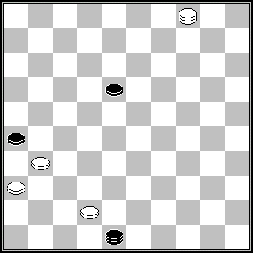 J.Scheijen (De motiefvriend, 1987) (26x37)31,37,27 +

Р079: Similarity
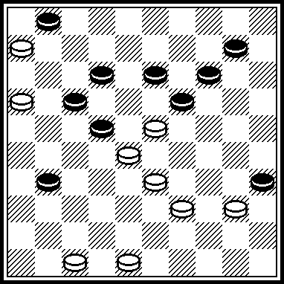 L.Colier, DP-06.1965. 29,482,11,22,37 etc.

P081-P088: V. POKHIL
Р082: Similarity to final phase:
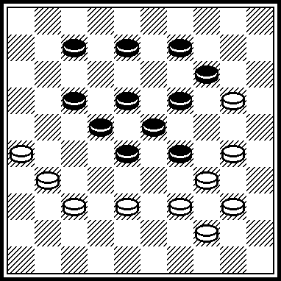 A.Uvarov, «Molodezh Azerbaijana» 06.02.1982. 393,382,21,28,1,46,6.

Р083: Similarity
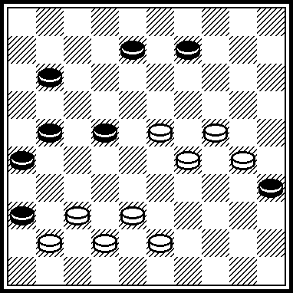 V.Matus, SHAHSKI-01.1976. 31,33,4,47.

P084 ППР 2. 26,2,36,45+.

Р085: Similarity to final phase:
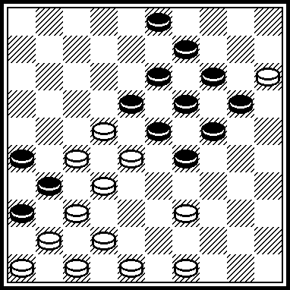 M.Douwes, HD-07.1949. 34,44,43,33,38,41,29,24,8,4(9) 25(17,17) 27.

Р087: ПР: 20, 27, 0702, 30, 28.

Р088: The idea 4534(28х30), 35х … was good arranged in:
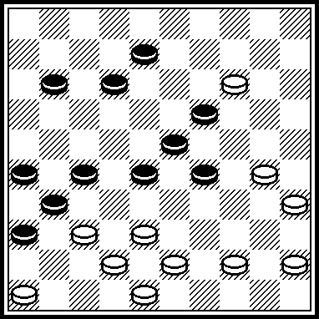 N.Boreiko, USSR Championship-1980. 24,41,33,34,2,21,37.

P089-P096: I. VLASOV
Р089: Similarity
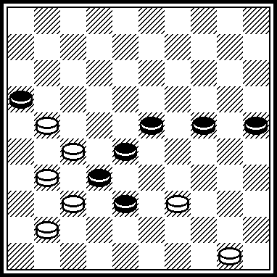 S.Korteling, from the book “Mir Miniatur“ by B.Shkitkin, V.Matus, S.Yushkevitch, 1994, №437: 22 etc.+.

Р090: A mirror’s reflection of S.Yushkevitch’ miniature from the book “Mir Miniatur“ by B.Shkitkin, V.Matus, S.Yushkevitch, 1994, № 126.

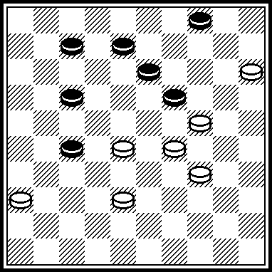 31, 2(10, 44) 22(49) 19.
The similar ideas was demonstrated in R.Bergsma’ posiions from “Dam Eldorado”, January 1987, page 28:

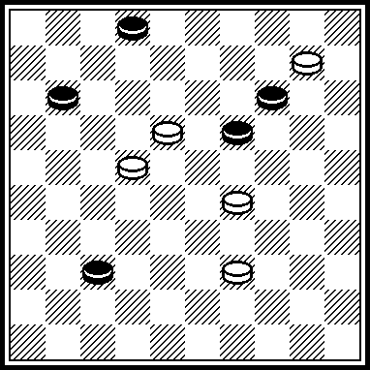 5(17, 7, 42) 24(48) 28.

Р091: Similarity
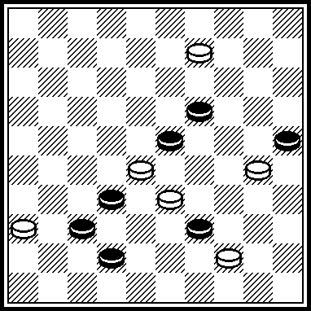 3, 21, 13, 27, 47+. M.Fedorov, Ukraine championship-1995.

P092 ППР 18,439,39,1,14+.

Р093: The final play author is E.Andrezen, see “Shakhmatnoe obozrenie”, 1892 year. At 100-square board this idea was arrangen in S.Yushkevitch’ miniature, from “Krymska svitlytsa”, 11.06.1999 г.

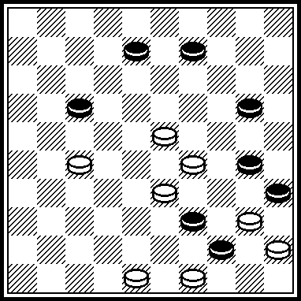 21, 34(50) 24, 44.

P094 ПР in endgame: 8. 13[22]8[28]2+. 9. 9[28]3+. 10. 4[33]27+.
Similarity
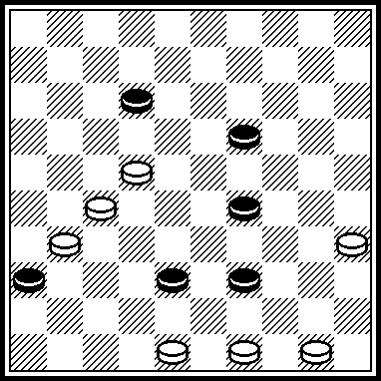 L.Dalman, from the book “Mir Miniatur“ by B.Shkitkin, V.Matus, S.Yushkevitch, 1994, № 404. 493,42,38,44+.

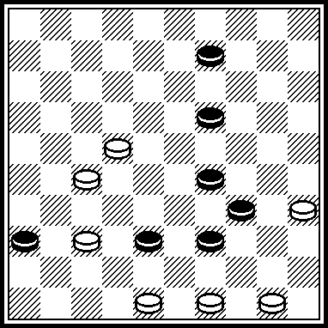 S.Yushkevitch, DP-июнь 1998. 493, 31, 43, 44 etc.+.

P095: Similarity
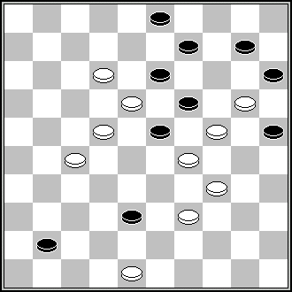 «Patent», № 1(9), June 2003, page 12. 30,39,8,18,4,48 +

P097-P104: N. ROMANIK
P097 ППР 38,382,10,394,2,39+. ППР 31,2+.

P098: Similarity
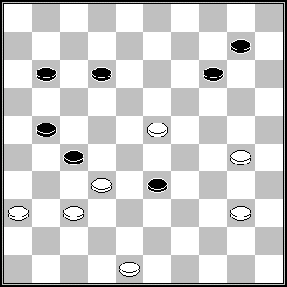 A.Beemer (De Maasbode, 24-9-1938) 371,19,43,27,38 +

P099: Similarity
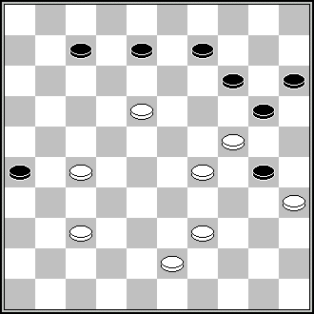 G.Geerlings (DE, 5-1961) 13(18)34,23,3,2… +

P100: Similarity
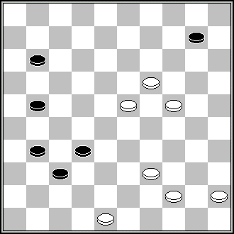 N.Boreiko, («Leninska zmina», 11-5-1986) 42,14,5,6 +

Р101: Endgame black 12, 18, 22, white King дамка 3 after (17) 21 has no exact play.

P102: The moves’ changing 2. 20,38,17 etc. Dual : 31,38,17,20 or 31,20,38,17+.
Similarity
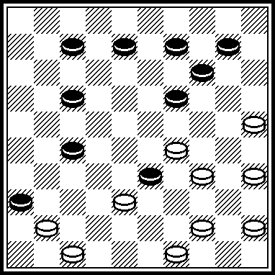 D.Vuurboom, «Eigen werk”, dee 2, 1969. 42,450,350,20,32,5,1.

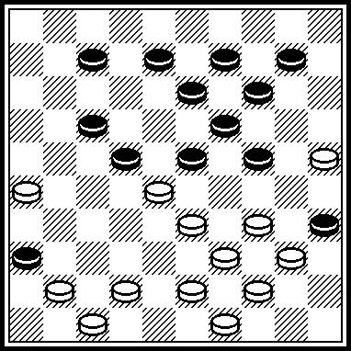 H.Laros, HD-28.03.1940. 428, 18, 339,28, 20, 38, 38, 21 итд.

P103: Similarity
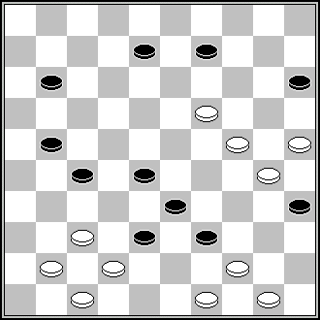 J.van den Boogaard (Verzamelde 2002) 13(18)43,31,38,38,44,2,19 +
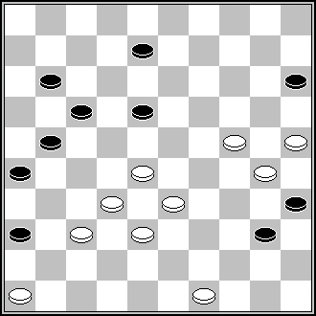 (Champ Bélarus 2002) 22,31,41,44,2,19 +

P104 ППР 44,417,428,38,39,24,3,40+. ППР 35,428,16,38,2+.

P105-P112: S. DARCHENKO
P107 ППР 7,1[35]4[19,13,17]34[10]7[15]1[21]6[26]339,46+.

Р108. Copy, «Patent», № 1(9), June 2003., page 12.

P113-P120: V. NESTERENKO
P113 ППР 27,31,32,2,40,19+.
Р113. ПР: 31,2,7,47 +

P116 ППР 38[23A]2[29]271,25,35,43+. A[21]22,8,4,44+.

P117 ППР 36,31,39,3[37]8[6]30,20+.

P118 ПР 3. 25,11,28[24]23[12]19,20 +.

P119 VP ЧПР 4. 9,32+. A ЧПР 4. 8,36+.
Р119. Dual: 19,8(28A)3(24)17,49 + or 19,8(28)3(24)8,44 + A) 19,8(18)2(17)8,38 +
Therefore B-variant is considered as main variant.

P121-P128: M. FEDOROV
Р124: Similarity
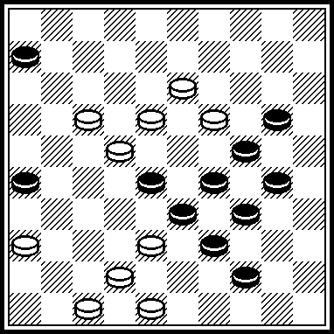 Г. Кетлер, HD-01.1964. 43,31,33,11,12 etc.

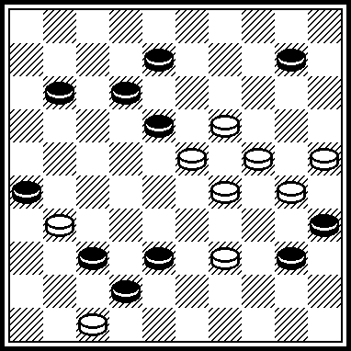 G. Ketler, “L’Effort”, 05.1965. 13, 33, 23 etc.

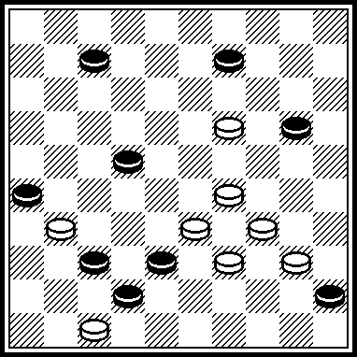 В.Гребенко, «Литва-2006». 13,24,1,6 etc.

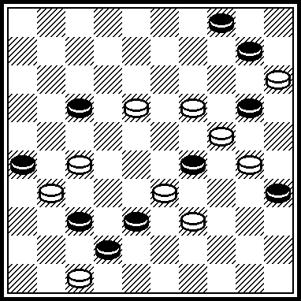 В.Шульга, Беларусь-2008. 34,22,193,9,4 etc.

P129-P136: V. TRINOS
P129: Similarity
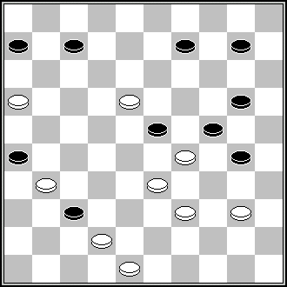 G. Ketler, HD, 12-1963. 43,34,3,182,11,50 +

P130 ППР 27[11A]30,28,4+. A[13]39,11[6:8]30,4,3+.

P132 ППР 2. 12,17,8,2,37[24]37-42[30]48[35]34[31]23+.

Р133: Similarity
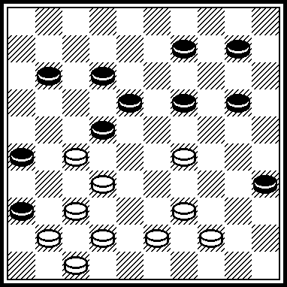 D.Vuurboom, “400 eigen werk”, volume 3, 1970. 24(29/30) 40,31,43 etc.

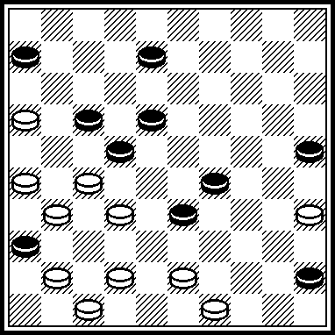 M.Boshuis, DP-06.1983. 261, 42, 3, 30, 11, 40, 44.

P134: Similarity
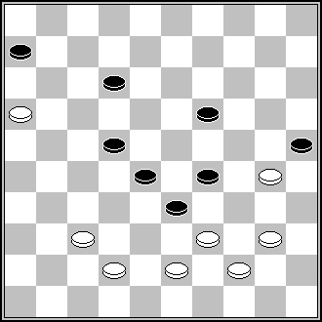 NN (Kring voor dam Problematiek 1943) 11,32,8,2,6+

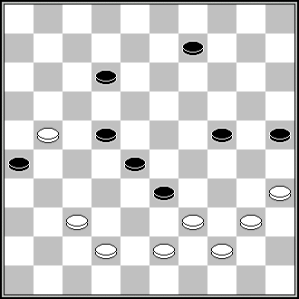 G.Bogatyrev, USSR-contest-1978. 30,32,8,3,6 +

P135 VP has the dual 7. 31/36+. A ЧПР 8. 18[6]22[30]39+.

P136 VP ЧПР 10. 38 [17]27[33]43[22]16+. 12. 20[22]9[28]14+.
- 20[28]42+. A ЧПР 9. 29[45]20+. 10. 29+.

P137-P144: B. FEDOROV
P142: Similarity
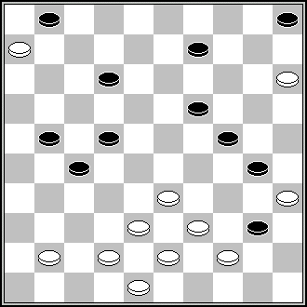 H.A.Fermin (DE, 3-1972) 32,29,4,7,42.. +

P145-P152: A. KATUKHA
P145: Similarity
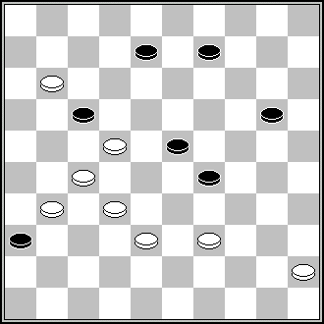 L.de Rooij (DP, 4-1958) 28,21,4… +

P146: Similarity
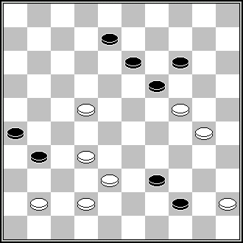 P.Lauwen (DP, 6-1979) 40,18,2,48… +

Р147: Author of final is A. Beemeer, DP-07.1949.
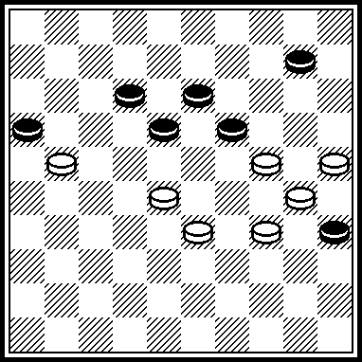 349, 283, 23, 5, 19.

Р148: in «А» instead of 43 and 34 also 49 and 40 gives win.
In «В» after (29) also 21(37) 8+, or also 21(37) 26(41) 8+, or also 14+. In «С» instead of 13 also win is with 4237, 4226, 4248, 0409, 0418, 0422, 0427, accordingly, there is no D-variant.
P149: ПР in main variant: 4. 3,3:26:42:44+.
Therefore «А»-variant is considered as Main variant.
P150: Similarity
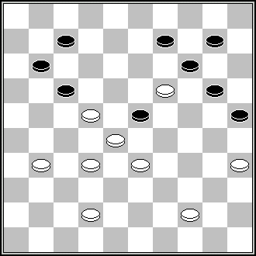 H.van Diense (HD, 12-1926) 30,39,327,26,6,38,1 +

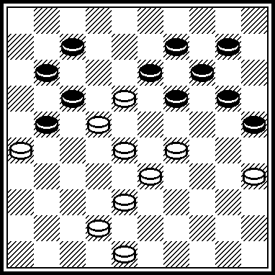 A.Nikolaev, BVLD-1994/1995. 283(1939) 43,33,6,30,1.

Р151: Similarity
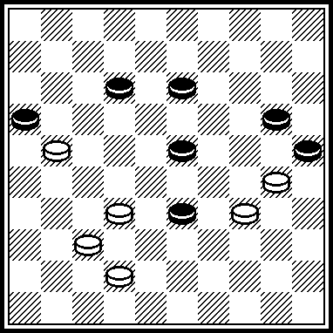 A.Nikolaev, «Molodezh Azerbaijana», 28.09.1985. 38,29,9,3.

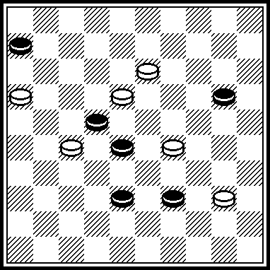 S.Ysuhkevitch, DP-08.2004. 34(30) 11(17) 24,12,3.

Р152. ПР: 37,20,3… +
P152 A ЧПР 10. 3[30]20[7]38[35]31,2+. 10. 14[29]4[34]15[40]33+.

P153-P160: V. NIKITCHUK
P153 ПР in main variant: 472(46) 13,32,3+.
Therefore «А»-variant is considered as main variant.

Р154: The mechanism 34:…, 4439 was arranged many times, i.e., in A.Kovrizhkine book « Комбинации на 100-клеточной доске», 1963 year.
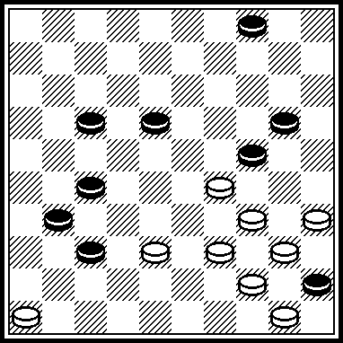 350,41,24,32,39,26 etc.

The first problem for this theme was I.Weiss position from his book “Taktique et Strategie” 1910 year.
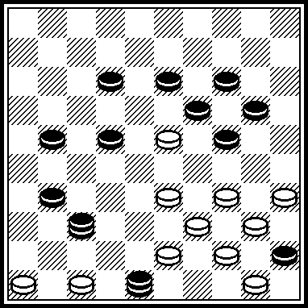 I.Weiss. 42, 3329, 41, 3530, 38, 24, 41, 39, 10.

Р157: Similarity
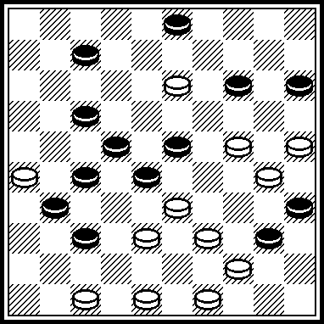 E.Repetto, “L’Effort”, 07.1974. 43,29,32,1(43) 39,41,37,33,8,10,14.

P158: ПР in main variant: 4. 11,26[32]21,32,4+.
Therefore «А»-variant is considered as main variant.

Р160: Similarity
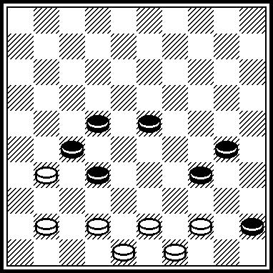 W.Monsma (from G.Gortmans «1001 miniaturen», 1939, № 996) 439 etc.

P161-P168: A. BALANUK
P162: Similarity
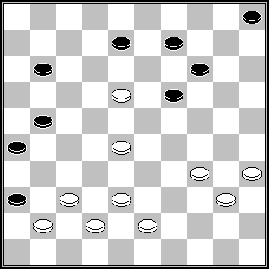 S.Pokhavlitov, USSR-contest of 1978 year. 31,4,183,10,34 +

P163 A draw in «A»!
A[13]5,46[50]29??-- ( it had to play 38!)—
[31]24[33]249[29]39[20]34[25]29[20]293[25]13[34]19[30]44[35]39[30]
33[25]29[20]293[25]=.
or
[45]24[34]38[31]44[48]40[25]28[9]46[18]35[27]33[22]46-28[9]29[18]28-23[9]=.

P165: Similarity
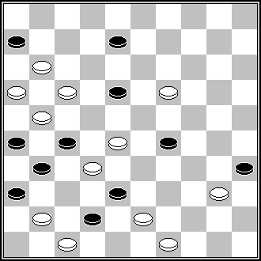 A.Tavernier (Retro concours 2005) 14,40,38,22,2,10,11-7,5,5-19,12,7,7 +

P166 ППР 193,22,20,3,36+.
P167 ППР 39,3,32,14+.
Р167. ПР in main variant: 31,2,37,40,13,22 +

P169-P174: L. NESTERENKO
P170: Similarity
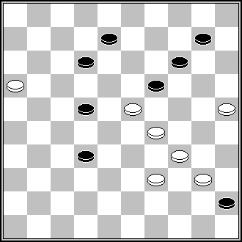 P.Jongeneelen (Het Algemeen dagblad, 15-8-1987) 30,20,5,17,49 +

P172: Similarity
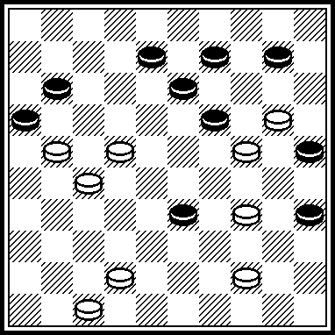 P.van der Kwartel, DP-03.1959. 40, 18, 15, 2, 30, 37, 49.

P173 ППР 43,3[36]172,39+.

Р174: ПР: 20,204,33,3,6.

