12.06.2010 г.
X CHAMPIONSHIP OF UKRAINE-2009.

REMARKS FOR THE “ENDGAME” CATEGORY

There are present remarks indicated by V. Trofimenko and J. Bastiaannet (JB).

Theere is marked in solutions:
By GREEN – correct variant(s),
By RED – incorrect variants,
By BLUE – the remark(s) of the judge of this category,
the international Grand Master J. Bastiaannet.
The abbreviation is : «МиФ» - the website of M.Lepsic.
ЧПР – Partial second solution.

E01
VP: 48(31, A) 26(28, B) 22(41) 5(46, C) 37.
A(41) 37, 16(31) 38(37) 47.
B(41) 37, 1128(29, a) 37(38) 48.
C(47) 42. = ~ VP
a(38) 19/5, Z.
Z: 42? (32)+.
E01 was scored with 55 points in Vinnitsa-championship, 2004.

E02
VP: 35(45) 44(36, A, B) 5(40, C) 35(41, D) 46(50) 4628(45) 6(23) 40, 1.
A(39) 40, 44.
B(50) 39, 6, 26.
C(39) 50 → , but 6/32/37/46
D(50) 3519.

E03
VP: 1(7, A) 40(34, B) 44(3540) 35(39) 34, 24.
A(28) 6, 40(44, C) 50.
B(44) 6, 50.
C(34) 25(40) 39(45) 50.

E04
VP: 28(14, a) 22Z(19) 24, 17(35Y) 12(20, A) 8(24) 3(29, B) 17(34) 12.
A(11) 8(17) 3(22) 21(20) 38(25) 32.
B(11) 12(16) 39(21, C, 40) 34, 8(30) 35(34) 44(40) 35.
C(30) 8(21, 40) 17(45) 34, 50.
a(11) 22(16, b) 17. b(20) 18(17) 13(22) 9.

Z JB МИФ (19-01-2010): 24 +.
Y JB МИФ (19-01-2010): (20 !), 12(24), 8(29), 3(33), 20(39), 33(11 !), 2029(11/17) =.
V.Trofimenko: An addtion to F.van Sterkenburg, “Het Nieuwe Damspel”, 1986
Б.п.: 12,49. Ч.п.: 6,15,35.
L.Vitoshkin, “ЭТЮДЫ в международные шашки.Антология, ч.1,” №61, page 15

E05
VP: 17(21, A) 8Z(2112, B) 17Z1(8) 1(12) 18(50) 22(45) 18, 27.
A(50) 8, 17, 17.
B(0312) 8(27) 21, 3(50) 17, 17.
Z JB: 1(27), 6(32), 7(37/38), 12(43z), 50(49), 1 etc.+.
z (50), 2 ! +.
Z1 JB: 21(13), 12(19) 1(50), 6 +.

E06
VP: 15(7, A) 21(0611, B) 18, 17(28, 32) 1(11) 7(38, C) 2(10, D, E) 4(42) 0413(47) 29.
A(11, 11) 21.
B(12) 17, 27.
C(37) 2(10, 41) 13 (46) 23.
D(42) 10, 19, 17.
E(43) 10, 19, 48.
Миф/cудья: E = D1
V.Trofimenko: Variants A and B have one and the same final. «В» -it is «А1»
JB: in C instead of 13 and 19/23(47), 41 [or even 15(36), 41] +.

K.W.Kruijswijk, De Problemist 6/7-1956:
4,7,9,11/16,21,25,29 → 7,11,13,14/15,16,21,23, but it is not Ressemblance!

E07
VP: 6(49, A) 43(16, B) 11, 1(7) 5.
A(35) 30(8, C, D, E) 7, 3.
B(21) 7, 26.
C(24) 7, 4.
D(19) 7, 5.
E(13) 7,15.
V.Trofimenko: Variants C,D and E have one and the same idea.
JB: piece 10 is supefluos.

E08
VP: 19(5, A) 46(28, A1, B, C) 35(43) 38, 24(37) 47(41) 36.
A(10) 5(44, D) 24, 50.
A1(10) 5(44) 24, 50.
B(44) 4237, 49.
C(43) 4237, 49.
D(35) 33.
V.Trofimenko: Variant C is an analogy of B.

Миф: endgame 30,39,D5/D32,D42 , S.Ustianov, PWCE-2005, C15 was scored with 23/45/35 (G.de Bruijn, R.Mackevičius, P.Shkludov) - 34,5 points.

E09
VP: 30(27, A, B, C, D) 34, 15(31/32) 43(36/37) 38, 47.
A (45) 44(27) 25, Z1, Z2(39) 16/21(50) 1632.
B (28) 46, Z3(38) 48(45) 44, Z4(50) 48-37.
C (38) 48(45, E) 44(50, F, G) – ideatic of C.Blankenaar, 1899: 28(22x33) 25, 32/16(39) 49.
D (39) 48(45) 44(50, B1) 28(2233) 25, 43.
E (27) 28(32) 46 etc. Like in B.
B1 (28) 46(50) 48-37.
F (42) 18/13(50) 10-04.
G (28) 43(50) 43-39(45) 40.
Z1: 48? (39)=.
Z2: 23? (38, Y1, Y2, Y3) =.
Z3: 37? (39, Y4, 45)=.
Z4: 48-37? (42, 50)=.
Y1: (39?) 16/21(50) 16-32+.
Y2: (32?) 46(38) 48+.
Y3: (31?) 25 итд.+.
Y4: (38?) 39(45) 50+.
Published in «Shashechnyj mir», № 3, 1998. The first endgame with variants С (and В) is C.Blankenaar, “Le Jeu de Dames. Revue special et mensuelle”, November 1899: 22, 40/ 10, 49, K26. Solution: 5(45) 44(50, А) 28 etc. А (28) 46, 2637. Variants А and С repeat variants of L.Vitoshkine endgame from «Shashki», November 1974, diagram 1791.
V.Trofimenko:
В варианте B Ч.п.р. 2.32(39) 3.48(45) 4.39 5.6(45) 6.1(50) 7.32-23 (17) 8.44 9.6+.
[Миф: Variant В had to be written in other way: 30(45)44 (28) 46 etc.]
In D Partial second solution 3.39(50) 4.6 (45) 5.1(50) 6.10-23 (39) 7.44 8.6+.
JB: D after (39), 43(45), only 39 +.
JB: Y3 also 43 +.
V.Trofimenko: /JB Z3 37(39), 43/48(45), 28/39etc+.
JB: Y4 instead of 50 also 6, or 23(!) +.

E10
VP: 15, Z1(34, A) 4, Z2(18, BC) 22(3641, C1) 3228, 39, 5.
A (18) 33(3641, D) 15, Z4(47) 49-38, 47(22) 41.
B (19) 3731, Z5, 5(39, E) 22, Z6(44, F, B1) 22-28, 49.
C (39) 50(3641) 3228, 32.
D (22) 6(3641) 3228, 32.
E (40) 22(45) 50.
F (41) 46(43) 39.
B1 (44) JB 2228, 50.
C1 (39) 50(3641) 3228, 32.
Z1: 4? (34) 45(3641)=.
Z2: 44? (18, Y1) 47, Z3(40) 35(22)=.
Z3: 50? (40) 20(45) 15(22) 6(3641, Y2) 47(50) 36(45)=.
Z4: 4938? (22, Y3) 6(47) 15(36) 4(47)=.
Z5: 0431?, 5(32, Y4) 37(39)=.
Z6: 18? (41/JB 37/32, Y5) 46(43)=.
Y1: (19?) 47(23) 32-28, 6+.
Y2: (50?) 15-33, 33(36-41) 47+.
Y3: (47?) 15, 47(22) 41+.
Y4: (28?) 32+.
Y5: (43/44?) 1823+.
Endgame took 2 place in “Lietuva-1999” being scored with 67,7 points.
Published: “De Problemist”, December 2000.
JB: Y1 instead of 32-28 also 24(!) +.
Variant B: (44): author’s conception is (43), 22-28,

E11
VP: 44(13) 4(25, A, B) 0422(3843) 34(6, C) 50.
A (26) 33, 31.
B (12) 0418(26) 1(3842) 37(42) 33.
C (50) 6.
Endgame took 6 place in “Lietuva-1999” being scored with 57,7 points.
Published: “Saskiu kaleidoskopas”, № 13, 2001.

[JB: Z 1.4034?(13, Y1, Y2), 4(26), 29(12) =.
Y1 (14?), 3443!, 3 +.
Y2 (12?), 29(14Y3), 42, 31/37 +.
Y3 (18), 12(42), 26/31(43), 38 +.]

E12
VP: 0903(3339, A) 17, Z1(43, B) 39, 30(44, C, D) 5039, 48.
A (38) 1309(44, 43) 30, 14.
B (3944, 48) 31(12) 17.
C (45) 48.
D (39) 48(45) 12 – М.Гоняев, 1886.
Z1: 1309? (3944, 43, Y1, Y2)=.
Y1: (48?) 31, 12/JB 17+.
Y2: (4044?) 14/JB 20, 48, 35(32) 43+.
JB: (4044?), 35(49), 14/20, 48(32), 43 +.
Published: «Shashechnyj mir», № 4/5, 1997.
V.Trofimenko:
Ressemblance: M.Stanovskij WK;3,16, piece 50. Black King;30. pieces 34,40. “Dambrete”,
1972, the link is in Л.С.Витошкин “ЭТЮДІЫ в международные шашки. Антология,ч.IY»,
№809,, page 44

E13
VP: 1331(3842, A) 17(41, B, C, 31, D, 46) 37.
A (41) 37, 16(31, E) 33.
B (48) 42, 21.
C (47) 42.
D (46) 37.
E (37, 41) 21.
Published (with King on 4 insteda of King on 13): «Krymska svitlytsa», 16.01.1998.

E14
VP: 16(41, A, B, С) 24.
A (27) 4(31) 24/15(36) 19, Z1(3641, D) 31, 46.
B (38) 43/49(42) 38, 15.
C (34) 30/25(42) 37.
D (42) 37, 10.
Published (with King on 4 insteda of King on 13): «Krymska svitlytsa»,
JB: In «1000 mini» (2009) it is indicated incorrectly as the author A.Nyrov

E15
VP: 44(50, A) 39, 6.
A (36) 5(41, B) 46(40) 35(50) 4628(45) 6(23) 40, 1.
B (40, C, 50) 3519.
C (50) 0528, 44.
Published: “Saskiu kaleidoskopas”, № 15, 2005.

E16
VP: 7(0211, A) 6(340, B) 39, Z1(45) 50(40) 11(44, C) 33, 50.
A (2211) 6, 25.
B (350) 35(39) 1(43) 23, 49.
C (27) 35(32) 24(37) 47.
Z1: 50?(45) 11(27, Y1) 31/36(50)=.
Y1: (40?) 6(44, Y2) 39, 50+
Y2: (27?) 35 etc. Like in C+.
Y2 JB: also 31/36 +.
Published: «Shashechnyj mir», № 4, 1998.

E17
VP: 43(49, A) 44(34, B, C) 45, 34.
A(34?) 16.
B(12) 1, 45.
C(40) 45, 1/7.
V.Trofimenko: In «А» is win not only with 16, but with45!+

E18
VP: 49(2721, A, B, C) 1538, 27/21(46*) 5.
*(1605) 46.
A(4) 36(2 !*) 7(16**) 1538, 27, 27.
*(1611?)
**(0211?)
B(36) 2329, 38, 38.
C не ecт !
V.Trofimenko:
А 1...(4) 2.36(2) ... now win is by 3.23-32! + or 3.23-41! + or 3.35! +.
B (36) also win : 12 or 1 or 19 or 23-32 or 34 or 23-40 или 45+. Many duals.

E19
VP: 27(21, A) 7, 4619, 26.
A(32) 19 ! (1520, B) 1924, 32.
B(47, C, D, E) 24, 25.
C(49) 39 ! (38 !, F) 24, 25.
D(38-20) 25(3*) 1914, 14.
*(33?)
E не ecт !
F(16) 11.
V.Trofimenko:
In «C» instead of 3.39 also 3.12(43а) 4.3(39в),5.35-30 6.19-14+
а3…(38) 4.35-24 5.3+
в 4…(27) 5.10 6.13+
In «F» besides 4.11 also 4.34 or 4.19-28 or 4.46+.
JB: In «C» besides 39 also 28 and 48 +.
JB: In «D» besides 25 also 12 and 48 +.

E20
VP: 1910(29, A) 5033(47 !) 15.
A(3647) 2833 ! (29, B) 36, 5022, 34.
B(42/38) 41, 5022, 48.
V.Trofimenko: In main variant 2.28-33(47) 3.15+
JB: In main variant 1.17 and 1.2839 +.
In main variant and 2.45 +.
In «A» also 2.2839 +.

E21
VP: 30(47, A, B, C) 45/1, 5033.
A(2418) 3024(18x30) 40, 25.
B(2420) 17, 3 (25, A) 2314, 29.
A(2429 !) 25, 39 !(23, B) 33.
B(20) 25(24) 9(23) 13(2429) 9(33) 14(2329*) 20, 20-38-49. *(2328?)
V.Trofimenko:
Solution had to be written so:
30(47АВ), 1, 33+
А(13), 24, 40, 25+
B (24-20), 17, 3(25С), 23-14+
С (29), 25, 39+
In main variant: 2.45 3.33+
In А ЧПР 2.29+ (cудья: и 19 +)
In В ЧПР 2.22 3.19 4.25+
JB: Ressemblance J. Bastiaanneta
Black 15,35, K24/ White K5,25,45 – «DB-Magazine», 1981.
In А instead of 39 and 30(22), 13(28), 24 + or 43(20), 25 etc +.
In B instead of 9 also 4 etc +.

E22
VP: 3 !!, 10 ! (31, A, B) 4(42) 31Z, 3221, 26.
A(42) 15 ! (48*) 26(39) 43, 1542, 48.
*(31?)
B(48) 26 ! (39) 43, 1037, 48.
Otherwise a draw is!
1…..(2603).
V.Trofimenko:
In A instead of 3.26 also 3.25(31) 4.4(42) 5.15(31) 6.42 7.32-43+.
JB: Z also 15(31), 4(42), 15(31), 4(42), 31 +.
In B instead of 3.26 also 3.25 and 3.20 ! +.

E23
VP: 3249(1607, A, B) 11, 35(0207, C?) 2749, 2.
A(0219?) 2738 (JB: also 2732), 14.
JB: K44 is superfluous.
B(35/30) 8(32, C) 16, 35.
C(35x02) 35, 16.

E24
VP: 26(9, A, B) 10, 3(18) 13, 14.
A(25) 3(1520) 24, 0514, 33.
B(25) 3(34) 30, 0514, 14.
V.Trofimenko:
In A* also 2.48(9) 3.5-10Z 4.25+
JB: Z also 5-14(20), 25 +.
* also in B

E25
VP: 3127(46, A) 43, 16, 5.
A(41/37) 43, 16, 46(33) 32(39) 49.

E26
VP: 25, Z(48, A) 23Z1, 26.
A(49) 23, 16.
Z: 14? (34)=.
Z1 JB: 2534 (!) +

E27
VP: 34(16, A, B) 39, 49.
A(39) 48(32) 43, 16.
B(3338) 48(42, C) 26(32) 21, 49.
C(3843) 25/39(32) 43, 16.
V.Trofimenko:
Ressemblance. See №315, from L.Vitoshkin’ book “ЭТЮДІЫ в
международные шашки.Антология,ч.Y,” page 19
JB: in main variant also 2.3430 +.

E28
VP: 45(3842, A, B) 28, 29, 47.
A(41) 33, 46.
B(3742) 33,48.
V.Trofimenko: In A 2.28 3.29 4.36+.

E29
VP: 0702(34) 0207(39) 0702(3943, A) 40, 49.
A(3944) 21, 49.
V.Trofimenko: In main variant also 3.7-11 39-43 4.11-44+
JB: In main variant also 3.7-40 и 3.35-2 +.

E30
VP: 10(47, A, B) 15, 26(41) 37, 33(37) 47.
A(37) 32, 46.
B(46) 32, 28.
JB: also 27, 28, 46 +.
Миф: With King 4 to 15 this endgame is correct.

E31
VP: 2621(3741, A, B, a) 28, 47(46) 41, 28.
A(47) 28, 38, 46.
B(48) 28, 43, 46.
a(29) 32, 47.
JB: alsoe 27(47), 48(28*), 39/50(3641), 32(46), 5 etc.+
* (15), 42, 38 +.

E32
VP: 49(43, A, B) 32(50) 33.
A(44) 40, 28.
B(50) 44(43, C) 1015, 49.
C(45) 28.
JB: also 40, 28 also 10-23 also 29-1 +.

E33
VP: 494(11, A, B, C) 6(27) 449 !, Z(32) 31(50, D) 26(33) 39(37) 28(42) 37, 37.
A(50) 27, 16.
B(27) 31(50, a) 27, 27.
C(26) 40, 44.
D(38) 393, 27(34, E) 21(40) 50(44) 6(50) 217.
E(50) 272.
Z: 28, Y(32) 37(50)=.
Y(31) 27(50) 272+.
Этюд участвовал в чемпионате России 2003 г. Публикация: книга «Федоров Михаил Васильевич», Старобешево, 2008, №21, с. 230.
V.Trofimenko: A fragment of E.Zubov endgame, see №494, from Л.С. Витошкин “ЭТЮДІЫ в международные шашки. Антология,ч.II,” page 36.
JB: In D: instead of 21 also 50 +.

E34
VP: 39(0213, A) 4, 15(25, B, C) 30, 9/3.
A(33) 30, Z, 9, 15.
B(1924) 30, 7.
C(29) 39, 49.
Z: 25, 9(3) =.
Published in the book: «Федоров Михаил Васильевич», Старобешево, 2008, №300, page 254.
An improvement of the endgame of the same author which took 12 place in C-category of PWCE.
[С21: 11,14,19,21,33,D20/D4,D48 - 19,5 очков]

E35
VP: 39, Z(43, A) 37(14, B) 49(16, C) 0427.
A(44) 5, 49 итд., как в VP.
B(42) 26.
Z: 37(42) 30(34)=.
Endgame took 19 place in «В»-caregory of PWCE (under # В44)

E36
VP: 29, Z(43, A) 34(49, B) 44, 45(25) 43(30) 24, 39(24, C) 34(40) 30, 34.
A(40) 34(43) 39(44) 24, 34, 39.
B(40) 39(44) итд., как в A.
C(23) 33.
Z: 44(25) 29(43) 34(49) 42, 45(30) 24, 38(24) 33=.
Published in the book: «Федоров Михаил Васильевич», Старобешево, 2008, №50, page 233
JB: In main variant dual 43 и 24.
A (40) → “endgame” J. Bastiaannet, «DAM-ELDORADO», 7-1969 with 2 solutions: 33 и 34 +!
Z и (40), 35 or 45(49) =.

E37
VP: 17(12, A) 17, 39(23) 25(33) 14(29) 20(34) 38(39, B) 49.
A(8) 32(47, C) 38.
B(40) 33(45) 50.
C(50) 3228.
Публикация: книга «Федоров Михаил Васильевич», Старобешево, 2008, №28, с. 231.

E38
VP: 6(11, A) 48, 49.
A(30) 2217, 49(16, B) 4738.
B(15) 4938.
Published in the book: «Федоров Михаил Васильевич», Старобешево, 2008, №239, с. 232.

E39
VP: 48(25, A, B) 39, 39/25(32) 43, 0644.
A(16) 49(25) 0639, 34(2) 35(16) 43, 5044.
B(11) 5039(50, C) 4839, 44.
C(44) 50(32) 43, 5044.
Published in the book: «Федоров Михаил Васильевич», Старобешево, 2008, №96, с. 237.
V.Trofimenko: In А also 2.48x30 or 2.48x25+
Jb: In А instead of 34 also 39 +.

E40
VP: 43(41, A, A1, B) 10(47, a) 15.
A(20) 15.
A1(19) 24.
B(12) 10/5(42) 37, 27.
a(46) 5.

E41
VP: 1207(34, A) 1(39, B) 2(32, C, D, E) 18.
A(27) 44(32) 1(37, F) 35(34) 45(41) 30, 46.
B(27) 30, 40/45(32) 29(37) 47.
C(44) 30, 49(33) 16.
D(43) 18, 49.
E(30) 35(43) 23, 49.
F(38) 33.
Author V.Trofimenko:
In А also 2.33(32) 3.1(37) 4.23 or 15 or 47+.

E42
VP: 3425(26, A) 3(10, B) 24(28) 2420(15, C, D, E) 34, 12.
A(46) 41, 29.
B(29) 15(10) 22/27(37) 31, 48.
C(14) 33(37) 42, 26.
D(33) 38(37) 0314, 24.
E(32) 8, 9.
JB: In D instead of 0314 also 24 +.

E43
VP: 11(24, A) 20, 7(30) 28(19, B, C) 2(1923, C1, D) 19(35) 1913, 7.
A(22) 7(27) 2(31) 23, 26.
B(23) 8(34) 1(39) 34.
C(35) 2(19) 24(40) 33(45) 50.
C1(35) 24(40) 33(45) 50.
D(1823*) 35, 24(37) 47.
Author V.Trofimenko:
In Main variant also 7.7+.
JB: Author does not indicate vaariant D* (1822), 35, 30(38), 48 +.

E44
VP: 48(26, A) 13(1721, B) 16(3, C, D) 38, 14.
A(47) 42, 39.
B(32) 24(2621) 4834(32, E) 38.
C(39) 43(33, C1) 1627(38, F, G) 32(17) 21, 3237.
C1(32) 27(17) 1621, 2731.
D(32) 24(12) 8, 26.
E(49) 2(1721) 40, 2530.
F(39) 25(8) 21, 3.
G(3) 25(39) 30(12) 8, 2709.

E45
VP: 3(30, A, B) 16(48, C) 29(2631, D) 25(4837, E, F) 42, 1643, 26.
A(39) 4512(30, G, H) 16(31, C1) 11, 25.
B(48) 25(37) 42, 4534.
C(19) 8, 4507.
C1(19) 0308, 1207.
D(11) 2(2631, J) 30, 2920(14) 20(37) 47.
E(36) 2934, 48(41) 37.
F(11) 7(4837, D1) 42, 0734, 26.
D1(36) 2934, 48, 37, 29(37) 47.
G(28) 3821.
H(50) 33.
J(4831) 21, 12, 36.
JB: Under # 15 E45 participated in PWCE-2005 and was scored with 133,5 points.

E46
VP: 4742(38, A, B, C) 33(27, D) 28(1520) 25(31) 23(37) 19.
A(1520) 43(27) 49(24, E) 4238.
B(26) 38, 9.
C(27) 38.
D(26) 29(1420) 42(31) 26(24) 20.
E(19) 4238, 25(32) 20(37) 47.
Author V.Trofimenko and JB:
In D also 4.25+.

Миф: Under# В36 E46 participated in PWCE-2005 and was scored with 35,5 points.

E47
VP: 2(12, A) 9(44, B*) 40, 25(33, C, D) 3(39, E, F) 11, 44.
A(33) 28, 27(44) 40.
B(34) 3(44) 11, 50.
C(21) 24, 26, 17, 50.
D(40) 35(45) 40, 6(34) 1.
E(38) 11, 49(11) 44(16) 49.
F(40) 11, 35.
Author V.Trofimenko:
In main variant also 6.13+

* cудья: (33), 3(21), 26(43), 48! + или 25(44), 40 +.

E48
VP: 48(3728, A) 37(41, B) 16(29, C) 32(23, D) 31, 5(33) 32(39) 49.
A(26) 37(3) 21, 5.
C(4128) 18, 31. (JB: 31, 2+ or 31, 5 +)
D(14) 31.
JB: there is no B0variant
Author did forget indicate that B-variant: B (46), 16(3641), 37, 5 +]

E49
VP: 3 ! (0107, A) 1(43) 31(49, B, C) 40, 13.
A(43) 0308, 7, 49.
B(39) 13 !, Z(48, D, E, F) 31, 0112.
C(38) 34 ! (49) 40, 13.
D(49) 40.
E(44) 7, 17.
F(7) 40 ! (49, G) 0308, 0802.
G(48) 31, 4012.
Z: 27(8 !!)=.
Under# В21 E49 participated in PWCE-2005 and was scored with 87,0 points.
JB: B вариантe G вместо 31 и 4012 +.

E50
VP: 36(44, A, B, C) 4(50, D, E) 12, 28.
A(43) 4(48) 34(25, F) 14.
B(0813) 2318 !, 4(43/44) 9.
C(25) 2314, 4.
D(12) 7, 9, 50.
E(7) 1(49, G) 40, 19.
F(30) 19.
G(50) 12, 28.
Published: «Горизонты шашек», № 4, 2005.
Миф: Variant С is non-thematic, and variant F may be considered as A-variant.

E51
VP: 49(3338, A, B) 48(2328, C) 34 ! (42) 9 !! (47, D, a) 4, 3418.
A(3238) 42, 47.
B(48) 38(25) 43, 4137.
C(2228) 17, Z(42) 27(48, b) 26(25) 43, 4137.
D(32) 27, 37, 23.
a(48) 0925. b(47) 4, 1722.
Z: 12? (42) 27(33 !)=.
JB: In A instead of 42 also 4137(39cd), 32, 16(44), 17, 49 +.
c(27), 21, 32 +. d (28/29), 32 etc +.
Миф: In C instead of 43, 4137 also 4137! (3), 13 +.

E52
VP: 2 ! (31, A, A1, A2) 36(38, B, C, a) 47(3943, D) 24 ! (21, E, E1) 26(49) 35(32) 21, 49.
A(43) 11, 49.
A1(44) 11.
A2(38/37) 11.
B(43) 34(49, F) 40, 3613.
C(21) 26(43) 47 !, Z(49, G) 38, 48(35) 30.
D(3843) 33, 23, 48.
E(48) 34.
E1(49) 40.
F(48) 3613.
G(38) 33 ! (49) 21, 3311.
a(44) 21, 50(37) 19/28.
V.Trofimenko:
In С instead of 4.47 also 4.48(49а), 5.34(37), 6.40, 7.36-13+
a 4…(37) 5.39(42) 6.47(48) 7.47-24+.
JB:
In A instead of 11 also 34 etc +.
In B instead of 40 also 36-13 and 36-04 and 34-01/07 +.
In E1 instead of 40 also 12-01/07 +.
There is no Z-variant
Миф: In G instead of 33 also 24(49), 35 (32), 21, 49 +.

E53
VP: 33(26, A, B) 8 !, Z(31, C, D, E, a) 26(30, F, G) 35(13, H) 2 ! (43) 48(49) 43.
A(30) 33x08x26, Z1(34) 3(7) 2(43) 0308(48, M) 3(39) 30, 48.
B(34) 26, 7.
C(30) 3(42) 7, 21, 48.
D(31) 26(43) 30, 7, 48.
E(31) 26(30) 35(7) 2(43) 3513, 12, 49.
F(43) 30, 7. [F = D]
G(7) 2(43) 13, 12, 49.
H(7) 2(43) 3513, 2612, 29. [ H = E]
M(49) 35(32) 21, 49.
a(7) 2(30) 3(31) 26(36) 31 итд..
Z: 2? (30) 3(42)=.
Z1: 4826? (42 !)=. JB: also (43) =.
V.Trofimenko:
In А с ЧПР 5.3-17(49а), 6.26-21, 7.17-11+
а. 5....(48), 6.3(34), 7.30, 8.48+
JB:
In А Second solution: 5.26-8 and 5.26-21 and 5.26-17 + !
In E Second soluton : instead of 3513, 12, 49 and 48(49), 40, 4830 and 2-30(48b), 25(14), 3(39), 30, 48 +.
b (49), 17(13c), 2(32), 21, 49 +.
c (32), 43, 1744 +.
Миф: In A 2.33x03x26(34), 2(43), 48 +.

VP: 1.33(7), 33x24!x8x26, 3!(13), 3-26(19), 8 +.

E54
VP: 21 ! (13, A, B, C, a) 20(41, D) 32(47) 15 !, Z(36) 41, 3024, 24.
A(41) 19, 46.
B(19) 4(8) 3(41) 14(47) 41.
C(8) 3 !, Z1(41) 19, 46.
D(8) 3(42) 0314(48, E) 3.
E(47) 3024 ! (36) 41, 15.
a(20) 48(41) 37, 15.
Z: 3024? (8)=.
Z1: 2? (19)=.
V.Trofimenko:
In D --ЧПР. 3.2(41),4.32(47),5.24(36),6.41,7.15,8.24+
Миф: In D also 4.20-14 or 24 +.

E55
VP: 25(3943, A, B) 48(2631, C) 26(43) 49(48)
21 ! (39, D) 43, 1937.
A(3843) 8, 34, 49.
B(32) 48(37) 41/46(31) 26(8) 3 ! (43) 49(48) 26(25) 43, 4137.
C(8) 2(2631) 26(43) 48 ! (49) 40, 4830.
D(8) 3 ! (39) 30, 48.
V.Trofimenko:
In В -- ЧПР 5.2(43), .6.16(48), 7.41-37+.
JB: In В – 6.28(48), 7.30, 8.2814 +.
Миф: In В – 6.46-19(49) 7.2 +.

E56
VP: 34(30, A, a) 25(14) 3(43, B, C) 34(48, D) 2420.
A(20) 4(42) 15(48) 3, 1520.
B(42) 26(48) 25.
C(1520) 25(42) 1203(47) 2514.
D(49) 43.
a(42) 48(47) 1234/1203, 30.
Published: «Горизонты шашек», № 4, 2005 г.
V.Trofimenko:
In А --ЧПР 3.3429(48), 3(37), 31, 2912 +

E01 E02 E03 E04
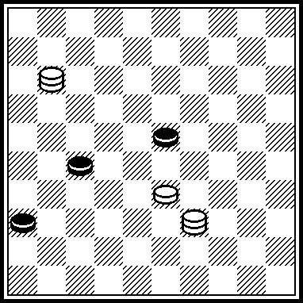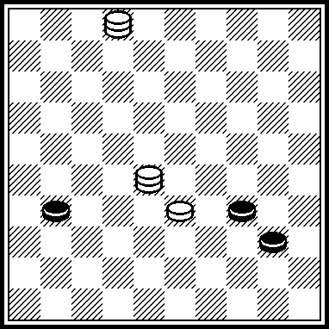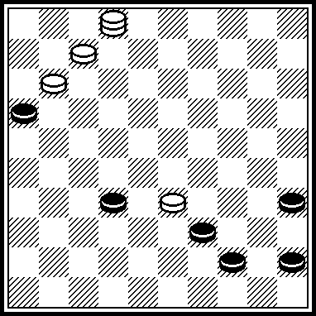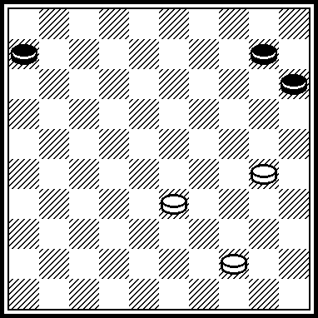

E05 E06 E07 E08
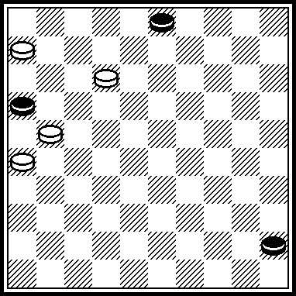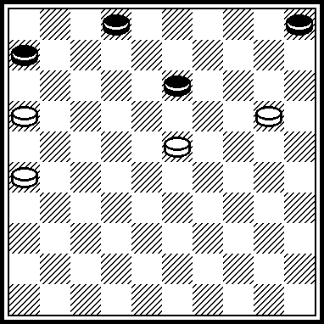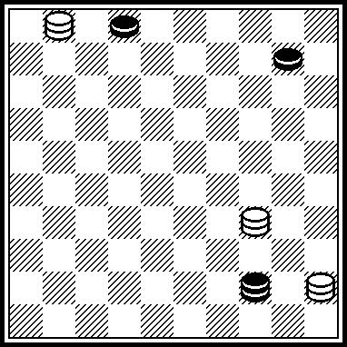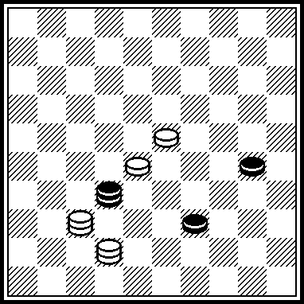

E09 E10 E11 E12
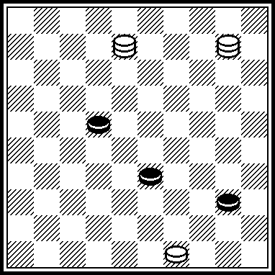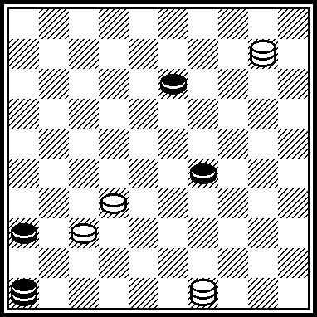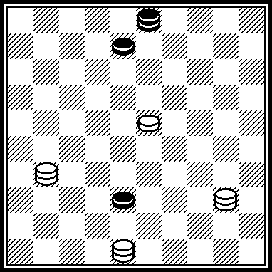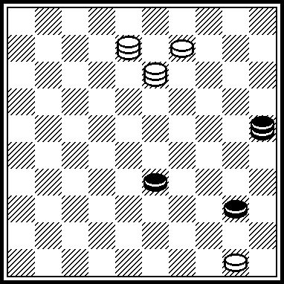

E13 E14 E15 E16
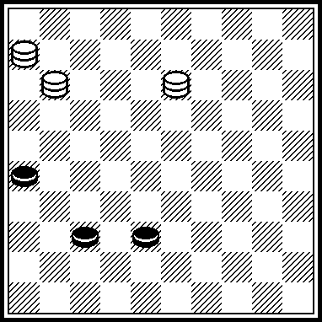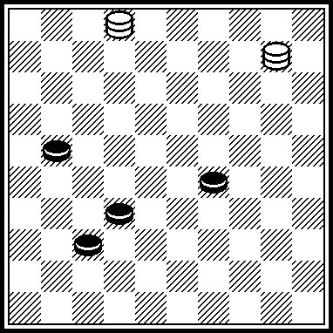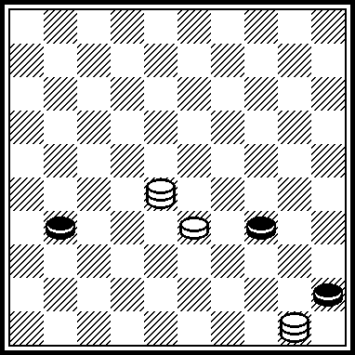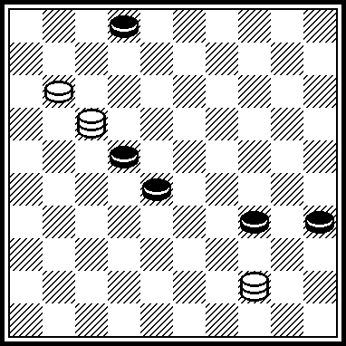

E17 E18 E19 E20
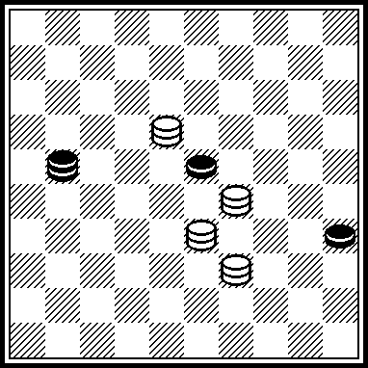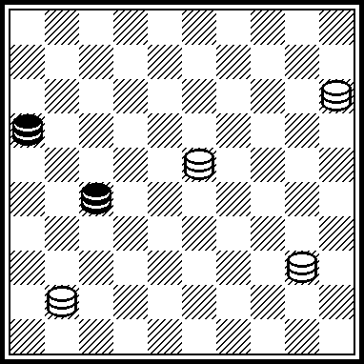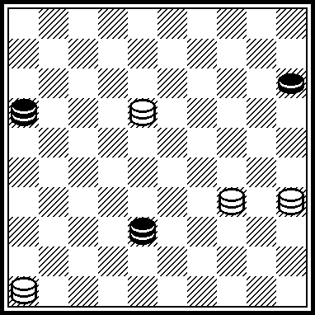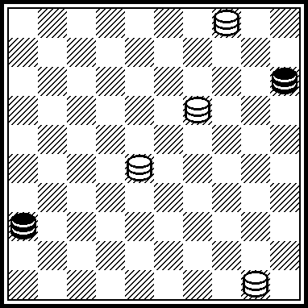

E21 E22 E23 E24
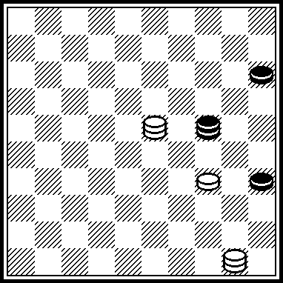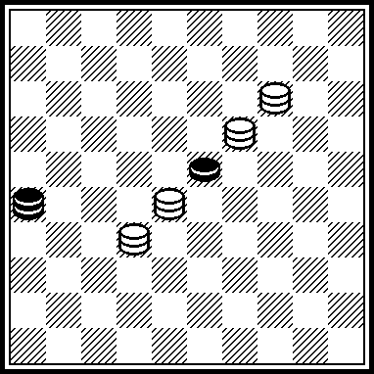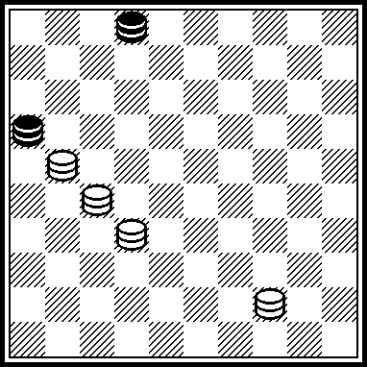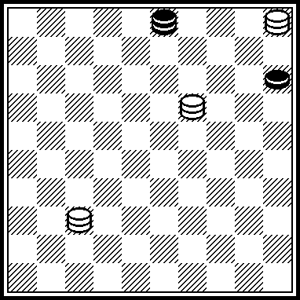

E25 E26 E27 E28
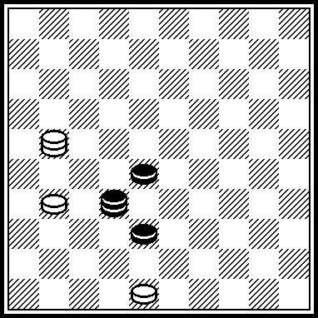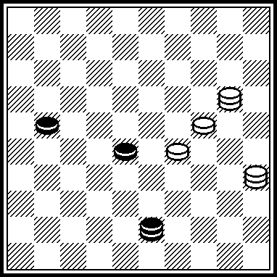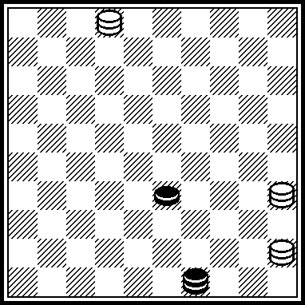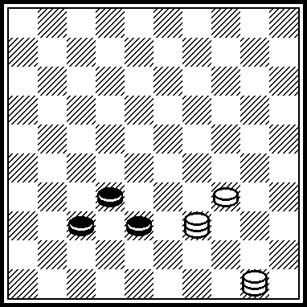

E29 E30 E31 E32
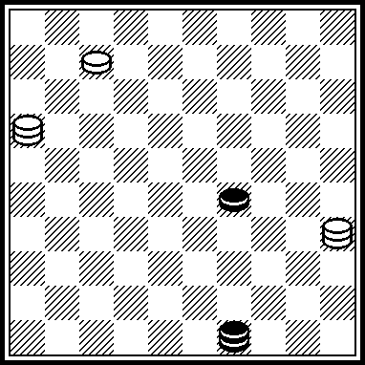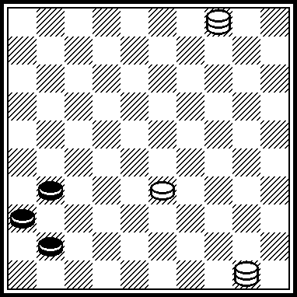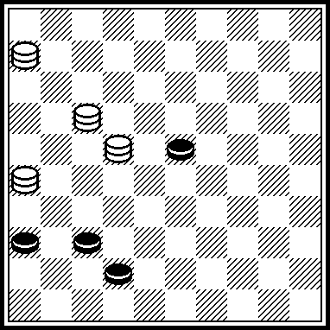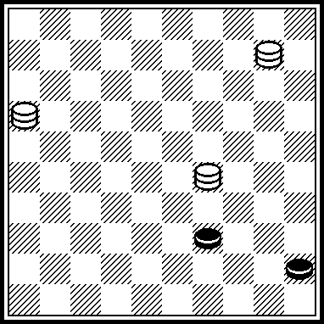

E33 E34 E35 E36
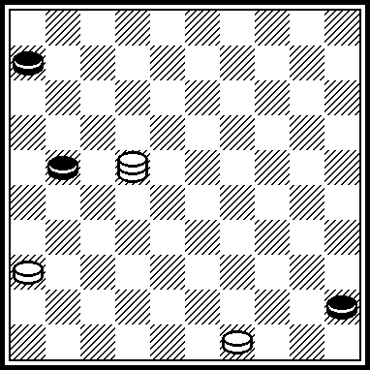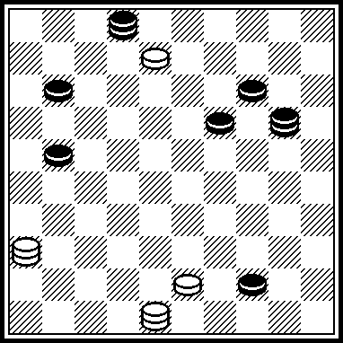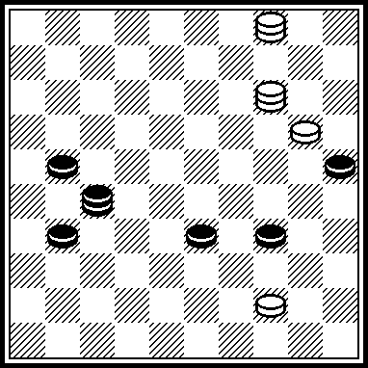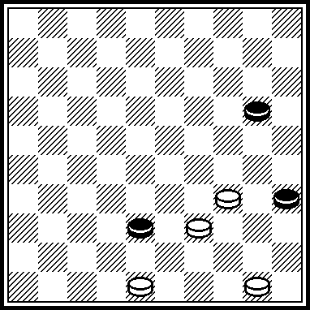

E37 E38 E39 E40
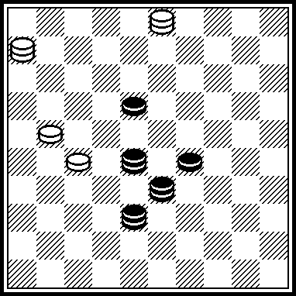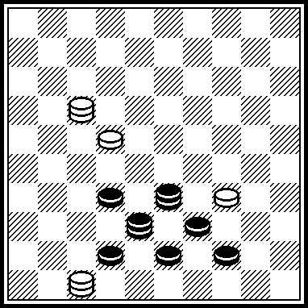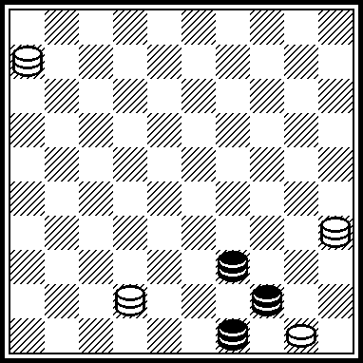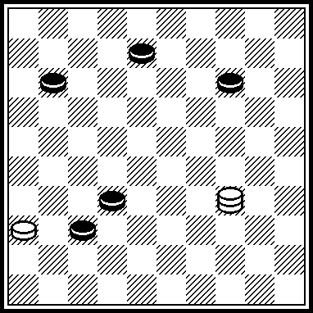

E41 E42 E43 E44
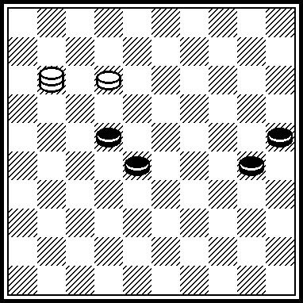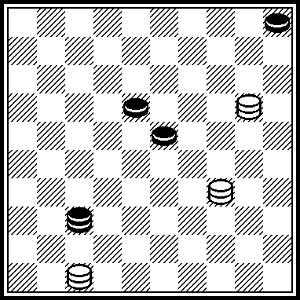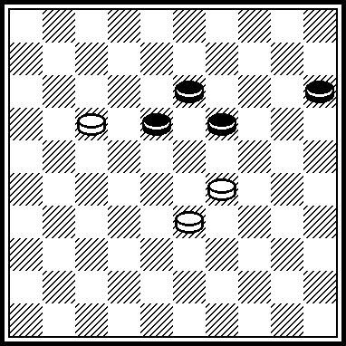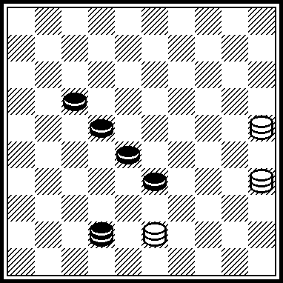

E45 E46 E47 E48
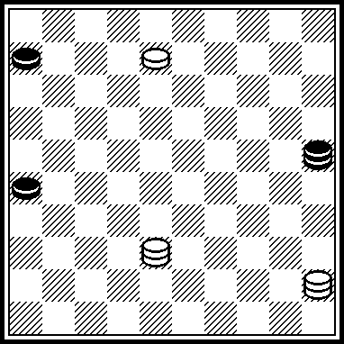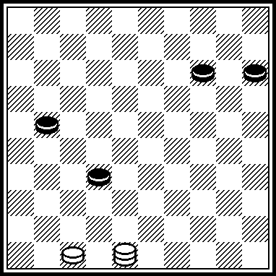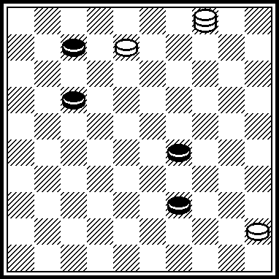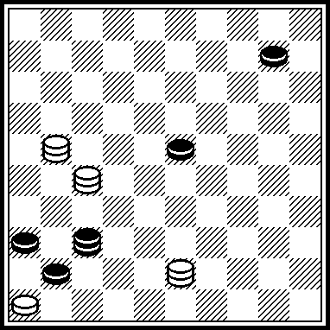

E49 E50 E51 E52
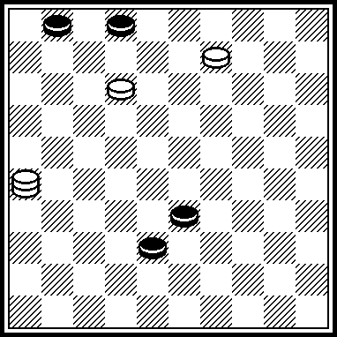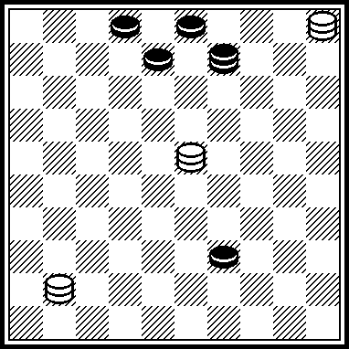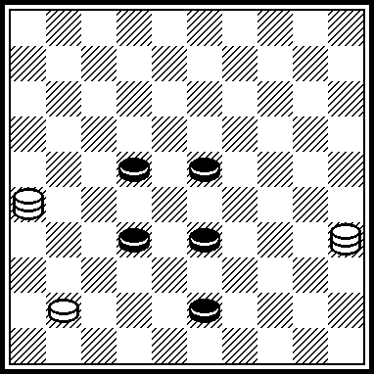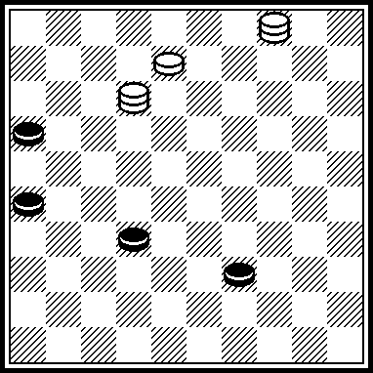

E53 E54 E55 E56
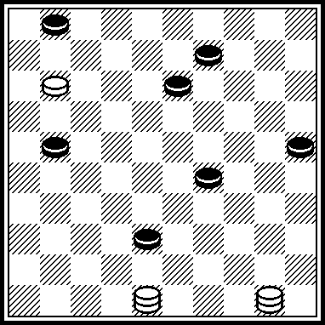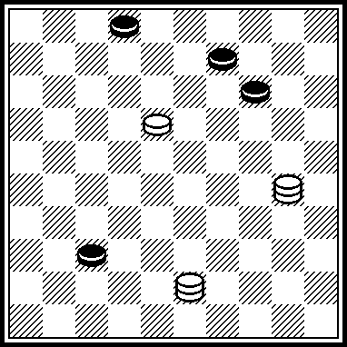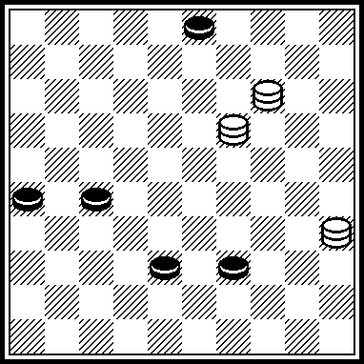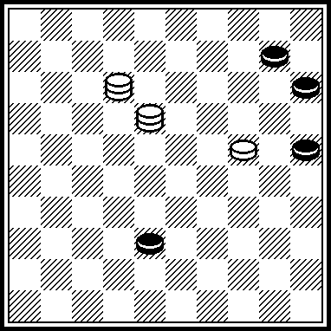

White to move and win in all positions.

The authors are:

Е01-Е08: S. Ustianov
Е09-Е16: S. Yushkevitch
Е17-Е24: I, Kobtsev
Е25-Е32: N. Shapoval
Е33-Е40: M. Fedorov
Е41-Е48: V. Trofimenko
Е49-Е56: A. Katukha

