Championship

for draughts composition

The “Problems” category

White to move and win in all positions.
There are kept author’s commets, author’s quotes etc.,
A score obtained earlier in another contest, if any, is indicated at the 100-point’s scale.
The championship is run under the International Rules of problemism at the Rules of Base level, paragraph 1.17.1.:
1.17.1. Rules of Base.
A problem satisfies the RB, if:
- the Initial position is legal (1.3.);
- in the Initial position equal pieces number of each color is present or a Black advantage is at most two pieces (a White advantage is not limited);
- the Problem has a solution (1.7.);
- the author’s solution is the only solution (1.8.);
- there is no type of the Dual (1.9.-1.9.5.) on the first move of the solution.

P001 P002 P003 P004
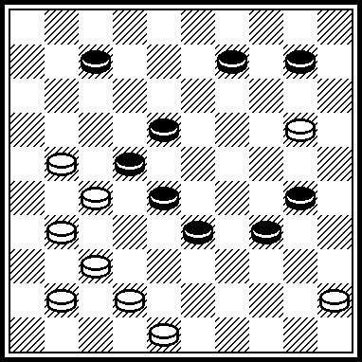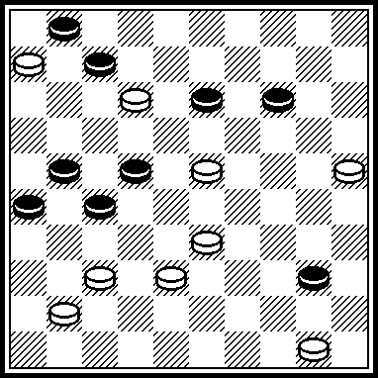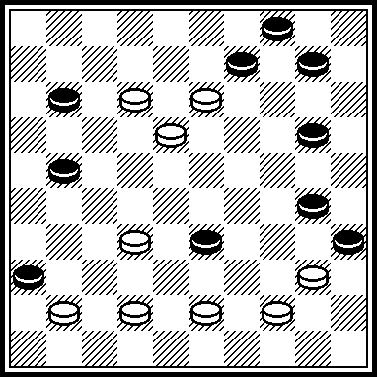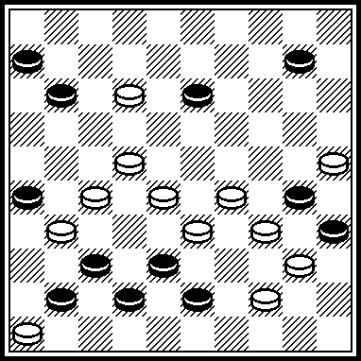

P005 P006 P007 P008
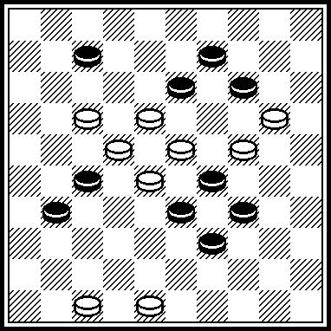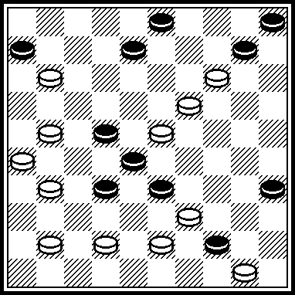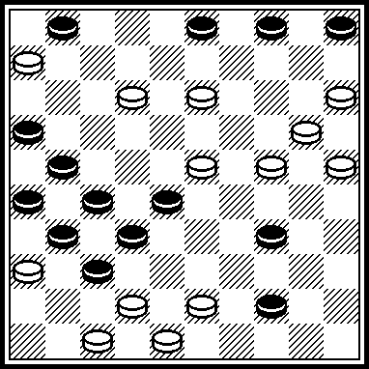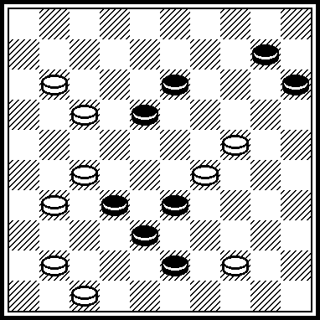

P009 P010 P011 P012
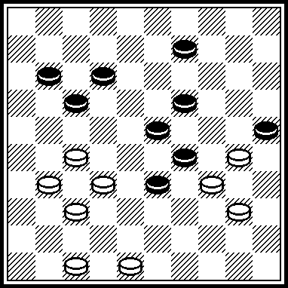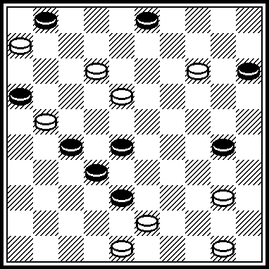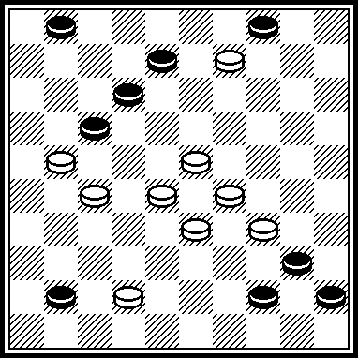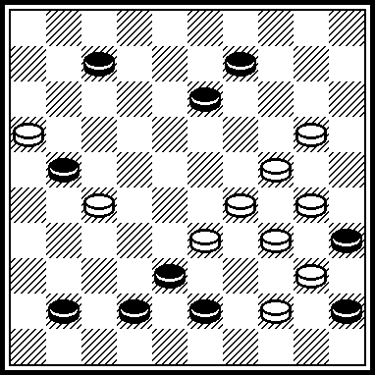

P001
VP: 32, 15(36 A, 38) 3544(3439) 4843, 43. A(3338) 235(36) 19(39) 40.

P002
VP: 44, 24, 2420, 17, 7, 1(2631) 29(36 A) 47(32) 2520(38) 24, 15, 24. A(32) 2520(36) 47(38) 24, 15, 24.
P002 was scored in “FFJD-2002” contest with 57,2 points (55+68+50).

P003
VP: 34, 28, 7, 5(40) 1(44 A) 40, 2, 3(10, 40) 28(45) 50. A(45) 6(50) 2, 8.

P004
VP: 8, 19, 21, 24, 5, 39, 39(40) 28(16 a 7) 22(611, 31) 1(36) 23. A(21) 23/5(31) 18, 9.

P005
VP: 1712, 1, 43, 30, 19, 42, 13, 41, 36(30) 25x

P006
VP: 36, 12, 9, 428, 21, 38, 41, 30, 37, 20.
P006 was scored in “Belarus” contest with 60 points.

P007
VP: 1208, 4238, 10, 7, 4842, 1, 32, 32(37 A, 31, 32) 37, 36. A(27, 27) 42.
P007 was scored in “FFJD-2004” contest with 55,75 (56+50+61)

P008
VP: 12, 39, 42, 9, 4(32 A) 20, 27(21) 16. A(20) I 2415(32) 27, 4x, I 415?(29, 27).

P009
VP: 21, 28, 3, 6, 50(46) 41, 37. P009 was scored in “FFJD-1999/2000” contest with 57,6 points.

P010
VP: 7, 1, 25, 44, 43, 9, 36, 42. P010 was scored in “FFJD-1999/2000” contest with 56 points.

P011
VP: 18, 37, 7, 3, 50. P011 was scored in “FFJD-1999/2000” contest with 45 points.

P012
VP: 23, 14, 1, 18, 49(30) 40, 40.
P012 was scored in “FFJD-2004” contest with 59,5 points.

P013 P014 P015 P016
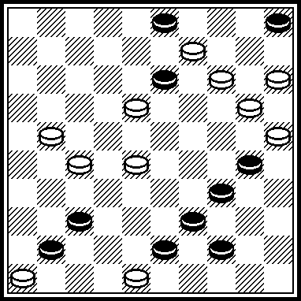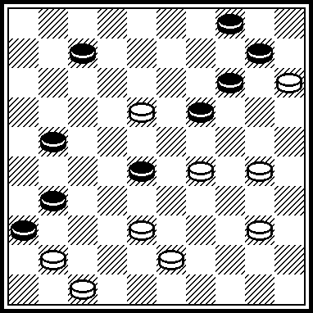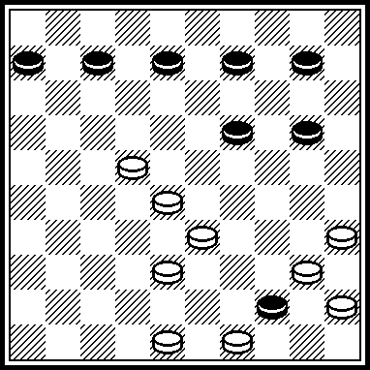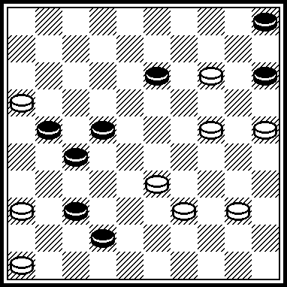

P017 P018 P019 P020
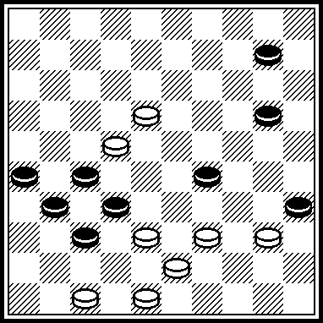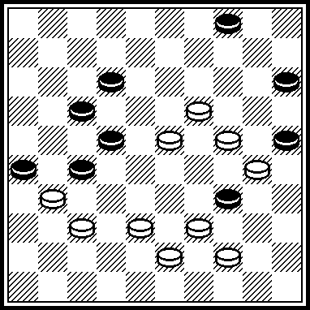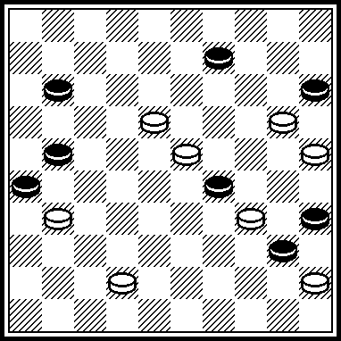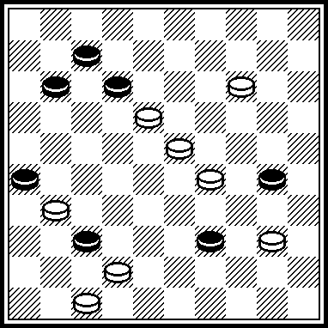

P021 P022 P023 P024
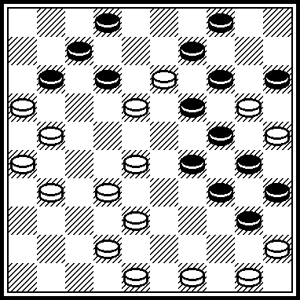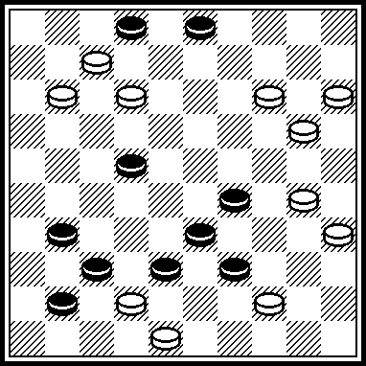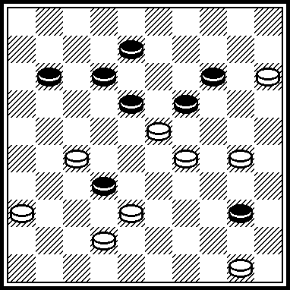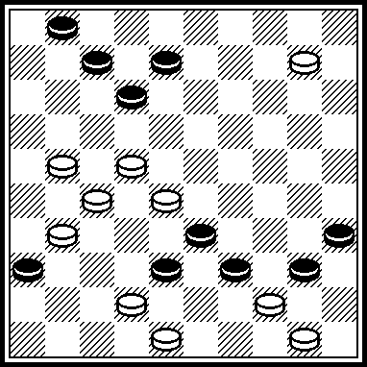

P013
VP: 1510, 10, 42, 37, 9, 43.
P013 was scored in “Lietuva-1999” contest with 45,3 points.

P014
VP: 42, 33, 9, 4, 26.

P015
VP: 34(50) 23, 11, 33, 44, 39.

P016
VP: 41, 28, 20, 10, 31, 47.

P017
393, 4(50 А) 482, 183, 44, 36. А(49) 39, 43, 183, 30(36) 19(361) 36(42) 37, 27. Published in “Horizonty shashek”, # 11, 2007.. A correction of problems from “Retro-contest” -2004.

P018
372, 21, 14(9, 40 А) 28(49) 383, 14, 48(20) 42(25) 48. А(17, 17) 19(27) 13(31) 8(36) 3(41) 21(47) 16, 30(27) 43. P017 was published in “Khronola shashek”, # 2, 2003 after 1 move. In 1998 P018 with black 16 instead of 26 was scored with 0 points in Belarus-championship. Now it is the optimal version because black piece 26 plays active role..

P019
13, 4(18) 2(24 А, В) 30(24 С) 30, 34, 34х А(29) 7, 34, 34(40) 30, 34. В(30) 254(24) 30(24) 30, 34. С(29) 34(40) 34, 34. Legality: 4, 6, 9, 22, 28, 29, 35, 36, 40/ 7, 8, 10, 11, 15, 18, 19, 20, 23, 25, 26, 27, 31, 32, 34, 37, 42, 45. 261(24) 5, 150(415) 18(41) 323, 519 see diagram. Participated in “FFJD-2008” contest.

P020
10, 5, 41, 34(10) 6, 43(234 А) 50, 35(39) 49. А(39) 44, 35(40 В) 11(45) 50. В(11, 39) 49. Legality: white piece on 26, black piece has to be moved from 26 to 17. Then: 261(26) – see diagram. Participated in “FFJD-2008”.

P021
23, 27, 31, 9, 17, 494, 44, 8, 39, 1(49) 27, 27(18) 20, 43(30) 38(34). 33(350) 29, 34(28) 29.

P022
43, 44, 150, 5, 6, 39(8 А) 9(314 В) 3, 36. А(10) 26, 8, 36. В(254) 26, 36. Legality: 3, 4, 24, 29, 31, 33, 37, 38, 39, 41/ 7, 9, 11, 12, 13, 14, 15, 18, 19, 20, 30, 35, 42, 48, 49. – 138, 44 – see diagram.

P023
294, 2(43) 16(48) 38, 44, 1621, 20, 38. Legality:
8, 12, 14, 18, 19, 27, 28, 32, 40, 43/ 15, 16, 21, 23, 29, 30, 3б, 38, 42, 49, 50. – 11, 27(11) 38(32) – see diagram.

P024
5(49) 523, 42, 44, 11, 7, 2, 34(6) 7. Legality: 1, 3, 7, 30, 33, 35, 36, 38, 39, 40/ 9, 13, 14, 18, 19, 21, 22, 24, 27. – 28, 31, 44, 47, 48, 50 10(12) 472 – see diagram.

P025 P026 P027 P028
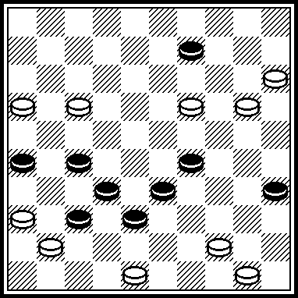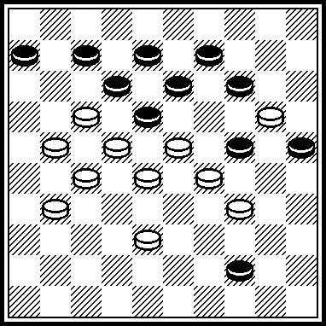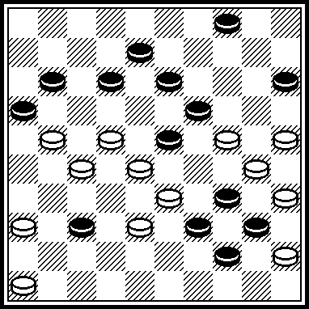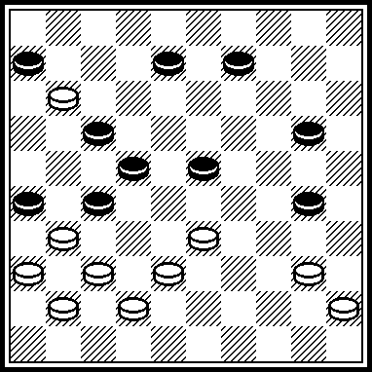

P029 P030 P031 P032
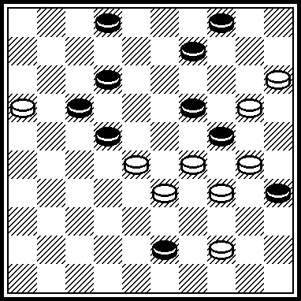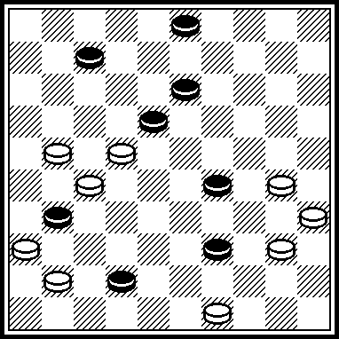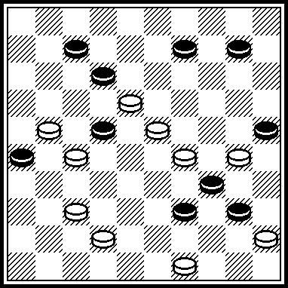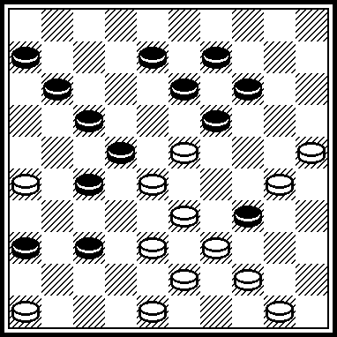

P033 P034 P035 P036
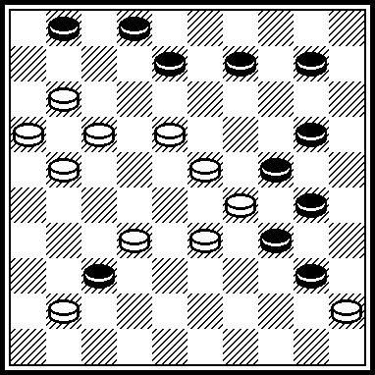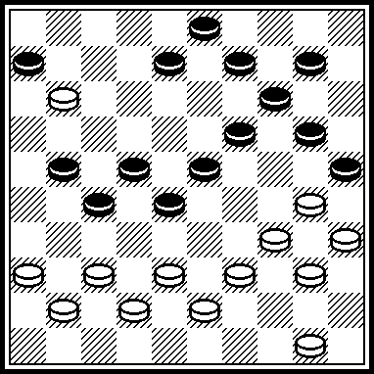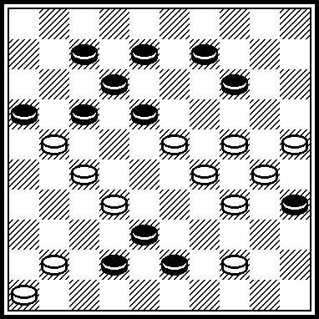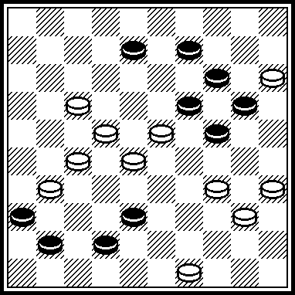

P025
VP: 31, 42, 40, 37, 14, 42, 36. Published in “Saskiu kaleidoskopas”, # 17, 2009 year.

P026
VP: 19, 16, 14, 1, 11, 30, 47.
Participated in “Steef de Bruijn” contest, 2004 year.

P027
VP: 2420, 28, 20, 34, 41, 31, 18, 9, 2, 23.
Participated in PWC.

P028
VP: 28, 38, 28, 34, 32, 27, 27.

P029
VP: I 11, 8, 10, 40, 23, 8, 3, 35, 44. I 10?(2415) 39, 8(13)=.

P030
VP: 44, 34, 1, 12, 37, 9, 24, 24.
Participated in PWC

P031
VP: 13, 31, 17, 1, 15, 43, 29, 43.

P032
VP: 42, 41, 32, 3, 30, 20, 37, 37.
Participated in “Steef de Bruijn” contest, 2004 year.

P033
VP: 13, 7, 28, 3, 2117, 7, 5.
5 place in “FMJD-98”

P034
VP: 3631, 3732, 24, 2, 13, 26, 12(8) 20, 44.
4 place in “Retro-contest”.

P035
VP: 2420(15) 20(33) 22(49) 4, 20, 38, 37, 37.
Participated in “Pinsk-2009” contest.

P036
VP: 4943, 3530, 3423, 2823, 154, 50.
With black piece on 6 P036 was scored with 0 points in “Lietuva-99”

P037 P038 P039 P040
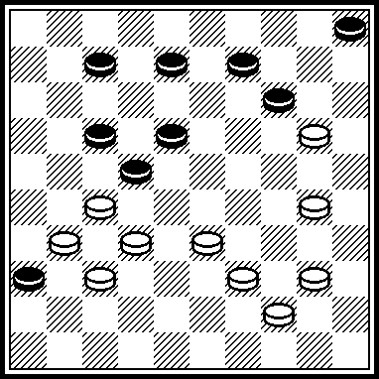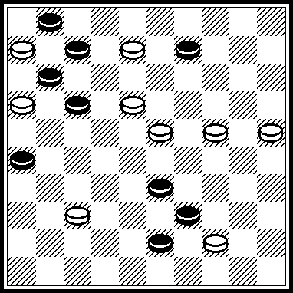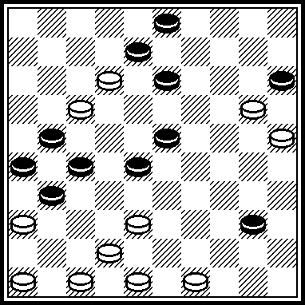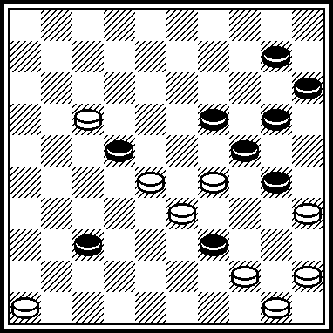

P041 P042 P043 P044
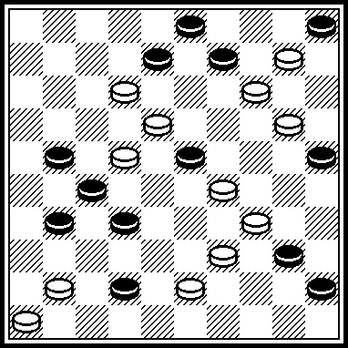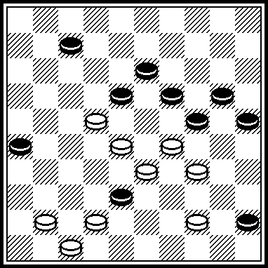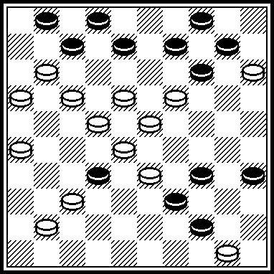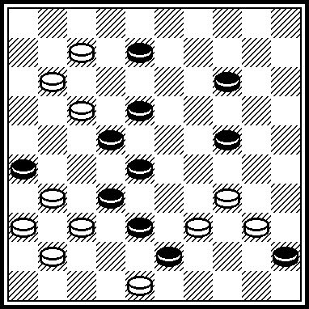

P045 P046 P047 P048
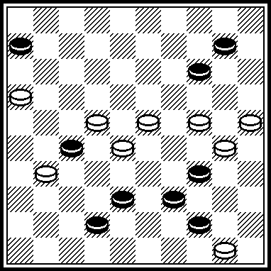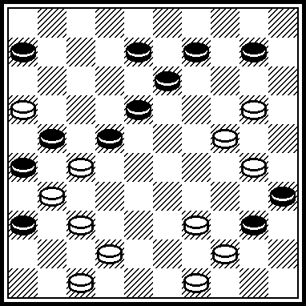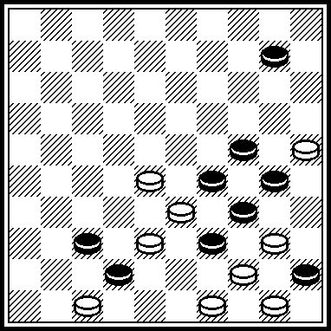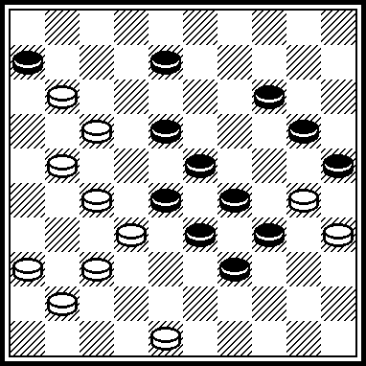

P037
VP: 3934, 2721, 10, 1(50) 10(46) 6, 5х

P038
VP: 31, 3, 3:26:22, 12(20) 3(50) 7, 17, 17.
Published in “Shashechnyj mir”, # 2, 2001 year.

P039
VP: 4641, 44, 20, 9, 3, 5(3137) 541(32) 37(46) 31, 41(42) 37.
P039 was scored in “Novopolotsk-2008” with 67,5 points.

P040
VP: 4540, 41, 4034, 5(49) 6, 20, 44, 44.
8 place in “Lietuva-2006”.

P041
VP: 30, 34, 15, 24, 37, 8, 19, 7, 1, 39, 50.
Participated in “G. Dalidovitch-memorial”, 2007 year.

P042
VP: 36, 41, 31, 10, 9, 14, 2.
Participated in “ KVD-2008”

P043
VP: 182, 13, 21, 43, 30, 37, 7, 9, 4(12) 7, 32. Participated in “Lietuva-2008”.

P044
VP: 27, 32, 33, 3, 10, 31, 7, 46.
P044 was scored in “Novopolotsk-2007” with 60 points.

P045
VP: 239, 11, 33, 5, 30, 30.
Participated in “Lietuva-2006”.

P046
VP: 41, 34, 45, 14, 43, 3, 11, 47.
P046 was scored in “Novopolotsk-2007” with 65 points.

P047
VP: 23, 43, 41, 439, 5, 39, 19, 49.
P047 was scored in “Novopolotsk-2007” with 55 points.

P048
VP: 43, 39, 34, 10, 3, 31, 30, 46.
Participated in “Lietuva-2008”.

P049 P050 P051 P052
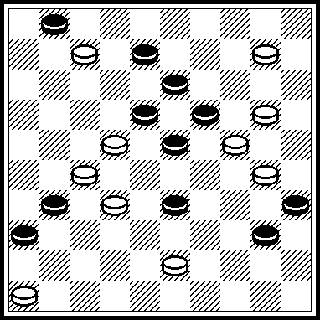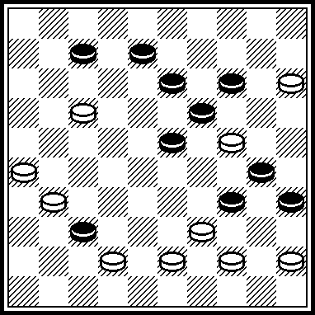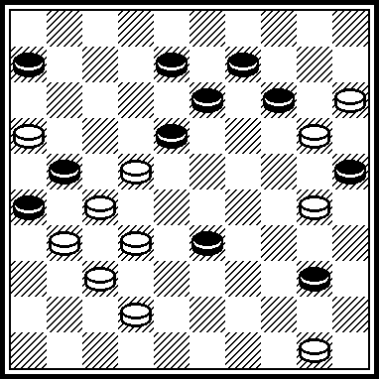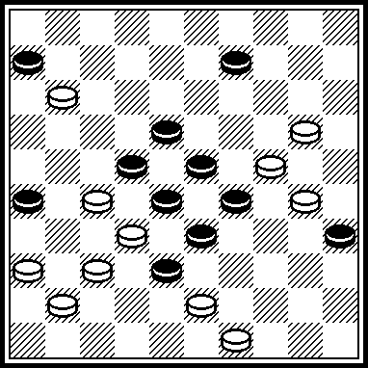

P053 P054 P055 P056
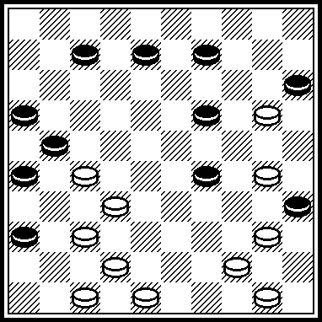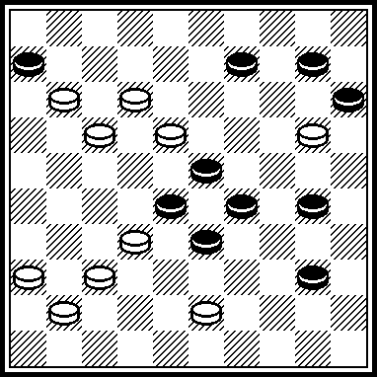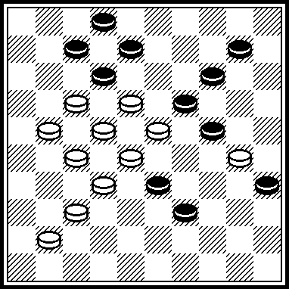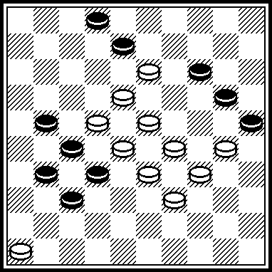

P057 P058 P059 P060
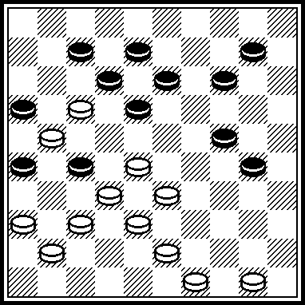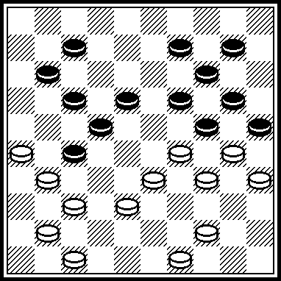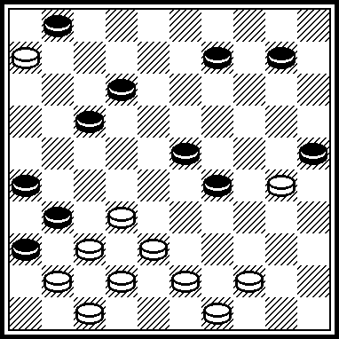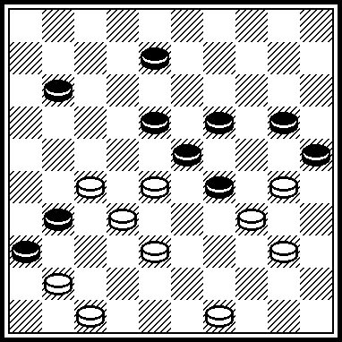

P049
VP: 15, 21, 41, 4, 26, 49.

P050
VP: 438, 450, 21, 12(50) 1, 1x40x49x27x:9x:39 2.

P051
VP: 45, 11, 3, 8, 46, 34, 14, 35.

P052
VP: 44, 14, 3, 0320, 25, 25x9x31x48, 361, 5.

P053
VP: 31, 41, 39, 43, 1, 40, 37.
4-х кратное большинство.

P054
VP: 38, 27, 1207, 1(17 A) 25, 5. A(24) 3, 5.

P055
VP: 11, 7, 228, 12, 3, 2, 5.
P056
VP: 294(38 A) 12, 3(43) 48, 8, 41, 5. A(2040) 12, 3, 48, 8, 41.

P057
VP: 23, 361, 328, 494, 23, 382, 31 !, 45, 3.

P058
VP: 28(2442) 48(36) 493, 38, 38, 21, 1, 6(32) 43, 44, 44.
10.X.2001. 75 points in “Belarus”.

P059
VP: 33 !, 428, 42, 21, 39, 07, 1.
“Saskiu kaleidoskopas”, 2003 year.

P060
VP: 42 !, 44, 28, 3, 48, 40, 43.
3 place in “FFJD-2004”.

P061 P062 P063 P064
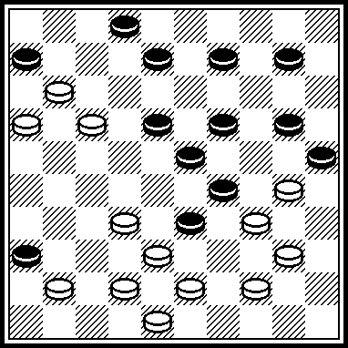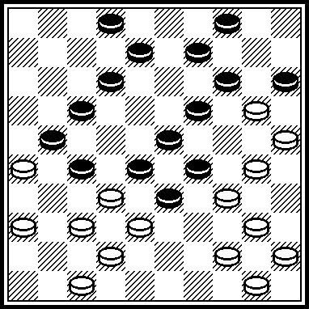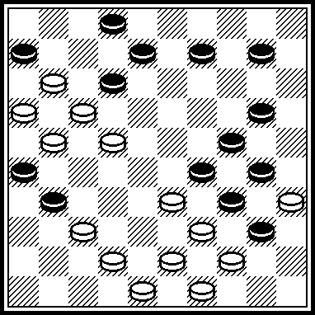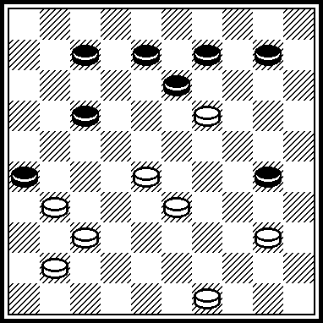

P065 P066 P067 P068
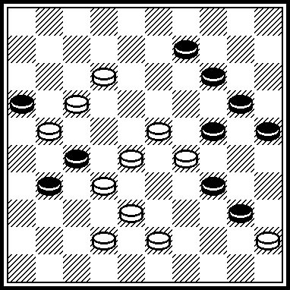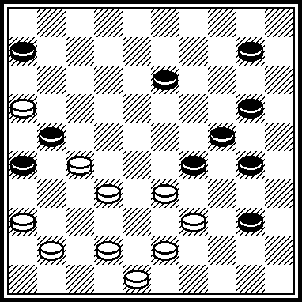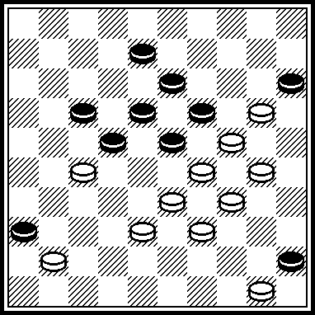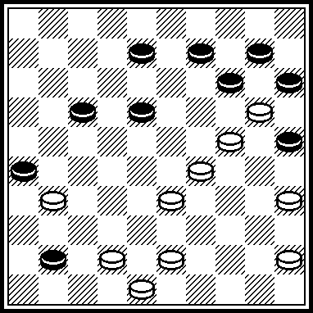

P069 P070 P071 P072
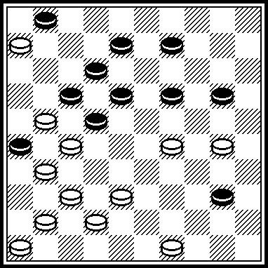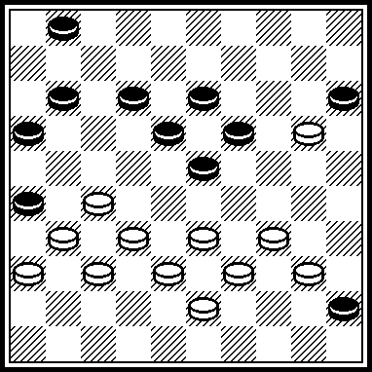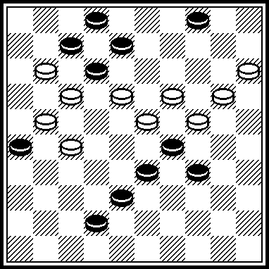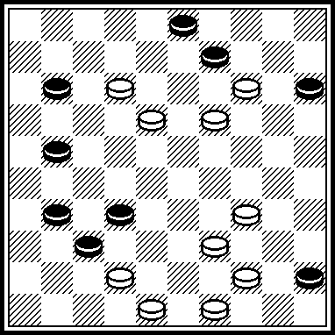

P061
VP: 7, 11, 439, 28, 28, 5, 49, 25(39) 43, 439, 40, 39.
Published in “Horizonty shashek”, # 2/2005

P062
VP: I 35, 7(11) 23(28) 32, 41, 10, 31, 44, 34, 24, 12, 6(12) 1(17) 29(22) 38(28) 29(32) 42.
I 3731?(48) 11, 17(21) 6(42) 38, 34(27) 39, 1, 47(32) 34(37). “I think, it is a draw”.

P063
VP: 4238, 47, 32, 38, 18, 7, 4742, 27, 29, 2(11 !, 39) 1643(44) 39, 38, 37.

P064
VP: 32 !, 22, 2, 29(34, A) 40, 40. A(44) 40(34) 33, 50.

P065
VP: 39, 30, 19, 37, 8, 3, 29(3:25:43:16:29) 34.
Participated in “Varyag-Press-2009” contest.

P066
VP: 31, 34, 5, 11, 38, 26(41) 37, 42.
Participated in “Lietuva-2008”.

P067
VP: 44, 40, 25, 24, 14, 20, 32, 28, 3, 49.
Participated in Novopolotsk championship-2009.

P068
VP: 37, 39, 42, 23, 4, 20, 30(19) 24, 40.
Participated in Pinsk championship 2009.

P069
VP: 3024, 23, 7, 44, 1, 3, 21, 37.
Participated in “KVD-2008”.

P070
VP: 3328, 2722, 21, 47, 41, 33, 14, 6(31) 10(37) 5(42) 38, 32(39) 49.
Participated in “KVD-2008”.

P071
VP: 2014, 1913, 8, 2, 10, 20, 43. (2:48:26:3:43x)
Participated in “KVD-2008”.

P072
VP: 8, 3, 20, 4843, 29, 6, 1(6) 44, 6.
Participated in “Lietuva-2008”

P073 P074 P075 P076
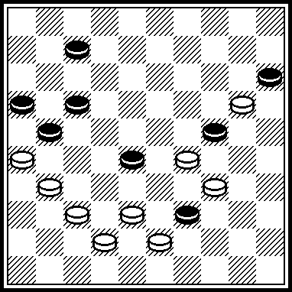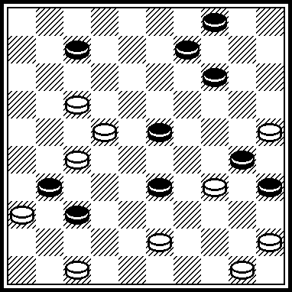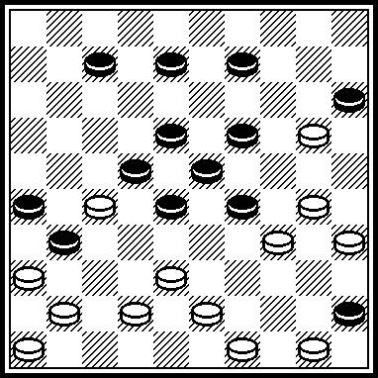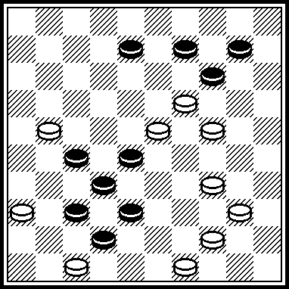

P077 P078 P079 P080
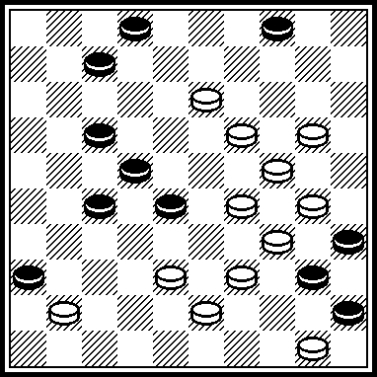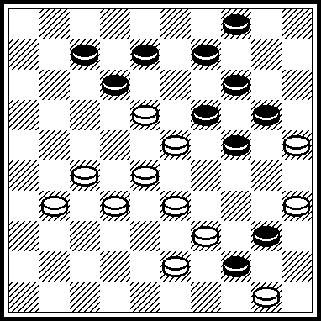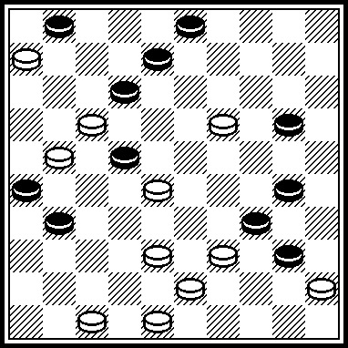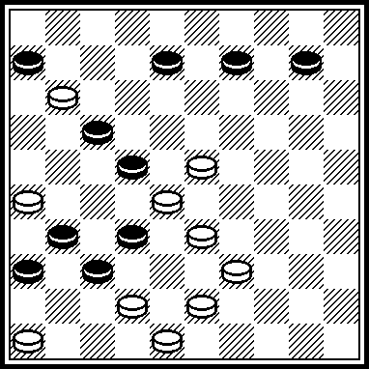

P081 P082 P083 P084
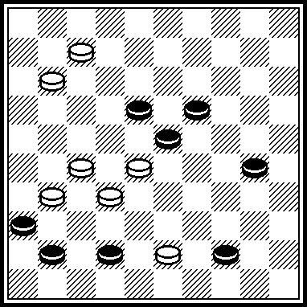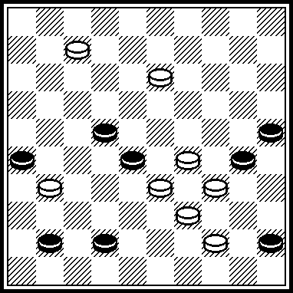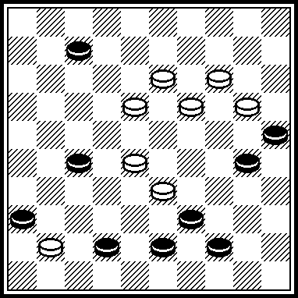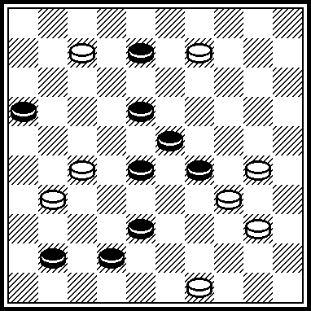

P073
VP: 27, 33, 2, 21 (27 A) 29, 35, 47. A(24) 35, 29, 47.
PWC, 2003-2004, B 36, scored with 63,5 points.

P074
VP: 40, 42, 10, 12, 4, 31 !, 37, 27.
PWC, 2003-2004, C 37, scored with 45 points.

P075
VP: 504, 449, 44, 40, 33, 29, 427, 31, 1, 40, 39, 47(37) 471, 37, 41.
PWC, 2003-2004, D 28, scored with 46 points.

P076
VP: 31, 20, 43, 38, 5 (48) 194, 34, 35.
“LIETUVA-1999/2000”, scored with 60 points.

P077
VP: 204, 1309, 39, 8, 23, 1, 40, 8(13) 19(27) 14(32) 10(37) 5(42) 38, 32(39) 49.
“FFJD-1999/2000”, scored with 67,6 points.

P078
VP: 282, 438, 28, 10, 1(44) (5…4045 6.3530 1520 7.0106+) 6(49) (6…20 7.2721, 8.0650.) 21, 44, 44.

P079
VP: 482, 13, 8, 33, 29, 14, 39, 37, 7, 1(15) 29(22) 38(28) 24(32) 42(20, 37) 47. (1.2823 2211 2.0617 3035 3.3930 3513 4.4534 3137)=.

P080
VP: 41, 21, 5, 42, 49.

P081
VP: 21, 2, 13, 2.

P082
VP: 24, 30, 2, 46, 6.

P083
VP: 22, 12, 3, 47.

P084
VP: 43, 2, 36, 21, 22, 45.

P085 P086 P087 P088
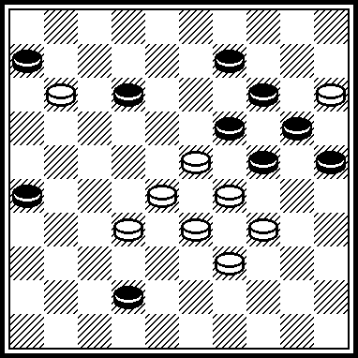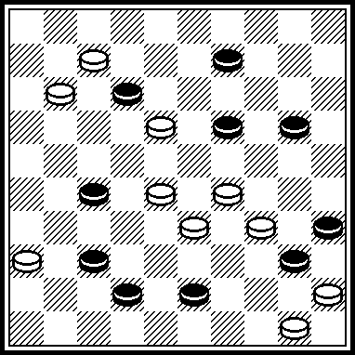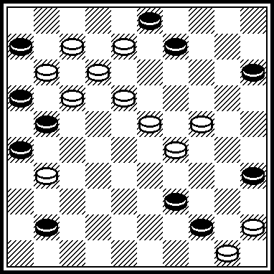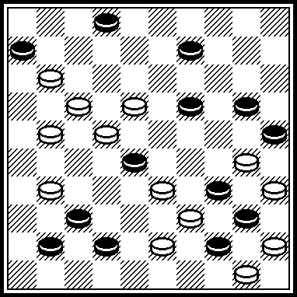

P089 P090 P091 P092
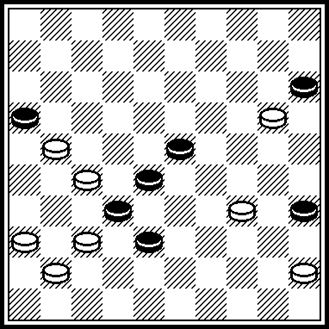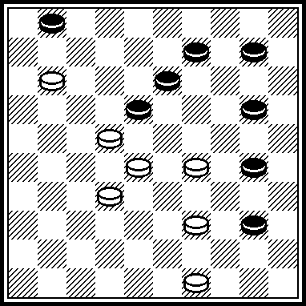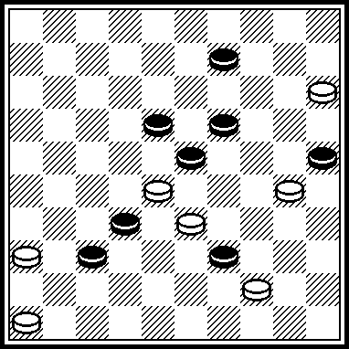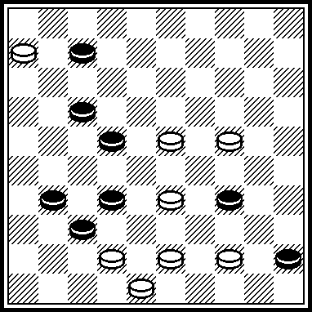

P093 P094 P095 P096
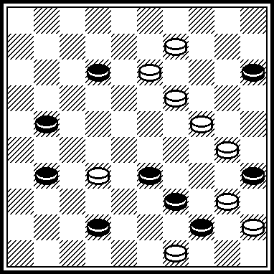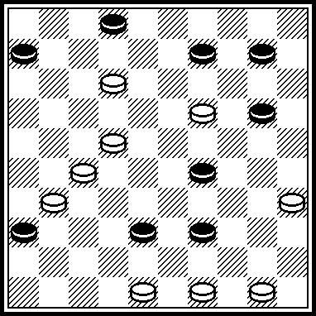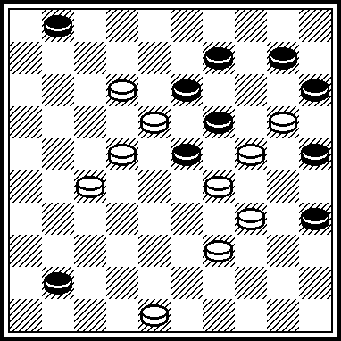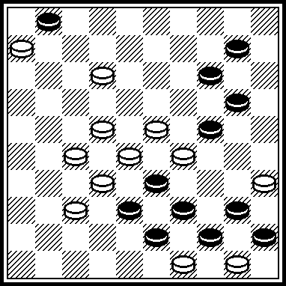

P085
VP: 3430, 2328, 3329, 1504, 0421, 3227.

P086
VP: 283, 3, 21, 31, 1, 40, 37.

P087
VP: 20, 13, 1, 1x34x16, 46, 39, 40, 28.

P088
VP: 182, 8, 18, 12, 38, 39, 34, 4, 48.

P089
VP: 361, 22, 42, 30, 34. Published in “Horizonty shashek”-4/2007”.

P090
VP: 44, 4(7, 42) 24! (48) 18(33) 38.

P091
VP: 10, 4, 13, 27, 38.

P092
VP: 4339, 1, 37, 6.

P093
VP: 20(1524) 28, 8, 48(50) 44, 39.
Published in “Horizonty shashek”-5/2006”.

P094
VP: 7, 4943, 42, 38, 44, 22(17) 11(17) 14(22) 10(28) 5(33) 32(39) 49.

P095
VP: 30, 39, 7, 18, 4, 48(40) 39(45) 50.

P096
VP: 30, 2218, 2319, 7, 1, 48.

P097 P098 P099 P100
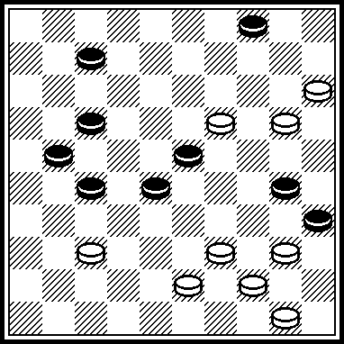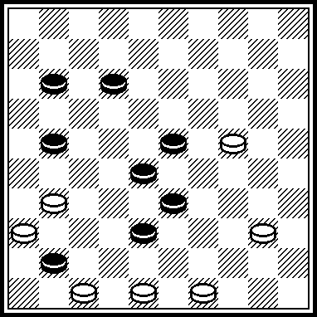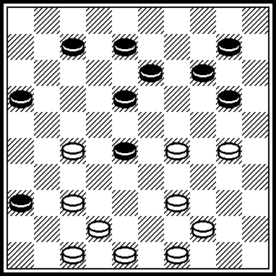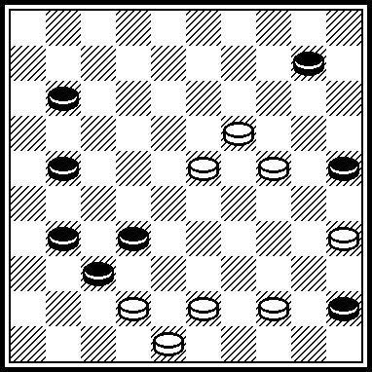

P101 P102 P103 P104
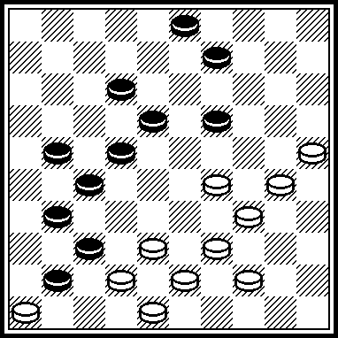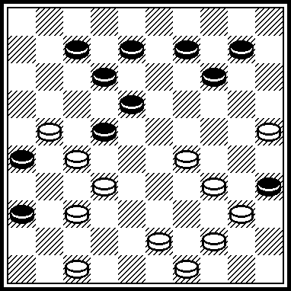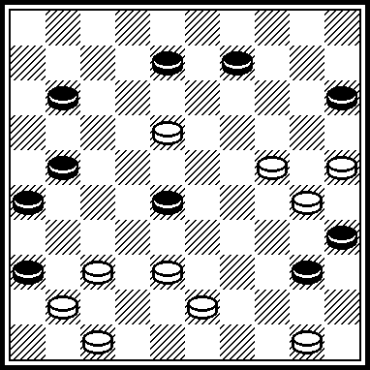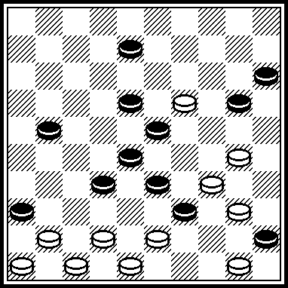

P105 P106 P107 P108
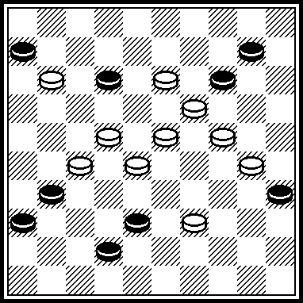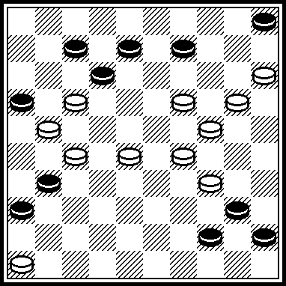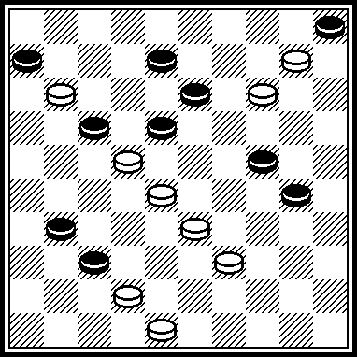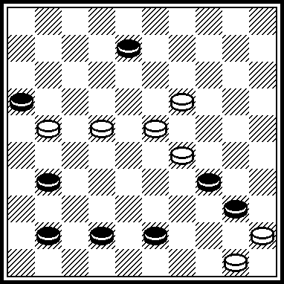

P097
VP: 10, 32, 394, 2, 16.

P098
VP: 493, 27, 38(46) 32, 41.

P099
VP: 304(15, A) 41, 493, 33, 43, 23, 3, 49. A (25) 20(0812) 9, 21, 32.

P100
VP: 30, 439, 39, 14, 5, 6.
Published in “Ladia”, # 1, 12.01.2008.

P101
VP: 304, 24, 3019, 32, 43,8, 34, (127) (7…1823 8.0317x)
21(23) 17(239) 6.

P102
VP: 31, 38, 17, 20, 41, 23, 5, 1(45) 40(50) 30, 6.
Published in “Ladia”, # 10, 23.05.2009.

P103
VP: 13(18) 42, 31, 44, 2, 19. Published in “Ladia”,
# 23, 06.12.2008.

P104
VP: 417(14, A) 428, 42, 461, 24, 3, 3x25x37, 45.
A (41) 37, 32, 31, 42, 24, 3, 48.
Published in “Ladia”, # 15, 11.08.2007.

P105
VP: 33, 20, 14, 5, 47.
P105 was scored in 8 Novopolotsk championship with 55 points.

P106
VP: 2722, 10, 19, 41, 2014, 1, 50.
Legality: (2631) P106 was scored in 8 Novopolotsk championship with 55 points.

P107
VP: 29, 43, 23, 3(17 A) 25, 50. A(14) 26, 49.
P105 was scored in 8 Novopolotsk championship with 60 points.

P108
VP: 44, 3, 49.

P109 P110 P111 P112
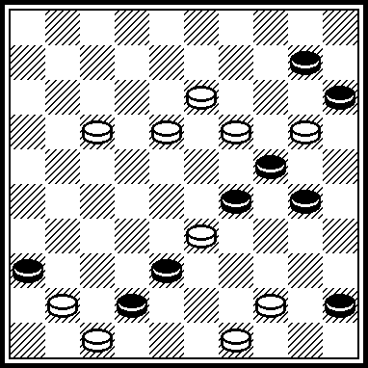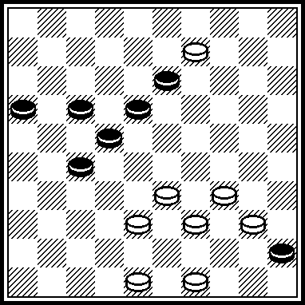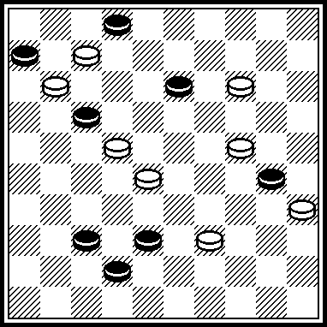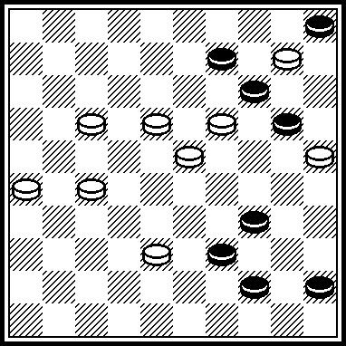

P113 P114 P115 P116
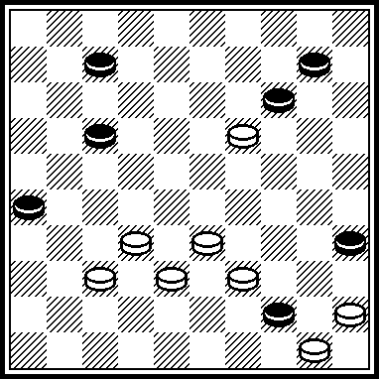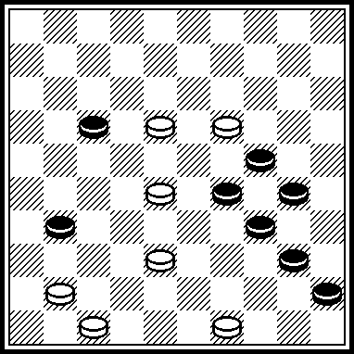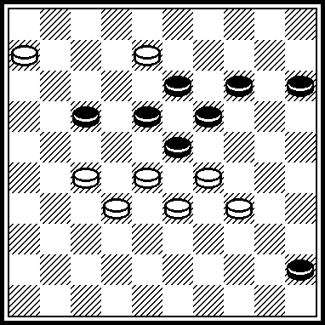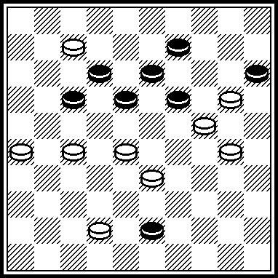

P117 P118 P119 P120
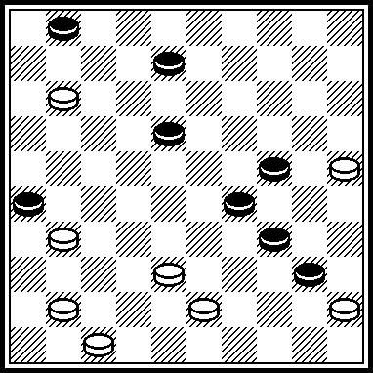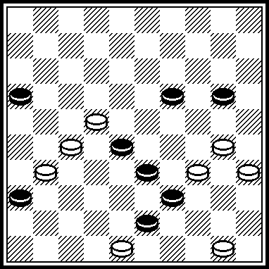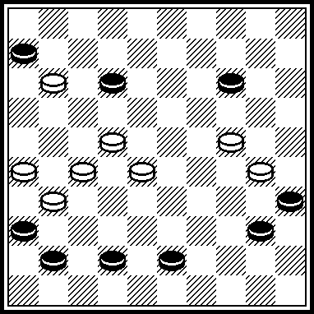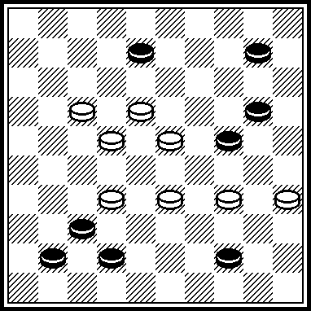

P109
VP: 43, 38, 9, 44, 4, 6.

P110
VP: 32, 21, 27.

P111
VP: 23, 33, 4, 6, 47.
Participates in 10 championship of Novopolotsk.

P112
VP: 33, 32, 3, 50. Published in “Horizonty shashek”, -11/2008».

P113
VP: 31, 2, 16, 38, 40, 19(15) 14.

P114
VP: 33, 44, 37, 40, 39, 38(22 a) 32. A(21) 32(26) 27.

P115
VP: 2722, 20, 2, 23, 11(50) 17, 17.

P116
VP: 2822, 38, 8, 4, 44(16) 49(21) 16(40) 11(45) 50.

P117
VP: 20, 39, 3, 41, 7, 42(20) 15(37) 47.

P118
VP: 45, 22, 24, 34.

P119
VP: 19, 8(28 A) 3(24) 8, 49. A(18) 2(17 B) 16, 11. B(24) 13.

P120
VP: 1712, 19, 4, 50(32) 33(37) 47.

P121 P122 P123 P124
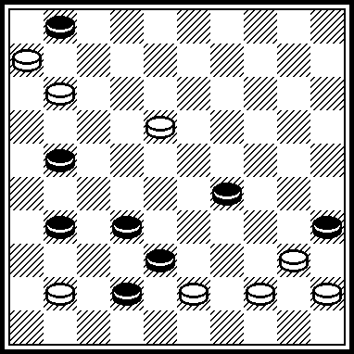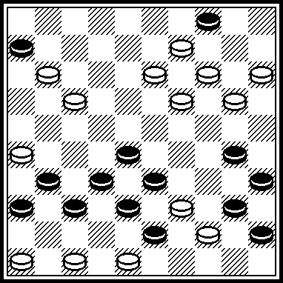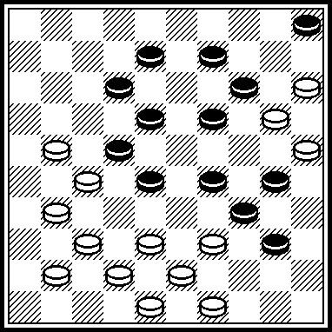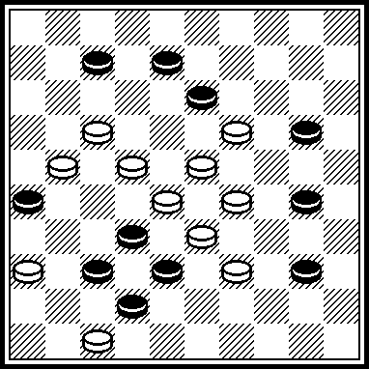

P125 P126 P127 P128
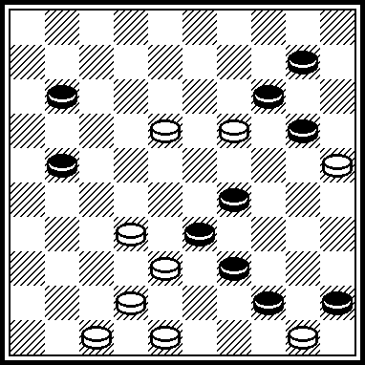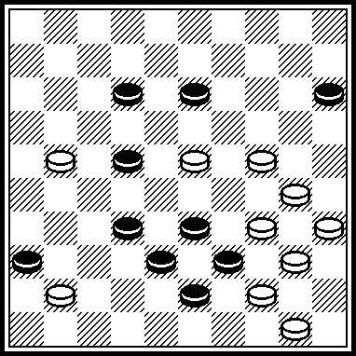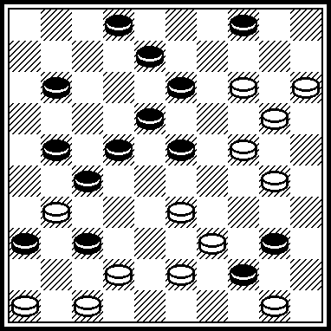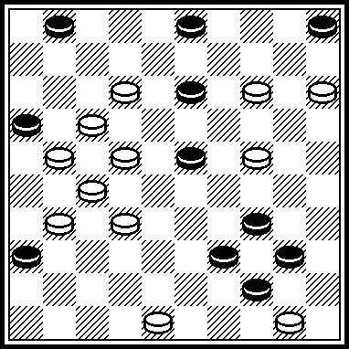

P129 P130 P131 P132
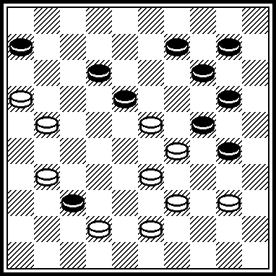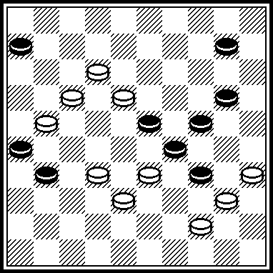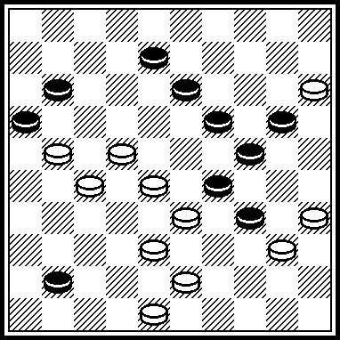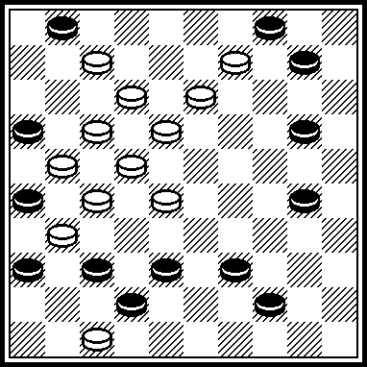

P121
VP: 7, 1, 37, 34(2940 A) 16, 49. A(4940) 30, 34, 16.
1 place in B-category of “Lietuva-2006”.

P122
VP: 1510, 12, 2, 34, 39, 4641, 37, 9, 49.
4 place in “G.Dalidovitch-memorial”, 2006 year.

P123
VP: 44, 17, 27, 21, 10, 3, 49, 3732, 20, 43(19) 39.
Participated in Russia championship 2003 year.

P124
VP: 11, 3(43) 45(24) 31, 46, 48.

P125
VP: 43, 39, 5(42 A) 40, 49. A(44) 49(50) 44, 38.
29 place in C-category of “Lietuva-2008”.

P126
VP: 29, 20, 37, 42(26) 30!, 48, 37.
14 place in “Steef de Bruijn”-contest Published in the book “Fedorov Mikhail Vasilievitch” (Starobeshevo, 2008), p. 144.

P127
VP: 19, 1510, 26, 30, 4741, 45, 3, 39!, 7, 41.
24 place in B-categor of “Lietuva-2008”.

P128
VP: 43, 30, 10, 19, 7, 8, 18, 9, 3, 35.
27 place in F-category of “KVD-2008”.

P129
VP: 11, (26, a) 19, 394, 3, 50. a(17) 15. False solutions: I. 1.4035?, 28(2444)=. II. 1.4034?, 25(30, 24).

P130
VP: 1711, 3227, 4439, 3530, 3304, 0403. False solution: 2116 и 3530.

P131
VP: 18, 32, 43, 30, 1502, 47. False solution: 2218, 3530, 1502, 0246, 4449(3439)=.

P132
VP: 11, 41, 5, 48, 30, 50. False solution: 0903?(2025)=.

P133 P134 P135 P136
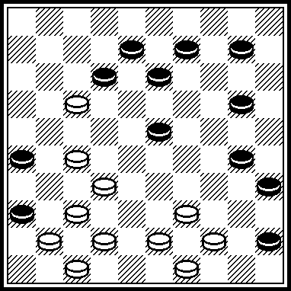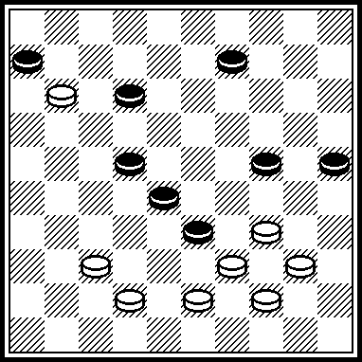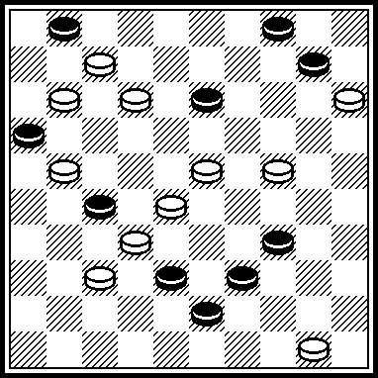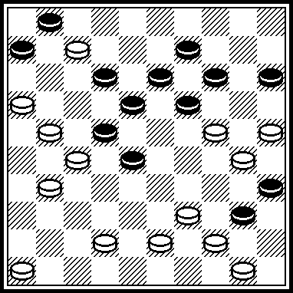

P137 P138 P139 P140
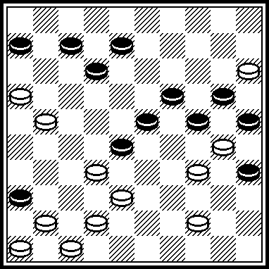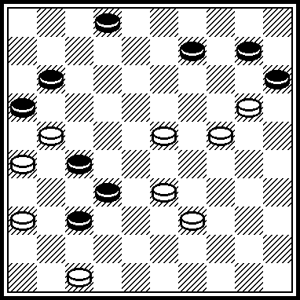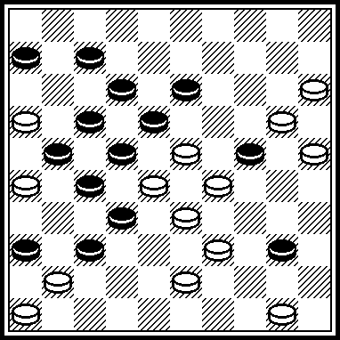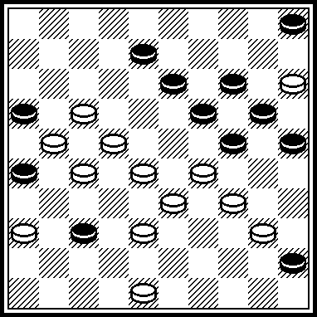

P141 P142 P143 P144
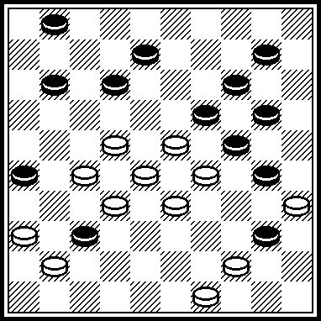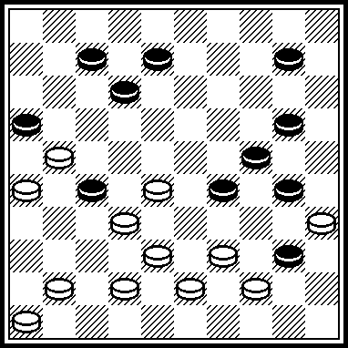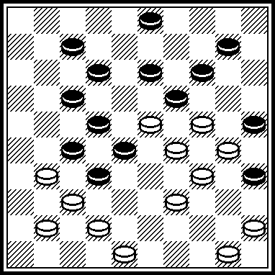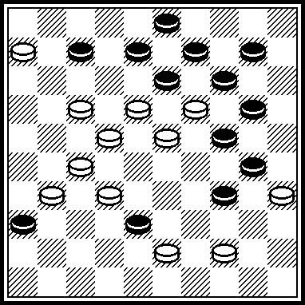

P133
VP: 40, 31, 42, 3, 40, 44.

P134
VP: 30, 32, 8, 3, 6.

P135
VP: 44, 2, 48, 25, 9, 4(19) 31 (23, A, B) 22(29) 39(7) . A(24) 42(30) 48(35) 34(6) 7. B(7) 18(11) 22(16) 27(23) 38.

P136
VP: 250, 33, 11, 41, 3, 24 ! Z, 33(23, A) 45 (20, B) 15(28) 20(32) 3(18) 9(23) 14(28) 19(33) 37(39) 32(44) 28. A(20) 15(40) 33(45) 28. B(18) 50(29) 40, 24. Z: 19?, 28(3540 !)=.

P137
VP: 40, 37, 461, 29, 22, 38, 17, 49.
“Shsashechnyj mir” contest, 1999-2001 years.

P138
VP: 42, 31(48:30:28 A) 3122, 4, 7, 21. A(48:25:28) 3122, 4(20 a) 0415, 7, 21. a(14) 27, 6.
1-й чемпионат мира.

P139
VP: 10, 44, 31(24 a) 2, 30, 41, 13, 24, 3(11) 7(37) 2(10) 26(41) 37, 24(37) 47(14) 393(20)29(25) 24. a(44) 2, 19. PWC.

P140
VP: 42, 32, 31, 18, 29, 2, 29, 35(30, 14) 24.

P141
VP: 43, 31, 17, 2, 4, 7, 0415. Endgame.

P142
VP: 23(18)383, 29, 4, 11(27 A) 16(41) 37(31) 261, 17, 47. A(7) 17, 17.

P143
VP: 40, 43, 44, 20, 2(34) 14, 8, 32.

P144
VP: 449, 28, 17, 18, 2, 8, 50.

P145 P146 P147 P148
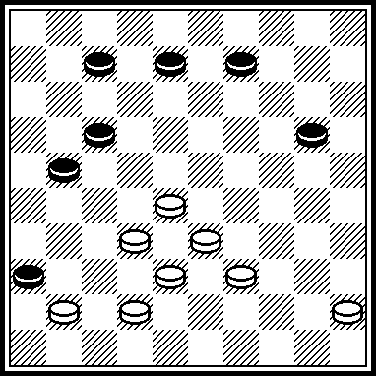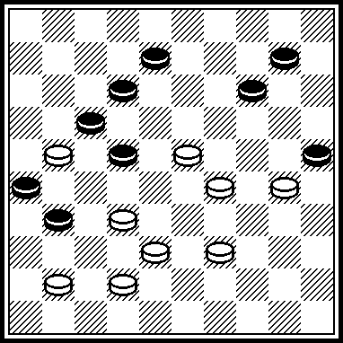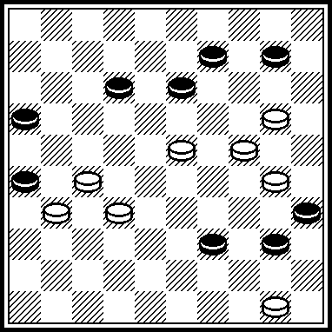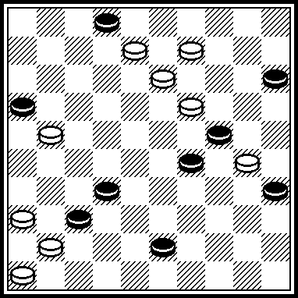

P149 P150 P151 P152
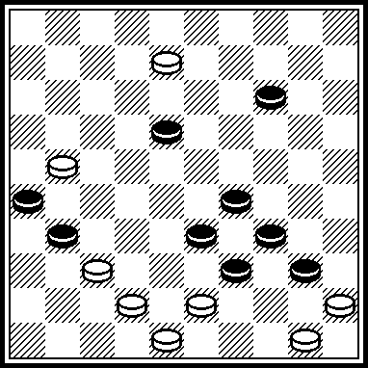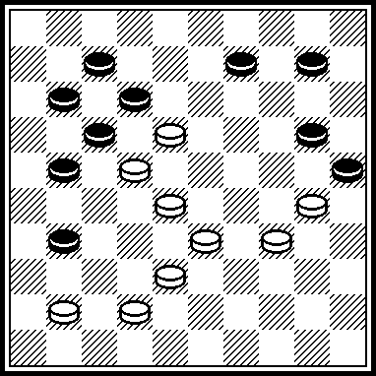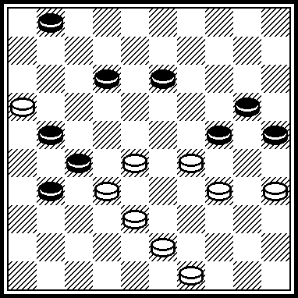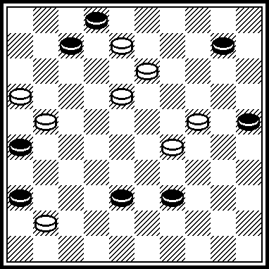

P153 P154 P155 P156
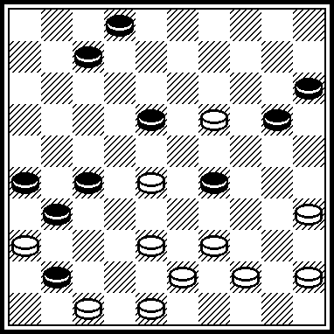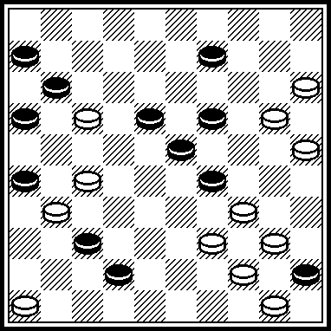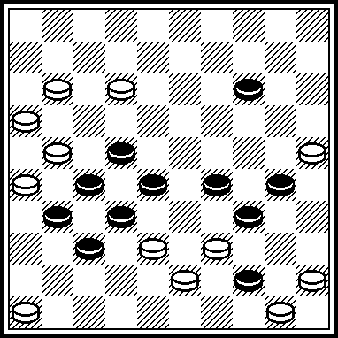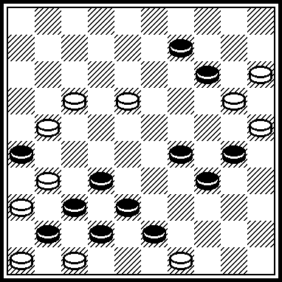

P145
VP: 27!, 22, 4(39) 15(24 A) 40(34 B) 44, 50. A(33) 38(44) 40. B(33) 38.
Published in “Horizonty shashek”, 4/2005.

P146
VP: 18, 3, 48(37) 31(46) 28, 5.
Published in “Horizonty shashek”, 4/2005.

P147
VP: 21, 14, 45, 5, 19!.
Published in “Horizonty shashek”, 4/2005.

P148
VP: 4, 31, 41, 4:18:34:48:31!(2413 A) 4(24 a) 3!(37 B C) 14(42) 19, 48. A(0213) 43, 34. a(13) 43/48. B(29) 8, 24. C(38) 20(30) 42(34) 13(39 D) 20. D(20) 15(39) 30(44) 39.

P149
VP: 38!(42 A) 37(31) 44(38) 40, 3, 3:26:42:20:9:22:50. A(42) 3, 35(47) 26, etc.+. Legality: 21, 37, 11, 42, 8, 48, 43, 45, 50/
26, 31, 7, 33, 39, 29, 14, 34 , 40. – 12(18).

P150
VP: 3429(2543) 4137(39) 6, 38, 1.

P151
VP: 3530!(22 A) 33, 9, 44, 3!(36 B C D) 3х21х43х25х14. A(42) 29!, 48. B(25) 40/45. C(18) 3:25:43:27:36!(23) 22(29) 39(7) 6!(34) 1.
D(24) 3:21:43:30:13:36.

P152
VP: 11!(6 A) 3, 1308, 2120, 15, 1. A(27) 3, 2420, 21!, 3(31) 26(36) 37(15) 13(20) 9(24) 4!(29 B) 15(34) 29. B(30) 18. Legality: 8, 13, 14, 16, 17, 18, 21, 22, 23, 24, 29, 41/ 2, 6, 7, 25, 26, 36, 38, 39. – 1711(0610)

P153
VP: 4742!(46 A) 14, 37, 28, 1(2, 37) 30(25) 24(20, 30) 10(34) 4(42 B) 37(39) 27(44) 3732 ! B(39) 3631, 22(31) 44/50(37) 28. A(47) 37!, 42, 1, etc.+.

P154
VP: 10!, 41, 5, 21, 2014(20 A) 14, 11!, 41, 39, 37. A(10) 11!, 41, 39, 37(14) 32(19) 28(24) 23.

P155
VP: 1107, 11, 38(43) 41, 39, 32(23) 8, 2, 48(19) 34, 34(23) 29, 44.

P156
VP: 10, 13, 12, 14, 4639, 3(3237 A) 42!(3748) 31, 10, 26. A(48) 31, 43.

P157 P158 P159 P160
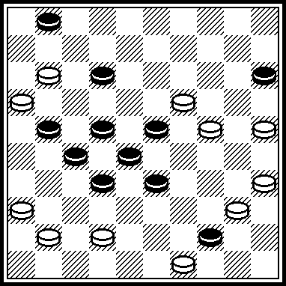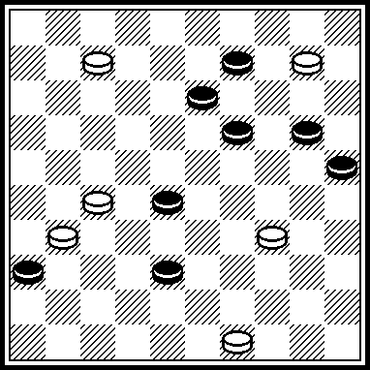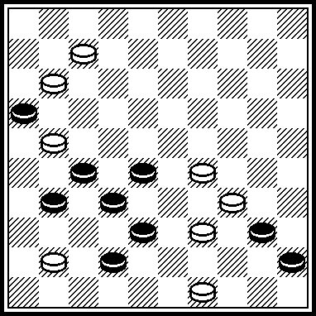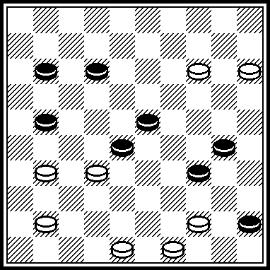

P161 P162 P163 P164
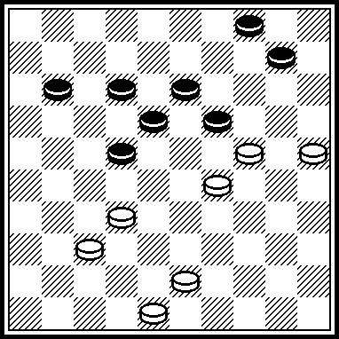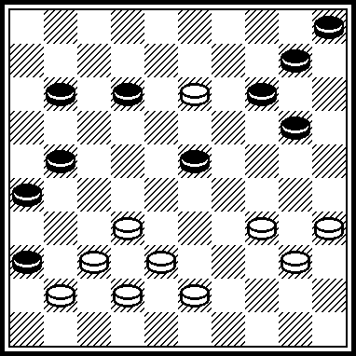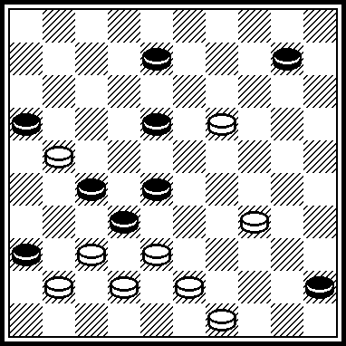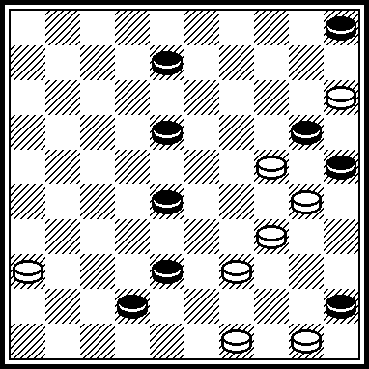

P165 P166 P167 P168
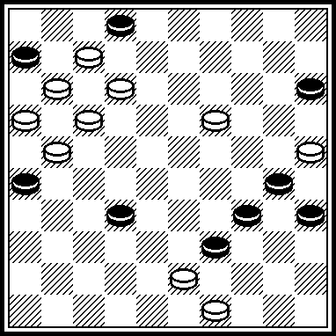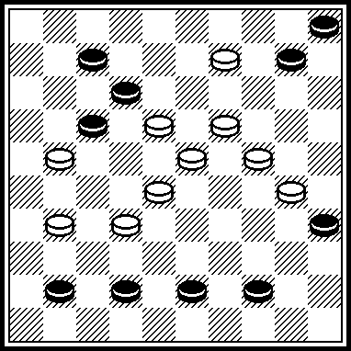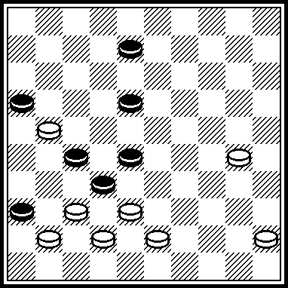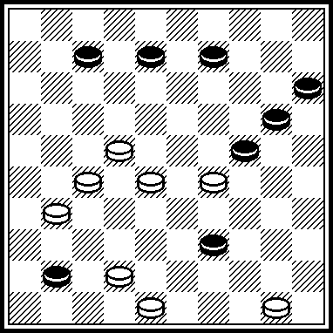

P157
VP: 30, 43, 39, 38, 31, 7(12 A) 6, 1, 10, 14. A(20) 2, 10, 14.

P158
VP: 43, 2(21 A) 30!, 5, 32, 16. A(16) 5, 21, 35.

P159
VP: 44, 37, 43, 29(44 A) 1, 50. A(50) 1, 6, 50.

P160
VP: 3127, 40(5 A) 10, 34, 44, 39. A(34) 1510(28) 5, 44.

P161
VP: 23, 5(27, 49) 32(21, 13) 43.

P162
VP: 31!, 4, 28!, 10, 34.

P163
VP: 31, 2, 37!(40 A) 44, 8, 14, 50x. A(13) 5, 46(50) 29.

P164
VP: 43!, 3, 10, 31!, 39, 27, 27.

P165
VP: 8, 2, 43, 1107, 20, 40, 12!, 7, 7(11, 20) 11.

P166
VP: 14, 4, 14, 19, 1410, 19!, 1(32 A) 29(37) 47. A(33) 34(38) 48.

P167
VP: 31, 2, 37!, 40, 11, 4.

P168
VP: 21, 43, 4, 47(24, 24) 44.

P169 P170 P171 P172
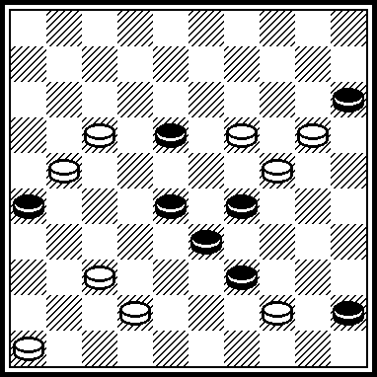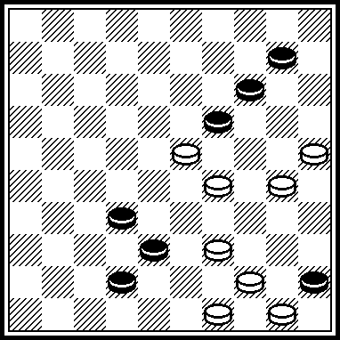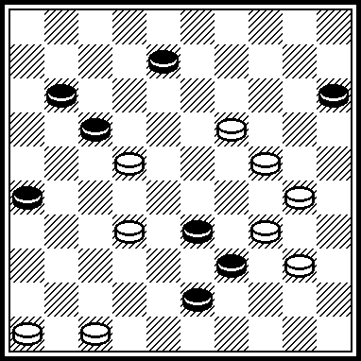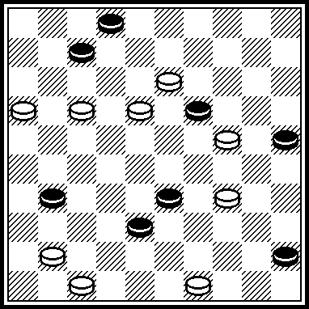

P173 P174
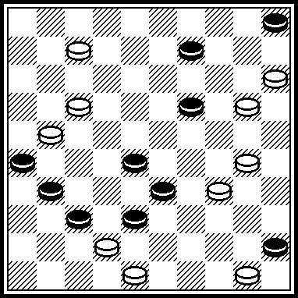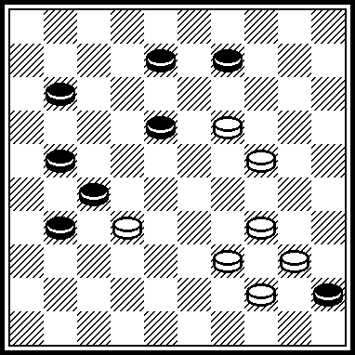

P169
VP: 12!, 38, 242, 26(50) 37, 37.

P170
VP: 40!, 20, 5, 39(42) 43(47) 38, 39x

P171
VP: 20(44) 13(37) 2, 31, 4741, 37, 41.

P172
VP: 1611, 8!, 2, 30, 37, 40, 44.

P173
VP: 10, 43!, 3, 12, 40, 44,

P174
VP: 14, 3, 6, 33!, 39.

The remark:
There are kept author’s commets, author’s quotes etc., Author’s variants are indicated in short notation.
The remark of A. Uvarov to his positions:
“All compositions are the patent of author. A reprint is forbidden for all kind so mass-media, including electronically, without the author’s permission with the indication of the source: “Ukraine championship-2009.”

Authors of positions:

P001-P008: S. Ustianov
P009-P016: A. Maslov
P017-P024: M. Levandovskij
P025-P032: N. Shapoval (Donetsk)
P033-P040: I. Ivatsko
P041-P048: A. Nych
P049-P056: A. Uvarov
P057-P064: I. Kobtsev
P065-P072: S. Reznikov
P073-P080: V. Muliar
P081-P088: V. Pokhil
P089-P096: I. Vlasov
P097-P104: N. Romanik
P105-P112: S. Darchenko
P113-P120: V. Nesterenko
P121-P128: M. Fedorov
P129-P136: V. Trinos
P137-P144: B. Fedorov
P145-P152: A. Katukha
P153-P160: V. Nikitchuk
P161-P168: A. Balanuk
P169-P174: L. Nesterenko

The judge of the “Problems” category is S. Yushkevitch (Ukraine),
International Grand Master of draughts composition.

15.01.2010.

