Championship

for draughts composition

The “Miniatures” category

White to move and win in all positions.
There are kept author’s commets, author’s quotes etc.,
A score obtained earlier in another contest, if any, is indicated at the 100-point’s scale.
The championship is run under the International Rules of problemism at the Rules of Base level, paragraph 1.17.1.:
1.17.1. Rules of Base.
A problem satisfies the RB, if:
- the Initial position is legal (1.3.);
- in the Initial position equal pieces number of each color is present or a Black advantage is at most two pieces (a White advantage is not limited);
- the Problem has a solution (1.7.);
- the author’s solution is the only solution (1.8.);
- there is no type of the Dual (1.9.-1.9.5.) on the first move of the solution.

M001 M002 M003 M004
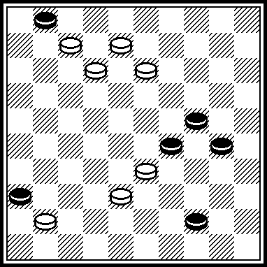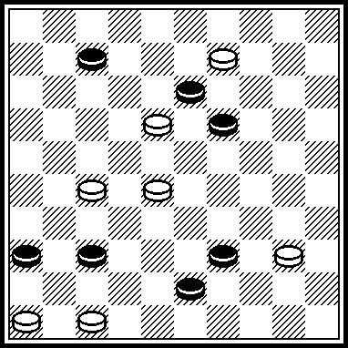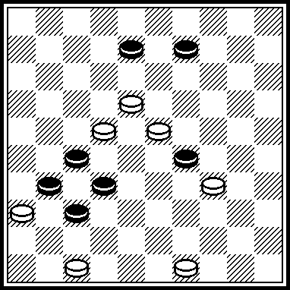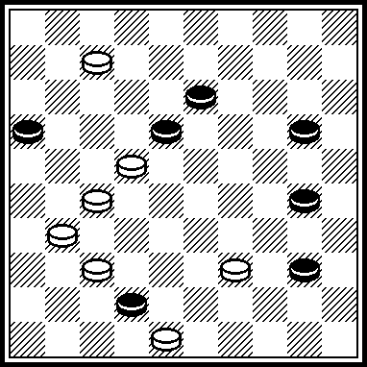

M005 M006 M007 M008
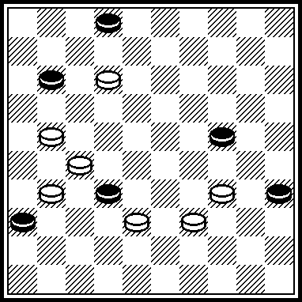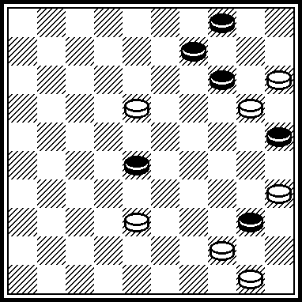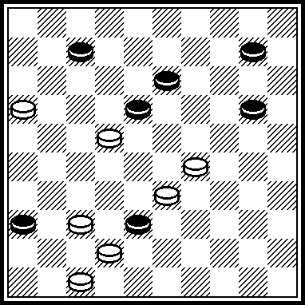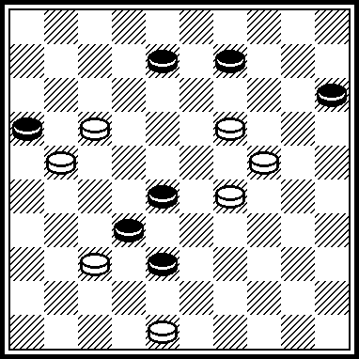

M009 M010 M011 M012
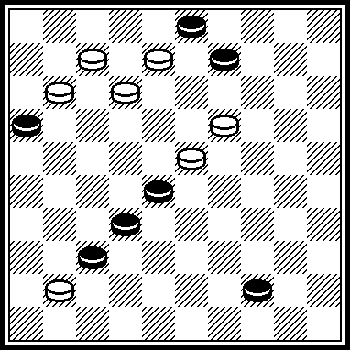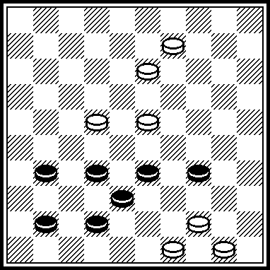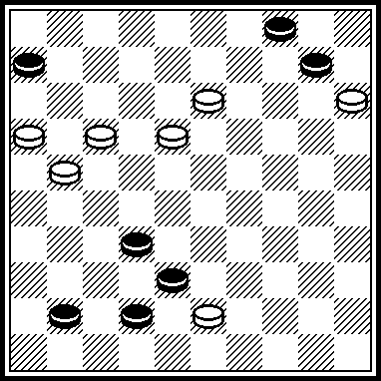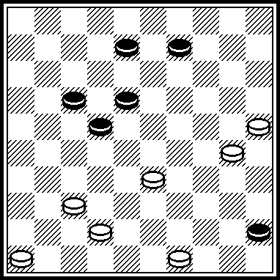

M001
VP: 28, 23, 3(33 A) 50(3306) 2(29) 1207, 11(17) 6(34) 1(40) 45. A(29) 50(47) 33, 2, 11(29 B) 39(7) 6(34) 1(40) 45. B(30) 39(35) 34(6) 7(11, 40) 11, 50.
M001 was scored in PWC with 139 points (57+82).

M002
VP: 34(33 A) 4, 4741, 41(13 B C D) 3 (35 E) 24(40) 33(45) 50. A(31) 3, 4641, 26, 1. B(18) 35. C(9) 436, 47242, 1647. D(4722) 49. E(24) 7(29) 25. M002 was scored in “Lietuva-2006” PWC with 68 points (59+73+70).

M003
VP: 12, 3(41 A a) 21, 28(46) 41, 38(21) 32(26) 27. A(42, 43, 37) 31(36) 14(3641) 32, 46. a (38) 26. M003 was scored in PWCP-2 with 53,75 points (50+55+55).

M004
VP: 34(29 A) 21(1836 B) 1(27 C) 31, 31, 37. A(39) 21(1836 D) 2(27 E) 15, 10(32, 41) 37, 42. B(1636) 1(27) 31, 37. C(31) 18, 23(32, 41) 37, 42. D(1636) 2, 15, 10(32, 41) 37, 42. E(31) 15, 10(32, 41) 37, 42.
M004 was scored in “Lietuva-2006” PWC with 30,5 points (0+61+0)

M005
VP: 8(13 A) 17, 30, 6(40 B) 1(45) I 6(31) 3933(36) 28(41) 22. A(43, 13) 27, 9, 4(29) 31, 22(45) 50(40) 43(44, 50) 39. B(31) 1(36) 23(40, 41) 34(46 C) 32. C(47) 33. I 3933? (32)=. M005 was scored in PWCP-2 with 53,75 points (50+55+55).
M006
VP: 39(44) 3933, 30, 10, 13, 33, 10(33 A) 4(23) 10(29) 15(34) 38(40) 33(45) 50. A(32) 4(23) 15(37) 10(42) 48. M006 participated in “Respublika Belarus” contest 2007 г.

M007
VP: 23(27 a b) 11, 2(32 A) 4(41) 31, 36(32) 37, 47. A(22) 4(28, 27) 31, 38. a(1829) 4. b(3829) 1. M007 was scored in PWCP-2 with 57,65 points (58+57+55).

M008
VP: 13, 12, 8, 42, 3(20 A) 47. A(24) 347, 22, 25.
Published in “Ladia”, 2006 year.

M009
VP: 14, 1, 16(46) 21, 5.

M010
VP: 40, 43, 44, 4, 50.

M011
VР: 171, 9, 4, 27, 27.

M012
VP: 44(50) 28, 23, 41, 31, 24, 32.
M007 was scored in “FMJD-98” contest with 42,8 points.

M013 M014 M015 M016
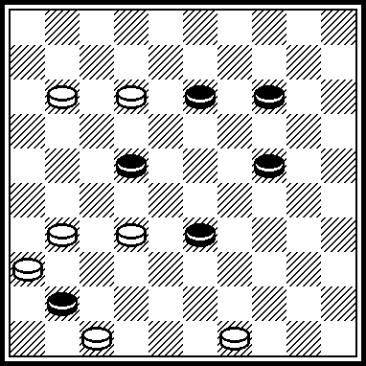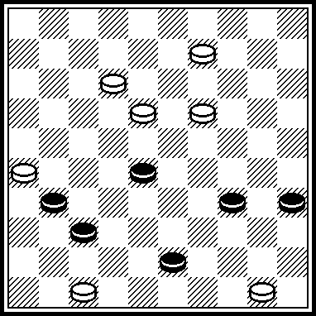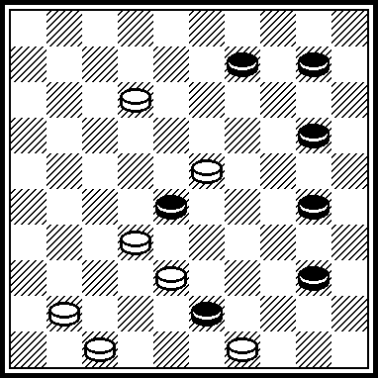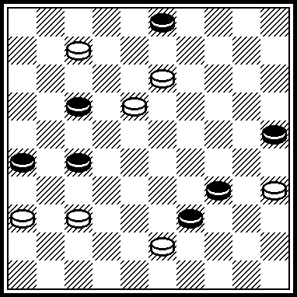

M017 M018 M019 M020
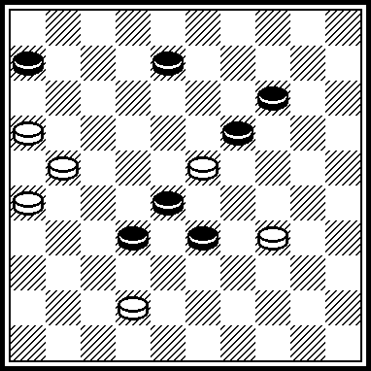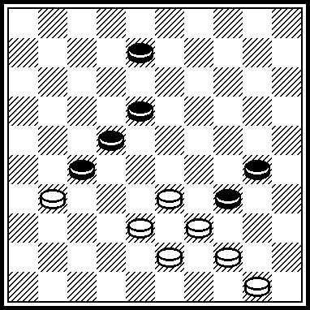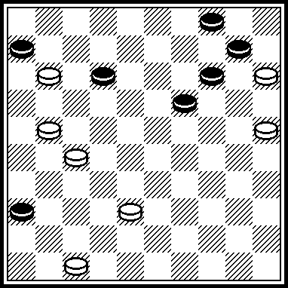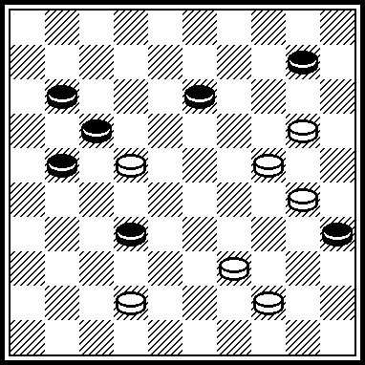

M21 M022 M023 M024
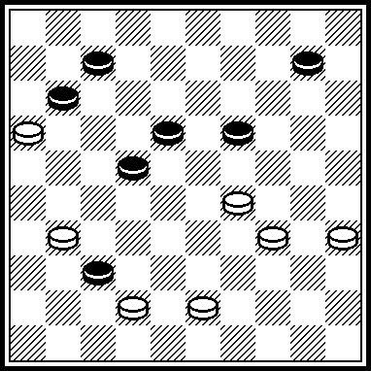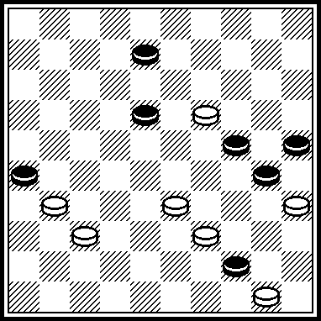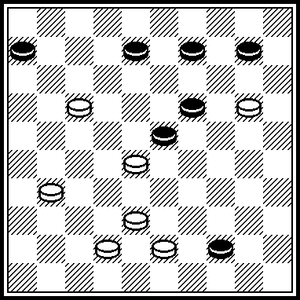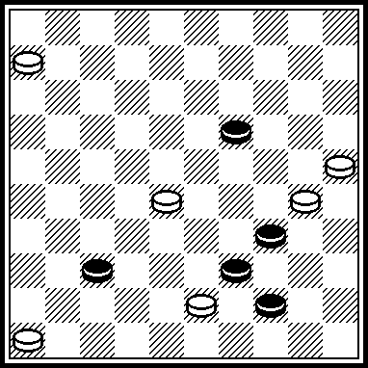

M013
VP: 3127, 27(46) 42, 38, 18.

M014
VP: 42, 37, 40, 48.
M014 was scored in “Lietuva-2003” contest with 79,5 points.

M015
VP: 8, 44, 13, 49.
Published in “ De Problemist ”, April 2004.

M016
VP: 1, 8, 45, 30, 32.

M017
I 29, 11, 3(37 А) 22, 31(22) 27, 37. А(38) 22, 33(22) 21. I 11?, 3(328) 43(39) 20, 47(24, 41)=.
M017 was scored in championship of Belarus-1998 with 82,5 оч.

M018
28, 2(47) 35(40) 24, 42, 39.
Published in “Dе Problemist”, # 1, 1997 year.

M019
20, 9, 4(41) 1(46) 32(28) 6(2823) 41, 21, 5.
Published in “Shashechnyj mir”, #6, 1997 year. In “Shashechnyj mir”, # 1, 1998) E.Zubov wrote: “Black King is mated. If it is new, then it is excellently!”

M020
15, 4(38) 7, 45(15) 440, 24, 32(39) 49. M020 took3-4 places in “Lietuva-2001”.

M021
293, 1(27) 13, 7(41 А) 2(47 В) 29, 5. А(14) 9, 2(41) 8, 46. В(14) 9, 8, 46.
M021 took 2-3 places in “Lietuva-2003”.

M022
32, 2(13) 0224(19) 30, 48(24) 43(30) 39(35) 34.
M022 was scored in championship of Novopolotsk-2008 with 70 points.

M023
15, 2(49) 35(37) 26, 44(3) 17, 17. M023 was scored in championship of Belarus-1998 with 82,5 оч.

M024
41(46) 1(48 А) 50, 34, 34(23) 29, 44. А(23) 49, 43(39) 24, 43. M024 took 3 place in PWCP-2. Legality: 19, 26, 34, 39, 44/ 6, 25, 28, 30, 31, 46, 48: 43(37)

M025 M026 M027 M028
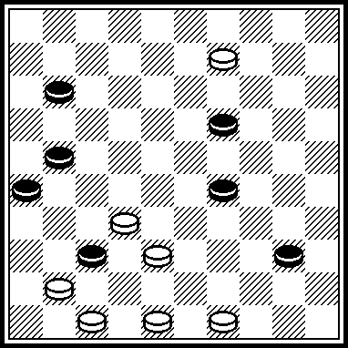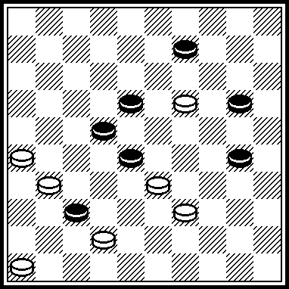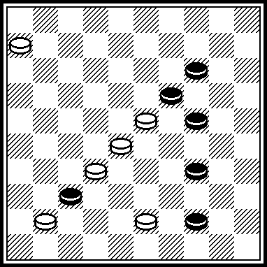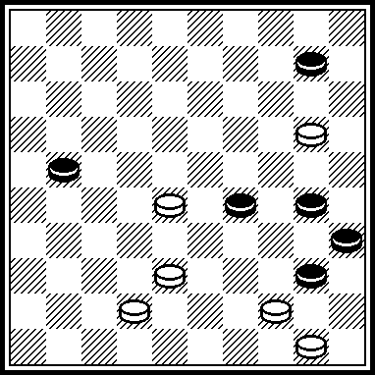

M029 M030 M031 M032
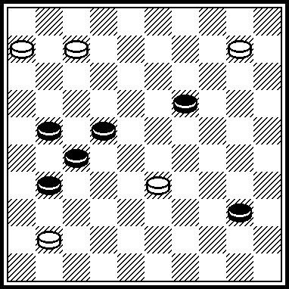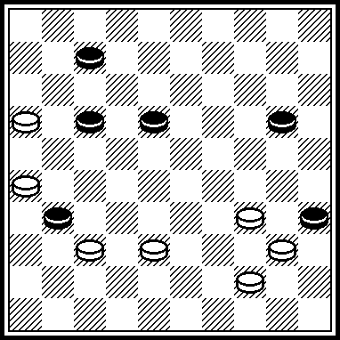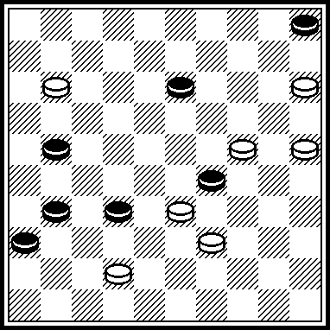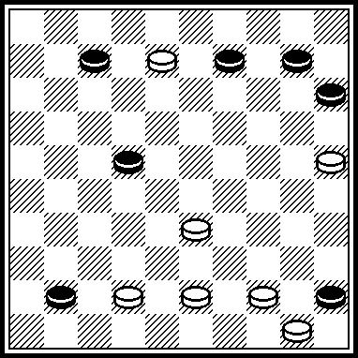

M033 M034 M035 M036
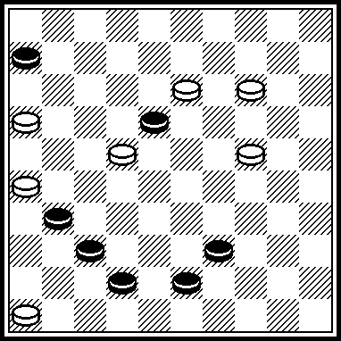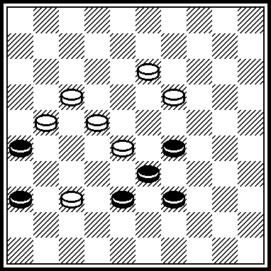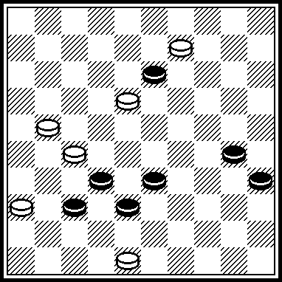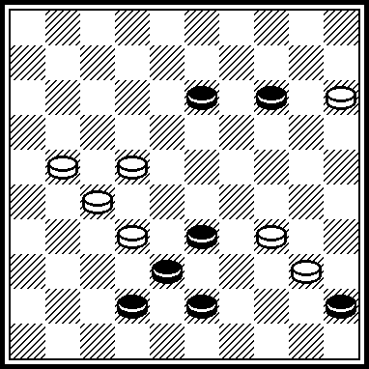

M025
VP: 36, 31, 44, 3(32) 16(46 A) 32, 41, 37. A(37) 4742.
Published in “Shashechnyj mir”, # 1, 1998 year.

M026
VP: 13, 4, 29, 14, 37, 37.
M026 took 2-4 places in “FFJD-2006” contest.

M027
VP: 1, 39(22) 18, 5. M027 was scored in “Novopolotsk-2008” with 70 points.

M028
VP: 32, 15, 4(49) 23, 16(4940) 44, 38, 25, 33, 50.

M029
VP: 5(36) 26, 31, 45.

M030
VP: 21, 1(39) 15(50) 38, 49, 40, 45, 11, 50.
Published in “Shashechnyj mir”, # 1, 2001 year.

M031
VP: 7, 2, 3(47) 33(20) 14(41) 8(47) 1410, 24. Published in “Shashechnyj mir”, # 4/6, 2003 year.
M032
VP: 37, 2(28) 38, 39(34) 2520, 40, 44.
Participated in “Lietuva-2001”

M033
VP: 11, 41, 34, 39.
M033 was scored in championship of Novopolotsk -2004 with 50 points.

M034
VP: 31, 14, 3, 16.
M034 was scored in championship of Novopolotsk -2004 with 50 points.

M035
VP: 31, 3, 25(40) 39(43) 34, 39.
M035 took 8 place in “Retro”-contest 2004 year.

M036
VP: 29, 18, 10, 26.
M036 was scored in championship of Novopolotsk -2004 with 50 5,5 очков.

M037 M038 M039 M040
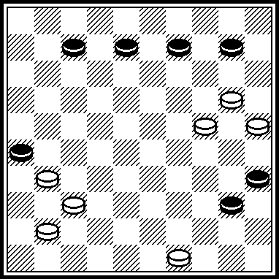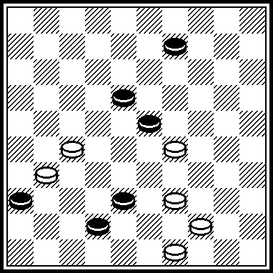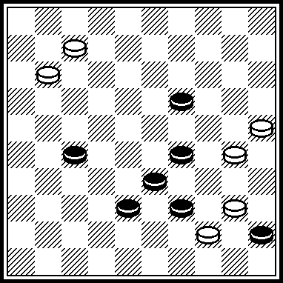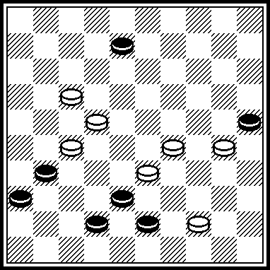

M041 M042 M043 M044
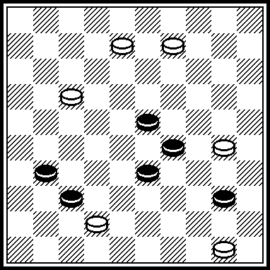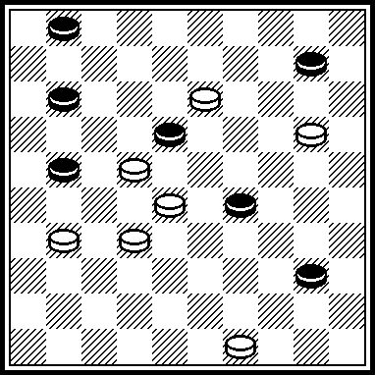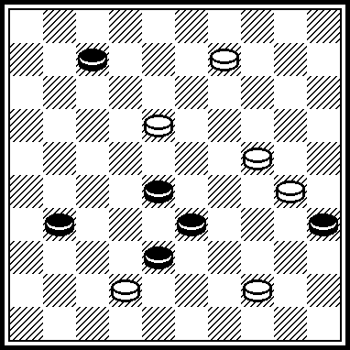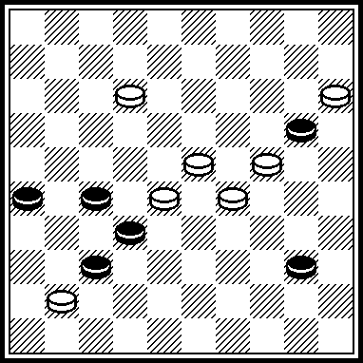

M045 M046 M047 M048
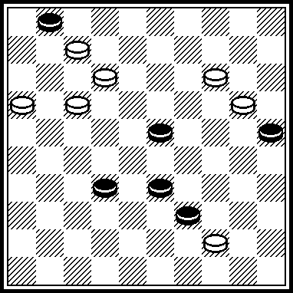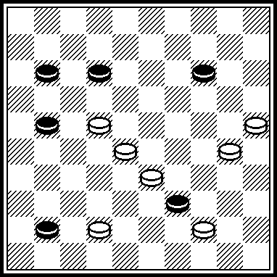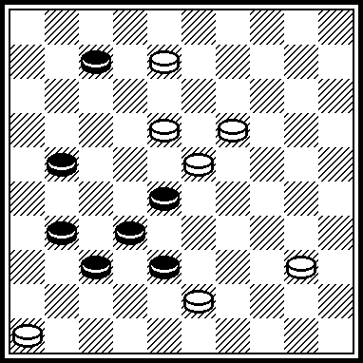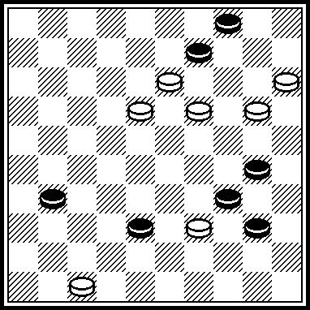

M037
VP: 44, 32, 15, 1(31) 4(37) 31, 18.
Participated in PWCP-2.

M038
VP: 43, 22, 4, 45.
Participated in PWCP-2.

M039
VP: 34, 24, 21, 2, 50.
Participated in PWCP-2.

M040
VP: 23, 2, 49, 39, 47.
Participated in FFJD-2008.

M041
VP: 45(48) 34, 0803, 0312, 1226, 2645.

M042
VP: 3127, 7, 17, 23, 44, 15, 31.
M043
VP: 4, 39, 15, 36, 12, 49.

M044
VP: 18, 21, 13, 44.
3-time of majority.

M045
VP: 9, 8, 18, 33.
3-time of majority.

M046
VP: 20, 37, 40, 27.
3-time of majority.

M047
VP: 12, 2, 41, 26, 5.

M048
VP: 10, 4, 19, 37, 49.

M049 M050 M051 M052
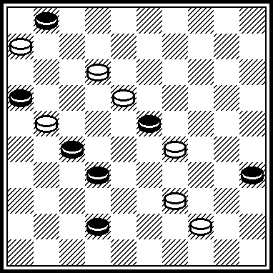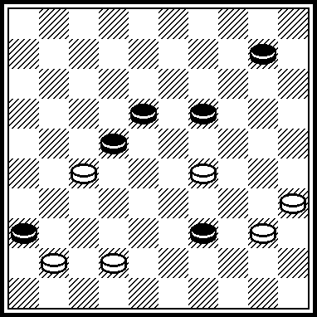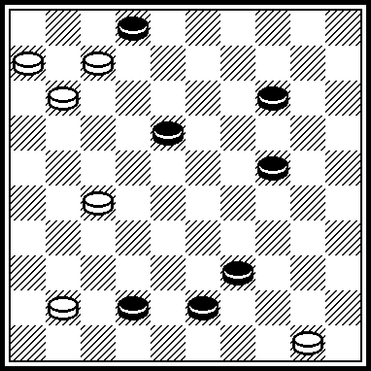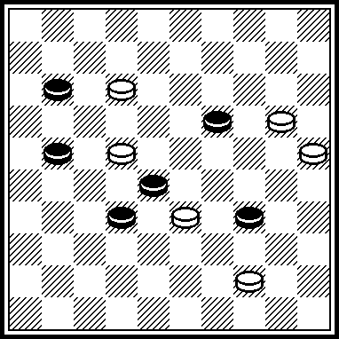

M053 M054 M055 M056
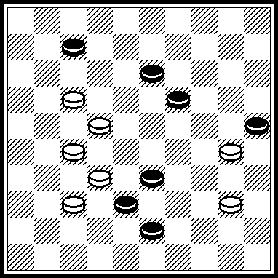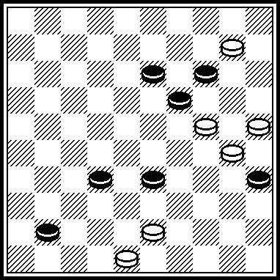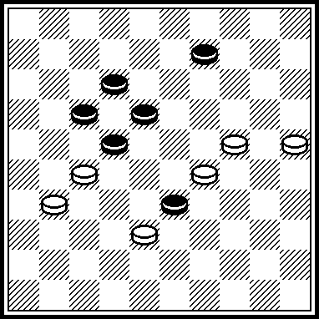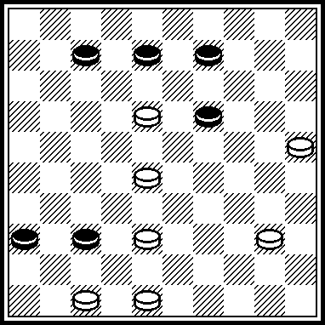

M057 M058 M059 M060
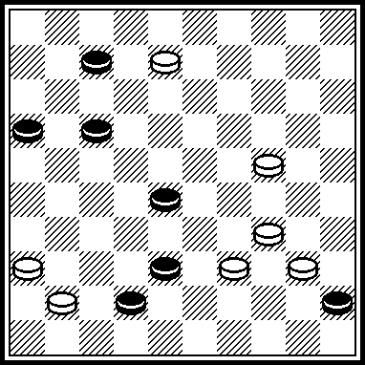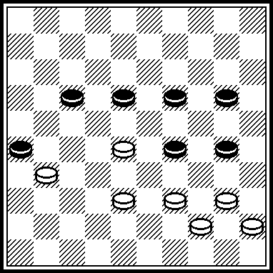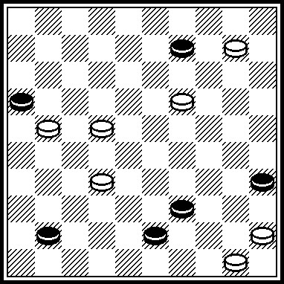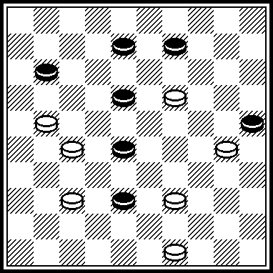

M049
VP: 7, 40, 1, 50(32) 33, 42.

M050
VP: 23, 5, 23, 34, 42.

M051
VP: 44, 0601, 22, 6, 5.

M052
VP: 8, 2, 8, 14, 14.

M053
VP: 18, 11, 2, 50.

M054
VP: 20, 4, 4:36:40, 38, 50.

M055
VP: 21, 23, 3, 47.

M056
VP: 4842, 41, 23, 1, 34, 34.

M057
VP: 33, 3, 11, 37, 27(12 a) 22. A(11) 21\22(16) 17.

M058
VP: 4034, 34, 21, 27.

M059
VP: 13, 40, 4, 33, 48.

M060
VP: 17, 14, 32, 47.

M061 M062 M063 M064
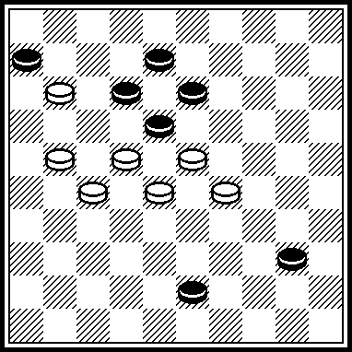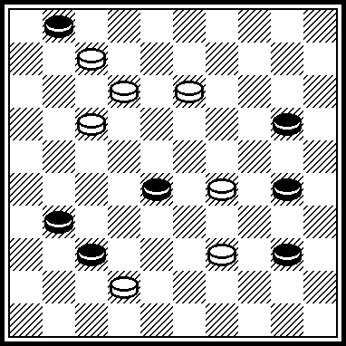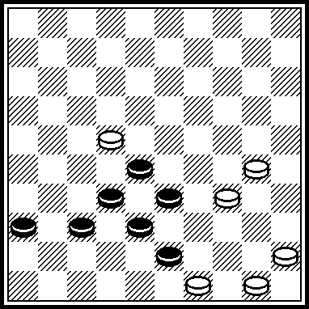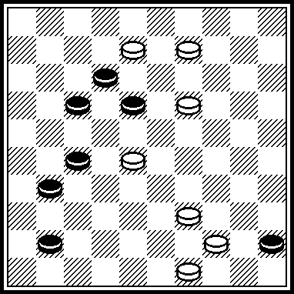

M065 M066 M067 M068
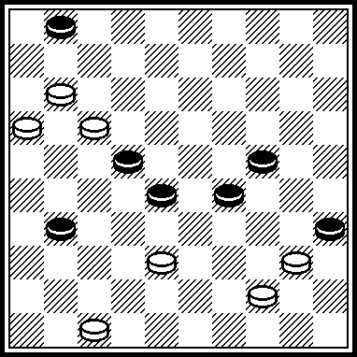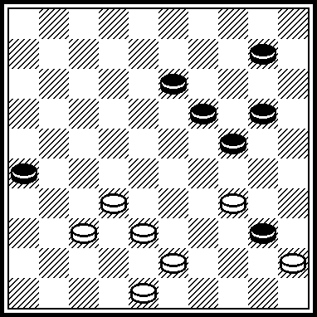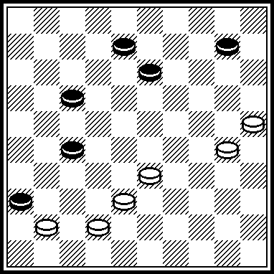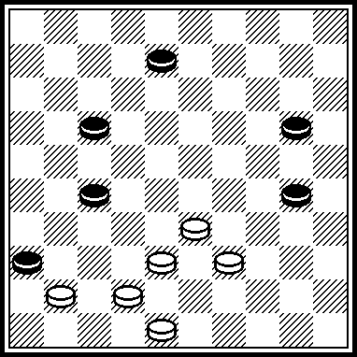

M069 M070 M071 M072
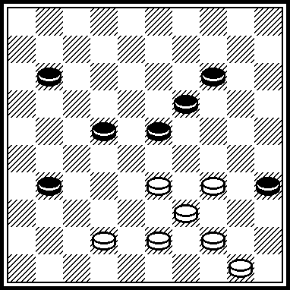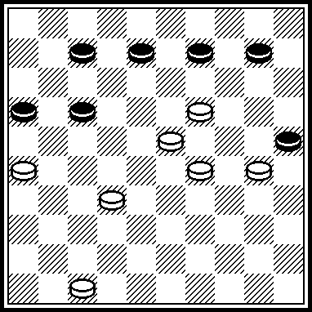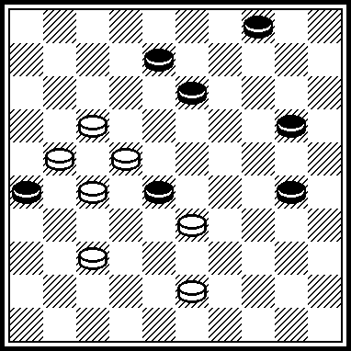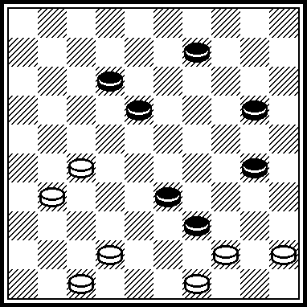

M061
VP: 2117, 3, 8, 35(39) 49.

M062
VP: 24, 3, 26!, 25(34) 39, 45.

M063
VP: 29, 31, 38, 40, 48(32 A) 42. A(31) 42(36) 37.

M064
VP: 23, 32, 28, 40, 47.

M065
VP: 6, 7, 1(283) 36 !, 38(30) 31 !(304) 39 !, 30.

M066
VP: 31 !, 32 ! (37) 42, 5(23) 32 ! (249) 16 ! (33) 2 (18) 7 (22) 16(39) 11(27) 44(32) 33(37) 47.

M067
VP: 32, 3(33) 20(39) 14, 24, 43.

M068.
VP: 32, 3(293) 34, 39, 43.

M069
VP: 30, 29(34, 35) 37, 38, 40, 6(23) 1(28) 29(32) 42(19) 15(23) 20(37) 14(29) 41(33) 32(39) 49.

M070
VP: 21, 14, 42, 4.

M071
VP: 12 !, 3, 9 !, 18.

M072
VP: 22, 41, 43, 3(18) 9(23) 14(29) 20(34) 38(39) 49.

M073 M074 M075 M076
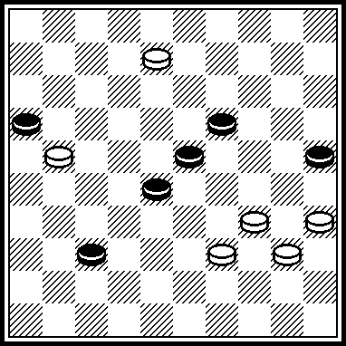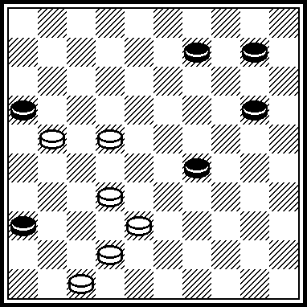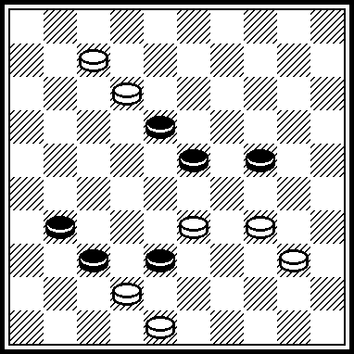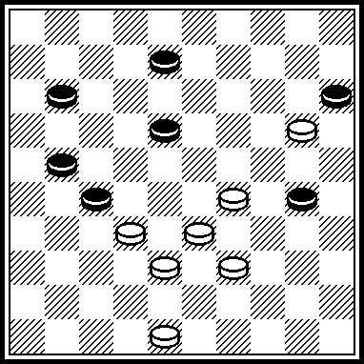

M077 M078 M079 M080
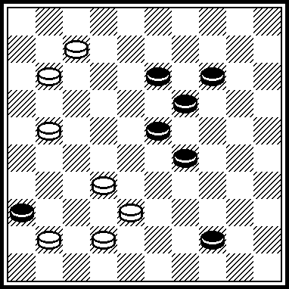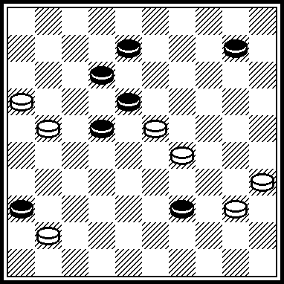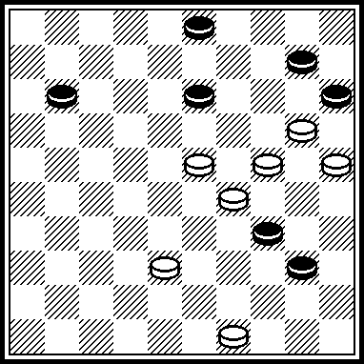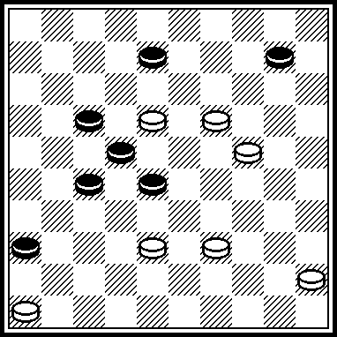

M081 M082 M083 M084
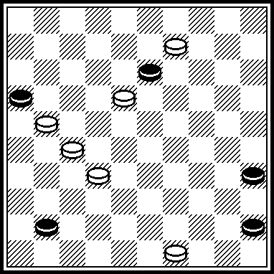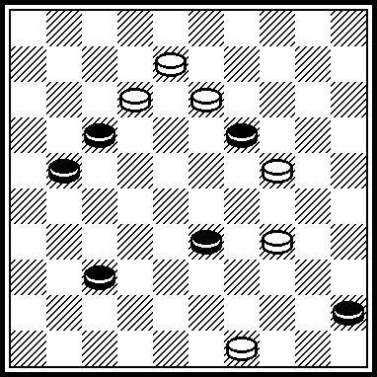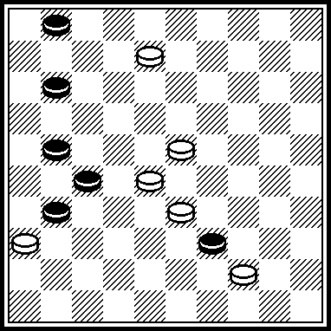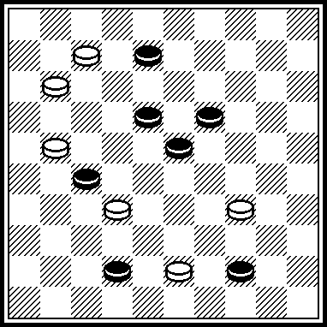

M073
VP: 3429, 3530, 0802, 0250.

M074
VP: 4741, 3833, 3331.

M075
VP: 3430, 4843, 0701, 0150.

M076
VP: 3934, 4842, 4202, 0247.

M077
VP: 3833, 3724, 0701, 0150.

M078
VP: 19, 23, 34, 33, 17, 9(12) 3(18) 17(23) 33.
Published in “Ladia-34/2006”.

M079
VP: 18, 44, 19, 16(8, A) 11(12) 6(18) 1(22) 23(27) 5(20) 14(32) 9(38) 32, 4. A(14) 11(19) 7(23) 2(28) 19(33) 24+. П-1(2329) 0213(2933) 1324(3339) 2520. П-2(0309) 0224(0914) 2433(1419) 2520, 3315.
Participated in Novopolotsk-2008 in another redaction. Participates in Novopolotsk-2009.

M080
VP: 40, 41, 14, 3(18) 17(23) 33(14) 15(28) 38(19) 15(32) 10+.
If 5…1014 6.1703+.
Legality: white 16 and 50 instead of 45. Black 6 instead of 22: 1.1611 1722 2.5045.
False solutions: I. 1813(3641!, 2832)=.
II. 1.1812 2833=.

M081
VP: 44, 40, 4(44, A), 50+. A(34) 45.

M082
VP: 2, 44, 2x24x17, 6.

M083
VP: 22, 7, 42.

M084
VP: 29, 2, 48, 50.

M085 M086 M087 M088
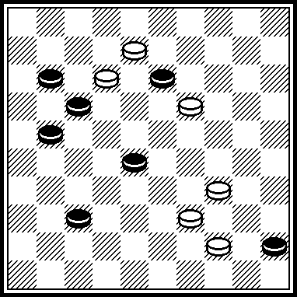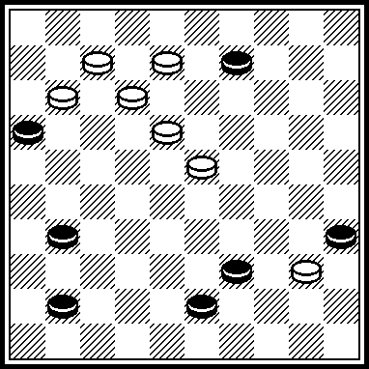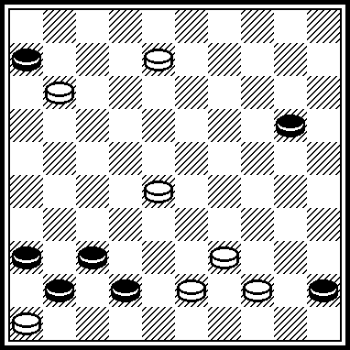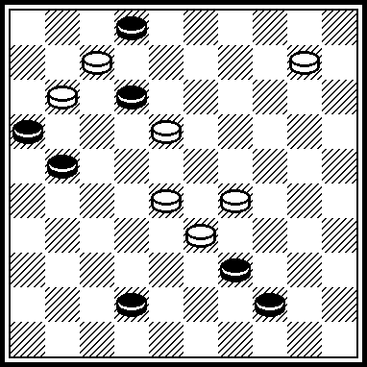

M089 M090 M091 M092
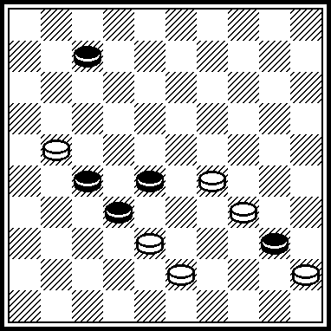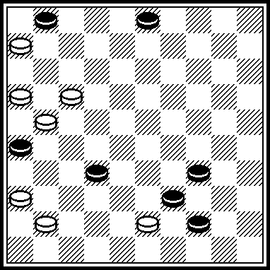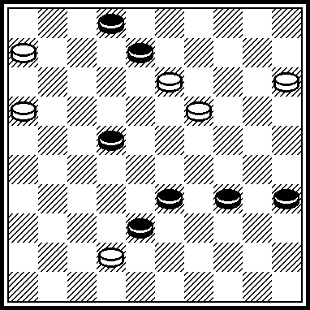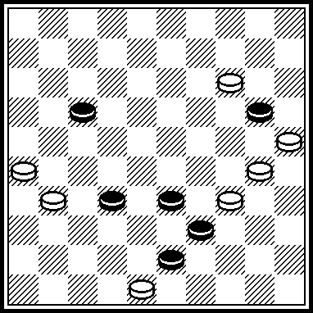

M093 M094 M095
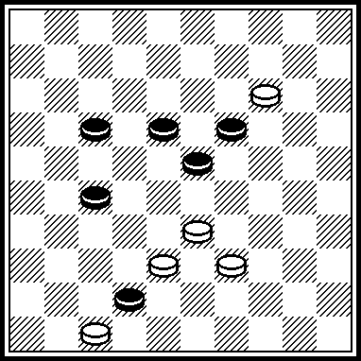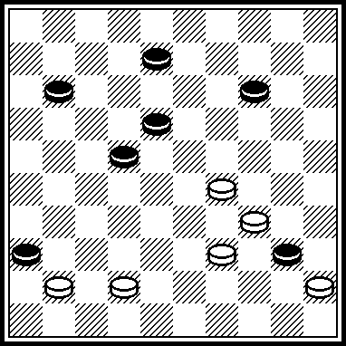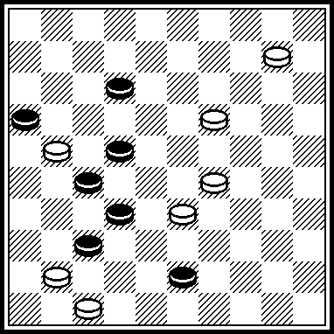

M085
VP: 33(50, A) 29, 2, 6. A(30) 2, 25, 40, 3.

M086
VP: 13, 1, 34, 2, 47.

M087
VP: 38, 40, 3, 31, 37.

M088
VP: 283, 4, 1, 8, 50.

M089
VP: 23, 39, 1(34) 34, 40.

M090
VP: 161, 7, 8, 1, 21 !, 37, 27.

M091
VP: 11, 7, 30, 2, 24, 24.

M092
VP: 21 !, 24, 28 !, 5(29) 41(33) 32(39) 49. 1.3024 3910 2.4837 2024 3.3732 A 2429 4.3127 2934 5.3228 3439 6.2721 3944 7.2112 4450 8.2823 5045 9.2318 1014 10.2621 1419 11.21161923=. A 3.2520 2415 4.3732 1520 5.3127 2024 6.2721 B 1722 7.2116 2429 8.1611 2934 9.1107 3440 10.0701 4044=. B 6.3228 2429 7.2721 2934 8.2112 3440 9.1207 4044=. Participated in “Retro-contest” 2004 year.

M093
VP: 29, 21, 27.

M094
VP: 23, 3, 6(42) 34(48) 39(26) 17, 34.

M095
VP: 4, 41, 28, 7, 16(31) 38(37) 47

M097 M098 M098 M100
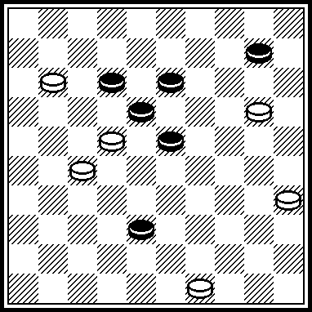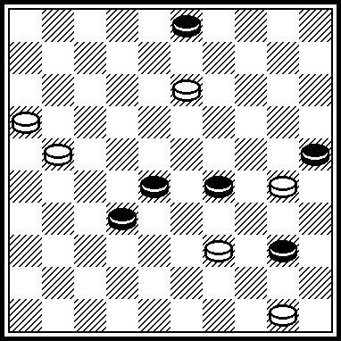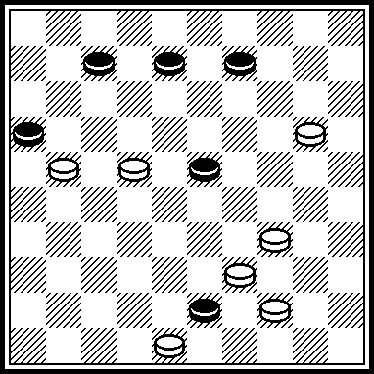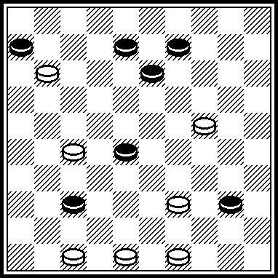

M101 M102 M103 M104
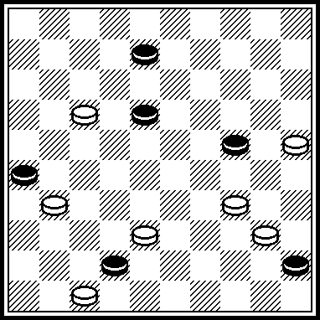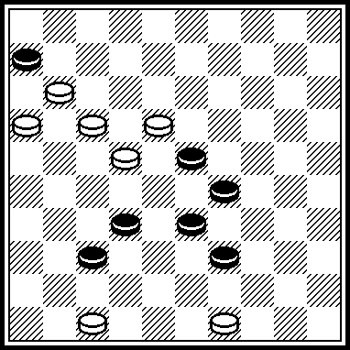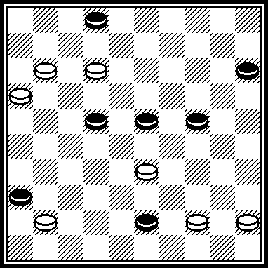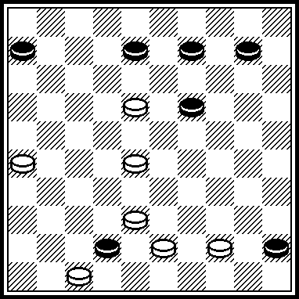

M105 M106 M107 M108
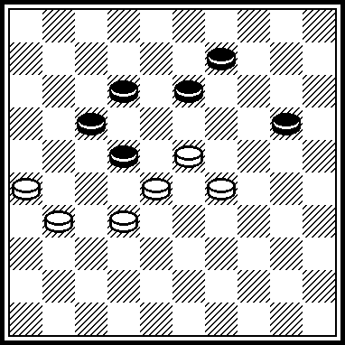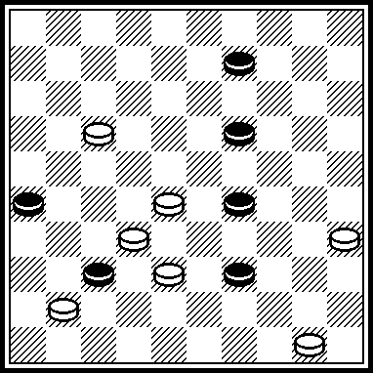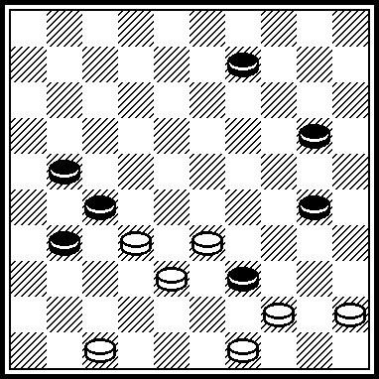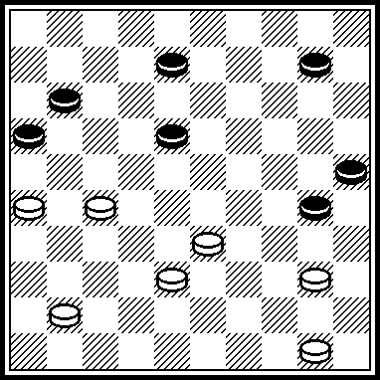

M097
VP: 43, 14(2) 5, 24, 24.

M098
VP: 8, 45, 23, 17, 49.
Published in “Horizonty shashek”-4/2007.

M099
VP: 14, 1(49) 29, 40.
Published in “Horizonty shashek”-4/2007.

M100
VP: 4843, 42, 44, 21, 43.
Published in “Horizonty shashek”-4/2007.

M101
VP: 11, 7, 42, 2, 44, 35.
Published in “Horizonty shashek”-9/2008.

M102
VP: 41, 38, 43, 38, 43.

M103
VP: 6, 11, 39, 1107, 39, 34, 34.
Published in “Horizonty shashek”-3/2007.

M104
VP: 12, 5(50) 11, 41, 37, 37.
Published in “SK-17/2009”.

M105
VP: 1.2924 2018 2.2621 1737 3.2819 3728 4.4913.

M106
VP: I 22, 18, 44, 4. I 36?(33!)=.

M107
VP: 43, 32, 3(27) 26(32) 41, 5.

M108
VP: 1.4035 3034 A 2.3530 3440. (2…3439 3.3344 2534 4.4439) 3.2621 2534 4.3329 34235.5044 4049 6.2722 4946 7.2202 16278.0205. A1…0813 2.3524 1823 3.2621 2329 4.3328 2920 5.2822.

M109 M110 M111 M112
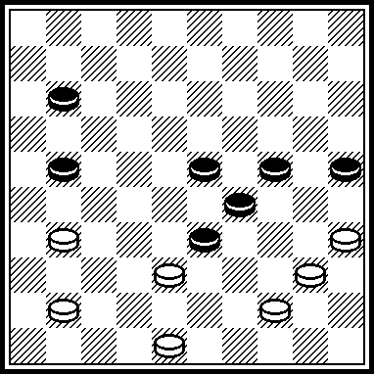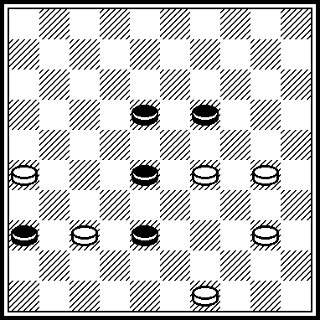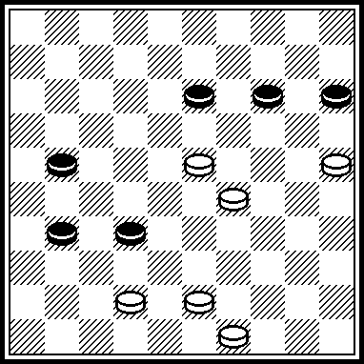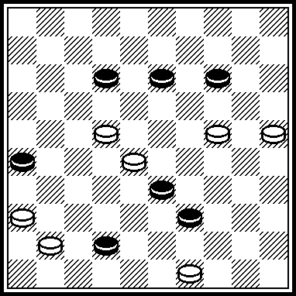

M113 M114 M115 M116
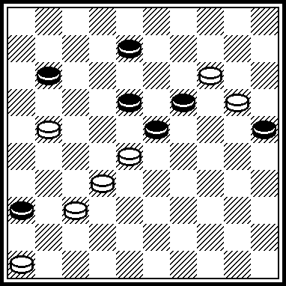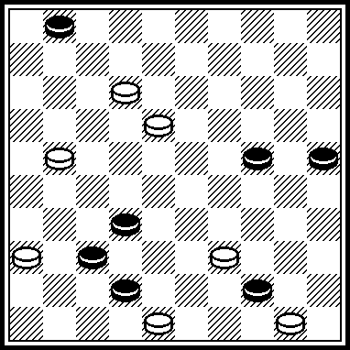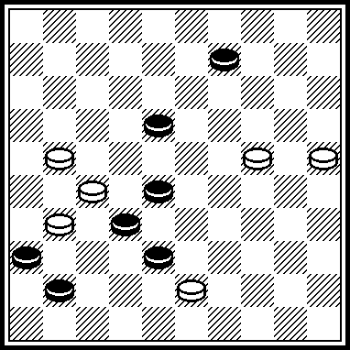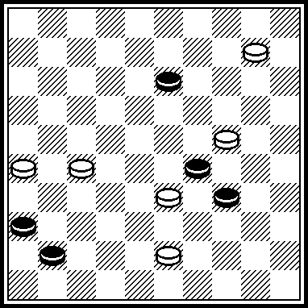

M117 M118 M119 M120
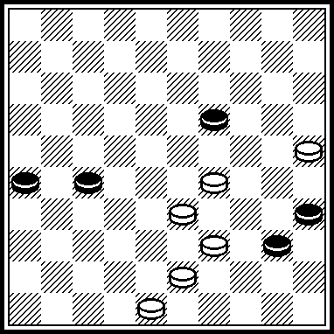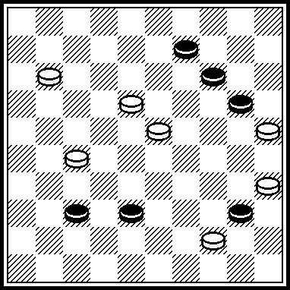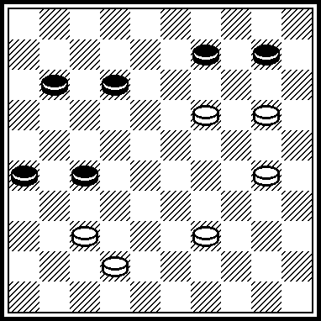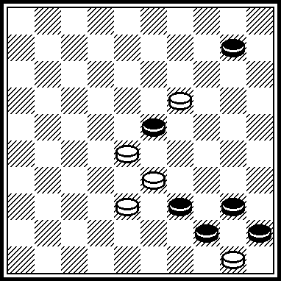

M109

VP: 1.3530 2545 2.4440 4534. (2…3342 3.4842 4534 4.3127 3132 5.3739x) 3.3127 2143 4.4839.
Published in “Ladia”, # 13, 11.07.2009.

M110
VP: I 1.4943 3849 2.2924 4935 3.2433 3531 4.2637.
I 2924?(32!)=.

M111
VP: 1.2520 1533 2.2319 ~~ 3.4338 3243 4.4909 2126. 4…3136, 5…2127 6.0904) 5.4238 3137 6.0904 3741 7.0410 4146 8.1005.

M112
VP: 18, 19, 37, 9(31) 4(37) 36(42) 43, 47.

M113
VP: 17,28, 3, 47.

M114
VP: 7, 31, 30, 48.

M115
VP: 17, 23, 3, 46.
Published in “Horizonty shashek”-12/2008.

M116
VP: 4, 40, 46.

M117
VP: 23, 31, 42, 34, 45.
Participates in 10 championship of Novopolotsk

M118
VP: 19, 3, 24, 24.
Published in “Horizonty shashek”-8/2008.

M119
VP: 31, 1914, 5, 4.

M120
VP: 14, 5, 49.

M121 M122 M123 M124
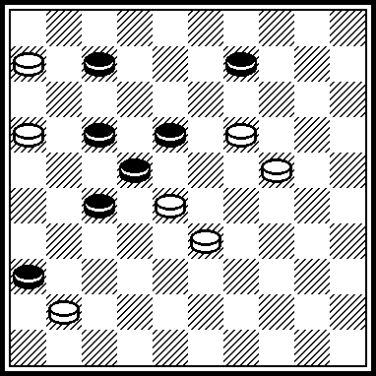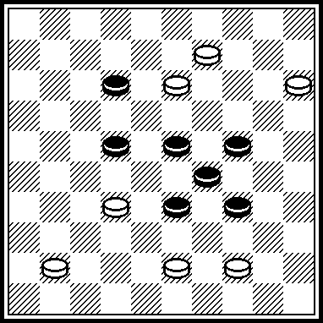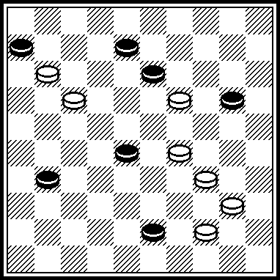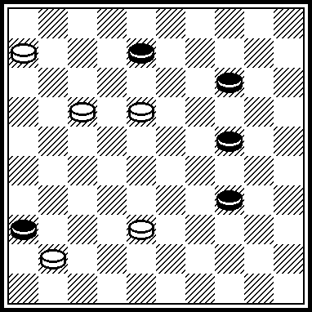

M125 M126 M127 M128
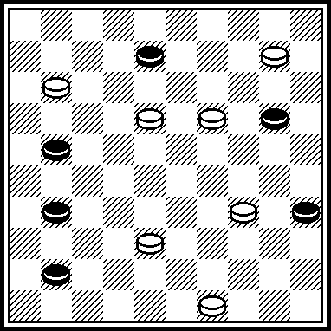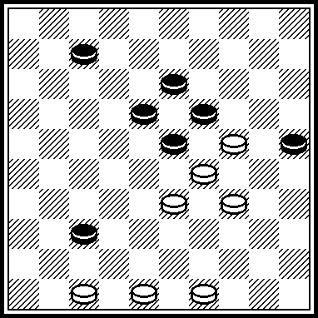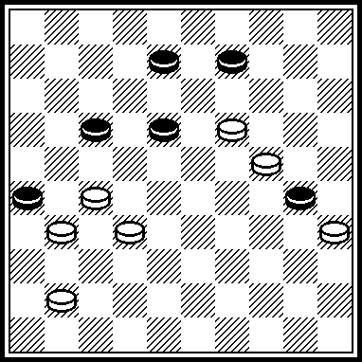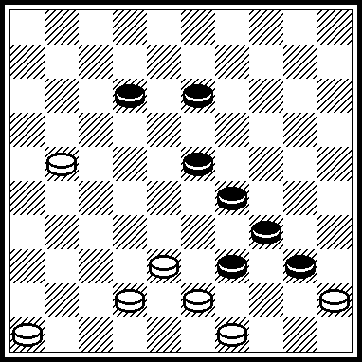

M129 M130 M131 M132
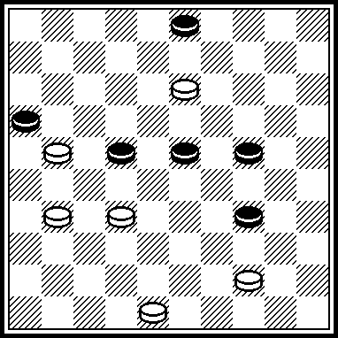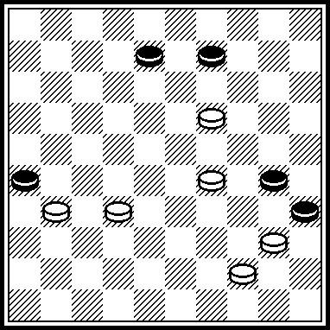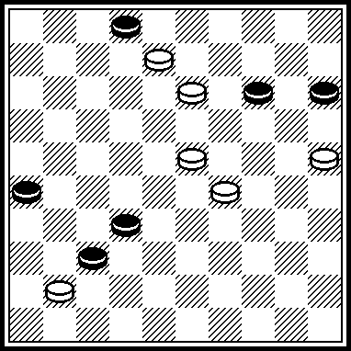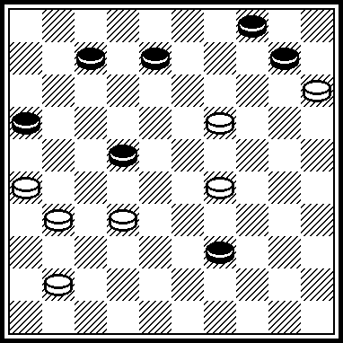

M121
VP: 11(16 A) 20!, 204(2 B) 3, 7, 17. A(47) 2(15) 1, 20x. B(8) 32, 28, 1. 3 place in “PWCP-2”, B-category.

M122
VP: 38, 37, 3(40) 0330!, 34!(4904 A) 36. A(9) 4(37) 31, 10(31) 5. 1 place in the contest “FMJD-98”

M123.
VP: 12, 3, 25(38) 29(49) 43 Z(42) 38, 35, 44. Z=48?(42) 37(38) 23(33)=.
2/4 in the contest “Lietuva-2006”..

M124.
VP: 1702 Z(47 A) 3(1 B) 45. A(17) 1, 1812!, 21(40 C) 17(45) 50. B(7) 1(39) 34, 1x. C(39) 49. Z=33, 1712(17) 1(12)=.
11 place in A-category of PWCP-2.
“I believe the judges decreased the score for my error: I did not indicate to the end the A-variant and I did not indicate the C-variant”.

M125
VP: 14, 30, 5(47) 0537!(16) 38, 38.
11 place in A-category of PWCP-2

M126
VP: 28, 8(12) 17(22) 28(30) 4943(44) 41, 39!, 50.
5 place in the contest “Lietuva-2003”.

M127
VP: 21(46) 14(28 A) 13!, 22x. A(23) 28, 30(14) 24.
18 place in the contest “FFJD-2008”, A-category.
The legality: 8, 9, 16, 17, 18, 30, 38, 39/ 19, 24, 27, 31, 35, 40, 41. – 34(161) 32(26)

M128
VP: 17, 28(44) 40(39) 33, 41, 34!, 32.
Published in the book “Fedorov Mikhail Vasilievitch” (Starobeshevo, 2008), p. 118, №4.

M129
VP: 39!(36) 17(41) 42(47) 8!.
Published in “Horizonty shashek”-4/2005.

M130.
VP: 13, 2(34 A) 39, 4. A(32) I 2924!, 24(13 B) 8!(38) 26(43) 48(49) 30, 35. B(37) 39x. I 8?(37) 3(41 II) (46)=. II(13?) 24, 20, 39.
Published in “Horizonty shashek”-4/2005.

M131
VP: 20, 3, 21!, 3.
Published in “Horizonty shashek”шек-4/2005.

M132
VP: 21(47) 27, 9, 4(19) 13.

M133 M134 M135 M136
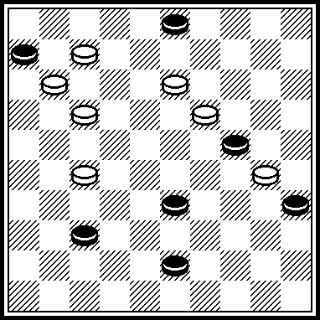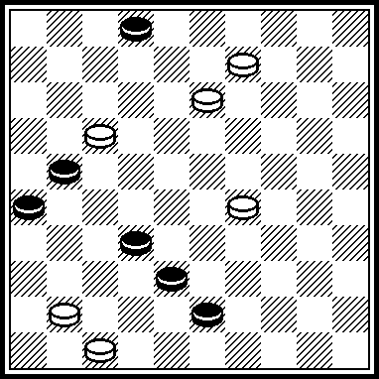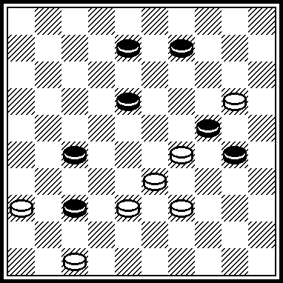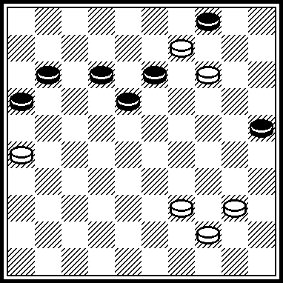

M137 M138 M139 M140
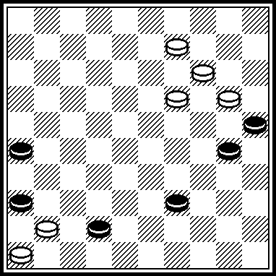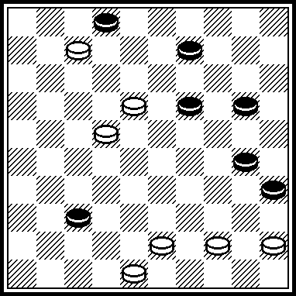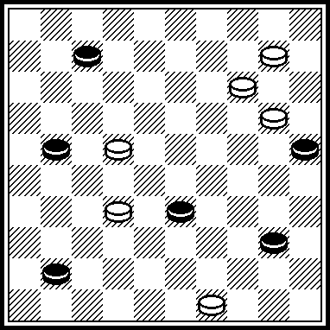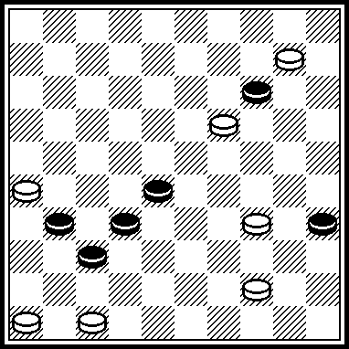

M141 M142 M143 M144
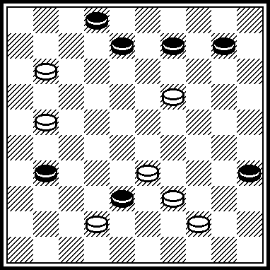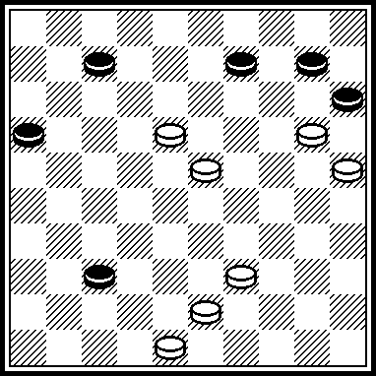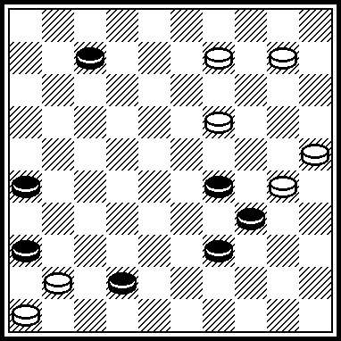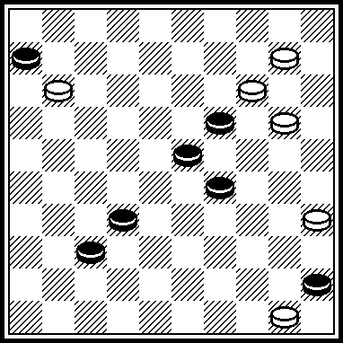

M133
VP: 8!(32) 2(13 A) 31!, 48, 38. A(17) 16, 16:38:24:8:26:48:39/34.

M134
VP: 42(36) 3, 49(41 A) 32(47 B) 21, 3.
A(8) 2(41) 32(47) 3219. B(46) 5(31 a) 8, 2923, 26x. a(7) 24!(31) 2419.

M135
VP: 31!(26 A B) 34, 14, 21, 38. A(36) 14, 32, 2, 49. B(15) 4(42) 34, 10!, 32.

M136
VP: I II 10!(15) 4!(21) 19(20) 6(24) 30(43) 4439, 50. I 3?(1217) 21(27), a draw.
II21?(27) 3(1117), a draw. If 4035, then (19) 1423(0413), a draw.

M137
VP: 13, 41, 10, 4, 25.

M138
VP: I 4439, 42, 34, 3(50) 13, 6(40, 45) 1x. I 1?(41) 38(46) 33(7, 12, 40, 50)-+.
M139
VP: 9!(5 A) 44, 4, 1(10 B) 23(15) 32(26) 37(20) 42(25) 48.
A(3) 44, 4, 1(27) 23. B(27) 23.

M140
VP: I 5, 29, 39, 46, 41, 37, 49. I 4?,36(41, 41) 4(46) 15(33) 38(28)=.

M141
VP: 34, 14, 1(36) 37(7, 40) 28.

M142
VP: 12, 14(19) 42, 34, 3.

M143
VP: 13, 41, I 20(5 A) 4, 1(10 B) 23(15) 37(20) 42(25) 48.
A(3) 4, 1(31) 23. B(31) 23.
I 4?, 48(31) 26(40)=.

M144
VP: I 44, 40, 30, 4, 15, 20x. I 7?(11) 16(34) 15(28) 23, 11(23) 5(28)=.

M145 M146 M147 M148
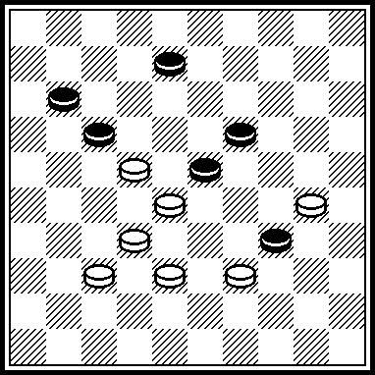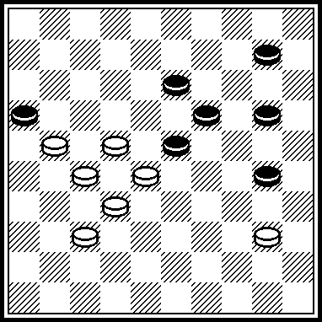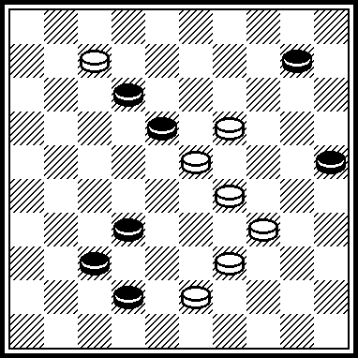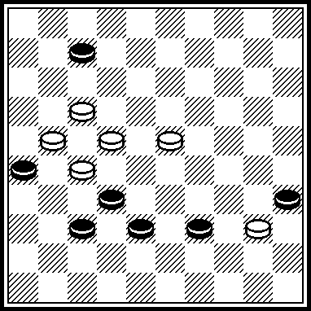

M149 M150 M151 M152
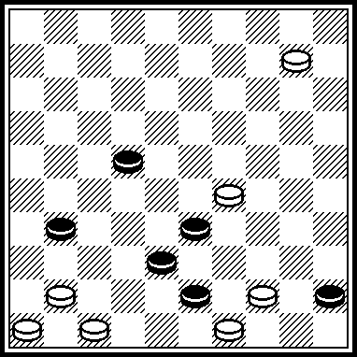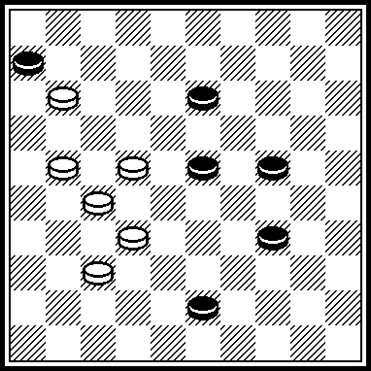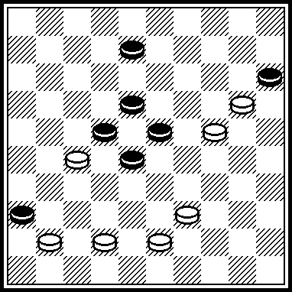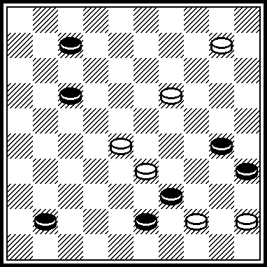

M153 M154 M155 M156
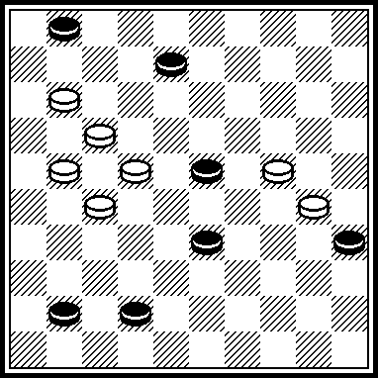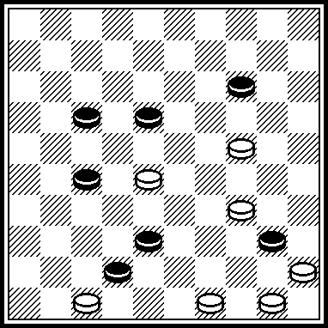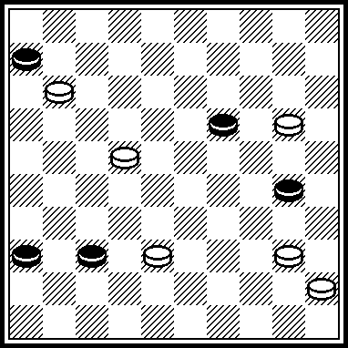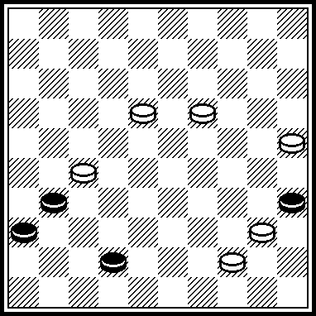

M145
VP: 27, 24, 2, 46.

M146
VP: 18, 34, 5, 48.

M147
VP: 38, 30, 1, 15, 47.

M148
VP: 12, 1, 29, 49.

M149
VP: 40, 42, 27, 5(27) 37(41) 31, 37.

M150
VP: 18, 28, 37.

M151
VP: 4338, 34, 29, 33, 2, 26.

M152
VP: 450, 22, 2, 4, 6.

M153
VP: 2419, 2218, 7, 16, 18.
M153 was scored with 55 points in “Pinsk-2009”.

M154
VP: 19, 5044, 4943, 21, 27.

M155
VP: 14, 41, 34, 25.

M156
VP: 39, 20, 47.

M157 M158 M159 M160
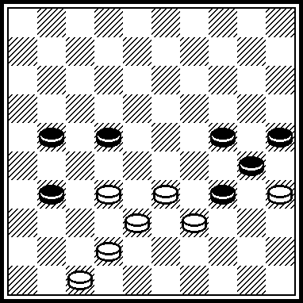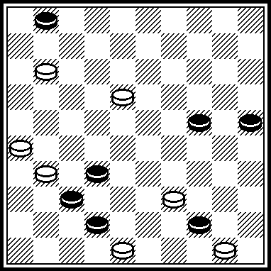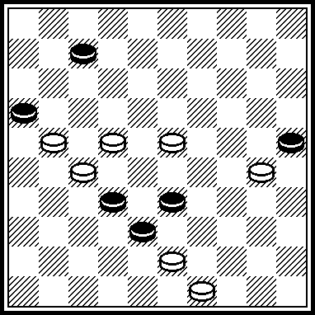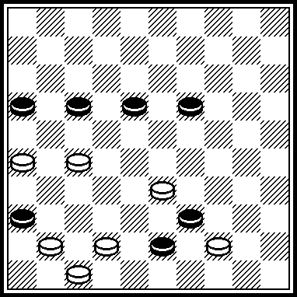

M161 M162 M163
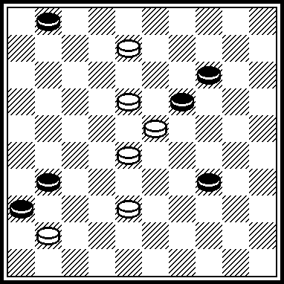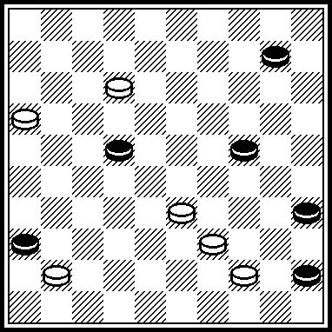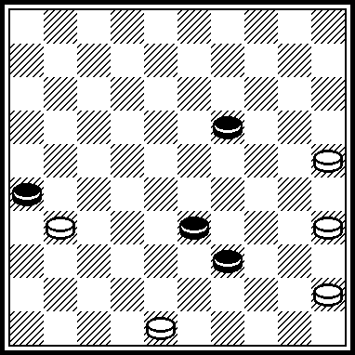

M169 M170 M171 M172
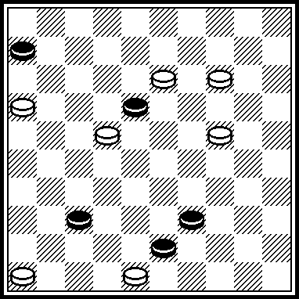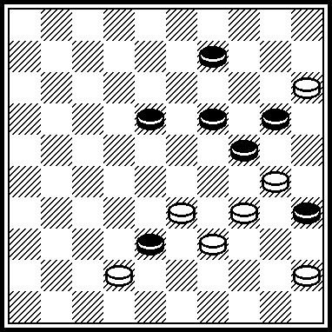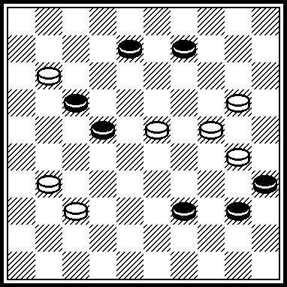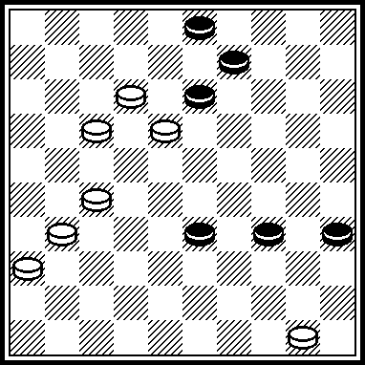

M157
VP: 3328, 3227, 4237, 20, 24.

M158
VP: 7, 21, 30, 48.

M159
VP: 44, 29, 1,45.

M160
VP: 4238, 42, 11, 17.

M161
VP: 22, 2, 1812, 36.

M162
VP: I 40, 11, 117, 1, 49. I 11?, 117, 1, 27 (40)=.

М163
VP: 30, 24, 43(39) 34(41) 42.

М169
VP: 11!, 41, 34, 39.

М170.
VP: 3329, 4, 50, 33.

М171
VP: 14, 27, 2, 47.

М172
VP: 8!, 27, 40, 48(13) 43(18) 38(22) 32.

The remark:
The marking by red color in М124 was made by the author.

The remark of A. Uvarov to his positions:
“All compositions are the patent of author. A reprint is forbidden for all kind so mass-media, including electronically, without the author’s permission with the indication of the source: “Ukraine championship-2009.”

Authors of positions:

М001- М008: S. Ustianov
М009- М016: A. Maslov
М017- М024: M. Levandovskij
М025- М032: I. Ivatsko
М033- М040: A. Nych
М041- М048: A. Uvarov
М049- М056: N. Shapoval
М057- М064: V. Nesterenko
М065- М072: I. Kobtsev
М073- М080: V. Trinos
М081- М088: V. Pokhil
М089- М095: V. Muliar
М097- М104: I. Vlasov
М105- М112: N. Romanik
М113- М120: S. Darchenko
М121- М128: M. Fedorov
М129- М136: A. Katukha
М137- М144: I. Naumenko
М145- М152: A. Savchenko
М153- М160: V. Fakanov
М161- М163: V. Kruchkov
М169- М172: L. Nesterenko

The judge of the “Miniatures” category is S. Yushkevitch (Ukraine),
International Grand Master of draughts composition.
15.01.2010.

