Championship

for draughts composition

Final result in the “Endgames” category

Place | Participant | Sum for 6 works | NN of positions
1 | S. Yushkevitch (Kharkov) | 355 | Е09-Е16
2 | V. Trofimenko (Kiev) | 342 | Е41-Е48
3 | A. Katukha (Vinnitsa’ region) | 264 | Е49-Е56
4 | S. Ustianov (Kharkov) | 207 | Е01-Е08
5 | M. Fedorov (Donetsk’ region) | 187 | Е33-Е40
6 | N. Shapoval (Donetsk) | 38 | Е25-Е32
7 | I. Kobtsev (Dnepropetrovsk) | 30 | Е17-Е24
The scores of positions are present below. The numerations of positions are present in first column; the scores of positions (at the 100-point’s scale) are present in second column.
The judge of the “Miniatures” category is J. Bastiaannet (Holland),
International Grand Master of draughts composition.

S. Yushkevitch  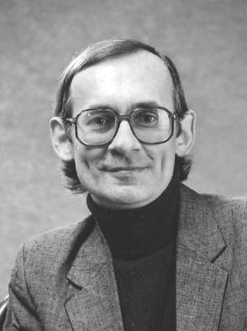 | V. Trofimenko  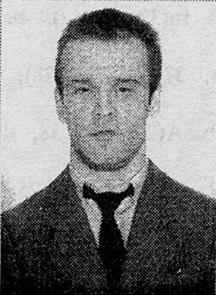 | A. Katukha  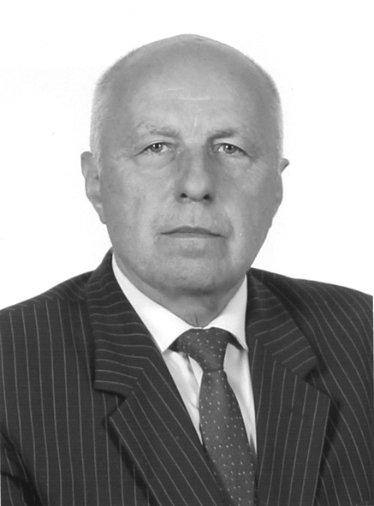

 | Author | Score | ∑ 6 |  |  | Author | Score | ∑ 6
E01 | S. Ustianov | 45 | 207 |  | E29 | N. Shapoval | 0
E02 | S. Ustianov | 40 |  |  | E30 | N. Shapoval | 0
E03 | S. Ustianov | 35 |  |  | E31 | N. Shapoval | 0
E04 | S. Ustianov | 0 |  |  | E32 | N. Shapoval | 0
E05 | S. Ustianov | 0 |  |  | E33 | M. Fedorov | 0 | 187
E06 | S. Ustianov | 32 |  |  | E34 | M. Fedorov | 28
E07 | S. Ustianov | 25 |  |  | E35 | M. Fedorov | 30
E08 | S. Ustianov | 30 |  |  | E36 | M. Fedorov | 34
E09 | S. Yushkevitch | 62 | 355 |  | E37 | M. Fedorov | 22
E10 | S. Yushkevitch | 75 |  |  | E38 | M. Fedorov | 35
E11 | S. Yushkevitch | 64 |  |  | E39 | M. Fedorov | 20
E12 | S. Yushkevitch | 50 |  |  | E40 | M. Fedorov | 38
E13 | S. Yushkevitch | 50 |  |  | E41 | V. Trofimenko | 40 | 342
E14 | S. Yushkevitch | 40 |  |  | E42 | V. Trofimenko | 52
E15 | S. Yushkevitch | 42 |  |  | E43 | V. Trofimenko | 42
E16 | S. Yushkevitch | 54 |  |  | E44 | V. Trofimenko | 60
E17 | I. Kobtsev | 10 | 30 |  | E45 | V. Trofimenko | 75
E18 | I. Kobtsev | 0 |  |  | E46 | V. Trofimenko | 40
E19 | I. Kobtsev | 20 |  |  | E47 | V. Trofimenko | 56
E20 | I. Kobtsev | 0 |  |  | E48 | V. Trofimenko | 57
E21 | I. Kobtsev | 0 |  |  | E49 | А. Katukha | 50 | 264
E22 | I. Kobtsev | 0 |  |  | E50 | А. Katukha | 38
E23 | I. Kobtsev | 0 |  |  | E51 | А. Katukha | 39
E24 | I. Kobtsev | 0 |  |  | E52 | А. Katukha | 40
E25 | N. Shapoval | 20 | 38 |  | E53 | А. Katukha | 52
E26 | N. Shapoval | 0 |  |  | E54 | А. Katukha | 35
E27 | N. Shapoval | 0 |  |  | E55 | А. Katukha | 45
E28 | N. Shapoval | 18 |  |  | E56 | А. Katukha | 0

Pl. | Author | Scores of 6 best endgames | ∑ 6
1 | S. Yushkevitch | 75 + 64 + 62 + 54 + 50 + 50 | 355
2 | V. Trofimenko | 75 + 60 + 57 + 56 + 52 + 42 | 342
3 | А. Katukha | 52 + 50 + 45 + 40 + 39 + 38 | 264
4 | S. Ustianov | 45 + 40 + 35 + 32 + 30 + 25 | 207
5 | M. Fedorov | 38 + 35 + 34 + 30 + 28 + 22 | 187
6 | N. Shapoval | 20 + 18 + 0 + 0 + 0 + 0 | 38
7 | I. Kobtsev | 20 + 10 + 0 + 0 + 0 + 0 | 30

