Championship

for draughts composition

The “Endgames” category

White to move and win in all positions.
There are kept author’s commets, author’s quotes etc.,
A score obtained earlier in another contest, if any, is indicated at the 100-point’s scale.
The championship is run under the International Rules of problemism for Endgame’s problems.

E01 E02 E03 E04
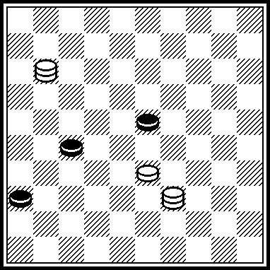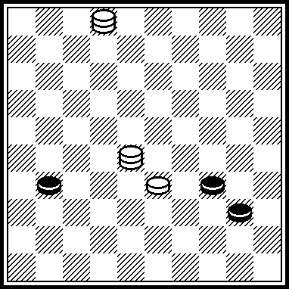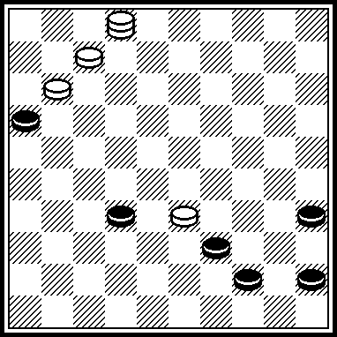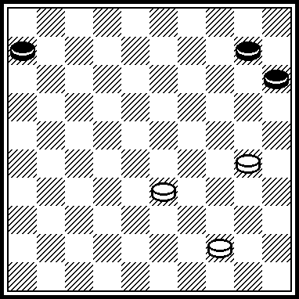

E05 E06 E07 E08
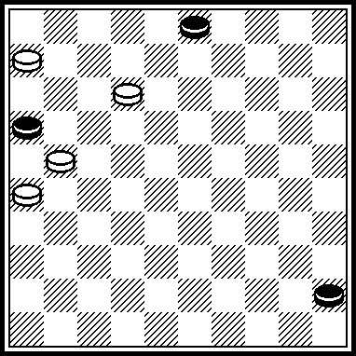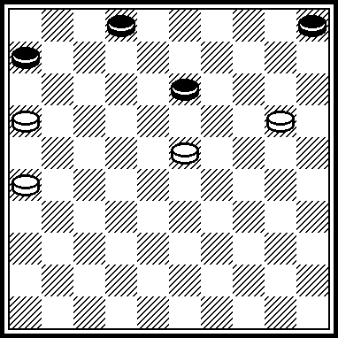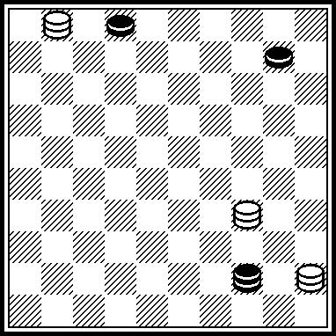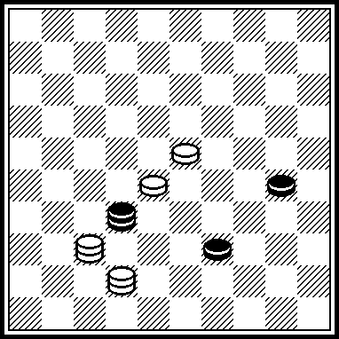

E09 E10 E11 E12
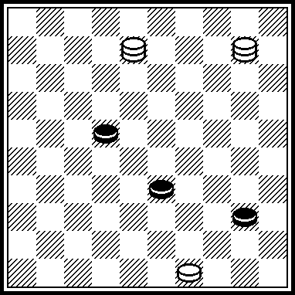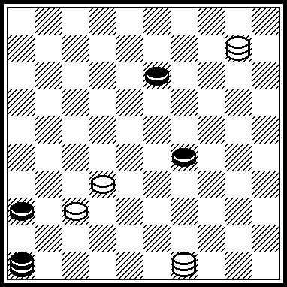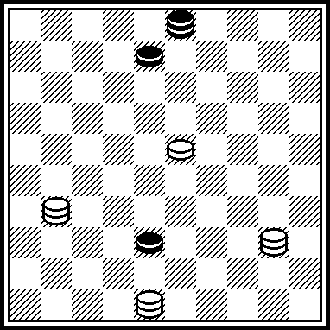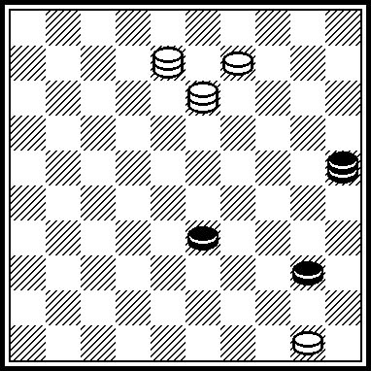

E13 E14 E15 E16
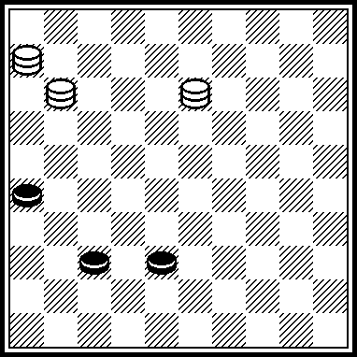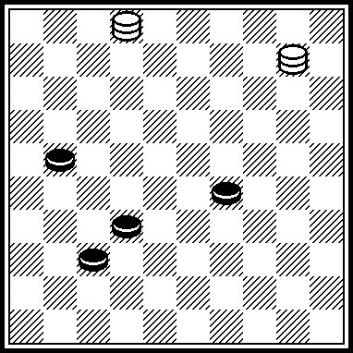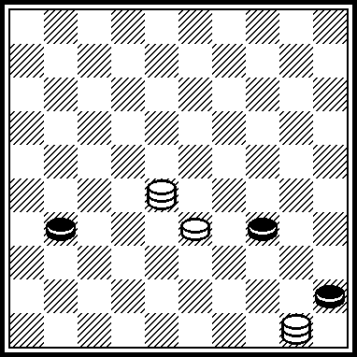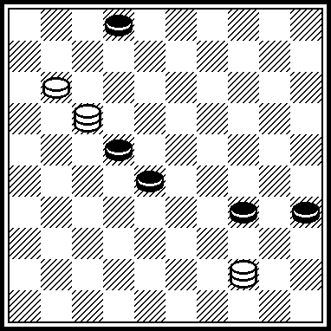

E17 E18 E19 E20
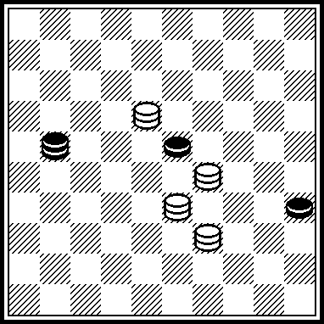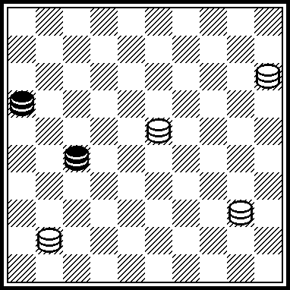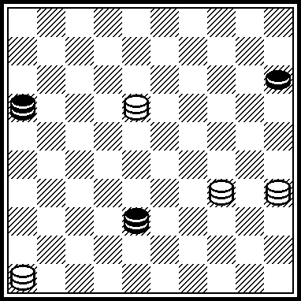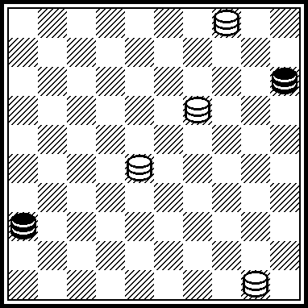

E21 E22 E23 E24
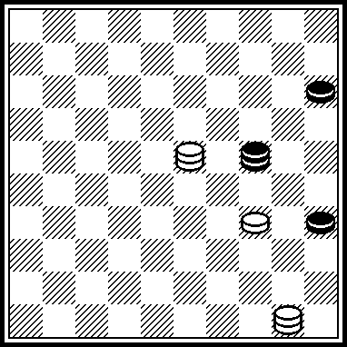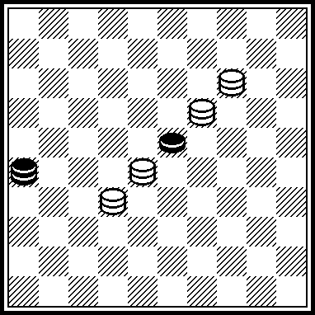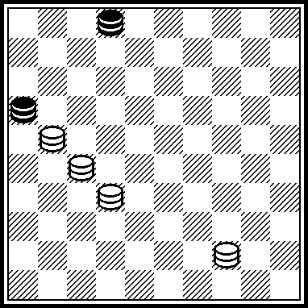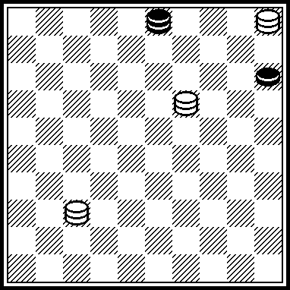

E25 E26 E27 E28
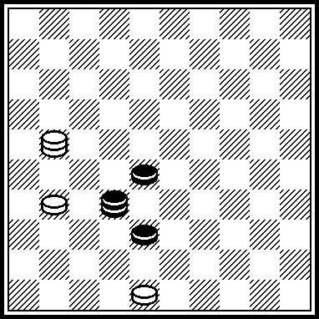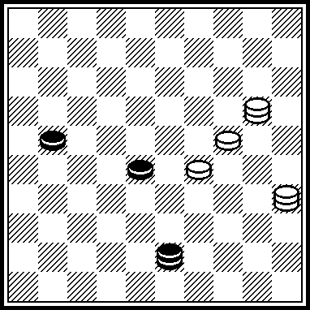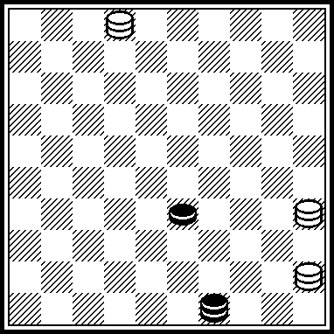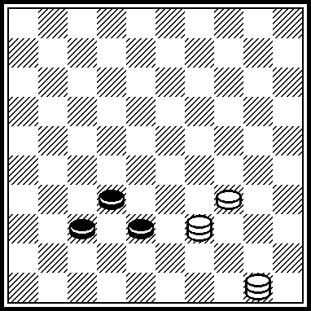

E29 E30 E31 E32
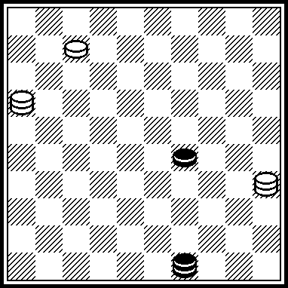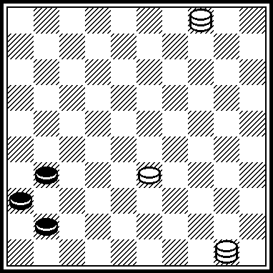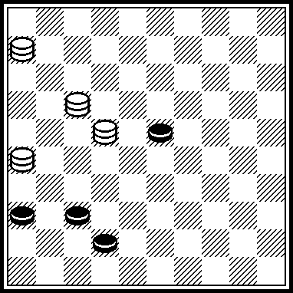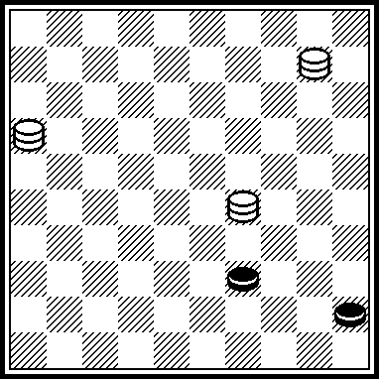

E33 E34 E35 E36
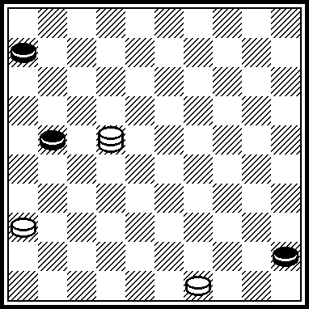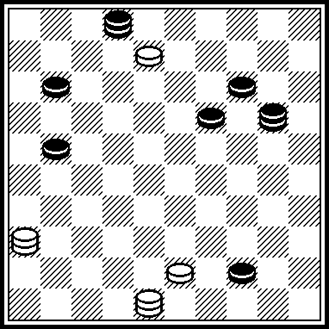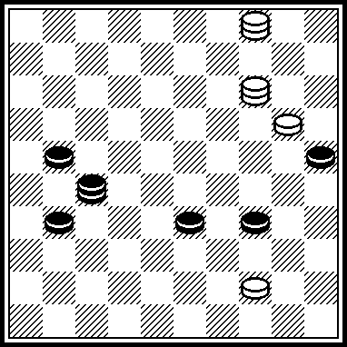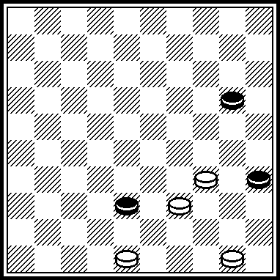

E37 E38 E39 E40
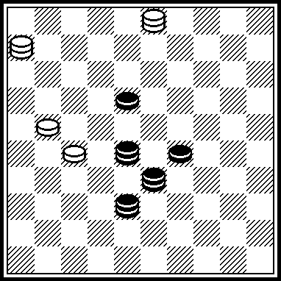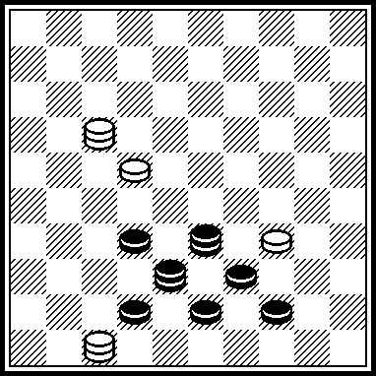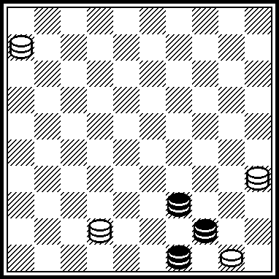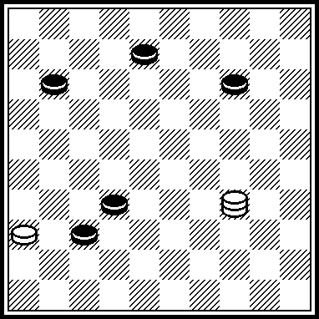

E41 E42 E43 E44
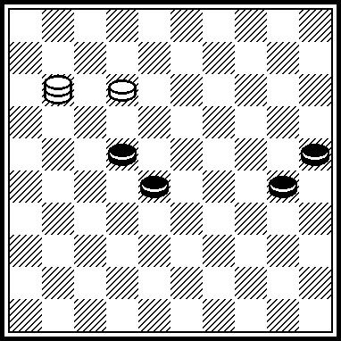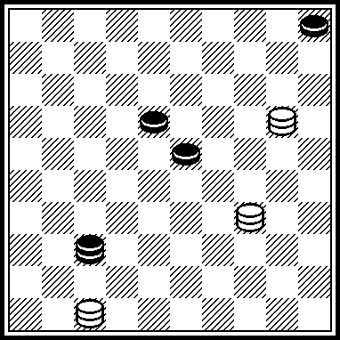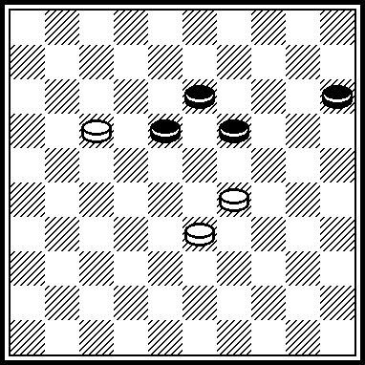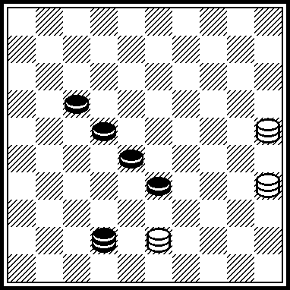

E45 E46 E47 E48
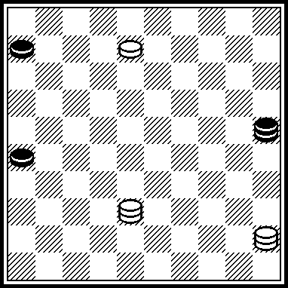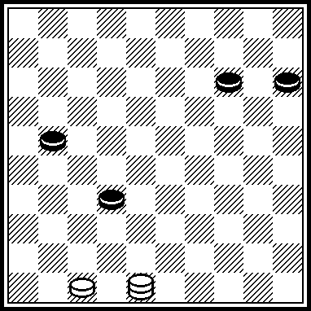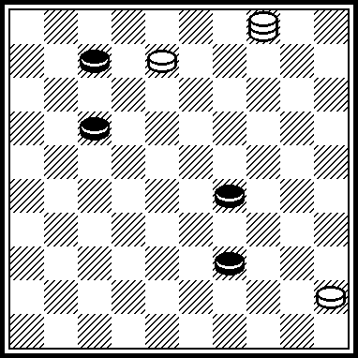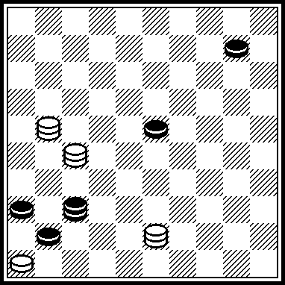

E49 E50 E51 E52
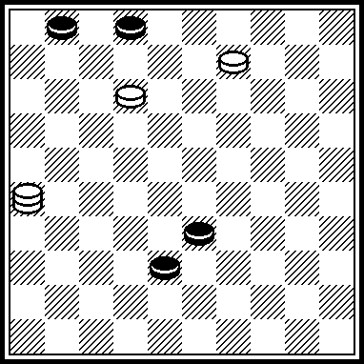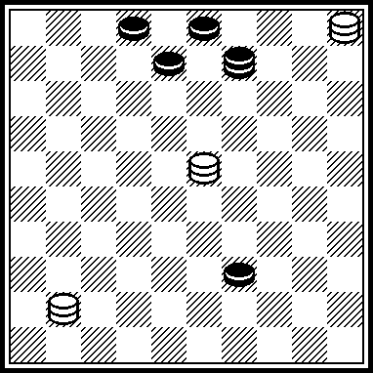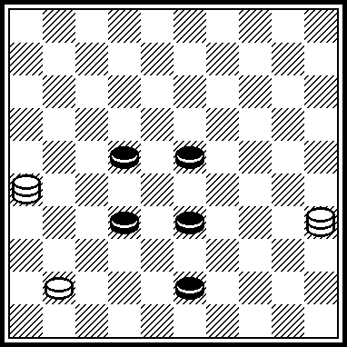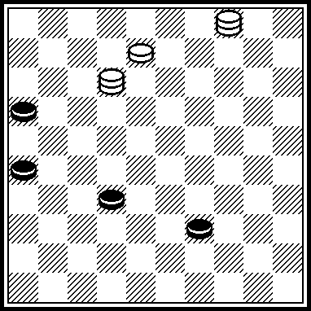

E53 E54 E55 E56
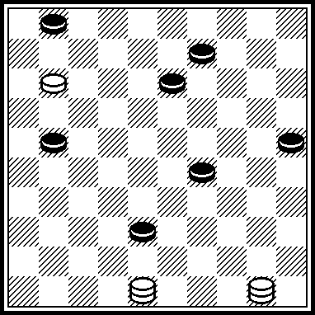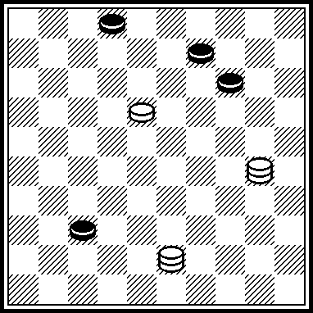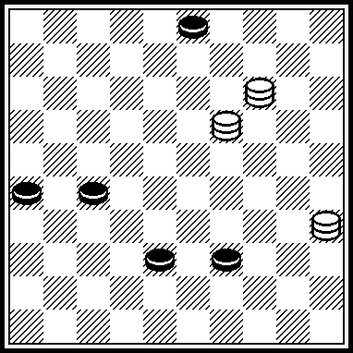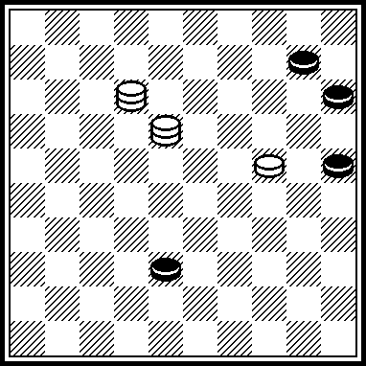

E01
48(31, A) 26(28, B) 22(41) 5(46, C) 37.
A(41) 37, 16(31) 38(37) 47.
B(41) 37, 1128(29, a) 37(38) 48.
C(47) 42.
a(38) 19/5, Z.
Z: 42? (32)+.
In Vinnitsa’ championship 2004 г. E01 was scored with 55 points.

E02
35(45) 44(36, A, B) 5(40, C) 35(41, D) 46(50) 4628(45) 6(23) 40, 1.
A(39) 40, 44.
B(50) 39, 6, 26.
C(39) 50.
D(50) 3519.

E03
1(7, A) 40(34, B) 44(3540) 35(39) 34, 24.
A(28) 6, 40(44, C) 50.
B(44) 6, 50.
C(34) 25(40) 39(45) 50.

E04
28(14, a) 22(19) 24, 17(35) 12(20, A) 8(24) 3(29, B) 17(34) 12.
A(11) 8(17) 3(22) 21(20) 38(25) 32.
B(11) 12(16) 39(21, C, 40) 34, 8(30) 35(34) 44(40) 35.
C(30) 8(21, 40) 17(45) 34, 50.
a(11) 22(16, b) 17. b(20) 18(17) 13(22) 9.

E05
17(21, A) 8(2112, B) 17(8) 1(12) 18(50) 22(45) 18, 27.
A(50) 8, 17, 17.
B(0312) 8(27) 21, 3(50) 17, 17.

E06
15(7, A) 21(0611, B) 18, 17(28, 32) 1(11) 7(38, C) 2(10, D, E) 4(42) 0413(47) 29.
A(11, 11) 21.
B(12) 17, 27.
C(37) 2(10, 41) 13(46) 23.
D(42) 10, 19, 17.
E(43) 10, 19, 48.

E07
6(49, A) 43(16, B) 11, 1(7) 5.
A(35) 30(8, C, D, E) 7, 3.
B(21) 7, 26.
C(24) 7, 4.
D(19) 7, 5.
E(13) 7,15.

E08
19(5, A) 46(28, A1, B, C) 35(43) 38, 24(37) 47(41) 36.
A(10) 5(44, D) 24, 50.
A1(10) 5(44) 24, 50.
B(44) 4237, 49.
C(43) 37, 49.
D(35) 33.

E09
VP: 30(27, A, B, C, D) 34, 15(31/32) 43(36/37) 38, 47.
A (45) 44(27) 25, Z1, Z2(39) 16/21(50) 1632.
B (28) 46, Z3(38) 48(45) 44, Z4(50) 48-37.
C (38) 48(45, E) 44(50, F, G) – идея C.Blan-kenaar, 1899: 28(22x33) 25, 32/16(39) 49.
D (39) 48(45) 44(50, B1) 28(2233) 25, 43.
E (27) 28(32) 46 итд. как в B.
B1 (28) 46(50) 48-37.
F (42) 18/13(50) 10-04.
G (28) 43(50) 43-39(45) 40.
Z1: 48? (39)=.
Z2: 23? (38, Y1, Y2, Y3) =.
Z3: 37? (39, Y4, 45)=.
Z4: 48-37? (42, 50)=.
Y1: (39?) 16/21(50) 16-32+.
Y2: (32?) 46(38) 48+.
Y3: (31?) 25 итд.+.
Y4: (38?) 39(45) 50+.
E09 was published in “Shashechnyj mir”, #3, 1998. The first endgame with the theme of С (and B) variants is: C.Blankenaar, “Le Jeu de Dames. Revue special et mensuelle”, November, 1899: 22, 40/ 10, 49, K26. Solution: 5(45) 44(50, А) 28 etc. А (28) 46, 2637. The variants A and C are known from the L. Vitoshkin endgame, “Shashki”, November 1974, diagram 1791.

E10
VP: 15, Z1(34, A) 4, Z2(18, BC) 22(3641, C1) 3228, 39, 5.
A (18) 33(3641, D) 15, Z4(47) 49-38, 47(22) 41.
B (19) 3731, Z5, 5(39, E) 22, Z6(44, F, B1) 22-28, 49.
C (39) 50(3641) 3228, 32.
D (22) 6(3641) 3228, 32.
E (40) 22(45) 50.
F (41) 46(43) 39.
B1 (44) 2228, 50.
C1 (39) 50(3641) 3228, 32.
Z1: 4? (34) 45(3641)=.
Z2: 44? (18, Y1) 47, Z3(40) 35(22)=.
Z3: 50? (40) 20(45) 15(22) 6(3641, Y2) 47(50) 36(45)=.
Z4: 4938? (22, Y3) 6(47) 15(36) 4(47)=.
Z5: 0431?, 5(32, Y4) 37(39)=.
Z6: 18? (41, Y5) 46(43)=.
Y1: (19?) 47(23) 32-28, 6+.
Y2: (50?) 15-33, 33(36-41) 47+.
Y3: (47?) 15, 47(22) 41+.
Y4: (28?) 32+.
Y5: (43/44?) 1823+.
In “Lietuva-99” contest E10 was scored with 67,7 points, having took the second place.
Published in “De Problemist”, December 2000 and “Saskiu kaleidoskopas”, #13, 2001.

E11
VP: 44(13) 4(25, A,B)0422(3843) 34(6,C) 50.
A (26) 33, 31.
B (12) 0418(26) 1(3842) 37(42) 33.
C (50) 6.
In “Lietuva-99” contest E11 was scored with 57,7 points, having took the sixth place. Published in Saskiu kaleidoskopas”, #13, 2001.

E12
VP: 0903(3339, A) 17, Z1(43, B) 39, 30(44, C, D) 5039, 48.
A (38) 1309(44, 43) 30, 14.
B (3944, 48) 31(12) 17.
C (45) 48.
D (39) 48(45) 12 – M. Goniaev, 1886.
Z1: 1309? (3944, 43, Y1, Y2)=.
Y1: (48?) 31, 12+.
Y2: (4044?) 14, 48, 35(32) 43+.
E12 was published in “Shashechnyj mir”,
# 4/5, 1997.

E13
VP: 1331(3842, A) 17(41, B, C, 31, D, 46) 37.
A (41) 37, 16(31, E) 33.
B (48) 42, 21.
C (47) 42.
D (46) 37.
E (37, 41) 21. E13 was published in “Krymskaya svetlitsa” (with King 4 instead of King 13), 16.01.1998.

E14
VP: 16(41, A, B, С) 24.
A (27) 4(31) 24/15(36) 19, Z1(3641, D) 31, 46.
B (38) 43/49(42) 38, 15.
C (34) 30/25(42) 37.
D (42) 37, 10.
Z1: 47? (3641, 42)=.
E14 was published in “Krymskaya svetlitsa”, 17.11.2000.
E15
VP: 44(50, A) 39, 6.
A (36) 5(41, B) 46(40) 35(50) 4628(45) 6(23) 40, 1.
B (40, C, 50) 3519.
C (50) 0528, 44.
E15 was published in “Saskiu kaleidoskopas”, # 15, 2005.

E16
VP: 7(0211, A) 6(340, B) 39, Z1(45) 50(40) 11(44, C) 33, 50.
A (2211) 6, 25.
B (350) 35(39) 1(43) 23, 49.
C (27) 35(32) 24(37) 47.
Z1: 50?(45) 11(27, Y1) 31/36(50)=.
Y1: (40?) 6(44, Y2) 39, 50+
Y2: (27?) 35 итд. как в C+.
E16 was published in “Shashechnyj mir”, # 4, 1998.

E17
43(49, A) 44(34, B, C) 45, 34.
A(34?) 16.
B(12) 1, 45.
C(40) 45, 1.

E18
49(2721, A, B, C) 1538, 27(46*) 5.
*(1605) 46.
A(4) 36(2 !*) 7(16**) 1538, 27, 27.
*(1611?)
**(0211?)
B(36) 2329, 38, 38.

E19
27(21, A) 7, 4619, 26.
A(32) 19 ! (1520, B) 1924, 32.
B(47, C, D, E) 24, 25.
C(49) 39 ! (38 !, F) 24, 25.
D(20) 25(3*) 1914, 14.
*(33?)
F(16) 11.

E20
1910(29, A) 5033(47 !) 15.
A(3647) 2833 ! (29, B) 36, 5022, 34.
B(42/38) 41, 5022, 48.

E21
30(47, A, B, C) 45/1, 5033.
A(2418) 3024(18x30) 40, 25.
B(2420) 17, 3 (25, A) 2314, 29.
A(2429 !) 25, 39 !(23, B) 33.
B(20) 25(24) 9(23) 13(2429) 9(33) 14(2329*) 20, 20-38-49. *(2328?)

E22
3 !!, 10 ! (31, A, B) 4(42) 31, 3221, 26.
A(42) 15 ! (48*) 26(39) 43, 1542, 48.
*(31?)
B(48) 26 ! (39) 43, 1037, 48.
A draw.
1…..(2603).

E23
3249(1607, A, B) 11, 35(0207, C) 2749, 2.
A(0219?) 2738, 14.
B(35/30) 8(32, C) 16, 35.
C(35x02) 35, 16.

E24
26(9, A, B) 10, 3(18) 13, 14.
A(25) 3(1520) 24, 0514, 33.
B(25) 3(34) 30, 0514, 14.

E25
3127(46, A) 43, 16, 5.
A(41/37) 43, 16, 46(33) 32(39) 49.

E26
25, Z(48, A) 23, 26.
A(49) 23, 16.
Z: 14? (34)=.

E27
34(16, A, B) 39, 49.
A(39) 48(32) 43, 16.
B(3338) 48(42, C) 26(32) 21, 49.
C(3843) 39(32) 43, 16.

E28
45(3842, A, B) 28, 29, 47.
A(41) 33, 46.
B(3742) 33,48.

E29
0702(34) 0207(39) 0702(3943, A) 40, 49.
A(3944) 21, 49.

E30
10(47, A, B) 15, 26(41) 37, 33(37) 47.
A(37) 32, 46.
B(46) 32, 28.
E31
2621(3741, A, B, a) 28, 47(46) 41, 28.
A(47) 28, 38, 46.
B(48) 28, 43, 46.
a(29) 32, 47.

E32
49(43, A, B) 32(50) 33.
A(44) 40, 28.
B(50) 44(43, C) 1015, 49.
C(45) 28.

E33
VP: 494(11, A, B, C) 6(27) 449 !, Z(32) 31(50, D) 26(33) 39(37) 28(42) 37, 37.
A(50) 27, 16.
B(27) 31(50, a) 27, 27.
C(26) 40, 44.
D(38) 393, 27(34, E) 21(40) 50(44) 6(50) 217.
E(50) 272.
Z: 28, Y(32) 37(50)=.
Y(31) 27(50) 272+.
Published in the book “Fedorov Mikhail Vasilievitch” (Starobeshevo, 2008),
# 21, p. 230. E33 participated in Russia’ championship-2003.

E34
VP: 39(0213, A) 4, 15(25, B, C) 30, 9/3.
A(33) 30, Z, 9, 15.
B(1924) 30, 7.
C(29) 39, 49.
Z: 25, 9(3) =.
Published in the book “Fedorov Mikhail Vasilievitch” (Starobeshevo, 2008), #300,
p. 254.
The improvement of the endgame of the same author from PWCE.

E35
VP: 39, Z(43, A) 37(14, B) 49(16, C) 0427.
A(44) 5, 49 итд., как в VP.
B(42) 26.
Z: 37(42) 30(34)=.
E35 participated in PWCE.

E36
VP: 29, Z(43, A) 34(49, B) 44, 45(25) 43(30) 24, 39(24, C) 34(40) 30, 34.
A(40) 34(43) 39(44) 24, 34, 39.
B(40) 39(44) etc., like in A.
C(23) 33.
Z: 44(25) 29(43) 34(49) 42, 45(30) 24, 38(24) 33=.
Published in the book “Fedorov Mikhail Vasilievitch” (Starobeshevo, 2008), # 50,
p. 233

E37
VP: 17(12, A) 17, 39(23) 25(33) 14(29) 20(34) 38(39, B) 49.
A(8) 32(47, C) 38.
B(40) 33(45) 50.
C(50) 3228.
Published in the book “Fedorov Mikhail Vasilievitch” (Starobeshevo, 2008), # 28,
p. 231.

E38
VP: 6(11, A) 48, 49.
A(30) 2217, 49(16, B) 4738.
B(15) 4938.
Published in the book “Fedorov Mikhail Vasilievitch” (Starobeshevo, 2008), # 239,
p.. 232.

E39
VP: 48(25, A, B) 39, 39/25(32) 43, 0644.
A(16) 49(25) 0639, 34(2) 35(16) 43, 5044.
B(11) 5039(50, C) 4839, 44.
C(44) 50(32) 43, 5044.
Published in the book “Fedorov Mikhail Vasilievitch” (Starobeshevo, 2008), # 96,
p. 237.

E40
VP: 43(41, A, A1, B) 10(47, a) 15.
A(20) 15.
A1(19) 24.
B(12) 10/5(42) 37, 27.
a(46) 5.

E41
1207(34, A) 1(39, B) 2(32, C, D, E) 18.
A(27) 44(32) 1(37, F) 35(34) 45(41) 30, 46.
B(27) 30, 40/45(32) 29(37) 47.
C(44) 30, 49(33) 16.
D(43) 18, 49.
E(30) 35(43) 23, 49.
F(38) 33.

E42
3425(26, A) 3(10, B) 24(28) 2420(15, C, D, E) 34, 12.
A(46) 41, 29.
B(29) 15(10) 22/27(37) 31, 48.
C(14) 33(37) 42, 26.
D(33) 38(37) 0314, 24.
E(32) 8, 9.

E43
11(24, A) 20, 7(30) 28(19, B, C) 2(1923, C1, D) 19(35) 1913, 7.
A(22) 7(27) 2(31) 23, 26.
B(23) 8(34) 1(39) 34.
C(35) 2(19) 24(40) 33(45) 50.
C1(35) 24(40) 33(45) 50.
D(1823) 35, 24(37) 47.

E44
48(26, A) 13(1721, B) 16(3, C, D) 38, 14.
A(47) 42, 39.
B(32) 24(2621) 4834(32, E) 38.
C(39) 43(33, C1) 1627(38, F, G) 32(17) 21, 3237.
C1(32) 27(17) 1621, 2731.
D(32) 24(12) 8, 26.
E(49) 2(1721) 40, 2530.
F(39) 25(8) 21, 3.
G(3) 25(39) 30(12) 8, 2709.

E45
3(30, A, B) 16(48, C) 29(2631, D) 25(4837, E, F) 42, 1643, 26.
A(39) 4512(30, G, H) 16(31, C1) 11, 25.
B(48) 25(37) 42, 4534.
C(19) 8, 4507.
C1(19) 0308, 1207.
D(11) 2(2631, J) 30, 2920(14) 20(37) 47.
E(36) 2934, 48(41) 37.
F(11) 7(4837, D1) 42, 0734, 26.
D1(36) 2934, 48, 37, 29(37) 47.
G(28) 3821.
H(50) 33.
J(4831) 21, 12, 36.

E46
4742(38, A, B, C) 33(27, D) 28(1520) 25(31) 23(37) 19.
A(1520) 43(27) 49(24, E) 4238.
B(26) 38, 9.
C(27) 38.
D(26) 29(1420) 42(31) 26(24) 20.
E(19) 4238, 25(32) 20(37) 47.

E47
2(12, A) 9(44, B) 40, 25(33, C, D) 3(39, E, F) 11, 44.
A(33) 28, 27(44) 40.
B(34) 3(44) 11, 50.
C(21) 24, 26, 17, 50.
D(40) 35(45) 40, 6(34) 1.
E(38) 11, 49(11) 44(16) 49.
F(40) 11, 35.

E48
48(3728, A) 37(41, B) 16(29, C) 32(23, D) 31, 5(33) 32(39) 49.
A(26) 37(3) 21, 5.
C(4128) 18, 31.
D(14) 31.

E49
3 ! (0107, A) 1(43) 31(49, B, C) 40, 13.
A(43) 0308, 7, 49.
B(39) 13 !, Z(48, D, E, F) 31, 0112.
C(38) 34 ! (49) 40, 13.
D(49) 40.
E(44) 7, 17.
F(7) 40 ! (49, G) 0308, 0802.
G(48) 31, 4012.
Z: 27(8 !!)=.
E49 participated in PWCE.

E50
36(44, A, B, C) 4(50, D, E) 12, 28.
A(43) 4(48) 34(25, F) 14.
B(0813) 2318 !, 4(43/44) 9.
C(25) 2314, 4.
D(12) 7, 9, 50.
E(7) 1(49, G) 40, 19.
F(30) 19.
G(50) 12, 28.
Published in “Horizonty shashek”, # 4, 2005.

E51
49(3338, A, B) 48(2328, C) 34 ! (42) 9 !! (47, D, a) 4, 3418.
A(3238) 42, 47.
B(48) 38(25) 43, 4137.
C(2228) 17, Z(42) 27(48, b) 26(25) 43, 4137.
D(32) 27, 37, 23.
a(48) 0925. b(47) 4, 1722.
Z: 12? (42) 27(33 !)=.

E52
2 ! (31, A, A1, A2) 36(38, B, C, a) 47(3943, D) 24 ! (21, E, E1) 26(49) 35(32) 21, 49.
A(43) 11, 49.
A1(44) 11.
A2(38/37) 11.
B(43) 34(49, F) 40, 3613.
C(21) 26(43) 47 !, Z(49, G) 38, 48(35) 30.
D(3843) 33, 23, 48.
E(48) 34.
E1(49) 40.
F(48) 3613.
G(38) 33 ! (49) 21, 3311.
a(44) 21, 50(37) 19/28.

E53
33(26, A, B) 8 !, Z(31, C, D, E, a) 26(30, F, G) 35(13, H) 2 ! (43) 48(49) 43.
A(30) 33x08x26, Z1(34) 3(7) 2(43) 0308(48, M) 3(39) 30, 48.
B(34) 26, 7.
C(30) 3(42) 7, 21, 48.
D(31) 26(43) 30, 7, 48.
E(31) 26(30) 35(7) 2(43) 3513, 12, 49.
F(43) 30, 7.
G(7) 2(43) 13, 12, 49.
H(7) 2(43) 3513, 2612, 29.
M(49) 35(32) 21, 49.
a(7) 2(30) 3(31) 26(36) 31 итд..
Z: 2? (30) 3(42)=.
Z1: 4826? (42 !)=.

E54
21 ! (13, A, B, C, a) 20(41, D) 32(47) 15 !, Z(36) 41, 3024, 24.
A(41) 19, 46.
B(19) 4(8) 3(41) 14(47) 41.
C(8) 3 !, Z1(41) 19, 46.
D(8) 3(42) 0314(48, E) 3.
E(47) 3024 ! (36) 41, 15.
a(20) 48(41) 37, 15.
Z: 3024? (8)=.
Z1: 2? (19)=.

E55
25(3943, A, B) 48(2631, C) 26(43) 49(48)
21 ! (39, D) 43, 1937.
A(3843) 8, 34, 49.
B(32) 48(37) 41/46(31) 26(8) 3 ! (43) 49(48) 26(25) 43, 4137.
C(8) 2(2631) 26(43) 48 ! (49) 40, 4830.
D(8) 3 ! (39) 30, 48.
E56
34(30, A, a) 25(14) 3(43, B, C) 34(48, D) 2420.
A(20) 4(42) 15(48) 3, 1520.
B(42) 26(48) 25.
C(1520) 25(42) 1203(47) 2514.
D(49) 43.
a(42) 48(47) 1234/1203, 30.
Published in “Horizonty shashek”, # 4, 2005.

The remark:
There are kept author’s commets, author’s quotes etc.

The authors of positions:

Е01-Е08: S. Ustianov
Е09-Е16: S. Yushkevitch
Е17-Е24: I. Kobtsev
Е25-Е32: N. Shapoval
Е33-Е40: M. Fedorov
Е41-Е48: V. Trofimenko
Е49-Е56: A. Katukha

The judge of the “Endgame” category is
J. Bastiaannet (Holland),
International Grand Master of draughts composition.

15.01.2010.

