«Memorial Garry Dalidovich-2007»

(Category A - zadachi)

N1 Blok 1 N2 Blok 1 N3 Blok 1White N4 Blok 1
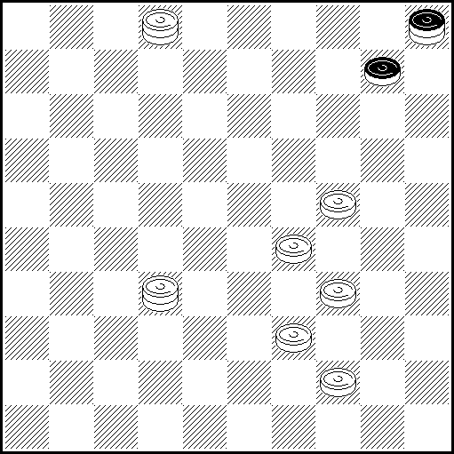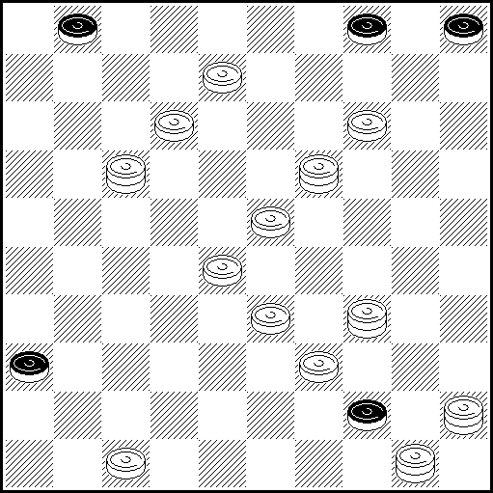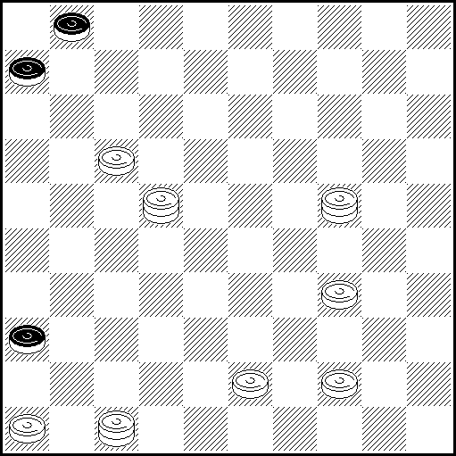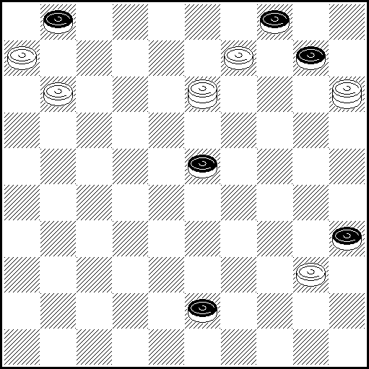

N1 29-23(14 А),20,40,32-19,30 – [25] A(15),33(5:19),30,32-19(24 B),23,23-40 – [35]
B(25),28,40,50 – [45]
N2 9(2 A),10,19,7(22 В),18,7,28,41 – [36] А(24),41,3,11,20,7,17,15,20,50-44,35,40,50 – [45]
B(21),7,41,39-34,49 – [44]
N3 46-41(7 A),47-38,8,11(2) – [11] A(11),6,11,44-39,47-38,16,43-38,33,7(1) – [6]
N4 7(12 A),1,32,10 – [4] A(44),18,12 – [1]

N5 Blok 1 N6 Blok (1) N7 Blok 1 N8 Blok 2
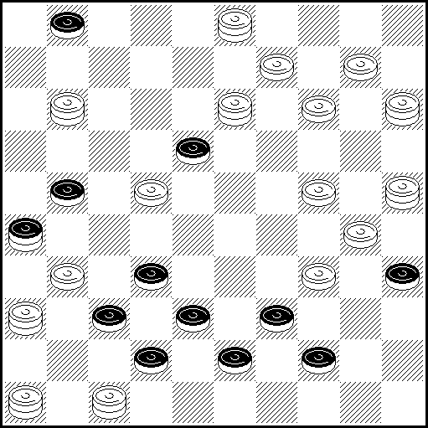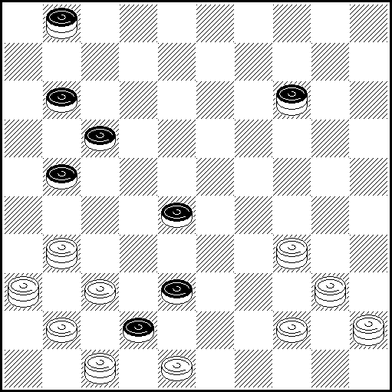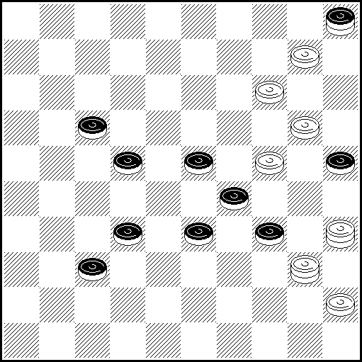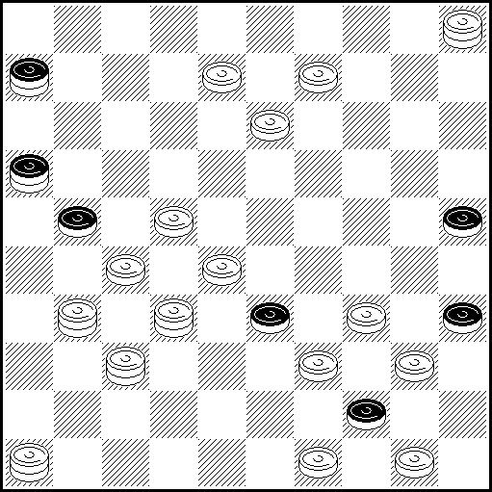

N5 3-17(27 A),22,13-18,19,22-17,7(12/15 B),25-30,28,10,9,48,49 – [43]
A(12),27,16,7,32,8,17,8,19,25-20,25,24,25-20 – [15] B(30),50,16,18,33,20,48 – [42]
N6 26,22(28 A), 35,38,19,32,41,37 – [(46)] A(46),22-18,32,22,33,44,39 – [(50)]
N7 4,39(14 A),43 – [34] A(43),38,20,49,44… – [35&45]
N8 29,23(17 A),26,42,20,11,32 – [21,44] A(12),32-10,7,28,30,28,28-44 – [40,45]

N9 Blok 1 N10 Blok 2 N11 Blok 1 N12 Blok (1)+1
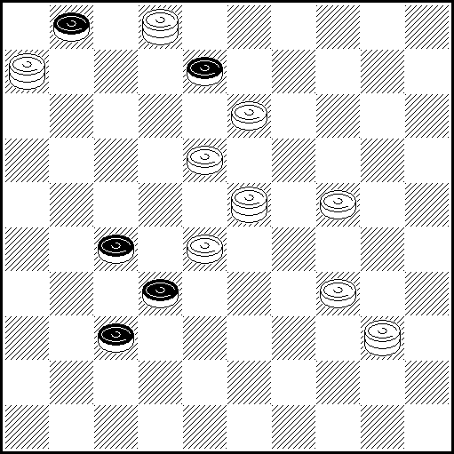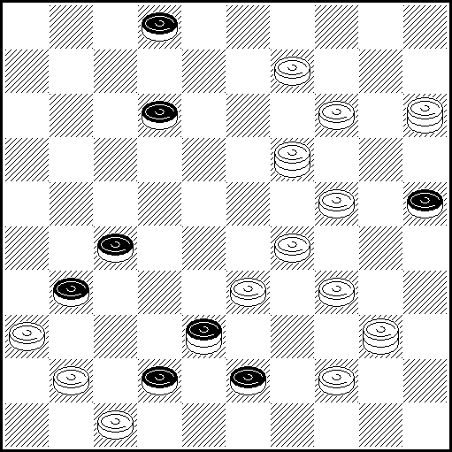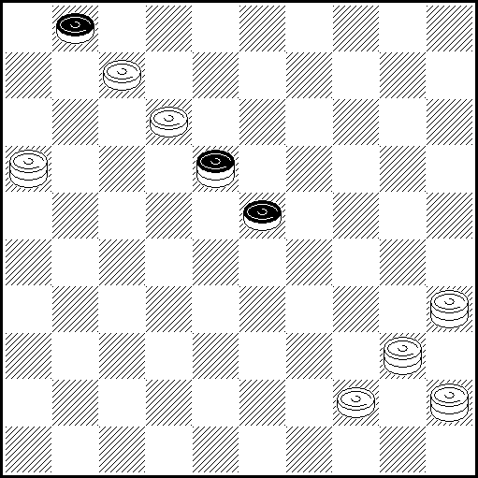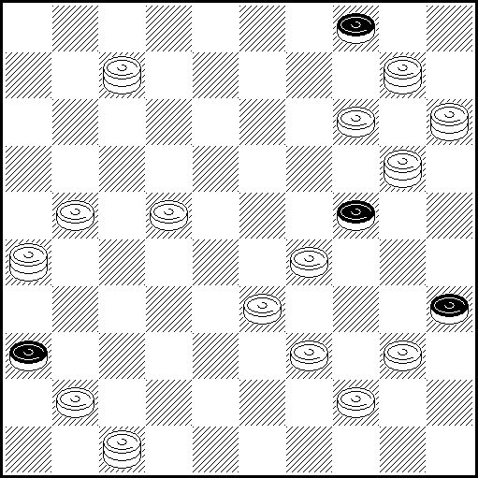

N9 7,23-34(12 A),18,12 – [1] A(23),29,50 – [45]
N10 30(45 A),8,9,40,29,37,48 – [31,42] A(23),34,15:42:8,10,31,45,25,30,45-40 – [35,36]
N11 13(4 A),18,11,50,6 – [1] A(9),4,10,43,8,19,30,45-40 – [35]
N12 26-37(30 A),38,38-42,19,9,19(18),13,39:30 – [(24)-35]
A(9),3,39-34,37-32,10-23,17,20-24,7-23,15-24,30,39,45 – [(50)-36]
N13 Blok 1 N14 N15 Blok 1 N16 Blok 2
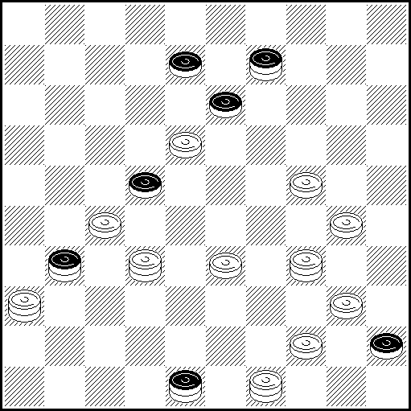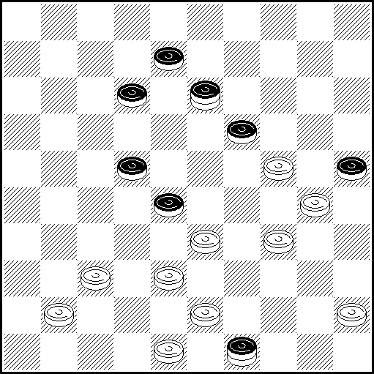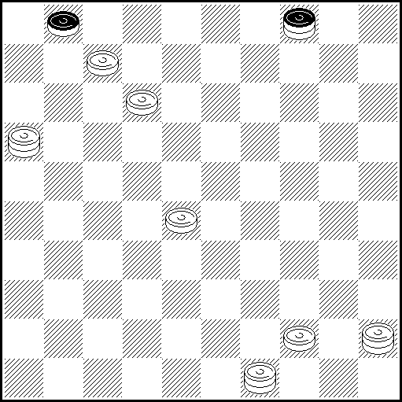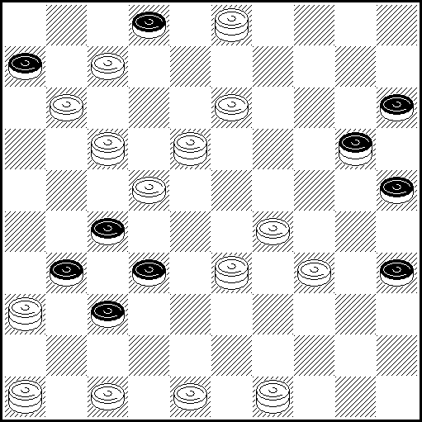

N13 32-43(50 A),34-43,30,48-43,19,22 – [13] A(22),19,38(50 B),38-47(44),21,18,17,39,6,50 – [45]
B(13),27-21,18,47,17,39,6,50 – [45]
N14 40(39 A),42(35 B),38-32,28,31,2,35,43(30 С, 38),43+ A(35),38-32,28/42…+ B(48),33,28…+ С(39),34+
N15 22(36 A),49-27,11,50,6 – [1] A(27),21,43,16-32,8,19,30,45-40 – [35]
N16 33-42,20(14 A),20,17-12,47-41,34-29,49-40,1,42 – [31,37]
A(24),17-8,47-42,17,17,23,42-38,46:30,30 – [25,43]

N17 Blok 1 N18 Blok 1 N19 Blok (1)+1 N20 Blok 6
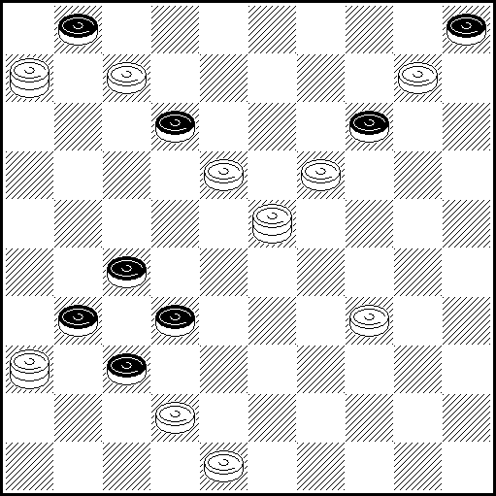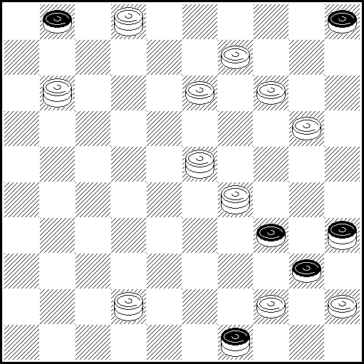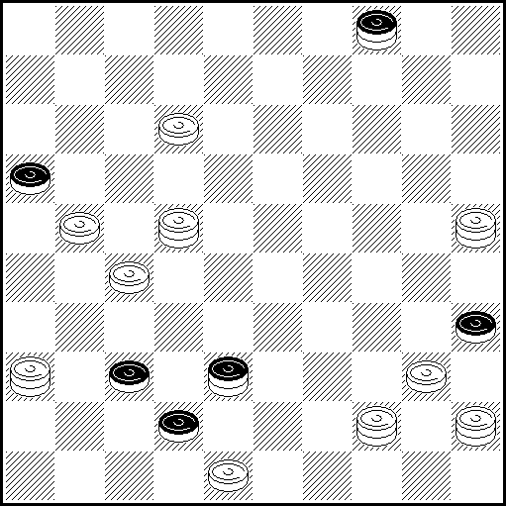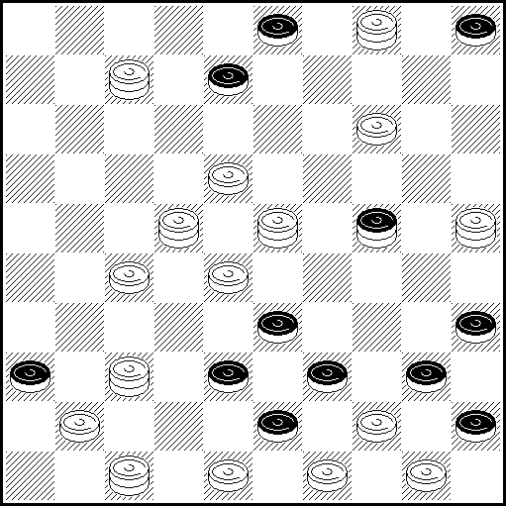

N17 43,34(12 A),18,12 – [1] A(14),20,40,35,40,50 – [45]
N18 10(25 A),20,13-8,7,17,42-24,16,49 – [40] A(3),9,11-7,1,1:34,24(40 B),34,30 – [25]
B(19),35,49,44… – [35&45]
N19 22-33(1 A),41!!,25-34!,44-50,36,41 – [(47)-42] A(7),25-39,1,22,46,42,32,49 – [(50)-44]
N20 I 23-34(29 A),14-10,9,4-13,13,40,17,40 – [35,36,38,39,42,43]
A(39:30),28:39,15,41,14-10,9,20,7-12,48-43,39 – [25,30,34,35,40,45]
I 25-34(30?),39,15,41,14-9,10,20,7-12,48,43,39 – [25,30,34,35,40,45]

N21 Blok 1 N22 Blok (1)+1 N23 Blok 2 White N24 Blok 1
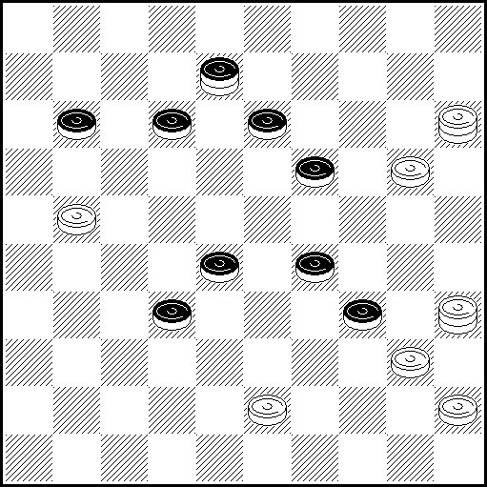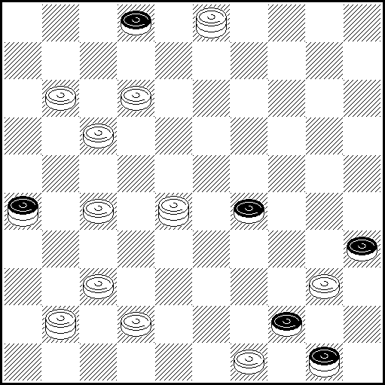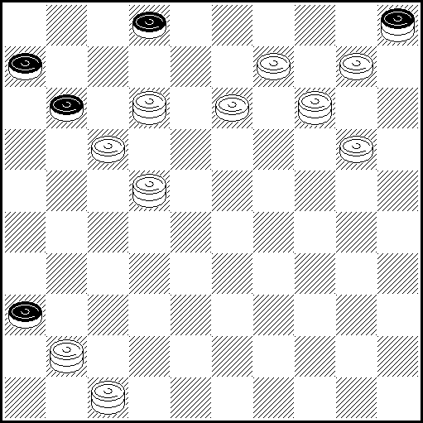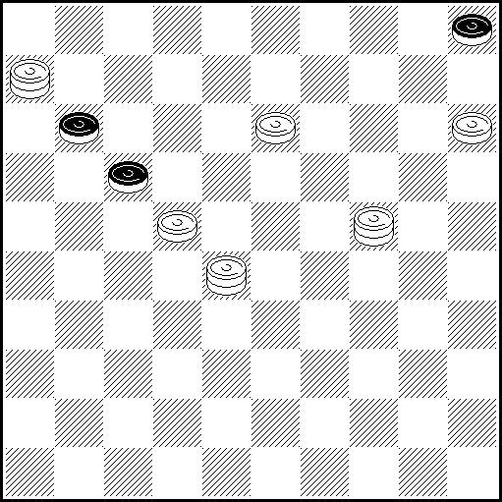

N21 17(22 A),14,24,39 – [34] A(21), 38,14,24,49(39),34,44… – [35&45]
N22 11-7(31 A),36,34,50,40 – [(45)-31] A(33),21,39,38,36,45 – [(50)-44]
N23 7(16 А), 7-11, 38, 11, 8 – [9,11] A(8), 2, 31, 17-11, 12, 31, 26, 21, 29, 1(26 В), 15, 41-37, 18(47 D), 41 – [10,15] В(27), 41-32, 15(43 С), 18(49 D), 32 – [10,15] D(48), 37 – [10,15] С(42), 18(47 D), 41 – [10,15]
N24 28-10(28 A), 44, 10, 8, 2(14 B), 20, 2-11, 35, 40, 50 – [45] A(14), 10(5 C), 8, 44, 2(14D), 20… -> VP – [45] B(15), 30, 2-19… – [35&45] С(28), 44, 8... -> А – [35&45] D(15), 30… -> B – [35&45]

N25 Blok 1 N26 Blok 1 N27 Blok 1 N28 Blok 1
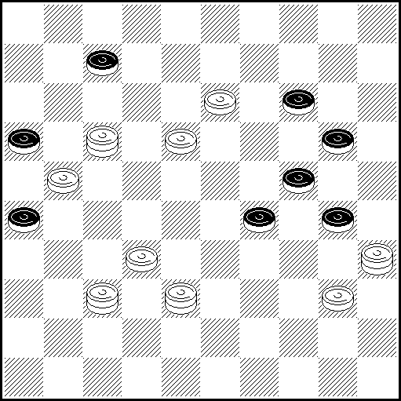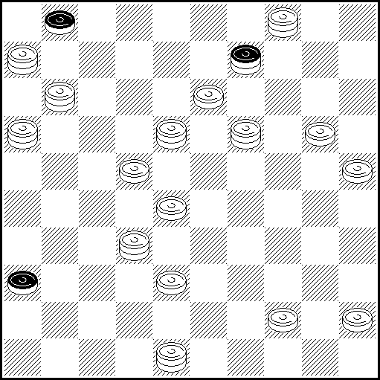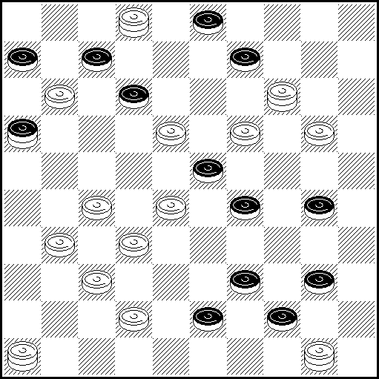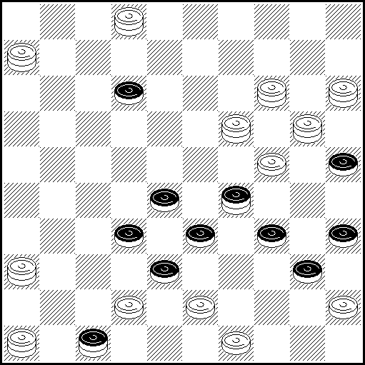

N25 9(27 A),21,8,34,33 – [29] A(3),47,33,18-12,8,34,31 – [26]
N26 41,18-7(40 A),34,36,7,38(42 B),31,11,31-13,36-27,20,13-30 – [25]
B(47),20,29,28(6 C),28-37,2(17 D),11,43,16,21,36-31 – [26] C(7),11,47,26,31,19-41 – [36]
D(16),47,26,21,19,26,31,19-41 – [36] A(35),8,7,29,44,9,20,48-43,49,44... – [35&45]
N27 27-22,19-13,46:45,2:41(22 A),8,18 – [9] A(27),36/31,28,9,40,35,40,50 – [45]
N28 44(40:49 A),3,26,40,40,6-22,29,46:30,35(41),47,49 – [38]
A(38:49),6-11,7,7,27,30,23,23,25,30,16,49 – [40]

N29 Blok (1)+2 N30 N31 N32
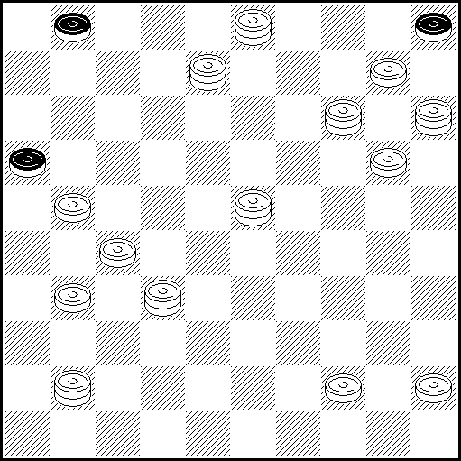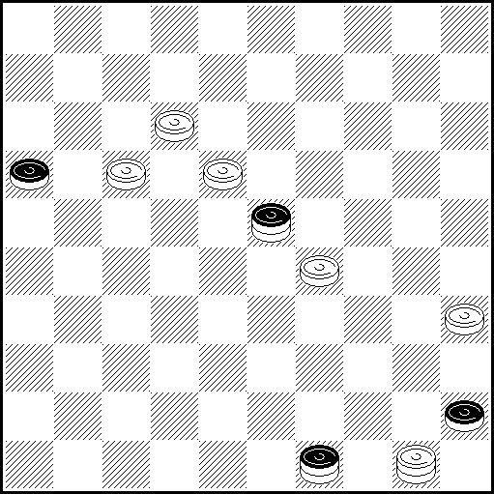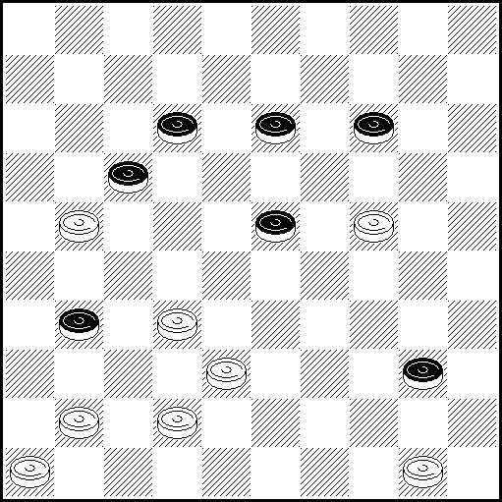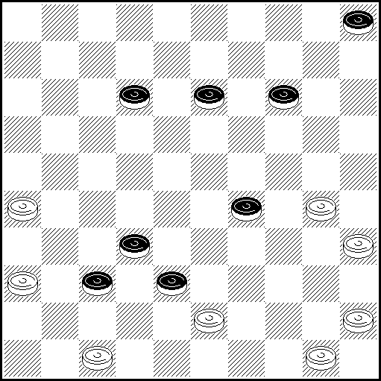

N29 23-19(7 A),12,19-23,36(33 C),38,44-40(47 B),36-41,41,15-47,35,30,3-17,44… – [(36)-16,35&(36)-16,45] B(48),3-17,37,36-31,35,30,15-33,44… – [(26)-16,35&(26)-16,45]
C(34),44-40,43,3-17,37,36-31,35,30,15-33,44… – [(26)-16,35&(26)-16,45]
A(6),32-23,23-12,41-37,22,12-34,8-13,19-23,3-9,14-19,15-10,19-30,23-19,19-23,34-40,
23-29,33,47/15,38,49 – [(50)-26,44]
N30 I 22(40 A,35 B),13(2 C),7,6(50 D),17,17+ D(21),50(27),1(32),29(37),47+ A(34),11,1,40,44,44+
B(40),11,1…+ C(8,21,50),3-17(45),18,17+ I 11?(7,12),18(38),29-23(32),28(16),50(32)…=
N31 41-37,27,44,19,10,37,37+ N32 41,31,27,10,44,23,24,24+

N33 Blok 1 N34 N35 Blok 1
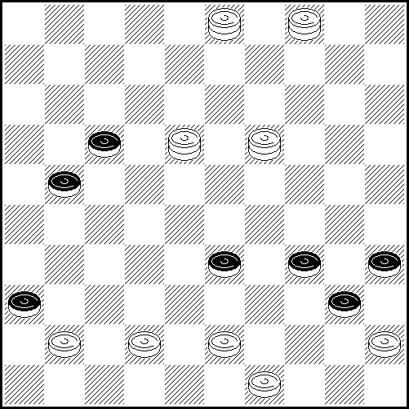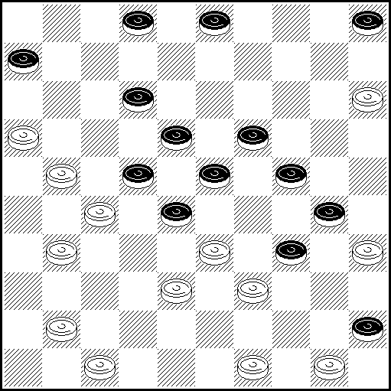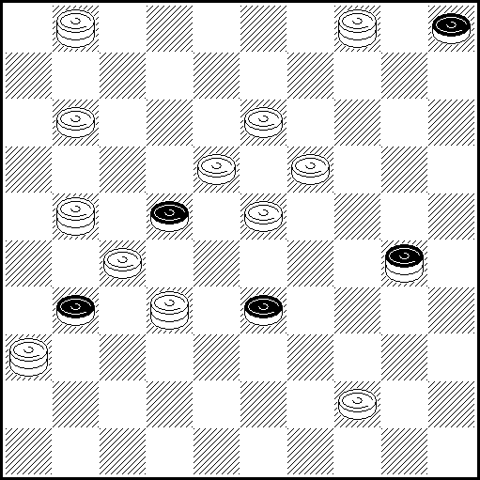

N33 44(49А),18-12,30,16,49 – [40] A(47), 40,40,30,27,15,47 – [36]
N34 32,49-44,40,44,29,11,39,37,7,7(22),2(28),16(33),43(9),34(38),48(13),25(19),3(10,43),13x
N35 138,10(14 A),21-12,37,42 – [31] A(13),15,4,38, 49/22,20,22,35,40,50 – [45]

N36 N37
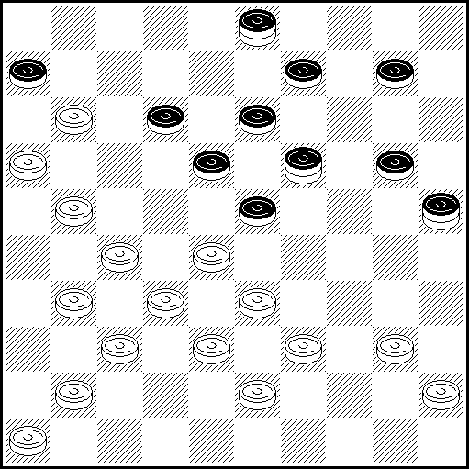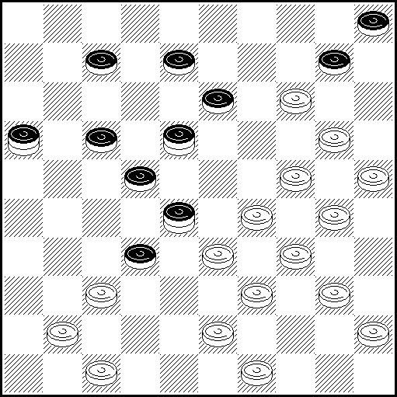

N36 29(26),24(36),17,40,22(35),24(41),37(31),36+
N37 15(19),10(14),23(31/26),42(35),20(39),38(43),22(47),38(40),43+

DALYVIAI – PARTICIPANTS – УЧАСТНИКИ
Bielorussie – 7, Ukraine – 5, Russie – 2,Germany-1,Uzbekistan-1, France – 3.
Total : 19 participants (6 pays), 37 problems (ZADACHI).

Уважаемые господа!
Благодарим Вас за участие в соревновании!
Просим Вас до 2008-01-01 прислать свои замечания по качеству композиций (вторым решениям, отсутствию решения, совпадениям и идейным предшественникам) по адресу: Шульга В.И. БЕЛАРУСЬ, 220051 Минск-51, абонентский ящик 52, или Shulga-@mail.ru
С уважением, Виктор Шульга.

Messieurs!
Nous vous remercions de la participation à la compétition!
Nous demandons d'envoyer les remarques sur la qualité des compositions (les deuxièmes décisions, l'absence de la décision, les coïncidences et les prédécesseurs idéologiques) à l'adresse: Victor Shul'ga LES BIÉLORUS, 220051 Minsks - 51, la boîte d'abonné 52, ou Shulga-@mail.ru
Respectueusement, Victor Shul'ga.

Dear sirs!
We thank you for participation in competition!
We ask you up to 2008-01-01 to send the remarks on quality of compositions (to the second decisions, absence of the decision, concurrences and ideological predecessors) to the address of: Victor Shul'ga Belarus, 220051 Minsk-51, a user's box 52, or Shulga-@mail.ru
Yours faithfully, Victor Shulga.

