LIETUVA – 2008
Categorie D

Les remarques supplémentaires
(Дополнительные замечания)

1.S.Yushkevitch, ressemblances :
Partial Resemblances to D10
(to the idea of White sacrifice under Black King on the diagonal 16-49)

M. Douwes
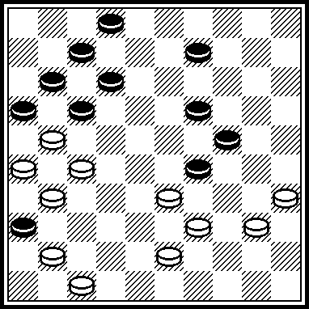 42, 30, 4, 18, 1, 38, 27. De Problemist 01.1944.

D. Kleen
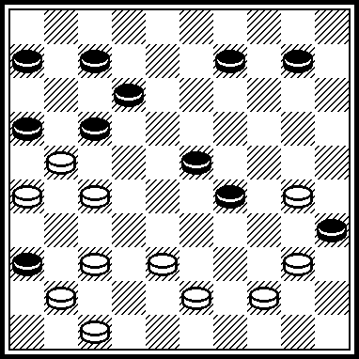 24, 42, 449, 18, 31, 1, 27, 27. Het Damspel-03.1947

With two Black Kings:

L. de Rooij
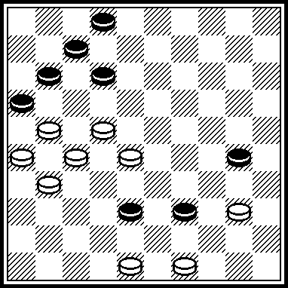 44, 23, 43, 34, 18,1, 43, 27. Damweelde-12.1966.

These partial Resemblances are present because the absence of a Resemblance makes impression that the theme of White King sacrifice under Black King at the diagonal 16-49 is arranged in D10 in the first time.

Partial Resemblances to D42

H. Wilsens
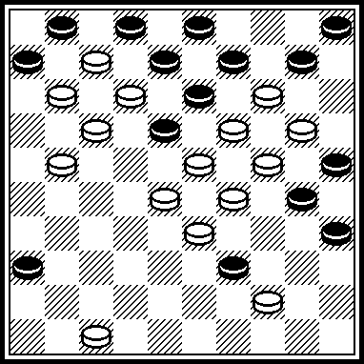 15, 4, 15, 20, 0422, 4, 9, 3, 8, 25, 10, 18(31) 23 etc. Hoofdline, #81-11.2001.

H. Wilsens
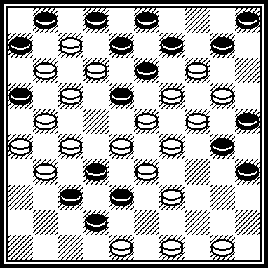 493, 47, 44, 482, 15(34) 4, 15, 20, 21, 23, 9, 3, 8, 25, 10, 45 etc. Hoofdline, #82.

H. Wilsens
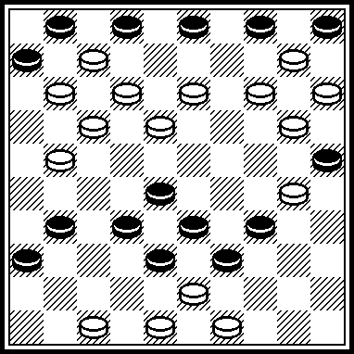 44, 43, 39, 149, 4, 9, 3, 8, 25, 10, 35 etc. Hoofdline, #86.

H. Wilsens
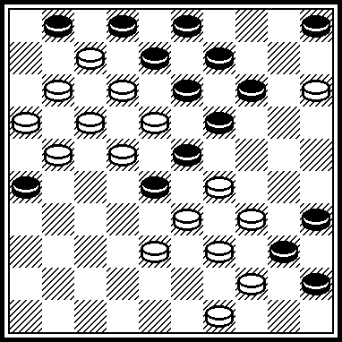 30, 43, 24, 4, 9, 3, 8, 25, 10, 22 etc. Website of H. Wilsens, August 2003.

Le protestation
( Протест)

A.Kuyken:
D6 please think about rehabilitation!

I position by the author II proposed by „observations”.

IA IIA1

IIA2

IB
IIB

I original D6:
Contains two perfect clean mega-motivs:
IA and IB.
No figurant in the motifs at all

II as proposed by “observations Lietuva 2008”:
No perfect motif at all!! Because:
IIA1 becomes at least three solutions, so it cannot be “thematic”
IIB ends by a “enfermé” and added a white piece at 35. Which is not perfect at all, but just “tolerated” by the rules. Piece 35 becomes in the motif a figurant.
II

IIa is a incorrect motif. Because after (40) different winning moves. Not only 35, but also 26 (45) 40 and even 41-37, 26x40/45 would be winning!
So the only motif without “dual” would be IIB. Ending in a position where, at the end, the white piece on 35 becomes a figurant, a statist. Which is “no done” in the Netherlands till now, but which is “tolerated” by the international rules.

IIA1 IIA2

Incorrect:
Duals after (40)

IIB

The only “correct” end-position in II. But:35 is “superflu”, ugly.

I

Contains the two perfect pure motifs:

IA IB

No figurants in the motifs at all !!

CONCLUSION:

+++++++++++++++++++++++++++++++++++++++++++++++++++++++++++++++++
2 actual illustrations
Ericsdamsite
The best compositions

J Gobinsh

1
Na het rücksichtslose 39-33 lijkt het onduidelijk waar de witte winst nog vandaan moet komen. Wel een beetje jammer dat het eindigt met een opsluiting plus een oppositie.

Why “jammer” ? “Dommage”, “a pity” ?
Because at the very end the white piece 43 becomes a “figurant”, a “statist”, not functional for the “enfermé”, for “de opsluiting”.
***************************************************************************
WC Miniaturen 2008

Arne van Mourik

A beautiful forcing. But: Only place 27 in cat D. Why?? Because at the very end, the moving white piece becomes a “figurant, a “statist” on 26 without any function any more

Perfect Analogon: the famous “megaopsluit-motief“ of Zubov
(Erics damsite Zubov nr 8) . Price-winning in Russian contest.

For the combination, 35,45,50 are “figurants”, “statists” .

For the “megaopsluit-motief, 35,45,50 are “functional”

Perfect ANALOGON to D6

D6

For the combination, 40,45,50 are “figurants”, “statists”.

For the 2 thematic “megaopsluit-motiefs”, 40,45,50 are “functional”

Conclusion
OA)When the combination is the principal idea (almost always), “statists” have to be connected by the combination.
OB)When the principal idea is the end, as the item of “megaopsluit-motiefs”(it is more exceptional), “statists” have to be connected by the “final motief”.

So the remark by D6 is the wrong adaption of the right rule.
It is the adaption of rule for the case OA), adapted on case OB).

It is quite possible that the “international rules” are not clear about this item. In that case the rules have to be developed!

L'opinion du jury du concours (l'organisateur avec cette opinion est d'accord) :
Мнение жюри конкурса (организатор с этим мнением согласен):
RI 1.6.2. On parle des "avantages" pour la position finale apparue après la fin de partie, seulement dans l'aspect de la propreté de la position finale. Sur les figurants on dit à RI 1.13. Et 1.13.1. Faites attention sur 1.13.с.
Ce ne peut pas être accepté comme l'argument que quel la position sur quel cela le concours a reçu cela quel cela l'estimation. Les erreurs du jury dans de différentes compétitions – il y a beaucoup de, c'est naturel. Nous examinons l'oeuvre concrète à notre concours.
Non plus on peut accepter les raisonnements sur l'amélioration RI. Cela – non dans notre compétence.

RI 1.6.2. speaks about "privileges" for the final position arising after the endgame position, only and aspect of cleanliness of a final position. About supernumeraries it is spoken in RI 1.13. And 1.13.1. Pay attention on 1.13.с.
That what that the position on what that competition has received what that an estimation cannot be accepted as argument. In different competitions – it is a lot of mistakes of jury, it is natural. We discuss concrete product at our competition.
Reasonings on improvement RI also cannot be accepted. It – not in our competence.

RI 1.6.2. говорит о «льготах» для финальной позиции, возникающей после эндшпиля, только в аспекте чистоты финальной позиции. О статистах говорится в RI 1.13. и 1.13.1. Обратите внимание на 1.13.с.
Не может быть принят как аргумент то, что какая то позиция на каком то конкурсе получила какую то оценку. Ошибок жюри в разных соревнованиях – очень много, это естественно. Мы обсуждаем конкретное произведение на нашем конкурсе.
Также не могут быть приняты рассуждения об улучшении RI. Это – не в нашей компетенции.

