CONCOURS “LIETUVA – 2008”. Categorie D
Observations
Замечания

D1. 1. S.S.: 182,12,8,34,44,39,11,5,12(27),161,3... +.
D3. Dans le finale après 48 – inadmissible des alternations : (10) 37+ ou 483+. В финале после 48 – недопустимые альтернаций: (10) 37+. или 483+.
N4. Ressemblances:
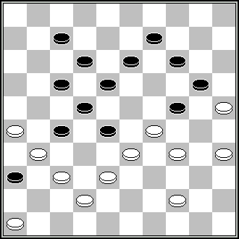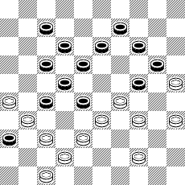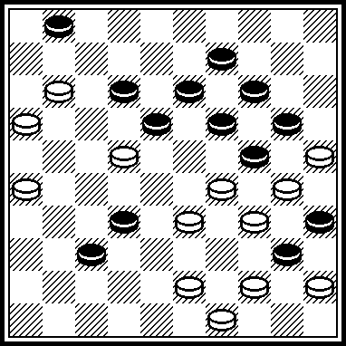
J.Bus, DP, 1962, N1. A.Miedema, J.Bus, P.van der Kwartel and J.Scheijen,
23,30,10,3,41,21,46 + conc. KVD-1961. DP, 1962, N1. 7,18,38,38,21,17,7,40,
23,30,10,3,41,21,46+. 23....+.
D5. 1. SS: 27(15a),240,17,3,30,20,48(11),26(16),43(18),34(27),42(32),48(23),40,38,50+. a. (37):
250(25),43,17,5(12),41,439,38(138),393(27),39,50(37),28(31),19(36),14(361),32(47,36),10(17),24(182),23(28,13),29(35),5(13),328(21),10(26),4(19),293(2),238(8),23(31),15(36),45(830),12(34),29(48),7(37),18(48),47(31),12(26),40(8),2(12),405(23),11(10),50(37),45(5),24(37),23+.
2. Ressemblances:
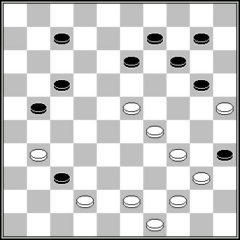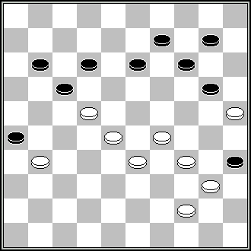
P.Lauwen, DP, 1978, N12. B Shkitkin, Champ. URSS, 1978.
30,19,3,27,1...+. 30,283,19,3,6...+.
D6. 40,45/50 – les figurants (40,45/50 – статисты).
D7. Ressemblances:
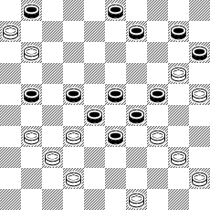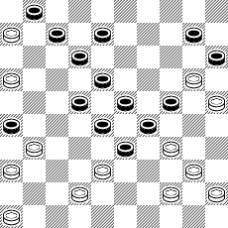
P.Shkludov (П.Шклудов), P.Shkludov (П.Шклудов), champ.Belorus, 1994.
«Zviazda“, 10-11-1993. 11,13(42),41(9),37(31),7(12),30...+.
7,317,8,44(12),30,34,1,44,34+.
D8. Ressemblance:
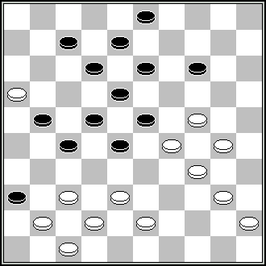
J.Burggraaff, “De Amersfoorste Courant”,
24-11-1982. 19,39,382...+.
D9. 1. Copy. V.Malashenko, DP, 1968, N8. 2. Ressemblances:
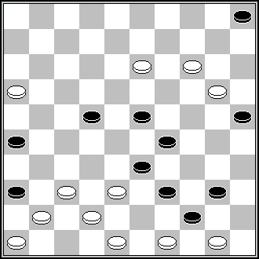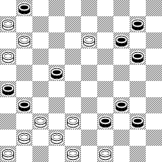
V.Malashenko, DP, 1992, N6. 10(47),4,483, V.Malashenko, conc.’Orenburg-1992”.
10,44,4-9,17,37,36+. 117,1(36),4,483,494,4-9,17,37,36+.
D11. 1. S.S.: 1.1. 35,8,42,4(31),36(37),20,161+. 1.2. 34,171,2,29+. 2. Ressemblance:
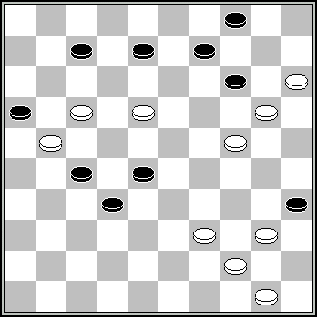
D.van den Berg, „L’Effort“, 1962, N1.
13,10,12,394,4,36,38,48+.
D12. S.S.: 2,5,38,472,4...+.
D14. 1. S.S.: 37,26,48,482(31),34(37,27),39(31),30(22),32(9-13)27(28)32,44(128)304(139,9),24(9-13),240(27,29),20+. 2. Ressemblances :
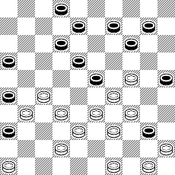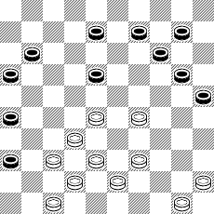
F.Hermelink, DP, 1965, N11. W.Lente, ‚DE Zeeuwse Courant, 31-07-1987.
43,22,7,21,29,41,24,2,39,30,30+. 31,22,21,41,24,2,39,30,30+.
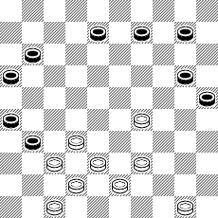
J.J. van Tol, HD, 1988 (?). 41(36),27,31,29,2/3...+.
D16. La solution doit être (видимо, правильное решение) 383,27,427,27,250,28,25,24,14,20,33,3, mais 30 ou 25 + donc dual (но с неточным заключительным взятием).
D18. Ressemblance:
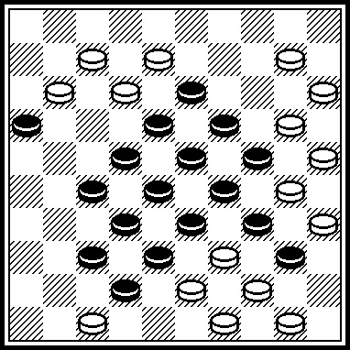
H.Wilsens, site S.Korteling. 5, 5-14, 4, 13, 8, 2, 24, 3, 30, 35, 18, 38, 26, 10, 44, 44+.
D19. Ressemblance:
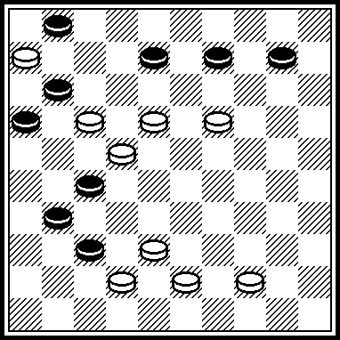
N.Irzhavskij (Н.Иржавский), «Shahki, 1976, N7. 182,5,33,7+.
D20. Ressemblance:
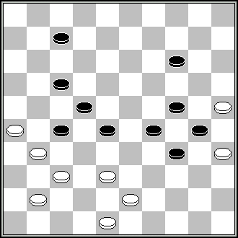
D.de Ruiter, HD, 2001, N9. 21,1,42,32,39,20,24,14+.
D22. 1. D45/D6, 29,34. 50 ou 11/44...+. 2. Ressemblance:
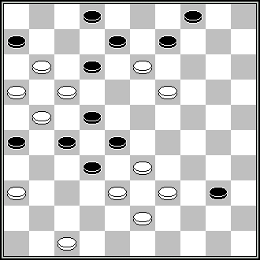
H.J.Simons, DP, 1997, N12. 42,31,34,29,23,3,9,8,23+.
D23. Dual in a combination: 42,43,30,16,8,9,7,40,40,1,15,2(24),35 ...+.
D24. 1. S.S: 31, 41...+. 2.Ressemblances:
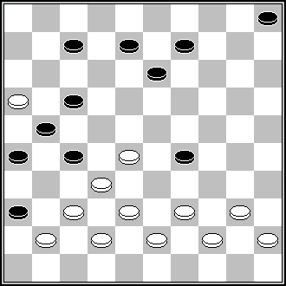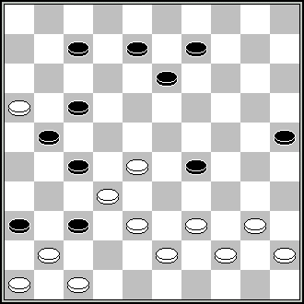
D.Bosma, HD, 1927, N6. L.de Rooij, DE, 1992, N11.
35,31,30,24,18,1…+. 42(48)35,30,24,18,1,6+.
D25. Ressemblances:
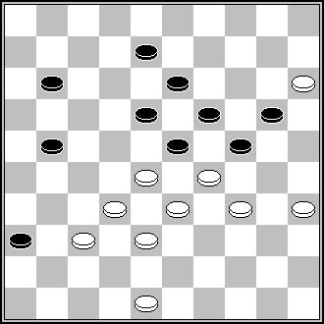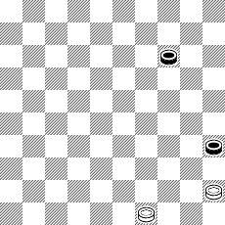
M.Douwes , DP, 1944. A.Mishin (А.Мишин), „Резец», 1926.
31,350,24,19,482,2,47+. 44(19A), 39(24B),34(40),30,34+ A.(20),450,34+. B.(23),33+.
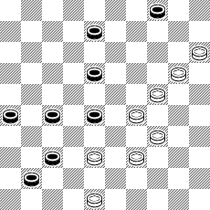
G.Abdulajev, conc. „Orenburg-1992“. 10,393,472,2,36+.
D26.S.S.: 271,31,6(25,8-13,30),338+.
D27. S.S.: 240,31,36,20,15,4,7,28(21),7(12),18(27),13(261),9(37),
22,4(23),10+.
D28. 1. Dans la fin de partie 4/24 SS (в эндшпиле SS) : (9a),19/20+. a.(10),19/20+.
2. Ressemblance:
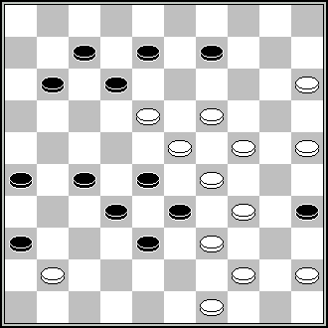
G.Shestirikov (Г.Шестириков), DP, 1986, N12. 43,38,3,21,6 (17),
50,40,24,24+.
D29. Ressemblances:
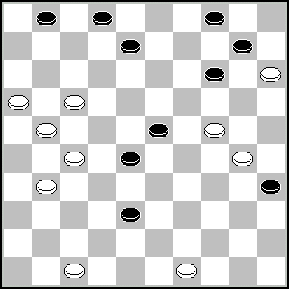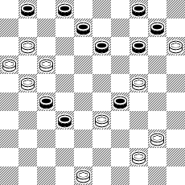
G.Geerlings, Book of Geerlings, 1988. J.Gobins, Championnat de Lettonie (IX).
42,22,33,161,16,7,9,4...+. 34,28,32,19,7,9,4(12),7,42+.
D30. S.S.: 449,38,40,10,3+.
D31. S.S.: 372,20,28,1,20,8,28+.
D34. 1. 282,24,394,39,32,2,7 2:24:15:7+ ou 2:24:47:7+. Le coup du moulin („мельница»). 2. Ressemblances:
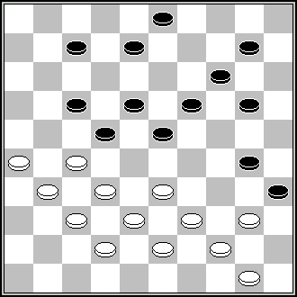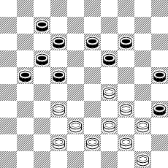
A.Mélinon, „L’Effort“, 1974, N3. N.J. van Hal, DE, 1970, N11.
261,21,328,27,394,39,32,4,9,44+. 27(31),24,33,39,382,2,20,44+.
D35. Ressemblances:
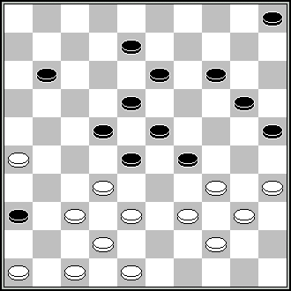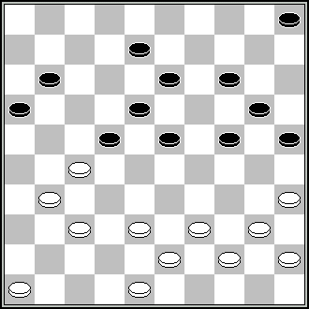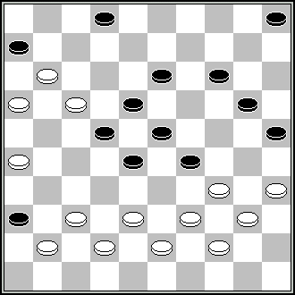
A.P. de Zwart, HD, 1941, N9. J.J. van Tol, DE, 1980, N5. H.J van Alphen, DP,1980,N4.
27,372,43,37,42,41,350,10,3,25,6+. 404(249),450(228),21,372, 12,21,17,7,372,
42,41,350,10,3,25,6+. 350,10,3,25,6+.
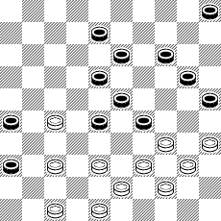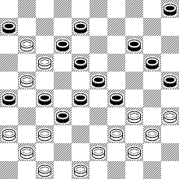
V.Solnykov, Shakmaty v SSSR“, 1987 (?), N6. J.Viergever, DP, 1985,N3. 16,361(36),38,
21,372,482,41,350,10,3,25,6+. 472,372,31(37),482 (ou36), 36...+.
D36. S.S.: 9,19,19,1,4,48,6+.
D37. Ressemblances:
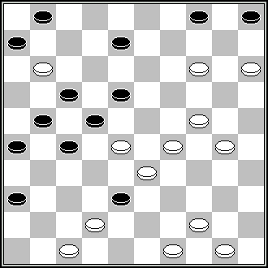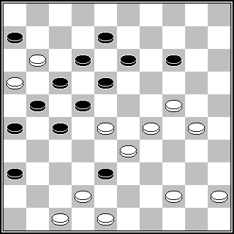
L.Faber. Livre L.de Rooij “Canalejas”, 1988. P.Lauwen, “Eindhovens Dagblad”, 5-12-1970.
9,10,19,45,41,43,3,31,2+. 7,19,11,41,43,3,31,2+.
D38. S.S.: 1. 17,21,29,42,3,6(7),43(12),38(18),50+. 2. 17,21,29,42,3,6(7),494(12), 11(18),40,7+. 3. 17,21,29,42,3,6(7),494(12), 28/33+.
D39. S.S.: 18,7(36),37(21),2(26),16(31,41),383,46+.
D40. 1. S.S.: 427,44,493,482,19, 31,13,3,48,38,25+. 2.Ressemblance:
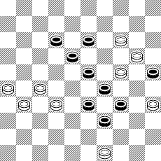
H.Borgman, „HND“, 1977. 43,28,19,13,3,17,33+.
D43. S.S.: 44,30,26(31a),46,30,20,1,47 + a) (34),30(25),20...+ .
D44. S.S.: 37,23,3,8,41,2(24),30(14),25(49-27a),3(31b),11(227),
16(32),43... +. a.(19),30(16),14(227),13+. b.(36),26(41),31+.
D47. Copy. M.Tsvetov (М.Цветов), site http://www.shashki.com, “Novyjie problemy”, 02-07-2006.
D49. Ressemblances:
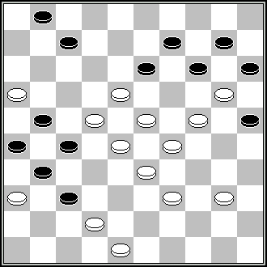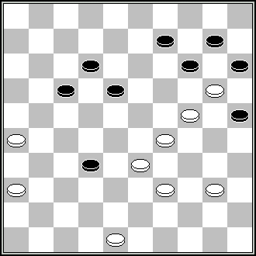
J.van Kollenburg, HD, 1961, N4. J.Leblanc, DP, 1993, N10 (?).
17,22,27,31,12, 350,10,3,25,6+. 21,31,42…+.
D51. Ressemblances:
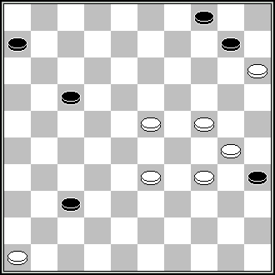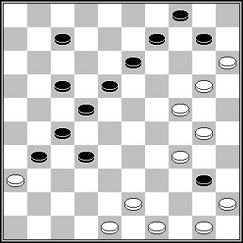
G.Dumas, Conc. “Amicale 1995”. D.Vuurboom, VW, deel 27, 1991.
41,339(14)20,9,4…+. 494,43, 40,25,14,21,9,4…+.
D52. Ressemblance:
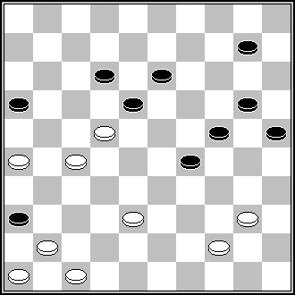
M.Sabater , “Leninska Zmina”, 4-1-1983. 42,33,30,3,31…+.
D53. S.S.: 36(30,30),24,35,438,23,7(33),31(30,40),11(45),6(50),20(339),2(18),1(9-14),43(25),32+.
D54. Ressemblance:
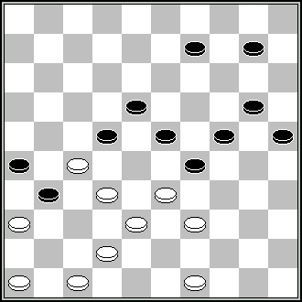
J.van den Boogaard, “De Maasbode”, 23-1-1954. 37,31,44,15,30,33…+.
D55. S.S.: 1. 16,15,4,7, 4-18(27),36(11),7,27+. 2. 16,15,4,7,17,4:27:49:40:18,46+.
D56. Le finale 2,36/В46 est inadmissible selon RI (финал 2,36/В46 недопустим по RI).
D58. 1. Copy. S.Ustjanov (С.Устьянов), conc. « Retro – 2004 », cat.C. 2. Remise (ничья): 30,12,45,461,37,33,20(16)17(11,15)14(21)=.
D59. Ressemblance:
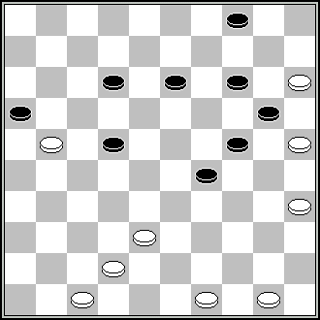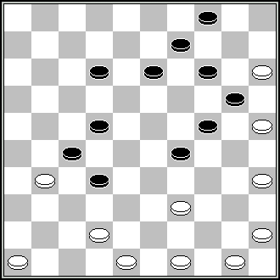
L.Colier, “Vrienden”, 10-1-1944. DP, 1966, N5. 38,483,41,39,38,30,24, 40,10,3+.
37,31,41,494,30,24,40,10,14 +
D60. Ressemblance:
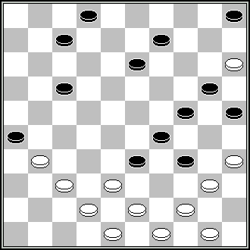
A.Hlasny, livre A.Hlasny „500 problèmes“, 1997. 372,439,30,39,40,38,8,2(14,14)44+.
D62. 1. S.S.: 30, 361,483,30,44,36,2,16...+. 2.Ressemblance:
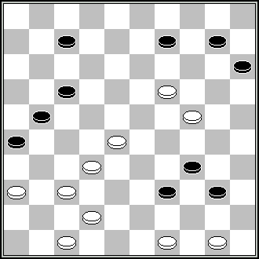
C.vd Sommen, “Eindhovens Dagblad”, 18-2-1967. 43,44,41,371,2,31,20,5+.
D63. Ressemblances:
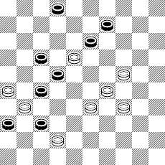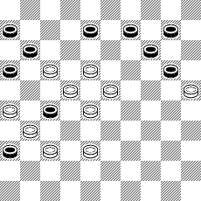
J.C.Vink, HND, 1981. L.Faber, conc. BVLD (SLSI) 1994/1995.
23,28,3,8,27,37+. 382,21(16:27),172,19,5,7,13,22+.
D66. S.S.: 1. 504(50),4,7,42...+. 2. 13,36,2,13,35+.
D67. Ressemblances:
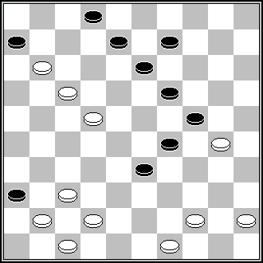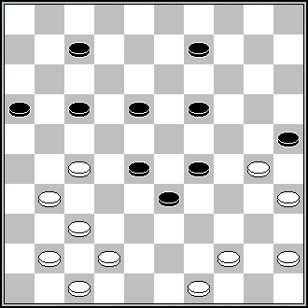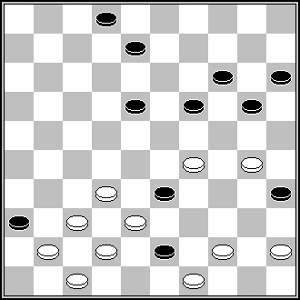
J.Bus, “Keessen de parel damspel”, J.van den Boogaard, DE, A.Hlasny, livre
1966, N2.12(828)38,42,43,3,8,12+. 1972, N9. 21,38,42, A.Hlasny “500 problems”,
43,3,1(39)34,24+. 1998. 294,27,38,42,43,3,12+.
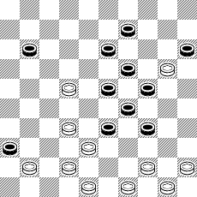
(?), DP, 1985, N4. 28,30,43,3,12,22-18,40,6+.
D68. Ressemblance:
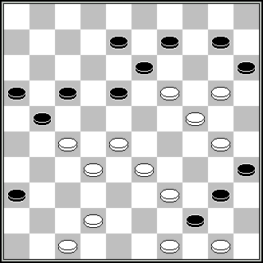
J.vd Wal, “Het Algemeen dagblad”, 20-1-1993. 194,23,43,41,45,14,19,8,3,12+.

Avec tous les remerciements pour leur aimable collaboration a (спасибо за сотрудничество, предоставляя свои замечания): Mrs.A.Tavernier, A.Gimbutas, S.Zilevicius, S.Yushkevitch, L.Vitoshkin, A.Vermeulen, I.Ivacko, G.Dumas, P.Shkludov, A.Timmer, S.Rezel.

On peut expédierles les remarques supplémentaires jusqu'à 12 – 08 – 2009 selon 2.8. RI CPI FMJD aux adresses (дополнительные замечания можно отправить до 12 – 08 – 2009 согласно 2.8. RI CPI FMJD по адресам):
kaciuska@splius.lt
ou (или)
A.Kaciuska,
Architektu 38 - 21,
78263 Siauliai,
Lietuva – Lithuania
Les remarques supplémentaires par la poste traditionnelle sont reçues plus tard 01 – 09 – 2009 ne seront pas examinés( дополнительные замечания по традиционной почте получены позже 01 – 09 – 2009 рассматриваться не будут).

A.Kaciuska,
Siauliai, 11 – 07 - 2009

