Konkursas “Lietuva – 2003”. A kategorija. Miniatiūros

Concours “Lietuva – 2003”. Categorie A. Miniatures

1
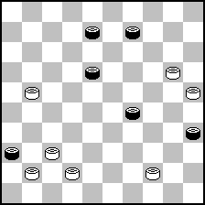

6
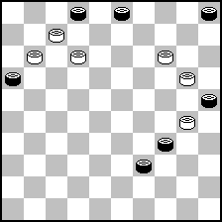

11
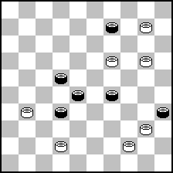

16
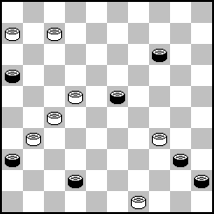

21
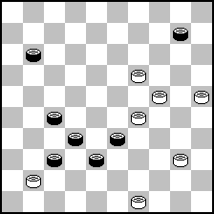

26
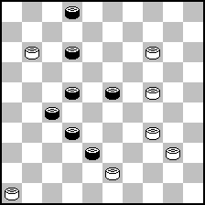

2
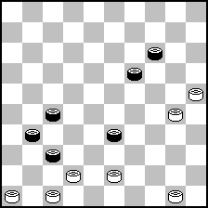

7
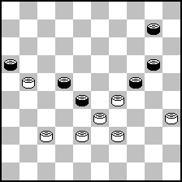

12
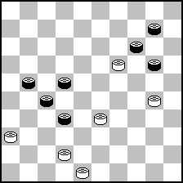

17
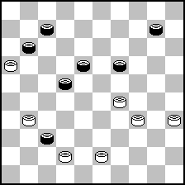

22
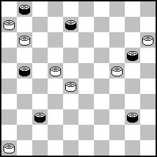

27
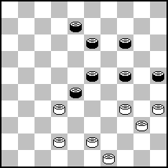

3
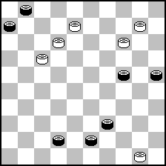

8
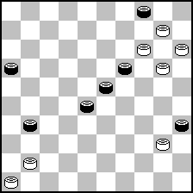

13
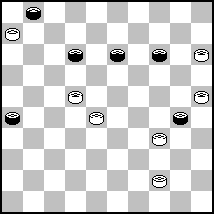

18
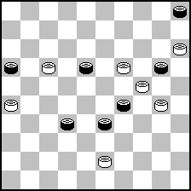

23
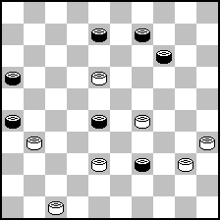

28
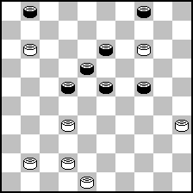

4
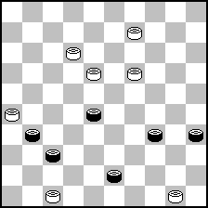

9
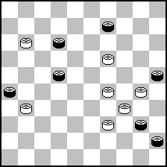

14
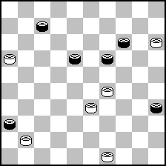

19
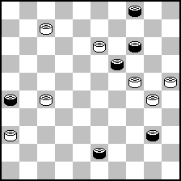

24
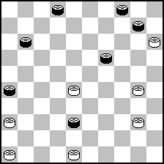

29
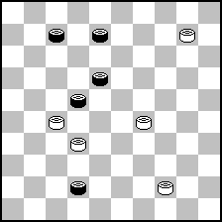

5
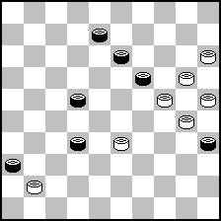

10
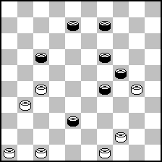

15
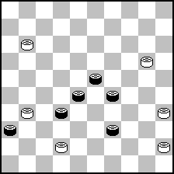

20
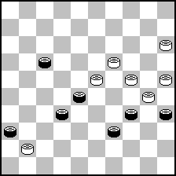

25
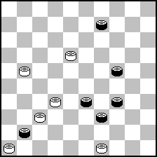

30
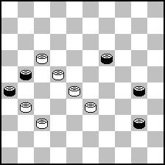

31
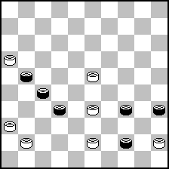

36
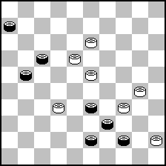

41
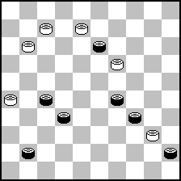

46
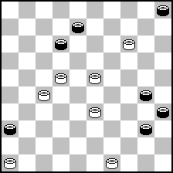

51
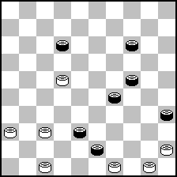

56
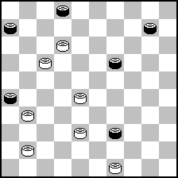

32
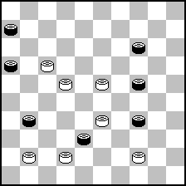

37
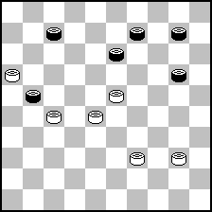

42
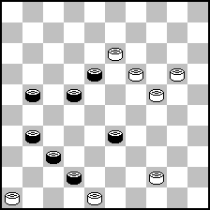

47
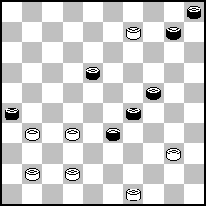

52
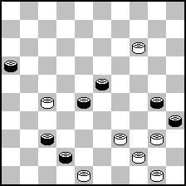

57
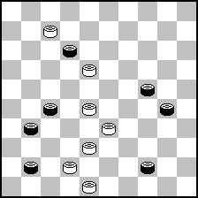

33
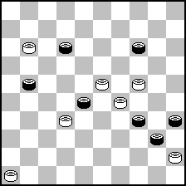

38
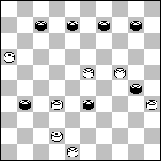

43
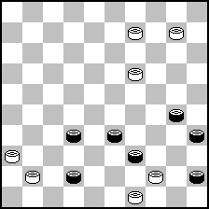

48
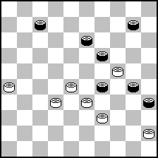

53
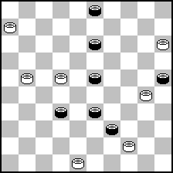

58
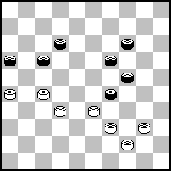

34
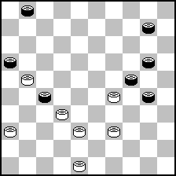

39
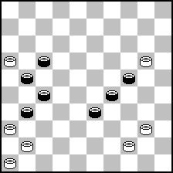

44
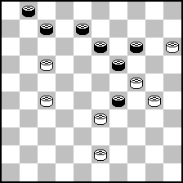

49
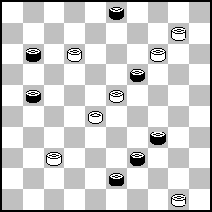

54
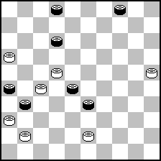

59
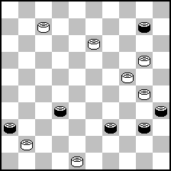

35
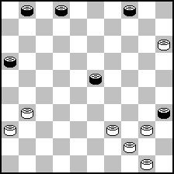

40
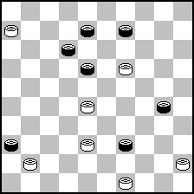

45
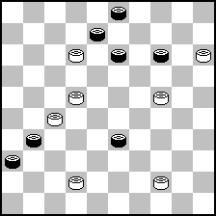

50
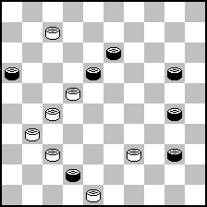

55
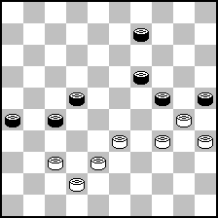

60
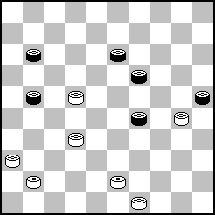

61
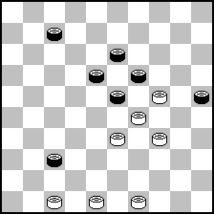

66
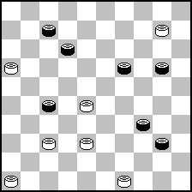

71
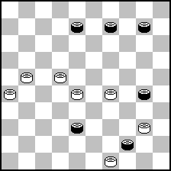

76
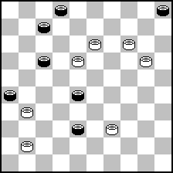

81
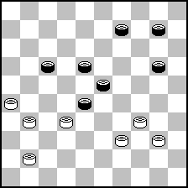

86
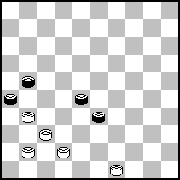

62
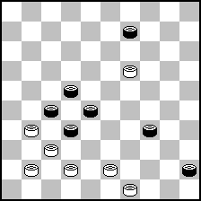

67
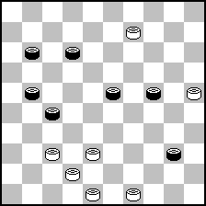

72
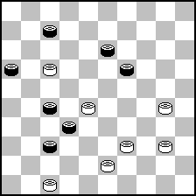

77
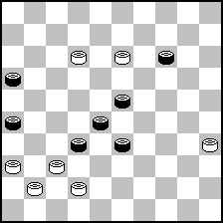

82
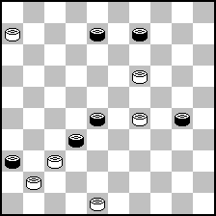

87
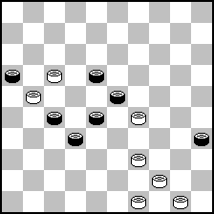

63
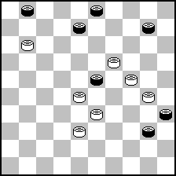

68
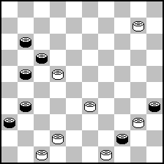

73
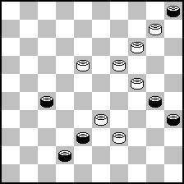

78
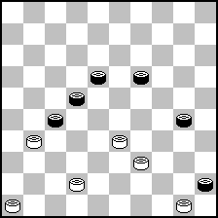

83
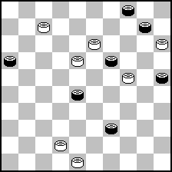

88
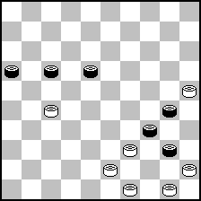

64
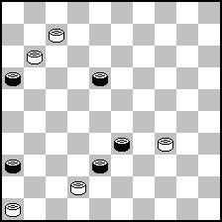

69
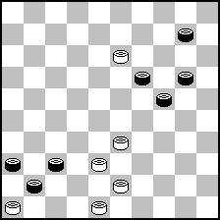

74
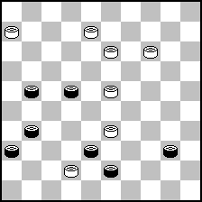

79
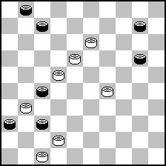

84
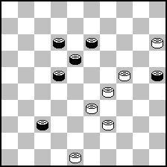

89
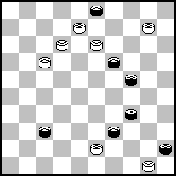

65
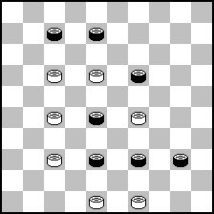

70
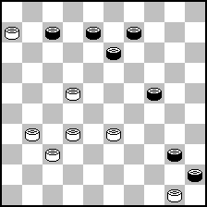

75
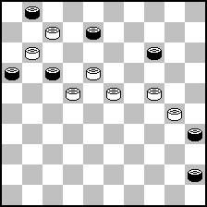

80
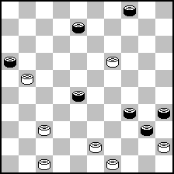

85
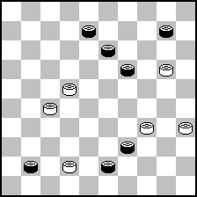

Konkursas “Lietuva – 2003”. B kategorija. Etiudai

Concours “Lietuva – 2003”. Categorie B. Etudes (fin de partie)

1
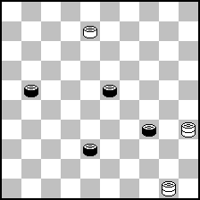

6
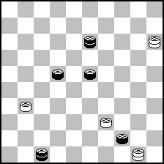

11
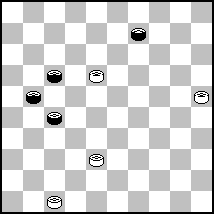

16
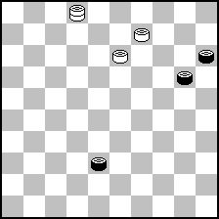

21
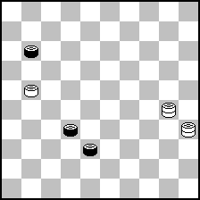

26
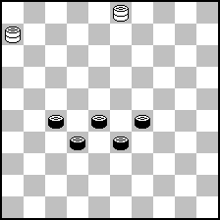

2
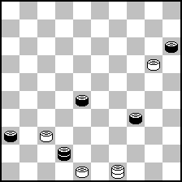

7
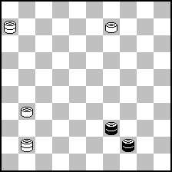

12
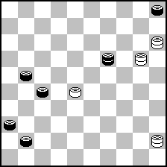

17
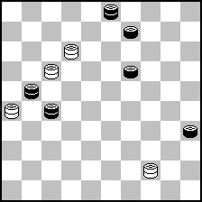

22
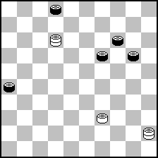

27
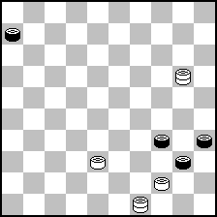

3
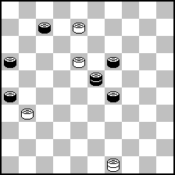

8
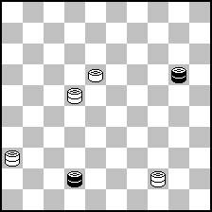

13
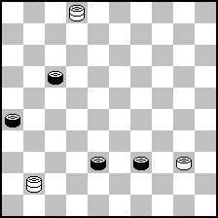

18
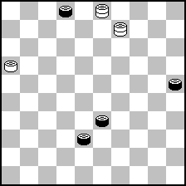

23
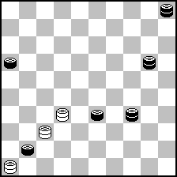

28
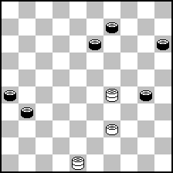

4
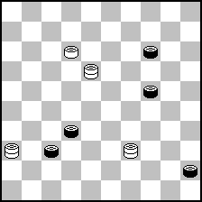

9
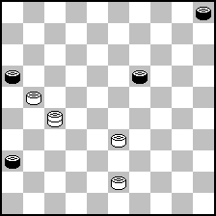

14
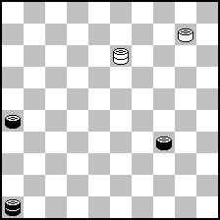

19
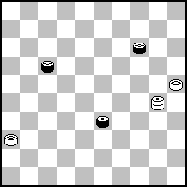

24
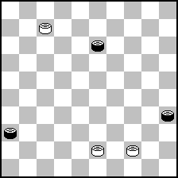

29
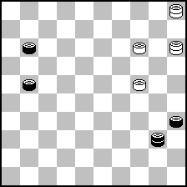

5
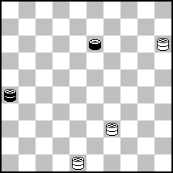

10
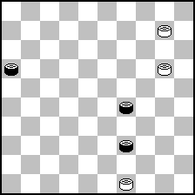

15
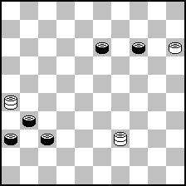

20
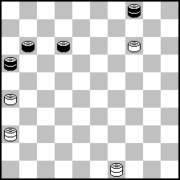

25
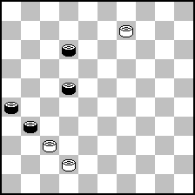

30
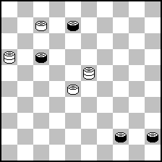

31
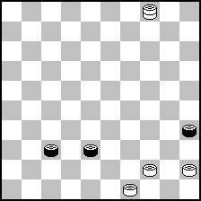

36
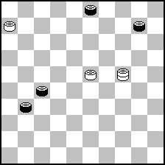

41
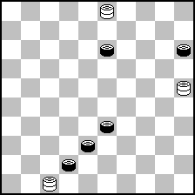

46
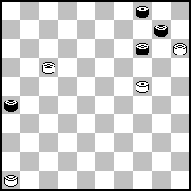

51
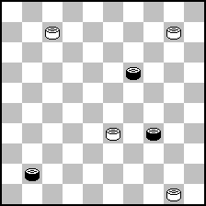

32
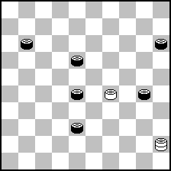

37
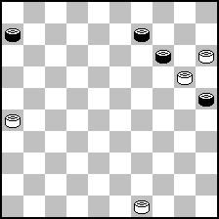

42
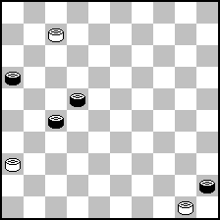

47
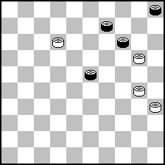

33
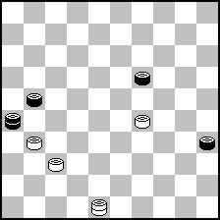

38
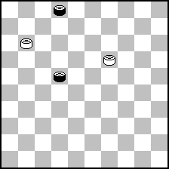

43
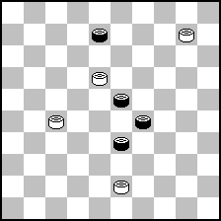

48
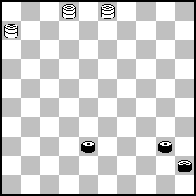

34
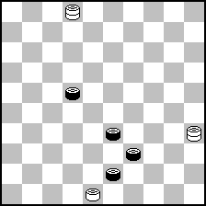

39
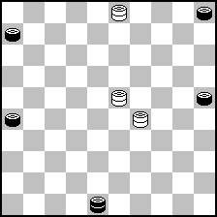

44
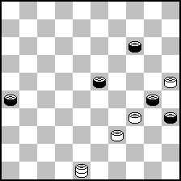

49
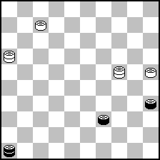

35
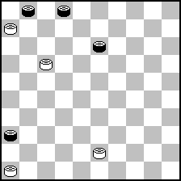

40
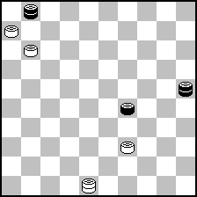

45
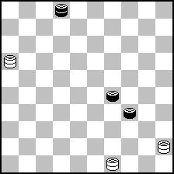

50
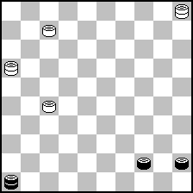

Konkursas „Lietuva – 2003“. A kategorija. Miniatiūros
Concours „Lietuva – 2003“. Categorie A. Miniatures
Teisejai (juges), dalyviai (participants), autoriniai sprendimai (solutions d‘auters)

Teisėjai (juges): A.van Mourik (Pays – Bas), A.Nagumanov (Russie), S.Žilevičius (Lituanie).
Dalyviai (participants): A kategorijoje dalyvauja (en categorie A participent):
- Prancūzija (France) – 10 dalyvių (10 participants): H.Cordier – 1, G.Dumas – 2, F.Laurent – 1, J.C.Patry – 2, R.Quters – 2, S.Rezel – 2, M.Sabater – 2, A.Tavernier – 2, A.Vermeulen – 2, F.Volan – 2.
- Lietuva (Lituanie) – 9: V.Bieliauskas – 2, N.Comik – 1, D.Janulevičius – 2, A.Jovaišas – 2, A.Kačiuška – 2, J.Leišys – 2, V.Masiulis – 2, B.Morkus – 2, J.Šiožinys – 2.
- Ukraina (Ukraine) – 9: M.Fiodorov – 2, I.Ivacko – 2, I.Kobcev – 2, V.Kozlov – 2, M.Levandovskij – 2, A.Maslov – 2, V.Nikitčuk – 2, S.Ustjanov – 2, A.Uvarov – 2.
- Baltarusija (Belarus) – 6: V.Grebenko – 2, B.Ivanov – 2, P.Kožanovskij – 2, A.Liachovskij – 2, V.Šulga – 2, L.Vitoškin – 2.
- Latvija (Lettonie) – 3: G.Andrejev – 2, J.Gobinš – 2, U.Rikmanis – 2.
- Olandija (Pays - Bas) – 3: W.Riemens – 2, M.van Rooij – 2, L.Springer – 2.
- Rusija (Russie) – 2: V.Matus – 2, B.Ručkin – 2.
- Italija (Italie) – 1: B.Cataldi – 2.
- Izraelis (Israel) – 1: M.Cvetov – 2.
- Šveicarija (Suisse) – 1: A.Kuyken – 2.
- Vokietija (Allemagne) – 1: J.Bus – 2.
Iš viso (en total): 46 dalyviai (46 participans), 89 miniatiūros (89 miniatures).
Autoriniai sprendimai (solutions d‘auters)
N1. 14,34(43),39(48A),33,34+. A.(49),30,34,32,34+.
N2. 46-41(39),24,43(19A),39,39(23),33(28),22,37,38+. A.(36),37(19),39,39(23),33+.
N3. 50-44 39:50,10-5 50:11,12-7 11:10,5:48:2+.
N4. 47-42 37:48,26:37 48:23,18:40 35:44,50:48+.
N5. 10, I.4, 38,2,24,14+. I.15?,23,4(27),31(38),48(30),25(42)=.
N6. 10(5-14A),9,8,2,I.50(40BC),22,39,50. B.(39,14),24+. C.(18,22),34(27),28(20),33(32,37),47. A.(25-10),19,1,43(7D),14(12),34(17),39(21),43(26),48. D.(9),34(14/13),10/8. I.44?(40)=.
N7. 39-34 28:30,37-32 24:42,35:4 16:38,4:48+.
N8. I.9(44),14,4,II.49(36),4,III.41,497(22),27(33),42(21),16(39),49+. I.34?(29),34:32(36),23(47),5(40=).
II.50?(36),4(47),41(36),502(18),27(29=). III.15?(283=).
N9. 29-24 40:20,29-13 25:43,13:4 26:37,4:17 45-50,11-6 50:11,6:17+.
N10. 42(47),43,41,21(40),45+.
N11. 4(37),34(48),44-39(33),27,38+.
N12. 25,5(38),26(47),26-31(15),4(20),42,15+.
N13. Z.20(50),7(12),17(11),8(31),2(37),24(41),19(47A),24,24+. A.(46),5+. Z.17?(50),10(22),4(28=). Z.29?(128),34(27),24(261),20(25),10(36),22(18),5(13),12(41),23(47=). Z.39?(31),20(25),10(37),5(41),29(47=). Z.10?(50),17(31),11(45),20(37),14(42=).
N14. 44,24,22(12a),11(17),18,13(11b),8(16c),3Y(19),12(24),39(30d),8(21,40),17(45),34,50+. d)(21,40),34,8(30,33),30(38),48+. c)(20),2(16),7(21),29(25),38(26),42(30),48+. b)(19,11),19(17),13(22),8/9(28),3(33),25(38),48+; (20),8/9(24),3(29),17(34),12(350e,39),34,24+. a)(19),17(24),171(29f),2(33),24(39g,40),13(44),22+. g)(40),38,27,27+. f)(12),6(18),1(22),23(27),11(31),32(29),7(40,33),1(39),34+. e)(39,11),18(17),28(21),22(26),17+.
N15. 40,34,31(37),38,15(29A),7Y(31),2Z(36B),10(41a),19(47b),4,23+. b)(33),46,37,5+. a)(33,41),5(47),5-19+.
B.(37),32,10(32c),4(34),31(40),11(45),50(38),48+. c)(283),4(39),30P(44),39,15+. P11(43),39,15(40),33(45),50+. A.(31),10(29),5(34),6/7(40),1(44),6(49),28,6+. Z.10?(33,37)=. Y.10?(34),5(40),28(31)=.
N16. 349,494,072,028,082(450A),227,067+. A.(161),220(217),061(272),019(327),297+.
N17. 23,1(27),13,7(41),2(14A),9,8,46+. A.(46).23,5+.
N18. 14,25,3(10a),4(338),27,I.21(49),27,17+. I.32?(17,38)=. a.(338),39(42),10,47+.
N19. 20,9(13),2,32(39),38(31A),33(28),22,27+. A.(44),49(50),44,27+. Legalumas(legalite): 4,19,23,26,40,43/7,8,9,13,22,24,25,27,30,36. 18(40).
N20. 14,4,15,45,34,34+.
N21. 250,43,38,204,5,2,48+.
N22. 10,41,5(23),16(34A),7,2(45),39(50),17(11),8+. A.(45),7,17,2(50),11(45),1+.
N23. 12R1(17A),33,11,41,23,34,4(12B),15(17),42(21),26(27),3(19),9(32),4(23),15(28),42+. A.(37),3(33C),34(30/42),24/38,38/24(13),20a(41),19,36+. a.(19),(41),8(46),3+. B.(19),18(11),22(16),27 si (24),38(30),43(35),49(21,40),11(44/45),50+, si (23),38(28),27/49(33),43(21,39),49+. C.(37,43),23/24(48),19,41...+.R1.23?(19).32,34,4R2(21),42R3,R4(33),13,22(38,26),29(20),17(25) si 22(24,24)=, si 28(30,35). R2.2(33),7(13,39)=. R3.12,22(32),11(38),16(42,48)=. R4.15(13,33)=.
N24. 34(8A),29(13B),42,25(24),31,41.20,9,4(16),27+.A.(17),29(14),29-24(21,9,27,37),31,23(31),41(7),18(11),
12(16),7(21),2(36),37(27),16(32,41,46),32(19),24,10(34),5(39/40),28-23+. B. Si (14),42,29-24,2+, si (12),29-24+.
N25. 43,28,19+.
N26. 11-6 38:49,34-29 49:5/10,29:7 2:11,6:37 5:41,46:37+.
N27. 35-30Z,30:10,40-34,10-4(13-19),4-13(39-44A),13:30,49:18+. A.(25-30),13:35(23-28),35:2(28-32),2-24(32-37).24-47+. Z.34-30?,30:10(44),34(50),44,24(29,30),4(35),18(13,40)=.
N28. 32-27Z,14-9(30),35:24(19),24:22,48-43(28AB),33(7),2(36),2:24(36:20),39(24),34+. A.(7),2(36),2:32(36:18),38+. B.(29),39(19),17+. Z1.9?(30,7,22-28:46)+. Z2.7?(12),9(30,29,28,18:36)=. Z3.28?(33),9(30,19,4:13)=.
N29. 44-39 22:31,32-27 31:22,4 48,4-13 48:23,13:5+.
N30. 28-23 19:39,37-32 26:28,22:24 21:12,24-19 12-17,19-14 17-22,14-10 22-28,10-5 28-33,5-32 33-39,32-49+.
N31. 43-39 34:43,36-31 27:47,16:40 47:18,40-34 18:40,45:34+.
N32. 44-39Y 38:37,39:10 31-36A,41-37 27-31B,37:26 36-41C,26-21 16:27,10-5 41-47D,05-32 47:11,32:07 16-11,07:16+. Y.44-40? 38:37,40:09 31-36,41-37 27-31,37:26 36-41,42-37 41:32,09-03 06-11,17:06 32-38,03-14 16-21,26:17 38-43=. A....27-32,10-05 31-36a,05:37 36:38,37-48 16-21b,17:26 06-11,26-21 11-16,21-17 16-21,17:26 38-32,38-42 ou 43,48:37 ou 39+. Aa....31-37,42:31 32-38,05-23 38-42a‘,23-18 42-47a‘‘,18-27 47:36,17-11,27-04 36:27,4:31+. Aa.‘...38-43,23-12 16-21,17:26 43-49,12-07 49-16,07-02 06-11,41-36 11-17,02-24 16-11,24-38 17-22,26-21 11-02[si(11-06)?,38-27(22-28),21-17(06:22),27:18(28-33),18-34(33-38),34-48+],38-32 02-13,21-16 13-02,31-26 02-07,28-43 22-28,43-39 28-32,39-43 32-37,43-48+. Aa‘‘...42-48,18-12 48:26,12-03 26:12,03:26+. Ab....06-11,17:06 16-21,06-01 21-,01-29+. B....27-32,37:28 36-41,42-37 41-23,10-05 23-29,05-28+. C....06-11,17:06 36-41,42-37 41:32,10-05 32-38,05-32 38:27,06-01 27-32,01-29 32-37,29-47+. D....41-46,17-11 06:17,42-37+.
N33. 6,1,9(44),22(50A),6(40,45),17(41),37,32+. A.(27),50,45,47+.
N34. 34,5,37,5-32(7,43),16(48),361(25),43,26,37+.
N35.27(29),394Z(33),29,34(8),29Y,X,40,28(7),23W(13),31(11A),15V,18(21),26(27),13(17B),9,10(19),4(22),21,27(24),38(30),43(35),49(21,40),11(45),50+. B.(32),9,10(18),4(23),27,6(28),1(32),29(37),47+. A.(12),22(21),26+.V.22?(21),26(18,27),1(32)=. W.31?(11),272(13),23(21)= comme V. X.39?(13),33(7),30(19),44(12),31(18),26(183),261(28,29),18,12(33),7(38),1(29),45(42),1(48a),17(24),172z,y(29),127(33),2(38),24(482),24-2(47)=. z.11,20(43),22(25),47(30),17(9)=. y.22(250),172(9),17(13),127(21,2)=. a.(47?),17(194),39+. Y.31?(7),29,40,28(11=) comme W. Z.31(1-7),394x,w(33),(35:44,49),26,17(12,13)=. x.22(11b),27(8c),18(22,2),394(33),29,34(8),29,40,28(12),272(21),17(27,31),2(37),24(41),23(9),249(14,47)=. b.(12?),394(33d),29,34,29,18+. d.(21,27),10,5(33),32(10,38),23(17),26+. c.(17,7),394(33),29,34,29,40+. w.26(8),394(33),39(35:44),28(21)=. T.29,34(8),29,40,28(11)=.
N36. 40,19,12,2,49(11AB),27,35+. A.(26),44(11C),6(31),27,25+. B.(35),44(26),27+. C.(31),27,17(34),44+.
N37. 33,11,2(29),4(34),22,50+.
N38. 32-28 33:22,16-11 30:28,11:15 31-36A,15-10Z 36-41,42-37 41:36,10-4 22-27,4:36 32-37(...28-33,36-41 32-38,41-47+.),36-47 28-33,47:24 37-41,48-42+. A....28-33,42-38 33:42,48:26 22-28,15-10 28-33,10-4: a....33-38,4-10 38-43,10-28+. b....33-39,4-22 39-34,22-28+. Z.42-37 22-27,15-10 28-32,37:28 36-41,10-5 27-31=.
N39. 34,38,37(42a),31,47(22A),42(27),37(41),31,37+. A.(21),46-41,37+. a.(41),26(31),37(27),37-31(22),11(32),27+.
N40. 22(27),1(47),3(13),30,40,40+.
N41. 3,26-21,2,19,46(39A),28(43B),39,20+. A.(33),32(34-39),17+. B.(33),25+.
N42. 43,41,449,48(254A),20,39,39+. A.(13),39,39(18),20(22),14(28),10(32),5(38),37+.
N43. 40(44A),40,37,40(43B),9-4Z(49C),5(35),15(34),24(350D),29,45+. A.(34),37,40,40+. B.(35),34,3(40),17(45),50(34),5+. C.(48),5(42a),15(26b),47(3)[si(17),35(34),29+],35(34),30,14,15+. a.(43),15(21)[si(16),47+],35(3,20),13(47),19(36),4+. –(26),34,31,50+. –(35),15,42,50+. –(39),34+. b.(47),35(34),13(39),30+. –(31),35(34),29+. D.(49),38,40+. –(340),194,45+. Z.10-4?(49)=. -10-5?(35),34(48),29(34,44)=. -3?(48),194zyx(42),26[si 4 ou 5(29)=](15),4(34)=. z.5(42),26(15),48(24)=. y.4(35)=. –x.25(35)=. -35?(48,42)=.
N44. 25,25-20,18,11(6),7+.
N45. 19,10,5(39A),41,42(28B),38(9m),10(19),4(32),30,48+. A.(9m),37(28m),3(38),33(41),12(47),28(41),22+. B.(19),10(24),4(28),38+.
N46. 10,41,44,2,16,17(40),39(45),50+.
N47. 42-38 26:46A,40-34 46;3,34:12 3:43,49:20 10-15,20-14 14-20,14:25 5-10,25-20+. A.(26:28),9-4(33:42),4:47(10-15),41-37(15-20),47-36+.
N48. 40,23,5,2(18),7(22),11(28),17(32),39(37A),28(42),37,37+. A.(38),48+.
N49. 44,5,32,9,5:32:26+.
N.50. I.34(29A),II.27(18:36B),1(16:27C),31,31,37+. A.(39),21(18:36D),2(27E),III>15,10(32,41),37,42+. B.(16:36),1(27),31,31,37+. C.(31),18,23(32,41),37,42+. D.(16:36),2,15,10(32,41),37,42+. E.(31),15,10(32,41),37,42+. I.1?(45),14(47)=. II.26,37 (21,27),11z(18),6y(35),6-1(294),6(340),50(45),43(40),43-39(44),33(25,50),2(23=). III.47(24)=. z.7-1(304),6(40),50(45),161(33,50)=. y.2(24),11-7(294),1(32)=.
N51. 18Z,42,38.40,10(33AB),4(39CDE),13(29),18(33F),22(38),44(43),49(48),361(39...),43,26,37+. A.(34),4(40a),22(45bc),50(29d),371 ou 372(33),28(50),27,27+. a.(39), 13 idemVTP+. b.(29),371 par exemple+. c.(30),371 par exemple+. d.(30),371 par exemple (38),27+. B.(30),4(ad.lib.),22 par exemple+. C(38),32 par exemple+. D(29),15 par exemple+. E.(30),22 par exemple+. F.(34),40(43),49 idem VTP+. Z.40,48(34),44(30),361z(43,43),39,26+. z.39,39(34,43)=.
N52. 21,394,31(44A),39,37(28B),9(32C),(31),3(36ou37),26(41),37,33+. A.(26),37,39 idemVTP+. B.(31),(28),10 par exemple (32),5 par exemple+. C.(31),(32),33 par exemple (37),4(ad.lib.),10+.
N53. I.15-10 39:50,10-5 25:34,5:8 50:26,6-1 3:12,1:37 26:42,48:37+. I.22-18? 23:12,6-1 39:50,1:4 25:34,15-10a 34-39=. a.4-27 34-40=.
N54. 20,14,38,37,7,7(31),2(9),3(36),26(41),37,24(37),47+.
N55. 28,20,31,25,4(32),15(37),47(19),20(23),15(29A),24(41),19(46B),5+. A.(28),10(33),15(41),47(46),5+. B.(47),24,24+.
N56. I.23,5(43),7(22),32(28A),38(46B),32,17+. A.(10),11,38+. B.(50),33+. I.27?(24),33(43,30)=.
N57. 32(47A),I.2(32),16,47(34),20(39),25(44),39,43+. A.(29),1,47+. I.1?(32),42,47(34,II.39=). II.(40?),33(45),50+.
N58. 40-34,32-28,23,11,8(12,19),12(23),8(28),3(32),26(38),33,8(33A),30+. A.(30),35(33B),30+. B.(34),44+.
N59. 7-2 36:47,20-15 47:20,15:4 35:24,4-9 20:3,13-8 3:26,2:37 26:42,48:37+.
N60. 24z(30A),18,28,38,37,7(30-34B),1(30),43y(35),39,48(40),39(45),50+. B.(33),1(35),43+. A.(20),18,28,38,37,7(23),1(28),43+. Y.7?(35)=. z.31,32-27,17,39,9(33),3(38),8(24,42)=.
N61. 28(39),8(12),17(22),28(30),49-43(44),41,39,50+.
N62. 13,4,40,39,38+.
N63. 7,28,14,2,8,22+.
N64. 41(387),29,1,15+. A.(367),29,33,1,34/40/45+.
N65. 182,483,272(12),2,23(45),40,44+.
N66. 44zy,11(41),2x,25,48(28),37,37+. z.5(204,45,34),44(29),37-32(31),39,49(34),23(40)=. y.4(45),31(50),26(17),33(39),15(40)=. x.46:37(16),5u(32)=. u.4(32),15(41),26(46)=.
N67. 37-31 27:36,49-44 40:49,25-20 49:4,20:27 4:31,42-37 31:42,48:37+.
N68. 41,5,6(50A),1,45. A.(34),50(45),494.
N69. 29,4(427A),15(372),46,438,26,37,42. A.(417),15(371),46,438,26,37,42.
N70. 44I.,18,31(50AB),1,6,50. B.(44),1,50. A.(39),1,50. I.1?(29),14(18II.),27(44,50),34(11),31(7),26(1)=. II.(36?),28(44,50),26,6.
N71. 24(19),23,5,44(40a),35(43),28+. a.(43),39,28+.
N72. I.17-11 32:23,11:2 37-42,47:38 19-24,2:21 24:42,43-38 16:27(…42:33,21-43+.),38:47 27-33,47-42+.
I.28-22? 27:18,17-12 37-41,12:14 41-46,39-33(47-42 32-38,42:33 46:10,47-41 46:37 14-10 37-46)32-38.
I.28-22? 27:18,17-1116-21,11:2 19-23,2:28 32:23,30-25 21-27,25-20 27-31,43-38 37-42,39-34 42:33. Legalumas (legalite): 4,7,13,16,27,32,37/14,17,30,33,39,40,43,47. 14-9 13-19,33-28 4:13.
N73. 14-9 5:12,9-4 38:20,4:48 35-40(…30-34,39:30 35:24,48-25+ …20-25,39-34 30:39,48:7+….20-29,39-34 30:39,48:17 35-40,17-6 40-45,6-50+.),39-34 30:39(…40:29,48:17 29-34,17-44+.),48:17 40-45,17-50+.
N74. 339,083,035,451,061(272),019(327),297(371),476+.
N75. 6z(19),2(23),7y(24),3(50),17,17+. z.2?(19),243(7),11(19),50(24),12(6)12(6)7(29=). z.12(19),2(24),30(50A),6(21),2(27),11(32=). A.(6),12-8(17),3(50=). y.1?(24),3(50=).
N76. 33(46),11,15,4(8),2(42),11,12,48+.
N77. 38,38(31A,B),13-8(37C,D,37),32,3(21E,F),20Z(27G),42(27-32),31(38),8(43),3(49H),18,44,44. H.(48),3-26(25),30(43),22,48+. G.(26),47. F.(19),7(32),26(21),24. E.(32),20(37e),14(29),41 ou 46(33),8(39),28(43),3. e.(21),14(28),7(33),37(39),1(43),48(49),39. C.(29),3 comme A. D.(36),37(29d),2(283),31,13. d.(21),3(26,31,41),14. A.(29),13-8(31),3(19),20(24a),25(21),48(26),39(36),6(47),7(33),50(31b),30,1(36),40,28. a.(29-33,32),7. b.(30,31),39(37),48(41),37,28,1. B.(19,31),7(37,37),1. Z.25?(26=).
N78. 28,35(49),44,44(50),37,31+.
N79. 12,23,41,13+.
N80. 13(19),32,14(39),(40),38(45),44(50),9,38,33+.
N81. 21(17:46),33(50),35,33+.
N82. 6-1 36:47,1-12 47:13,12:22 13:42,48:28+.
N83. 43,9,4,42 – J.Bastiaannet,1981 – (34ab),1(39),I.48(44c),30,49(33),43(21),16(39),49+. I.33?(21),26(43=). a.(21) ou 2(34d),30(40),26,35(39),42+ ou 1(26),37+, ou 40+ b.(32),1(21),47(35),7(37),16(26),7(30),23(34),45(31),23(40),45(36),23(36-41),36(42)37+. c.(32),34(37),7(21),16(26),6(42),21+. d.(35),11(32),16(27),29+.
N84. 24-20 25:14,48-42 37:48,15-10 48:23,10:19 18-22,19-14 22-27,14-10 27-32A,10-5+. A….27-31,10-5+.
N85. 18,37(42A),14,2,46. A.(30),2(32),14,26(38),48.
N86. 27I.,36,47(31A),43(37B),31(32),27,42/41(27),37+. A.(39),37(33),42(44),40(39),38+. B.(36),37+. I.43?(31),26(39),34(33=).
N87. 17-11 23:42,49:38 a….32:43,21:12 16:18,44-40 35:44,50:48+. b….16:7,44-39 32:34,21:1 34-39,1-45+.
N88. 49-44,33,40,21+.
N89. 4,4-9,3,31,3(8),40,44+.
- Ačiū, kad dalyvaujate konkurse. Je vous remarcie pour la participation dans le concours. Спасибо за участие в конкурсе.
- A.Kačiuška pastabas priima iki 2004 – 06 – 01. Be to, svetainėje http://www.lskms.ten.lt bus paskelbtas sprendimų analizės konkursas. Toutes les remarque seront prises par M-r A.Kačiuška jus gu au 01 – 06 -2004. En suite, je voudrais dire que en internet (http:///www.lskms.ten.lt) sera publie le concours de l‘analyse des solutions („contest of the solution analysis“). A.Kačiuška замечания принимает до 01 – 06 – 2004. Кроме того, на сайте http://www.lskms.ten.lt будет обьявлен конкурс по анализу решений.
A Kačiuška
2004 – 02 - 22
Šiauliai

Konkursas “Lietuva – 2003”. B kategorija. Etiudai
Concours Lietuva – 2003. Categorie B. Etudes (fin de partie)
Teisėjai (juges), dalyviai (participants), autoriniai sprendimai (solutions d’auters)

Teisėjai (juges): J.Bastiaannet (Pays – Bas), P.Škludov (Belarus), R.Mackevičius(Lituanie).
Dalyviai (participants): B kategorijoje dalyvauja (en categorie B participant):
- Baltarusija (Belarus) – 6 dalyviai (6 participants): V.Grebenko – 2, B.Ivanov – 2, P.Kožanovskij – 2, A.Liachovskij – 1, V.Šulga – 1, L.Vitoškin – 2.
- Prancūzija (France) – 6: H.Cordier – 1, G.Dumas – 2, F.Laurent – 2, J.C.Patry – 1, A.Tavernier – 2, A.Vermeulen – 2.
- Lietuva (Lituanie) – 5: V.Bieliauskas – 2, N.Comik – 2, A.Kačiuška – 2, V.Masiulis – 2, J.Šiožinys – 2.
- Ukraina (Ukraine) - 3: I.Ivacko – 2, I.Kobcev – 2, S.Ustjanov – 2.
- Olandija (Pays – Bas) – 2: W.Riemens – 2,, L.Springer - 2.
- Rusija (Russie) - 2: A.Novikov – 2, B.Ručkin – 2.
- Latvija (Lettonie) - 1: G.Andrejev – 1.
- Italija (Italie) – 1: B.Cataldi – 2.
- Izraelis (Israel) – 1: M.Cvetov – 2.
- Vokietija (Allemagne) – 1: M.Stanovskij – 2.
Iš viso (en total): 28 dalyviai (28 participans), 51 etiudas (51 etudes – fin de partie).
Autoriniai sprendimai (solutions d’auters)
N1. 45(43A),26(48B),3(39),30,48+. A.(39),26(38-43C),49(48D),3(39-34E),35(39),30,48+. B.(49),2(32),21,49+. C.(39-43),48(49F),2(42G),26(32),21+. D.(44),35(49H),2+. E.(39-43),38+. F.(42),26+. G.(38-43),39+. H.(48),3+.
N2. 16(24AB),43(31),26(41),37(32),42. A.(26),43(24),37(42),37. B.(31),43(24),26(41),37(32),42.
N3. I.3(37A),40,11,1+. A.(23:12),17(37),21,31. I.2(23:12a),47,44(16-21),36(29),28(37-42),37,2. a.(26:37),26(23:12),8(11),8-21,7.
N4. I.48(30A),3(42B),47(38C),18-9(48),33(50),25,26+. A.(38),26(43D),40,9,8,48+. B.(38),182(372),II.50(43),47(428),42+. C.(48),40,42,25/30+. D.(50),362(3),18-12,42/47+. I.28?,3(42),47(48z),42,17(50),6(45=). z.(50?),38+. II.47?(48),34x),22-18(30y=). x.(50),25,26+. y.(48?),40,42+.
N5. 38(19AB),30(23C),34(28C1)34-39(C2),27(12),18+. A.(18),6/11(23D),11-33(29EF),20(12),21,3+. B.(8),26(2),16(18),39-11(22G),44(19),8,35+. C.(3),13(44H),20,13-30+. H.(12),21+. C1.(3),18+. C2.(3),22+. D.(22),28(12),21+. E.(3),33-29(29J),20+. F.(12),28+. G.(35),8+. J.(28),22(14),20+.
N6. I.27(31A),393(24),2(35B),15-24(19C),24(37),47+. A.(33),2/8,2-24,26+. B.(47),2-24,26+. C.(8),36+. I.393?(20=).
N7. 36(48AB),50,3(37),31,50-17+. A.(25),50,26(14),9,17,17+. B.(50),44,27+.
N8. 47(20-38A),50(15),29(6),12(1),45+. A.(15),29(50B),6(45),1+. B(6),50(1),45+.
N9. 33-29 5-10,43-38 10-14(10-15,27-32 16:37,32:5+.),38-32 14-20,20-24 20:29A,27-13 16:38,13:47+. A.19:30,27-9 16:38,9:32+.
N10. 5(21),28(27A),44z(32),43(37),38(41),28(33),29(47B),24(36),41,15,24+. A.(33),32(26),15(31),150(37),41(38),32,5+. B.(46),5+. z..50?(32)=.
N11.20(26),15(261),10(14,37),193(42),8.2(21),30(38),12(31),7(37),1(41A,42),29(48),25(37),31,12(48),26+. A.(382,41),19(47),19-23(7),26+.
N12. 18(32A),31,14,47. A.(37),42(47BC),37(10),5(36-41),41,24/38,16. B.(46),31,14. C.(10,46DE),27,37,47. D.(27),31,37,42(31,38),48. E.(47),4-15(24),16,32.
N13. 2-30 38-43AB,30-35 17-21(42-49,35-2 49:35,41-19 35:19,35+.)(42-48,37-31,40-34 39-30,35:36),41-46 21-27,40-34 39:30,35:31 26:37,46:49+. A.39-43,30:48 26-31,48:8 38-43,41-37 43-49,8-2 49:35,19-13,19+. B.39-44,40:49 38-42,41-47I. 42-48,30-25 48-37,47-42 37:48,43-39,48+. I.41-37? 42:31,30-19 31-36,49-43 26-31,23,10,15,17-22=.
N14. 5(31A),36(39B),I.22(41C),46(43),39+. A.(40),13-19,45+. B.(40),22(45),50+. C.(43),22-28,49+. I.18?(41/32II.),46(43)=. II.(28?),32(44),40+.
N15. 25(14-19AB),14,4(19C),10(36-41),32,46(33),32+. A.(13-19),9(42G),48(41),37,10(24),5+. B.(42),48(13-19),9(41),37,10+. C.(18),22(42),48(41),37+. G.(24),10(30),10-4(42),25(41),25-14+.
N16. 4(24A),I.II.III.16(42),32(30BCD),41(47EF),IV.4-9,4,35+. A.(42),10,9,47+. B.(47),41+. C.(29),23,48+. D.(20),14,48+. E.(35),47(48),42,18+. F.(20),V.14,25+. I.10?,9,30(42=). II.7?(42),23(29=). III.11?(29),28(ZY34=). IV.46?(24/20=). V.47?(48=). Z.(42?),23+. Y.(20?),14+.
N17. 12-8 21:12A,8:14 9:20,44-17 3:21,26:25 35-40,25-39 40-45,39-50+. A….3:12,17:32 27:40,26:45+.
N18. 11(7),2(30),35(39BC),27(393),31(49),17(42c),48(32),43,17-44+. c.(49-43),37(34),33,48+.B.(43),49(39D),21(44),21-12(49),27+. C.(42),14(38ef),37,26(36),49(42),48(41),37+. e.(39),37,25(36),48(41),37,24(37),47+. f.(47),35-13(38g),3-9(41),46(43),4(49),32+. g.(36),3-9(39),37(41),36(43),4+. D.(48),31,49-21(17),21(39),49+. A.(30),7,17,25(38),48+.
N19. 43(21AB,39),49(19),20(23),14(28),10(32),27(44),5(49),5-32(40),23,27+. A.(19),20(23),14(21a),16(39),49(29),9(33),4(38),32(44),4-27(50),28+. a.(28),9Z(32),12(38),34Y(42),48(47),4(33),42,15+. Y.3(42),29(48),31,29-12+. Z.10(32),12(38),34(42),48(47),4+.B.(22),16(19),11(28),20(23b),15(32),39(38),48(29),10(34),30(42),48(47),4(33),42,15+. b.(32),39(38),48(23),14(29),9/10(34),25(42),48(47),4(33),42,15+.
N20. 149(27A),7,26-21+. A.(18),13(18),6(7),11,26-21+.
N21. 48(37),I.26(17A),12(43),8(48B),3(42/34),30,48+. A.(43),48(49),II.37/31,49+. B.(49),2(43/27),21,49+. I.31?(17),12(43=). II.26?(16),49(17),8(Z.11/7=). Z.(2?),495+.
N22. 12-29R1,R2(31,7A,37B),45(41C),39-34R3(46D),20,30,5+. A.(37),39-34(7),47(12E),34-29(18),24,12…(35F),34(20,41G),30,36+. B.(36),39-33R4(41H.I),28(23,46),5+. C.(23,41),23(47,36),41,39-33+. D.(23),34-29,46+. E.(24),9 si (41),22/27+.,si(42),20+. F.(20,41),23(34),46+. G.(40,41),23+. H.(20),13(41),13-18 si (46),28+, si (47),12/23+. F.(24,41K),1-23(47),(36),41,15+. I.(23),29(20,41),19+. K.(19),28 si (41),47+, si(23),19(41),47(46),23+ R1.12-18?(7,31),50R5(36),18(19-24),12R6(19),18(41)=. R2.45-18/39-34?(8,25,14)=. R3.50?(23),47(29,46/47)=. R4.45?(20,41)=. R5.1-29(36,20,41)= R6.23(19,41)=.
N23. 32-19 41:32(ABC),46:14 16-21,19-46 5:41,46:16+. A….5:28,37:39 33:44,46:50+. B….5:32,37:11 16:7,46:1+. C….5:23,37:11 16:7,46:1+.
N24. 2(19),24(40A),35,43-38+. A.(41),40,39,36+.
N25. 4(27A),10(32),28(37),(37),22(42),18+. A.(36),27(31),(41),37,8+.
N26. 14(31AB),22,34(38),48+. A.(34),23,31(38),48+. B.(37),41/46(38),23,1(22),6(32),42+.
N27. 38-33(39A),43,44+. A.(45),40,12(11),20-3(50),28,6+.
N28. 39-34,3(36AB),47(19),8(23),I.8-24(31),24-42(28DE),26(20),15(41),37,42+. A.(19),8(37),35(41C),20,46+. B.(18),12(37),21+. C.(20),15(41),19(47),19-24+. D.(29),24(37F),19(37-41),46+. E.(37),26(20G),15(41),37,20(37),14+. F.(20),15(37),10(36-41),36(42),37+.G.(29),24(41),37,42(20),15(37),47+.
I.12?(28),12-29(31),29-42(32),26(20),15(41),47(38II.),15(46)=. II.(46?),41,42+.
N29. 14-09 40-49A,05-23 21-27B,09-03 27-31C,03-14 31-36D,23-34 11-16E,14-28 36-41F,28:46 49-27 ou 21,34-40 35:44,46-32 27 ou 21 ou 20,15:50+. A1….40-45,09-04 35-40a,04-22 45-50b,22:06 40-44c,24-19 21-27d,15-29 27-31,29-40 44:35,06-33 50:14,05:37 35-40,37-28 40-45,28-50+. Aa….45-50,03-22 50:17,05-28 17:20,15:07+. Ab….11-16,22-50 21-27,05-37+. Ac…50-45,06-50 21-26 ou 27,05-37+. Ad….44-49,15-38 49:14,05:28+. A2….40-07,09-04 07-02e,04-09 02:30,09-25 30-48f,05-23 48-31,15-42 31:48,23-34 48:30,25:07 35-40,07:45+. Ae….21-27,04:31+. Af….30-13,15-24 13:30,25:07+. A3….40-12,09-03 12-34,03:26 34-40,05-19 30-25,26-12 11-17,22:21 35-40,21-17 40-45,17-50 25-03,15-04+. A4….40-34,09-04 34-30,05-19 30-25, 04-22 35-40,22:06 40-45,06-50+. A5….40-1,09-04 01-06,05-32 21-26,32-16 11-17,16-11+. A6….40-18,09-04+. B1….49-43,09-04 43-30,23-19 30-26,19-02 11-…,02-07+. B2….35-40,23:45 49-32,09-04+. C1….35-40,23:45 27-32,03-25 49-35,25-30 32-38a,45-34 11-17b,34-48 17-21c,15-04 21-26,04-36 35-44,36-47 44-33,48-42 33:15,42:33 15:38,47:33+. Ca….11-16 ou 11-17 ou 32-37,45-50 35:44/49,30-39/43 44/49:20,15x…+. Cb….35-49,34-48 11-17,30-35 17-21/22,24-19+. C2….27-32,23:37 35-40,03-21 49:16,37-32 16:20,15:06 40-45,06-50+. C3….11-17,03:32 49:27,23-32 27:20,15:29+. D1….11-16,23-45 31-36,14-28 16-21,24-19 49-27,19-14 27-13,14-10 13-02,10-05 02-16,28 50 21-27a,15-33+. Da….21-26,15-38 16:43 ou 49,45-40 ou 50-44,35:44 ou 49:40,50:48 ou 45:34+. D2….49-21,23-45 21-03,14-23 11-16,23-28 31-36,24-19 03-09,15-38+. E1….49-44,14-41 36:47,34-12 47:20,15:50+. E2….49-27 ou 21,14-41 36:47,34-45 47:20,15:07+. E3….11-17,14-46 49-16,24-19 17-22,19-14 22-27,46-28+ par 14-10-05. F….16-…,34-45+. F.49-27 ou 21,28-41 36:47,34-45+.
N30. 16-49 17-22AaBCD,49:2 22:33,7-1 45-50d,2-13 33-39E,13-27 50-44,27-16 44-50F,23-45 39-43G,16:49 50-28,49-44 28:50,1-6+. A….8-13,49:21 45-50,21-16 50:2,23-7+. B….44-50,23-40R 45:34,7-2+. C….45-50,49:2 50:22,23-12+. D….17-21,49:2 45-50,2-35 50:2,23-19 2:24,35:26+. E….33-38,1-6 50-45,13-18 45-50,23:45 38-42,18-34 42-48,6-39+. F….44-35,23-34 39:30,16-49+. G….50-44,45-50 44-39,50:17+. a….8-12,49:40/35+. d….33-38,1-6 38-43,2-16(ou 6-39+) 43-48,23-40+. R.7-2? 50:32,2:36 17-21Z=. Z….17-22?,36:18 45-50,18-1+. Z….45-50?,23-28+.
N31. 15(43A),38(41),29(46B),1(5B1),23,34+. A.(37-42),43,47(44),33+. B.(47),1,6(40),34(45),1+. B1.(41/37),32,6+.
N32. 23(19A),25(23),34(28),29(32),42+. A.(29),45:23:25(17),39(21),43(26),48(20),42(20),42(25),48+.
N33. 29-23 19:28,37-32 28:37,31:42 35-40AB,42-37 26:42,48:45+. A….26-37,42:31 35-40,48-39 40-45,39-50+. B….21-27,42-37 26:42,48:18+.
N34. 49(44Aab),17,2-11(45),6(23),40,1(50),6+. A.(38),I.11(27),50(31B),39(42),38,36+. B.(32),39(42),27/16(48C),43(37),32+. C.(47),38+. a.(27),29(44),40+. b.(28),23+. I.7?(27),II>29((32),42/47(37),41/46(44=). II.11?(z44),50(42),21/16(47/48=). z.(31),50(y36),39(42),38,28+. y.(37),39(372),32/16(48),43(37),32+.
N35. 39(18),33(8),28(13A),11(22B,18),7,1(22),34(22-27CDE),43(31),16(37),38(41),47+. A.(22),23,17(13),11+. B.(19),7,1+. C.(21-27),43(31),48(28),26(33),21(39),49+. D.((26),43(28),38(31),42(32),26(38),48+. E.(28),43(26),38+.
N36. 6-1R 3-8A,24:2 27-32B,23-19S 31-37Cc,1-23 32-38D,23:41 10-14e,19:10 38-43,2-24 43-48,24-42+. A1….31-36,24-33 36-41F,33-28 41-46/47,23-18/28-33 46/47:7,1:5+. F….27-32,33-28 32-38,28-33 38:18,1:5+. A2….31-37,24-8+. A3….10-14,23-19 14:23,1:29 31-37,24-19 27-32,19-10/5 3-8,29-33+. A4….10-15,24-38 31-37,38:26 37-42,16-43+. A5….27-32,23-19 31-37,1-23T 3-8G,24-15 8-12Hh,15:4 32-38,23:41/46 38-43,19-13 12-17I.,46/41-32+. G1….10-15,19-13+. G2….10-14,19:10 3-8,24:2 32-38,23:41 38-43,1-24+. G3….3-9,23-28 32:14,24-15+. H….10-14,19:10 8-12,23:7/1 37-41,1/7-18 41-46h,18-27 32:21,10-5+. h….32-37: a.18-31 37:26,15-47+.b.18-36 41-47,10-4 37-42(37-41,4-10+.),36-41 47:36,15:47+. I….7-18,13:22+. B….31-37,2-11 10-15J,11-28 37-42K,23-18 15-20L,28-14 20:9,18-13 9:18,1:47+. J1….10-14/27-31,11-28 37-42,28-33+. J2….27-32,11-28 32-38,28:41/46 38-43,46/41-23 10-14,28-39 34:43,23-19/1-6+. K….27-32,23-18+. L….27-31,28-33 42-48,33-39 48:7,1:36+. C1….32-37,1-23 37-42,23-29 42-48,29-34 48:13,1:5+. C2….31-36,1-23 32-38,23-29 38-43,19-14 10:19,2:48 36-41,48-37+. c….10-14,19:10 32-37,10-5 37-42,1-29/2-24 42-48(…42-47,1-29/2-24),29/24-42+. D….10-15,2-16 32-38,28:46/41 38-42,46/41-37 42:31,16-32+. e.1….10-15: a.41-47 38-43,47-20+.b.41-32 38:27,2-16 27-31,16-32+. e2….38-43,19-14/41-32+. R1.24-47? 31-36,6-1 10—15=. R2.24-38? 31-37,38:16 37-41,6-1 41-46+. R3.24-33? 31-37,6-1 10-15,33-28 37-42,23-18 15-20,28-39 27-31=. R4.23-19? 31-37,6-1r 10-14Z,19:10 3-8Y,24:2 37-42=. r.24-47 3-8 comme T. Z….37-41?,24-47 27-32(…41-46,47-36+.),47:36 10-14(…32-38,36-9+.),19:10 32-38,10-5 3-9(…38-43,36-9+.),36:4 38-43,1-18+. Y….37-41?,10-5 41-47,24-15+. S.2-11?10-15,11-28 32-38,23-18 31-36=. T.24-47? 3-8X,1-23U 8-12,23:7/1 32-38,47:4 37-42W=. X….32-38?,47:4 37-42(…37-41,1-23+.),4-9 3:23,1:48+. W….37-41?,1/7-23 41-47,23-41+.
N37. 21(30A),17,10(14,34B),13(39),8(30),2(35),44,16,7+. A.(11),10,16,7+. B.(35),13(40),8(45C),2(11),6(50),11(45),1(30),11-7+. C.(30),2(35D),16(44E,44),49+. D.(34),2-7(45,34),44+. E.(45),44(50),39,7(11),16(40),11+.
N38. 13I.II.(27A),8,7(32BC),2(19D),24(37),47. D.(18),7(22E),11(27F),16(31),38(37),47. F.(28),33,47. E.(23),29,47. C.(19),2(23GF),11(28-32GF),16 comme D. G.(18),1(22GF),6. B.(31),2(36H),19. H.(19),24,47. A.(28),8,7(33K),2(18),7(22),16III.(39L),11. L.(18),43. III.11?(28)=. K.(18),1(22),6. II.6?(28),1(33),34(7,38)=. I.14?(28)=.
N39. 38(25-30ABC),37,38-21,25+. A.(26-31),34,38-20,26+. B.(10),5(11D),37,38-21,48+. C.(11),34,38-20,6(31E),28+. D.(26-31),42+. E.(10),28(15),37(20),42(25),48+.
N40. 7(43A),12. A.(23),1,34,45.
N41. 48(39A),8(48),24(20BC),25(26D),8-3(37),42,26. A.(43),9(48),24(20),25(37),42,26. B.(26),24-19(48E),26(43),30,48(150),8/17. C.(25),8-19(39F),30,19-14. D.(37),42,26. E.(31),10,13. F.(150),15(39),30,15-20.
N42. 2(28),13(33A),31(39B),27(21C),16(44),39(50),27,27+. A.(27-32),19(33D),37(39),32(21),16(44),39(50),27,27+. B.(38),46(21),31+. C.(44),39(50),33,27+. D.(21),31(26EF),27,16+. E.(27),33+. F.(33),37(39),32(44GH),16(49),312+.G.(26),46+.H.(27),22(44),39(50),28+.
N43. 12,5(21AB),44,40(33),44(38),49(42),38(33),27(39),49+. A.(38),11(49),16 et 24+. B.(28),37(21 ou 22b),18 ou 16(34m),42(39),48(44),39(33),30(38),48+. b.(38),32(34),48(40),39(45),6(50),22+.
N44. 37(19),20(31A),26(28),25(40),8(45B),24(32),42(50),47,20(24),20(37),47+. A.(29),14(40),10(45),14(50m),41,5,35+.B.(23),12z(45),29+.z.24(45),14(32),19(29m),46(50),20(5),14(19),14+.
N45. 35(39),12(44AB),49(19),8,35+. A.(43),49(11),7,16+. B.(11),2(43),24/13(49C),40+. C.(48),34+.
N46.12Z(20A),19(31,37),41,8,3(4-9),19(46),5+. A.(31),7Y(37a),1(9b),(19),20,23(42),37,41(13),14(18),10(22c),5(36),37(27),31+. a.(20),1,34(37),48+. b.(19,42),8(48),3(25),26(30)[ si (104),23+],112(35)[si (25),23+],3(30),42(34…),24(39…),2(25),26(104),48(140,10),7(3),20,34,30+. c.(23),4(36),37(28),27+. Z.41?(31),12(20),7(29),2(33)=. Y.8?(20),3y,9,4(19,33),27(39),49(24=). y.19(37,14,15)=.
N47. 24Z,19,7(13),2(30A),(14),24+. A.(18),7(22),34Y(19ab),39X(27),43(23),(28),43(33c),34(38),350+. a.(28),350(32),45,37+. b.(20),39(27),43(24),21(29),12(33),34(38),350+. c.(10),34(30),24(32),48+. Z.8?,3(13),25(39),43(28),38(19),30(10),25(14)=. Y.45?(30,28),29(32),42(10),26(38),12(19,43)=. X.350(23,34)=.
N48. 26(43)[(50),26-17+.],48(49),16(50A),48-39,35+. A.(40-44),50(40B),49(23),34+. B.(35),49(2)[(19),40+.],34(35/16),34-43(2)[(7),34+.],35(16),43-49(7),40,39,2+.
N49. 7-1 39-44A,1-6 44-49B,6-44 49:40,16-32 46:30,25:34+. A1.(46-10),24-15 puis 1-6 ou 15-33 si les noirs jouent (10-28). A2. (35-40),1:45(39-44),45-40(44:35),16:32+. B1.(44-50),16-32(46:30),25:34+ motif. B2.(35-40),6:50(40-45):les blancs prennet la position – clef:pion15,dames34,49 et 50.Gagnant ds toutes les variants.
N50. 7-1 45-50A,27-22 44-49B,1-6 50:11,6:28 46:19,5:32 49:21,16:49+. A1.(44-50),1-6+. A2.(44-49),1-6+. A3.(46-41),5:46(45-50),1-6(44-49),27-22(50:11),6:33(49-35),35-44,46:32+. B.(46-41),5:46(44-49),1-6+.
N51. 5(47),40(1A),40-45(6),34+. A.(45),1+.
- Ačiū, kad dalyvaujate konkurse. Je vous remarcie pour la participation dans le concours. Спасибо за участие в конкурсе.
- A.Kačiuška pastabas priima iki 2004 – 06 – 01. Be to, svetainėje http://www.lskms.ten.lt bus paskelbtas sprendimų analizės konkursas. Toutes les remarque seront prises par M-r A.Kačiuška jus gu au 01 – 06 -2004. En suite, je voudrais dire que en internet (http:///www.lskms.ten.lt) sera publie le concours de l‘analyse des solutions („contest of the solution analysis“). A.Kačiuška замечания принимает до 01 – 06 – 2004. Кроме того, на сайте http://www.lskms.ten.lt будет обьявлен конкурс по анализу решений.
A Kačiuška
2004 – 02 - 22
Šiauliai

