CONCOURS « KVD 2008 »

Catégorie F

Remarks/Remarques

Note I: new remarks or remark related to the initial version of this document are indicated in red typing.
Note II: final remarks are indicated in blue typing.

F1. Non conforme au règlement,pion blanc à 8
42,32,34,127(23xA)1Z,15,20,34 + A) (3x)2,27,8 or 3 +
Z) 8-2,15(293)38(30)2(35)29,23,49 +
F2. This problem does not correspond to the RI in its Endgame-position. Endgame-position appeared after last white move in combination – 3, 17/K47 – because this Endgame-position contains more than one Dual in the next play.
F5. Avec pion blanc 45 à 44, Copie : V.Muliar (DP, 12/1986)
F6. 42,29,12,40Z,44Y,38X,10,14,8,5,16 +
Z) 8,40,44 +
Y) 8,44,38 +
X) 8,38,10,14,5,16 +

F3  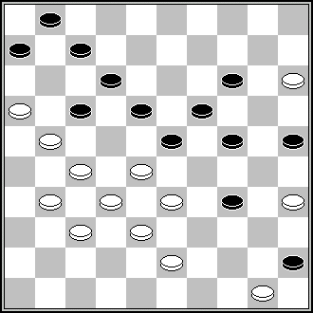 | F5  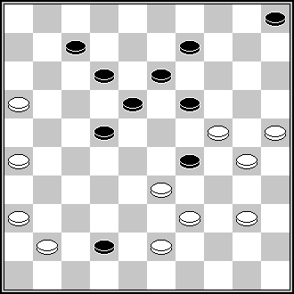 | F5  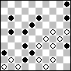 | F6  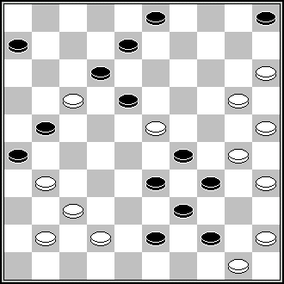
L. de Rooy (DP, 8-1998) 11(16)44,30,40,39, 40,21,10,4,2 + | M. Avenel (De Problemist, 1953) 394,29,11,21,37,  23,3,10 [via 27],29 + | V. Muljar (De Problemist 1986 december) 40,40,7,250,41,25, 1,10,27,34 + | G. Geerlings (Book Geerlings, n° 672) 10,9,24,30,40,44, 38, 10,14,5,2 +
F6  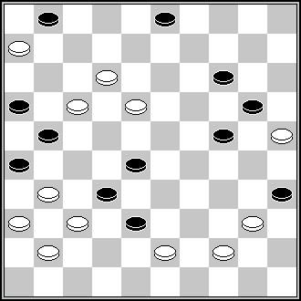 | F7  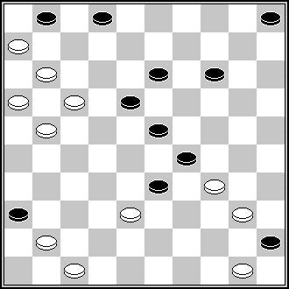
B. Shkitkin (Dambrete, 8/1985) 8(3x)439,33,10, 14,5,17,17 + | S. Žilevičius (Odessa – 1985) 7,11,38,17,10,12,  127,1,39,39 +

F8. This problem does not correspond to the RI in its Endgame-position appeared after last white move in combination – 4/K3 – see article 1.5.1.c):
1.5.1. If in the Endgame position (and its transformations) Black is not attacked, then:
c) If Black has one man, which may move, in this case the sacrifice of this man is not considered as development of the play if Black has the choice: to sacrifice or not to sacrifice.
Author of F8 stopped his notice in the position 4/K3, but it is not a real end of the solution, because black has 1 piece still. If black will play in the position 4/K3 (10) then next play of white will contain many Duals.
F9. 10Z,20,449,328,28,10,4,35(2-8,8,14)44 +
Z) 449(26)10,20,328,28,10,4,35,40+.
After 35 white has to move and can win in several ways.
F11. Dual (moves’-order changing): 23,7,417,7,30,42 etc.
F13. The endgame-position in which author stopped his notice is not a real end of the game. This position – 1, 31/K19 – contains many Duals in the next play, and, thus, this problem does not correspond to the RI.
F15. Copie: S.Ustianov (FFJD 2004 – Memorial René Fourgous)
F17. S.S. : 372,21,487,32,37(14,39)42,38(40)20(394,30)383,4,32,35(239)36(294) 49,20(34)33(40)50(45)7(17)11(12)50(18)31(24)27(29)1etc. +

F13  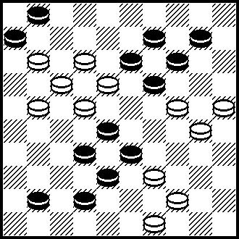 | F14  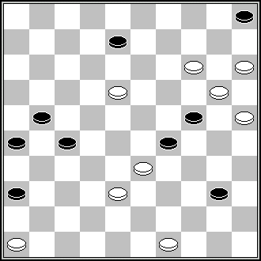 | F15  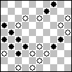 | F17  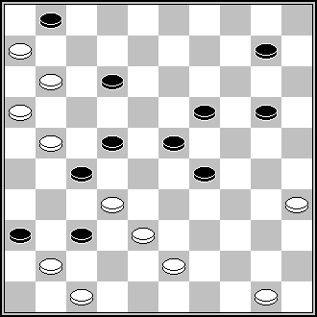
In the published position the white piece on field 44 was on field 43.  This is the correct setting. | S. Yushkevitch (HND, 7/1985) 41,44,12,3,4, 31,24, 14 +  Ressemblance partielle | L. de Rooij (Tubantia 20 maart 1971) 482,10,29,12,1,32,32 | A.Miedema (DP, 8/1992) 42,30,25,5,17,18,7,1,34 +  Ressemblance partielle

F18. Copie : J.Nesme (Effort, 1/1963, Dammen Spel 18 nr 14776)
F21. Pas conforme au règlement;le pion blanc va à dame pendant le motif final.
Noir 6 figurant.
F22. S.S.: 44,25,3(32-23)24,36,37(35)38(28)9(13)4(40)22,35, etc. +
F23. 171,22,38,41,37,17,29,4,9,340,9,3(13)21(19A)8Z(23)21(33)43(339,40)39(45)50 +
Z) 38(23)16/27 or 43 or 49, etc. +
F25. Pas conforme au règlement;le pion blanc dame dans le motif final.
S.S.: 449,383(47x)11(47)38,40,39(30)7,8(294)33(28,39)13A(34)18(44)182(39)7 (50)2(43)17,7 (49)1, etc. + A) 2(35)227(43)31(48)8,172 +
F26. Pas conforme au règlement,la mise à dame des blancs est effectuée par une prise.

F19  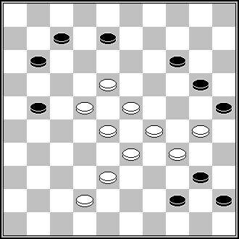 | F22  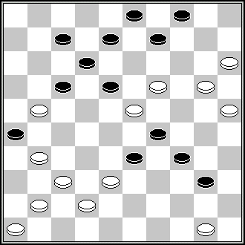 | F22  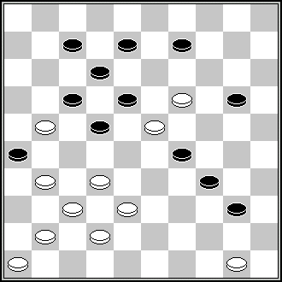 | F26  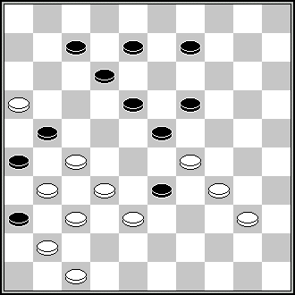
L. Faber (DE, 5/1982)  17,19,38,28,9,3,50 + | N. Irzhavskij (64, 1978) 44,13,13,10,4,21,37 + | V. Matus (Shashki, 2-1979) 28,44,13,4,9,21,37 + | A. Uvarov (De Problemist 1/1993) 30,28(21x)42,11,4,50 +

F29 SS;28(233)19,1,40,45(36)13,16(361)33(216)32(22)39(4)427(22)49(4)28+
Incorrect. There is no SS after 28(47)6(41A)33(24)28(10)1(712) = A) (11)26(41) 33(24)28(10) =
F31. S.S.: 171,7,11,42, etc. +

F29  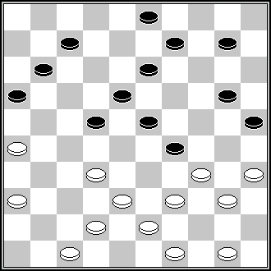 | F31  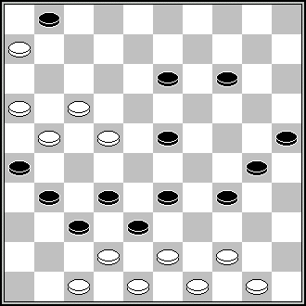 | F33  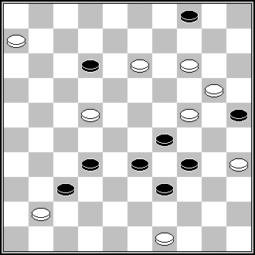 | F35  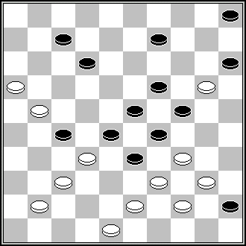
M. van Dijk (Het Nieuwe Damspel, Jan 1976) 504(228)21,41,31,  350,8,1,6,1 + | A. Liakovski (PWCP I, 2003) 41,449,20,42,44,18, 7,1,28 + | B. Morkus (Champ de Lituanie 1998) 43,1,37,3,28,33 + | A. Rom (DE, May 1983)  11,2,43,32,28,3,13,  24 +

F37. SS;139(26)183(317)33,33,27(23)28,13,4(41)139(8)20,3(46)494(19)14,29 etc +
F38. Final incorrect; il reste plus de blancs qu'il en faut pour gagner.
18,6,7,428,38Z,30,2,3 +
Z) 2,38+
F39. Pas conforme au règlement,le pion blanc va à dame dans le motif final.
F42. S.S. : 261(31m)12,7,37,49(13m)44+
F44. 43,30,42,15Z,22,150,41,5,21 [via 34],21(16)17(21,11)21 +
Z) 10,22,14,41,5,21 [via 34],21(16)17(21,11)21 +
F45. Pas conforme au règlement,pion blanc à 8.
S.S. I: 2,128,17,45,37(44)21,7 +
S.S. II: 2,45,19,128,14,38 +
F49. 483,9,4,10,449,31,5Z,19,350,12,7,30,38 +
Z) 9,104,30,12,30,38 etc. +
F51. The author of the position 26, K36/32, K4, K47, black to move, is B.ten Wolde, “Org.Prov. Groningse db”, 01-03-1933.
F52. In the Légalité of this position the white piece on field 28 was not mentioned. The Légalité should be as stated below:
Légalité: 1-2-3-7-9-25-31-33-35-36-37-38-D39-41-43/8-12-14-15-16-17-18-20-22-24-26-27-28-34-45-46-47-48-50 482(21)27(13)...
F54. S.S. : 18(50)9(44)18,11,1,32(13m)17,161(45)6(1)49(39)12,1etc +
This remark is not correct. This “SS” is the author’s variant written under the letter “A”.

F40  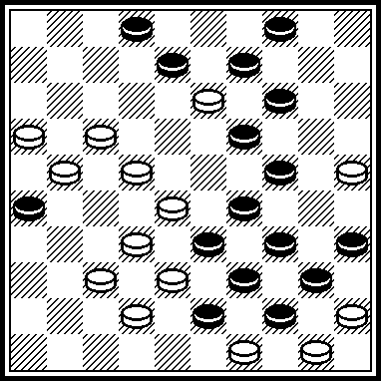 | F46  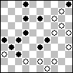 | F46  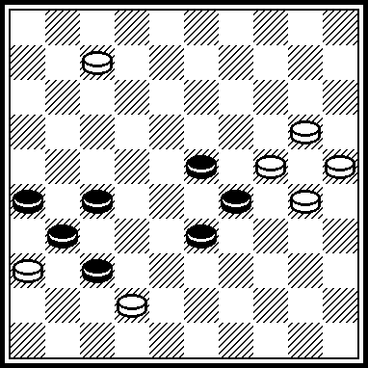 | F46  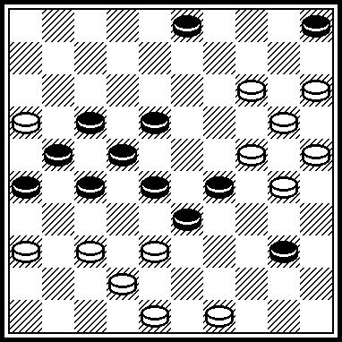
Partial Resemblances:  P. Kuijper (DE-11.1981)  31,20,9,7,37,31,3,43, 30,14,19 + | P. Kuijper (De Problemist 1979 June) 9,7(11),44(39),30,9, 14,3,2(37),31 | Partial Resemblances:  A. Maslov (Book «700» by M. Ben and S. Yushkevitch, 1997 year, #471)  2,2-19,9,14,3,21,27 + | Partial Resemblances:  H. Wilsens (Brabants Dagblad, 29-09-1979)  44,372,31,4,42,9,9,14, 31,27,3,23 +
F46  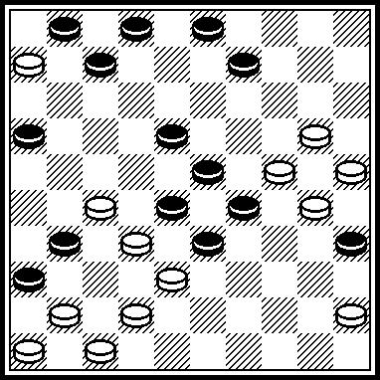 | F48  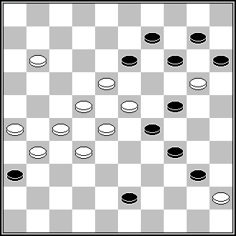 | F50  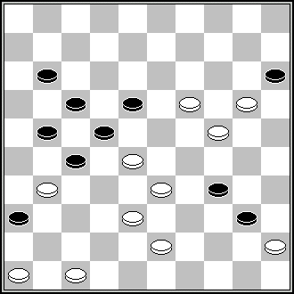 | F57  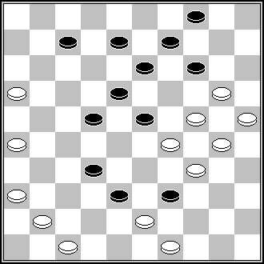
L. de Rooij (DP-10.1983)  22,4,38,36,40,9,9,14, 3,50, P. Lauwen (12) 45(21)7(11)26(7)21 (12)17,41 + | H.C. de Waard (DE, 3/1981) 19,18,28,7,21,2,4,15 + | V. Muliar (Champ d’Ukraine, 1989) 471,194,32,33,41,10, 5,38,27,22,32 + | L. de Rooy (Dagblad voor het Oosten, 7-5-1960) 31,27,10,37Z, 43,42,19,11,4,44,45 +  Z) 43!(39Y)32 + Y) (49)19,11,4,44,45 + Playing the king up and down, as in the authors solution, is not necessary.

F57
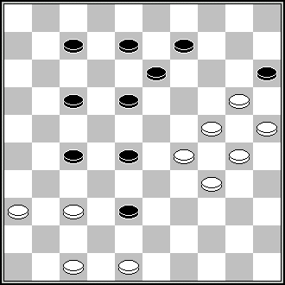
J. van den Boogaard (Verzamelde 11, n° 2426) 32,43,42,19,31,4,44, 45 +
Different SS possible. For example:
SS1: 19,361,4, etc.
SS2 : 19,371,4, etc.

Remark to remarks already published towards F57 in Second version of Observations.

To F57 there were indicated two problems as Ressemblances:
To both of them there were indicated remarks to those of two Ressemblances (RED-remarks):

Those RED-remarks do indicate Second solutions in the Ressemblances indicated to F57 (positions of L. de Rooij and J. van den Boogaard).

RED-remarks have no relation to the positions of the KVD-2008 contest.
They are relevant to the positions, which DO NOT participate in the KVD-2008.
So, it is not understood: why they were placed in/between the remarks which are relevant to the KVD-2008 positions and why those RED-remarks still are standing there.

Towards the sense of those RED-remarks:
They would be in point (in place), if positions of L. de Rooij and J. van den Boogaard would participate in the KVD-2008.
But those two positions of L. de Rooij and J. van den Boogaard DO NOT participate in the KVD-2008, they are indicated as Ressemblances.
What does it mean?
It means those two positions of L. de Rooij and J. van den Boogaard do indicate that the containing of F57 is not original partially, because F57 partially uses a combinational structure (a mechanism of a solution), which already was demonstrated earlier.
From the point of view an investigation of the originality as regards to the positions sent to the KVD-2008 (like to any other contest) – and namely this is the aim of Ressemblances – it has no importance: was a combinational structure (a mechanism of a solution) demonstrated earlier either in practical game or in an analysis of a game played or in a problem published, and it has no importance – was that problem correct or incorrect. It has importance that a combinational structure (a mechanism of a solution) already was demonstrated earlier, consequently, any further repetition of that combinational structure (a mechanism of a solution) will not be as completely original.

Remerciements pour leurs recherches à Messieurs: A. Gimbutas, A. Kuyken, B. Morkus, A. Tavernier, A. Vermeulen, S. Yushkevitch, S. Žilevičius.

Contact person for Contest KvD 2008:
André Schokker,
Lomondlaan 18
1060 PL Amsterdam
The Netherlands
zaschokker@hotmail.com

