CONCOURS « KVD 2008 »

Catégorie E

Remarks/Remarques
Note I: new remarks or remark related to the initial version of this document are indicated in red typing.
Note II: final remarks are indicated in blue typing.

E2. pas conforme au règlement,deux noirs en opposition.
E3. S.S.: 239,37,30(28A)34,3,33(16)28 + A) (20)3,34,33(16)28 +
Incorrect. There is no SS after 239, 37(47x20).

E1  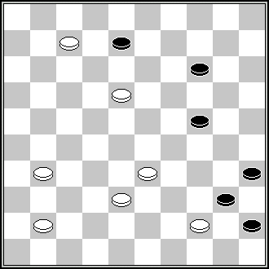 | E1  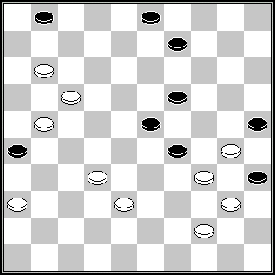 | E1  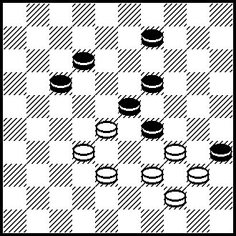 | E1  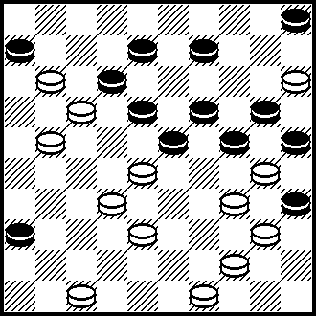
S. Ustjanov (Socialistiches – Kaya Kharkov – shtchina, ?) 1,182,3,40 + | S. Žilevičius (Championship of Lithuania, 1981) 7(12)8(12)17(21) 28,3,40(44A)31,  50 + A(34)31,20 + | C. van der Kuilen (HDG Vooruit 1942) 27(43),3,40,22 + | J. Viergever (De Noord Ooster 23-07-1955) 16,27,272,14,38(9*),41, 33,3,40 +
E1  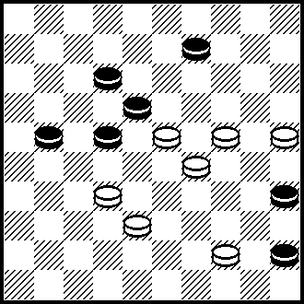 | E1  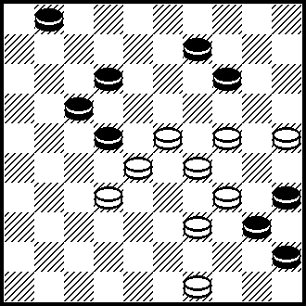 | E2  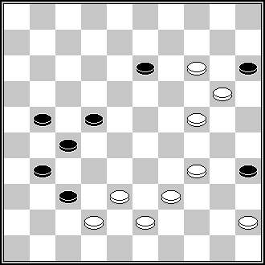 | E4  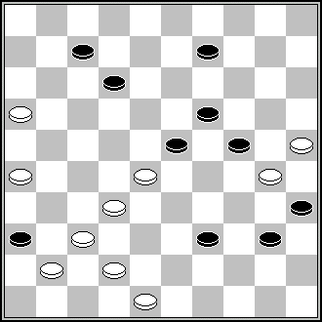
J.C.R. Bus (De Parel, Book of Keessen 1966)  27,39,40,3 + | P. Kuijper (Nederlands Dagblad 10-11-2007) 27,239,7,3,40,22 + | N. Irzhavskij (Shashki, 12-1976) 30,32,19,8,3,44,34 + | L.Dalman (Effort, Mars/Avril 1975) 38,33,11,20,21,43,3,46 +

E8. pas conforme au règlement,l'opposition n'est pas directe.

E5  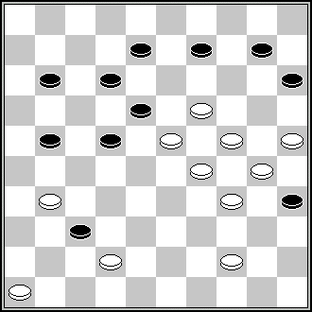 | E5  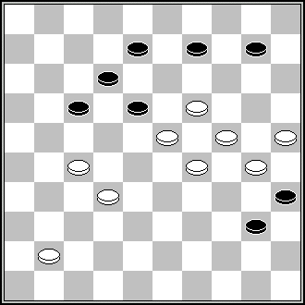 | E8  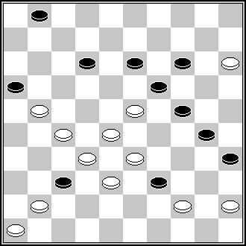 | E10  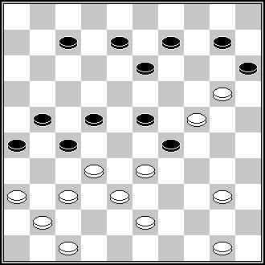
A. Demishev (Shashki, 1-1990)  13,23,38,41,5,3 + | A.Geurts (DE, 11/1984)  22,13,23,3,5 + | N.N. (FFJD, 1992, C-50)  N.N. (De Problemist, 2-1993) 450,29,7,14,150,41,5, 39 + | D. de Ruiter (Dagblad voor West-Friesland, 21-02-1953)  D. de Ruiter (Schijven Spreken, 1963) 361,328,18,12,5,2(31)30, 38,39,39, +
E10  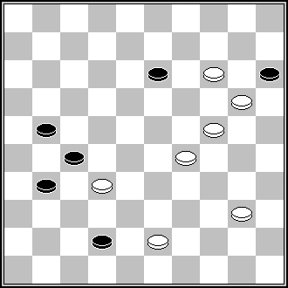 | E11  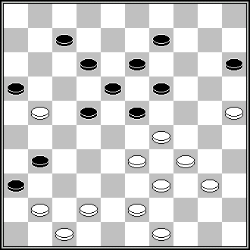 | E11  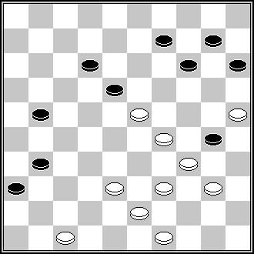 | E11  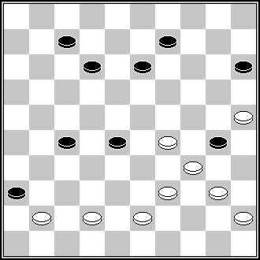
G.Silo  (Lietuva 2006)  10,5,8,47 + | H.van Alphen  (HD, 1942) 24,339,427,38,24,44, 3,30 + | Th. Van Prooijen (Het Nieuwe Damspel, 1973) 19,41,24,44,5,43, + | V. Stepanov (Komjaunimo tiesa,  8-11-1978)  428,24,40,3,33 +
E11  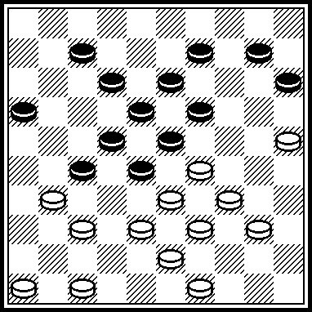 | E11  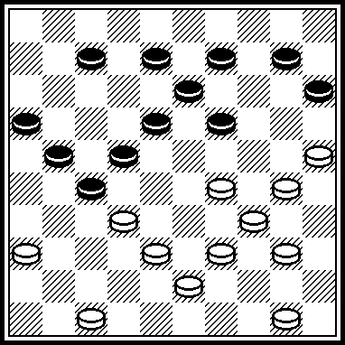 | E12  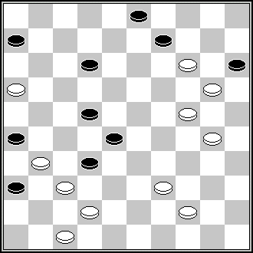 | E15  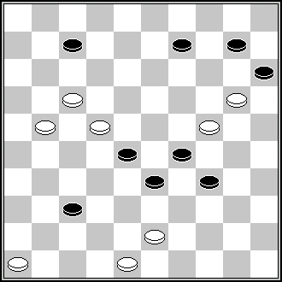
A. de Graag  (HD-07.1927)  24,339,372,471,24, 44,5,25 + | J. van der Wal  (Suiker-1973, DP-12.1974)  31,27(31)304,41,24, 44,1,5 + | S. Pereplolkin (64, 1-1980) 33,8,2,41,8,3,25,  17,7 + | J.C.R. Bus (Het Damspel, 5-1962) 11,38,4,47(39)471(42)37 (43)47(48)42(39)33,37 +

E10. noir 36 figurant.
Incorrect. According to changes, made by the CPI under leading of Mr. J. Bus, black piece 36 is not a figurant any longer, because this piece refuses SS which would be present if this piece would not be placed, i.e., with first move 328 or first move 37 etc.
E13. pas conforme au règlement,pas de noir en opposition.
S.S.: 14,5,21+
S.S.: 31,14,42,24,3+.
S.S.: 21,42,14,24,3+.
S.S.: 32,7,1,20+.
E14. S.S.: 42(11A)31,13,3,48+ A) (33)31,13,3,22+

E 15  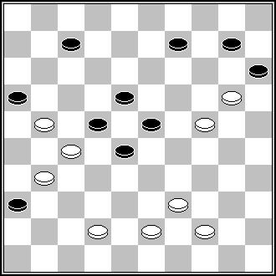 | E15  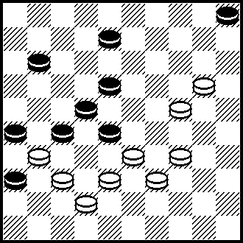 | E17  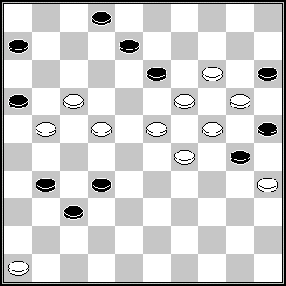 | E19  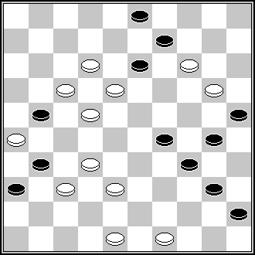
A. van den Elzen  (DP, 5/1968) 26,37,32,34,3,1… + | P. Kuijper (Hoofdlijn Nov. 2008) 382,27,34,2(41*),16, 38(37*,37),14(41), 47(46),15,4 + | S. Žilevičius (Orenberg, 1992)  S. Žilevičius (De Problemist, 10-1994) 41,3,8,3-14,26,30,  11,5 + | J. Ceron (Conc Amicale, 2001)  33,483,31,6,38,8,3,44(50) 40,1, +

E19. noir 34 figurant,il n'évite pas un dual.
The above statement is not correct. The black man on 34 is not a figurant. See RI 1.14. The underlined part explains why the black man on 34 is permitted. The black man on 34 ensures that the white King performs an exact capture move (3x44). Without the black man on 34 there are two winning fields for the white King (3x44 and 3x49).

R.I. 1.14. The Latent figurant.
The Latent figurant is Black man which did not participate in the development of the play (1.13.1.) before an Endgame position or a Final position and which is not staying in an Endgame position or a Final position being captured by a White piece during the combination. The Latent figurant may be removed out from the Initial position without an infringement either Initial position or a change of White moves of author’ TV [Example 1: Black 10,32,42; White 33,39,43,D50; Solution: 28,38,5 +. In this example Black man 10 is not latent figurant because Black man 10 is utilized to form exact capture move of White King. Example 2: D. de Ruiter, De Problemist, February 1992 . Black 7,8,10,14,19,20,22,24,27,28,29,32,35,36; White 16,30,31,33,39,40,42,43,44,45,46,47,48,50; Solution: 394, 43, 33, 33, 39, 471, 11, 11x4, 49(41) 37(23) 450, 44, 5 +. In this example Black man 8 may be removed out from Initial position without an infringement of author’ TV, but if it will be done, in this case White moves will be changed: 394,43,33,33,39,471,11, 11x2,etc… +, Therefore Black man 8 is not Latent figurant.].

E19  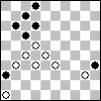 | E20  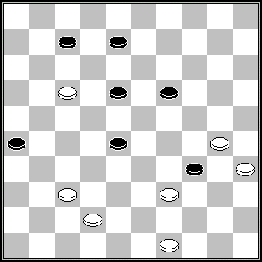 | E20  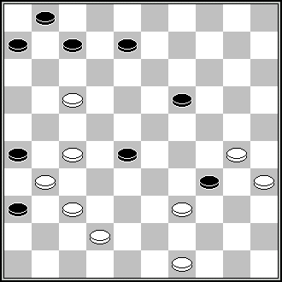 | E20  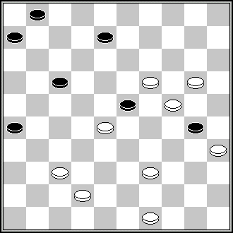
A.V. Uvarov (Dam Eldorado 1984 March)  21,18,1,7,41 | J.Pranger (DP, 4/1956)  33(39)12(17)31,43,  34,2 + | J.Scheijen (De Zuid Limburger,  8-3-1973)  22,33(39)12(17)  31,43,34,2+ | J.A. Pennings (Het Damspel, 5-1960) 31,33,22,43,34,2 +  SS: 22,11,44,31,34,2 +

E21. S.S.: 8,21,3(8ABC)16 + A) (12)29 + B) (13)16 + C) (18)50,17 +

E 20  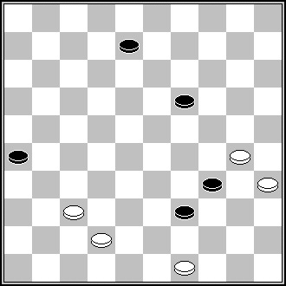 | E20  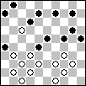 | E20  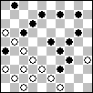 | E22  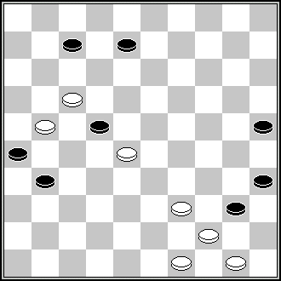
NN (HD, 8/1987) 31,43,34,2+ | A.F. Hoogvelt (De Problemist 1951 September) 35,340,39,33,327,30 (46*),41,43,34,2 + | P. Kuijper (De Problemist 1966 April) 361,33,43,11,217,30 (46*),41,43,34,2 | B. Ivanov (FFJD, 1990)  N.N. (De Problemist, 6-1991)  43,12,3,1 [via 31], (40)33(45)6(30)34,50 +
E22  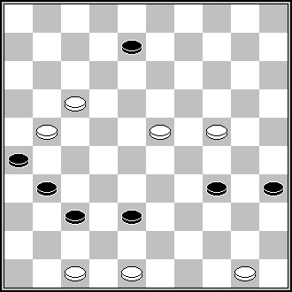 | E23  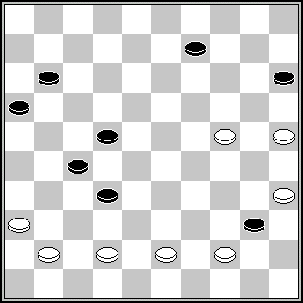 | E23  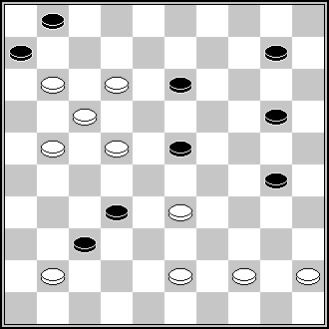 | E25  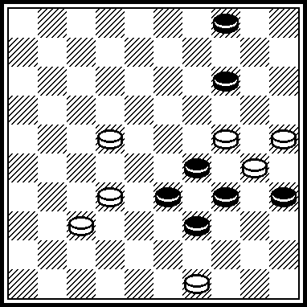
G.Kupka (IX Champ de Moscou 1982) 41,12,3,40,39,39 + | A. Michels (Het Damspel, 12-1967) 428,31,18,24,3 +  SS: 417,6,3 + | B. Morkus (Conc Odessa, 1984)  440,127,37,34,5 + | L. Dalman (Book by L.Dalman - Combat dans l’arène, # 213)  18,13,43,28,10,3 +
E25  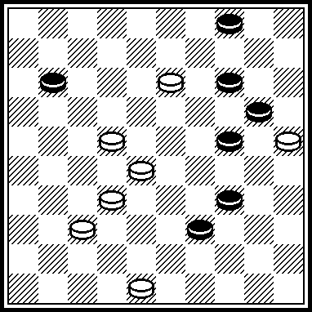 | E28  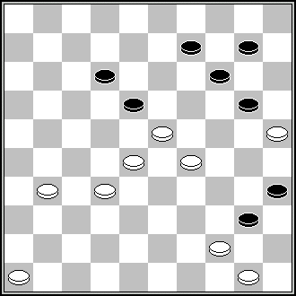
A. Tkach (Le Monde Damiste, # 42, 02-1977)  17,43,28,10,3 + | M.van Rooij (M. van Rooij, Probleem parade, deel 2, n° 49)  45,40,41,19,30,50+

E27. dual : 30,13,2,10 ou 5+
E29. S.S.: 239,29,23,2,5 +
E35. S.S.: 23,3,43 +
S.S.: 39,23,3,43 +
S.S.: 43,32,23,3,19 +
E37. démolition;39(38)43,39(23)11(249,28,37) =
E42. interversion : 31,7ou 7,31

E34  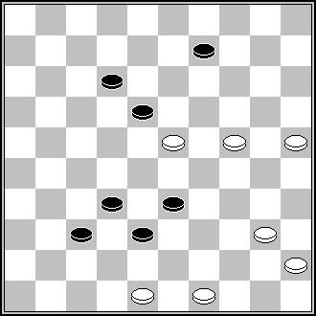 | E37  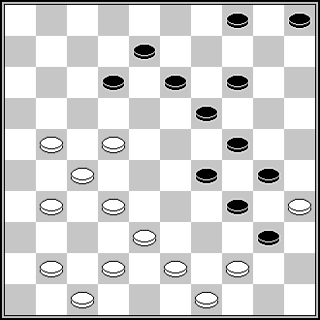 | E38 | E42  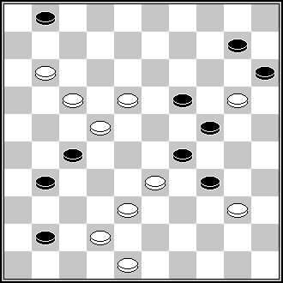
D. van den Berg (Springdans, 2002, n° 410) 493,3,15,40(49)43,42 + | B. Mogilevskij (Shashki, 8-1970) 439,28,43,33,42,  18,9,2,19 + | J. Ceron (Conc Amicale, 2001)  33,483,31,6,38,  8,3,44(50)40,1, + | A. Jovaišas (Patent,  6-2001) 13,7,37,30,4,50 +

E44. 7,29,39Z,18Y,2,38X +
Z) 23,2,21 + Y) 23,2,39 + X) 9, etc. +
E48. S.S.: 38,36,26(32)29(37)30,40(13)34(138)29, etc. +

E42  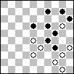 | E42  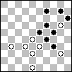 | E48  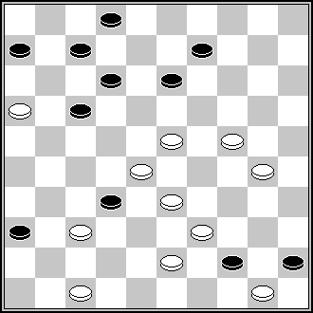 | E 50  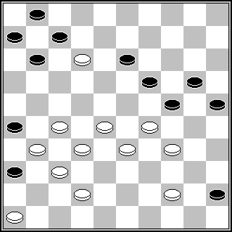
D. van den Berg (Dam Eldorado 1978 November) 22(27),39,30,4,38,48 + | J.C. Vink (Dam Eldorado 1980 January) 327(21),27,30,4,50 + | V. Bulat (Made in Belarus, 12-1992)  V. Bulat (BVLD, 1994/95, 7E) 249,41,11,4,8,1(40)39  (44)40,48 + | J.de Wit (De Problemist, 6-2003)  272,41,31,40,9,14,4,2+

E51. S.S.: 11,6,41,1,32(34)14(39)20(30)354(43)31(48)25(20)17(34)19(1)6(117)13(1)
227(29)9(23)4(41)12+

E50  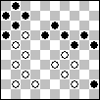 | E50  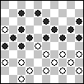 | E 51  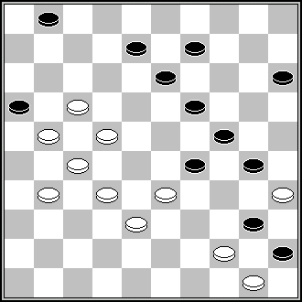 | E 51  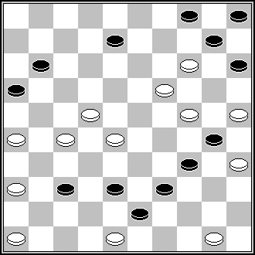
P. Kuijper (Het Parool 1971 February 27th) 23,32,9,40,33,14,4,2 + | P. Kuijper (DP 1978 December) 371,41,38,31,9,14,29, 4,39(34*),440(20),29 (24),20,30(19),24,40 + | G.Artigala (Effort, Sept/Oct 1974) 328,11,7,44,40,  18,20,2,14 + | H.A Fermin (DE, 11/1976)  9,44,39,14,261,41, 31,227,20,2,32 +
E51 | E51  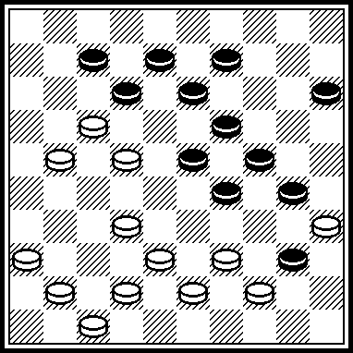 | E 54  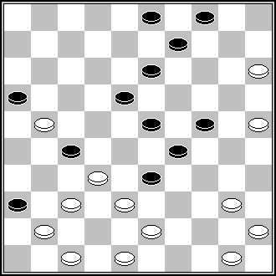 | E 54  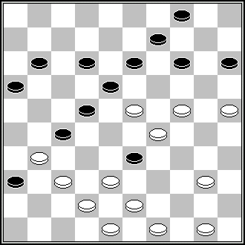
B. Mogilevskij (Shashki, 8-1970) 439,28,43,33,42,  18,9,2,19 + | F.van Gaans  (DP-09.1965)  27,383,41,31,11,18, 20,2,14 + | J.H.H. Scheijen (Zwijndrechtse courant, 1-4-1954)  10,38,472,37,35, 42,30,40, 8,24,3… + | A.F Hoogvelt (HD, 10/1954) 39,382,504,32,240,42,40, 10,24,3 … +

E56. 8,9,39,14Z,4,45 +
Z) 13,3,45 +
E58. pas conforme au règlement(hors sujet)
E60. coup du moulin : 3x20x42x26x3 ou 3x12x26x24x3
An exact Mill-move (Coup de Moulin, Molenweekslag) is neither a quality nor a shortcoming, according to the RI. This remark would have a sense if a Mill-move would be inexact, then, according to the RI, that incorrect Mill-move should be considered as a Dual. In E60 we see exact Mill-move, therefore the simple indication “Coup de Moulin” has no sense because the Mille-move in E60 is the exact Mill-move.

E57  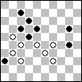 | E57  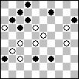 | E58  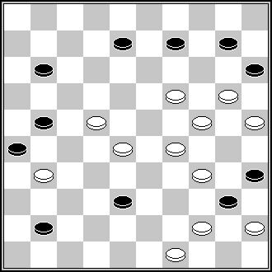 | E62  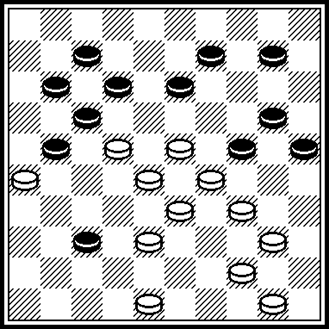
J.H.H. Scheijen (Clubblad Excelsior 1972 december) 293,18,1,33,47 + | J.H.H. Scheijen (Clubblad Excelsior 1973 february) 21,19,1,7,13,44 + | V. Malashenko (Memorial of L.A. Shmidt, 1983)  V. Malashenko (Dam Eldorado, 3-1984) 17,23,204,20,43,3,47 + | Partial Resemblance to the system 26x30, 23x1 etc.  J.Viergever (De Prins, 21.10.1950)  42,45,34,22,30,1,6 +
E62  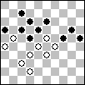 | E62  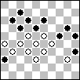 | E62  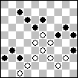 | E64  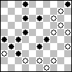
P. van Dijk (Het Damspel 1955 March) 31,21,30,1,15,26 or 31 + | H. Wilsens (De Brouwerij 1981 March) 261,41,32,17,27,30, 1,15,50 + | L. de Rooij (Excelsior Revue 1985 February) 32,41,39,27,30,1, 15,49 + | P. Kuijper (De Problemist 1979 June) 9,7(11),44(39),30,9,14,3, 2(37),31 +
E64  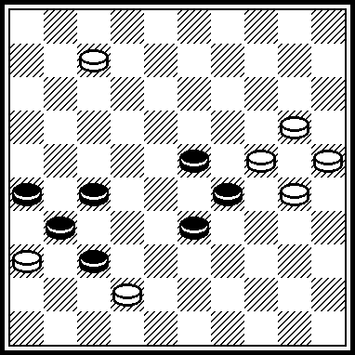 | E64  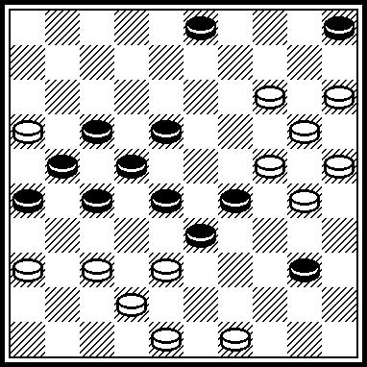 | E64  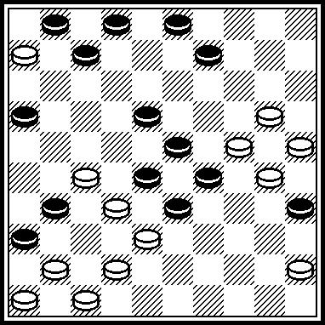 | E 66  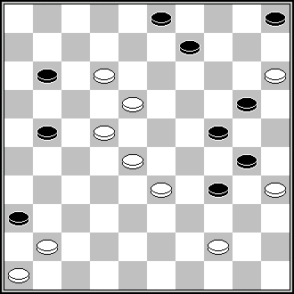
Partial Resemblances:  A. Maslov (Book «700» by M. Ben and S. Yushkevitch, 1997 year, #471)  2,2-19,9,14,3,21,27 + | Partial Resemblances:  H. Wilsens (Brabants Dagblad, 29-09-1979)  44,372,31,4,42,9,9,14, 31,27,3,23 + | L. de Rooij (DP-10.1983)  22,4,38,36,40,9,9,14, 3,50, P. Lauwen (12) 45(21)7(11)26(7)21 (12)17,41 + | G.Geerlings (Book of Geerlings, 10-1988 n° 277)  23,29,354,41,8,27,4,27 (339),33(40),49 (45),32 +

Remerciements pour leurs recherches à Messieurs: A. Gimbutas, E. Kopilov, A. Tavernier, A. Timmer, A. Vermeulen, S. Yushkevitch, S. Žilevičius.

Contact person for Contest KvD 2008:
André Schokker,
Lomondlaan 18
1060 PL Amsterdam
The Netherlands
zaschokker@hotmail.com

