CONCOURS « KVD 2008 »

Catégorie F

Remarks/Remarques

Note: new remarks or remark related to the initial version of this document are indicated in red typing.

F1. Non conforme au règlement,pion blanc à 8
42,32,34,127(23xA)1Z,15,20,34 + A) (3x)2,27,8 or 3 +
Z) 8-2,15(293)38(30)2(35)29,23,49 +
F2. This problem does not correspond to the RI in its Endgame-position. Endgame-position appeared after last white move in combination – 3, 17/K47 – because this Endgame-position contains more than one Dual in the next play.
F5. Avec pion blanc 45 à 44, Copie : V.Muliar (DP, 12/1986)
F6. 42,29,12,40Z,44Y,38X,10,14,8,5,16 +
Z) 8,40,44 +
Y) 8,44,38 +
X) 8,38,10,14,5,16 +

F3  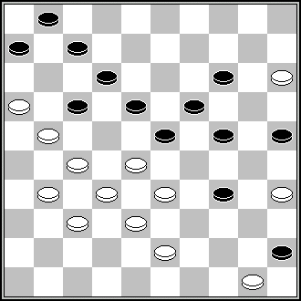 | F5  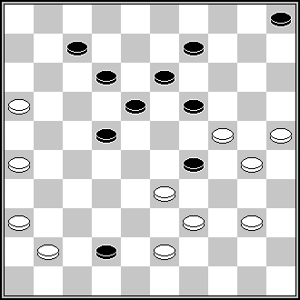 | F5  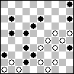 | F6  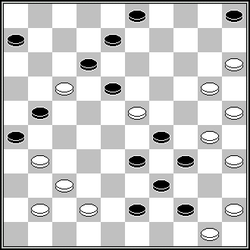
L. de Rooy (DP, 8-1998) 11(16)44,30,40,39, 40,21,10,4,2 + | M. Avenel (De Problemist, 1953) 394,29,11,21,37,  23,3,10 [via 27],29 + | V. Muljar (De Problemist 1986 december) 40,40,7,250,41,25, 1,10,27,34 + | G. Geerlings (Book Geerlings, n° 672) 10,9,24,30,40,44, 38, 10,14,5,2 +
F6  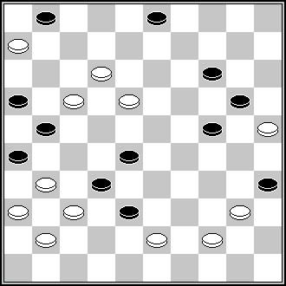 | F7  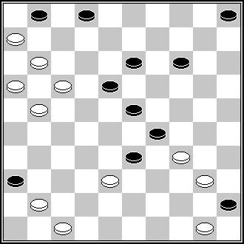
B. Shkitkin (Dambrete, 8/1985) 8(3x)439,33,10, 14,5,17,17 + | S. Žilevičius (Odessa – 1985) 7,11,38,17,10,12,  127,1,39,39 +

F8. This problem does not correspond to the RI in its Endgame-position appeared after last white move in combination – 4/K3 – see article 1.5.1.c):
1.5.1. If in the Endgame position (and its transformations) Black is not attacked, then:
c) If Black has one man, which may move, in this case the sacrifice of this man is not considered as development of the play if Black has the choice: to sacrifice or not to sacrifice.
Author of F8 stopped his notice in the position 4/K3, but it is not a real end of the solution, because black has 1 piece still. If black will play in the position 4/K3 (10) then next play of white will contain many Duals.
F9. 10Z,20,449,328,28,10,4,35(2-8,8,14)44 +
Z) 449(26)10,20,328,28,10,4,35,40+.
After 35 white has to move and can win in several ways.
F11. Dual (moves’-order changing): 23,7,417,7,30,42 etc.
F13. The endgame-position in which author stopped his notice is not a real end of the game. This position – 1, 31/K19 – contains many Duals in the next play, and, thus, this problem does not correspond to the RI.
F15. Copie: S.Ustianov (FFJD 2004 – Memorial René Fourgous)
F17. S.S. : 372,21,487,32,37(14,39)42,38(40)20(394,30)383,4,32,35(239)36(294) 49,20(34)33(40)50(45)7(17)11(12)50(18)31(24)27(29)1etc. +

F13  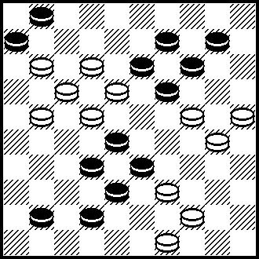 | F14  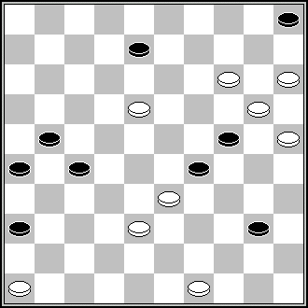 | F15  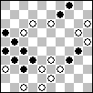 | F17  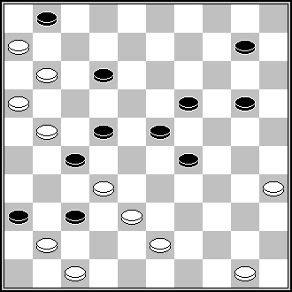
In the published position the white piece on field 44 was on field 43.  This is the correct setting. | S. Yushkevitch (HND, 7/1985) 41,44,12,3,4, 31,24, 14 +  Ressemblance partielle | L. de Rooij (Tubantia 20 maart 1971) 482,10,29,12,1,32,32 | A.Miedema (DP, 8/1992) 42,30,25,5,17,18,7,1,34 +  Ressemblance partielle

F18. Copie : J.Nesme (Effort, 1/1963, Dammen Spel 18 nr 14776)
F21. Pas conforme au règlement;le pion blanc va à dame pendant le motif final.
Noir 6 figurant.
F22. S.S.: 44,25,3(32-23)24,36,37(35)38(28)9(13)4(40)22,35, etc. +
F23. 171,22,38,41,37,17,29,4,9,340,9,3(13)21(19A)8Z(23)21(33)43(339,40)39(45)50 +
Z) 38(23)16/27 or 43 or 49, etc. +
F25. Pas conforme au règlement;le pion blanc dame dans le motif final.
S.S.: 449,383(47x)11(47)38,40,39(30)7,8(294)33(28,39)13A(34)18(44)182(39)7 (50)2(43)17,7 (49)1, etc. + A) 2(35)227(43)31(48)8,172 +
F26. Pas conforme au règlement,la mise à dame des blancs est effectuée par une prise.

F19  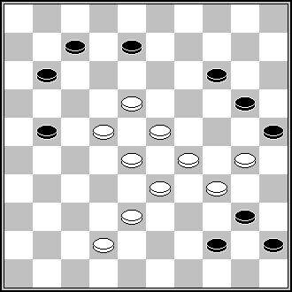 | F22  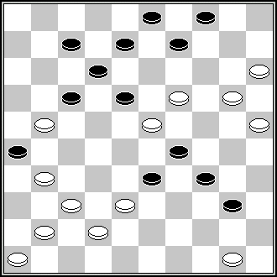 | F22  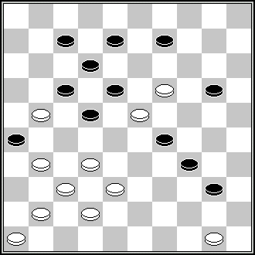 | F26  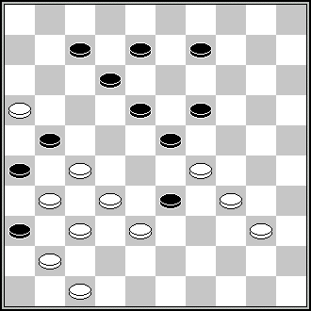
L. Faber (DE, 5/1982)  17,19,38,28,9,3,50 + | N. Irzhavskij (64, 1978) 44,13,13,10,4,21,37 + | V. Matus (Shashki, 2-1979) 28,44,13,4,9,21,37 + | A. Uvarov (De Problemist 1/1993) 30,28(21x)42,11,4,50 +

F29 SS;28(233)19,1,40,45(36)13,16(361)33(216)32(22)39(4)427(22)49(4)28+
Incorrect. There is no SS after 28(47)6(41A)33(24)28(10)1(712) = A) (11)26(41) 33(24)28(10) =
F31. S.S.: 171,7,11,42, etc. +

F29  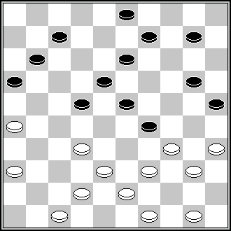 | F31  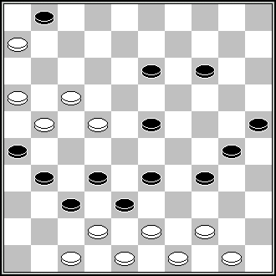 | F33  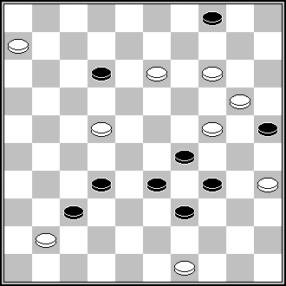 | F35  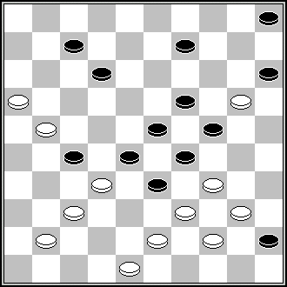
M. van Dijk (Het Nieuwe Damspel, Jan 1976) 504(228)21,41,31,  350,8,1,6,1 + | A. Liakovski (PWCP I, 2003) 41,449,20,42,44,18, 7,1,28 + | B. Morkus (Champ de Lituanie 1998) 43,1,37,3,28,33 + | A. Rom (DE, May 1983)  11,2,43,32,28,3,13,  24 +

F37. SS;139(26)183(317)33,33,27(23)28,13,4(41)139(8)20,3(46)494(19)14,29 etc +
F38. Final incorrect; il reste plus de blancs qu'il en faut pour gagner.
18,6,7,428,38Z,30,2,3 +
Z) 2,38+
F39. Pas conforme au règlement,le pion blanc va à dame dans le motif final.
F42. S.S. : 261(31m)12,7,37,49(13m)44+
F44. 43,30,42,15Z,22,150,41,5,21 [via 34],21(16)17(21,11)21 +
Z) 10,22,14,41,5,21 [via 34],21(16)17(21,11)21 +
F45. Pas conforme au règlement,pion blanc à 8.
S.S. I: 2,128,17,45,37(44)21,7 +
S.S. II: 2,45,19,128,14,38 +
F49. 483,9,4,10,449,31,5Z,19,350,12,7,30,38 +
Z) 9,104,30,12,30,38 etc. +
F51. The author of the position 26, K36/32, K4, K47, black to move, is B.ten Wolde, “Org.Prov. Groningse db”, 01-03-1933.
F52. In the Légalité of this position the white piece on field 28 was not mentioned. The Légalité should be as stated below:
Légalité: 1-2-3-7-9-25-31-33-35-36-37-38-D39-41-43/8-12-14-15-16-17-18-20-22-24-26-27-28-34-45-46-47-48-50 482(21)27(13)...
F54. S.S. : 18(50)9(44)18,11,1,32(13m)17,161(45)6(1)49(39)12,1etc +
This remark is not correct. This “SS” is the author’s variant written under the letter “A”.

F46  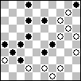 | F48  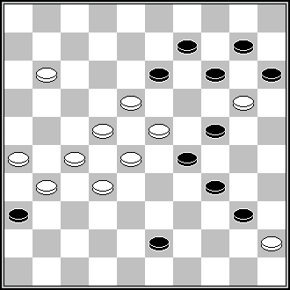 | F50  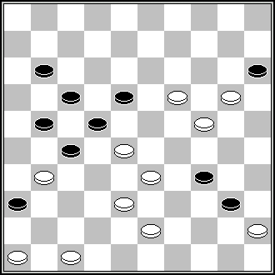 | F57  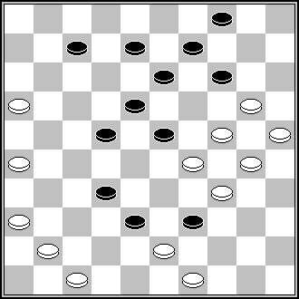
P. Kuijper (De Problemist 1979 June) 9,7(11),44(39),30,9, 14,3,2(37),31 | H.C. de Waard (DE, 3/1981) 19,18,28,7,21,2,4,15 + | V. Muliar (Champ d’Ukraine, 1989) 471,194,32,33,41,10, 5,38,27,22,32 + | L. de Rooy (Dagblad voor het Oosten, 7-5-1960) 31,27,10,37Z, 43,42,19,11,4,44,45 +  Z) 43!(39Y)32 + Y) (49)19,11,4,44,45 + Playing the king up and down, as in the authors solution, is not necessary.

F57
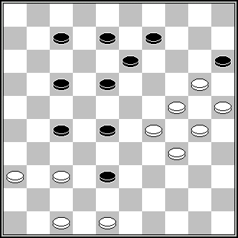
J. van den Boogaard (Verzamelde 11, n° 2426) 32,43,42,19,31,4,44, 45 +
Different SS possible. For example:
SS1: 19,361,4, etc.
SS2 : 19,371,4, etc.

F46 and E64.
In fact, these are two variations of one and the same problem.

Generally, the history of the problemism-contests knows examples when two authors sent one and the same problem (or a variation of a one and the same problem) composed independently to one and the same contest.
In such cases there is nothing outstanding. It is possible two (or even more) problemists could composed one and the same problem independently from each other.

The other case is, however, if one problemist did send two variations of one and the same problem to a contest.
Such case is forbidden by the RI, see article 2.7.b):
If it turns out that one of the competitors has entered 2 or more problems which are too similar. In this case the problem scoring the most points is retained, and the others are disqualified.

In the history of the competitions organized by the CPI the article 2.7.b) did apply never, because no one author did permit himself to send two variations of one and the same problem to one and the same contest.
Of course, now it is not possible to say something certain, because now names of authors are hidden and they are to be advertised only with final result.
But after the final result advertisement the author’s names will be known, and then it will be clear seen: are E64 and F46 composed by two different authors or are they composed by one and the same author.
If it will be turned out that E46 and F64 are composed by one and the same author – then it is exactly the case to apply the article 2.7.b) of the RI.

Remerciements pour leurs recherches à Messieurs: A. Gimbutas, A. Kuyken, B. Morkus, A. Tavernier, A. Vermeulen, S. Yushkevitch, S. Žilevičius.

Final observations should be sent before October 10th, 2009/ Les observations finales sont à envoyer avant le 10 Octobre 2009 à:
André Schokker, Lomondlaan 18, 1060 PL Amsterdam, The Netherlands
zaschokker@hotmail.com

