The jury did select 14 positions for the final stage of RENAISSANCE-contest.
[The conditions of the contest see in “De Problemist”, February 2009.]
Everybody is welcome to send his remarks until 1 of October 2009.
No remark is considered after 1 of October 2009.
Le jury a sélectionné 14 positions pour l'étape finale du concours "RENAISSANCE".
[Pour les conditions du concours voir “De Problemist, février 2009.]
Les remarques seront les bienvenues et chacun pourra les envoyer jusqu'au 1er octobre 2009.
Aucune remarque ne sera examinée après le 1er octobre 2009.
The post address to send remarks is:
L’adresse postale pour envoyer les remarques est:
S.Yushkevitch,
DO VOSTREBOVANIA,
Kharkov-23,
61023, Ukraine.
Email: yushkevitch@yahoo.com
S.Yushkevitch

Positions selected for the final stage.
Positions sélectionnées pour l’étape finale.

R01 R06 R07 R10
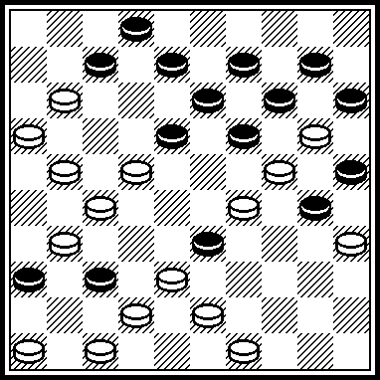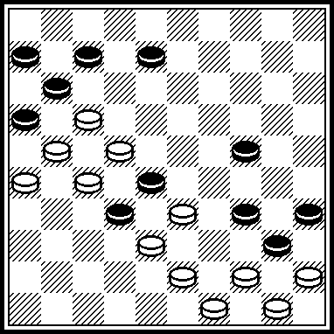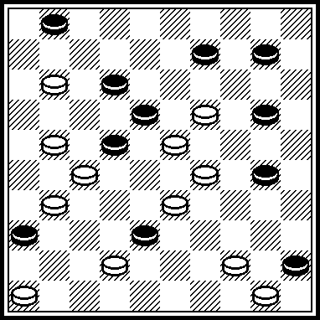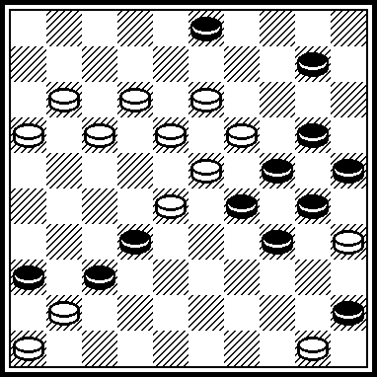

R11 R12 R14 R16
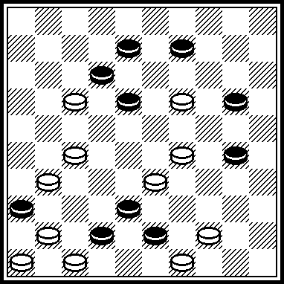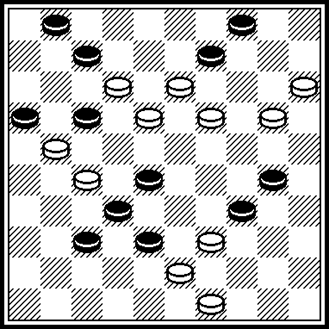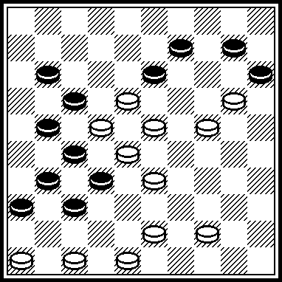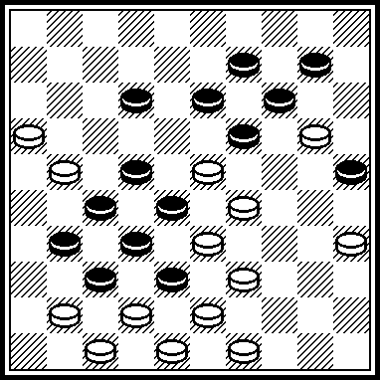

R17 R18 R19 R23
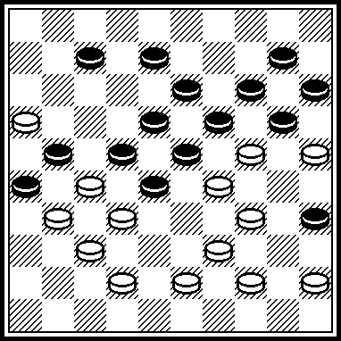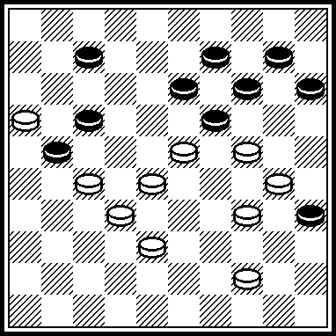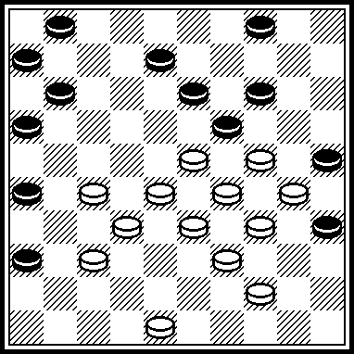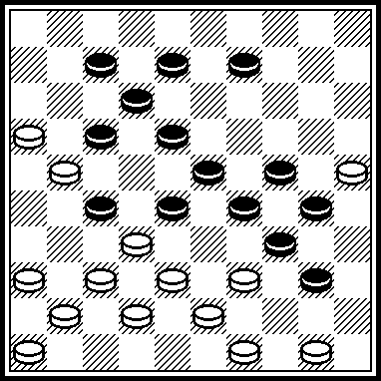

R24 R27
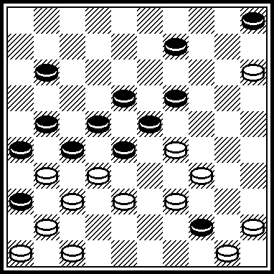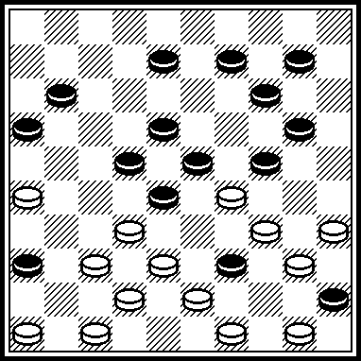
The author’s solutions Solutions des auteurs
(The abbreviation “SS” means “Second solution”. L'abréviation “SS” signifie “ seconde solution”.)

R01 | 227, 43(42) 38, 6, 41, 23, 1(17) 7, 21*, 17, 18, 4, 20, 24.  *SS: 18, 4, 20, 24.
R06 | 12, 3, 38, 25*, 43, 1, 17, 29, 40, 17(21, 11) 21.  *SS: 9, 42, 1, 17, 28.  See NOTA BENE (SY)
R07 | 40, = Z 1, 2, 3 = (47, A) 41, 40, 34, 7, 45, 3, 5.  A(34) 40(18x) 13, 7, 2.  Z1: 37? (25, 28, 22, 47) =. Z2: 13, 35? (28, 16) 19(17, 14) 8, 3(25)=.  Z3: 24(20x) 35(47) 15: Second solution, white plus 2 pieces.  See NOTA BENE (SY)
R10 | 138, 4, 2(47) 02-13*, 41, 30, 44.  *SS: 15, 02-24, 26 etc.
R11 | 23*, 34, 497, 38(16) 27, 37, 37.  *SS: 37, 39.
R12 | 44*, 38, 10, 4, 11, 41.  *SS: 128 etc, selon Dam2.2.
R14 | 471, 42, 3*, 8, 26, 41, 5.  *SS: 5, 41, 47 or 41-14 etc.
R16 | 30*(46,a) 11, 44, 43, 30, 41, 3, 5(42) 417, 48(36) 37.  a(34) 30, 5 etc.  Legality:  1, 9, 10, 11, 14, 19, 22, 25, 27, 28, 31, 32, 37, 38/  7, 8, 12, 16, 20, 21, 23, 29, 33, 35, 39, 42, 43, 46, 47, 48, 49.  Moves: 46-41, 7(12).  *SS: 36(30, 30) 24, 35, 438, 23, 7(33) 31(30, 40) 11(45) 6(50) 20(339) 2(18) 1(914) 43.
R17 | 30, 3, 11*, 2, 4, 30, 7, 23, 20, 6.  Legality:  2, 10, 11, 13, 14, 15, 18, 19, 20, 21, 22, 23, 26, 30, 39, 40, 44/  7, 16, 24, 25, 27, 29, 31, 32, 34, 35, 37, 38, 43, 45, 48, 50.  Moves: (8) 33(2) 42(28) 39(7) 44(35).  *SS: 27(29, A) 2, 30, 37, 27. A(31) 428, 33, 30, 250, 47.
R18 | 40*, 20, 30, 282(177) 11, 2, 41(33, A) 47(39, B) 15.  B(15) 24/29.  A(13) 8/2.  *SS: 272(712) 27(128, 140) 28(13, 13, 14, 4, 42) 16.
R19 | 31, 41, 21*, 18, 2, 9, 32, 16, 483, 2.  *SS: 42, 18, 2, 9, 26.
R23 | 361*, 11, 21, 494, 383, 2, 39, 34, 21, 37.  *SS: 20(15) 504 etc.
R24 | 42*, 40, 29, 3, 10, 27, 41.  *SS: 24, 4, 48(27) 9 etc.
R27 | 33*, 38, 31, 2, 504, 39, 21, 10(27) 4(32) 36(37) 36-41.  *SS: 350, 40(48) 33, 35, 2(40) 35(117) 49 etc.
NOTA BENE (SY)
R06: SS indicated by author is not possible. Perhaps, the author wanted indicate the following variant: 12, 3, 38, 8, 43, 1, 17, 28.
La SS indiquée par l’auteur n’est pas possible. L’’auteur a peut être voulu indiquer la variante suivante: 12, 3, 38, 8, 43, 1, 17, 28.
R07: The author's notice is copied completely. La note de l'auteur est copiée complètement.
The author himself did not indicate legality, but this initial position has its legality.
L'auteur n'a pas indiqué la légalité, mais cette position initiale a sa légalité.
1, 9, 10, 12, 18, 20, 22, 28, 30, 36, 41, 45/
11, 19, 21, 23, 27, 29, 31, 37, 42, 44, 46, 49, 50, King (Dam) 32.
Moves: 32-38, 38(32) 33(38).

Positions non-selected for the final stage.
Positions non-sélectionnées pour l’étape finale.

R02 R03 R04 R05
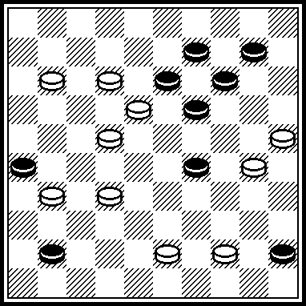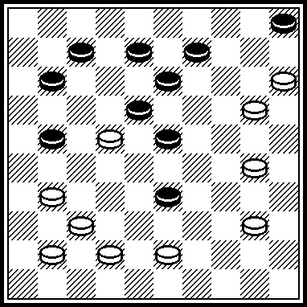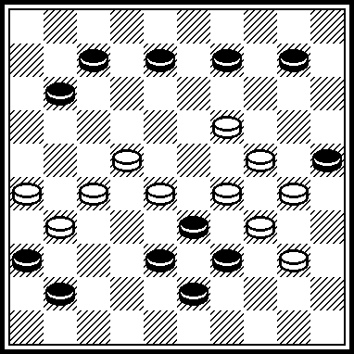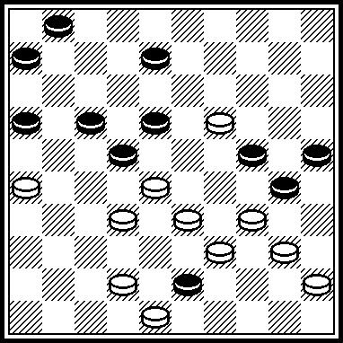

R08 R09 R13 R15
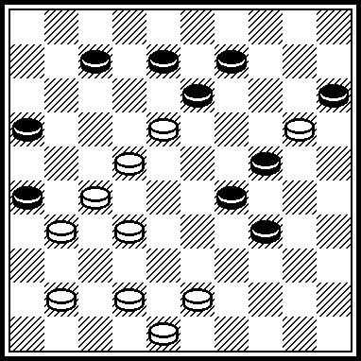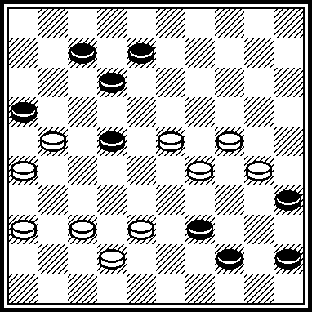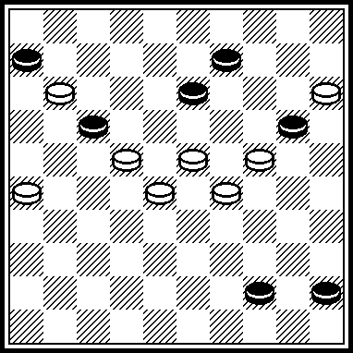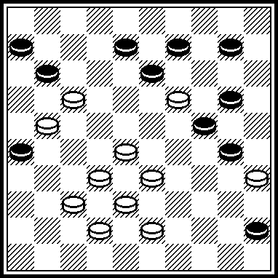

R20 R21 R22 R25
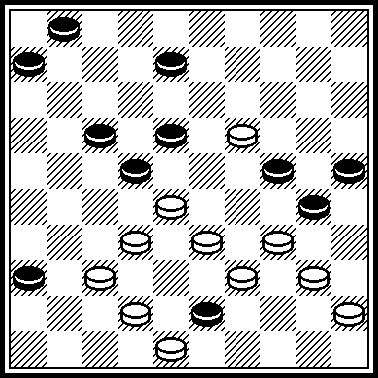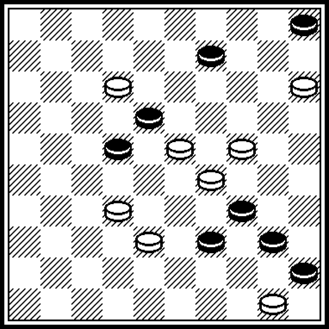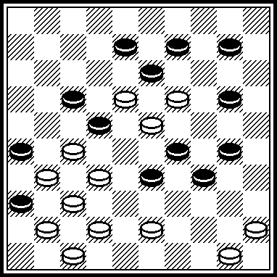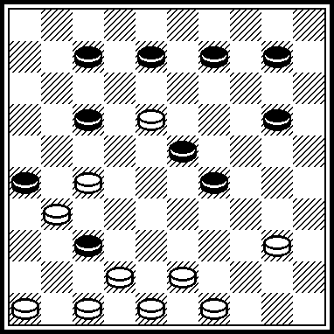

R26
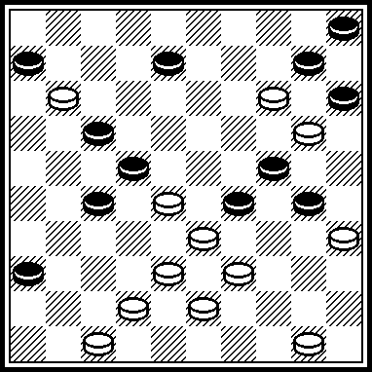
The author’s solutions Solutions des auteurs
(The abbreviation “SS” means “Second solution”. L'abréviation “SS” signifie “ seconde solution”.)

R02 | 117*, 20*, 40, 39, 2, 48.  *SS-1: 127, 2, 15(11) 40, 39.  *SS-2: 8, 2, 15(50) 438(47) 304.  *SS-3: 2, 15(50) 438(47) 304.
R03 | 10*, 14(19) 1, 2(46) 5.  *SS: 26, 6(39, 11, 32, 44) 11(50) 6(45) 30(1) 36(08-13) 25.
R04 | 20*, 6, 1, 13, 5.  *SS: 14, 4, 271(16) 21, 2.
R05 | 21(47) 42*, 3, 49, 450, 2.  *SS: 14, 3, 49.
R08 | 39*, 19, 194, 1(36) 40, 35(42, AB) 21, 37.  B(171) 26.  A(29) 40(42, CB) 21, 37.  C(33) 44(42, B) 11, 37.  *SS: 14, 1, 36(30, 35) 39, 39(22) 18(40) 34(44, 49) 13.
R09 | 33, 11, 38*, 7, 21, 2, 50.  *SS: 17, 50.
R13 | 261*, 249, 50, 4, 36.  *SS: 249.
R15 | 29*(33, a) 31, 28, (42, b) 14, 4, 17(50, c) 16, 7.  a(22) 4, 16, 35, 40, 39.  b(22) 14.  c(11) 6, 217.  *SS: 23, 39, 29, 4, 49(50) 19(45) 14(28, 1) 10(13) 33(45) 28(1) 35(13-18) 38(7) 40.
R20 | 31(47) 42*, 3, 49, 450, 2.  *SS: 14, 3, 49.
R21 | 28*, 249, 13, 1, 37(44, 50, A) 14.  A(10) 4(50) 04-10.  *SS: 249, 27, 13, 1, 26(44, 50) 34.
R22 | 44*, 13, 23, 450, 449, 32, 42, 3, 50.  *SS: 438, 44, 18, 18, 5(349) 23, 14(39) 25.
R25 | 35*, 461, 41, 428, 42, 44, 22.  *SS: 22(28) 471, 34, 31.
R26 | 37*, 372(31) 34, 42, 41, 23, 7, 30, 2, 40, 17(10) 12(11) 8(17) 3(22) 21(28) 38(14) 15(32) 42(19) 15(23) 20(28, A) 42.  A(37) 14.  *SS: 44, 14, 23, 28, 2.

