By S. Yushkevitch
THE RENAISSANCE CONTEST

FINAL RESULT.

Final table

Place | NN | Sum | AM | AvdS | AT | JSW | HW
1 | R27 | 53 | 4(17) | 3(18) | 12(9)* | 3(18) | 2(19)*
2 | R14 | 52 | 3(18)* | 10(11)* | 3(18) | 5(16) | 3(18)
3 | R01 | 50 | 6(15) | 9(12)* | 5(16) | 2(19) | 1(20)*
4 | R16 | 47 | 8(13) | 4(17) | 9(12)* | 1(20)* | 4(17)
5 | R17 | 45 | 13(8)* | 1(20)* | 6(15) | 7(14) | 5(16)
6 | R19 | 43 | 10(11) | 2(19)* | 11(10)* | 4(17) | 6(15)
7/9 | R06 | 42 | 2(19)* | 8(13) | 4(17) | 9(12) | 13(8)*
7/9 | R11 | 42 | 5(16) | 11(10)* | 1(20)* | 6(15) | 10(11)
7/9 | R12 | 42 | 1(20)* | 6(15) | 8(13) | 10(11)* | 7(14)
10 | R07 | 41 | 9(12) | 5(16) | 2(19)* | 12(9)* | 8(13)
11 | R24 | 36 | 7(14)* | 12(9)* | 7(14) | 8(13) | 12(9)
12 | R10 | 33 | 11(10)* | 7(14)* | 10(11) | 11(10) | 9(12)
13 | R18 | 25 | 12(9) | 13(8)* | 13(8) | 13(8) | 11(10)*
--- | R23 |  | --- | --- | --- | --- | ---

There are indicated in the final table: in the first column - the place taken by a position, in the second column - NN under which a position was registered in the contest, in the third column – the sum of points obtained by a position apart from highest and lowest points (they are marked by “*”). In the next columns there are indicated the ranking of all judges in alphabetic order: A.Moiseyev (AM), A.van der Stoep (AvdS), A.Tavernier (AT), J.-S.Weyeneth (JSW), H.Wilsens (HW), and in brackets – points obtained by a position for every one place (for the first place – 20 points, for the second – 19 points, for the third – 18 points etc.).

The winner-positions

1. S. Yushkevitch [R27] 2. V. P. Matus [R14] 3. P. Kuijper [R01]
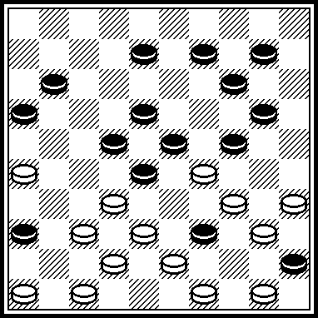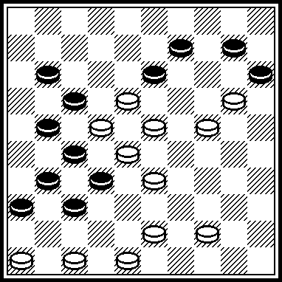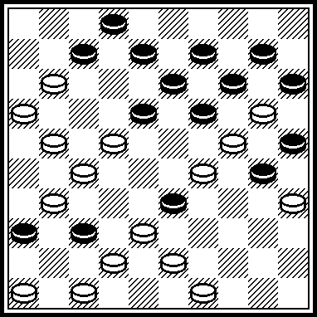

1 [R27]: 33*, 38, 31, 2, 504, 39, 21, 10(27) 4(32) 36(37) 36-41.
*Second solution (SS): 350, 40(48) 33, 35, 2(40) 35(117) 49 etc.
2 [R14]: 471, 42, 3*, 8, 26, 41, 5. *SS: 5, 41, 47 or 41-14 etc.
3 [R01]: 227, 43(42) 38, 6, 41, 23, 1(17) 7, 21*, 17, 18, 4, 20, 24. *SS: 18, 4, 20, 24.

Comments of A. Moiseyev.

Hello everyone !
Not bad at all !
Only three positions out of total 27 were rejected - very high quality and authors personal responsibility !
I also would like to congratulate an author of R08 (whoever he is). With new look and revision, his position
gets a second life and second chance and now could become a part of future references and publications
in media.
I personally was very impressed by most positions in contest and it was a hard choice for me to select best
of them for the next contest phase.
Serge, many thanks for your terrific job and management as contest director and organizer !
Respectfully,
Alex Moiseyev
Comments of A. van der Stoep.

R17 is my winner. Good initial position with two rather separated colours. The two white kings jump over the board, one of them sacrifies itself.
R19. Outstandingly well separated colours in the initial position. Pseudo-sacrifice of the white king, making three movements. A good initial position is a master proof, it reveals compositional skills.
R27. If a composer is satisfied with an initial position where the black and white pieces are criss-cross put on the board, it is easy to create the formation of four black blocked pieces. To form this blockade from a reasonably divided initial position demands much more skill, like in this composition.
R16. Laborious motief reached with nice meerslagen from a reasonable position.
R07. Marvellous travel of the black king, original creation of the capture 45x3, rare position after 27x7 with a white piece looming up in the back of the black king.
R12. Splendid sacrifice 4x11!, with the meerslag effect called in Holland "waterfall".
R10. Nice capture 16x40. But it is easy, if not cheap, to scatter a cluster of white pieces nearby the promotion row without black guards.
R06. The excursion of the white king 3-25x43 and the stick of the black king on square 32 are novelties added to an earlier applied capture system. The initial position is reasonable.
R01. The sequence 24x4(15x24)4x20 is far from new, which is a pity, for the introductory performance with travels of the kings is compelling.
R14. The sequence (…x19)23x3(32x12/12x32) has been applied before, but the author succeeded in dividing the two colours in a satisfactory way.
R11. Nice meerslagen, but if they are created by means of these appalling black pieces 48/42/43 I give up.
R24. Simple means used to prepare the king's sacrifice 3x27 with blockade.
R18. One nice discovery: 28-22!, but the chosen system does not leave room for a satisfying introduction.

REMARKS

Remarks of B.Ivanov.

R01. There is one more Second solution: 21, 471, 6, 23, 3, 1, 31.

R07. It is possible to play in A-variant : A(34) 40(18x) 13, 7, 9, 4, 41, 34, 19-13.
In Z-variant after 24(20x) 35(47) the move 15 is impossible.
Ressemblances:
H.Borgman
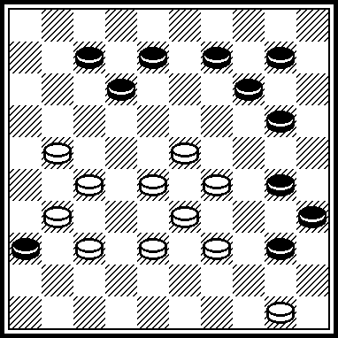 17, 45, 22, 1, 2(44) 40(50) 16(46) 49, 5. DE-01.1983.

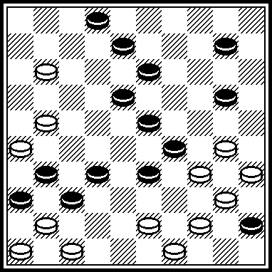 449, 39, 42, 43, 41, 19, 3, 8, 30, 5. From Championship of Vitebsk-region, 1994 and Championship of Belarus-1998. [Nota by S.Y.: Mr B.Ivanov did not indicate an author of this problem.]

R10. Ressemblance.
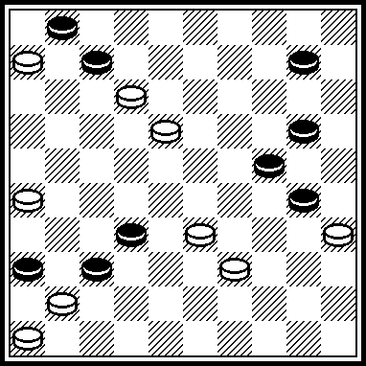 29, 4, 41, 40, 7, 1(17) 23(42) 37, 37.
From Championship of Novopolotsk-2004. [Nota by S.Y.: Mr B.Ivanov did not indicate an author of this problem.]
R11. There is one more Second solution: 13, 4, 12/17/21/26.

R12.
The copy.
E.Skliar
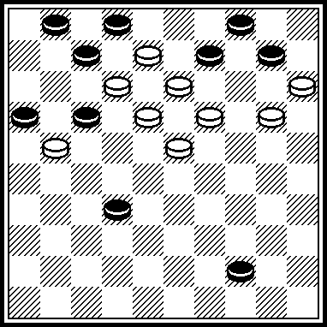 Website of M.Lepsic, topic “Selected compositions of E.Skliar”, placed 05.08.2008.
[Nota by S.Y:. E.Skliar does not participate in RENAISSANCE.]

Ressemblance.
A.Stuurman
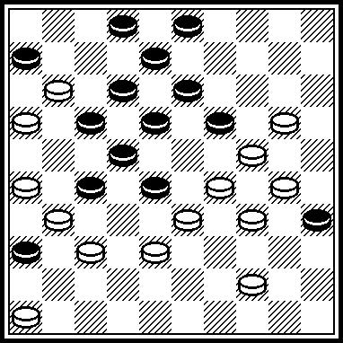 23, 15, 37, 32, 10, 21, 4, 7, 2, 8, 27. DP-1990.

R14.
Ressemblance.
J.van Kollenburg
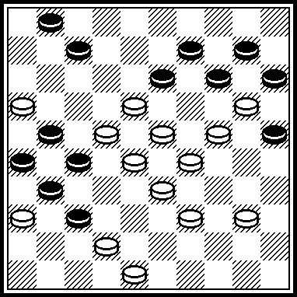 17, 22, 367, 12, 7, 31, 42, 23,4, 20, 34. HD-02.1961.

R17.
Ressemblance.
A.Nikolaev
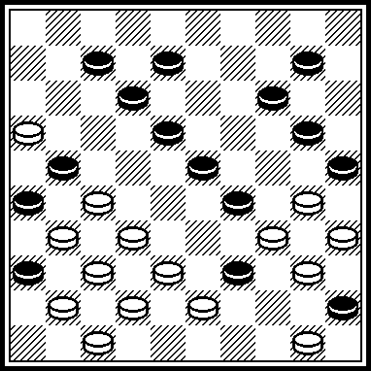 24, 33, 38, 28, 42, 11, 4, 30, 44, 44. “Transportnyj vestnik”, 21.05.2005.

R23.
The copy.
S.Perepelkin
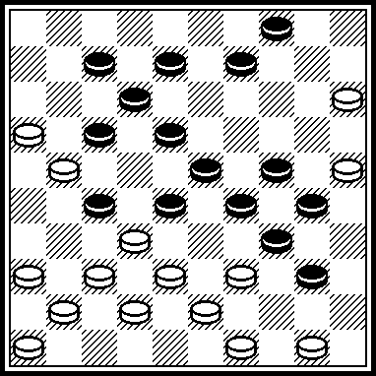 361, 11, 21, 494, 383, 2,39, 34, 21, 37. “64”, # 13, 1978.
[Nota by S.Y:. S.Perepelkin does not participate in RENAISSANCE.]

Remarks of A.Moiseyev and A.Tavernier.

R04. There is no SS, because the endgame after 14, 4271(16) 21, 2 (30) 38/16 (30) is the draw’-endgame.
R08. There is no SS, because the endgame after 14, 1, 36(30, 35) 39, 39(22) 18(40) 34(44, 49) 13 is the draw’-endgame, according to 7-pieces database of Kingsrow-program.
R26. There is no author’s solution, because after 37*, 372 black play (23, 32, 49) and the draw. All these three positions [R04, R08, R26] do not correspond to the contest conditions.

Remarks of A.Moiseyev

There are positions with SS non-indicated by authors.
R01. SS non-indicated by author: 6, 1+.
R03. SS non-indicated by author: 27, 39, 25+.
R05. SS non-indicated by author: 37, 21, 3, 49+.
R10. Partial SS non-indicated by author: after black capture (47), also 34 wins.
R11. SS non-indicated by author: 13, 4+.
R12. SS non-indicated by author: 138.
R15. Partial SS non-indicated by author: 29(33), 28+.
R17. Partial SS non-indicated by author: 30, 3, 12+.
R22. SS non-indicated by author: 44, 438, 18, 18, 5/25 etc+.
R25. SS non-indicated by author: 438, 32, 22+.

Remarks of S.Yushkevitch
R06.
Ressemblances:
J.Scheijen A. de Zwart
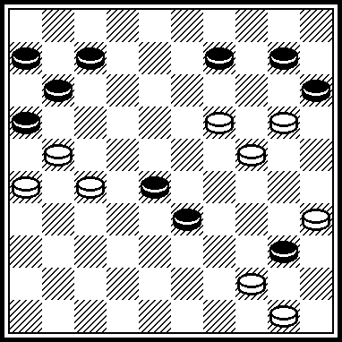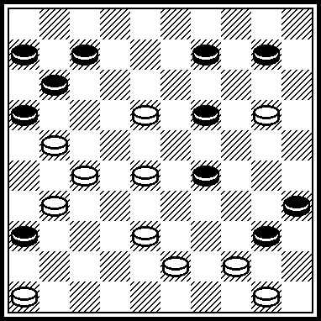
30, 194, 4, 4-22, 1, 17, 40, 17. 26, 23, 13, 41, 15, 4, 22, 1, 17, 40,17.
“Vrienden”, 20.06.1944. DP-01.1963

Authors of positions sent to the Renaissance-contest are (in brackets – NN of positions):

Fakanov, V. [R02, R13], Ukraine.

Fedorov, B. [R16], Ukraine.

Fedorov, M. [R24], Ukraine.

Fermin, B. [R05, R20], The Netherlands.

Ivanov, B. [R08, R18], Belarus.

Ivatsko, I. [R03, R21], Ukraine.

Kopylov, E. [R04, R15], Russia.

Kuijper, P. [R01, R19], The Netherlands.

Levandovskij, M. [R11, R22], Ukraine.

Matus, V. [R14], Russia.

Navrotskij, I. [R26], Belarus.

Rom, A. [R10, R23], U.S.A.

Ruiter, D. de [R07], The Netherlands.

Shapoval, N. [R09, R25], Ukraine.

Yushkevitch, S. [R12, R27], Ukraine.

Zilevicius, S. [R06, R17], Lithuania.

Problems from G. Andrejevs (Lettonia), S. Darchenko (Ukraine), A.-J. de Jong (The Netherlands) and S.Ustianov (Ukraine) were not accepted because authors sent them after the deadline announced (after 01.04.2009).

Positions for final stage of RENAISSANCE are published in “De Problemist”, August 2009, pages 93-94.
Final result of RENAISSANCE are published in “De Problemist”, December 2009, page 148.

Thanks very much to all participants of the “Renaissance”-contest !
Thanks very much to all of the jury members for perfect work !

