Concours « FFJD 2008 »

Catégorie B

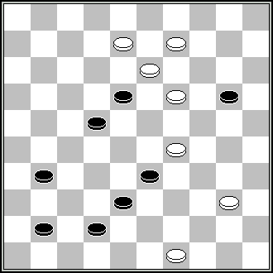 | 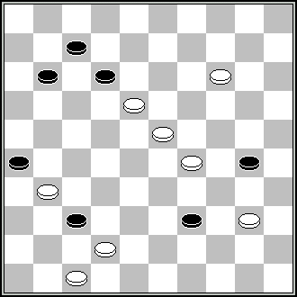 | 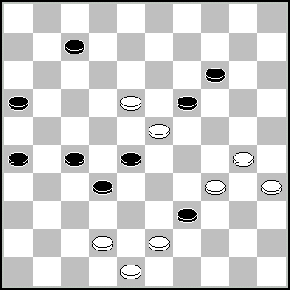 | 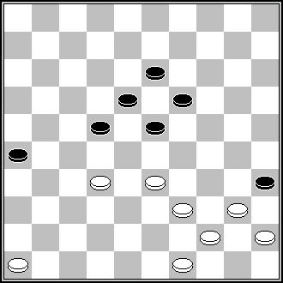 | 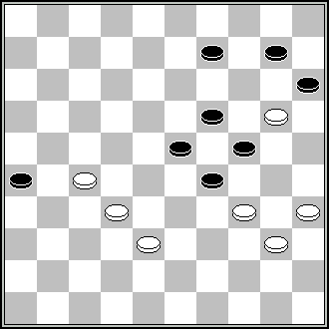
1 | 2 | 3 | 4 | 5
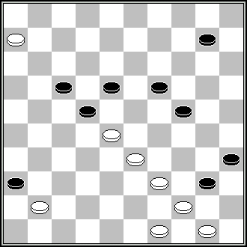 | 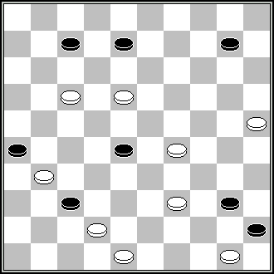 | 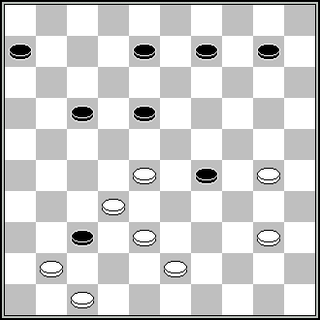 | 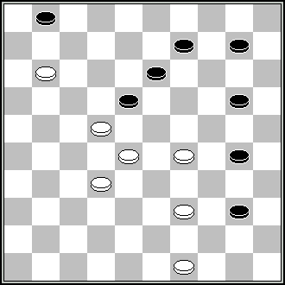 | 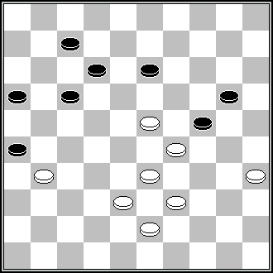
6 | 7 | 8 | 9 | 10
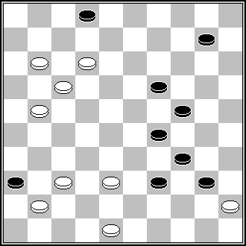 | 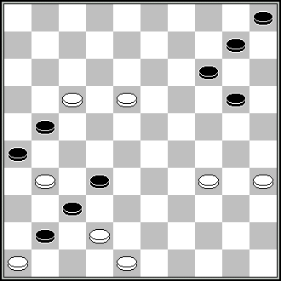 | 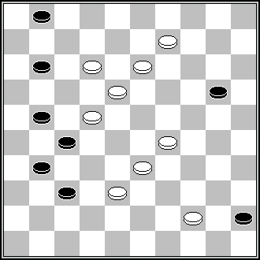 | 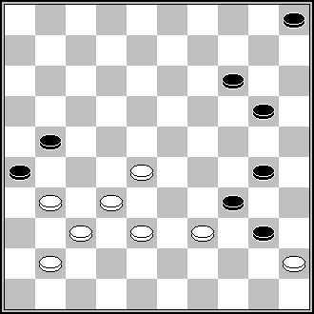 | 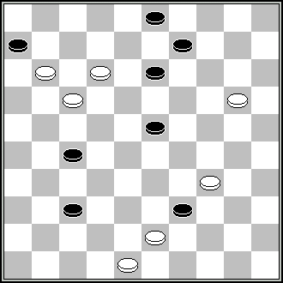
11 | 12 | 13 | 14 | 15
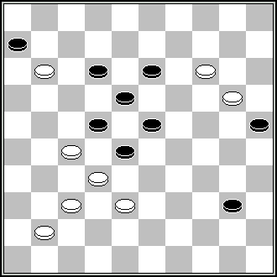 | 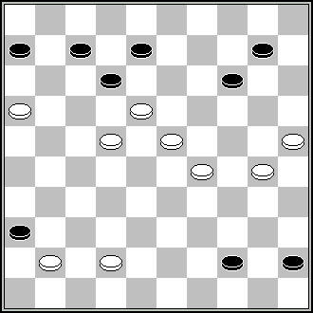 | 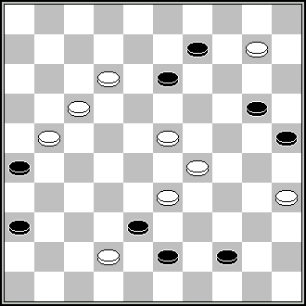 | 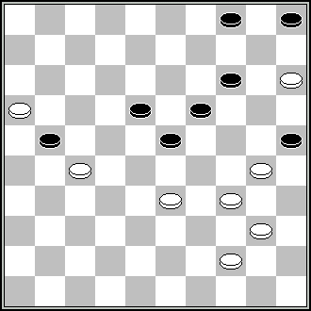 | 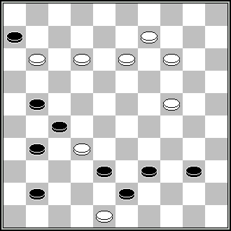
16 | 17 | 18 | 19 | 20
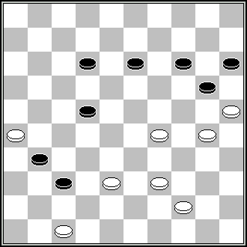 | 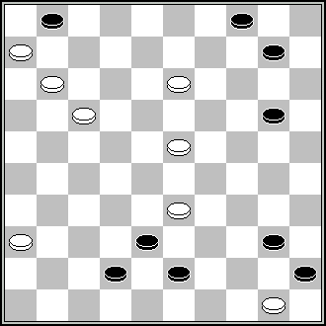 | 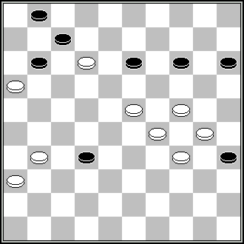 | 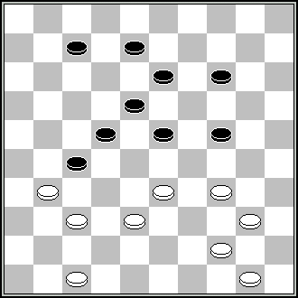 | 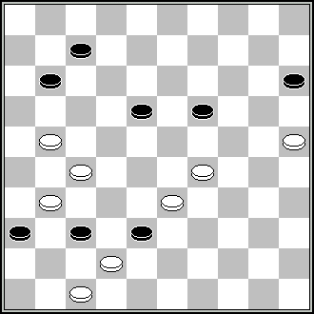
21 | 22 | 23 | 24 | 25
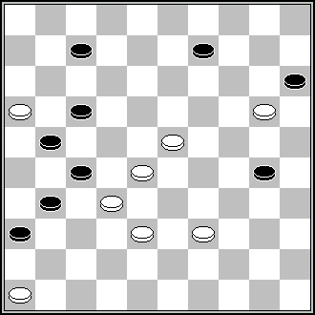 | 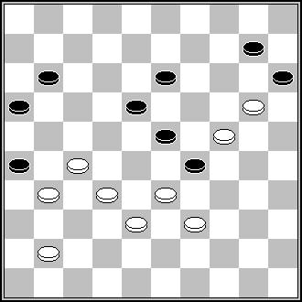 | 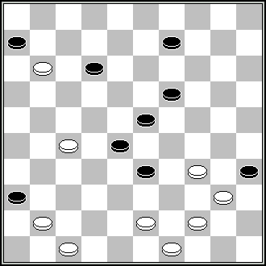 | 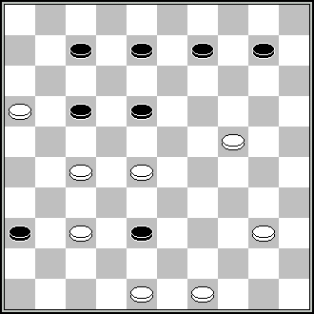 | 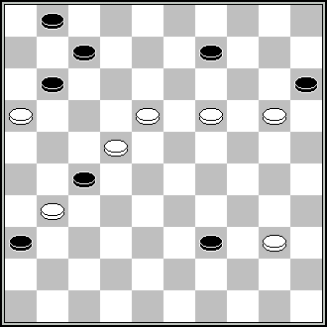
26 | 27 | 28 | 29 | 30
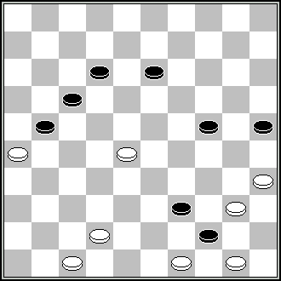 | 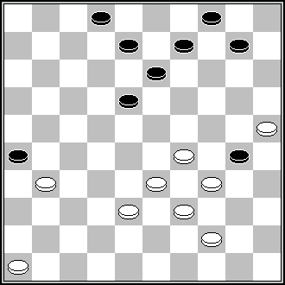 | 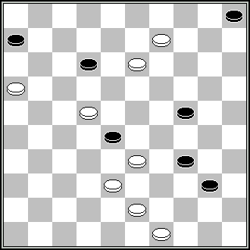 | 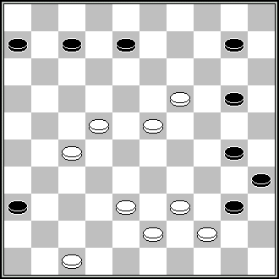 | 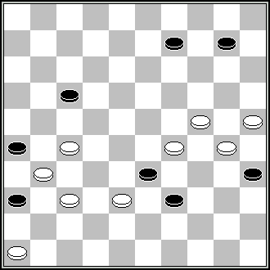
31 | 32 | 33 | 34 | 35
Concours « FFJD 2008 »

Catégorie B

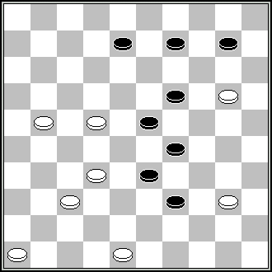 | 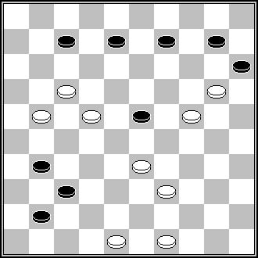 | 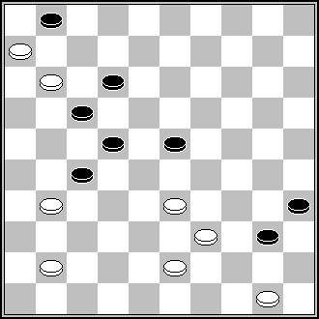 | 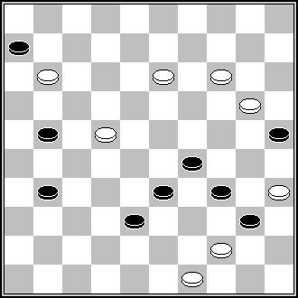 | 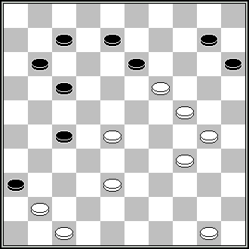
36 | 37 | 38 | 39 | 40
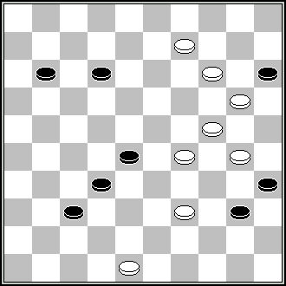 | 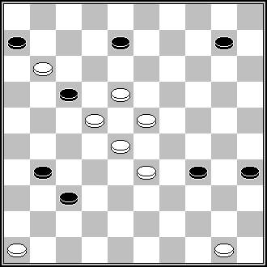 | 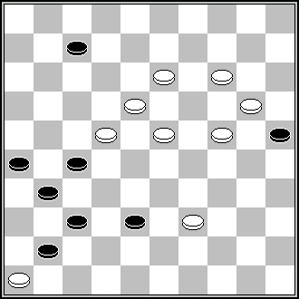 | 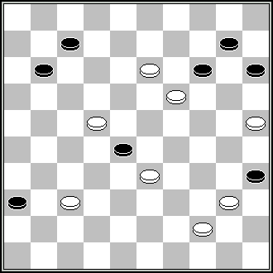 | 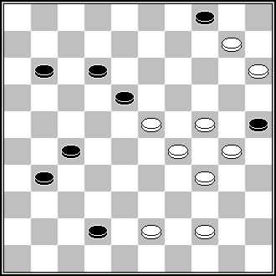
41 | 42 | 43 | 44 | 45
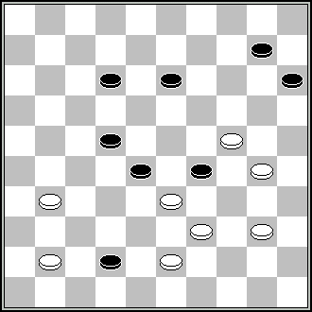 | 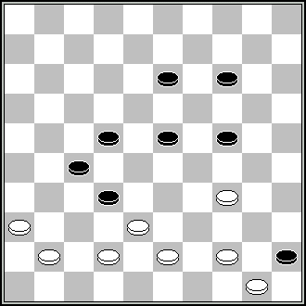 | 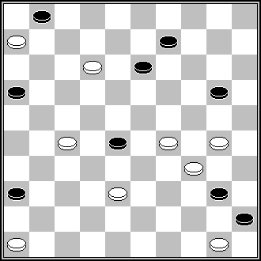 | 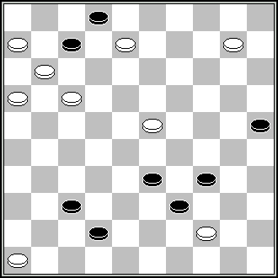 | 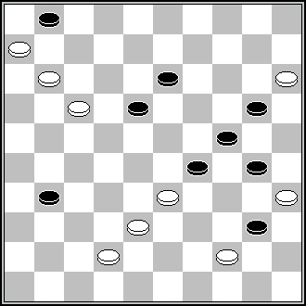
46 | 47 | 48 | 49 | 50
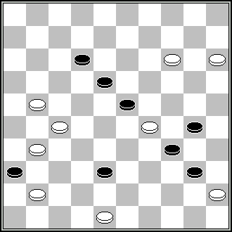 | 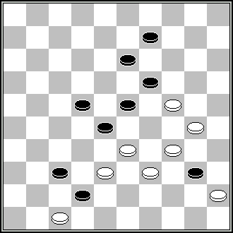 | 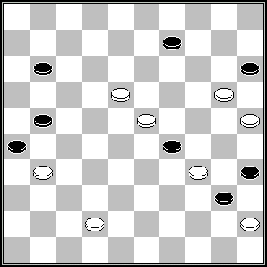 | 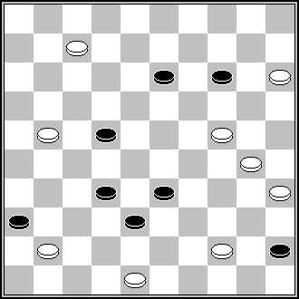 | 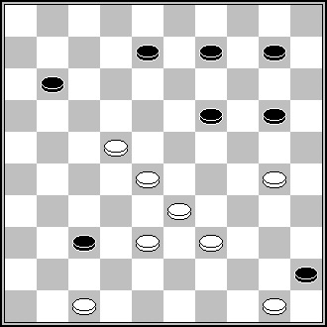
51 | 52 | 53 | 54 | 55
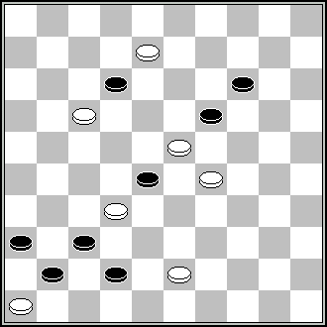 | 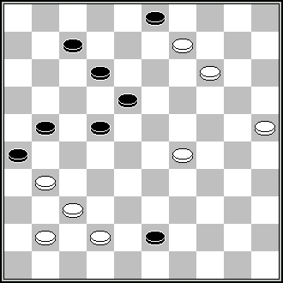 | 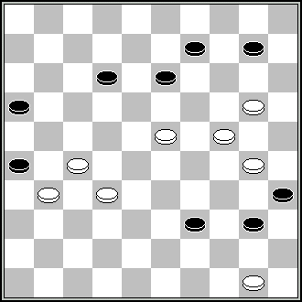 | 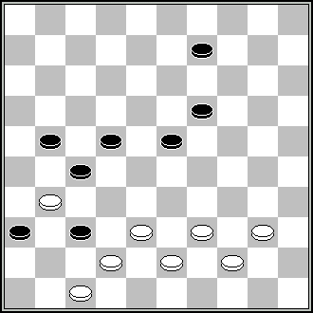 | 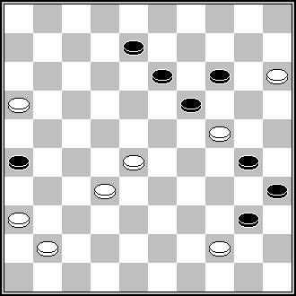
56 | 57 | 58 | 59 | 60
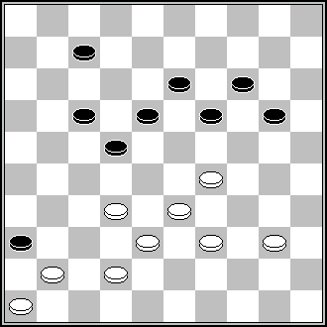 | 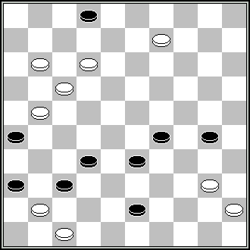 | 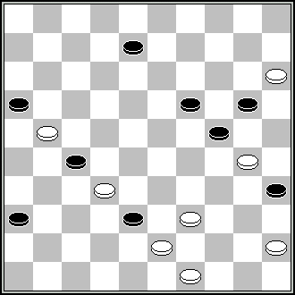 | 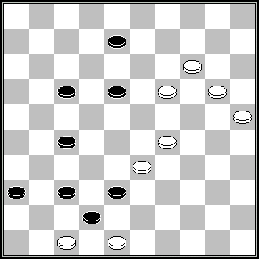 | 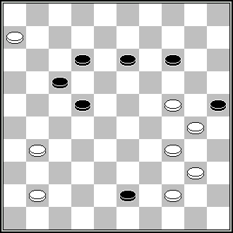
61 | 62 | 63 | 64 | 65
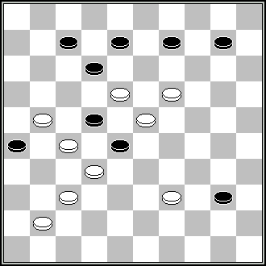 | 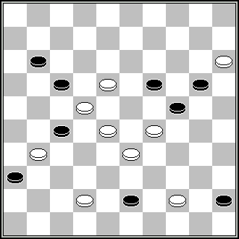 | 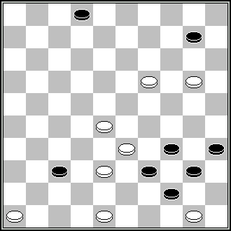 | 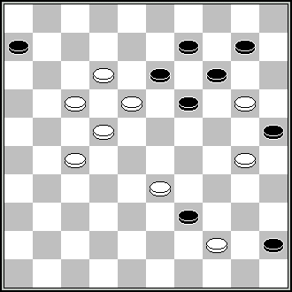 | 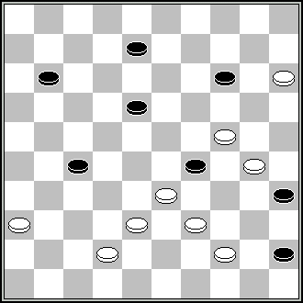
66 | 67 | 68 | 69 | 70
Concours « FFJD 2008 »

Catégorie B

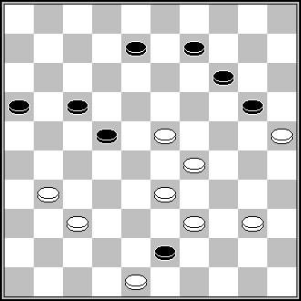 | 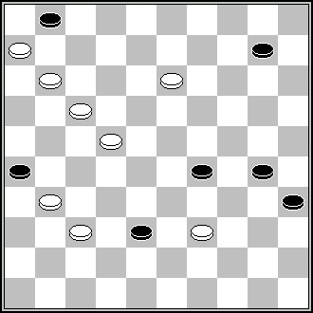 | 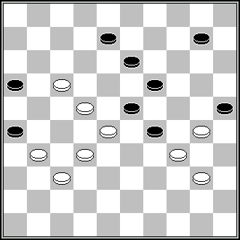 | 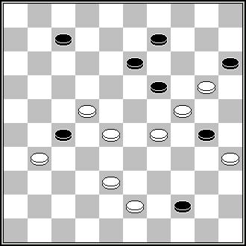 | 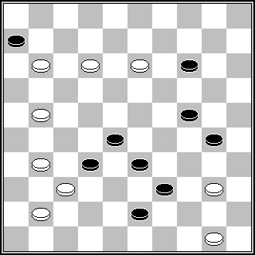
71 | 72 | 73 | 74 | 75
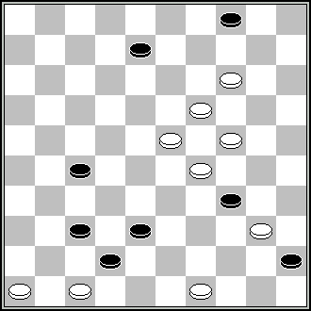 | 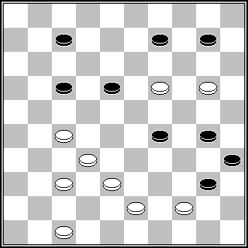 | 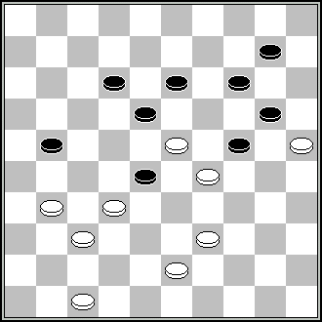 | 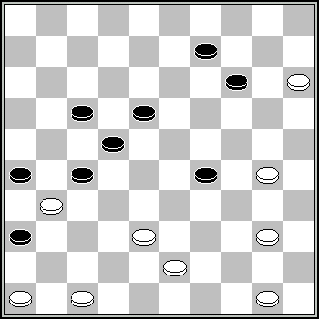 | 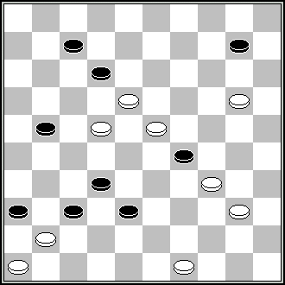
76 | 77 | 78 | 79 | 80
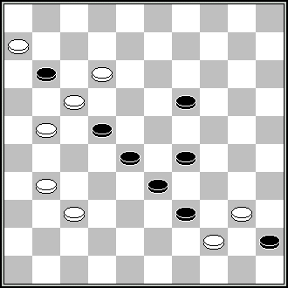 | 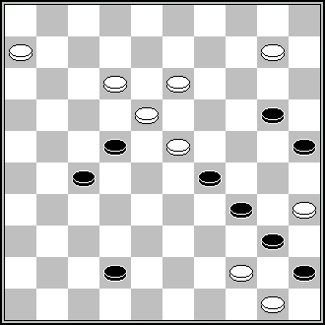 | 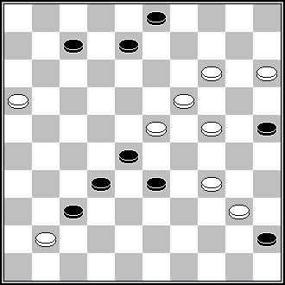 | 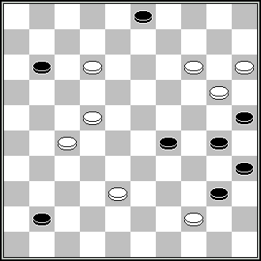 | 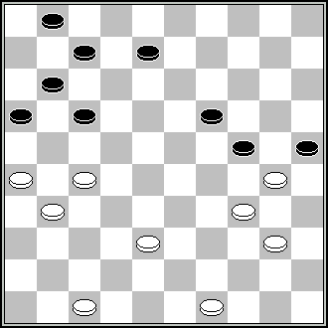
81 | 82 | 83 | 84 | 85
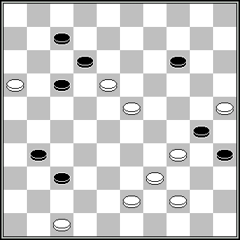 | 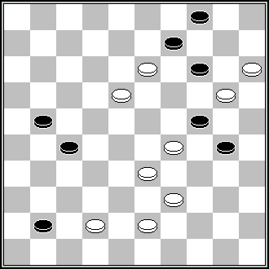 | 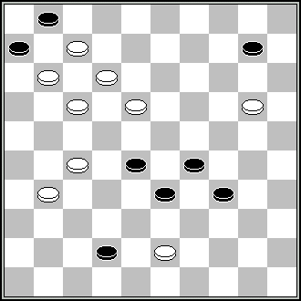 | 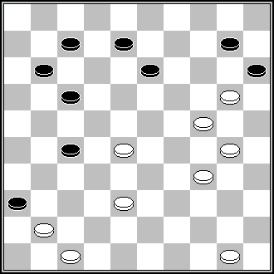 | 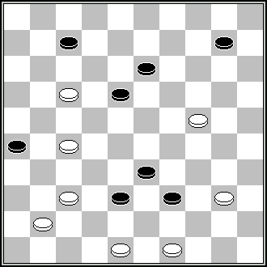
86 | 87 | 88 | 89 | 90
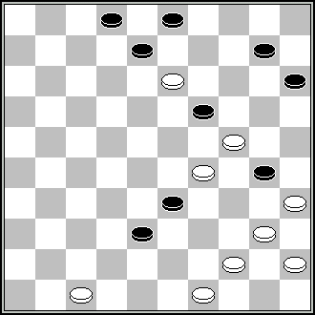 | 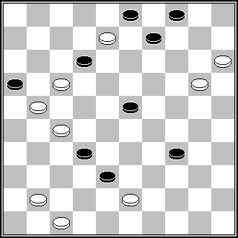 | 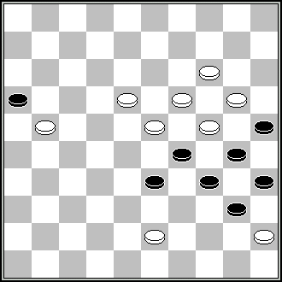 | 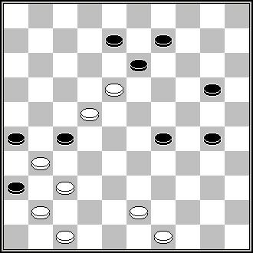 | 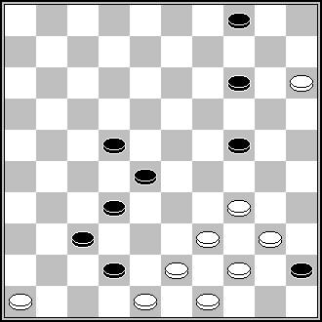
91 | 92 | 93 | 94 | 95
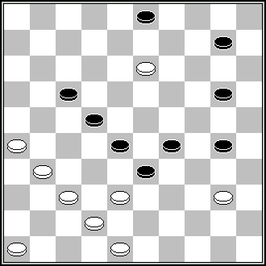 | 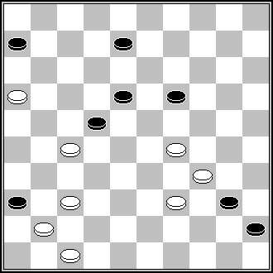 | 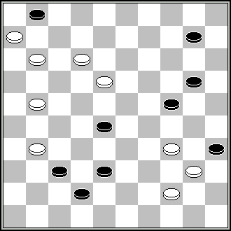 | 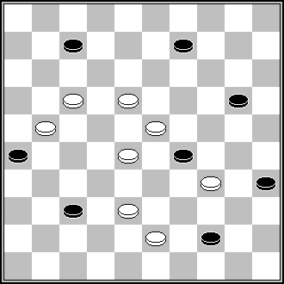 | 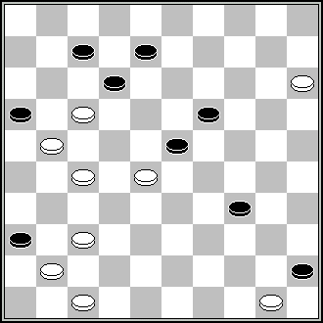
96 | 97 | 98 | 99 | 100
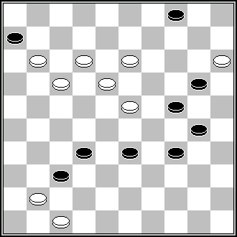 | 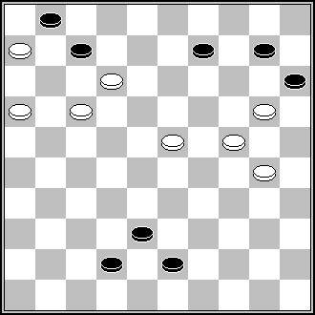 | 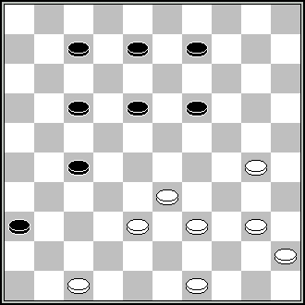 | 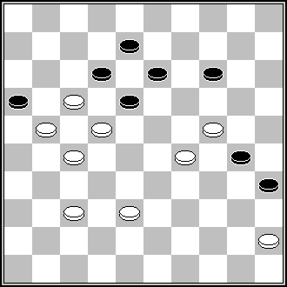
101 | 102 | 103 | 104

Concours « FFJD 2008 »

Solutions des problèmes de la catégorie B

Certaines solutions des problèmes reçues par J.Céron contenant tout et n’importe quoi pour désigner les variantes et sous variantes (minuscules, majuscules, des a’, des a’’’, des o, etc., etc.…), tout reproduire bêtement auraient compliqué la tâche des jurés et des organisateurs, c’est pourquoi seules des lettres majuscules ont été attribuées pour toutes les variantes et sous variantes, pour toutes questions éventuelles voici l’e-mail de notre ami : ceron.jacques@wanadoo.fr

Certain solutions of problems receveid by J.Ceron containing everything and anything to indicate variants and under variants (small letters, capital letters, a’, a’’’, o, etc., etc. …), all reproduce everything silly would have complicated the task of the members of the jury and the organizers, that is why only capitals letters were attributed for all the variants and under variants, for any possible questions here is the e-mail of our friend: ceron.jacques@wanadoo.fr

1. 24,43,2,4,38(13A)24(42B)47 + A) (42)193,47 + B) (20)15 +
2. 10,5,41,34(10)6,43(234A)50,35(39)49 + A) (39)44,35(40B)11(45)50 +
B) (11,39)49 +
3. 438,21(27*)12,25,31,39,34,34 +
4. 338,28(31A)41(37B)34,29,27,22,440,9(31)4(36)10(24)40(29)15(34,41)10 si (47)15 +
si (46)5 + A) (29)41(24C)27(30)23(33)12(38)37(19)7(23)2(28)43,16 + B) (22,37)36,11
(32)7(37D)1(18E)34(24)43(42FG)38,29,42 + C) si (18-23)37(18)34,34 + si (31)36
(37,24)34,34 D) (38)1(18H)34(24)30(29)6,33(30,42)30(47)25(28I)14(23J)25(33KL)
25-39(28)39-43(42)48(42-38M)37(38-32)37(32-38)47(28-32)31+ E) (29,42)48(47)
48-31(18)24(20)34 si (33)44-40,40 + si (25)29(20)43,34 + si (24)31(42)26(48)29(30)
23(8)44-40,40(35)34(40)29 + F) (24-29)31,33 + G) (30,42)38,45-40 si (39,44)28/29 +
si (38)34(43)29,40+ H) (28)23(33)14(42)25(19)39(24)28 si (47)28-39 etc... +
si (48)33(24-30)28(26)39 + I) si (22)14(23-29)44-39(27)10 etc... + si (29)9(23)14 +
J) (33)25(23)25-39 etc... + K) (29)14 si (47-33)37,42, etc... + si (28-33)25, etc... +
L) (32)44-40 si (29)14(32-38)25 etc... + si (28)48(28-33)44(39)25(37)14(37-42)25(48)
40-34 + M) (47)49-43(32)38 Z = 17-11(14)6(28,14-19,43…) =
5. 21,350,28,3,5 +
6. 1,5,43,5-23,30,44 +
7. 43,20,14,44,172,3,50 +
8. 33(49)23,5,472(23,17)37 +
9. 44,4(7,42)24(48)18,38 +
10. 30(35)18,30,39,32,2(19)33(25)29,38(30)43(35)49(21,40)11(45)50 +
11. 11-7,8,3,43,217,30,5(40)28(45)50 +
12. 43,4,10(37A)31(26)4 + A) (14)317 +
13. 7,32,3,6,50 +
14. 327,25,10,14,4 +
15. 42(398)18,10,4(8-13A)15(18)10(8)4(9-13)10(22)32(18)21(28)3 + A) (14)18(9,12)15
(17)42(21)26(27)3(19)9 +
16. 10,5,17,26,5 +
17. 11,23,20,5,50 +
18. 18,30,4,49(47A)15,47 + A) (29)16(41)37,15 +
19. 11[349,11(x34)+]349[7(22) =]7,29,40,2(20AB)25(29C)39(5-10)25(33)[(14)3(33)21(39)
49 +]9,4(19)10(24)15(29)20(34)38(40)33(45)50 + A) (9)4(29)22(34)10(40,45)50 +
B) (28)20 via 32(32)42(9)[si (5-10)20 +, si (37)9,4(19)10 +, si (14)20x9,10 +, si (18)4
(23)15 +, si (38)4(19)10(24)15 +26(13)48(38)25(19)3(10,43)13,49 + C) (28)20[si 48(33), si (32)42 +, si (5-10)25 +, si 43(5-10)si 34(38)48(13)25 +, 25(10-14) =](32)
42…see B
20. 13-8,42,9-3,25,2,16(48A)16-43 + A) (49)25-43 +
21. 41,37,10,14 +
22. 9,7,1,4(44,50)27,27 +
23. 26,7,239,20,31,29,27,28 +
24. 372,41,328,39,3,19 +
25. 41,24,1,6(21A)47,42(20,37)47(41)36 + A) (42)22,47,15 +
26. 18,34,41,13,4,11,36(11)31(17)27 +
27. 328,19,8,21,2,5 +
28. 29,42,3,39,40(34A)22,25(40)39(45)50 + A) (44)22,50 +
29. 282z,493y,32(13A)5,37,37(12)11(18)7(22B)31[si 2(27)19(32,41) =]2(32)11(27)16 +
A) (19)1(22,[si (23)29(41)47(46)41 +]41)42(14)13(46C1,C2)8(28)[si (41)37,7,7 +]3
(149)8 + B) (23)2(28)16 + C1) (20)23(47)7,7 + C2) (19)47,29 + z) 272,42,31(15)
4(41) si 23(417)13(41)139(29) = si 35(46)282(19)al(30) = y) 42,31(15)21,5(29)35
(11,1) =
30. 194,3(29)182(718)7,23(29)34,12 +
31. 30,40,44,22,39,38,38 +
32. 28,41,283,293,5(10,13)33 +
33. 4,44,17,43,18 +
34. 17,41,34,5(38A)194,49(11)44(16)49(21,40)11(45)50 + A) (10)16,49 +
35. 22,31(37A)23,3(24B)5,37,41 + A) (42)41,23,3,5 + B) (42)26,41,5 +
36. 43,34,15(41)2,28,28 +
37. 28,42,11,4,38,38 +
38. 29,7,34,38,1,40,17 +
39. 43,23,3(49A)40,44,44 + A) (14)39,44,44 +
40. 42,20,32(22AB)1,349,40,6(12C)1(17)23(15)28(21)32(26)37(20)42(25)48 + A) (40)1,
45(16D)22 + B) (45)1,283,4 + C) (13/14/15)1 + D) (17)12 +
41. 42,4(5A)19(153B)49,46 + A) (10)19(153C)49,5(33)32(39)49 + B) (353),35,46 +
C) (35x13)35,5(33)32(39)49 +
42. 41,13,5(23A)12,45(43),40,48 + A) (19/10)40,40-44/45(43)40,48 +
43. 12(29)42,3(48A)37(14)25(42B)394,37,26 + A) (14)25,37(42C)394,37,26 +
B) (34)48,37,26 + C) (34)48,37,26 +
44. 8,2(23A)13(44B)20,49,31,1(17C)29(14D)42(21)26(27)3(32E)20(37)47 + A) (17)2-13,
2,31,20, 1 + B) (17)2,31,20,1 + C) (14)34(19)39(16)43(24)38(30)43(35)49 + D) (22)
15(28F,33),27(39)49 + E) (19)9(32)4(23)15 + F) (14)4(28)15(32)42(19)15(23)20 +
45. 38z,38,5(34A)150(15B)46,16(40CD,36)20,19 + A) (32)8,10,20,7/2 + B)(32)20,6(32)
33(37)47 + C) (32)30(20,37)24(41)19(47)24,24 + D) (37)25(42E)48(47)25 +
E) (41)14 + z) 5(47)239(10) =
46. 27,7,33,20,2,5 +
47. 29(34)31,40,35,44 +
48. 7,44,22,41,25,3,8(50)17,17 +
49. 3,41,5(19)30 via 33,8,2,26(2AB)1(19)8,7,7 + A) (28)17 + B) (7)1(2)7 +
Légalité: 2-7-22-25-30-33-34-D36-39-40-42/6-8-D9-10-11-13-15-16-21-23-32-46
17(28)9-14(20)44(37)…
50. 7,10,4,38(49)1,29,44,44 +
51. 17,37(41A)24,4,29(39,34)39,39 + A) (27)19,25 +
Légalité: 1-12-23-24-29-30-34-36-40/11-14-15-20-21-27-31-41-45-D47-48
7(18)33(38)29(12)…
52. 349,18(22*)4,34,24,40 +
53. 13,4(18)2(24AB,24C)30,34,34 + A) (29)7,34,34(40)30,34 +B) (30)254(24,24)30,34 + (C) (29)34(40)34,34 +
Légalité: 4-6-9-22-28-29-35-36-40/7-8-10-11-15-18-19-20-23-25-26-27-31-32-34-37-42-45 261(24)5,150(415)18(41)323,519… +
54. 40,43,20,29,24,24,24 +
55. 24z(30)42,44,18,40,23,2(16,39A)33,49(33)43(21,39)49 + A) (21)32(39)49 +
z) 25(42,48)8(30)17,17(23)2(35)29y,171(340)6(44,50)383(14)11(45)1(30) =
y) 171(14)6(28,149,43…) =
56. 38,3,48,31,37 +
57. 23,38,8,2(5)15,10(20)14 +
58. 21,14,45,5,19 +
59. 32,404,41,4(228A)10(27)33,44,33 + A) (217)10(29)37 +
60. 31,11,6(16)1,27,2(40)11(45)50 +
61. 427,41,24(29)24,394,31,1(44)10,4(18)32(40)28,35 +
62. 11-7,3,38,38,34,25 +
63. 44,34,29,2(27A)16,19 + A) (24)27,18,47 +
64. 13,14,24,41 +
65. 39(49AB)33,27,349,28,1,26,5 + A) (48)20,7 + B) (20)15(49)35 +
66. 14,3,19,47,34,5 +
67. 13,22,38,4,6 +
68. 41,204,5(28)30,33,8,43 +
69. 11,22,15(34 A)4,48(19BCD)40,2(32)11(27)16(31)38(37)47+ A) (22)2, 48(33)40, 27(39)49 + B) (50)26(39)43(33)16+ C) (12)40,21(33)16 + D) (19)40,2(33)16 +
70. 40,31,2,43,25 +
71. 19,21,28,50 +
72. 32,7,1,42(40)34,4 +
73. 11,18,28,5,46,50 +
74. 39,283,2,24,47,3(34)25(40)44 +
75. 9(26*)49(33,46)45,34,43(34A)39,29 + A) (35)44 +
76. 461,13,2,40,9,29(43)38,42 +
77. 439,204,22(27A,14*,46B,40)34,471(32)37(33C)32(39)49 + A) (28)5(41)36(40)194
(45)9(50)34(11)3 + B) (41)46(40,45)28 + C) (34)28(40)33(45)50 +
78. 33,317,42,28,19,5(28,39)7(34)40(43)38,29(37)47 +
79. 34(40*)24,44,471,461,23,4(28)15(32)42(19)15(23)20(28)42 +
80. 43,15,4,17,8,41,35(41/42)239 +
81. 32,28,17,2,16(40A)11(45)50 + A) (39)49 +
82. 5,14,4,30,1,40,44,44 +
Légalité: 20-22-25-27-29-32-33-34-40-45/6-10-12-13-18-23-35-43-44-49-50
38(43)38(42…
83. 20,29,11,2,4,9,5 +
84. 17,150,5(8A)9(254B)25,46(40)28(45)50 + A) (10)26,8,46,28,50 + B) (314)3,46(40)28
(45)50 +
85. 261(37)42,40,35,2(12A)21,32(30)14z(35)23(17)382(6)1(11)6(40)27(45)22,50 +
A) (6)33 + z) 21(18)17(35)44(7)383(11)29(16) =
86. 41,40,11,2,26,34,34(19)29 +
87. 34,28,10,4,48 +
88. 39(43A)14,13,3,27(17B)23(19C)29 + A) (44)8,2,27,12,50 + B) (21)32,43(22)16 +
C) (21)16(39)49 +
89. 42,19,32(22AB)1,349,40,6(12C)1(17)23(15)28(21)32(26)37(20)42(25)48 +
A) (40)1,45(16D)22 + B) (45)1,283,4 + C) (13/14/15)1 + D) (17)12 +
90. 483,21,43,12,1,5 +
91. 39,9,13,13,24(40,140A)19(25)29(30)24(35)20,30,9(29)4(42B)38,43(7/8)38,38 +
A) (19)30,42,25,5 + B) (43)38,42(7/8)38,38 +
92. 2,8,38,41(27A)10,37 + A) (32)10,4,31(28/29)9 +
93. 183,3,38(42A)3-17,8,29(44)33(49B)44,34 + A) (27/19)18,13,30,34+ B) (50)6(45,40)1 +
94. 32,42,23,18,43 +
95. 29,38,41,37,39,9,10(33AB)4(19)10(24)15(29)20(34)38(39C)49 + A) (18 F)4(23)
10 + B) (32)4(19)15(23D)20(28E)42 + C) (40),33(45)50 + F) (19)5(23)10/14 +
E) (37)14 + D) (37)10 +
96. 21,372(287)43,35,4,41,139,5 +
97. 23,3,38,11(50A)8,6,50 + A) (44)26,50 +
98. 39,33,7,1,37(29,33)32(39)49 +
99. 172,39,32,1(18,40)33(45)50 +
100. 272,42,10,5,40,44 +
101. 9,39,10(43)4,41,19,38 +
102. 161,33,7,1,5(40)28(45)50 +
103. 41,32,1(33…) 44,6 +
104. 19,2,40(27A)17,50 + A) (40)49,5 +

Jury : M.Lepsic (Croatie), V.Masiulis (Lituanie), M.Sabater (France), S.Weyeneth (Suisse).

Nombre de participants: 54

Bielorussie (7) : Ivanov.B, Kogotko.A, Navrockij.I, Shkludov.P, Shulga.V, Vitoschkin.L, Varushyla.V
Etats-Unis (2) :Moyseyev.A, Rom.A.
France (8) : Bochaton.S, Doubovy.N, Dumas.G, Garlopeau.P, Outters.R, Patry;J.C, Tavernier, A,Vermeulen.A
Israel (2) : Skliar.E, Tsvetov.M.
Lettonie (1) : Andrejev.G
Lituanie (7) :Bieliauskas.V, Kaciuska.A ,Leisys.J, Mackevicius.R, Morkus.B,. R,Siozinys,.J,
Studencov.V
Pays-Bas (3) : Bus.J, Smedinga.T, Timmer.A,.
Russie (7) : Nikolaev.A, Nikolaev.D, Nyrov.A, Kopilov.E, Shayakhmetov.R, Perepelkin.S,
Shestirikov, G
Suisse (1) : A.Kuyken
Ukraine (16) : Darchenko.S, Fedorov.B, Fedorov.M, Ivatsko.I, Katiuha.A, Levandovsky, Maslov.A, Nich.A, Nicitshyk.V, Reznikov.S, Shapoval.N, Trinos.V, .Ustianov.S, Uvarov.A,, Vlasov.I, Yushkevitch.S

Remarks should be sent before 15 december 2008. Les observations sont à envoyer avant le 15 décembre 2008 à :
Tavernier Alain. 33, rue de Montmorency. 78990 ELANCOURT. FRANCE.
E-mail : tavernieralain@wanadoo.fr

La Fédération Française de Jeu de Dames et l’Amicale des Problémistes Français adressent leurs sincères remerciements à Mrs LEPSIC, MASSIULIS, SABATER et WEYENETH d’avoir bien voulu accepter la lourde et redoutable tâche de juger le présent concours..

Sachant que sans juges il ne saurait y avoir de concours, nous pensons bien faire , nous faisant l’interprète de l’ensemble des participants, de joindre à ces remerciements, l’expression de notre gratitude (J.C)

