

FEDERATION MONDIALE DU JEU DE DAMES (FMJD)
COMMISSION DU PROBLEMISME INTERNATIONAL (CPI FMJD)

CPI-INFO
OFFICIAL EDITION OF CPI FMJD
Nr. 9, December, 2008

CONTENTS
2…..Rating table.
4…..The International contest “Memorial Garry Dalidovich-2007”.
6…..Final results of the Second Personal World Championship of Problemism (PWCP-II), (“Miniatures”).
12….International titles.

CPI members:

J. C. R. Bus, CPI President, Germany, E-mail: Jaapbus@t-online.de
V. Matus, CPI member, Russia, E-mail: intlegal@rim2000m.ru
V. Shulga, CPI member, Belarus, E-mail: shulga-@mail.ru

RATING TABLE on December 2008.

 | Name | Country | Points | Places
 |  |  |  | 1 | 2 | 3 | 4 | 5 | 6
- 1 | Matus Vladimir | Russia | 880 | 14 | 15 | 2 | 6 | 2 | 2
- 2 | Perepelkin Sergey | Russia | 570 | 8 | 3 | 12 | 5 | 3
- 3 | Zubov Evgraf | Russia | 555 | 13 | 4 | 3 | 4
- 4 | Yushkevitch Sergei | Ukraine | 470 | 8 | 6 | 3 | 4 | 5
- 5 | Tavernier Alain | France | 430 | 1 | 8 | 7 | 3 | 11 | 2
- 9 | Kuyken Andreas | Switzerland | 405 | 4 | 6 | 4 | 3 | 7 | 4
- 6 | Nikolaev Alexander | Russia | 390 | 7 | 5 | 2 | 3 | 1 | 1
- 7 | Bastiaannet Johan | Netherlands | 390 | 7 | 4 | 4 | 3 | 1
- 8 | Morkus Benjaminas | Lithuania | 340 | 5 | 5 | 3 | 2 | 1
- 10 | Fedorov Boris | Ukraine | 230 | 5 | 1 | 1 | 3 | 1
- 12 | Rom Alexander | USA | 220 | 1 | 3 | 3 | 1 | 4
- 11 | Ruiter, Dick de | Netherlands Голландия | 210 | 3 | 2 | 2 | 2 | 4
- 13 | Fedoruk Alexander+ |  | 210 | 3 | 2 | 3 | 1 | 2
- 14 | Miedema Aart + |  | 155 | 1 | 2 | 3 | 3 | 2
- 15 | Nikolaev Dmitriy | Russia | 155 | 1 | 2 | 1 | 2 | 2
- 16 | Torres Jean Paul | France | 150 | 1 | 2 | 2 | 4 | 2
- 18 | Fedorov Mikhail | Ukraine | 145 | 2 | 1 | 1 | 2 | 1
- 17 | Jong, Ardjan de | Netherlands Голландия | 110 | 2 | 1 | 1 |  |  | 2
 | Bieliauskas Valdas | Lithuania | 110 |  | 2 | 1 | 2 | 1 | 1
- 19 | Fourgous Rene + |  | 90 | 1 | 1 | 2 | 1
- 20 | Konkov Alexander + |  | 90 |  | 2 | 1 | 2 | 3
- 21 | Ustianov Stanislav | Ukraine | 90 | 2 |  | 1 |  | 1 | 1
 | Moiseyev Alexander | USA | 90 | 1 |  | 1 | 2 | 1
- 22 | Levandovsky Mikhail | Ukraine | 90 |  | 1 | 3 |  | 1 | 1
- 23 | Klomp Steven | Netherlands Голландия | 85 |  | 2 | 2 | 1 | 1
- 24 | Korteling Siep | Netherlands Голландия | 80 | 1 | 2
- 26 | Andrejevs Gennadij | Latvia | 65 | 1 | 1 |  | 1 | 1
- 27 | Bakumets Alexander + |  | 60 |  | 1 | 2 | 1
- 28 | Muliar Vassil | Ukraine | 60 | 1 |  |  | 2 | 1
- 29 | Sabater Michel | France | 60 |  | 1 | 1 | 1 | 1 | 1
- 30 | Bus Jaap | Germany | 60 |  | 1 | 1 |  | 1 | 1
- 31 | Shulga Viktor | Belarus | 55 |  |  | 2 | 2
- 32 | Studencov Viktor | Lithuania | 55 |  | 2 | 1
 | Ivanov Boris | Belarus | 55 | 1 |  | 1 |  | 1
- 33 | Dumas Gerard | France | 50 |  |  | 1 | 1 | 3
- 34 | Linde, Gerrit van der + |  | 50 | 1 | 1
- 35 | Silo Grigorijus | Lithuania | 45 |  | 2 |  |  | 1
- 36 | Grebenko Vasilij | Belarus | 45 | 1 |  |  | 1
- 37 | Masiulis Virmantas | Lithuania | 40 |  |  | 1 | 2
- 38 | Sabonis Viktor | Lithuania | 40 |  | 2
- 39 | Vitoshkin Leonid | Belarus | 40 | 1 |  |  | 1
- 40 | Smedinga Tijpke | Netherlands Голландия | 40 |  |  | 1 |  | 2 | 1
- 41 | Vemeulen Alain | France | 40 |  |  | 1 | 1 | 1 | 1
- 42 | Ivatsko Ivan | Ukraine | 40 | 1 |  |  |  | 1
- 43 | Trofimenko Vjatcheslav | Ukraine | 40 |  |  | 1 | 2 | 2
 | van der Stoep Arie | Netherlands Голландия | 40 |  |  | 2 |  |  | 1
- 44 | Zilevicius Stasys | Lithuania | 35 |  | 1 |  | 1 | 1
 | Sapegin Alexander | Belarus | 35 | 1 |  |  |  |  | 1
 | Shayahmetov R. | Russia | 35 |  | 1 |  |  | 1
- 46 | Bugajev Igor + |  | 30 | 1
- 47 | Hlasny Adam | Poland | 30 | 1
- 48 | Kaciuska Algimantas | Lithuania | 30 |  |  | 1 | 1 | 1
- 49 | Pankratiev Alexey | Russia | 30 | 1
- 50 | Uvarov Anatolij | Ukraine | 30 | 1
- 51 | Patry Jean Claude | France | 30 |  | 1 |  |  | 1
- 52 | Jovaisas Alvydas | Lithuania | 25 |  |  |  | 1 | 1 | 1
- 53 | Klomp Jan | Netherlands Голландия | 25 |  |  | 1 |  | 2
- 54 | Gorin Alexander | Russia | 20 |  | 1
- 55 | Kobtsev Ivan | Ukraine | 20 |  |  | 1
- 56 | Kravtsov Grigoriy | Belarus | 20 |  |  | 1 |  | 1
- 57 | Maslov Alexander | Ukraine | 20 |  |  |  | 1 | 2
- 58 | Morkus Tadikas | Lithuania | 20 |  | 1
- 59 | Romon Christian | France | 20 |  |  |  | 2
- 61 | Sklyar Eliazar | Israel | 20 |  |  | 1
- 62 | Beemer Arnoldus + |  | 15 |  |  | 1
- 63 | Bulat Vadim | Belarus | 15 |  |  | 1
- 64 | Kooter, Ruud de | Netherlands Голландия | 15 |  |  | 1
- 65 | Kovalev Sergey | Russia | 15 |  |  | 1
- 66 | Leisys Juozas | Lithuania | 15 |  |  | 1
- 67 | Berg, Dirk van den + |  | 15 |  |  |  |  | 2
- 68 | Shapoval Nikolai | Ukraine | 15 |  |  |  | 1
- 69 | Tsomik Nakham | Lithuania | 15 |  |  |  | 1 | 1
- 70 | Sterkenburg, Frank van | Netherlands Голландия | 15 |  |  | 1
 | Nikitchuk Vasiliy | Ukraine | 15 |  |  |  |  | 1 | 1
 | Timmer Arjen | Netherlands Голландия | 15 |  |  |  | 1
- 71 | Faber Leo | Netherlands Голландия | 10 |  |  |  |  | 2
- 72 | Fliantsraikh Pavel | Russia | 10 |  |  |  | 1
- 73 | Malashkevich Krishtof | Belarus | 10 |  |  |  | 1
- 74 | Simons Hubert | Netherlands | 10 |  |  |  | 1
- 75 | Siozinys Jonas | Lithuania | 10 |  |  |  |  | 1
- 76 | Telpuk Vasiliy | Belarus | 10 |  |  |  | 1
- 77 | Terekhov Anatoliy | Russia | 10 |  |  |  |  | 1
- 78 | Rooij, Martinus van | Netherlands Голландия | 10 |  |  |  | 1
- 79 | Voland Francis | France | 10 |  |  |  | 1
- 80 | Tsvetov Mikhail | Israel | 10 |  |  |  |  | 1 | 1
- 81 | Shestirikov Gennadiy | Russia | 10 |  |  |  |  | 1
- 82 | Bobrov Gennadiy | Russia | 5 |  |  |  |  | 1
- 83 | Gobins Janis | Latvia | 5 |  |  |  |  |  | 1
- 84 | Khaletskij Konstantin | Uzbekistan | 5 |  |  |  |  | 1
- 85 | Kopylov Evgeniy | Russia | 5 |  |  |  |  |  | 1
- 86 | Malashenko Vladimir | Belarus | 5 |  |  |  |  | 1
- 87 | Melinon Antoine + |  | 5 |  |  |  |  | 1
- 88 | Novikov Anatoliy | Russia | 5 |  |  |  |  | 1
- 89 | Rikmanis Uldis | Latvia | 5 |  |  |  |  | 1
- 91 | Stanovskij Moiseij | Germany | 5 |  |  |  |  | 1
- 92 | Alphen, Hendrik Johan van + |  | 5 |  |  |  |  | 1
- 93 | Veldstra Meno | Netherlands Голландия | 5 |  |  |  |  | 1
- 95 | Shkludov Petr | Belarus | 5 |  |  |  |  |  | 1
- 96 | Rezel Stephane | France | 5 |  |  |  |  |  | 1

The International contest “Memorial Garry Dalidovich-2007”

«B»: Problems
Place Name, Country
1 А. Sapegin (Belarus)
2 V. Matus (Russia)
3 A. van der Stoep (Netherlands)
4 A. Timmer (Netherlands)
5 А. Rоm (USA)
6 V. Matus (Russia)

«C»: Problems
Place Name, Country
1 V.Matus (Russia))
2 R. Shayahmetov (Russia))
3 B. Ivanov (Belarus)
4 M. Fedorov (Ukraine)
5 R.. Shayahmetov (Russia)
6 A. Tavernier (France)

The best problems for the Category B

№1 A. Sapegin (Belarus) №2 V.Matus (Russia) №3 A. van der Stoep (Netherlands)
№37 №3 №11
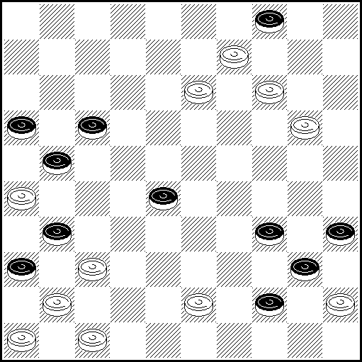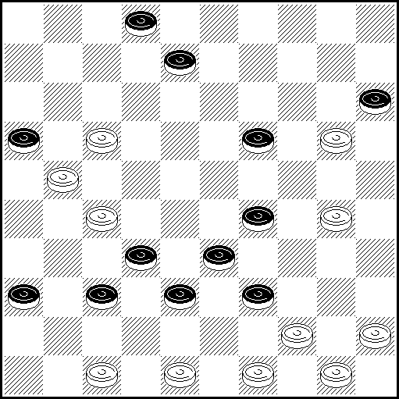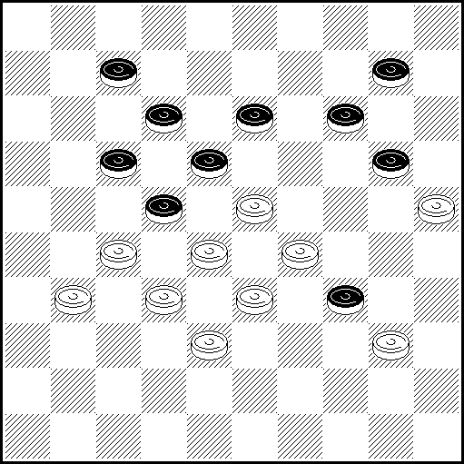

№4 А.Timmеr (Nethelands) №5 А.Rom (USA) №6 V.Matus (Russia)
№5 №59 №19
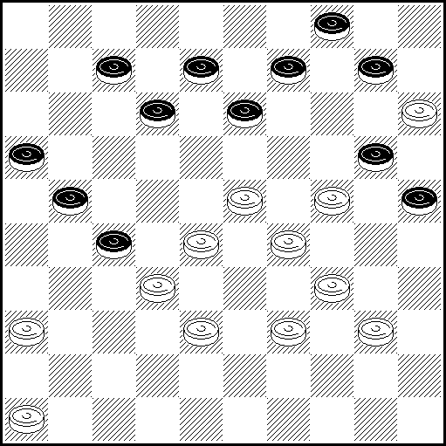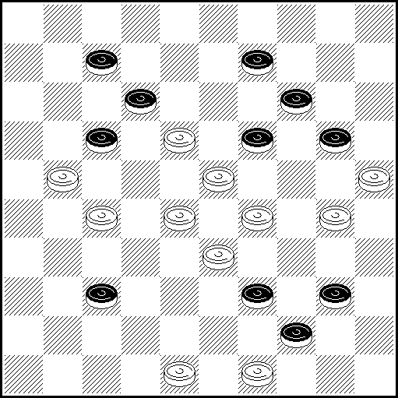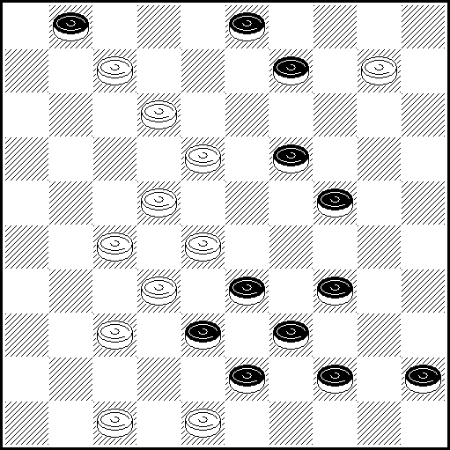

Solutions:
N37 10,4,38,41,6(49),17(40-44),40(50),17-11,1,45x
N3 11,7,47-42,38(27),45-40,2,41x
N11 21,19,1(45)33,5,40,32(40)28(45)50+ [34>24, add black piece on 34, white king on 34, white piece on 49. Black plays (24-30), white 34-40, 49x40, black (30-34)]
N5 31, 41, 27, 3, 9, 4 (12-18, 30, 39) 38 (44), 40, 49(21, 40) 11 (45) 50 x
N59 29-24,20,3,1,29,45(50),44x

Classification points for the Category B

А. Sapegin - 30 points
V. Matus - 25
A. van der Stoep - 20
A. Timmer - 15
А. Rоm - 10
V. Matus - 5

The best problems for the Category С

№1 V. Matus (Russia)) №2 R. Shayahmetov (Russia) №3 B. Ivanov (Belarus)
№27 №1 №16
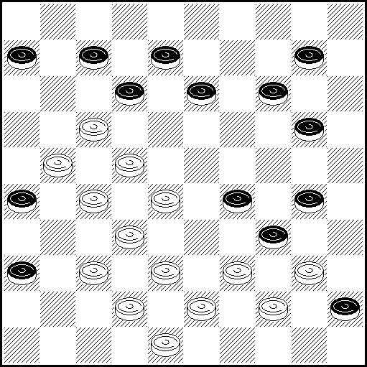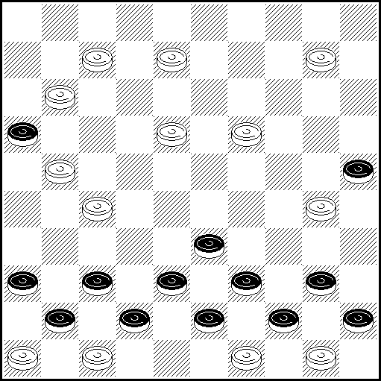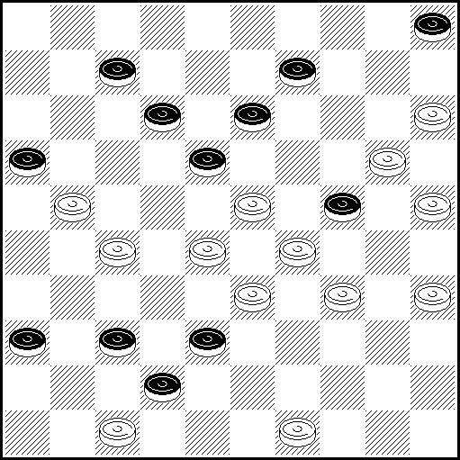

№4 M.Fedorov (Ukraine) №5 R. Shayahmetov (Russia) №6 A.Tavernier (France)
№30 №35 №8
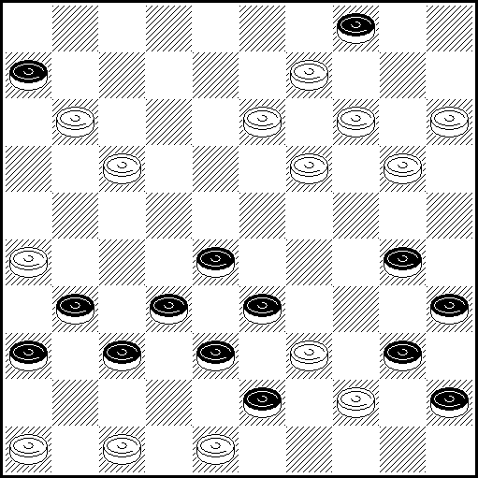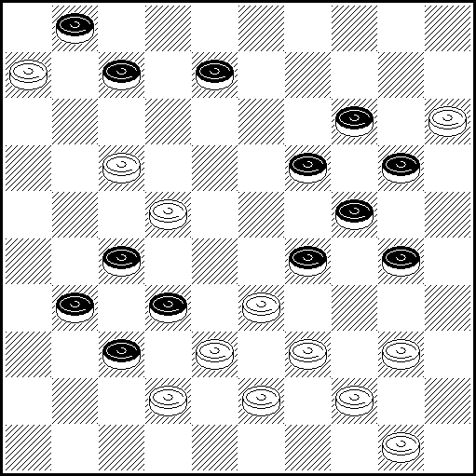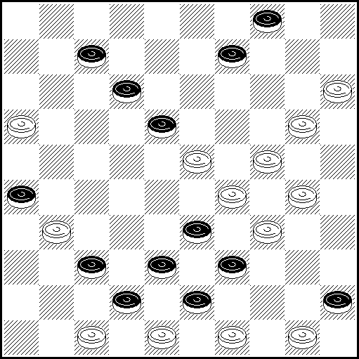

Solutions:
№ 27 I 16,31,41,11,38-33,4,4:22:1,40x
I 11?(16),35,4,(41!),7(47),11a,30(50),45(36),12(36-9),3(47-36),26(3)=
a 30 (36),11(49),34(7),1(50)=
№ 1 4,15,(42-48A),29,3,21,2,42x A(43-48),29,3,21,2,43x
№16 43,38,38,32,31,14,3,43(45А) 10,20,35-30, 50x А.(44), 10, 20, 35-30, 50x
№ 30 15-10, 12, 2, 34, 39, 46-41,37,9,49x
№ 35 404, 29, 11, 7, 1 (18A), 1: 23: 37: 43 + A (43), 7, 7: 34: 48+
№ 8 10, 24-19,(33:35),11(15:13),2,46,44x

Classification points for the Category С
- V. Matus – 30
- R. Shayahmetov - 25
- B. Ivanov - 20
- M. Fedorov - 15
- R. Shayahmetov - 10
- A. Tavernier – 5

OFFICIAL TABLE CPI FMJD
Second Personal World Championship of Problemism (PWCP-II)
(“Miniatures”)
Place  Место | Authors  Авторы | Category A |  | Category B |  |  | Category C |  | Category D |  | Sum  Сумма
Place  Место | Authors  Авторы | №sum | №sum | №sum | №sum |  | №sum | №sum | №sum | №sum | Sum  Сумма
I | V.Matus  Russia | 12-97 | 53-100 | 16-97 |  | 54-100 | 32-86 | 33-100 | 23-90 | 24-97 | 494
II | А.Мoiseyev  USA | 8-92 | 49-86 | 2-92 |  | 42-87 | 22-72 | 23-90 | 16-100 | 17-94 | 468
III | A.Kuyken  Switzerland | 5-88 | 46-81 | 8-92 |  | 48-88 | 11-97 | 12-92 | 3-87 | 4-88 | 457
IV | V.Bieliauskas Lithuania | 15-87 | 56-0 | 19-76 |  | 57-76 | 38-94 | 39-82 | 40-92 | 41-66 | 431
V | А.Таvernier France | 21-69 | 62-80 | 25-62 |  | 63-82 | 50-88 | 51-83 | 50-86 | 51-79 | 419
VI | S.Ustjanov Ukraine | 24-77 | 65-76 | 28-54 |  | 66-61 | 56-40 | 57-85 | 56-81 | 57-84 | 403
7 | М.Cvetov  Israel | 17-52 | 58-0 | 21-74 |  | 59-79 | 42-87 | 43-54 | 44-76 | 45-78 | 394
8 | М.Levandovsky Ukraine | 28-94 | 69-59 | 33-66 |  | 71-65 | 66-0 | 67-84 | 64-0 | 65-78 | 387
9 | А.Тimmer  Netherlands | 20-0 | 61-79 | 24-0 |  | 62-0 | 48-73 | 49-79 | 48-71 | 49-80 | 382
10 | S.Perepelkin  Russia | 11-59 | 52-71 | 15-85 |  | 53-84 | 30-79 | 31-0 |  |  | 378
11 | М.Sabater  France | 23-0 | 64-53 | 27-80 |  | 65-57 | 54-0 | 55-75 | 54-75 | 55-74 | 361
12 | G.Andrejev Latvia | 22-44 | 63-65 | 26-69 |  | 64-70 | 52-72 | 53-59 | 52-0 | 53-83 | 359
13 | А. van Моurik Netherlands | 32-64 | 73-68 | 37-81 |  |  | 74-76 | 75-0 | 31-67 |  | 356
14 | A.Vermeulen  France | 6-47 | 47-60 | 13-84 |  | 51-63 | 26-79 | 27-33 | 20-64 |  | 350
15 | N.Doubovy France | 39-73 | 78-85 | 10-50 |  | 50-0 | 15-55 | 16-80 | 5-0 | 6-0 | 343
16 | А.Rom  USA | 18-78 | 59-38 | 22-73 |  | 60-71 | 44-39 | 45-66 |  |  | 327
17 | М. Fedorov Ukraine | 11-83 | 42-0 | 3-94 |  | 43-0 | 24-74 | 25-0 | 18-63 | 19-0 | 314
18-19 | P.Garlopeau France | 33-71 | 74-0 | 38-0 |  | 75-49 | 76-58 | 77-65 | 32-68 | 33-0 | 311
18-19 | G.Shestirikov Russia | 13-51 | 54-0 | 17-78 |  | 55-51 | 34-67 | 35-64 | 25-0 | 26-0 | 311
20 | B.Ruchkin  Russia | 30-55 | 71-68 | 35-0 |  | 73-65 | 70-51 | 71-62 | 29-0 | 30-0 | 301
21 | А.Kaciuska  Lithuania | 19-43 | 60-59 | 23-52 |  | 61-0 | 46-44 | 47-44 | 46-70 | 47-60 | 285
22 | V.Nikitchuk  Ukraine | 9-0 | 50-90 | 32-0 |  | 70-77 | 64-36 | 65-0 | 62-0 | 63-82 | 285
23 | A.Sajachmetov  Russia | 3-76 | 44-84 | 5-0 |  | 45-0 | 3-51 | 4-0 | 12-73 | 13-0 | 284
24 | L.Vitoshkin Belarus | 38-0 | 77-34 | 7-0 |  | 47-57 | 9-45 | 10-42 | 1-65 | 2-73 | 282
25 | W.Riemens Netherlands | 35-56 | 75-45 | 40-0 |  | 77-67 | 80-56 | 81-48 | 36-0 | 37-0 | 272
26 | D.de Ruiter Netherlands | 40-0 | 79-0 | 11-0 |  |  | 17-61 | 18-53 | 7-85 | 8-69 | 268
27 | А.Nyrov  Russia | 16-0 | 57-82 | 20-0 |  | 58-72 | 40-70 | 41-37 | 42-0 | 43-0 | 261
28 | А.Jovaisas  Lithuania | 25-68 | 66-0 | 29-49 |  | 67-68 | 58-68 | 59-0 | 58-0 | 59-0 | 253
29 | А.Uvarov Ukraine | 26-63 | 67-50 | 30-0 |  | 68-55 | 60-81 | 61-0 |  |  | 249
30 | V.Studencov Lithuania | 14-62 | 55-62 | 18-0 |  | 56-86 | 36-0 | 37-0 | 38-0 | 39-0 | 210
31 | А.Nyc  Ukraine | 93-30 | 94-73 | 86-54 |  | 87-45 | 96-0 | 97-0 | 76-0 | 77-0 | 202
32 | B.Ivanov  Belarus | 10-54 | 51-76 | 14-0 |  | 52-0 | 28-0 | 29-69 | 21-0 | 22-0 | 199
33 | I.Ivacko Ukraine | 87-0 | 88-0 | 80-43 |  | 81-47 | 91-60 | 92-42 | 70-0 | 71-0 | 192
34 | Е.Коpylov Russia | 29-50 | 70-46 | 34-44 |  | 72-0 | 68-47 | 69-0 | 27-0 | 28-0 | 187
35 | А.Маslov Ukraine | 91-43 | 92-33 | 84-0 |  | 85-0 | 94-47 | 95-51 | 74-0 | 75-0 | 174
36 | V.Vorushilo Belarus | 31-0 | 72-39 | 36-42 |  | 74-0 | 72-36 | 73-52 |  |  | 169
37 | S.Reznikov Ukraine | 34-0 | 95-30 | 39-58 |  | 76-0 | 78-0 | 79-0 | 34-0 | 35-61 | 149
38 | J.Shioginys  Lithuania | 37-0 | 76-36 | 6-0 |  | 46-59 | 7-34 | 8-0 |  |  | 129
39 | S. M.van Eijk Netherlands | 80-35 |  |  |  |  | 82-57 | 83-0 | 66-0 |  | 92
40 | I.Navrocky Belarus | 2-0 | 43-31 | 4-0 |  | 44-46 | 1-0 | 2-0 | 10-0 | 11-0 | 77
41 | А.Каtjuha Ukraine | 86-0 |  |  |  |  | 89-0 | 90-63 | 69-0 |  | 63
42 | I.Kobcev Ukraine | 89-0 | 90-0 | 82-0 |  | 83-0 | 93-0 |  | 73-62 | 72-0 | 62
43 | R.Mackevicius  Lithuania | 36-0 |  | 9-60 |  | 49-0 | 13-0 | 14-0 |  |  | 60
44 | S.Sarsak Ukraine | 83-48 | 84-0 |  |  |  | 86-0 |  | 67-0 | 68-0 | 48
45 | А.Savchenko Ukraine | 85-43 |  |  |  |  | 87-0 | 88-0 |  |  | 43
46 | R.Outters  France | 4-0 | 45-40 |  |  |  | 5-0 | 6-0 |  |  | 40
47-48 | S.Darchenko Ukraine | 27-0 | 68-38 | 31-0 |  | 69-0 | 62-0 | 63-0 | 60-0 | 61-0 | 38
47-48 | I.Bulatov  Ukraine | 7-0 | 48-0 | 1-0 |  | 41-0 | 20-0 | 21-38 | 14-0 | 15-0 | 38
49 | V.Trinos Ukraine | 81-32 | 82-0 | 78-0 |  | 79-0 | 84-0 | 85-0 |  |  | 32
50 | B.Fermin Netherlands | 41-30 |  | 12-0 |  |  | 19-0 |  | 9-0 |  | 30
No place | P. Kuiper Netherlands |  |  |  |  |  |  |  |  |  | 417

Category А

Place Name, Country
1 V.Matus (Russia)
2 V.Matus (Russia)
3 M. Levandovskiy (Ukraine)
4 A. Moiseyev (USA)
5 A. Nikitchuk (Ukraine)
6 A. Kuyken (Switzerland)

The best problems for the Category А

1 – V. Matus 2 - V. Matus 3 – M. Levandovsky
№53 №12 №28
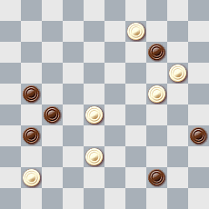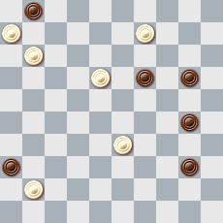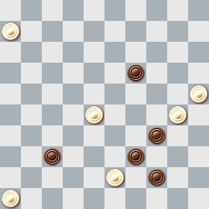

4 – A. Moiseyev 5 - A.Nikitchuk 6-A. Kuyken
№8 №50 №5
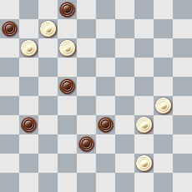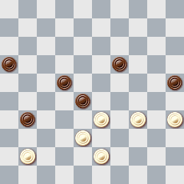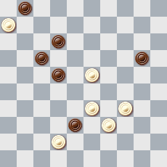

Solutions:
№53. 4, 282, 50(40a), I. 20, 45(44A), 50(49A1), 17, 5+ A, A1 (36), 10, 15, 16+ a (36), 50-33/50-45, 29, 16(40), 11(45), 50+
№12. 7, 4, 1(29A), 4-18, 28(45), 50+ A (24), 14, 45+
№28. 41(46), 1(48A), 50, 34, 34(23), 29, 44+ A (23), 49, 43(39), 24, 43+
№8. 8(17), 29, 40Z (13A), 2, 36(28), 27(33), 43(21B), 16(39), 49+ A(11/44), 3, 50(27,32), 33(37), 47+ B922), 16(39), 11+ Z 3?, 33(40,49)=
№50. 36(48A), 18, 13(30), 8(34), 2(40), 35(45), 44(50B), 6(21), 12(27), 7(31), 7-1(36), 12(44), 50, 23(47), 50-33(36), 41, 15+ A(30), 13(227), 9(30), 4(34), 18(39), 34(32), 36x27(43), 9+ B(21), 50(27), 13(31), 9(36), 4(41), 10+
№5. 18, 7, 34, 1 и 3 варианта(variants):
1) (27), 34(31), 48(36) [(21или (or) 22), 37, 25+] 43(21) A[(41), 37, 25+] 16(41), 37,
15+ A(24), 37(22), 16(28), 31, 30… +
2) (27), 34Z (24), 37(21), 43(29), 49(34), 372, 16(40), 11(45), 50+ Z 40? (31)=
3) (24), 40 [34? (21!)+] (27), 44 [37? 32! 30!=] (21), 49(30), 37Y (34/35), 372,
16(40), 11(45), 50+ Y 43?(35), 49(26!), 16(40), 11(45), 50(31)=

Master’s points for the Category А

V. Matus - 30
V. Matus - 25
M. Levandovskiy - 20
A. Moiseyev - 15
A. Nikitchuk - 10
A. Kuyken – 5

Категория B

Place Name, Country
1 V.Matus (Russia)
2 V.Matus (Russia)
3 M. Fedorov (Ukraine)
4-5 A. Moiseyev (USA)
4-5 A. Kuyken (Switzerland)
6 A. Kuyken (Switzerland)

The best problems of the Category B

1 - V. Matus 2 - V. Matus 3 M. Fedorov
№54 №16 №3
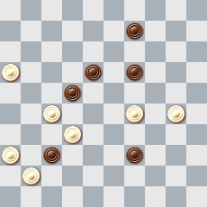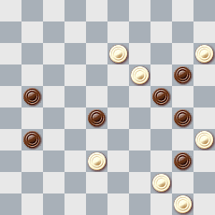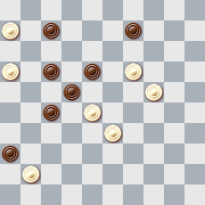

4-5 - A. Moiseyev 4-5 - A. Kuyken 6 - A. Kuyken
№2 №8 №48
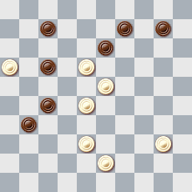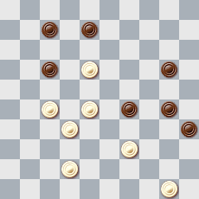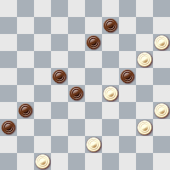

Solutions:
№ 54 294(31A), 4(46), 44, 27, 27+ A (46), 4, 9, 44, 27, 27+
№ 16 10, I, 5 (4), 13(27A), 43, 44, 44+ A (22), 39, 39(29), 34, 44+
№ 3 11(16A), 20, 204(2B), 3, 7, 17+ A(47), 2(15), 1, 20+ B(8), 32, 28, 1+
№ 2 32(49), 11, 2, 239(8A), 12+ A(13), 5+
№ 8 12, 21, 23(33), 3, 34(49), 45(27…), 38(49A), 44, 18(31, 40), 22(45), 50+ A(43), 40, 48+
№ 48 14(20), 10, 5(39), 26(48), 30, 48(27), 472(18 ABC), 404, 31, 37+ A(31), 404, 18+ B(32), 37Z, 404, 46+ Z 404? (43!)= C(24), 404, 2(41), 37, 16(31), 38(37), 47+

Master’s points for the Category B

V. Matus - 30
V. Matus - 25
M. Fedorov - 20
A. Moiseyev - 15
A. Kuyken - 10
A. Kuyken – 5

Category C

Place Name, Country
1 V.Matus (Russia)
2 A. Kuyken (Switzerland)
3 V. Bieliauskas (Lithuania)
4 A. Kuyken (Switzerland)
5 A. Moiseyev (USA)
6 A. Tavernier (France)

The best problems of the Category С

1 – V. Matus 2 - A. Kuyken 3 - V. Bieliauskas
№33 №11 №38
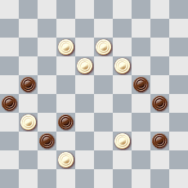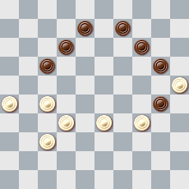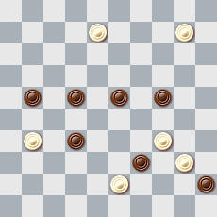

4 - A. Kuyken 5 - A. Moiseyev 6 - A. Tavernier
№12 №23 №50
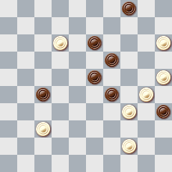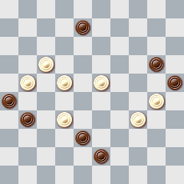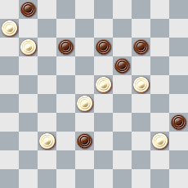

№33 I. 9(22A), 7, 1(34B), 4, 48+ A(4), 7, 1, 46, 16+ B(37), 45, 45x12x42(34), 4(28C), 10(39D), 38, 49+ D(40), 38, 35+ C(27), 31(39), 33, 42+ I. 7?, 1, 46, 45(27), 23(31)= Легальность (Legality): 15, 21, 26, 30, 32, 34, 37, 40/12, 13, 18, 19, 20, 31, 42, 43, 48 39(43), 39(24)
№11 261, 23, 19, 3(29), 25(33), 22(38), 31, 3(382AB), 18, 47+ A(372), 17, 48+ B(41), 18, 36+
№38 5(48), 26(30A), 2, 19, 27, 35(39), 49+ A(25), 3, 27, 48+
№12 39, 20, 9, 34, 10(32), 28(34), 23, 4(19), 8(40A), 3(45B), 13, 50+ A(23), 3(40), 4-18, 35+ B1(44), 13, 50+ B2(32), 13, 35+ B3(23), 18, 35+ B4(24), 15(30), 25+
№23 12, 3(17A), 45, 15+ A(34), 48, 45+
№50 18, 7(12a), 1(44A), 1x29x25, 50+ A(30), 33, 50+ a). (30/44), 2, 46+

Master’s points for the Category C

V.Matus - 30
A. Kuyken - 25
V. Bieliauskas - 20
A. Kuyken - 15
A. Moiseyev - 10
A. Tavernier – 5

Category D

Place Name, Country
1 A. Moiseyev (USA)
2 V.Matus (Russia)
3 A. Moiseyev (USA)
4 V. Bieliauskas (Lithuania)
5 V.Matus (Russia)
6 A. Kuyken (Switzerland)

The best problems of the Category D

1 - A. Moiseyev 2 - V. Matus 3 - A. Moiseyev
№16 №24 №17
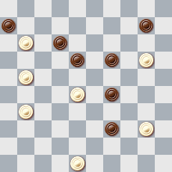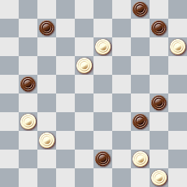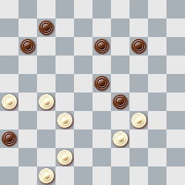

4 - V. Bieliauskas 5 - V. Matus 6 - A. Kuyken
№40 №23 №4
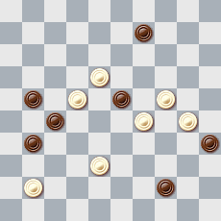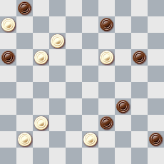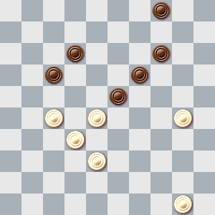

Solutions:
№16 17, 15, 4(26), 11, 2(23A), 19(41B, a), 43, 34, 36+ A(34), 29(23), 19 и т.д. как в варианте B(and so on as in variant B) B(34), 29(41b), 193(44), 43(50B1,C), 39, 46+ B1(49), 23, 46+ C(47), 38, 49+ a(42, 43), 8(33), 2(38), 8+ b(44), 43(50b1), 39+ b1(49), 193+
24. 39(49A), 9, 4, 35(48), 504, 49(25), 43, 26, 37+ A (48), 9, 4, 35(49), 504, 49(25), 43, 26, 37+
№24 39(49 А),9,4,35(48),504,49(25),43,26,37+ А(48),9,4,35(49), 49(25),43,26,37+
№17 28, 6, 1(41a), 25(46A), 41(34B), 39, 50+ A (45, 50), 394(45), 340(29), 37(23), 371(19), 27, 30, 27+ B(30), 45+ a(45), 20(50), 20-33+
№40 13, 4, 50(40), 20, 45(44), 50(49A), 17, 5+ A(36), 10, 15, 16+ Легальность (Legality): 2, 4, 6, 8, 19, 21, 27, 28, 31, 33, 35, 37, 42, 44/13, 18, 24, 29, 30, 38, 47 23(11), 41(17), 29(9), 38(7), 22(23)
№23 7, 14, 3(26), 48(50A), 417, 17, 17+ A (27), 417, 22(21B), 50(27), 1(32), 29(37), 47+ B(50), 17, 17+
№4 272(21), 24[18?(27!)=] 10, 17(18, 22), 21(27) 16(31), 27, 11(27), 7[6?(34!), 1(32!)= (31), 1(36), 50-45(20A), 1-40(24B), 23(34C), 40(41), 23(47), 34, 34+ A (41), 23(47), 34, 25+ A(34,41), 23+ B(41), 23(47), 34, 14+ B(34, 41), 10+ C(29, 41), 34+

Master’s points by the Category D

A. Moiseyev - 30
V. Matus - 25
A. Moiseyev - 20
V. Bieliauskas - 15
V. Matus - 10
A. Kuyken – 5

A title or a higher title was reached by:

V.Bieliauskas (Lithuania) – International Master;
М.Fedorov (Ukraine) – International Master;
М.Levandovsky (Ukraine) – Master of FMJD;
А.Мoiseyev (USA) – Master of FMJD;
B.Ivanov (Belarus) – Master of FMJD.

CPI FMJD informed Mr. Frank Teer, the General Secretary of FMJD, about granting the international titles to the persons listed above. Congratulations!

International titles (table)

International Grand Master Honoris Causa (GMI HC)

G.Avid (1900-1989), J.C.R. Bus, F.W.J. Hermelink, P. Kuiper, V. Matus,
L.de Rooy, A.Fedoruk, R.Fourgous (1920-1993), A.v.d. Stoep, J.Viergever, D. Vuurboom, B.Shkitkin, A.P. de Zwart, S.Yushkevitch.

International Master Honoris Causa (MI HC)

H.van Alphen (1918-1997), M.Douwes (1923-1998), J.Pennings (1920-1995), G.Post (1914-1995).

International Grand Master (GMI)
J.Bastiaannet, E.Zubov, B.Fedorov, A.Kuyken, V.Matus, B.Morkus, A.Nikolayev, S.Perepelkin, D.de Ruiter, A.Tavernier, S.Yushkevitch.

International Master (MI)

A.J.de Jong, A.Miedema (1924-1997), A.Rom, JP.Torrés, А.Fedoruk.

Master of FMJD (MFP)
G.Andreev, V.Studencov, A. J. de Jong, S.Klomp, A.Konkov, V.Muliar, B.Fedorov, D.Nikolayev, G.Dumas, V.Bieliauskas, V.Shulga, S.Ustianov.

