Dear Sirs,

After the PWCP II publication on Internet of the participating compositions it was found that an email with 8 compositions was sent in time, but because of provider´s problems they were not included in the publication. The participant has proposed to have these compositions judged by the jury members, but out of the competition of the PWCP II, because he did not ask for a confirmation by the contact when sending his email.

The CPI and the contact accept his proposal with gratitude.

This means that the 8 compositions will be published on the usual Internet sites and will be scored by the jury separately.

Best regards,
Ayrat Nagumanov
The Coordinator of PWCP-II

A-95 A-96 B-88 B-89
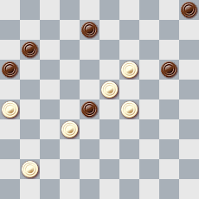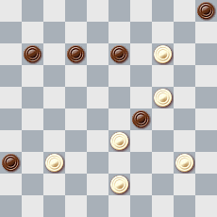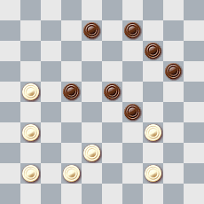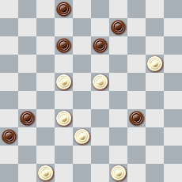

C-98 C-99 D-78 D-79
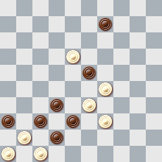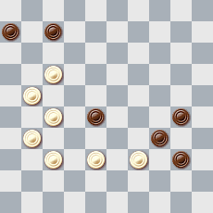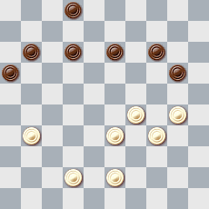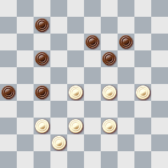

A-95: 13, 2(10), 24, 21, 4
A-96: 10, 31, 4, 14
B-88: 17, 10, 4(24), 30(25), 2ab a(24), 2 b(12), 25(24), 3(18), 8 or 9 etc
B-89: 41, 14, 3(43), 8, 43
C-98: 13, 4, 27, 41(18), 23
C-99: 372, 11, 2, 11(17), 38
D-78: 304(21), 15(27), 22(20), 24(19), 13(8), 2(127), 16, 32, 23, 29
D-79: 383(32), 293, 37, 37, 2(31), 10, 15(48), 34

